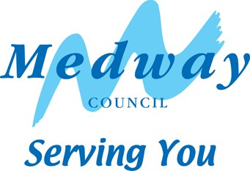
Canvasser Application
Please complete in CAPITAL LETTERS

Surname
First name(s)

Address
 |  |  | Post Code
Telephone | Daytime |  | Evening
 | Mobile |  | E-mail

Department (if council employee)

Date of Birth

Preferred Areas of Work e.g. Chatham, Gillingham, Rochester or “any”.
Please note: Canvassers will be allocated according to our requirements. There is no guarantee that canvassers will be allocated to their area of choice, but every effort will be made to allocate you to that area or nearby.

Do you have experience of working in a customer service environment?

Please describe your experience of dealing with the public in face-to-face situations.

Please give an example of when you had to demonstrate excellent verbal communication skills including powers of persuasion in a particularly challenging situation.

Describe your experience of organising and managing your own time to meet deadlines with minimal supervision

Describe your experience of maintaining written records in a methodical manner and complying with legislation.

Give an example of your self-motivation and how it helped achieve a specific goal

Please give the name, address and contact details of two references:

1).

Tel:

2).

Tel:

Where did you see this job advertised?

Declaration

I declare that I have not, am not and will not assist anybody else with a campaign for any Parliamentary, Local, European or Parish election, nor do I occupy any position in connection with a political party or organisation.
I confirm that all the information provided on this form is correct and complete.
I am entitled to work in the UK.

Signed: Date:

Please return this form to Electoral Services, Gun Wharf, Dock Road, Chatham, ME4 4TR or email to electoralservices@medway.gov.uk or fax to 01634 332416.

Equal Opportunities Monitoring Form

To help us ensure that our recruitment procedures give genuine equality of opportunity please answer the questions below. This document will be kept separate from your application. Please tick box where appropriate.

Vacancy Information
Job  Title | Casual Annual Canvasser | Ref No | N/A | Closing  Date

Personal Information
Name |  | D.O.B.

Gender – Please tick box
Male |  | Female

Ethnic Origin
White  British |  | White  Irish |  | Any other White background (please specify)

Multi Ethnic
Black Caribbean  And White |  | Black African  And White |  | Asian or  Asian British |  | Other multi-ethnic background (please specify)

Asian or Asian British
Indian |  | Pakistani |  | Bangladeshi |  | Any other Asian background (please specify)

Black or Black British
Caribbean  British |  | African |  | Any other Black background (please specify)

Chinese or other Ethnic Group
Chinese |  | Any other ethnic group (please specify)

