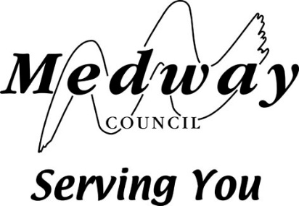

Form of Statement for

Street Collection or House to House Collections

Police, Factories, & c. (Miscellaneous Provisions) Act 1916 and

House to House Collections Act 1939

Gravesham and Medway Shared Licensing Service, Civic Centre, Windmill Street, Gravesend, Kent DA12 1AU
Email: licensing@gravesham.gov.uk

Part 1 – Details of Person licensed

Title: Mr Mrs Ms Miss Other: ……………………..

First name: ……………………..

Last name (block capitals): ……………………..

Name of charity or fund which is to benefit: ……………………..

Home address, including postcode:

……………………..……………………..……………………..……………………..……………………..……………………..……………………..……………………..……………………..……………………

Business address, including postcode:

……………………..……………………..……………………..……………………..……………………..……………………..……………………..……………………..……………………..……………………

Phone numbers, including area codes:

Home: ………

Work: ………

Mobile: ………

Email address: ………………

Part 2 - Details of collection

Date of collection: ………

Part 3 – Financial details of collection

Proceeds of collections

 | Amount | Total
From collecting boxes
Interest on proceeds
Other items
 | Total:

Expenses and application of proceeds

 | Amount | Total
Printing and stationery
Postage
Advertising
Collecting boxes
Badges
Emblems
Other Items
Payments approved under Regulation 15(2)
Disposal of Balance (insert particulars)
 | Total:

Part 4 – Certificate of the person whom the permit/licence was granted
I certify that to the best of my knowledge and belief the above is true account of the proceeds, expenses and application of the proceeds of the collection.

Signature of person licensed for Street Collection or House to House Collection

Signature: ………

Print name: ………

Date: ………

Part 5 – Certificate of Accountant or Independent Responsible Person
I certify that I have obtained all the information and explanations required by me and that the above is in my opinion a true account of the proceeds, expenses and application of the proceeds of the collection.

Signature: ………

Print Name: ………

Capacity: ………

Qualification (if applicable): ………

Date: ………

This authority is under a duty to protect the public funds it administers, and to this end may use the information you have provided for the prevention and detection of fraud. It may also share this information with other bodies responsible for auditing or administering public funds for these purposes.

Medway Council is a Data Controller under the Data Protection Act 1998. We hold information for the purposes specified in our Data Protection Notification made to the Information Commissioner and may use this information for any of them.

We may get information about you from others, or we may give information to them. If we do it we will only do so as the law permits, to check accuracy of information or prevent or detect crime. We may check information we receive about you with what is already in our records. This can include information provided by you as well as by others such as government departments and statutory agencies. We will not give information about you to anyone outside Medway Council unless the law permits us to do so.

