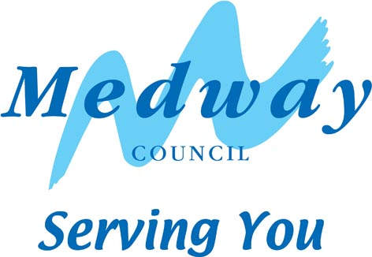

MEMORIAL TREES

Memorial trees are planted within a designated area of the Country Parks. Within this area we are currently planting traditional fruit trees, following consultation with the Park Rangers to decide the precise location.

Planting takes place between November and January in order to ensure the best start for the tree.

For enquiries and consultation regarding ordering a memorial tree the guide price of a traditional fruit tree, including planting and staking, will be around £200 + VAT.

Once planted, every effort is made to care for donated trees but losses do sometimes occur. The country park will pay for a replacement should the tree be lost in the first year. After this period lost specimens will be removed without replacement by the park staff.

The park does not permit the installation of a plaque at the base of your tree and its precise location will not be mapped. It should, however, be tagged to allow for its replacement if it is lost in the first year. Please note, for legal reasons we do not permit the burying of ashes or urns beneath the trees.

* Please note we ask that nothing be tied to memorial trees, such as flowers, wreaths and pictures.

If you would like a memorial tree please contact:

Capstone Farm Country Park - 01634 338191
or
Riverside Country Park - 01634 337432

APPLICATION FORM - MEMORIAL TREE

Please indicate in which of the parks you would prefer your memorial to be placed:

 | TICK | NAMED AREA
CAPSTONE FARM COUNTRY PARK
RIVERSIDE COUNTRY PARK
RECREATIONAL AREA
URBAN PARK

NAME:

ADDRESS:
POSTCODE:

EMAIL:

TELEPHONE NUMBER:

MOBILE TELEPHONE NUMBER:

TERMS AND CONDITIONS FOR MEMORIAL TREES:

- Once you have chosen to purchase a memorial tree, we will confirm the price, and other relevant details, in writing to you. Medway Norse will order and take delivery of the tree for you.
- The location in which the memorial tree will be placed is determined by the staff on site dependent on need and availability. Whilst we will try to locate a memorial tree at a requested location, this cannot be guaranteed.
- Installation will be undertaken or organised by staff on site, which is included in the overall cost.
- The public nature of the park dictates that we only permit the placement of a single flower at the base of the tree on significant days. Floral bouquets and other tributes will be removed.
- For legal reasons we do not permit the placement of ashes under any of the memorial tributes.
- Medway Norse cannot guarantee the long term safety or security of the memorial tributes, and is not responsible for the replacement, resulting from any damage or deterioration. However we will notify you of any recorded damage.

I have read and understood all of the terms and conditions regarding memorial benches and accept them in their entirety.

SIGNED:
PRINT NAME:
DATE:
Please return to: Capstone Farm Country Park, Capstone Road, Gillingham, Kent ME7 3JG for Capstone Farm Country Park, Recreational and Urban Park Sites.

or
Riverside Country Park, Lower Rainham Road, Gillingham, Kent ME7 2XH

