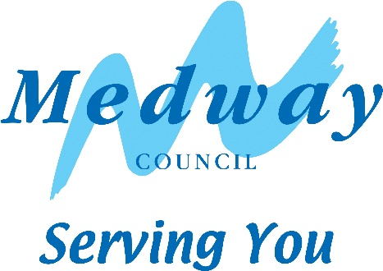

Notes on Making An Application

The Commons (Registration of Town or Village Greens) and Dedicated Highways (Landowner Statements and Declarations)(England) Regulations 2013 apply to any application made on or after 1st October 2013 to:

- deposit a map and statement under section 31(6) of the 1980 Act;
- lodge a declaration under section 31(6) of the 1980 Act;
- deposit a statement under section 15A(1) of the 2006 Act.

- The application form set out in Appendix A should be used or in a form to the same effect, with insertions or omissions as relevant to each particular case.
- The application must be signed by every owner of land to which the application relates, or by their duly authorised representative, and by the secretary or some other duly authorised officer of every owner of the land where the owner is a body corporate or unincorporated association. Proof of authorisation is required where used.
- The application must be accompanied by an Ordnance Map, at a scale of not less than 1:10,560 showing the boundary of the land to which the application relates in coloured edging. In respect of declarations under section 31 (6) of the 1980 Act or statements under Section 15A(1) of the 2006 Act, reference may be made to a map previously deposited in accordance with these Regulations or a map deposited in accordance with section 31(6) of the 1980 Act prior to 1st October 2013.
- The application must be accompanied by the appropriate fee.
- Once the map and statement relating to section 31(6) has been acknowledged as being accurate in respect of public rights of way, a declaration form must be completed to validate and complete the process. This form should be used to renew the declaration within 20 years of the original or previous declaration.

Fees

There is a standard fee of £350* for the processing of these applications and a standard fee of £50 for processing a renewal declaration.

PROCESS | DETAILS | INCLUDING | FEE
Process  Application | Acknowledgement and checking of application / comparison of records.  Preparation of notices/ receipts and publishing thereof. Serve notice of application by email. | Officer time / administration  (4 hours) | £200
Post notice of application | Posting notices on site by at least one point/s of entry. | Officer time, travel expenses  (2 hours) | £100
Update registers | Add entries to relevant registers (paper and electronic forms) | Officer time , scanning and digitisation of records  (1 hour) | £50
Process declaration  (standard fee for renewals) | Update records and registers | Officer time, scanning and digitisation of records  ( 1 hour) | £50

- In the case of applications covering extensive areas or multiple parcels of land, additional time may be involved. The time will be recorded and charged at a rate of £50 per hour (pro rata).

Completed forms should be sent to:

PROW Team
Highways Department
Medway Council
Front Line Services
Gun Wharf
Dock Road
Chatham
Kent. ME4 4TR

For further information or queries please contact : 01634 333333 and ask to speak to the Public Rights of Way team.

