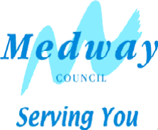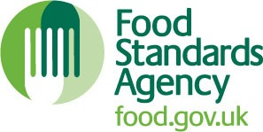

Food Hygiene Rating Scheme: Request for a re-visit

Notes for businesses:
- As the food business operator of the establishment, you have a right to request a re-visit for the purposes of re-rating if you have taken action to rectify the non-compliances identified at the time of inspection.
- Medway Council will charge you for this re-visit. The current charge is £168.30. A cheque made payable to “Medway Council” should accompany your request or alternatively you can pay over the telephone by card by calling 01634 333333. There is no limit on the number of requests you may make, provided that the fee is paid each time.
- You must provide details of the improvements made with your request, including supporting evidence where appropriate.
- If we consider that you have provided sufficient evidence that the required improvements have made, we will make an unannounced visit. This will take place within three months of the receipt of your request and payment of the fee.
- The inspecting officer will give you a ‘new’ food hygiene rating based on the level of compliance that is found at the time of the re-visit – you should be aware that your rating could go up, down or remain the same.
- To make a request for a revisit, please use the form below and return it to the Food & Safety Team - contact details are provided below.

Business details
Food business operator/proprietor
Business name

Business addresses

Business tel. number
Business email

Inspection details
Date of inspection
Food hygiene rating given

Action taken
Please describe the remedial action you have taken with reference to the issues identified in the inspection letter/report provided to you by your local authority with your score:
Compliance with food hygiene and safety procedures

FHRS 4 (Rev. 04/20)

Compliance with structural requirements

Confidence in management/control procedures

Please provide any other supplementary evidence
(For example photographs, invoices, copies of relevant HACCP documentation)

Signature

Name (in capitals)
Position

Date

Please now return this form to: Food and Safety Team, Medway Council, Gun Wharf, Dock Road, Chatham, Kent, ME4 4TR

FHRS 4 (Rev. 04/20)

