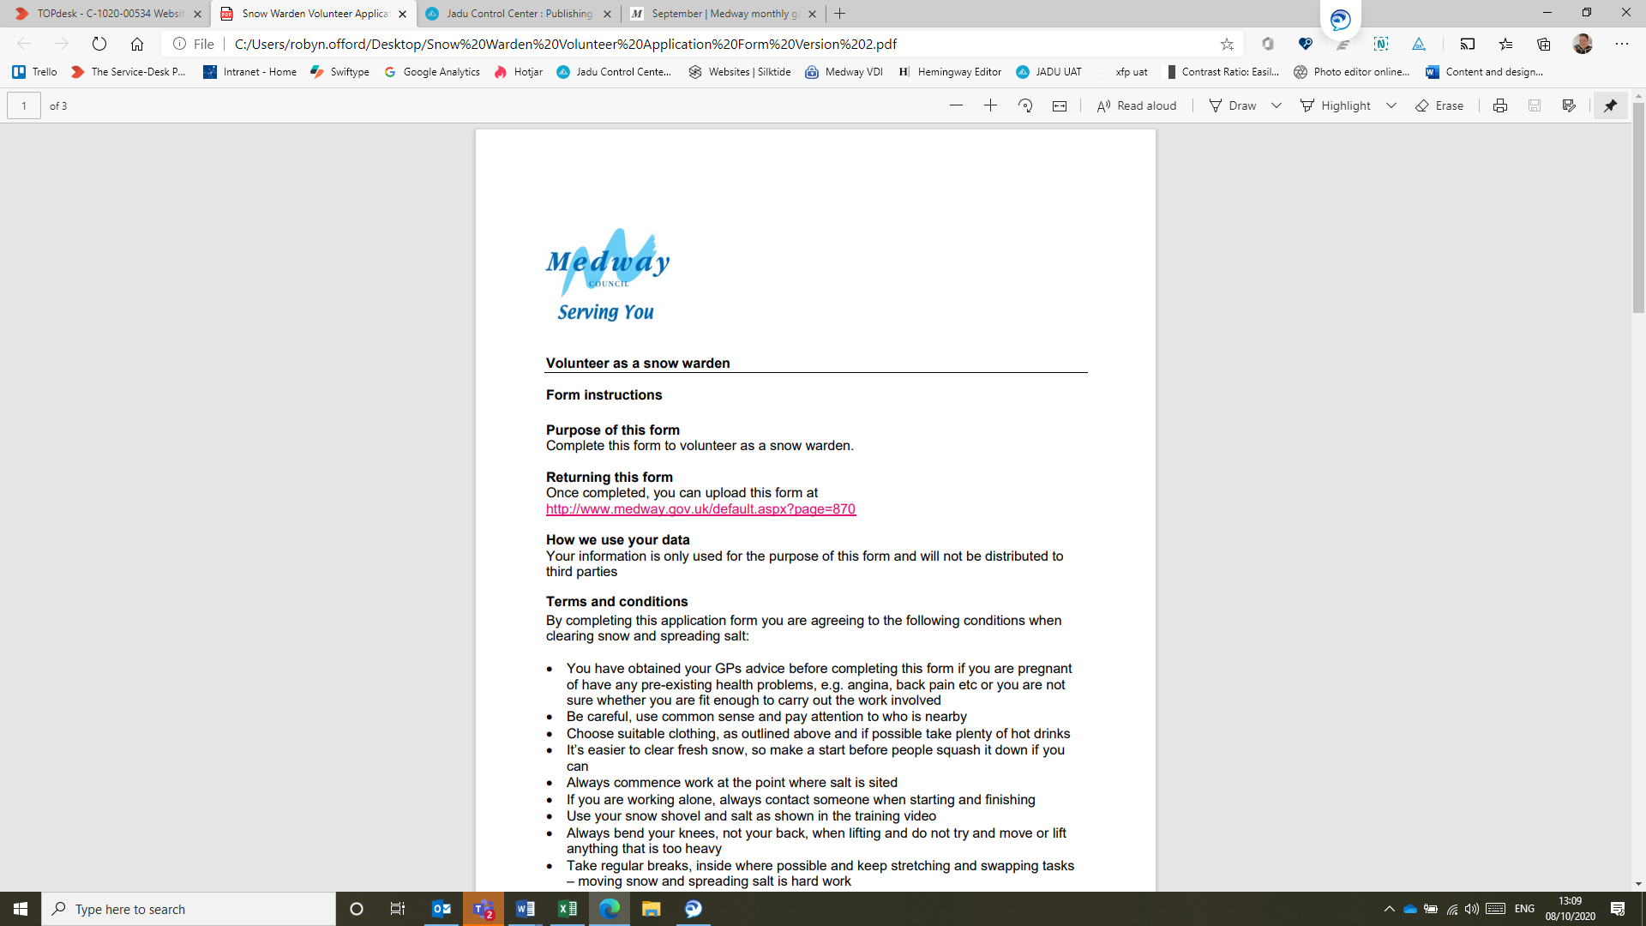

Volunteer as a snow warden

Form instructions

Purpose of this form
Complete this form to volunteer as a snow warden.

Returning this form
Once completed, please upload it on our website

How we use your data
Your information is only used for the purpose of this form and will not be distributed to third parties
Terms and conditions
By completing this application form you are agreeing to the following conditions when clearing snow and spreading salt:
- You have obtained your GPs advice before completing this form if you are pregnant of have any pre-existing health problems, e.g. angina, back pain etc or you are not sure whether you are fit enough to carry out the work involved
- Be careful, use common sense and pay attention to who is nearby
- Choose suitable clothing, as outlined above and if possible take plenty of hot drinks
- It’s easier to clear fresh snow, so make a start before people squash it down if you can
- Always commence work at the point where salt is sited
- If you are working alone, always contact someone when starting and finishing
- Use your snow shovel and salt as shown in the training video
- Always bend your knees, not your back, when lifting and do not try and move or lift anything that is too heavy
- Take regular breaks, inside where possible and keep stretching and swapping tasks – moving snow and spreading salt is hard work
- Don’t attempt to clear snow from roads, only clear snow from footways and pavements next to minor side roads
- Always try to face oncoming traffic when working near a carriageway
- Make a pathway down the middle of the area to be cleared first, so you have a clear surface to walk on. You can then shovel from the centre to the sides
- Think carefully about where you pile snow, do not block paths, drainage channels or fire exits
- Spread salt as you progress to stop ice forming on the area you have cleared
- Try to walk only on the areas you have salted to reduce the risk of slipping
- Use the sun to your advantage. Removing the top layer of snow will allow the sun to melt any ice beneath but you will need to cover any ice with salt to stop overnight refreezing
- Pay particular care and attention to steps and steep gradients – use extra salt if required
- DO NOT use hot water to melt snow, this will create black ice
- Regularly wash/wipe hands of salt and avoid contact with eyes
- Report ALL accidents, incidents and near misses that involve you or those working with you to Highways, Gun Wharf, Dock Road, Chatham ME4 4TR
- Your assistance is on an entirely voluntary basis. There is no contractual relationship between Medway Council and volunteers
- I have watched and understood the Medway Council Snow Warden Video
Customer details
First name:
Last name:
Address:
Postcode:
Phone:
Email:
Emergency contact name:
Emergency contact phone:
Location details Road/location where you wish to undertake snow clearing duties:

Size of Hi-Vis vest: Please circle Medium Large X-Large

Fit to participate declaration
The type of work you are volunteering to do can often be physically demanding and tiring. For this reason we would strongly advise that you ask yourself whether you are physically capable of carrying out the work involved. If you are pregnant of have any pre-existing health problems, e.g. angina, back pain etc or you are not sure whether you are fit enough to carry out the work involved, then you should seek advise from your GP before you complete this form.
DECLARATION
☐I declare that I am fit to manually clear snow and spread salt.
Signature:
Date:

