Alley-gating

Self Help Guide for Residents

Introduction

This pack gives you all the information you need to successfully progress an application for gating an alley.

Q: What information does this pack contain?

The pack contains the following:

- what the Council and other agencies will do to help you;
- what the residents need to do to take the application forward;
- useful contacts;
- information about planning and highways;
- an outline of the costs you are likely to incur;
- sample letters, and project forms.

Q: Are there different types of alley?

Yes. There are two types of alley:

- private
- public highway
The rights of people to pass and re-pass over the land depend on the type of alley.

Sometimes these rights are complex, if in doubt you may need legal advice

These differences mean that you will have to first of all identify whether the alley you want to gate is public highway or private.

Q: How do I do that?

Medway Council keeps records, in the form of digitalised maps, showing all the streets, roads and alleyways in Medway, which are designated “highway”. Most are maintainable at public expense, but some are maintained at private expense, meaning they still have highway rights of access over them.

You can check the status of an alleyway, via our website, using the link:-

http://medgis1.medway.gov.uk/webmaplayers/map.aspx

Once on the website, there will be a list of “map layers” on the right hand side. Click in the box next to “Highways”, then, below that, click on “address search”, add the house number, street and town and hit “search”. A list of matching properties will appear, click on the relevant property, in the list and wait for the map to download.

- Anything coloured grey is “highway maintained at public expense”.
- Any alleyways coloured in red are passageways which are “highway maintained at public expense”.
- Anything coloured in pink hatching is “highway maintained at private expense”

An example is shown below:-

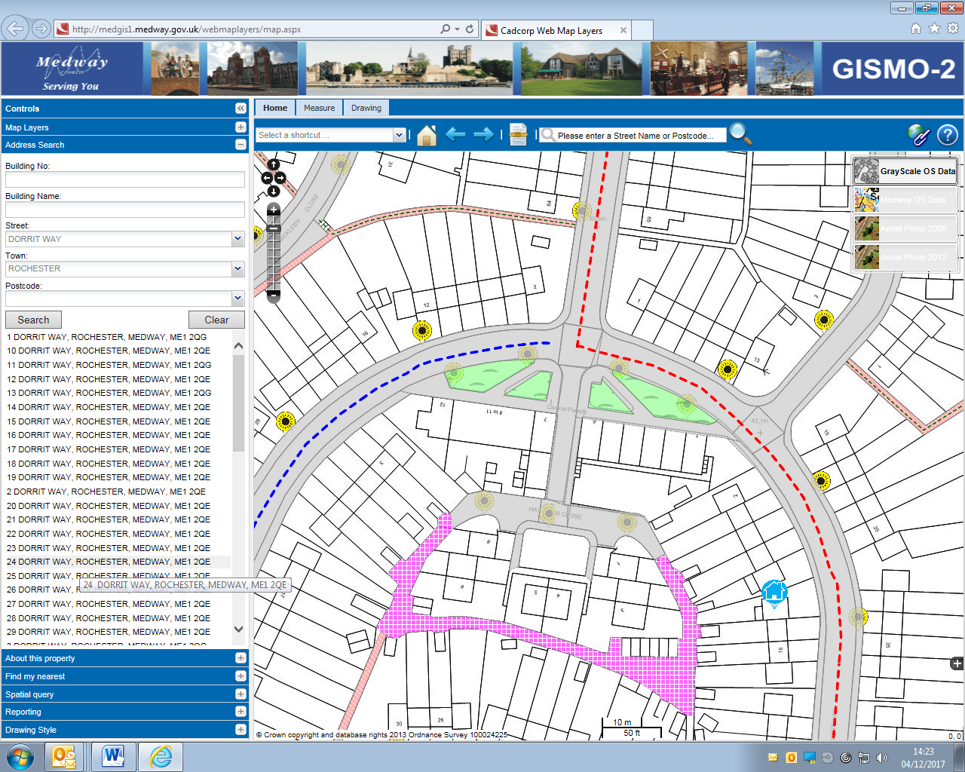

All of the above require the permission of the Highways Section, before alley gating can be considered. Highways will only give permission, where the alleyway is surplus to highway requirements and therefore any alleyway with highways rights over it or is a direct “short cut” or “link” or where the alternative route is longer, are unlikely to be considered. However, each will be judged on its own specific merit.

If you do not have access to the web, please call our Customer Contact Team, on (01634) 333333 and ask for a Highway Search to be logged. They will enter your contact details and the details of the alleyway, on to the system and you will be contacted thereafter for confirmation on the status of the alleyway.

Once you have identified whether the alley is private or public highway, you will need to follow the instructions set out in the rest of this guide.
The guide is in two parts:

- Part A – for public highway alleys
- Part B – for private alleys

Please use either Part A OR Part B

Part A – Public highway

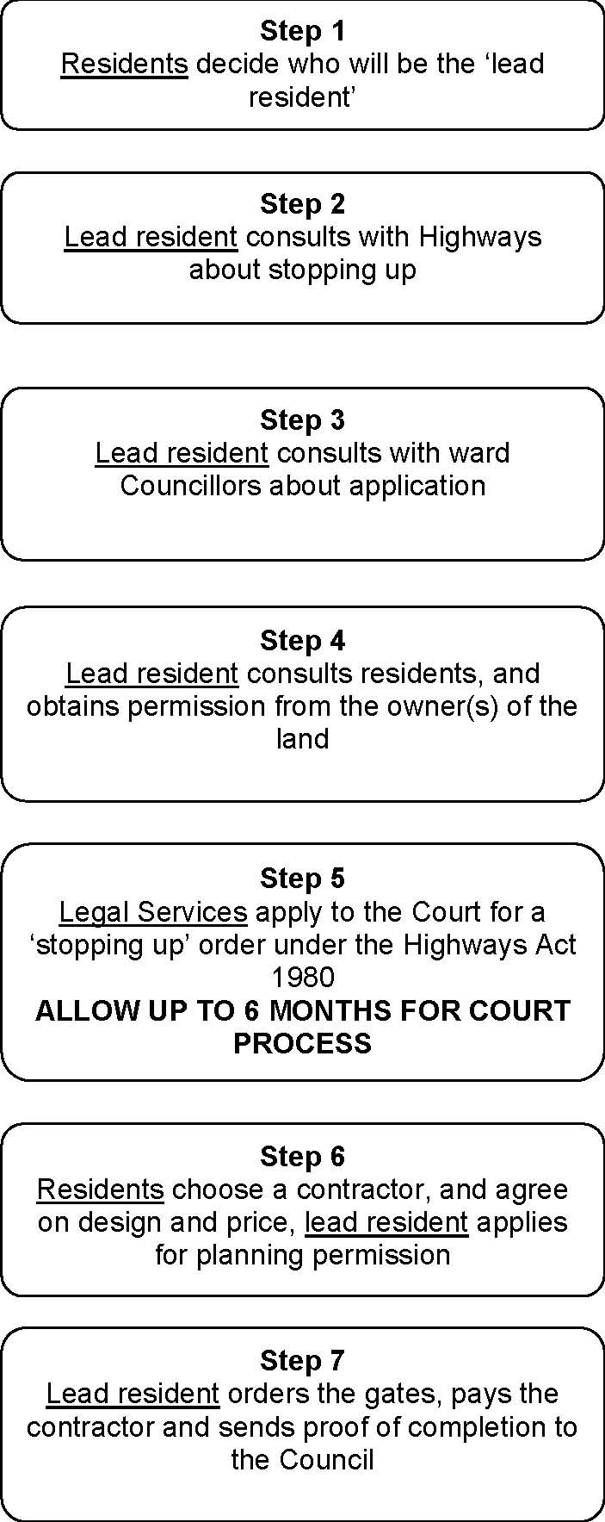

7 Steps To Alley-gating

You will have seen from the diagram on the earlier page that we have defined seven steps to public highway alley gating.

Q: Seven?

Yes. In order to install gates in a public highway alley there are seven steps.

Q: What are the steps?

Step 1

The ‘lead resident’ is an important person.

These are the tasks that the ‘lead resident’ will have to carry out: consult other residents;
obtain planning permission, where required; obtain the permission of the owner(s) of the land; obtain quotes from contractors;
place the order;

pay the contractor once the work is completed;

send proof of completion to the Council (see last page )

Your local Neighbourhood Watch might be prepared to offer assistance with these tasks

For further information, please contact Erin Scott, Medway NHW Liaison Officer on 01634 792131, weekdays 8am to 10pm.
(There is an answer phone for when the office is unstaffed.)

We have also included some information about setting up a Neighbourhood Watch scheme in your area

You may contact your ward Councillors for advice or assistance if there are issues you want to discuss.

Step 2

The lead resident has to consult with Highways about the feasibility of what is known as ‘stopping up’. The Highways Department is responsible for maintenance of the public highway, and highways officers will advise whether the proposal will satisfy the test set down in the Highways Act 1980 for closure of the alley

If Highways cannot support the closure of the alley, then the application can proceed no further

To contact Highways, please write to the principle Engineer, Medway Council, Highways Department, Gun Wharf, Dock Road, Chatham, Kent, ME4 4TR, giving the location of the alleyway.

Step 3

The lead resident will now have to consult with the ward Councillors about the proposal. If you do not know who your ward Councillors are, phone 01634 332732. They will be able to assist.

You should put your request to the Councillors in writing, and allow 2 weeks for a reply. Councillors have wide ranging knowledge of the area, and those groups who are likely to have an interest in the alley as users. The ward Councillors may have grounds to object to the proposal.

Step 4

You have now to carry out the following tasks:

- consult other residents;
- obtain the permission of the owner(s) of the land. Consulting other residents
We have included a standard letter to be sent to all residents who use, or have an interest in, the alley.

You will need to obtain the agreement of all the residents to the closure of the alley

Obtaining the permission of the owner(s) of the land

The alley may be owned by the properties that have direct access to it. This may be set out in the title deeds, together with rights over the land. If the title deeds do not clarify the position, you will need to contact the Land Registry. Please be aware that the Land Registry will charge a fee for a land search.

The contact details for the Land Registry are attached.

Step 5

The Council’s Legal Services department will apply to the Court on your behalf for a stopping up order under s116 Highways Act 1980.

This provides that if the Court finds that a highway:

- is unnecessary, or

- can be diverted so as to make it nearer or more commodious to the public, i.e. a new path can be created

the Court may by order authorise it to be stopped up or, as the case may be, to be so diverted.

You will have to send to Legal Services the consultation replies from residents and the owner(s) of the land. Legal Services are based at Gun Wharf, Dock Road, Chatham, Kent ME4 4TR. Contact Melisa Moore on 01634 332831. Legal Services may make a charge for this work.

You will also need to speak to Highways Department to confirm that they will display the public notices that are required under the terms of the Highways Act 1980. Phone 01634 333333 and ask to be put through to the Highways Department.

Given the number of applications made to the court, delays of up to six months may be experienced.

The application may be challenged and the court may not agree to stopping up the alley.

Legal Services will write to you to advise you of the outcome of the application.

Step 6

You must now obtain competitive quotes, and designs, for the gates from contractors, and make this information available to the residents. You must also apply for planning permission, if required.

The residents should be given the opportunity to agree on design and price You must remember that the gates will be the shared property of the residents
Decide how the cost of installation and maintenance will be shared amongst the residents
If residents want the gates to be opened at certain times of the day, discuss this and agree what those times should be
You must now collect the agreed contributions from the residents (don’t forget the cost of a planning application, and clearing the alley), and bank them. Residents are entitled to be given a receipt for the money they pay toward the cost of the gates.

Obtaining planning permission

There are two Medway Council publications Conservation areas in Medway – a guide to the law and our policy and Applying for Planning Permission that set out the basic requirements. Copies can be obtained from Planning department.

These are important. Please obtain copies and read them.

The erection of gates in public highway alleys will require planning permission.

Planning permission may take eight weeks to obtain, the current application fee is set out in the brochure but refer to Planning to confirm the cost of an application. We will need to see proof that you obtained planning permission.

Emergency access for Kent Fire and Rescue Service
We have asked Kent Fire and Rescue Service about their requirements for emergency access to alleys.
In an emergency the securing mechanism, that is the padlock or padlock and chain, must be accessible so that it can be cut or broken if needed.
If the mechanism cannot be cut or broken in an emergency a life could be placed in jeopardy. It might be yours.
Local contractors

Residents may wish to use the Medway Fair Trader Scheme in order to help select suitable contractors.

The Medway Fair Trader Scheme is a Medway Trading Standards Service initiative. The aim of the scheme is to improve business standards and increase customer confidence in member businesses. Approved businesses have agreed to abide by the terms and conditions of the scheme and have been checked by Trading Standards to ensure compliance.

For further information either email fairtrader@medway.gov.uk or telephone 01634 333333.

Step 7

The last step. Well done, you will by be ready to order the gates. Ask the contractor you chose for an estimated installation date. If rubbish has collected in the alley, make arrangements with a contractor for it to be cleared just before the gates are installed.

Once the contractor has installed the gates, you must make sure that residents have been issued with keys, if they are needed.
The final tasks after installation of the gates are to:

- pay the contractor

- fill out and send off Project completion form ( see last page ) Please refer to the attached form for details.

Congratulations.

Part B – Private

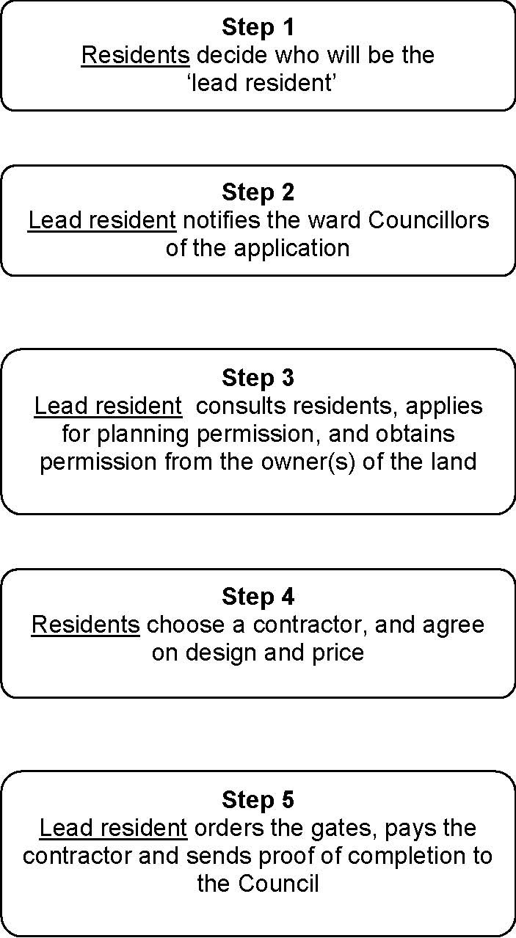

5 Steps To Alley-gating

You will have seen from the diagram on the earlier page that we have defined five steps to private alley- gating.

Q: Five?

Yes. In order to install gates in a private alley there are five steps.

Q: What are the steps?

Step 1

The ‘lead resident’ is an important person.

These are the tasks that the ‘lead resident’ will have to carry out: consult other residents;
obtain planning permission, where required; obtain the permission of the owner(s) of the land; obtain quotes from contractors;
place the order;

pay the contractor once the work is completed;

send proof of completion to the Council ( see last page )

Your local Neighbourhood Watch might be prepared to offer assistance with these tasks

For further information, please contact Erin Scott, Medway NHW Liaison Officer on 01634 792131, weekdays 8am to 10pm.
(There is an answer phone for when the office is unstaffed.)

We have also included some information about setting up a Neighbourhood Watch scheme in your area

Agree among yourselves who will be the lead resident

You may contact your ward Councillors for advice or assistance if there are issues you want to discuss.

Step 2

The lead resident will now have to notify the ward Councillors about the application. You should write to the Councillors, providing basic details about the proposal. If you do not know who your ward Councillors are, phone 01634 332732. They will be able to assist.

Step 3

You have now to carry out the following tasks:

- consult other residents
- obtain planning permission, where required
- obtain the permission of all the owner(s) of the land. Consulting other residents
We have included a standard letter to be sent to all residents who use, or have an interest in, the alley.

You will need to obtain the agreement of all the residents to the closure of the alley.

You may also decide to display notices to let people in the area know that there is a proposal to close the alley, giving them the opportunity to comment.

Obtaining planning permission

There are two Medway Council publications Conservation areas in Medway – a guide to
the law and our policy and Applying for Planning Permission that set out the basic requirements. Copies can be obtained from Planning department.

These are important. Please obtain copies and read them.

In some parts of Medway, the erection of gates in private alleys will require planning permission.

Planning permission may take 8 weeks to obtain, the current application fee is set out in the brochure, but refer to Planning to confirm the cost of an application.

Obtaining the permission of the owner(s) of the land

The alley may be owned by the properties that have direct access to it. This may be set out in the title deeds, together with rights over the land. If the title deeds do not clarify the position, you will need to contact the Land Registry. Please be aware that the Land Registry will charge a fee for a land search.

The contact details for the Land Registry are attached.

Step 4

You must now obtain competitive quotes, and designs, for the gates from contractors, and make this information available to all the residents.

The residents should be given the opportunity to agree on design and price. You must remember that the gates will be the shared property of the residents.

Decide how the cost of installation and maintenance will be shared amongst the residents.

If residents want the gates to be opened at certain times of the day, discuss this and agree what those times should be.

You must now collect the agreed contributions from the residents (don’t forget the cost of any planning application, and clearing the alley), and bank them. Residents are entitled to be given a receipt for the money they pay toward the cost of the gates.

Emergency access for Kent Fire and Rescue Service

We have asked Kent Fire and Rescue Service about their requirements for emergency access to alleys.

In an emergency the securing mechanism, that is the padlock or padlock and chain, must be accessible so that it can be cut or broken if needed.

If the mechanism cannot be cut or broken in an emergency a life could be placed in jeopardy. It might be yours.
Local contractors

Residents may wish to use the Medway Fair Trader Scheme in order to help select suitable contractors.

The Medway Fair Trader Scheme is a Medway Trading Standards Service initiative. The aim of the scheme is to improve business standards and increase customer confidence in member businesses. Approved businesses have agreed to abide by the terms and conditions of the scheme and have been checked by Trading Standards to ensure compliance.

For further information either email fairtrader@medway.gov.uk or telephone 01634 333333.

Step 5

The last step! Well done, you will by be ready to order the gates. Ask the contractor you chose for an estimated installation date. If rubbish has collected in the alley, make arrangements with a contractor for it to be cleared just before the gates are installed.

Once the contractor has installed the gates, you must make sure that residents have been issued with keys, if they are needed.

The final tasks after installation of the gates are to:

- pay the contractor

- fill out and send off Project completion form ( see last page ) Please refer to the attached form for details.

Congratulations.

Medway Neighbourhood Watch Scheme

Taken from information supplied by Medway Neighbourhood Watch

How to set up a Neighbourhood Watch Scheme

- Decide on the geographical area you wish your scheme to cover, for example a street, or part of a cul-de-sac, or a small state.

- Canvass all households in the area, inviting their participation. Do not be discouraged by apparent lack of interest. If you have difficulty in making contact, post and enquiry through their door, accompanied by a letter introducing yourself, to be returned by a certain date. Persevere! It may be possible to bring reluctant households into the scheme at a later date.

- When you have a good response, preferably around 60%, contact the Neighbourhood Watch Liaison Officer and arrange a meeting at a venue of your choice, inviting all participating households.

- You will need to appoint a Co-Ordinator and Deputy Co-Ordinator to run the scheme and to be the contact point between yourselves and the Police. This is most important, and they should be identified before the initial meeting. If the area is fairly large, say in excess of 40 households, then the Co-Ordinator and Deputy will require extra help in the form of Street Co-Ordinators. The ideal would be for each group of up to 20 households to have its own Street Co-Ordinator to assist with the collection and distribution of information.

- At the meeting, the Neighbourhood Watch Liaison Officer will explain how Neighbourhood Watch works, how it is organised, and the role of the Police. He/she will also discuss home security. There will be ample supply of leaflets and stickers covering both Neighbourhood Watch and general security.

- It may be that the area where you live adjoins or is close to an area that already has an active Neighbourhood Watch scheme, in which case we may liaise with that Coordinator with a view of putting you in touch with each other.

For further information, please contact Erin Scott, Medway NHW Liaison Officer on 01634 792131, weekdays 8am to 10pm.
(There is an answer phone for when the office is unstaffed.)

Medway Council

Community Wardens, Community Safety Telephone 01634 333333

Planning Service, Development Control (Planning Department) Telephone 01634 331700/01

Medway Neighbourhood Watch

Erin Scott
Medway NHW Liaison Officer Medway Police Station Purser Way
Gillingham Kent ME7 1NE
Telephone: 01634 792131
Email: erin.scott@kent.pnn.police.uk

Medway Police Crime Reduction Unit

Contact 101 to speak to your local Neighbourhood Policing Unit

Land Registry

The Land Registry web address is www.landreg.gov.uk.
Land Registry, Nottingham Office, Chalfont Drive, Nottingham, NG8 3RN. Telephone 01159351166

Sample consultation letter to residents.

Dear Neighbour

ALLEY-GATING

I am acting on behalf of the local community to install security gates in the alley adjacent to our homes. I have received an information pack from Medway Council and I am prepared to carry out the work required to co-ordinate the installation of the gates.

The gating of alleyways in Medway and elsewhere in the country has been proven to significantly reduce the likelihood of burglary and other crimes. As residents, we will retain the full use of the alleyway, but no one else has lawful use.

The Council will only support our request if all the residents are in favour. I have to consult with you to gain your agreement. Please return the attached form to me within 30 days of receipt of this letter.

If we install the gates then the responsibility for maintenance and repair will be ours and the gates will be our shared property. If we are all in favour I will then ask three local contractors to supply quotes. We have to pay the contractor and will also have to pay some other costs.

If you are prepared to help me with the project please get in touch. I enclose a plan for the location of the gates.

Yours faithfully

Propose Closure of Alleyway Alley-gating
Self Help Scheme

Name
Address
Phone

 | Yes | No
I support the gating of the alley adjacent to my home**
I own the land and give consent for gating
I am prepared to help with this project
I am prepared to pay towards the cost of gating

** If you do not own the property, please advise the owner of the contents of this letter as soon as possible.

Signature

Comments (optional)

Project Completion Form

Alley-gating Self Help Project

Scheme Location:

Lead Resident: Phone

Action | Date | Initial | Estimated Timescale
Agreement of Councillors (if applicable) |  |  | 2 Weeks
Planning Permission |  |  | 8 Weeks
Quotes from three contractors |  |  | 2 Weeks
Agreement on cost sharing |  |  | 2 Weeks
Contributions collected |  |  | 2 Weeks
Court order (if applicable) |  |  | 6 Months
Gates ordered
Payment made to contractor

Date of installation: / /

Please send this completed form (within one month of installation) and a sketch map to:

Roger Emmerson
Alley Gating Officer
Medway Council
Safer Communities Team
Gun Wharf
Dock Road
Chatham
Kent
ME4 4TR

Or email to: hub3b@medway.gov.uk

