ASSETS OF COMMUNITY VALUE – COMMUNITY RIGHT TO BID  NOMINATION FORM | 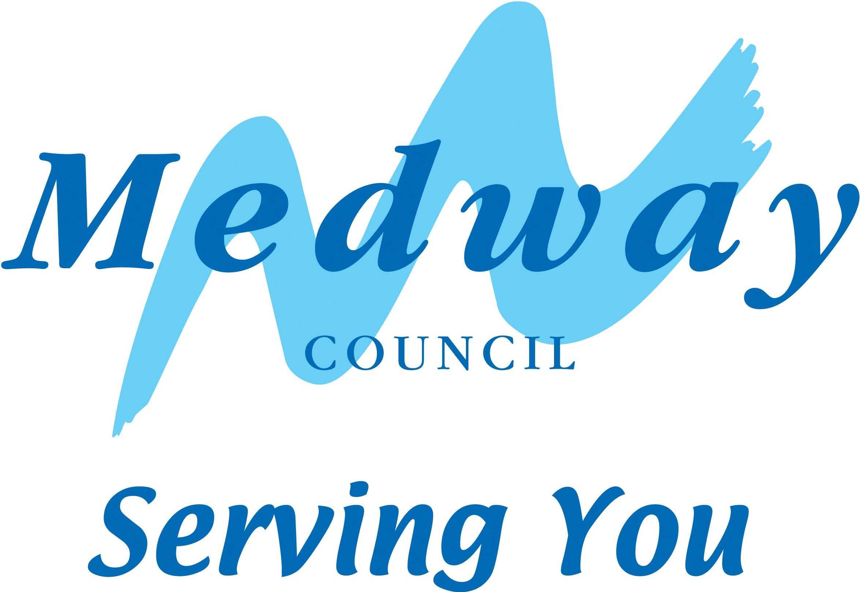

About your organisation

Organisation’s name and address

Name of organisation*

Address including postcode

*Full name as written in your constitution or rules (if appropriate)

Contact details

Name

Position in organisation

Address including postcode

Daytime telephone no.

Email address

Your relationship to the nomination organisation

Type of organisation

Description | Put a cross against all those that apply | Registration number of charity and/or company (if applicable)
Neighbourhood forum
Parish Council
Charity
Community interest company
Unincorporated body
Company limited by guarantee
Industrial and provident society

Number of members registered to vote locally (unincorporated bodies only)

In the case of an unincorporated body, at least 21 of its members must be registered to vote in the Medway area. If relevant, please confirm the number of such members. If they are registered to vote in the area of a neighbouring local authority, rather than in Medway, please confirm which area that is.
Please enclose evidence that at least 21 locally registered voters support the registration as an asset of community value.

Local connection

Your organisation must have a local connection, which means that its activities are wholly or partly concerned with the administrative area of Medway Council or a neighbouring local authority. In some cases this will be obvious, e.g. a parish council in Medway, or an organisation whose activities are confined to the district. If your connection may not be obvious to us please explain what your organisation’s local connection is.

Distribution of surplus funds (certain types of organisation only)

If your organisation is an unincorporated body, a company limited by guarantee, or an industrial and provident society, its rules must provide that surplus funds are not distributed to members, but are applied wholly or partly for the benefit of the local area (i.e. within the administrative area of Medway or a neighbouring local authority). If relevant, please confirm that this is the case, and specifically which area this applies to.

More about your organisation (Not required for if a Parish Council)

What are the main aims and activities of your organisation?

Your organisation’s rules

Please send us a copy of the relevant type of document for your organisation, and put a cross in the next column to indicate which one this is | X
Memorandum and Articles of Association (for a company)
Trust Deed (for a trust)
Constitution and/or rules (for other organisations)

About the land or building(s) you are nominating

Description and address

What it is (e.g. pub, local shop)

Name of premises (e.g. Medway Council Gun Wharf)

Address including postcode (if known)

Location Plan

Please attach a plan of the land. This should show: -

- The boundaries of the land that you are nominating
- The approximate size and position of any building(s) on the land.
- Any roads bordering the site.
- Land registry title number if known.

Owners and others with an interest in the building or land
You should supply the following information, if possible. If any information is not known to you, please say so.

 | Name(s) | Address(es)
Names of all current occupants of the land |  | Same as B1.
Names and current or last known addresses of all those owning the freehold of the land (i.e. owner, head landlord, head lessor)

Names and current or last known addresses of all those having a leasehold interest in the land (i.e. tenant, intermediate landlord, intermediate lessor)

Why you think the building or land is of community value
Note that the following are not able to be assets of community value: -
- A building wholly used as a residence, together with land “connected with” that residence. This means adjoining land in the same ownership. Land is treated as adjoining if it is separated only by a road, railway, river or canal.
- A caravan site.
- Operational land. This is generally land belonging to the former utilities and other statutory operators.

Does it currently further the social wellbeing or social interests* of the local community, or has it done so in the recent past? If so, how?

Could it in future further the social wellbeing or social interests* of the local community? If so, how? (This could be different from its current or past use.)

*These could be cultural, recreational and/or sporting interests, so please say which one(s) apply.

How could the building or land be acquired and used in future?
If it is listed as an asset of community value, community interest groups (not just limited to your organisation) will get the opportunity to bid for it if it comes up for sale.

Submitting this nomination

What to include

- The rules of your organisation.
- Your location plan

Signature
By signing your name here (if submitting by post) or typing it (if submitting by email) you are confirming that the contents of this form are correct, to the best of your knowledge.

Name (please print clearly)

Signature

Date

Where to send this form
You can submit this nomination: -

By post to:

Local Land Charges
Gun Wharf
Dock Road
Chatham
ME4 4TR

DX

DX 140142 Chatham 8

By email to:
landcharges@medway.gov.uk

Remember to include any attachments such as building plans, photos and evidence that 21 local people support you.

