Medway Libraries & Archives Volunteer Application Form

1. Personal details

First name:

Surname:

Address

(including
postcode):

Home phone:

Mobile phone:

Email address:

Date of birth:

2. Next of kin/emergency contact details

Name:

Contact phone

number(s):

Relationship to

you:

3. Role

Which role(s) are you applying for? Available roles and role descriptions can be found at www.medway.gov.uk/libraries. (Please note the reading hack is only available for ages 11-25 years).

Computer buddy eBook buddy

Home library service courier Reading hack Other
(please specify)
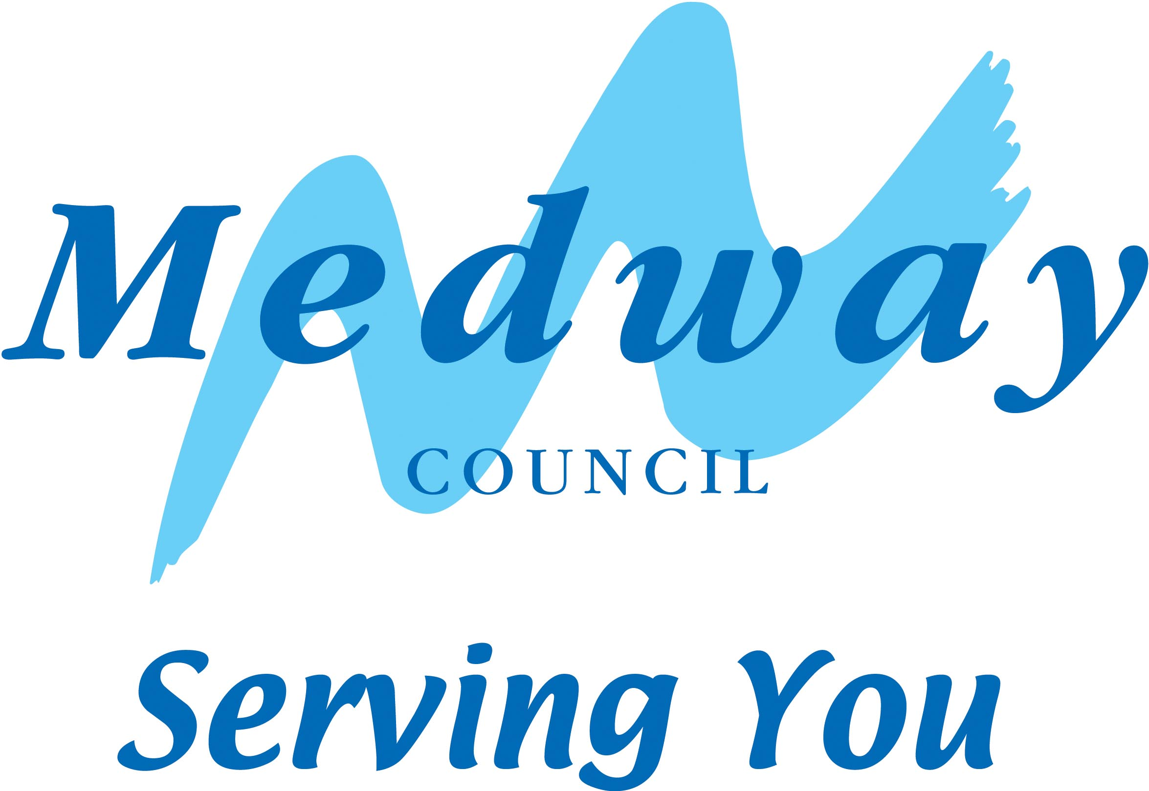

4. Availability

When are you available? Delete as appropriate and indicate hours in the box provided

Monday: Yes / No

Tuesday: Yes / No

Wednesday: Yes / No

Thursday: Yes / No

Friday: Yes / No

Saturday: Yes / No

Which library are you volunteering for? (circle all relevant)

Chatham / Cuxton / Gillingham / Grain / Hempstead / Hoo / Lordswood / Luton / Rainham / Rochester / Strood / Thomas Aveling School and Community Library / Twydall / Walderslade Hook Meadow / Walderslade Village / Wigmore / Medway Archives and Local Studies Centre

5. Skills, interests, qualifications, work background and hobbies

Please give a brief description:

In addition to your reply to section 5, please indicate whether you have any IT skills you feel you could bring and what they are

Do you have regular access to a car that you would be willing to use if we felt you were appropriate for a role as a home library service courier?

Yes / No

6. Referees

Before we can place you as a volunteer, we must receive two references for you. Please give names and addresses of your referees below (they should be someone with whom you have recent contact and could be a current or past employer, teacher, religious leader, neighbour or family friend. They must not be a relative)
If you have a social worker, psychiatrist, probation officer or other professional working with you, please include them as a referee.

Referee 1: Contact Details
Email:

Name &

address:

In what capacity do you know referee 1?

Referee 2: Contact Details

Email:

Name &

address:

In what capacity do you know referee 2?

7. Other screening

Some activities will require additional screening, such as a Disclosure & Barring Service check, for working with children or vulnerable adults. We will tell you if this is required.

The disclosure will reveal spent and unspent convictions. It is important that you tell us about any convictions or cautions you have. Convictions or cautions do not prevent volunteering but may restrict the range of activities available to you.

Please provide any relevant information below.

8. Health and support

Is there anything you would like us to know so we can assist you? Please list any illnesses, disabilities (sensory, mental or physical) or allergies you would like us to take into consideration. This will not prevent you being offered a volunteering opportunity.
Please give information in the box below:

9. Signatures

Your signature:

Date signed:

If you are under 18, or subject to guardianship, the signature of a parent or guardian is required.

Parent/guardian

signature:

Print name:

9. Equalities monitoring

We are committed to equal opportunities and use this information for monitoring purposes. It will be treated as confidential.

1. What is your sex? Male Female

2. How old are you?

Under 16 16-24 25-34 35-40 41-59 60 and over

3. Do you have a disability? Yes No

4. What do you consider to be your ethnic group?

White British White Irish White and Asian
White and Black African White and Black Caribbean White other
Asian Bangladeshi Asian Indian Asian Pakistani
Asian other Chinese Black African
Black Caribbean Black other Mixed other
Other ethnic group
(please specify)

Please return this form to:

librariesadmin@medway.gov.uk

or

FREEPOST RSCC/HCEE/BUXL
Medway Council
Strood Library
Rochester
ME2 3EP

