Medway Libraries
Young People’s Volunteer Application Form

1. Personal details

First name:

Surname:

Address

(including
postcode):

Home phone:

Mobile phone:

Email address:

Date of birth: School:

2. Next of kin/emergency contact details

Name:

Contact phone

number(s):

Relationship to

you:

3. Duke of Edinburgh Aware or similar scheme

Are you using volunteering as part of your Duke of Edinburgh award or similar scheme?
Yes / No (delete as appropriate)

Name of scheme:

If Duke of Edinburgh, please specify which strand you wish to pursue:

Library skills Volunteering

Please say which level of award:

Bronze Silver Gold

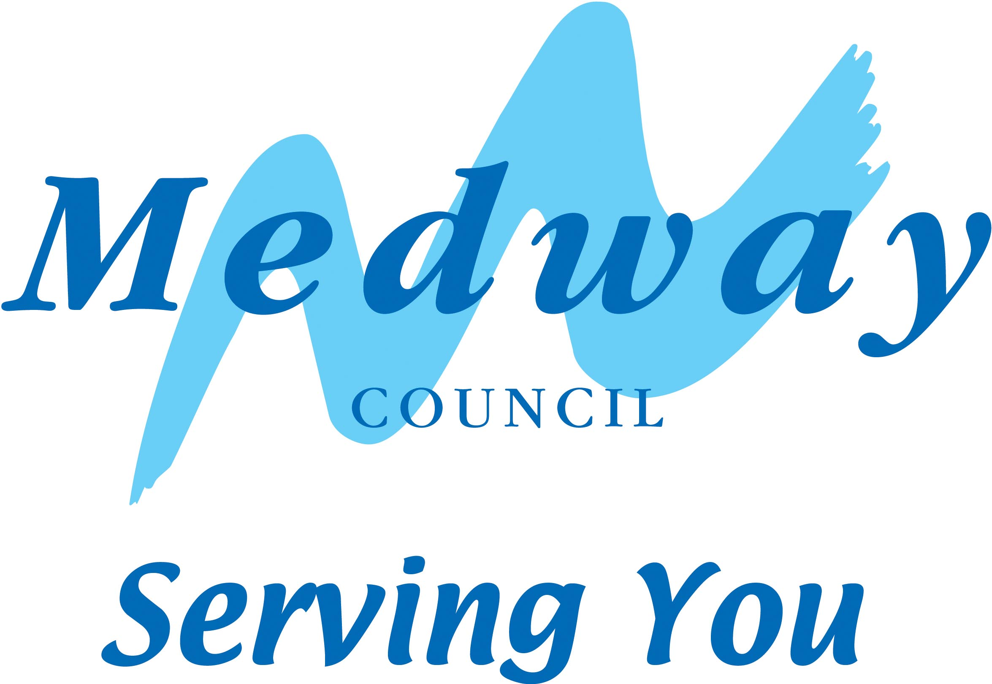


4. Availability

When are you available? Delete as appropriate and indicate hours in the box provided

Monday: Yes / No

Tuesday: Yes / No

Wednesday: Yes / No

Thursday: Yes / No

Friday: Yes / No

Saturday: Yes / No

Which library are you volunteering for? (circle all relevant)

Chatham / Cuxton / Gillingham / Grain / Hempstead / Hoo / Lordswood / Luton / Rainham / Rochester / Strood / Thomas Aveling School and Community Library / Twydall / Walderslade Hook Meadow / Walderslade Village / Wigmore

5. Health and support

Is there anything you would like us to know so we can assist you? Please list any illnesses, disabilities (sensory, mental or physical) or allergies you would like us to take into consideration. This will not prevent you being offered a volunteering opportunity. Please give information in the box below:

6. Signatures

Your

signature:

Date signed

If you are under 16, the signature of a parent or guardian is required

Parent./guardian

signature:

Print name:

7. Equalities monitoring

We are committed to equal opportunities and use this information for monitoring purposes. It will be treated as confidential.

1. What is your sex? Male Female

2. How old are you?

Under 16 16-24 25-34 35-40 41-59 60 and over

3. Do you have a disability? Yes No

4. What do you consider to be your ethnic group?

White British White Irish White and Asian
White and Black African White and Black Caribbean White other
Asian Bangladeshi Asian Indian Asian Pakistani
Asian other Chinese Black African
Black Caribbean Black other Mixed other
Other ethnic group
(please specify)

Please return this form to:

librariesadmin@medway.gov.uk

or

FREEPOST RSCC/HCEE/BUXL
Medway Council
Strood Library
Rochester
ME2 3EP

