Council Logo

Community Involvement and Engagement Strategy 2019 - 2022

# Introduction

Medway Council is committed to listening and working with our residents to develop, improve and build our services. We want residents not only to be engaged with us, but for residents to have a say in how their homes and services are managed.

Meaningful and consistent engagement with our residents is vital to developing a proactive relationship that enables residents and staff to work together. We are looking to provide a range of inclusive and accessible involvement options at every level that use people’s individual skills, and enable residents groups to work together, to shape and build our services.

# Purpose

The purpose of this strategy is to set out Medway Council’s approach to resident communication and engagement, providing a clear response to national and local priorities.

The strategy has been developed in consultation with residents and provides a framework for us to meet the regulatory requirements as proposed in the five principles of the 2018 green paper, A New Deal for Social Housing. This will enable us to prepare for the objectives that will be set out in the subsequent white paper. The five principles are;

* Ensuring homes are safe and decent
* Effective resolution of complaints
* Empowering residents and strengthening the regulator
* Tackling stigma and celebrating thriving communities
* Expanding supply and supporting home ownership.

The strategy also contributes to the Council plan 2016 – 2021 priorities of:

* Making Medway a place to be proud of
* Supporting Medway’s people to achieve their full potential
* Maximising regeneration and Economic growth.

This strategy aims to contribute to the Council’s three core ways of working 2016 - 2022

* Giving value for money
* Digital services that are so good everyone who can use them, prefers to do so.
* Working in partnership where this benefits our residents.

# Scope

This strategy relates to all residents of Medway Council General Needs, Homes for Independent Living and Leasehold stock.

# Vision

Our vision is to enable residents to work collaboratively with officers, contractors and our external partners to improve services, deliver accountability and improve residents’ quality of life.

Through effective resident consultation we aim to reach as many customers as we can to ensure that residents have an opportunity to take an active part in improving the communities where they live.

We aim to build upon the work set out in our previous Resident Engagement Strategy, by ensuring accountability and transparency when monitoring our services, working in co-operation with our residents to deliver a housing service that meets their needs. We will look to maximise the impact of the strategy overall by working with other partners and housing providers as appropriate, investing our resources in local innovation to create sustainable communities for the future.

# Objectives

To do this we have developed the following strategic objectives;

* Understanding our customers
* Providing a wide variety of opportunities for residents to influence services and give feedback in a way that suits them
* Working collaboratively with residents to provide sustainable community engagement
* Supporting Social Wellbeing

**Key legislation and reports influencing this strategy**

* Ministry of Housing, Communities and Local Government (2018) A new deal for social housing.
* Landlords and Tenants Act 1985 (revised by the Commonhold and Leasehold Reform Act 2002)
* Homes and Communities Agency (HCA) Regulatory Framework 2012
* [Public Services (Social Value) Act](http://www.legislation.gov.uk/ukpga/2012/3/enacted) 2013

# Objective 1: Understanding our customers

Knowing our customers, and the services that they require, is key to ensuring that our residents have a real opportunity to shape and inform our services.

We want to ensure that all our residents have the opportunity to participate and provide feedback on our service and will continue to use social media, surveys, complaints, and resident consultation and scrutiny meetings to gain feedback to assist us in shaping our services.

We will deliver this by:

* Improving the data we hold on our customers, to ensure that information is communicated in the appropriate format and to identify gaps in our resident profile, when developing consultation events.
* Continually monitoring performance and providing this information to residents to scrutinise and review at focus group meetings and online.
* Gathering satisfaction data through social media, focus groups, complaints and satisfaction surveys.
* Targeting hard to reach groups and developing new engagement approaches.
* Reporting to residents how we are performing in areas such as;
* Effectively handling complaints
* Maintaining the safety of buildings
* Responsible neighbourhood management

# Objective 2 – Supporting Social Value

We are committed to supporting the public health agenda to improve the communities by working with residents to improve their emotional, social and economic well-being.

We will deliver this by:

* Supporting social value initiatives such as working with partnership agencies to support initiatives to reduce social isolation and loneliness.by holding events such as free adult education taster sessions, community events and signposting to support services and local organisations.
* Improving signposting to and supporting Social Prescribing services, to support residents to make local connections in their community.
* Developing engagement opportunities, such as Big Lunches and sports activities to promote community connectivity.
* Working in partnership with the Community Safety Team to develop initiatives to improve local estates and neighbourhoods.
* Using the information we have gathered on our residents to identify where residents may suffer from social isolation, and plan appropriate engagement activities for the area.
* Building upon our Welfare Reform surgeries to offer benefits and tenancy sustainment advice.
* Developing initiatives for residents to become involved in environmental, fuel poverty, energy conservation and climate change initiatives.
* Supporting contractors and partners with social value projects, such as working with tenants to improve our local estates.

# Objective 3

**To provide a wide variety of opportunities for residents to influence services and give feedback in a way that suits them.**

Listening to residents views to help create better services, homes and neighborhoods is crucial to providing sustainable community engagement. Resident involvement is key at every level of the Housing Service, whether we are reviewing our service provision or developing our policies or procedures. Working with residents helps to direct resources to areas where they are needed most. We believe that all forms of engagement are beneficial and aim to provide a range of enjoyable and accessible ways to get involved.

We will deliver this by:

* Supporting residents who wish to get involved through training and capacity building.
* Providing a range of involvement options that are accessible to all. This will include less formal, structured forms of involvement and formal options to influence service provision.
* Enabling residents to provide feedback at a time and in an accessible method that suits them.
* Providing a range of involvement options to enable tenants to have more of an impact on the services they receive.
* Reviewing the effectiveness of current engagement methods by looking at ways to make the best use of digital technology.
* Improving our existing structures to improve our services by providing more opportunities for involvement, including performance monitoring and scrutiny.
* Involving residents in the design and the delivery of the service.
* Holding Service-specific resident panels.

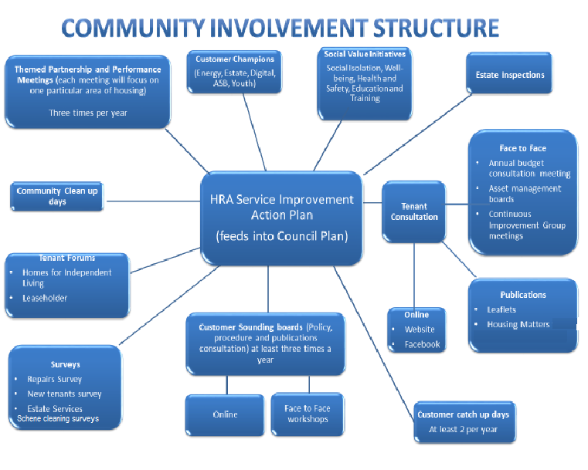

# Objective 4

**Working collaboratively with residents to provide sustainable community engagement**

All of our involvement mechanisms will be reviewed regularly to ensure that they remain fit for purpose and are effective in making a difference. If necessary, these will be refreshed, replaced or disbanded to ensure that available time, effort and resource are put into the most effective and productive engagement channels.

We will deliver this by:

* Supporting the Youth Engagement Strategy by providing an opportunity for young people to influence the housing services. We aim to better identify and meet the needs and aspirations of this customer group by encouraging active citizenship and ‘community development’.
* Developing and maintaining a collaborative working agreement with the Health improvement Services offered by Public Health to ensure individuals and families are offered support and services.
* Supporting Mears Continuous Improvement Group with their role of monitoring and challenging our repairs service.
* Introducing a feedback framework, to demonstrate the value of resident involvement
* Checking that involvement activities meet resident need and have meaningful outcomes.
* Monitoring engagement methods to ensure they are representative of the diverse nature of our residents.
* Supporting residents to engage with us on issues of building safety, including providing access to information on fire risk assessments.
* Develop new methods to engage with young people, through working with partners such as the Prince’s Trust to develop the Young Persons Strategy and expand the Youth Ambassador group.
* Ad-hoc and regular involvement in procurement activity and contractor monitoring.
* Promoting resident involvement activities and outcomes to staff

# Feedback Framework

# Monitoring and Benchmarking our services

We understand our vital role in not only providing a good standard of housing but also in supporting the wider community, ensuring that people are happy with the area that they live in. We aim to build safer communities, to ensure children and young people have the best start in life and ensure older and vulnerable people maintain their independence.

Working alongside other agencies and partners, we will encourage tenants and residents to become involved in local issues and wider community development issues in the Medway area.

We are members of the Kent Housing Group, (KHG) which is a forum for social housing organisations in Kent. KHG has representation from all twelve Kent local authorities, Medway Council, over thirteen housing associations and Kent County Council. KHG also has affiliated membership with a number of organisations who have a vested interest in the housing sector across Kent and Medway.

The Kent Engagement Group (KEG) is representation from across the KHG membership who work in partnership and share good practice to ensure successful engagement across all communities in Kent and Medway. Colleagues are representing both Resident Engagement and Community Development within this one sub group.

We monitor and benchmark our performance against other housing providers, via an organisation called Housemark. This enables us to analyse our performance with other housing providers and identify areas for improvement.

We aim to be effective in encouraging wider involvement and to achieve this we will be researching the needs of communities within Medway so that we can tailor our services to meet their diverse needs.

# Equality and Diversity

All Housing Services projects, policies and procedures have a diversity impact assessment undertaken to ensure that we are actively seeking to increase and support the involvement of minority and under represented customer groups.

We will also use the information provided to ensure that information is available in a variety of formats, including different languages, large print, Braille or audio and that information is easily accessible at our Community Hubs and the Medway Council website.

# Monitoring and Review

We will ensure that all resident involvement activities are monitored for effectiveness and that feedback will be reviewed to make sure that the needs and priorities of tenants and residents are taken into account.

We will work alongside service improvement focus groups to monitor our progress and tailor this strategy and associated involvement options to customer requirements.

This strategy will run from October 2019 to September 2022 and will require review if there are any changes to government legislation regarding resident involvement.

# How to get involved

To find out how you can become involved and make a real difference to the services you receive from us, please contact us on;

Email: [Tenant.Participation@medway.gov.uk](mailto:Tenant.Participation@medway.gov.uk)

Telephone the Community Development Officer on: 01634 334115

Facebook: search and follow as @ Medway Council Housing Services

Website: [www.medway.gov.uk/housing](http://www.medway.gov.uk/housing)