TITLE  Name / description of the issue being assessed |  |  | Former Tenant Arrears Policy
DATE  Date the DIA is completed |  |  | 20th May 2020
LEAD OFFICER  Name, title and dept of person responsible for carrying out the DIA. |  |  | Aisling Sims – Policy and Partnerships Manager
- Summary description of the proposed change
- What is the change to policy / service / new project that is being proposed?
- How does it compare with the current situation?
The policy sets out how Medway Council Landlord Services intends to collect and manage all Former Tenant Arrears. The policy was updated in July 2017 to include the making a money claim online (MCOL) via the HM Courts & Tribunals Service Internet based service, however, this has now been removed as it wasn’t an ecomically viable process. The policy has also been updated to reflect current legislation including GDPR.
- Summary of evidence used to support this assessment
- Eg: Feedback from consultation, performance information, service user records etc.
- Eg: Comparison of service user profile with Medway Community Profile
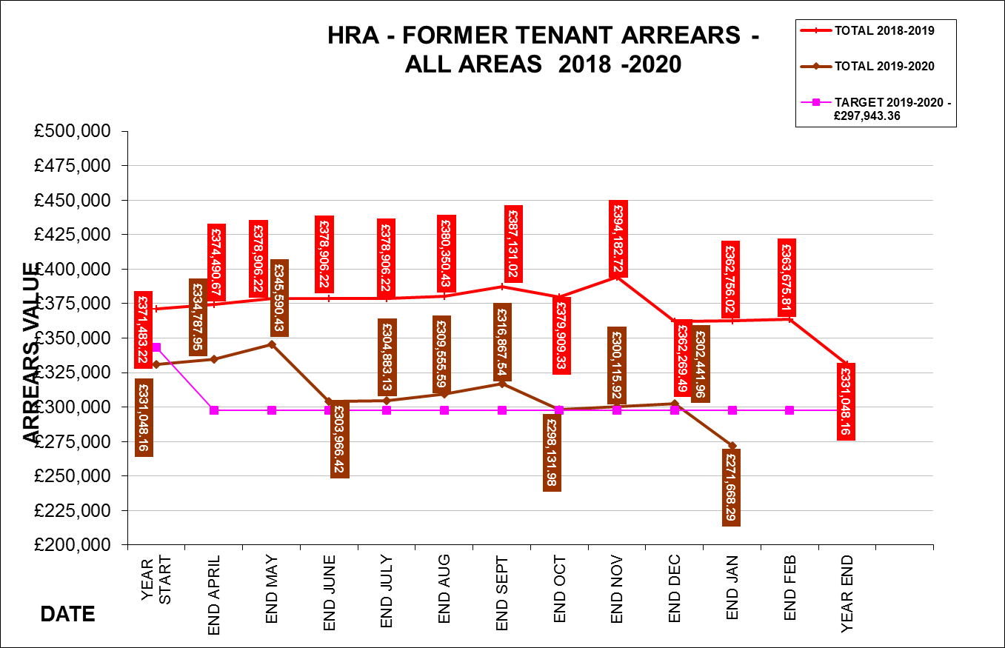

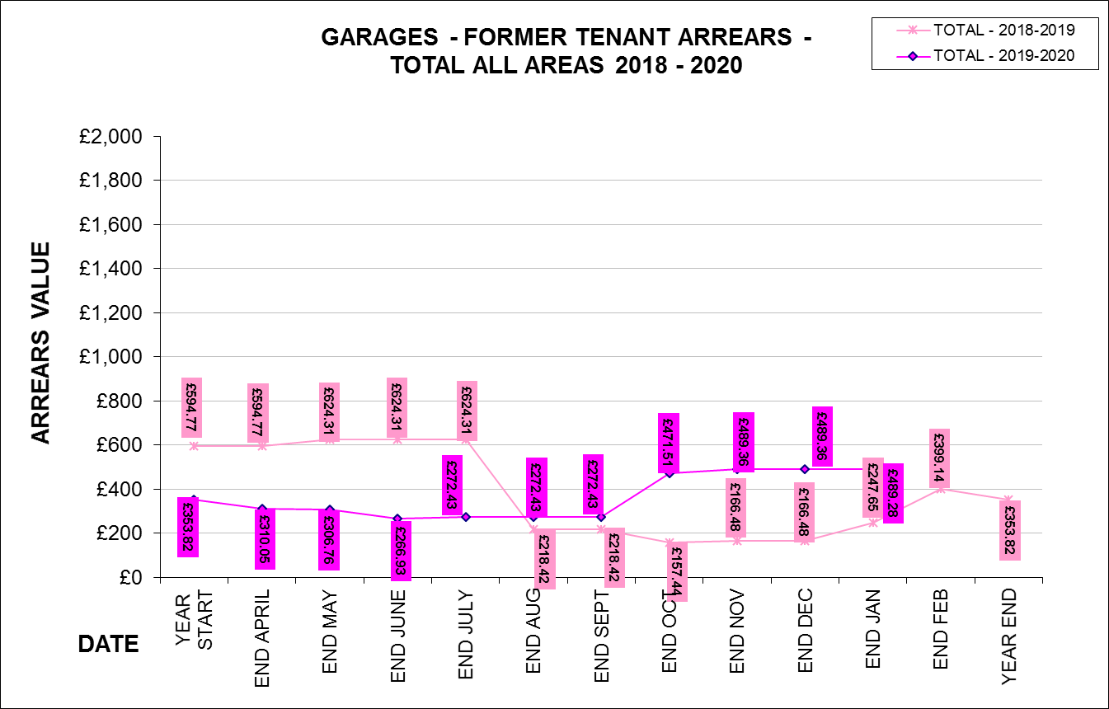

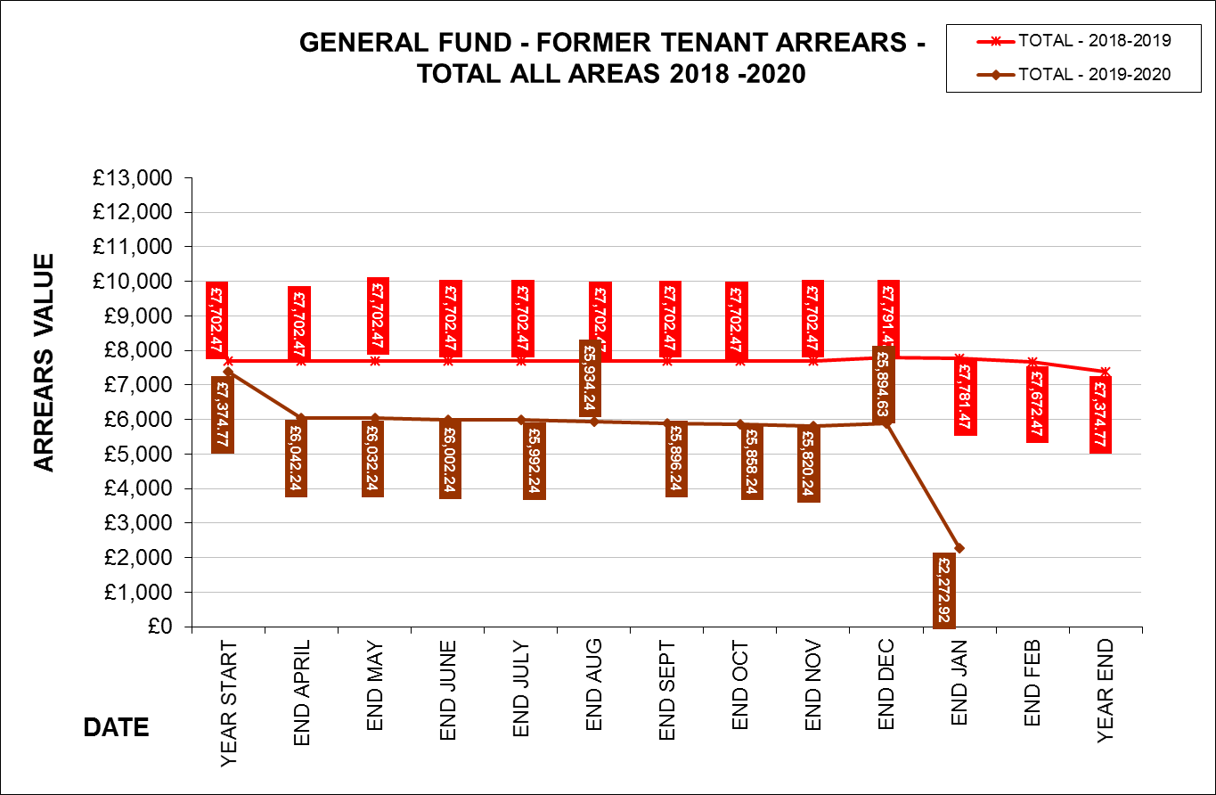

What is the likely impact of the proposed change?
Is it likely to :
- Adversely impact on one or more of the protected characteristic groups?
- Advance equality of opportunity for one or more of the protected characteristic groups?
- Foster good relations between people who share a protected characteristic and those who don’t?(insert in one or more boxes)
Protected characteristic groups |  | Adverse impact |  |  | Advance equality | Foster good relations
Age
Disabilty
Gender reassignment
Marriage/civil partnership
Pregnancy/maternity
Race

Religion/belief
Sex
Sexual orientation
Low Income Groups
People in exceptional housing need who are in arrears
- Summary of the likely impacts
- Who will be affected?
- How will they be affected?
Low Income Groups
Tenants on low incomes are at greater risk of falling into rent arrears and therefore are more likely to be adversely affected by aspects of this policy.
People in housing need who are in arrears
The Council does not allow tenants to transfer within our stock if they owe debt unless exceptional circumstances apply. This would limit the ability for some households to move property within our stock.

- What actions can be taken to mitigate likely adverse impacts, improve equality of opportunity or foster good relations?
- Are there alternative providers?
- What alternative ways can the Council provide the service?
- Can demand for services be managed differently?
Although adverse impacts have been identified in the DIA. The Former Tenant Arrears policy details the following actions that will be taken to mitigate the adverse impacts.

Low Income Groups
Landlord Service consider write offs where exceptional circumstances apply. Exceptional circumstance may arise from the former tenant’s mental capacity, a terminal illness, domestic violence or debt due to long-term imprisonment.

Tenants struggling with rent payments will be signposted to the Income officers who provide support, advice and information to assist in all aspects of financial management. Income officers assist our tenants with maintaining their rent accounts in accordance with the terms of their tenancy to assist in the prevention of arrears.

Where appropriate the Income Team will refer tenants and leaseholders to the Welfare Reform Team where more in-depth financial assistance and budgeting advice can be provided.

Housing Services use a range of communications to promote debt advice and support including our website, social media, monthly newsletters, tenants’ handbook and periodic rent campaigns. Welfare advice surgeries are also held in various locations within the council housing stock, to enable tenants to drop in for one to one advice.
People in housing need who are in arrears

Senior Officers will review cases with ‘exceptional circumstances’. If Senior Officers approve a transfer for a tenant in arrears the debt will be transferred to their new tenancy as a former tenant arrear. Tenants will be informed of this and must sign up to a payment plan for the Former Tenant Arrears before the move can take place.

Action plan
- Actions to mitigate adverse impact, improve equality of opportunity or foster good relations and/or obtain new evidence
Action |  |  |  | Lead |  |  | Deadline or review date
Monitor Complaints to identify any negative trends with regards to the Former Tenant Arrears policy. |  |  |  | Income Manager |  |  | May 2022
Continue to identify, support and prevent financial hardship |  |  |  | Income Manager |  |  | May 2022

Recommendation
The recommendation by the lead officer should be stated below. This may be:
- to proceed with the change, implementing the Action Plan if appropriate
- consider alternatives
- gather further evidence
If the recommendation is to proceed with the change and there are no actions that can be taken to mitigate likely adverse impact, it is important to state why.
To approve the current DIA for publication.

Authorisation
The authorising officer is consenting that:
- the recommendation can be implemented
- sufficient evidence has been obtained and appropriate mitigation is planned
- the Action Plan will be incorporated into the relevant Service Plan and monitored
Authorising Officer | Mark Breathwick  Head of Housing
Date | June 2020

