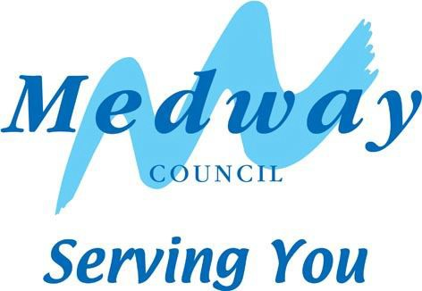

STATUTORY PROPOSAL FOR PRESCRIBED ALTERATION TO GREENVALE INFANT SCHOOL

In accordance with The School Organisation (Prescribed Alterations to Maintained Schools) (England) Regulations 2013, as conferred by sections 18, 19, 20, 21, 22, 23, 24, 31, 181 and 183 of the Education and Inspections Act 2006(a) and sections 29 and 537 of the Education Act 1996(b), Medway Council proposes to make a prescribed alteration to Greenvale Infant School to take effect from 1 September 2020.

School details
Greenvale Infant School, Symons Avenue, Chatham, ME4 5UP

Local Authority details
Medway Council, Gun Wharf, Dock Road, Chatham, ME4 4TR

Description of alterations
1. The ‘Extension of the age range’

The proposal will result in changing Greenvale from an infant to a primary school. The school already has capacity for 210 children, and so no additional classrooms are required. The change will lead, over time, to an additional 30 school places becoming available at the school.

The yearly intake admission number (PAN) will reduce from 60 to 30 pupils from September 2020, and those children admitted then will remain at the school for the entirety of their primary education.

Background
Greenvale Infant School currently provides Key Stage 1 education for children from the age of four until they transfer into junior school at age 7. Normally, children from Greenvale transfer to Phoenix Junior Academy. Phoenix has approval from the Regional Schools Commissioner to become a primary school from September 2020.

Why is there a need to change Greenvale from an infant to a primary school? Greenvale’s change from an infant to a primary school would complement Phoenix’s change from a junior to a primary school. If Greenvale becomes a primary school, then children will be able to stay at the school for the whole of their primary education. There would be no transition from infant to junior, and so there would be no disruption from changing school. Greenvale currently provides for 180 pupils, but it already has sufficient space to take up to 210 pupils. Therefore no additional classrooms would be required.

How the proposals would benefit Medway
In June 2017 Ofsted carried out an inspection at the school, and gave a rating of ‘good’ across all aspects of the report. The proposals are in line with current local and national policy, which allows good and outstanding schools to expand.

The proposals, by enabling children at both Greenvale and Phoenix to spend their primary education years at one school, mean that the pupils will benefit from a cohesive, seamless, and co-ordinated journey without any transitions.

Furthermore, there are a number of ongoing and proposed housing developments in the area. These housing schemes will undoubtedly add further pressure to primary school places in the Chatham area.

Medway Council has a duty to provide sufficient school places and the additional places resulting from this change will help towards ensuring that the obligation is met.

Impact upon other schools
Without this proposed change from infant to primary, the pupils at Greenvale will have to find alternative junior schools after year 2, as it is likely that no places will be available at Phoenix. This would increase pressure on school places in the Chatham area. Therefore, the change to a primary at Greenvale will avoid this pressure at other schools in the area. No negative impact upon other schools is expected.

Funding for the scheme
Greenvale infants already has sufficient overall space to become a 1FE primary school. However some internal reconfiguration and upgrade will be required to ensure facilities are age appropriate. This will be financed using the central government basic need grant, which is a fund for the creation of additional school capacity to ensure that sufficient school places are available in each local area. Further funding as required will come from developer contributions for new housing schemes in the area. This is where developers of new housing schemes pay a contribution to the Council to assist in the enhancement and provision of essential community facilities.

Next steps
By 24 March 2019 any person may support, object to or make comments on the proposals by sending them to FREEPOST RRUY-ZBTJ-CZZC, School Organisation (Post bag 75), Level 4, Gun Wharf, Dock Road, Chatham, ME4 4TR, or by email to prim.reorg@medway.gov.uk

