|  |
| --- |
| Medway Logo |
| Medway Council Landlord Services Energy Efficiency Strategy 2018-2020 |
|  |
|  |
| Published October 2018 |

|  |
| --- |
| Version 1 2018 |

Contents

Introduction 2

Scope 2

Vision 2

Purpose 2

Related Documents 2

Key concepts 3

Key legislation and reports influencing this strategy 4

Government legislation and reports 4

Local Strategies 5

Landlord Services current energy efficiency position 8

Fuel poverty, and who is likely to be affected 11

Characteristics affecting fuel poverty 12

Fuel poverty and health 14

Fuel Poverty targets 14

What Medway Council Landlord Services currently do to improve energy efficiency and reduce fuel poverty 15

Strategic Priorities 16

1. Identify the energy performance rating for all our properties (where possible). 16

2. Analyse the current energy efficiency of our stock and create a programme of works to improve the energy efficiency ratings of our properties in line with current government targets. 17

3. Identify those households within our stock most likely to be in fuel poverty and work with those residents to improve energy conservation within their homes. 18

4. Identify and utilise government initiatives that will help improve the energy efficiency of Medway Council stock. 18

Challenges 19

Monitoring 20

Review 20

Suggested reading 20

Action Plan 20

Diversity Impact Assessment (DIA) 20

Appendices 20

Appendix A - Government schemes available to improve energy efficiency 21

# Introduction

Medway Council Landlord Services Energy Efficiency Strategy 2018-20 ultimately sets out to identify the services priorities for improving the energy efficiency of the stock in order to meet government targets to reduce fuel poverty. In order to set the priorities in this strategy it has been important to explore both the current energy efficiency of the stock and the concept of fuel poverty and who amongst our residents is most likely to be affected. The priorities identified in this strategy allow for the both the improvement of the energy efficiency of the stock and the education of residents on energy conservation. In order to ensure the strategy is in line with local targets this strategy identifies the links and contribution it will make to the targets set out in the Kent Wide Energy Strategy and Medway’s Home Energy Conservation Act Report.

## Scope

This strategy relates to communal areas and dwellings used for rented accommodation within Medway Councils Housing Revenue Account.

## Vision

The vision of this strategy is that Medway Councils Housing Stock achieves the government energy efficiency targets set out in [**Cutting the Cost of Keeping warm: A Fuel Poverty Strategy for England 2015**.](https://www.gov.uk/government/publications/cutting-the-cost-of-keeping-warm) In achieving these targets Landlord Services hopes to further improve the quality of its housing stock and contribute to reducing fuel poverty levels in Medway.

## Purpose

The purpose of this strategy is as follows:

* Outline how Landlord Services Energy Efficiency Strategy interacts with government legislation and local strategy.
* Identify the current energy efficiency position of Landlord Services owned stock.
* Explore current levels of fuel poverty in Medway, and who amongst our residents is most likely to be affected.
* Set out what Landlords Services has already done to improve the energy efficiency of its stock and reduce fuel poverty.
* Identify Landlords Services priorities for further improving the energy efficiency of its stock and reducing fuel poverty.
* Set out an action plan to meet the priorities in this strategy.

## Related Documents

* Housing Revenue Account (HRA) Asset Management Strategy 2015-2020
* HRA Business Plan 2018
* Medway Councils Home Energy Conservation Act (HECA) report

## Key concepts

### Energy Efficiency

Energy efficiency refers to physical improvements to structures and appliances to reduce the amount of energy used to provide services such as lighting, heating and hot water. The aim of energy efficiency is to use less energy whilst still achieving the desired effect. Energy efficiency is about using the most efficient technology and processes to reduce energy usage, therefore reducing the amount of money spent. Energy efficiency may require more investment initially but will see benefits in the long term.

### Energy Conservation

Energy conservation is about learning to change behaviours to use less energy. Energy conservation requires a commitment by individuals to change their behaviour to reduce their energy consumption. An example is turning off electrics when not in use. Energy conservation can be more difficult as it requires a change of attitude but it has the potential to save more energy in the long run.

## Energy Efficiency Measurements

### Standard Assessment Procedure (SAP)

The Standard Assessment Procedure (SAP) was developed in 1992 as a means of identifying the current energy and potential energy rating of a dwelling. [Reduced Data SAP (RdSAP)](http://www.bre.co.uk/accreditation/page.jsp?id=2016) was introduced in 2005 as a lower cost method of assessing the energy performance of existing dwellings.

The SAP is the Governments recommended system for producing a home energy rating. A full SAP must be produced for all new buildings, whilst a reduced data SAP RdSAP can be created to monitor existing dwelling that already have a full SAP. The SAP rating can be affected by the properties Boiler, Cavity/Roof Insulation, Cylinder Stat & Insulation, windows (double glazing) and lighting.

### Energy Performance Certificates

As part of the *Energy Performance of Buildings (England and Wales) Regulations 2012*, it is a government requirement that dwellings have a valid Energy Performance Certificate (EPC) on construction, sale or rent. An EPC certificate provides a measure of a building’s overall energy efficiency and environmental impact. An EPC is measured via a Standard Assessment Procedure (SAP) rating.

The EPC shows both the Energy Efficiency Rating (EER) and the Environmental Impact (CO2) Rating (EIR) of a property. The EER measures the overall efficiency of a home and is related to running costs. The EER is based on an A–G rating scale; A being the highest energy efficiency band with the lowest running costs. The energy efficiency rating of a property is a key indicator of its energy saving potential.

The EIR rating shows the effect of the properties carbon dioxide (CO2) emission on the environment. The EIR rating is based on an A-G rating scale, A being the most environmentally friendly (low CO2 emissions).

The EPC provides a summary of the homes energy performance and rates the key elements such as main heating, walls etc. as good or poor. The EPC also provides recommendations for improving the properties energy efficiency.

EPCs are valid for 10 years and can be reused as required within that period. A new EPC is not required each time there is a change of tenancy, or the property is sold, provided it is no more than 10 years old.

The higher the Energy Efficiency and Environmental Impact rating of a property the greater effect it will have on reducing the household’s likelihood of fuel poverty and the environmental impact of their energy consumption.

### Fuel Poverty

Fuel poverty occurs where a household has a low income and the higher than normal energy costs. Fuel poor households are more likely to live in energy inefficient homes.

The current method used by government to measure fuel poverty is the Low Income High Costs Indicator (LIHC), which was introduced by the [Hills review in 2012](https://www.gov.uk/government/uploads/system/uploads/attachment_data/file/48297/4662-getting-measure-fuel-pov-final-hills-rpt.pdf).

The LIHC indicator determines a household to be fuel poor if it:

* has an income below the poverty line (including if meeting its required energy bill would push it below the poverty line); and
* has higher than typical energy costs.

Fuel poverty is measured on how much money a household would need to spend on energy to be sufficiently comfortable, rather than the actual amount a household spends. This is because a household may restrict how much it spends on energy consumption if it cannot afford it.

The LICH considers both the number of households in fuel poverty, as well as how deeply it affects the household. It does this by measuring the Fuel Poverty Gap, which identifies how much more fuel poor households would need to spend to keep warm compared to typical households. The national average fuel poverty gap in 2015 was £353; this is lower for local authority housing tenants for which the average is £175[1].

## Key legislation and reports influencing this strategy

### Government legislation and reports

Energy efficiency and reducing fuel poverty has long been a priority for the UK Government. In 1995 the government published the ***Home Energy Conservation Act***. This act placed a duty on all English Authorities that maintained a responsibility for housing to produce a report that outlined the energy conservation measures being undertaken to improve the energy efficiency of residential properties within its area. This legislation was followed by the ***Warm Homes and Energy Conservation Act 2000*** (amended in 2013) which set out the government’s objectives for tackling fuel poverty.

In 2001 the governments ***Decent Homes Standard*** was introduced which set out a minimum standard for social housing. Where this standard was not met it would trigger any improvement action required. The standard allowed landlords to determine, in consultation with their tenants, what works need to be completed, and in what order, to ensure the standard is met. This standard applied to all social housing except leasehold and shared ownership properties.  
  
The Decent Homes Standard had four criteria for dwellings which were:

1. It meets the current statutory minimum standard for housing (i.e. the dwelling should be free of category 1 hazards under the HHSRS introduced in 2006)
2. It is in a reasonable state of repair
3. It has reasonably modern facilities and services
4. It provides a reasonable degree of thermal comfort.

The focus on thermal comfort within the criterion helped to ensure Local Authorities are focused on maximising energy efficiency within their stock. Under government, all social housing providers had to ensure that their properties met decent homes standards by 2010; Medway Council was successful in achieving this target.

Medway is now in a position to maintain its stock to a higher level than Decent Homes and as such the council in partnership with its residents has developed the “Medway Standard for Accommodation”, on which investment programmes are based.

In 2011 the Marmot review team published ***The Health Impacts of Cold Homes and***

***Fuel Poverty***report that identified the link between poor health and living in fuel poor homes.

The Marmot review and amendments to the *Warm Homes and Energy Conservation Act* in 2013 helped drive the government to launch *the* ***Cutting the Cost of Keeping warm: A Fuel Poverty Strategy for England in March 2015***. This strategy set out new targets for fuel poverty, including that Local Authorities take action to ensure that as many homes as possible achieve a fuel poverty energy efficiency rating of C by 2030.

### Local Strategies

The **Kent Environment Strategy** was published in 2016 and set out the county strategy to bring together environmental, economic and health themes and ensure good partnership working.

The Strategy has three themes;

1. Building the foundations for delivery

2. Making the best use of existing resources, avoiding and minimising negative impacts

3. Working towards a sustainable future

Theme 2 has several sub actions which includes 6.2 *Improve the resource efficiency of our homes, reducing costs, tackling fuel poverty and improving health outcomes.* The Kent and Medway Sustainable Energy Partnership support the Kent Environment Strategy action plan for theme 2. The partnership includes public, private and voluntary sector bodies including all the local authorities in Kent and Medway. Its purpose is to tackle fuel poverty by drawing in as much Energy Company Obligation (ECO) and other funding in as possible.

The Kent Energy Efficiency Partnership (KEEP) developed the **Delivering Affordable Warmth: A fuel poverty strategy for Kent** in 2016. This set out the Kent wide approach to tackling fuel poverty. The strategy identified four priorities for Kent.

1. Information gathering and sharing
2. Improving energy efficiency
3. Reducing fuel costs
4. Increase income – support vulnerable households to maximise income

The strategic priorities identified in this strategy link with and will contribute to the priorities set in the Kent wide strategies.

Medway’s[***Council Plan 2016/17 to 2020/21***](http://www.medway.gov.uk/pdf/Council%20Plan%202017-18%20v4.pdf)shows the Councils business plan for the next four years. It sets out how the council will provide the best possible services for our residents. The Council plan has 3 priorities

1. Medway: A place to be proud of
2. Supporting Medway's people to realise their potential
3. Maximising regeneration and economic growth

The priority of Maximising regeneration and economic growth includes the sub priority of *Delivering new homes to meet the needs of Medway’s residents*. Ensuring that any new home delivered meet energy efficiency standards will inform part of this strategy.

As a unitary authority Medway Council maintains responsibility for housing within the area, and has a duty to provide a **Home Energy Conservation Act (HECA) report**, which is reviewed every two years; Medway’s latest report was published in 2017. The HECA report identifies Medway Council’s commitment to the Kent Environment Strategy. It also identifies the actions Landlord services will take to increase energy efficiency and reduce fuel poverty within its properties. These actions included:

* developing an energy efficiency strategy
* prioritising homes with an energy efficiency rating of E and F in our capital and planned maintenance programmes.
* Carrying out works as part of our planned maintenance programme to improve properties and their energy efficiency.

The strategic priorities identified in this strategy will ensure these actions are achieved.

This **Housing Revenue Account Asset Management Strategy 2015-2020** was developed to inform the strategic medium and long-term approach to the council’s housing assets. It sets out the council’s vision for the housing stock and sets key priorities for the maintenance and improvement of the housing stock and how Medway will continue to meet the needs of the area, as well as looking at the key drivers in managing our assets. It aims to enable the council to improve its existing assets and to increase the supply of new affordable housing.

The Asset Management Strategy has 7 main priorities

1. To maintain well designed repair and maintenance systems
2. To maintain a well-designed database about Medway’s assets
3. Increase the ratio of spending on planned rolling programmes and reduce responsive repair spend
4. To increase the amount of environmental and cyclical maintenance
5. To deliver the best value from our stock – by replacing obsolete or uneconomic stock.
6. To regenerate and build new council housing to meet housing need
7. To develop a long term strategy to improve the thermal efficiency of the Housing Revenue Account (HRA) stock in order to reduce fuel poverty

This strategy will contribute to several of these priorities and will directly link to the achievement of priority 7.

Chart A shows how the above legislation drive Landlord Services Energy Efficiency Strategy

**Government Legislation**

**Local Strategy**

## Landlord Services current energy efficiency position[2]

Medway Council owns just over 3,000 social housing properties in Gillingham, Brompton, Rainham and Twydall. These properties are managed by Medway Councils Landlord Service. The following analysis has been conducted on the current energy efficiency of council owned dwellings.

### SAP rating

The median SAP rating in England in 2015 was 63.7. Based on the 1,510 properties that we have SAP ratings for the average SAP rating for Medway Council stock is 71.1 (EER rating c)

This is broken down into the following

|  |  |  |  |  |  |  |
| --- | --- | --- | --- | --- | --- | --- |
|  | **A** | **B** | **C** | **D** | **E** | **F** |
| **SAP** | **92 Plus** | **81 to 91** | **69 to 80** | **55 to 68** | **39 to 54** | **21 to 38** |
| No of properties | 1 | 139 | 917 | 429 | 21 | 3 |

The above data was taken from Codeman on 16/03/2018

Initial analysis of properties rated E and F indicates that measures recommended at the time the EPC was conducted to improve the rating have subsequently been undertaken. However new EPCs would need to be conducted on these properties to identify whether the work successfully increased the energy efficiency rating of the properties.

### Age of the property

The construction of Landlord Service properties spans from 1901 to 2017 with the highest percentage of stock at 43% (1292/3017) was built between 1945 and 1964.

The age of the stock can be broken down as follows

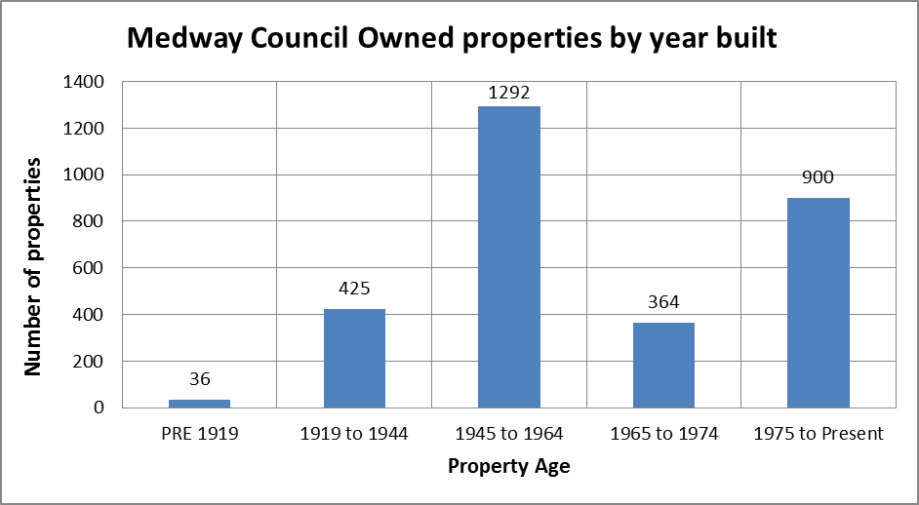

Older homes tend to be less energy efficient as thermal regulations were only introduced in the UK in 1965 and were only really effective from 1974. Nationally 75% of households living in fuel poverty live in properties built pre 1965. Just over 58% (1,753/3,017) of Medway Council owned properties were constructed before 1965. Where known the average SAP rating for Medway Council Stock is 71.1 (Band C). The table below shows that the older the stock is, the lower the average SAP rating is; showing the link between older properties and lower energy efficiency. Additionally of the 24 of our properties that we know to be rated E or F, 83% (20/24) were built prior to 1965.

Average SAP rating by date built

| Date Built | Number of properties | Average SAP rating (where known) |
| --- | --- | --- |
| Pre 1919 | 15 | 64 (D) |
| 1919 - 1944 | 151 | 67 (D) |
| 1945 - 1974 | 852 | 70 (C) |
| 1975 - 1994 | 418 | 73 (C) |
| 1995 to present | 56 | 82 (B) |

The above SAP data was taken from Codeman on 16/03/2018

Since 2014 56 new build properties have been constructed; all of these new builds achieved a band B energy efficiency rating.

### Size and property type

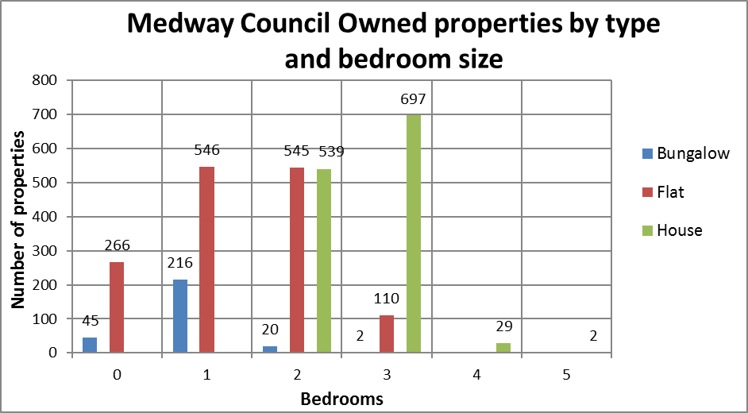

The largest proportion of Medway Council stock is flats at 49% (1,467/3017). This is followed by houses at 42% (1,267/3017) and bungalows at 10% (283/3017).

2 bedroom properties account for the largest proportion of our stock at 37% (1104/3017), followed by 3 beds at 27% (809/3017) and 1 beds at 25% (762/3017).

Three bed houses make up the largest percentage of our stock at 23% (697/3,017), followed by 2 and 1 bed flats respectively.

The chances of a household being in fuel poverty increases as the floor size of the inhabited property increases. Larger properties, with low energy efficiency will increase the potential fuel poverty gap for the household living within the property. Nationally, those in the smallest dwellings have a much smaller average fuel poverty gap (£179) than those in the largest dwellings (£595)[3].

Where EPCs have been conducted the average SAP rating of our stock by bedroom size is as follows:

| Number of bedrooms | Number of properties | Average SAP rating (where known) |
| --- | --- | --- |
| 0 | 212 | 76 |
| 1 | 423 | 70 |
| 2 | 568 | 71 |
| 3 | 288 | 71 |
| 4 | 17 | 66 |
| 5 | 2 | 77 |

The above SAP data was taken from Codeman on 16/03/2018

The above table identifies that the lowest average SAP rating is amongst 4 bed properties.

### Main fuel type

The table below identifies the fuel type used by households in our stock[4].

|  |  |  |  |
| --- | --- | --- | --- |
| Gas C.H | Electric (incl storage heaters) | Oil C.H | Solid Fuel (wood, coal) C.H |
| 2997 | 16 | 0 | 1 |

The above data was taken from Codeman on 16/03/2018

Nationally Mains Gas is the most common type of fuel used to heat homes, 99.4% of Medway Councils housing stock use Gas to heat their homes. Those households using electricity and other types of fuel are more likely to be fuel poor, only 0.6% of Medway Council households use a fuel type other than Gas. Nationally households with a rating of F or G are proportionately more likely to use a fuel type other than Gas.

### Insulation

Government data identifies that 18.1% of households living in dwellings with uninsulated solid walls are likely to be fuel poor compared to 6.2% households living in dwellings with cavity walls. Insulating walls can make a significant difference to improving the energy efficiency of a dwelling.

The construction type of a property can affect how easy it is to insulate the walls. Solid walls tend to be harder and more costly to insulate, but can be insulated post construction. As solid walls tend to lose more heat, the benefits from insulation can prove cost effective in the long run.

Landlord Services has identified the cavity wall status of 99.5% (1,543/1,550) of our houses and bungalows and 83% (207/250) of our blocks (which incorporates the data for maisonettes, bedsits and flats). Of properties for which we know the cavity wall status, 61% (946/1,543) have cavity wall insulation, 38% (587/1,543) are either not insulated or the cavity wall status is unidentifiable and 0.6% (10/1,543) have no cavity wall. For the blocks we know the cavity wall status of, 72% (150/207) have cavity wall insulation and 28% (57/207) are either not insulated or the cavity wall status is not identifiable. In order to gauge the full position of our stocks cavity wall status, the remaining blocks will need to have their wall type and insulation status identified[5].

## Fuel poverty, and who is likely to be affected

Households classed as fuel poor are those that have higher than average fuel costs and meeting these costs would leave them below the poverty line. In England in 2015, the estimated proportion of households in fuel poverty was 11% (2.50 million households), an increase of 0.6% since 2013[6]. The average fuel poverty level for Medway in 2015 was just above the national proportion at 11.5% (12,682 households); an increase of 1.7% since 2013. This highlights that the proportion of households in fuel poverty in Medway is increasing faster than the national rate.

Comparatively the average fuel poverty level in Kent in 2015 is 9.9% (62,497 households) and in the South East is 9.4% (346,392); identifying that Medway’s fuel poverty rate is higher than the county and regional percentage.

The chart below shows comparative fuel poverty data for the South East[7].

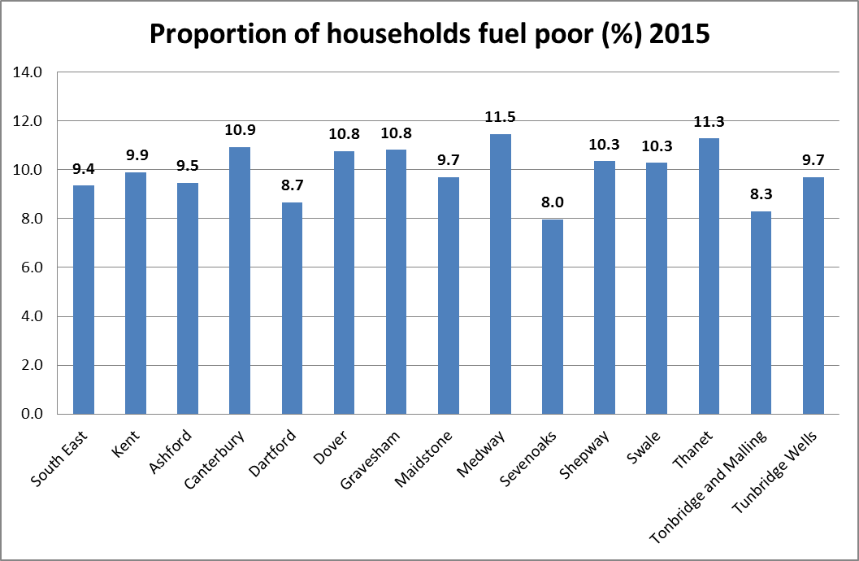

The majority of Medway Councils housing stock is in Rainham and Gillingham, fuel poverty statistics estimate that in 2015 the proportion of fuel poor households in Rainham and Gillingham was 12.3% (5,085 households)[8]. This is a higher proportion than in Medway overall and 1.4 percentage points above the national rate. The level of fuel poverty in these areas can be linked to the areas high levels of income deprivation (IMD 2015).

## Characteristics affecting fuel poverty

### Tenure

In general social housing stock is in a better state of repair than private sector housing as it must meet the Decent Homes Standard. The energy rating performance of Local Authority housing tends to be better than the private rented sector (68.9 compared to 63.4 in 2015[9]). The table below shows that whilst local authorities have the 2nd highest proportion of households in fuel poverty, the average fuel poverty gap is the lowest.

Fuel poverty and tenure

### Employment and income

Unemployment and low income are linked to higher levels of fuel poverty. Nationally 27% of households that are fuel poor are unemployed or inactive compared to 9% that are not fuel poor. As at February 2017 1.9% of Medway residents claimed out of work benefits. This is slightly higher than the South East at 1.3%, but lower than the national percentage of 2.1%[10].

|  |  |  |
| --- | --- | --- |
| Area | Claimant count[11] | Claimants as a % of residents aged 16-64 |
| Medway | 3,465 | 1.9 |
| Gillingham North | 345 | 2.6 |
| Gillingham South | 355 | 3.0 |
| Rainham Central | 70 | 1.0 |
| Rainham North | 70 | 1.3 |
| Rainham South | 70 | 0.9 |
| Twydall | 160 | 1.9 |
| Great Britain | 841,210 | 2.1 |
| South East | 73,530 | 1.3 |

The above table shows the claimant count in the areas Medway Council has housing stock and indicates a higher claimant rate for those living in Gillingham than in Medway overall. Lower rates of income in Gillingham may indicate a higher level of fuel poverty in that area. As at January 2018, 65% (1934/2992) of Medway Council lead Tenants were in receipt of either full or partial Housing Benefit, indicating lower income levels. The percentage of people on Housing Benefit across the areas of Gillingham, Rainham and Twydall was similar at 65%.

### Family composition

As of April 2018 43% (1299/2994) of households in our stock were single occupants and 57% (1695/2994) were multiple occupant households. Multi-person households are the most severely impacted by fuel poverty with a fuel poverty gap of £493, followed by couples with dependent children at £412. Households that are least impacted by fuel poverty are couples under 60 and single person households under 60, with fuel poverty gaps of £273 and £227, respectively[12].

### Energy Efficiency Rating

The figure below identifies that fuel poor households are more likely to live homes with a Fuel Poverty Energy Efficiency Rating band D to G. Only 8% of fuel poor dwellings are in band A-C[13]. This shows a correlation between households in fuel poverty and living in low energy efficient housing. Increasing the Energy Efficiency Rating of a property reduces the fuel poverty gap of the household living there.

Fuel poor vs non-fuel poor by FPEER, 2015  **Figure 3.1: Fuel poor vs non-fuel poor by FPEER, 2015** [14]

## Fuel poverty and health

The negative impact of fuel poverty on health has been firmly established. The Marmot review in 2011 identified that certain people, such as the very young, the oldest pensioners and people with long-term disability or illness, are particularly at risk of poor health from cold homes[15]. Medway has higher than average levels of fuel poverty and the life expectancy rate for both men and women is lower than the English average; with life expectancy 8.2 years lower for men and 5.8 years lower for women in the most deprived areas of Medway than in the least deprived areas[16]. Cold homes that are poorly ventilated can also lead to condensation and mould growth which can cause respiratory illnesses. Reducing fuel poverty within Medway will help improve the overall health of Medway Residents.

## Fuel Poverty targets

In 2014 the government published a fuel poverty strategy for England that set a statutory target that as many fuel poor homes as is reasonably practicable achieve a minimum Fuel Poverty Energy Efficiency Rating (FPEER) of Band C, by 2030.

The target is a three step approach as per the following:

(i) as many fuel poor homes as is reasonably practicable to Band E by 2020 and

(ii) as many fuel poor homes as is reasonably practicable to Band D by 2025

(III) as many fuel poor homes as is reasonably practicable to Band C by 2030

Fuel poverty targets for England 

**Figure 2.2: Fuel poverty targets for England** [17]

Stricter regulations have been set for the Energy Efficiency of Private Rented Properties. As of 1st April 2018 landlords of buildings within the scope of the Regulations must not renew existing tenancies or grant new tenancies if the building has less than the minimum EPC rating of E unless they fall into one of the exempted categories. Additionally as of 1 April 2023, private sector landlords must not continue to let any buildings which have an EPC rating of less than E unless they are exempted.

## Fuel Poverty Energy Efficiency Rating (FPEER)

FPEER is a measure of the energy efficiency based on the Standard Assessment Procedure (SAP) but accounts for policies that directly affect the cost of energy. Similar to SAP, the FPEER methodology generates a rating between 1 and 100, which is then translated into an energy efficiency Band from G (lowest) to A (highest) and underpins the Government’s fuel poverty target.

This methodology is intended only for use in measuring the energy efficiency of fuel poor households in relation to a new fuel poverty target for England. It will be applied solely to the housing survey data used for compiling and preparing the Annual Fuel Poverty National Statistics Report. It is not the intention for this methodology to either be used as a delivery tool, or to provide an alternative version of SAP[18].

## Current practice

What Medway Council Landlord Services currently do to improve energy efficiency and reduce fuel poverty?

* Medway Council is a member of the Kent and Medway Sustainable Energy Partnership (KMSEP) and the Kent Energy Efficiency Partnership (KEEP). The work on energy efficiency done by Medway Council directly contributes to the Kent wide strategies.
* Undertakes an ongoing boiler replacement and upgrade programme, installing A rated gas boilers, therefore replacing inefficient gas boilers, including back boilers.
* Show tenants how to use new boilers, and their thermostats and timers, to ensure they can control the heating and use it in an energy efficient manner that suits their lifestyle.
* Has a programme of upgrading the lighting in communal areas of our stock to LED lightbulbs.
* Has a continual programme of replacing and upgrading our pitched roofs, and when doing so ensuring that our roofs meet modern day building regulations, including our loft insulation levels.
* Conducts an annual window replacement scheme
* Taken part in the Warm Homes Scheme
* Installed low energy fans (environvent) into properties
* Installed Switch E thermostat into properties
* Trialled a programme of remote self-testing communal lighting, this prevents the needs for physical inspection which reduces maintenance costs and allows us to re-invest those savings on estate improvements to your area
* Replaced poor performing electric heating with combi boilers at pier road
* Ensured that contactors have a commitment to energy conservation within their contracts
* Entered into a collaborative working agreement with public health

# Strategic Priorities

The strategic priorities of this strategy focus on increasing the Energy Efficiency of Medway Councils properties in order to contribute to the reduction of fuel poverty in Medway.

This strategy has identified 4 main priorities to for Medway Council Landlord Services to achieve in relation to energy efficiency over the next 3 years:

1. Identify the energy performance rating for all our properties (where possible).
2. Analyse the current energy efficiency of our stock and create a programme of works to improve the energy efficiency ratings of our properties in line with current government targets.
3. Identify those households within our stock most likely to be in fuel poverty and work with those residents to improve energy conservation within their homes.
4. Identify and utilise government initiatives that will help improve the energy efficiency of Medway Council stock.

The delivery of these priorities will be met through the implementation of an action plan found at Appendix B.

These strategic priorities will improve the overall condition of the stock, improve the living conditions and health benefits for tenants and reduce amount of money tenants need to spend heating their homes.

1. Identify the energy performance rating for all our properties (where possible)

In order to create an accurate, targeted programme of works to improve the energy efficiency rating of our stock and meet government targets the Council needs to identify the current energy efficiency rating of all of its HRA stock.

Medway Council owns 3,016 dwellings and as at 20/01/18 and only 50% (1,510) of the stock has valid EPC data. Additionally as an EPC only last 10 years, there will be properties that require an update.

Obtaining valid energy efficiency data for all our properties will form a key part of this strategies action plan. This approach will allow us to be strategic in the works that will be undertaken to improve the energy efficiency ratings of the stock.

A programme and methodology for obtaining energy efficiency ratings for all of the stock will need to be created. The renewal of EPCs after 10 years will also need to be considered within this programme. The most appropriate ways of obtaining energy efficiency ratings for all of the stock will need to be costed and budgeted. To reduce budget costs data modelling SAP ratings could be explored. Additionally to reduce cost, reduced data SAPs could be used for properties requiring EPC renewals.

Tenants refusing access to properties for EPC certificates may be a risk to achieving this objective. It may be in that these circumstances a model is used to predict an energy efficiency rating.

## Outcome

At the end of this strategy the Council should have a clear and accurate picture of all of it stocks energy efficiency.

1. Analyse the current energy efficiency of our stock and create a programme of works to improve the energy efficiency ratings of our properties in line with current government targets.

The council will analyse the energy efficiency data it holds to construct a programme of works to improve the energy efficiency of its dwellings. Priority 1 will be an ongoing process and will allow us to be more accurate and strategic in our planning as more information is collected.

The government has set the following targets

(i) as many fuel poor homes as is reasonably practicable to Band E by 2020

(ii) as many fuel poor homes as is reasonably practicable to Band D by 2025

(III) as many fuel poor homes as is reasonably practicable to Band C by 2030

Analysis on the energy efficiency data held will allow us to identify and target properties that are suspected of or rated as having low energy efficiency.

The council will first need to focus on identifying and improving any properties rated below a band E by 2020 in order to meet government regulations.

The initial target should not however inhibit other viable and budgeted work streams that will improve the energy efficiency rating of properties rated as band E and above. Data for properties currently held identifies an extremely low number of properties rated as a band F. This should mean that work to improve the energy efficiency rating of other dwellings rated above an F can be completed in conjunction; and consideration can be given to the next target of as many fuel poor homes as is reasonably practicable to be Band D by 2025.

Rather than meeting the governments minimum targets the programme of works will focus on maximising the potential energy efficiency of a dwelling as much as is currently possible. This will increase the immediate benefits to the resident and prevent the properties being revisited unnecessarily in the future.

The programme of works to improve energy efficiency should include both traditional and innovative technological approaches. The Council is already starting to embrace new energy efficient technology, for example with the installation of environvents in some of its properties to help reduce damp and condensation. Part of this strategies action plan will include exploring new technological solutions to energy efficiency.

As the council continues with its programme of new builds it will need to ensure that the new properties meet the highest energy efficiency possible. All 56 properties built since 2014 have achieved a band B energy efficiency rating. This strategies action plan will require a minimum energy efficiency rating of C for all new builds as a set standard.

Contractor engagement will be an important part of this strategies action plan. It is important to ensure that contractors are using energy efficient resolutions and identifying any potential innovative solutions.

## Outcome

A programme of works is developed to improve the energy efficiency of our dwellings and reduce fuel poverty. This programme will ensure that the initial government target of all properties achieving a band E energy efficiency rating is met by 2020. Additionally the programme will ensure that properties rated as a band E and above start to receive works to improve their energy efficiency in accordance with subsequent government targets.

1. Identify those households within our stock most likely to be in fuel poverty and work with those residents to improve energy conservation within their homes

Any strategy for improving energy efficiency and reducing fuel poverty would not be successful if it did not prioritise engaging and educating residents. Educating our residents about energy conservation will help alleviate the financial burdens caused by fuel costs and help reduce the number of households affected by fuel poverty.

Landlord Services will create a programme to promote energy saving methods to residents and promote cost saving service such as Medway Switch and Save (as detailed in this strategies action plan). External partners will be involved in delivering training when required. Additionally work will be done with low income households to ensure that they are maximising their income and receiving all the relevant payments to alleviate fuel poverty, such as the Warm Home Scheme. This programme will bring benefits to the resident and strengthen the resident’s relationship with the council.

The government research explored in this strategy identifies the households and circumstances most likely lead to fuel poverty. Profiling based on this research will be undertaken on our current residents to identify those households that will most benefit from education on energy conservation. Whilst we will take a targeted approach, we will ensure that any programme of education is inclusive of all residents and only severs to advance equality.

Achieving the right methods of engagement can be challenging and methods of engagement will need to vary to ensure that all audiences are reached. Our programme of engagement will include face to face meetings, promotion on the council’s website and utilising social media. Particular focus will need to be placed on reaching vulnerable tenants to ensure they engaged with this process. Information will need to be provided in formats that are suitable to people’s individual needs, for example easy read or audio. Additionally where it is identified that English is not the residents first language information may need to be translated. Consideration will also need to be given to some outreach work for residents that are unable to leave their home.

## Outcome

A programme to promote energy saving methods to residents is constructed and undertaken. Residents are more aware of energy saving methods that will help to reduce fuel costs and the effects of fuel poverty.

1. Identify and utilise government initiatives that will help improve the energy efficiency of Medway Council stock.

The Government has a number of schemes to help improve the energy efficiency rating of households (see appendix A). It is important to explore these schemes as part of our action plan in order to increase funding and reduce pressures on budgets. Government schemes will need to be explored to identify those that most fit Medway’s objectives. Priority 4 will link in closely with Priority 3 as a lot of the government schemes require promotion to and involvement from residents.

## Outcome

Appropriate government schemes are explored and utilised to help improve energy efficiency.

# Challenges

In delivering this strategy there will be several challenges that will need to be addressed to ensure that progress is not prohibited.

## Information gathering

The service will need to gather all the relevant information to identify the full extent of Medway Councils housing stocks energy efficiency position. Without this information the council will not be able to strategically plan a programme of energy efficiency improvements. There will be financial costs attached to gathering this information in terms of the methods and resources used to gather the data; this will need to be accounted for within budgets. Additionally resource will need to be given to analysing the data and developing a programme of improvement work.

## Funding of improvement work

There will be costs associated with carrying out energy efficiency improvement works on properties and these costs will need to be resourced within budgets. The service will need to ensure that improvement works are carried out in line with this strategy. Funding for delivery should be prioritised on properties with the lowest energy efficiency rating to bring them up to government regulated standards. It will be necessary to ensure that the materials and resources used to deliver to works are value for money. This will involve being innovation in our approach and considering the use of new technology. Identification of any government funding available will be important in order alleviate any budgetary pressures.

## Engaging residents

This strategy cannot be delivered without engagement from residents. The service will need cooperation from residents to access properties in both the information gathering process and the delivery of improvement works. Landlord Services will need to take a considered approach to ensure that residents are engaged and cooperative in this process. This will involve communicating this strategy to residents to ensure they are informed of its objectives and the benefits it will deliver.

Strategic priority 4 specifically relates to educating residents on energy conservation. This priority will fail if the service is unable to significantly engage with residents. Landlord Services will need to use all its current methods of resident engagement to make this successful as well as identifying new approaches to make sure all the target audiences are engaged.

## Legislative change

The current fuel poverty energy efficiency target was set under the 2010 to 2015 Conservative and Liberal Democrat coalition government. Whilst there have been no changes to this target under the current Conservative government, legislation should be closely monitored for amendments to ensure the objectives of this strategy are relevant.

## Monitoring

This strategy will be monitored via the Asset Management Group (AMG). The AMG informs and monitors the strategic medium and long-term approach to the council’s housing assets. The group consists of the Portfolio Holder, council employees and residents. The Energy efficiency and fuel poverty reduction strategy Action plan will be reviewed at each meeting.

## Review

This strategy will run from October 2018 to October 2020.

This strategy will require review after 2020 to ensure that the initial government target of all properties achieving a band E has been met. An additional action plan will need to be developed to ensure the next target of as many fuel poor homes as is reasonably practicable to be Band D by 2025 is on track.

This strategy will require review if there are any changes to government legislation informing energy efficiency and fuel poverty.

## Suggested reading

[Cutting the cost of keeping warm: A fuel poverty strategy for England 2015](https://www.gov.uk/government/publications/cutting-the-cost-of-keeping-warm)

[Annual Fuel Poverty Statistics Report, 2017 (2015 Data)](https://www.gov.uk/government/statistics/annual-fuel-poverty-statistics-report-2017)

[Delivering Affordable Warmth: A FUEL POVERTY STRATEGY FOR KENT 2016](http://www.kenthousinggroup.org.uk/protocols/kent-fuel-poverty-strategy/)

Medway Council’s Home Energy Conservation Act 1995 Report 2017

[Fuel Poverty (England) Regulations 2014 and methodology](https://www.gov.uk/government/publications/fuel-poverty-england-regulations-2014-and-methodology)

[Marmot review The Health Impacts of Cold Homes and Fuel Poverty 2011](https://friendsoftheearth.uk/sites/default/files/downloads/cold_homes_health.pdf)

## Action Plan

An action plan has been developed to achieve the strategic objectives set out in this strategy.

## Appendices

Appendix A - Government schemes available to improve energy efficiency

# Appendix A - Government schemes available to improve energy efficiency

## Funding currently available:

<https://www.gov.uk/energy-grants-calculator>

### Green Deal

You can get finance for energy saving measure based on what you would expect to have on energy bills. Green Deal finance plans are taken out by the tenant but stay with the property – so this would have implications if the tenant were to move out during the repayment period.

### ECO – Energy Company Obligation

This places a duty on energy companies to install measures. It is currently set to run until 30th September 2018. There are two funding streams within it: HHCRO and CERO.

CERO focuses on installing primary measures such as insulations and has fewer eligibility criteria. HHCRO - suppliers promote measure to improve income and vulnerable households to heat their homes. This includes heating savings such as replacement of boiler (not sure this would be applicable to social housing tenants as we are responsible for this)

Useful link:

<https://www.ofgem.gov.uk/environmental-programmes/eco/about-eco-scheme>

### Affordable Warmth Obligation

If you live in social housing that has an energy efficiency rating of E, F or G you might be eligible for help with insulation or installing a heating system for the first time. Contact the Energy Saving Advice Service to find out if you’re eligible for help. They’ll tell you how to apply if you’re eligible.

### Domestic Renewable Heating Incentive (RHI)

This is a government financial incentive to promote the use of renewable heat. Those who join the scheme and stick to its rules receive quarterly payments for 7 years for the amount of clean, green and renewable heat it’s estimated their system produces. Once the system is installed, application for payments needs to be made within 12 months.

### Feed in tariffs (FITs)

The FIT scheme is available for anyone who has installed, or is looking to install, one of the following technology types up to a capacity of 5MW, or 2kW for CHP:

* Solar photovoltaic (solar PV)
* Wind
* Micro combined heat and power (CHP)
* Hydro
* Anaerobic digestion (AD)

FIT payments are made quarterly (at least) for the electricity your installation has generated and exported. Payments are made based on the meter reading you submit to your energy supplier.

### Payments to alleviate fuel poverty to promote to tenants:

Warm Homes Discount – eligible households could get a one off discount of £140 off electricity bill between September and March (low income/pension credit)

Winter Fuel Payment – payments are usually automatic if a person is eligible and gets the State Pension or another social security benefit (excluding HB, Council Tax Reduction, Child Benefit or Universal Credit.)

Cold Weather Payment – eligible persons will get a payment if the average temperature is recorded as below zero for 7 consecutive days. The current payment is £25 for each 7 day period between 1 November and 31 March.

1. Annual Fuel Poverty Statistics report, 2017 (2015 data) June 2017, Department for Business, Energy and Industrial Strategy
2. Unless stated the data used for property analysis was extracted from Academy on 20/02/2018 13:21:08
3. Annual Fuel Poverty Statistics report, 2017 (2015 data) June 2017, Department for Business, Energy and Industrial Strategy
4. The figure totals 3014 because Academy has 30 St Marks listed as flat A, B and C whereas Codeman currently only records all under 1 UPRN for 30 St Marks
5. Data taken from Codeman on 23/03/2018
6. Annual Fuel Poverty Statistics report, 2017 (2015 data) June 2017, Department for Business, Energy and Industrial Strategy
7. Department for Business, Energy& Industrial Strategy Sub-regional Fuel Poverty, England 2017
8. Department for Business, Energy& Industrial Strategy Sub-regional Fuel Poverty, England 2017
9. Annual Fuel Poverty Statistics report, 2017 (2015 data) June 2017, Department for Business, Energy and Industrial Strategy
10. ONS Claimant count by sex and age February 2018
11. ONS Claimant count by sex and age February 2018
12. Annual Fuel Poverty Statistics report, 2017 (2015 data) June 2017, Department for Business, Energy and Industrial Strategy
13. Annual Fuel Poverty Statistics report, 2017 (2015 data) June 2017, Department for Business, Energy and Industrial Strategy
14. Annual Fuel Poverty Statistics report, 2017 (2015 data) June 2017, Department for Business, Energy and Industrial Strategy
15. Marmot Review Team, 2011, The Health Impacts of Cold Homes and Fuel Poverty
16. Public Health England, Medway Health Profile 2017
17. Annual Fuel Poverty Statistics report, 2017 (2015 data) June 2017, Department for Business, Energy and Industrial Strategy
18. Fuel Poverty Energy Efficiency Rating Methodology 2014