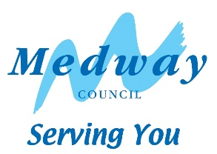**Medway Youth Service   
Training Application**

|  |  |  |
| --- | --- | --- |
| Course | Date | Tick if interested |
| Youth Participation and  Reflective Practice in a Youth Work Setting | 7th May |  |
| Domestic Abuse Basic Awareness | 4th June |  |
| Young People’s Development | 2nd July |  |
| Engaging and Communicating with Young People | 6th August |  |
| Group Work within a Youth Work Setting | 3rd Sept |  |
| An Introduction to Information advice and guidance and Careers Education | 1st Oct |  |
| Safeguarding in a youth work setting (CP) | 5th Nov |  |
| Working with Challenging Behaviour in Youth Work Settings | 3rd Dec |  |
| Register interest, please state which courses you are also interested in | | |

# 

# Name: __________________________

Organisation: ______________________________

Home address: ______________________________________________________________  
___________________________________________________________________________

Post Code: _____________________

Telephone number: ____________________ Mobile number: _____________________

Email: __________________________________

# Do you have an access requirement? i.e. physical or learning needs

# If yes, please specify: ____________________________________________________________________________

# ____________________________________________________________________________

**Do you have any worries or concerns about the training?  
___________________________________________________________________________________  
___________________________________________________________________________________**

**Do you give permission for this information to be kept on a secure database, so you can be contacted regarding the training course and future opportunities?**

**Yes / No (delete as appropriate)**

Course fee for organisations external to Medway Council Children’s Services:

£15 per person per session.

Please return form via email to: [youth.enquiries@medway.gov.uk](mailto:youth.enquiries@medway.gov.uk)