

WINTER SERVICE

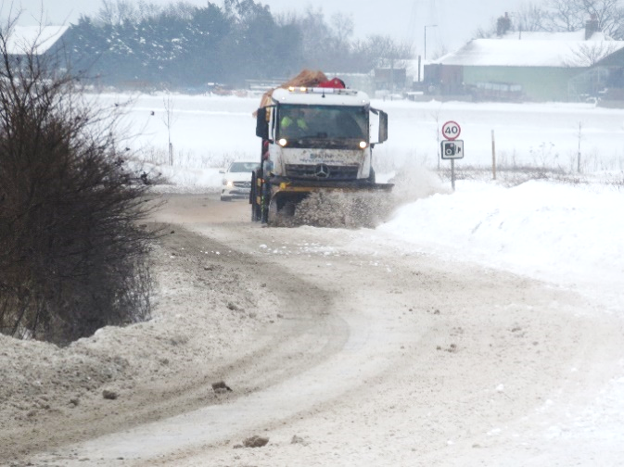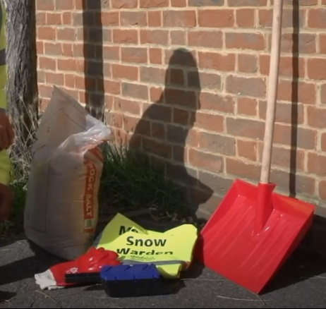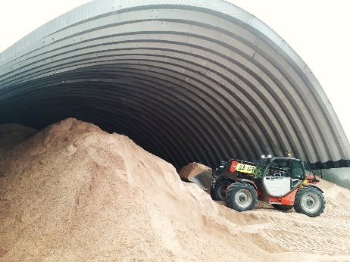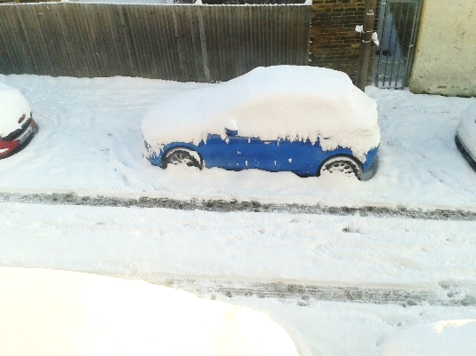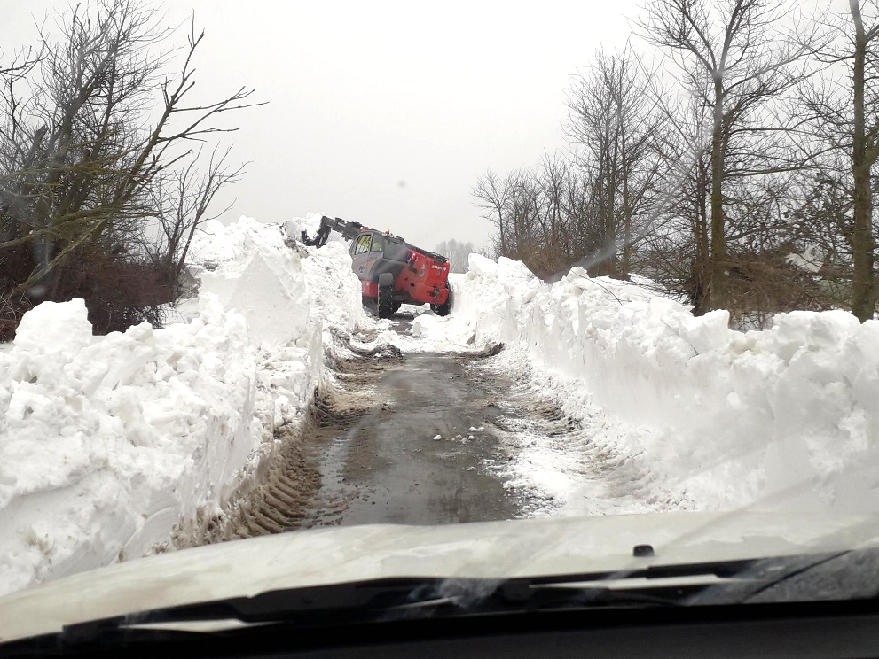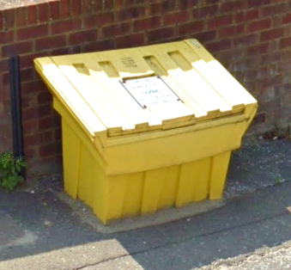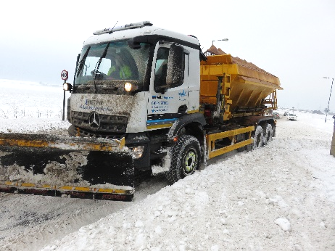POLICY FOR 2018/2027

This page is intentionally left blank

# Date: May 2023 Version: 4

|  |  |
| --- | --- |
| Document title | Winter Service Policy for 2018/2027 |
| Author | Senior Engineer Highway Operations |
| Principal Owner | Highways Operations Team |
| Document status | Live |

# Reviewer list

| Name | Role | Version 1 | Version 2 | Version 3 | Version 4 |
| --- | --- | --- | --- | --- | --- |
| JA | Principal Engineer Asset Management | ✓ | ✓ |  |  |
| LB | Principal Engineer Network Management | ✓ | ✓ |  |  |
| AA | Assistant Engineer Asset Management |  |  | ✓ | ✓ |
| JM | Principal Engineer Highway Operations |  |  |  | ✓ |

# Approvals

| Name | Role | Date | Version |
| --- | --- | --- | --- |
| SS | Head of Highways | 18/05/2021 | 2 |
| SS | Head of Highways | 27/04/2022 | 3 |
| AC | Strategic Lead Frontline Services | 05/06/2023 | 4 |

# Revision history

| Version | Date | Description | Author |
| --- | --- | --- | --- |
| 1 | 01/11/2018 | Initial Publish | MS |
| 2 | 18/05/2021 | 2021 Review | JM |
| 3 | 26/04/2022 | 2022 Review (Including Winter Fleet Conversion) | JM |
| 4 | 02/06/2023 | 2023 Review | KR |

This Policy will be reviewed and updated annually with the next review date scheduled for May 2024.

## CONTENTS

## INTRODUCTION

|  |  |  |
| --- | --- | --- |
| 1.1 | Winter Service – Statutory Duties | Page 4 |
| 1.2 | Winter Service Standards | Page 4 |
| 1.3 | Medway Council maintained Highways | Page 5 |
| 1.4 | County Council maintained roads | Page 5 |
| 1.5 | Motorway and Trunk roads | Page 5 |

## WINTER SERVICE OBJECTIVES

|  |  |  |
| --- | --- | --- |
| 2.1 | Salting | Page 5-6 |
| 2.2 | Snow Clearance | Page 6-7 |

## WINTER SERVICE GENERAL

|  |  |  |
| --- | --- | --- |
| 3.1 | Winter Service Contracts | Page 7 |
| 3.2 | Winter Service Season | Page 7 |
| 3.3 | Salt provision | Page 7 |
| 3.4 | Winter Resilience Standard | Page 8 |
| 3.5 | Alternatives to Salt | Page 8 |

## 4. WEATHER INFORMATION

|  |  |  |
| --- | --- | --- |
| 4.1 | Weather Information Systems | Page 8 |
| 4.2 | Weather Forecasts | Page 8 |
| 4.3 | County Duty Winter Maintenance Officers | Page 9 |

## SALTING

|  |  |  |
| --- | --- | --- |
| 5.1 | Planning of Precautionary Salting routes | Page 9 |
| 5.2 | Precautionary Salting | Page 9 |
| 5.3 | Post Salting | Page 9 |
| 5.4 | Spot Salting | Page 10 |
| 5.5 | Instructions for Precautionary Salting | Page 10 |

## 6. SNOW CLEARANCE

|  |  |  |
| --- | --- | --- |
| 6.1 | Instructions for Snow Clearance | Page 10 |
| 6.2 | Snow Clearance on Carriageways | Page 11 |
| 6.3 | Snow Clearance on Footways | Page 11 |
| 6.4 | Deployment of Additional Resources | Page 11 |
| 6.5 | Snow Wardens | Page 11 |
| 6.6 | Agriculture Snow Ploughs for Snow Clearance | Page 12 |

## 7. SEVERE WEATHER CONDITIONS

|  |  |  |
| --- | --- | --- |
| 7.1 | Persistent Ice on Minor Roads | Page 12 |
| 7.2 | Ice Emergencies | Page 12 |
| 7.3 | Snow Emergencies | Page 12 |

## 8. SALT BINS

|  |  |  |
| --- | --- | --- |
| 8.1 | Provision of Salt bins | Page 12-13 |

## 9. BUDGETS

|  |  |  |
| --- | --- | --- |
| 9.1 | Winter Services Budget | Page 13 |
| 9.2 | Ice and Snow Emergencies | Page 13 |

## 10. PUBLICITY AND MEDIA COMMUNICATION

|  |  |  |
| --- | --- | --- |
| 10.1 | Pre-Season Publicity | Page 13 |
| 10.2 | Publicity During Ice and Snow Emergencies | Page 1-14 |

## 11. SERVICE IMPROVEMENTS

|  |  |  |
| --- | --- | --- |
| 11.1  11.2 | Pre-wetted Salt  Road Surface Temperatures | Page 14  Page 14 |
| **APPENDIX 1** | Salt Bin Assessment Form | Page 15 |
| **APPENDIX 2** | Spot Salting Template | Page 16 |

## 

## 1. INTRODUCTION

## 1.1 Winter Service - Statutory Duty

1.1.1 The statutory basis for Winter Service in England and Wales is Section 41(1A) of the Highways Act 1980, modified on 31st October 2003 by Section 111 of the Railways and Transport Act 2003.

“(1A) In particular, a highway authority is under a duty to ensure, so far as is reasonably practicable, that safe passage along a highway is not endangered by snow or ice.

1.1.2 Medway Council recognises that the winter service is essential in aiding the safe movement of highway users, maintaining communications, reducing delays and enabling everyday life to continue. It is very important to both road safety and the local economy. The winter service that Medway Council provides is believed to be sufficient so far as is reasonably practical to discharge the duty imposed by the legislation.

1.1.3 Medway Council, as highway authority, takes its winter service responsibilities extremely seriously, however, it is important to recognise that the council must prioritise its response to deal with winter weather due to the logistics and available resources.

* + 1. Medway Council provides the winter service with the assistance of its highways term contractor (Volkerhighways).

1.2 **Winter Service Standards**

1.2.1 In order to respond as quickly and efficiently as possible to its responsibilities Medway Council has adopted policies and standards for each of the Winter Service activities and these are detailed within this document. The operational details for the Winter Service activities in Medway are detailed in the Winter Service Plan 2018/27, which complements this Policy.

1.2.2 Medway Council provides a Winter Service which, as far as reasonably possible will:

* Minimise accidents and injury to highway users, including pedestrians, and prevent damage to vehicles and buildings
* Keep the highway free from obstruction and avoid unnecessary hindrance to passage

## 1.3 Medway Council Maintained Highways

1.3.1 Medway Council delivers the winter service on Medway Council maintained highways.

1.3.2 The winter service policy will be reviewed annually by officers to ensure that the Policy continues to be fit for purpose.

## 1.4 County Council Maintained Highways

1.4.1 KCC Highway Operations delivers the winter service on Kent County Council maintained highways.

1.4.2 Medway Council treats designated roads totaling 37.17 km of the Kent network on behalf of Kent County Council. These roads are adjacent to and adjoining the Medway network on the north Kent borders. In return KCC provides Medway Council with the road weather forecast, access to their road weather station network and annual winter decision making training. A contract is in place detailing the arrangement.

## 1.5 Motorways and Trunk Roads

1.5.1 The Department for Transport (DfT) is the highway authority for motorways and all-purpose trunk roads and National Highways acts for the DfT in this respect. Responsibility for the operational maintenance of motorways and trunk roads lies with National Highways. Medway Council therefore has no responsibility for winter service activities on these roads. However, close liaison exists between the National Highways consultants, Kent County Council and Medway Council over action taken during the winter service operational period within respective areas of responsibilities.

## 2. WINTER SERVICE OBJECTIVES

## 2.1 Salting

2.1.1 Objectives:

* To prevent the formation of ice on carriageways (precautionary salting).
* To facilitate the removal of ice and snow from carriageways and footways (post salting).

## 2.1.2 Precautionary Salting Routes

Routine precautionary salting will be carried out on pre-determined primary routes covering the following roads:

* Class "A" and Class "B" roads
* Regular Service Bus Routes
* Other roads carrying over 440 vehicles in the morning peak hour or forming part of main traffic systems in urban areas
* Chatham, Gillingham and Rochester town centres (semi pedestrian zones)
* Other roads identified by the Head of Highways that are particularly hazardous in frosty/icy conditions and are of importance to the local road network.

2.1.3 Full details of primary routes, secondary routes and third tier salting routes are given in the Winter Service Plan.

2.1.4 It would be impractical and financially draining to carry out precautionary salting of footways, pedestrian precincts or cycle ways and therefore no provision has been made. However, there will be a certain amount of overspill onto footways and cycle ways when precautionary salting is being carried out on adjacent carriageways. Post salting of footways and cycle ways will be carried out on a priority basis during severe weather, as resources permit.

## 2.1.5 Minimum Winter Network

In the event of a prolonged snow event or other circumstances leading to a shortage of resources, precautionary salting will be limited to Medway Council’s [Resilient Network](https://www.medway.gov.uk/downloads/file/2101/resilient_network_-_map) which includes the main strategic network, i.e. all “A” roads and some other locally important roads as listed in the Winter Plan.

## 2.2 Snow Clearance

2.2.1 Objectives:

* To prevent injury or damage caused by snow
* To remove obstructions caused by the accumulation of snow (Section 150 of the Highways Act 1980)
* To reduce delays and inconvenience caused by snow

2.2.2 The only effective way to remove more than a few millimetres of snow is by ploughing. The purpose of ploughing is to move as much snow as possible away from the road surface as is practical for the given conditions though it will not always be possible to remove snow right down to the road surface.

2.2.3 Snow clearance on carriageways will be carried out on a priority basis as detailed in paragraph 6.2.

2.2.4 Snow clearance on certain minor route carriageways will be carried out by local farmers, who are under agreement to the Winter Service Contractor, using agricultural snow ploughs. Snow clearance on other minor route carriageways will be carried out as resources permit. Many minor routes and cul-de-sac will inevitably have to be left to thaw naturally.

2.2.5 Snow clearance on footways will be carried out on a priority basis as detailed in paragraph 6.3.

2.2.6 Snow clearance and salting of car parks will be undertaken in the town center car parks listed in the Winter Plan. This work to be undertaken by Medway Norse.

## 3. WINTER SERVICE GENERAL

## 3.1 Winter Service Contracts

3.1.1 Winter Service activities will be carried out by Medway Council's Term Maintenance Contractor, (Volkerhighways). This contract was awarded in 2017 and lasts for five years. However, with extensions of time for good service delivery the contract could potentially continue until 2027.

## 3.2 Winter Service Season

3.2.1 In Medway, weather is unpredictable, and the occurrence and severity of wintery conditions varies considerably throughout the season and from year to year. Severe wintery weather is most likely to be experienced in December, January and February but ice and snow can occur earlier or later. To take account of all possible wintery weather Medway Council's Operational Winter Service Season will run from mid-October to mid-April.

## 3.3 Salt provision

3.3.1 The Council’s Term Maintenance Contractor, (Volkerhighways), is responsible for procurement of sufficient salt to maintain the required stock throughout the winter period and its storage in a purpose made barn.

3.3.2 The contractor is contracted to store 4,000 tonnes of salt at the Highway depot and the minimum quantity of salt to be maintained is 3,400 tonnes.

3.3.3 A small stockpile of salt (approx. 10 tonnes) will be provided at the Medway Norse depot so that in prolonged periods of snow, Norse staff can be mobilised with salt directly from their depot to treat Town Centre footpaths and car park.

## 3.4 Winter resilience standard

3.4.1 At the start of the winter service season our Term Maintenance Contractor will have 4,000 tonnes of salt in stock in their Medway depot. National guidance to local authorities suggests a resilience benchmark of 12 days/48 runs i.e. the authority would be able to continuously salt its minimum winter network during its core winter period for 12 days. The level of salt in stock ensures that this number of runs can be carried out.

## 3.5 Alternatives to Salt

3.5.1 Rock Salt will be used as the de-icing material for precautionary and post salting. Medway Council uses a pre-wet system which improves the effectiveness of treatment by reducing particle distribution, increasing adherence to the surface and increasing the speed of anti-icing or de-icing action. Dry salt is also used in appropriate conditions including when there is severe snow and ice. In cases of severe snowfall, alternatives to salt will be used including sharp sand and other forms of grit, including a salt/sand mix up to 50/50 proportion.

3.5.2 There are now available several alternative materials which can be used in place of salt. The cost of these is extremely high and there are also environmental disadvantages associated with most of the alternatives. Salt will therefore, for the time being, remain in use throughout Medway for the precautionary and emergency treatment of snow and ice. However alternative methods and materials will continue to be investigated and if both cost effective and environmentally friendly will be considered.

## 4. WEATHER INFORMATION

## 4.1 Weather Information Systems

4.1.1 An effective and efficient Winter Service is only possible with reliable and accurate information about weather conditions at the appropriate times in the decision-making progress. Medway Council working with Kent County Council utilises the best weather forecast information currently available allied to KCC latest computer technology, to ensure that decisions are based on the most accurate data available.

## 4.2 Weather Forecasts

4.2.1 During the operational Winter Service period Kent County Council will receive detailed weather forecasts that are specifically designed to assist highway authorities with Winter Service activities.

## 4.3 County Duty Winter Maintenance Officers

4.3.1 Experienced members of staff from Kent Highway Services will act as County Winter Duty Officers, throughout the operational winter service period, on a rota basis. The Officer on duty is responsible for the following: -

* Receiving forecast information
* Monitoring current weather conditions
* Issuing suggested salting instructions
* Issuing the Kent Road Weather Forecast

The Kent Road Weather Forecast will be issued daily and will contain suggested salting instructions. The County Winter Duty Officer will also be responsible for issuing forecast updates and any revised suggested salting instructions when necessary. The Kent Road Weather Forecast will be disseminated to the Medway Winter Services Engineer (MWSE) who will be responsible for making the decision on what action to take and issuing instructions to the Contractor.

## 5. SALTING

## 5.1 Planning of Precautionary Salting Routes

5.1.1 Primary precautionary salting routes have been developed from those lengths of highway that qualify for treatment whenever frost, ice or snow are expected. Each primary route will have a vehicle assigned to it, which will be suitably adapted to allow the fixing of a snowplough when required. In times of severe snowfall and/or extreme ice formation, dedicated vehicles will be assigned to patrol key strategic routes. Secondary routes have also been developed from other important highways for treatment in severe weather conditions.

## 5.2 Precautionary Salting

5.2.1 Precautionary salting will take place on scheduled precautionary salting routes on a pre-planned basis to prevent formation of ice and/or the accumulation of snow on carriageway surfaces

## 5.3 Post Salting

5.3.1 Post salting will normally take place on scheduled precautionary salting routes as treatment to ice and snow that has already formed on carriageway surfaces. Post salting may also be required on roads or sections of road beyond the scheduled salting routes.

## 5.4 Spot Salting

5.4.1 Spot salting will normally take place on parts or sections of scheduled precautionary salting routes either to prevent formation of ice and/or accumulation of snow or as treatment to ice and snow that has already formed on carriageway surfaces. Spot salting may also be required on roads or sections of road beyond the scheduled precautionary salting routes.

* + 1. Spot salting records will be maintained by the MWSE as per Appendix 2.

## 5.5 Instructions for Precautionary Salting

5.5.1 Precautionary salting instructions will normally be issued if road surface temperatures are expected to fall below freezing and in line with the KCC winter treatment instruction matrix detailed in the KCC Winter Service Plan.

5.5.2 Instructions for precautionary salting of primary routes will also be issued if snowfall is expected.

5.5.3 The County Winter Duty Officer will issue routine instructions for precautionary salting of primary routes, for Medway, by means of the Kent Road Weather Forecast via the RoadMaster web-based system.

5.5.4 Observational data produced by sensors placed under the Smart Winter project will be used to validate pre-salting decisions.

5.5.5 The County Winter Duty Officer may issue instructions for post salting and spot salting.

5.5.6 Instructions for salting beyond the primary route network will be issued by the MWSE.

## 6. SNOW CLEARANCE

## 6.1 Instructions for Snow Clearance

6.1.1 The Medway Winter Service Engineer (MWSE) is responsible for issuing snow clearance instructions. Snow clearance will initially take place on scheduled precautionary salting routes given in para 6.2.1 Subsequently snow clearance will take place on other roads or footways on a priority basis.

6.1.2 Snow ploughing on carriageways where there are physical restrictions due to traffic calming measures, should only be treated after a safe method of operation has been agreed.

## 6.2 Snow Clearance on Carriageways

6.2.1 Snow clearance on carriageways should be based on the priorities given below:

* Medway Council’s Resilient Network
* "A" class roads
* "B" class roads
* Regular Service Bus Routes
* All other roads covered by precautionary salting routes
* One link to other urban centres, villages and hamlets with priority given to bus routes
* Links to hospitals and police, fire and ambulance stations
* Residential roads not on the precautionary salting routes but where there is only one access via a steep hill and serving more than 300 properties.
* Other routes as and when resources permit.

## 6.3 Snow Clearance on Footways and Cycleways

6.3.1 Snow clearance on footways and cycleways have been identified and prioritised in line with the National Winter Service Research Group (NWSRG) Section Eleven. These are based on the priorities given below:

* Both footways in and around main shopping centres of Chatham, Gillingham, Rochester, Strood and Rainham including Rainham Precinct.
* Both footways in and around local shopping centres, and on routes to railway stations, footbridges, hospitals, main medical centres.
* One footway on main arteries in residential areas.
* Other footways as and when resources and time permit.

## Deployment of Additional Resources

6.4.1 The Council’s street cleansing and waste contractor (Medway Norse) is contracted through the waste / greenspaces contract, when unable to undertake their normal duties, to be redeployed in salting and snow clearance activities.

## Snow Wardens

6.5.1 Medway Council promote a volunteer service to become Snow Warden. After completing an application and viewing a training video each person is equipped with salt, a spreader, gloves reflective vest and a snow shovel. An agreed length is then allocated to them to clear following snowfall.

## Agricultural Snow Ploughs for Snow Clearance

6.6.1 Agreements will be entered into whereby snow ploughs provided and maintained by Medway Council are assigned to local farmers for snow clearance operations generally, on the more rural parts of the highway.

## 7. SEVERE WEATHER CONDITIONS

## 7.1 Persistent Ice on Minor Roads

7.1.1 During longer periods of cold weather the MWSE may instruct salting to deal with persistent ice on minor roads which would not normally be pre-salted but only when all primary routes have been treated satisfactorily. The MWSE may act as the situation demands but priority will be given to roads on precautionary salting routes before other roads are considered for treatment. The MWSE should agree a course of action for dealing with persistent ice with the Head of Highways as soon as practicable.

## 7.2 Ice Emergencies

7.2.1 During longer periods of prolonged and persistent icing the Head of Highways may declare an ice emergency covering all or part of the Medway area. In this event the MWSE will agree a course of action with the Head of Highways in order to deal with the situation. This course of action will still follow the priorities set within this policy.

## 7.3 Snow Emergencies

7.3.1 In the event of significant snowfalls the Head of Highways may declare a snow emergency covering all or part of the Medway area. In this event the MWSE will agree a course of action with the Head of Highways in order to deal with the situation. This course of action will still follow the priorities set within this policy.

## 8. SALT BINS

## 8.1 Provision of Salt Bins

8.1.1 The objective is to provide motorists and pedestrians with the means of salting ice and snow on small areas of public maintainable carriageway or footway, where it is causing difficulty.

8.1.2 Salt bins are sited at potentially hazardous [locations](https://www.medway.gov.uk/info/200160/roads_and_pavements/491/icy_roads_and_salt_bins/2), such as steep gradients or sharp bends, where there is the potential for a serious accident to occur. An assessment criteria for installing a new salt bin has been devised and is shown at Appendix 1. The form will be used by Highways staff to assess requests for new salt bins, subject to funding being available.

8.1.3 Salt bins will be filled with salt and refilled as time and resources permit.

8.1.4 Generally Salt Bins will be free standing. In locations of vandalism of theft, consideration will be given to bolting the bins into place.

8.1.5 All Salt Bins will carry the Medway sign and highlight the contents are to be used on public maintainable roads and pavements only.

## 9. BUDGETS

## 9.1 Winter Service Budget

9.1.1 The budget for the operational Winter Service period is set at the beginning of each financial year. This covers precautionary salting, salt bins and the provision of the Contractor’s facilities i.e. salt barn, salt stock management and salt spreaders.

## 9.2 Ice and Snow Emergencies

9.2.1 There is no departmental budget for ice or snow emergencies. The cost of dealing with periods of icy conditions or significant snowfalls, over and above that which would normally be expected, will have to be met by Council Reserves.

## 10 PUBLICITY AND MEDIA COMMUNICATIONS

## 10.1 Pre-Season Publicity

10.1.2 A press release may be issued, if felt appropriate, before the start of the Winter Service period.

10.1.3 Advice will be provided on self-help for communities, including encouraging local action where appropriate e.g. use of salt bins.

## 10.2 Publicity During Ice or Snow Emergencies

10.2.1 Liaison with the news media, particularly local radio stations, is of the utmost importance to keep the public informed and this will be maintained by the Council’s media team during ice or snow emergencies, in liaison with the Head of Highways.

10.2.2 Information through the media and the council’s web site will be maintained showing what routes are being treated along with a list of car parks that are expected to be open for use. This will ensure that those choosing to travel by road can plan their journeys.

10.2.3 The Council’s website will be regularly updated daily showing the salting actions taken.

## 11 SERVICE IMPROVEMENTS

**11.1 Pre Wetted Salt**

11.1.1 For the 2022/23 season onwards the Councils winter fleet has been renewed which will enable precautionary salting using both dry and pre-wetted salt. The advantage of pre-wetted salt is it can spread more evenly and more quickly cutting salt usage by up to 20%. It also works straight away and doesn't have to wait to dissolve like traditional salt.

**11.2 Road Surface Temperatures**

11.2.1 During the 2021/22 season the Council trialled the use of ten road surface temperature sensors with the aim of a future route based forecast system. This initial trial was successful, and the Council will be installing an additional 34 sensors around Medway to expand the trial to the whole network for the 2023/24 winter season.

Appendix 1

## SALT BIN ASSESSMENT FORM

|  |  |  |
| --- | --- | --- |
| Location of Salt Bin | Assessment Date | Assessed by |

|  |  |  |  |
| --- | --- | --- | --- |
| Characteristic | Severity | Standard Score | Actual Score |
| 1 – Gradient | Greater than 1 in 15 (>3.8°)  1 in 15 to 1 in 29 (>1.9 to <3.8°)  Less than 1 in 30 (<1.9°) | 60  25  Nil |  |
| 2 – Severe bend | Yes  Moderate  No | 60  25  Nil |  |
| 3 – Close proximity to AND falling towards | Heavy trafficked road  Moderately trafficked road  Lightly trafficked road | 70  45  25 |  |
| 4 – Assessed traffic density at peak times | Moderate  Light | 35  Nil |  |
| 5 - *Number of premises for which access only | Over 50  20 – 50  0-20 | 30  20  Nil |  |
| 6 – Is there a substantial population of either disabled or elderly people | Yes  No | 20  Nil |  |
|  |  | TOTAL |  |

* N.B. Any industrial or shop premises for which this is the only access is to be automatically promoted to the next higher category within characteristic (V).

Any site for which the summation of the weighing factors equals or exceeds 130 would warrant the siting of a salt bin.

Appendix 2

**HIGHWAY SPOT SALTING GRITTING REQUESTS FORM**

|  |  |  |  |
| --- | --- | --- | --- |
| DATE | LOCATION | F/W or C/W | WORKS COMPLETED |
|  |  |  |  |
|  |  |  |  |
|  |  |  |  |
|  |  |  |  |
|  |  |  |  |
|  |  |  |  |
|  |  |  |  |
|  |  |  |  |
|  |  |  |  |
|  |  |  |  |
|  |  |  |  |
|  |  |  |  |
|  |  |  |  |
|  |  |  |  |
|  |  |  |  |
|  |  |  |  |
|  |  |  |  |
|  |  |  |  |
|  |  |  |  |
|  |  |  |  |
|  |  |  |  |
|  |  |  |  |
|  |  |  |  |
|  |  |  |  |
|  |  |  |  |
|  |  |  |  |
|  |  |  |  |
|  |  |  |  |
|  |  |  |  |
|  |  |  |  |
|  |  |  |  |
|  |  |  |  |
|  |  |  |  |
|  |  |  |  |
|  |  |  |  |