Litter Innovation Fund (LIF)

Final Report
Further to your award it is important for us to evaluate how effective your research project has been and if the wider aims of the fund have been achieved.

The purpose of the Litter Innovation Fund is to support councils and communities in the development and evaluation of innovative approaches to tackling litter, which have the potential to be implemented more widely. The Litter Strategy also encourages people to use and contribute to online best-practice
‘hubs’, to help test and refine new innovations, share learning and extend the implementation of best-practice. It is therefore a condition of your award that you provide a full report of your project, to share in the knowledge and insights gained from your experiences and, if successful, to enable others to replicate it.

To assist these two aims, we require you to complete the following document. Section A sets out a template final report which is designed to provide the information needed to identify interventions with the potential for wider application, and to enable your project to be implemented by others if appropriate. Please consult the monitoring and evaluation guidance for further help on answering any questions. You can also contact us at LitterFund@wrap.org.uk.

As set out in the guidance to applicants once we have signed off this report, successful applicants are expected to make the information from Section A of this template available online, to share best practice, enable others to replicate your project and learn from your experience. Information that you share with us may also be subject to requests for disclosure by Defra or MHCLG under the Freedom of Information Act or Environmental Information Regulations. It is likely therefore that information from this report will be released into the public domain. If there is any information contained in your report that you wish to remain confidential or regard as subject to copyright or commercially sensitive, please clearly identify it. In particular, please do not include personal data of any individuals.

The completed form should be e-mailed to litterfund@wrap.org.uk

LIF Reference Code | ENG102-001 | Date | 18 June 2019
Organisation Name | Medway Council | Completed by | James Stubbs

Project Abstract
Please provide an overview of this report, up to 400 words (Grant funding amount received, Aims, Results and Scalability of the project)

Medway Council received £10,000 to develop and implement the LitterBUSters intervention.

The LitterBUSters project aim is to decrease littering in the Chatham Waterfront Bus Station area and surrounding footpaths, reducing the personal effort it takes use a litter bin and reducing the pieces of litter visible in the bus station vicinity.

This was achieved through:

- improving cleansing regimes
- increasing bin visibility and infrastructure, installing additional containment
- increasing awareness of the social and environmental consequences of littering through public events
- waste minimisation through actively promoting smoking cessation services to help eliminate cigarette litter at source

Table 1: Summary of project goals and achievements
Project Goal | Measured through | Target | Result
Improvement in cleanliness public perception | 2 public questionnaires at hosted events | 10% | 71%
Improvement in litter containment usage | Sustained monitoring of bin fill | 20% | 36%
Reduction in observed littering – public perception | 2 public questionnaires at hosted events | 50% | 44%
Reduction in observed littering – cleansing standards | Sustained cleansing standards monitoring | 50% | 61%

This project was designed for public transport hubs, e.g. bus stations and train stations, it may also be appropriate for town squares or festivals – anywhere people congregate.

Other organisations could follow a similar plan, working in partnership with internal departments and contractors. Similar results can be achieved at a low cost and with a wide-reaching impact for litter, waste and place making.

As a 6-month project LitterBUSters has been developed to achieve short term results in one specific, high profile location. The project has informed
subsequent design of Medway Council’s authority wide fly tipping campaign and street cleansing vehicle livery.

Final Report

What did you want to achieve?
Please set out the project context, purpose and aims. This will have been laid out in your original application. For sharing purposes please include this, and any clarification needed
- What specific problem(s)/area(s) did your intervention target, and why did you choose it? Please include a description of the local context.
- What did your intervention aim to achieve? Set out the intended outcomes and impacts.

Chatham Waterfront Bus Station is at the heart of the Medway Towns, with 1100 bus departures/arrivals daily and thousands of visitors, commuters and workers passing through this gateway every week. The River Medway flanks the bus station, and the surrounding footpaths are annexed with popular greenspace areas.

The bus station is continually cleansed and has adequate bins however the footpaths and grass areas are littered with cigarette butts, coffee cups and fast food litter items (particularly where the footpath and grass meet) and the provided containment is underused.

The Litter Strategy for England observed that litter is most often dropped in “anonymous places for which nobody really feels responsible” such as bus stops, “at the same time, they are places where many people can see the littering. As a result, [the area] appears to be dirtier than it actually is.” This is a widespread issue which is experienced by all transport hubs and areas where people congregate.

The LitterBUSters project aim is to decrease littering in the Chatham Waterfront Bus Station area and surrounding footpaths, reducing the personal effort it takes use a litter bin and reducing the pieces of litter visible in the bus station vicinity.

The project goals are the:
  - improvement in cleanliness public perception
  - improvement in litter containment usage
  - reduction in littering observed by the public
  - reduction in litter recorded in the area signalling improved cleansing standards

The project targets are a:
  - 10% improvement in cleanliness public perception, to be measured through responses to two public engagement surveys before and after the additional cleansing regimes implemented and infrastructure is installed.
  - 20% improvement in litter containment usage, in the absence of dedicated tonnages from the area to be measured through ongoing monitoring of the fill of bins.
  - 50% reduction in littering observed by the public, to be measured through responses to two public engagement surveys before and after the additional cleansing regimes implemented and infrastructure is installed
  - 50% reduction in litter recorded in the area signalling improved cleansing standards, in the absence of dedicated tonnages from the area to be measured through ongoing monitoring littered sites in the area.

These will be achieved through the following interventions:
  - improving the frequency and visibility of cleansing regimes.
  - increasing bin visibility and infrastructure, installing additional containment.
  - increasing awareness of the social and environmental consequences of littering through public events
  - waste minimisation through actively promoting smoking cessation services to help eliminate cigarette litter at source

Our project is a partnership of Council departments and contractors who each have responsibility for an element of this area. Waste Services will co-ordinate an approach across Integrated Transport, Safer Communities, Public Health, Communications and Regeneration Delivery. We are working closely with contractors including Veolia, Medway Norse and Arriva. These partners have agreed to be part of the project, welcoming the opportunity to tackle an

avoidable problem together in an innovative way. The resources available through the Litter Innovation Fund has enabled us to work together and focus on this specific issue whilst delivering against key department and Council objectives.

In reducing litter in such a high-profile public place, it is hoped that the LitterBUSters project will have additional positive impacts across the public realm, placemaking and sense of place including:

  - Civic pride - residents will have an increased sense of local pride which will last beyond the bus station and their journey, hopefully to their homes. For visitors a clean first impression will increase word of mouth promotion of the area and the possibility of a return visit.
  - Public health - increased awareness of cigarette litter may lead to nudges for people to consider why they smoke. The smoking cessation team office is a short walk from the bus hub and will be signposted to those who identify themselves as a smoker during public events. Taking up services could lead to replication of the project in other areas, reducing the numbers of smokers would reduce NHS costs and expenditure on health services.
  - Waste reduction - smoking is the root cause of cigarette butt litter, reducing the number of smokers therefore reduces the corresponding litter.

Unintended negative consequences from increased litter or adverse reaction will be addressed with increased containment and robust communications.

The LitterBUSters project was implemented in four milestones to achieve our project goals and echo the strategy recommendation in the Litter Strategy (better cleaning leads to a cleaner environment, improving perception and reducing litter):

  - Milestone 1: Survey current bin provision and opportunities to improve cleaning
  - Milestone 2: Improve ‘binfrastructure’
  - Milestone 3: Communication campaign to raise awareness (digital and printed media)
  - Milestone 4: Celebrate “cleanness” with a public facing event, embracing smoking cessation

What was your project plan?

- Describe the project plan – what you intended to do, including details of intervention site(s), timelines, use of resources (e.g. materials) and involvement of people and other organisations. Include details of a control or comparison site, if applicable.

- How did you expect your intervention to achieve its aims and intended impacts (see the ‘intervention pathway’ diagram in the Monitoring & Evaluation guidance)

Table 2: LIF Project Gant Chart
Date |  | 02/04/2018 | 09/04/2018 | 16/04/2018 | 23/04/2018 | 30/04/2018 | 07/05/2018 | 14/05/2018 | 21/05/2018 | 28/05/2018 | 04/06/2018 | 11/06/2018 | 18/06/2018 | 25/06/2018 | 02/07/2018 | 09/07/2018 | 16/07/2018 | 23/07/2018 | 30/07/2018 | 06/08/2018 | 13/08/2018 | 20/08/2018 | 27/08/2018 | 03/09/2018 | 10/09/2018 | 17/09/2018 | 24/09/2018 | 01/10/2018 | 08/10/2018 | 15/10/2018 | 22/10/2018 | 29/10/2018 | 05/11/2018 | 12/11/2018 | 19/11/2018 | 26/11/2018 | 03/12/2018 | 10/12/2018
Week No. | Who | 1 | 2 | 3 | 4 | 5 | 6 | 7 | 8 | 9 | 1  0 | 1  1 | 1  2 | 1  3 | 1  4 | 1  5 | 1  6 | 1  7 | 1  8 | 1  9 | 2  0 | 21 | 2  2 | 2  3 | 2  4 | 2  5 | 2  6 | 2  7 | 2  8 | 2  9 | 3  0 | 3  1 | 3  2 | 3  3 | 3  4 | 3  5 | 3  6 | 3  7
Initial and ongoing project board | WS/PO/HT/IT
Receive finances
Litter / bin fill monitoring | WS
Draft questionnaire | WS/HT/PO
Confirm questionnaires | WS/ST
Initial public survey & results | WS/HT/PO
Final public survey & results | WS/HT/PO
Cigarette bin quote order & fit | WS
Gum bin, quote, order & fit | WS
Scope communications plan | WS/PO
Finalise/Agree comms plan | WS/PO/HT/IT
Arrange Comms package spec design | PO
Order comms package | PO
Comms interventions | WS
Promotion via MM / waste email | WS/PO
Visit / discuss external partners | WS
Agree external works required | WS
Price quote extras / order | External
Works interventions lit bins washing etc | External
Draft report | WS
Agree report internal | WS/HT/PO
Submit report | WS
KEY for 'WHO'

WS - Waste Services, HT - Public Health Team, IT - Integrated Transport, PO - Press Office/Communications, ST - In-House Survey Team

The intervention site was the entire Chatham Waterfront Bus Station (below) and the entrance to The Pentagon Shopping Centre south east of the bus station.
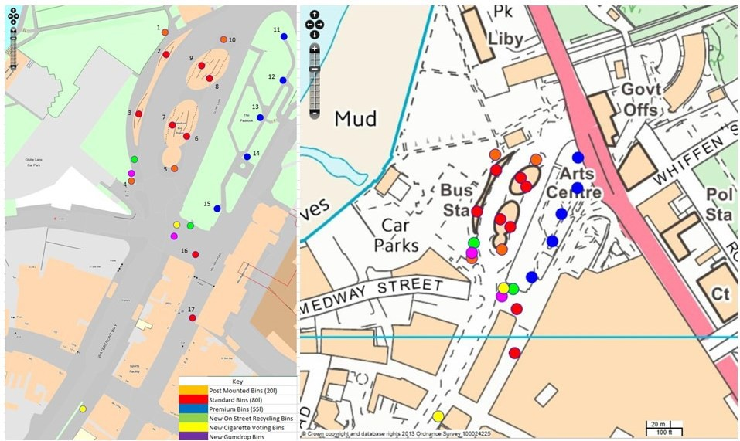

Below is a brief summary of the resources used during the LitterBUSters project:

Infrastructure

- Cigarette voting bins (2)
- Gumdrop bins (2)
- On street recycling bins (2)
- Weed removal (1)
- Street wash deep cleanse (2)
Communications

- Social media – departmental and corporate Twitter accounts
- Town centre big screen adverts
- Council printed media – Medway Matters magazine
- Bin stickers
- Bus station posters and totem displays
- Stencils and chalk for increased bin visibility
Public Surveys

- Tablet computer preloaded with questionnaire
- SNAP software for results analysis
Below is a brief summary of the roles and responsibilities of officers involved in the delivery of the LitterBUSters project:

Medway Council Waste Services

Recycling Officer - Project implementation, contractor liaison, procurement, monitoring and evaluation Community Recycling Officer & Apprentice - Site monitoring and delivery of events
Handyperson - Installation of post mounted cigarette and gum bins

Medway Council Public Health Directorate

Smoking Cessation Officer - Event staffing, provision of cigarette pouches and anti-smoking promotional items

Medway Council Communications

Account Manager - Design and production of digital and printed communications material, support of events

Medway Council Integrated Transport

Bus Station Manager - Contractor liaison and event support

External Contractors (street cleansing, greenspaces & bus operator)

Operational Managers - Provision of additional services as required

Project evaluation will use monitoring data pre and post intervention including litter prevalence and public perception.

Table 3: Summary of how the planned interventions will support the project goals
Intervention | A. Improvement in cleanliness  public perception | B. Improvement in litter containment  usage | C. Reduction in observed littering – public perception | D. Reduction in observed littering – cleansing standards
New bin infrastructure | ✓ | ✓ | ✓ | ✓
Signage at bus station | ✓ | ✓ | ✓ | ✓
Social/printed media coverage | ✓
Bin stickers |  | ✓
Smoking cessation advice |  |  | ✓
Additional weed removal | ✓ |  | ✓
Additional street washing | ✓ |  | ✓
Operative working time amendments to increase visibility | ✓ |  | ✓ | ✓
2 x celebration events | ✓ | ✓ | ✓ | ✓

What was innovative about this project?
Describe how your project differs from existing approaches, or extends/develops previous research.
Medway Council recognises the pressure on public services to deliver more impact for less money. The Council Plan embraces our ambition to achieve targets using new ways of working. We have set up Medway Norse and Medway Commercial Group as local authority trading companies. Our Transformation Division is progressing a digital by default agenda for Council services where appropriate. We are also exploring social impact bonds to achieve greater impact and influence contractor’s behaviour in areas such as substance abuse and children’s services. We embrace innovation and are excited to progress LitterBUSters.
The LitterBUSters project is innovative because it harnesses the latest research in behavioural science and nudge theory alongside the governments Litter Strategy to produce a cohesive project with tangible outputs. LitterBUSters will allow critical analysis of bin provision and visibility with awareness raising communication activities.

Focusing on Chatham Waterfront Bus Station gives the project a captive audience in a high-profile location with a broad demographic of Medway residents. This will ensure that the Litter Fund’s grant funding is spent on a specific project rather than a scatter gun approach. The bus station is a meeting place as well as transport hub therefore visitors may spend a few minutes here before their next task. We plan on using those few moments to raise awareness of the litter issue with our innovative communications.

Finally, this project is ground-breaking because it draws together partners with a common interest in creating a culture where it is completely unacceptable to drop litter, the link to the Councils Smoking Cessation Unit gives the opportunity to improve public health and wellbeing as well as eliminate smoking litter at source.

Our team has drawn upon a wide range of literature to inform a fresh approach to tackling this issue. Influences include "Using Behavioural Insights to Reduce Littering in the UK" by Kolodko et al, "Littering in Context: Personal and Environmental Predictors of Littering Behaviour" by Shultz et al, Action on Smoking in Health 2016 Litter Briefing, and Keep Britain Tidy Local Environmental Quality Survey of England. As well as. Tobacco Product Waste Reduction Toolkit.
California Department of Public Health, California Tobacco Control Program. Sacramento, 2013

In Medway, approximately 40,232 people smoke, and this represents 19% of the adult population resulting in approximately 33 tonnes of waste annually. Of this, more than 8 tonnes of cigarette waste is discarded as street litter that must be collected by Medway Council’s street cleaning services. Although the number of smokers is falling, cigarette waste remains the principal type of litter discarded on England’s streets. A survey conducted in 2014/15 reported that cigarette litter was the primary type of street litter on 73% of the sites surveyed. This is particularly significant given that only 15.5% of the adult population of England still smokes. Cigarettes contain more than 7,000 chemicals, including arsenic and formaldehyde. Cigarette butts also contain cellulose acetate which means they don’t break down easily or quickly. Instead, they gradually decompose depending on environmental conditions like the rain and sun. Estimates on the time it takes vary, but a recent study found that a cigarette butt was only about 38 percent decomposed after two years.

What did you do?
- How did you implement your project in reality? Please describe what happened during your project.
- Did anything change from your original plan, and if so, why? Did you encounter any problems or unexpected issues that might have affected your results?

- How did people react during the project?

To enable others to replicate your project, please include images of any key signage, posters, graphics etc. that you used, as well as photographs, maps or other essential information to show how interventions were deployed. Documents can be provided as appendices if appropriate. The information you provide should not be subject to copyright and should be able to be shared freely

Table 4: Project plan for the implementation of the LitterBUSters project
ACTIVITY DESCRIPTION | TARGET DATE | COMPLETED DATE | COMPLETED BY WHO?
Project Steering Group | All April 2018 | On time | Medway Council organising (all partners participating)
- Establish steering group + book programme of monthly meetings
- Hold first meeting
Benchmarking and cleaning | May & June 2018 | On Time | Medway Council co-ordinating Veolia and Medway  Norse
Identify Cleansing Gaps
2.1 Litter bin accessibility - further than 10 steps to bin? | May-18 | May-18
2.2 Assess current standard of Bus Station cleanse (develop audit criteria) | May-18 | May-18
2.3 Assess litter bin cleanliness | May-18 | May-18
Share findings
2.4 Address cleansing gaps with client and contractors (such as weeds and detritus build up) | Jun-18 | Jun-18
Take action
2.5 Review manual street cleansing schedules (Veolia and Medway Norse) | Jun-18 | Jun-18
Monitoring and Evaluation | All April 2018 | Ongoing until Nov-18 | Medway Council
3.1 Agree litter and bin assessment method (weighing regime + 10 monitoring points)
3.2 Establishing monitoring regime for litter bin fullness + litter survey
3.3 Survey litter present

3.3 Assess bin fill
3.4 Conduct face-to-face survey to assess perception baseline (50 minimum)
Communications | May & July 2018 | On Time | Medway Council (communications team)
4.1 prepare communications delivery plan | May-18 | May-18
4.2 review corporate social media channels and consider if LitterBUSter's Facebook or twitter account would have sufficient
campaign reach (vs use of hashtags)
4.3 engage designer to produce materials (infographics, video,  posters etc.) | Jul-18 | Jul-18
Steering group meeting | May-18, Jul-18, Aug-18, Oct-  18 | On Time | Medway Council organising (all partners participating)
Event | May-18 | On Time | Waste Services and Public Health
5.1 Run event to raise awareness of Smoke Free Medway providing cessation advice on the bus station platforms Event will launch the
public facing element of LitterBUSters project
5.2 document event participants sharing their views on litter for
campaign video
5.3 engage 100 visitors/attendees
5.4 post event review, report and evaluation to determine lasting impact
Monitoring and Evaluation | May-18 | On Time | Medway Council
6 Face-to-face survey to compare results and evaluate sustained project legacy (50 surveys)
Improve ‘binfrastructure’ nudging litter bin use | Aug-18 | On Time | Medway Council
6.1 Install + empty 2 "on the go" recycling litter bins |  |  | co-ordinating Veolia and Medway Norse
6.2 Do findings of benchmarking litter bin accessibility require bin movement?
6.3 Cleanse existing litter bins (Waste Services Graffiti Team)
Communications | Aug-18 | On Time | Medway Council (communications team)
7.1 produce materials (infographics, video, posters etc.)
7.2 start awareness raising campaign

7.3 produce materials (infographics, video, posters etc.)
7.4 start LitterBUSter awareness raising campaign
7.5 release LitterBUSters video from the Great British Spring Clean on Big Screen and social media
Monitoring and Evaluation | Aug-18 | Ongoing until Nov-18 | Medway Council
8.1 Survey litter present
8.2 Survey Bin fill
Communications | Jun-18 | On Time | Medway Council communications team & waste contractors
9.1 Continue social Media LitterBUSter awareness raising campaign which includes infographics, twitter and Facebook messages
9.2 Printed media including Bus stand banners and posters, Bus back signage
9.3 Produce and use chalk pavement stencil to flag when cigarette
butt waste has been removed (in conjunction with Veolia and Medway Norse)
Event | Nov-18 | On Time | Waste Services
10.1 Run celebration event to raise awareness LitterBUSters
10.2 Event will launch the public facing element of LitterBUSter
project
10.3 Film event participants sharing their views on litter for
campaign video
10.4 engage 100 visitors/attendees
10.5 post event review, report and evaluation to determine lasting impact
Monitoring and Evaluation | Nov-18 | On Time | Medway Council
11 Face-to-face survey to compare results and evaluate sustained project legacy (50 surveys)
Monitoring and Evaluation | Nov-18 | On Time | Medway Council
12.1 analyse results of monitoring and evaluation activities against LitterBUSter project activities

12.2 produce report summarising LitterBUSter activities, monitoring results and recommendations for scaling up or replicating project. What behaviour change has been observed.

The interventions were:

Install cigarette waste and chewing gum disposal: 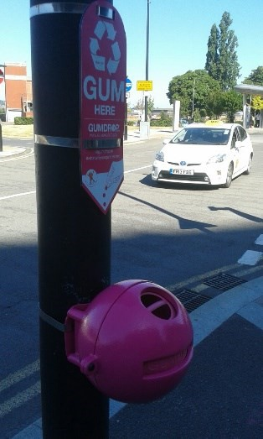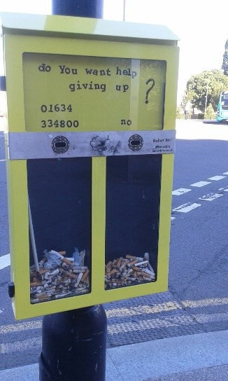

  - Complete weed removal by additional one-off treatment
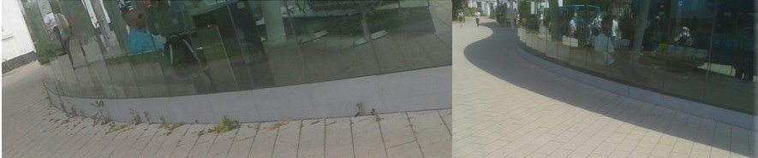
  - Install additional litter / recycling bins 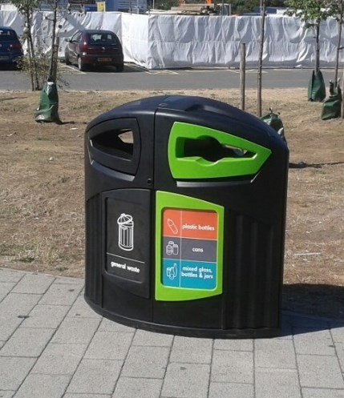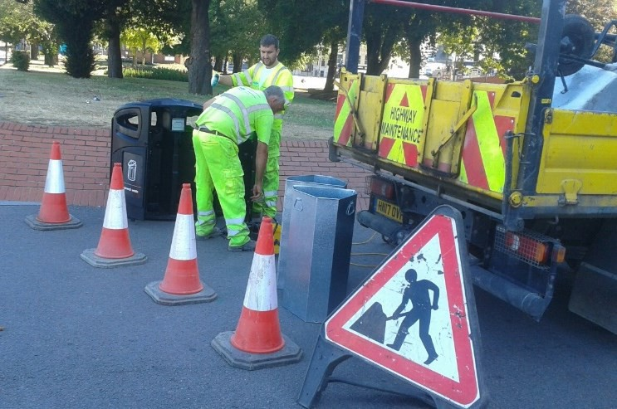

  - Install signage bin stickers and wider advertising including use of social media
  - Nudge theory (steps to bins) at varying locations around the bus station
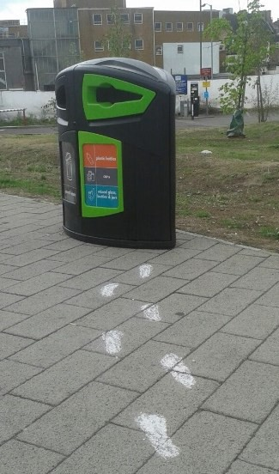
  - Two proactive street washing deep cleanses
  - Cleansing contractor asked to vary times of various works during the working day
  - Host two on site events pre and post intervention

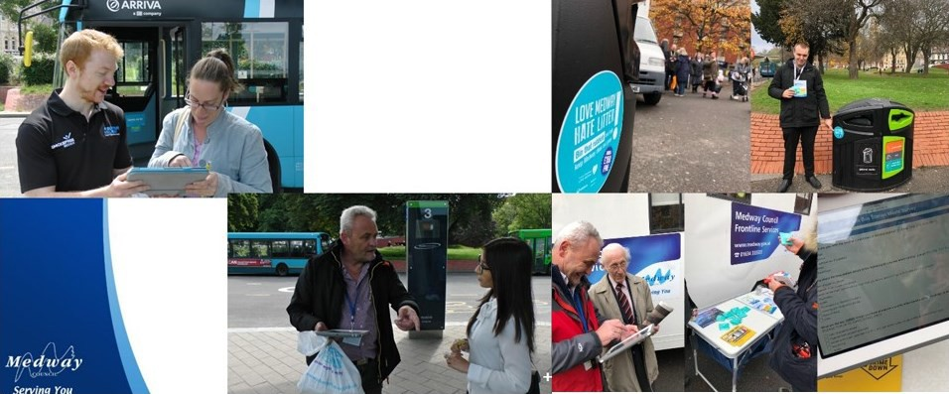

Milestone 1: Survey current bin provision and opportunities to improve cleaning

We completed an initial binfrastructure survey in the project area detailing:

  - the location, types and volumes of bins
  - pedestrian flow
We identified a cleansing gap within the project area following consultation with the three contractors in the project area. The main cleansing contractor was responsible for the roadway / pavement areas having left the bus terminal. The adjoining grassed areas were cleaned by grounds maintenance contractor. To address the gap contractors suggested a more visible approach to bin emptying through adjusting cleansing times during peak use and to maximise

interactions with bus station users. This came at no additional contract cost. The LIF paid for a one off weed clearance in the bus station in May and two proactive deep cleanses in September.

Milestone 2: Improve ‘binfrastructure’

As two different contractors operate in the area, the initial binfrastructure survey was the first holistic review of provision across the bus station. This highlighted gaps which informed the locations for the new street recycling bins (2), gum bins (2) and cigarette voting bins (2).
The improved bin provision was publicised on the council @MedwayRecycles twitter account with regular follow-up posts when cigarette voting bin question was changed. Initially the ballot bin was used to promote smoking cessation, subsequent question topics included predictions of England’s progress in the football World Cup, international rugby fixtures and Saturday evening TV preferences to maximise the general appeal and use of the bins.

Milestone 3: Communication campaign to raise awareness (digital and printed media)

The Waste Services department Communication Account Manager produced a comprehensive communications plan based on the LitterBUSters brief. Bright and eye-catching marketing materials used the theme “Love Medway, Hate Litter”. The new suite of printed graphics (posters and stickers) were displayed on totems, booking hall windows, advertising boards and lampposts within the bus station as well as an advert on rotation the nearby Council owned digital public information screen. The social media campaign focused on improvements at the bus station with Facebook and Twitter posts proving popular.
Additional examples in situ at the Bus Station can be found in Annex 5.

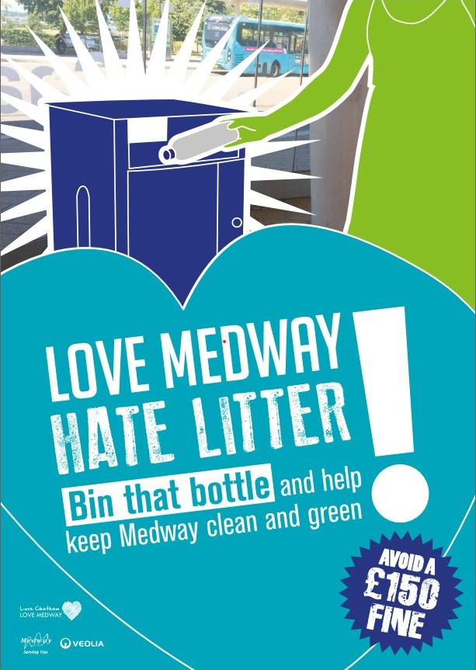

Bin stickers were created and applied to all existing bins and newly installed containers in the project area.
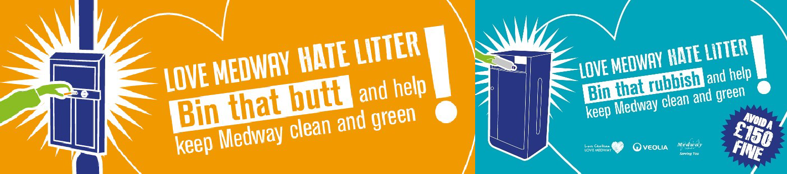

Graphics were distributed across all Medway Council social media Council accounts and on the monthly Waste Services monthly e-newsletter: 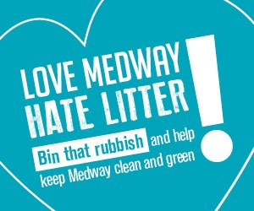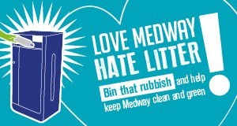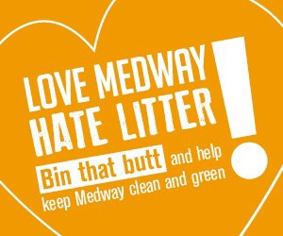
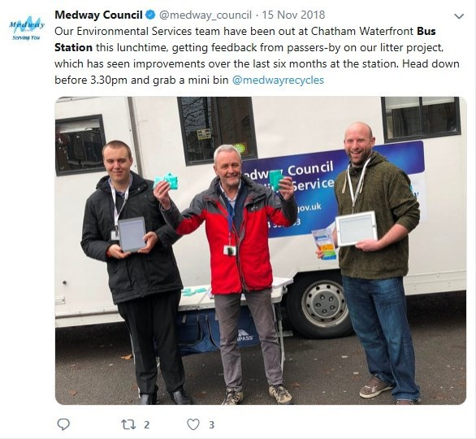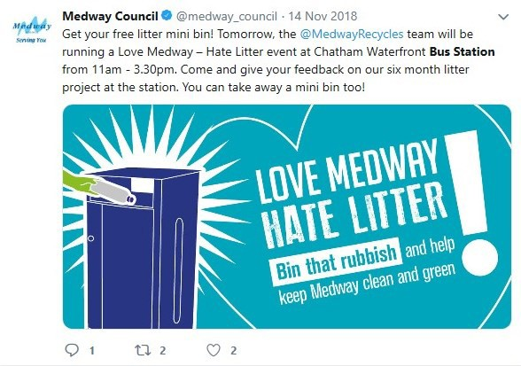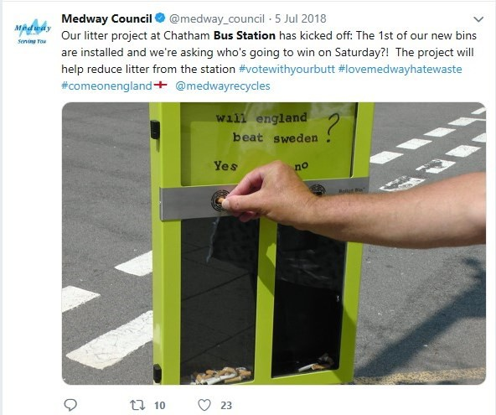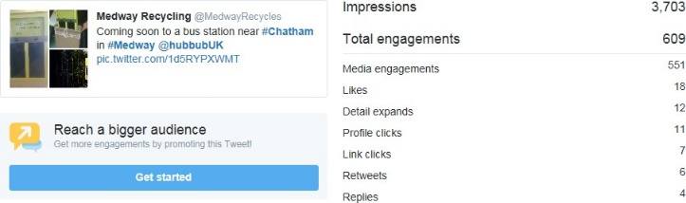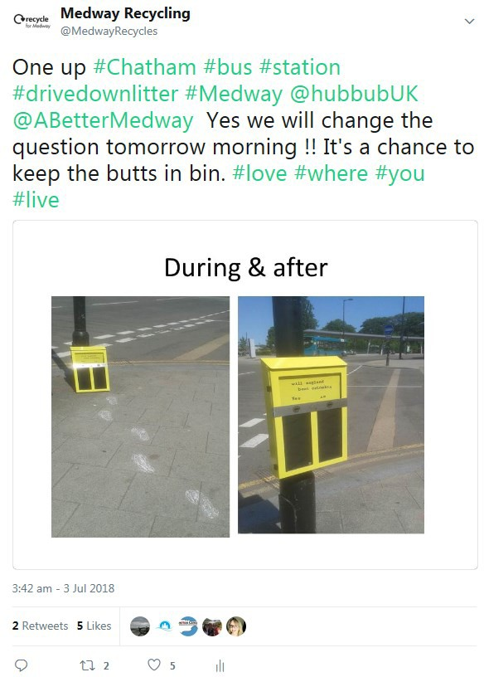
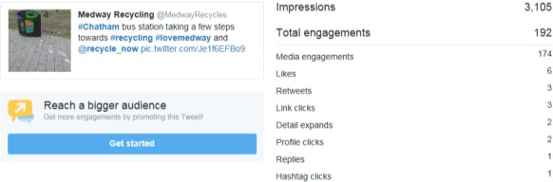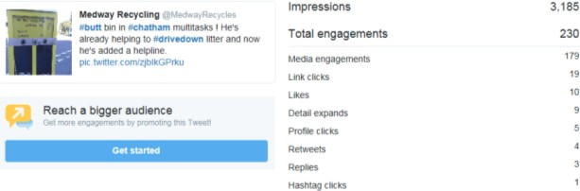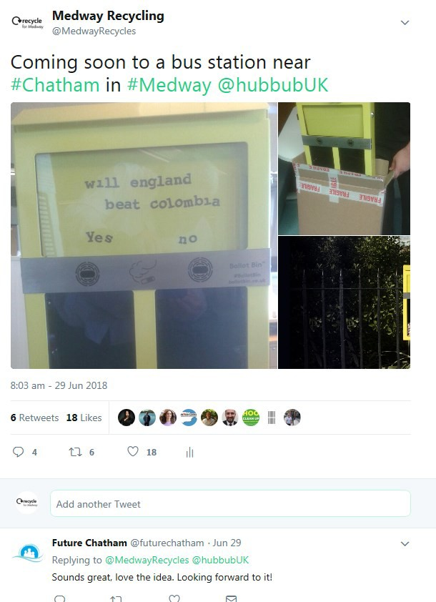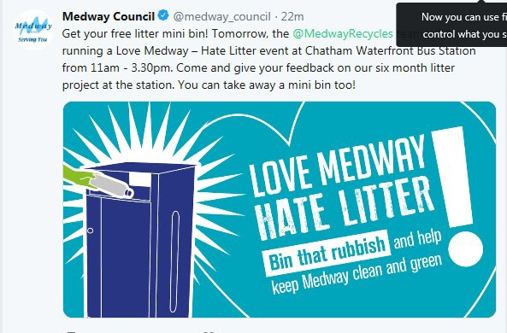

Two articles were published in the Medway Council quarterly magazine delivered to every home in the authority in the summer (August) and autumn (November) editions.
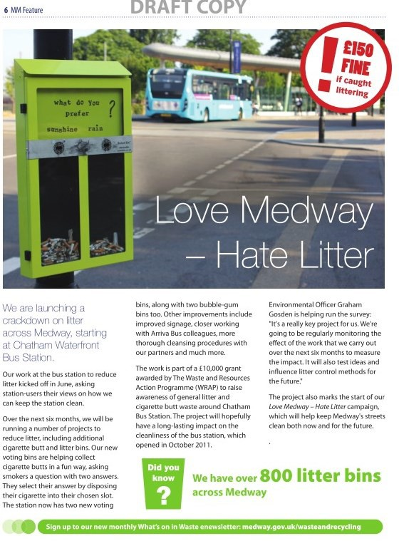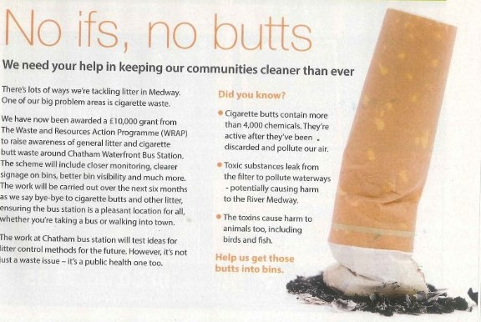

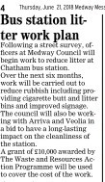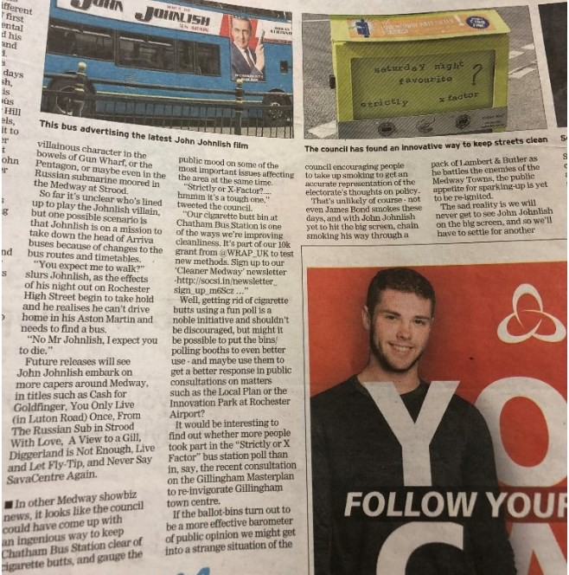The project was subject to three local newspaper articles in May, June and October 2018
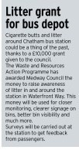

Milestone 4: Celebrate “cleanness” with a public facing event, embracing smoking cessation

The initial event was held on 22nd May 2018 and was staffed by both Waste Service and Public Health officers raising awareness of the proposed infrastructure improvements, collecting survey responses and signposting smoking cessation resources. This involved the distribution of free gifts such as portable ashtrays alongside practical advice.

Survey questions were devised with the assistance of the Medway Council Business Intelligence team and responses were captured using tablets and SNAP software. The survey was repeated at the closing celebration event on 15th November 2018 which was staffed by Waste Services staff.

How did you monitor your intervention?
Indicators:

- What indicators did you set out to monitor, in order to help understand if your project achieved its intended outcomes and aims?
- Were you able to establish a baseline, i.e. by collecting information on the original state of your indicators, before your intervention began? What were your intended indicators of success?
The below table sets out the indicators measured during the LitterBUSters project. Each goal was set a target to evaluate if the project had achieved its aim of reducing litter at the Chatham Waterfront Bus Station and surrounding footpaths.

Table 5: Summary of indicators, measurements and targets for each project goal
Project Goal | Indicators | Measured by | Target
Improvement in cleanliness public perception | Public satisfaction for cleanliness | Questionnaire | 10%
Improvement in litter containment usage | Bin fill | Continual usage monitoring | 20%
Reduction in observed littering – public perception | Public observed littering events in area | Questionnaire | 50%
Reduction in observed littering – cleansing standards | Litter prevalence | Continual site monitoring | 50%

To assess whether targets had been met Medway Council established a base line of public perceptions and observations was established through analysing the responses of an initial public questionnaire at the outset of the project in on 22/05/2018 and repeated at the end of project event on 15/11/2018.

Monitoring of bin fill levels and the observed prevalence of litter in the area was undertaken from 03/04/2018 until 28/11/2018. A total of 60 visits were made throughout the project duration with 35 visits before the installation of new bins and the communications campaign at the end of July forming the baseline for comparison at project completion.

Other qualitative indicators of success comprised of:

- Social media feedback
- Press coverage
- Public feedback
- Member/MP feedback

METHODS: Data sources and collection
- How did you source or collect the data/information to measure the indicators above?
- For each data source, set out at what points during the project you collected data (and why), and at what locations. Include information on the data you collected before your project began.

How did you make sure data collection was consistent?

Medway Council collected through a combination of 60 regular site visits between 03/04/2018 and 28/11/2018 and the results of two public questionnaires conducted on 22/05/2018 and at the end of project celebration event on 15/11/2018.

Site visits involved the completion of a visual estimation of the percentage fill all litter bins available for use at the time of the visit based on the methodology developed by Keep Britain Tidy and used in the collection of data for the Local Environmental Quality Survey of England.

The prevalence of litter was assessed at 10 randomly selected sites measuring 1m squared and established using a quadrant. The area within the quadrant was then assessed in line with the methodology developed by Keep Britain Tidy for the measurement of NI195 as listed below in line with the Code of Practice for Litter and Refuse:

  - Grade A no litter or refuse
  - Grade B predominantly free of litter and refuse except for some small items
  - Grade C widespread distribution of litter and refuse, with minor accumulations
  - Grade D heavily littered, with significant accumulations

In order to ensure consistency a uniform site inspection sheet was used and inspections carried out by two different members of the Waste Services team when available to reduce confirmation bias.

The number of quadrants falling below a grade C and the fill of each available litter bin was recorded in an excel spreadsheet provided separately to this report in Appendix 1.

An unintended consequence of the delay to the start of the project was that inspections were to run during the local school summer holidays. It was observed in August that usage of the area was considerably less than usual with the risk of skewing the final results. It was decided that inspections were to be resumed in September 2018.

A public perception survey was developed with assistance from the Medway Council Business Intelligence team an contributions from the Public Health team to designed to ascertain views on prevailing litter standards, perception of the area, the type of litter noticed during a visit, suggested cleansing priorities and respondents knowledge on specific tobacco / cigarette related issues and awareness of the smoking cessation services available through Medway Council.

An initial survey was conducted in May before any interventions commenced to establish a baseline and repeated at the end of the project in November. Individuals using or passing through the bus station were requested to complete the survey. Staff targeted every second person that walked by to limit gender and age bias. Responses were input on tablets running standard SNAP software enabling pdf summaries to be produced. Questions, response options and Individual survey results and combined comparisons can be found in Appendices 2, 3 and 4.

OUTCOME: Results and Data Analysis

Please record all the information derived from the project, using appendices if appropriate. As set out in the Monitoring and Evaluation Guidance, please include any assumptions made or qualifications needed.

Below are summary tables of the comparisons of responses in the two public surveys. Full data sets can be found in Appendices 2, 3 and 4.

Table 6: Street Cleansing Questions Comparison of May and November survey responses
Question Topic | Question Text | Response | MAY | NOV
Q1 Standards | How satisfied are you with the level of cleanliness of the bus station? | very satisfied | 3 | 13
 |  | fairly satisfied | 28 | 40
 |  | neither | 13 | 16
 |  | dissatisfied | 22 | 6
 |  | very dissatisfied | 11 | 6
Q2 Issues observed | Thinking about the bus station, which of the following do you see when visiting/using? | cigarette butts | 60 | 44
 |  | litter | 55 | 31
 |  | chewing gum | 22 | 25
 |  | debris | 8 | 20
 |  | dog fouling | 2 | 5
 |  | fly posting | 2 | 7
 |  | graffiti | 0 | 5
Q3 Priority issues | What are the three things you think should be a priority when looking at the cleanliness of the bus station? | cigarette butts | 60 | 43
 |  | litter | 53 | 37
 |  | chewing gum | 19 | 16
 |  | debris | 3 | 7
 |  | dog fouling | 1 | 2
 |  | fly posting | 0 | 0
 |  | graffiti | 1 | 2
Q4 Operative visibility | Do you ever see anyone cleaning the bus station? | YES | 43 | 60
 |  | NO | 34 | 22
Q7 Cigarette waste disposal | How do you get rid of your cigarette butts whilst at the bus station? | Stub in bin | 15 | 16

 |  | Pouch ashtray | 0 | 3
 |  | Drop on floor | 3 | 2
 |  | Drop in drain | 0 | 0
Q10 Do you chew gum | Do you chew gum? | YES | 24 | 19
 |  | NO | 53 | 63
Q11 Gum disposal | How do you get rid of your chewing gum whilst at the bus station? | Put in bin | 18 | 17
 |  | Drop on floor | 2 | 2
 |  | Pouch or wrapper | 1 | 2

Table 7: Public Heath – Smoking cessation Comparison of May and November survey responses
Question Topic | Question Text | Response | MAY | NOV
Q5 Chemicals in cigarette butts | How many poisonous chemicals are in cigarette butts? | Under 100 | 10 | 2
 |  | 101 to 1000 | 36 | 9
 |  | 1001 to 4000 | 27 | 40
 |  | Over 4000 | 10 | 30
Q6 Do you smoke | Are you a smoker? | YES | 21 | 18
 |  | NO | 57 | 64
Q8 Awareness of stop smoking services | Are you aware of the stop smoking services provided by A Better Medway? | YES | 16 | 15
 |  | NO | 5 | 3

Site inspection summary data

Full datasets and analysis can be found in Appendix 1.

Table 8: Average Bin Fill Observations
Bin Number | Description | APR | MAY | JUN | JUL | AUG | SEP | OCT | NOV | PRE | POST
1 | Post | 14% | 11% | 16% | 15% | 10% | 23% | 31% | 23% | 14% | 22%
2 | Standard Metal | 21% | 34% | 28% | 19% | 20% | 27% | 31% | 22% | 26% | 25%
3 | Standard Metal | 23% | 28% | 28% | 16% | 25% | 33% | 33% | 27% | 24% | 29%
4 | Post | 11% | 23% | 18% | 12% | 5% | 33% | 30% | 13% | 16% | 20%
5 | Post | 11% | 7% | 19% | 21% | 10% | 24% | 28% | 25% | 15% | 22%
6 | Standard Metal | 20% | 24% | 27% | 23% | 15% | 33% | 31% | 28% | 23% | 27%
7 | Standard Metal | 23% | 20% | 33% | 25% | 18% | 31% | 36% | 27% | 25% | 28%
8 | Standard Metal | 23% | 17% | 22% | 30% | 10% | 30% | 37% | 33% | 23% | 28%
9 | Standard Metal | 16% | 14% | 23% | 27% | 18% | 31% | 40% | 30% | 20% | 30%
10 | Post | 8% | 20% | 3% | 12% | 8% | 23% | 28% | 15% | 11% | 18%
11 | Premium | 4% | 3% | 6% | 6% | 3% | 3% | 10% | 3% | 5% | 5%
12 | Premium | 11% | 23% | 11% | 7% | 5% | 11% | 15% | 10% | 13% | 10%
13 | Premium | 7% | 26% | 16% | 6% | 10% | 23% | 11% | 17% | 13% | 15%
14 | Premium | 13% | 23% | 17% | 9% | 13% | 23% | 16% | 22% | 15% | 18%
15 | Premium | 13% | 30% | 7% | 11% | 8% | 30% | 31% | 30% | 15% | 25%
16 | Chatham | 23% | 21% | 38% | 20% | 20% | 42% | 53% | 34% | 26% | 37%
17 | Chatham | 33% | 20% | 33% | 31% | 25% | 44% | 44% | 30% | 29% | 36%
18 | New |  |  |  |  | 30% | 40% | 42% | 30% | N/A | 35%
19 | New |  |  |  |  | 33% | 39% | 39% | 35% | N/A | 36%
Average Total |  |  |  |  |  |  |  |  |  | 0.2 | 25%

Table 9 Littered Locations:
 | APR | MAY | JUN | JUL | AUG | SEP | OCT | NOV | Total | Total Pre | % Pre | Total Post | % Post

Littered  locations | 35 | 27 | 39 | 54 | 16 | 13 | 7 | 9 | 200 | 155 |  | 45
Total  Observations | 90 | 70 | 90 | 100 | 40 | 70 | 90 | 60 | 610 | 350 | 44.29% | 260 | 17.31%

Impacts and Evaluation - What did you learn?
- What were the outcomes against your indicators, and were they as expected? Please provide details of immediate, intermediate and long-term impacts. Can you demonstrate that the outcomes would have been different if intervention had not taken place? Did any negative consequences arise? Which interventions, or aspects of your intervention, were particularly effective, and why?
- If outcomes/impacts were not as expected, it’s useful to know why. Did you identify what factor(s) contributed to the project not working as intended?

A summary of the results against our expected targets is outlined in the table below. Full public survey results can be found in Appendices 2, 3 and 4.

Table 10: Summary of Project Goals and Achievements
Project Goal | Indicators | Measured by | Target | Result
Improvement in cleanliness public perception | Public satisfaction for cleanliness | Questionnaire | 10% | 71%
Improvement in litter containment usage | Bin fill | Continual usage monitoring | 20% | 36%
Reduction in observed littering – public perception | Public observed littering events in area | Questionnaire | 50% | 44%
Reduction in observed littering – cleansing standards | Litter prevalence | Continual site monitoring | 50% | 61%

Goal: Improvement in cleanliness public perception – target 10% improvement – Result 71%

The below extract from the comparison of the public survey data shows an increase of 71% in respondents identifying themselves as satisfied with the level of cleanliness of the bus station. 31 respondents were either ‘very’ or ‘fairly satisfied’ compared in May compared to 53 in November, a difference of 22. Results revealed a threefold increase in respondents identifying themselves as ‘very satisfied’. This has far exceeded our initial target of 10% suggesting that a more ambitious initial target could have been set.

Table 11: Q1 Standards response analysis
Question Text | Response | MAY | NOV | Difference | Change
How satisfied are you with the level of cleanliness of the bus station? | very satisfied | 3 | 13 | 10 | 333%
 | fairly satisfied | 28 | 40 | 12 | 43%
 | Total satisfied | 31 | 53 | 22 | 71%
 | neither | 13 | 16 | 3 | 23%

Evaluation

Question 4 of the public survey also confirmed that there was an increase of 40% in those noticing street cleansing operatives working in the area in November. Publicly observed littering as measured in Question 2 recorded a 44% reduction whilst Medway Council monitoring recorded a 61% reduction in littered areas observed and a 36% increase in litter bin usage. Combined these results suggest that there has been a noticeable decrease in litter in the area which may have contributed to the increased satisfaction levels reported in the survey. Other contributing factors may have been the success of our communications campaign reflected in the feedback received via social media which may have raised public awareness that we were tackling litter in the area and the change of working times for the cleansing contractor to ensure operatives were seen at peak times of usage.

Table 12: Q4 Operative Visibility response analysis
Question Text | Response | MAY | NOV | Difference | Change
Do you ever see anyone cleaning the bus station? | YES | 43 | 60 | 17 | 40%
 | NO | 34 | 22 | -12 | -35%
Goal: Improvement in litter containment usage, target 20%, result 36%

A summary analysis of the monthly average level of bin fill throughout the project shows that in months before the installation of new infrastructure and interventions (April – July) average bin fill was 18% across the study area. This increased to an average bin fill of 25% in the months after the installation and interventions (August -November). This is a percentage increase of 36% compared to pre-intervention levels and exceeds our initial target of 20%.

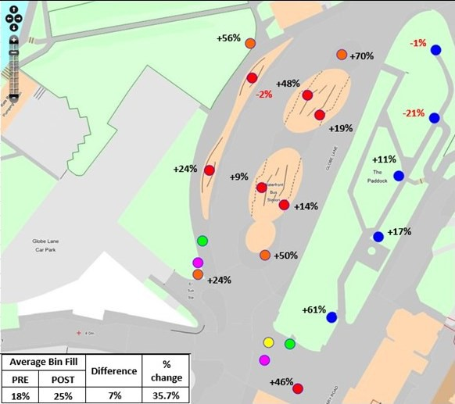

Evaluation

Only 3 of the original 17 bins on site experienced a reduction in average usage after the improvements in infrastructure and the communications campaign. Bins 2 and 11 experienced reductions of less than 3%, however bin 12 had a reduction of over 20% in use. Bins 11 and 12 are situated in amenity space between the bus station and the High Street which has significantly less footfall than other routes as there is no direct access to the shopping area. Bins 13 to 15 on the more direct route though the amenity space all experienced increased between 10 and 60% in use although overall these were less well used that those bins in the bus station itself and the two bins closer to the High Street (bins 16 and 17).

Due to their design the gum and cigarette bin fill was not recorded but the fill level of the new on street recycling bins (bins 18 and 19) once installed matched the two bins most used closest to the High Street at an approximate average fill of 36%. In the absence of litter weight statistics, this suggests that the new infrastructure was well used although additional monitoring with the bins installed in different locations would be needed to see if improvements would be observed regardless of location.

There were increases in all except one of the bins (bin 2 referred to earlier) in the bus station itself, post bin usage increased by almost 50% on average (bins 1,4,5 &10) as opposed to the ground mounted bins (2,3 & 6-9) where usage increased on average by 19%. This may be due to bin cleanliness issues or through increased visibility at eye level but this cannot be substantiated without additional research.

Observations were suspended over August due to low usage of the area during the school summer holidays. It is possible that results would be unduly more pronounced if monitoring continued as reductions would be affected more by the reduced usage of the area rather than as a result of the interventions.

Goal: Reduction in observed littering – public perception, target 50% reduction – result 44%

The below extract from the comparison of the public survey data shows a reduction of 44% in respondents reporting that they have seen litter in the bus station. Although this is a positive result, our target of a 50% reduction was not achieved.

Table 13: Q2 Issues Observed response analysis
Question Text | Response | MAY | NOV | Difference | Change
Thinking about the bus station, which of the following do you see when visiting/using? | cigarette butts | 60 | 44 | -16 | -27%
 | litter | 55 | 31 | -24 | -44%
 | chewing gum | 22 | 25 | 3 | 14%
 | Total litter | 137 | 100 | -37 | -27%
 | debris | 8 | 20 | 12 | 150%
 | dog fouling | 2 | 5 | 3 | 150%
 | fly posting | 2 | 7 | 5 | 250%
 | graffiti | 0 | 5 | 5 | N/A
 | dog fouling | 1 | 4 | 3 | 300%
 | Flyposting | 1 | 6 | 5 | 500%

Analysis shows that when questioned directly about littering 44% fewer people responded that they had seen litter in the bus station. When considering the components of litter, we asked about there was a smaller reduction of 27% in those observing cigarette butts and an increase of 14% of those reporting observing chewing gum. When the three components are combined the reduction in those observing litter, cigarette buts or chewing gum is only 27%.

This suggests that there may be a disconnect in public awareness that although chewing gum and cigarette butts are a component of litter they are viewed as a separate issue to larger, more visible items such as drinks bottles and fast food containers. The results for Question 3 with regard to the suggested priorities for the Council, there were reductions in the number of respondents citing that these be focussed on in order to improve the cleanliness of the area. The 40% improvement in visibility of cleansing operatives shown in Question 4 may also have impacted the reduction in priority for litter as there could have been the impression that this is already being addressed.

Table 14: Q3 Priority Issues response analysis
Question Text | Response | MAY | NOV | Difference | Change
What are the three things you think should be a priority when looking at the cleanliness of the bus station? | cigarette butts | 60 | 43 | -17 | -28%
 | litter | 53 | 37 | -16 | -30%
 | chewing gum | 19 | 16 | -3 | -16%
 | debris | 3 | 7 | 4 | 133%
 | dog fouling | 1 | 2 | 1 | 100%
Combined with the increased in reported flyposting, dog fouling and detritus this suggests that these could be subjects of further additional interventions.

Further investigation with an increased breakdown of litter components would be required to establish if these are valid conclusions or if the results are the construction of the design of responses to the questionnaire.

Goal: Reduction in observed littering – cleansing standards, target 50%, result 61%

The below summary of the numbers of quadrants in which litter was observed shows that there was a 61% reduction in observed littering in the months after the installation of the new bins. This is in excess of our initial target of 50%.

Table 15: Littered Location Analysis
 | Total | Total Pre | Total Post | % Pre | % Post | Difference | % change
Littered locations | 200 | 155 | 45
Total Observations | 610 | 350 | 260 | 44% | 17% | -27% | -61%
Observations were suspended over August due to low usage of the area during the school summer holidays. It is possible that results would be unduly more pronounced if monitoring continued as reductions would be affected more by the reduced usage of the area rather than as a result of the interventions.

General observations

Cigarette and gum bins

These were widely noticed by immediate passers-by and resulted in interaction and discussion at the celebration event. The cigarette voting bins were also featured in a local media article. When publicised on social media requests for installation in other areas of the borough were received.

A key result of using the voting bin was the change in perception of public health colleagues who initially feared that it may encourage smoking. Often non- smoking related litter was found in the bins suggesting that the novelty voting element was encouraging correct disposal rather than smoking.

Questions on the voting bin were changed on a weekly basis starting with publicising the smoking cessation helpline and proved particularly popular over the
summer period when resident’s predictions of the England Football team’s performance were featured in a local news piece.

Weed removal

The total removal of weeds as part of the increased cleansing regime in the bus station may have contributed to the increased perception of cleanliness in the bus station, we have no significant evidence from the responses to the questionnaire.

Signage bin stickers, advertising banners and footstep templates (nudge theory)

Noticed by passers-by and resulted in interaction at the end of project celebration event and on social media when installed. Increased volume of fill of bins after their installation suggests litter was in the bin than previously before the scheme. The communications package remains in place on the bins.

The bin footsteps had a short-term effect and very well received on social media. Also reported widely on third party social media accounts. However, these would require additional resource to maintain in situ that are not currently available.

Public Health awareness

It is not possible to draw inferences that the project helped to reduce the numbers of residents smoking although residents did respond that they were using the pouches provided in the initial event in May to dispose of their cigarettes. Only around 20 respondents identified themselves as smokers in each survey so any changes in disposal and awareness may not be statistically significant. Closer relations between the two teams have already led to collaboration on other smoking cessation campaigns on various NHS properties across Medway.

Table 16: Public Health questions response analysis
Question Topic | Question Text | Response | MAY | NOV | Difference | Change
Q5 Chemicals in cigarette butts | How many poisonous chemicals are in cigarette butts? | Under 100 | 10 | 2 | -8 | -80%
 |  | 101 to 1000 | 36 | 9 | -27 | -75%
 |  | 1001 to 4000 | 27 | 40 | 13 | 48%
 |  | Over 4000 | 10 | 30 | 20 | 200%
Q6 Do you smoke | Are you a smoker? | YES | 21 | 18 | -3 | -14%
 |  | NO | 57 | 64 | 7 | 12%
Q7 Cigarette waste disposal | How do you get rid of your cigarette butts whilst at the bus station? | Stub in bin | 15 | 16 | 1 | 7%
 |  | Pouch ashtray | 0 | 3 | 3 | N/A
 |  | Drop on floor | 3 | 2 | -1 | -33%
 |  | Drop in drain | 0 | 0 | 0 | N/A
 |  | Other | 3 | 0 | -3 | -100%
Q8 Awareness of stop smoking services | Are you aware of the stop smoking services provided by A Better Medway? | YES | 16 | 15 | -1 | -6%
 |  | NO | 5 | 3 | -2 | -40%
Q9 Would cessation advise help | Would it encourage you to stop smoking if there was support and advice available at the bus station? | YES | 6 | 3 | -3 | -50%
 |  | NO | 16 | 15 | -1 | -6%

What would you do differently?
- What, if anything, would you do differently if you ran a similar project again?
- If outcomes/impacts were not as expected, do you think the factor(s) you identified as contributing to the project not working as intended could be overcome were the project repeated, and if so, how?

What advice would you give to anyone else running this type of intervention?

Due to unforeseen delay’s in the LIF bid evaluation process the project start was delayed from January 2018 until April 2018. This also meant that we had missed the opportunity to link into the national Keep Britain Tidy Big Spring Clean as originally intended and moved the project end date back to November 2018. Linking with national campaigns would increase publicity and recognition.

Advice for anyone else running this type of intervention is to engage all stakeholders early in the planning stage and seek their input on forming the project goal. We were clear on the goal but flexible on approach responding to challenges as they arose rather than rigidly sticking to the project plan.

Feedback from the project officer managing the intervention recommended spending a whole day pre/post intervention observing behaviours to better understand the demographic of litters to allow for targeted interventions. However, this is very subjective and difficult to quantify.

What did it cost
Please provide details of your full project costs and contributions in kind (regardless of source), to enable others to understand the funding required to replicate your intervention. This could also include resource cost. Remember to include the costs of monitoring and evaluation. Be specific.

Table 17: Summary of project costs
Product/Service | Supplier | Cost
Additional kerbside weed control | Medway Norse | £180.00
2 x Cigarette voting bin (post mount) | Hubbub | £470.00
Cigarette bin install officer time (2 hours) | Medway Council | £50.00
2 x Gum disposal ball bin (post mount) | Gumdrop | £602.00
Gum bin installation officer time (2 hours) | Medway Council | £50.00
2 x On street dual recycling/litter bin | Glasdon | £1,290.08
On street recycling bin installation | Volker Highways | £391.62
Event gazebo | Argos | £92.00
May Survey staffing officer time (12 hours total) | Medway Council | £300.00
Additional highway washing | Veolia Environmental Services | £1,500.00
Communications campaign design and implementation | Medway Council | £2,700.00
Celebration event staffing officer time (12 hours total) | Medway Council | £300.00
Litter pickers | Bell Brush | £78.50
Gloves | ARCO | £25.95
Project Management Officer time (75 hours total) | Medway Council | £1,800.00
Officer time for site inspections (60 hours total) | Medway Council | £1,500.00
 | Total Spend | £11,330.15
 | LIF Grant | £10,000.00
 | Medway Contribution | £1,330.15

Next Steps

- How are you planning to build on the activity yourselves?
Based on what you have learned:

- If the project was successful, how could/should this intervention be replicated and/or scaled up by you or others?
- If the project was not successful, how might it be changed to potentially deliver better results?
- What further research or refinement is needed?
The Litter Investment Fund provided resources that enabled Medway Council to test ideas and form partnerships that wouldn’t have been possible within the current service delivery plan. We will continue to engage these stakeholders seeking their feedback on intervention style and approach. Medway Council have used the LitterBUSter intervention concept to build the 2018-19 Fly tipping campaign, monthly E-newsletter and 2019-20 street cleansing vehicle branding.

The bin stickers devised for the LitterBUSters project have been installed on all bins in the adjacent Chatham High Street following their success in the bus station.

Public Health have used the cigarette-voting bin at various locations in Medway; however, the bins have been vandalised. Future use of attention-grabbing novelty bins will be carefully considered.

The LitterBUSters project has been a success, focusing on a single location with a corresponding communications campaign underpinned by a review on cleansing practice and binfrastructure. It could be replicated by other authorities at a central transport hub or central area allowing focused monitoring pre and post intervention.

Is there any other information you wish to share?
e.g. Any media regarding the project, correspondence with those affected by intervention, or anything else of relevance.

LitterBUSters captured the attention of local media, politicians and residents through social media and the examples referred to above.

Feedback to us
Your feedback is important to us. We would be grateful for any comments on (or recommendations for future) Litter Innovation Fund management and materials:

Medway Council are extremely grateful to have received this funding, it enabled the communications and waste team to run a target campaign with proven results.

