Medway Council Questionnaire  Proposed St. Mary’s Island Parking Zone | 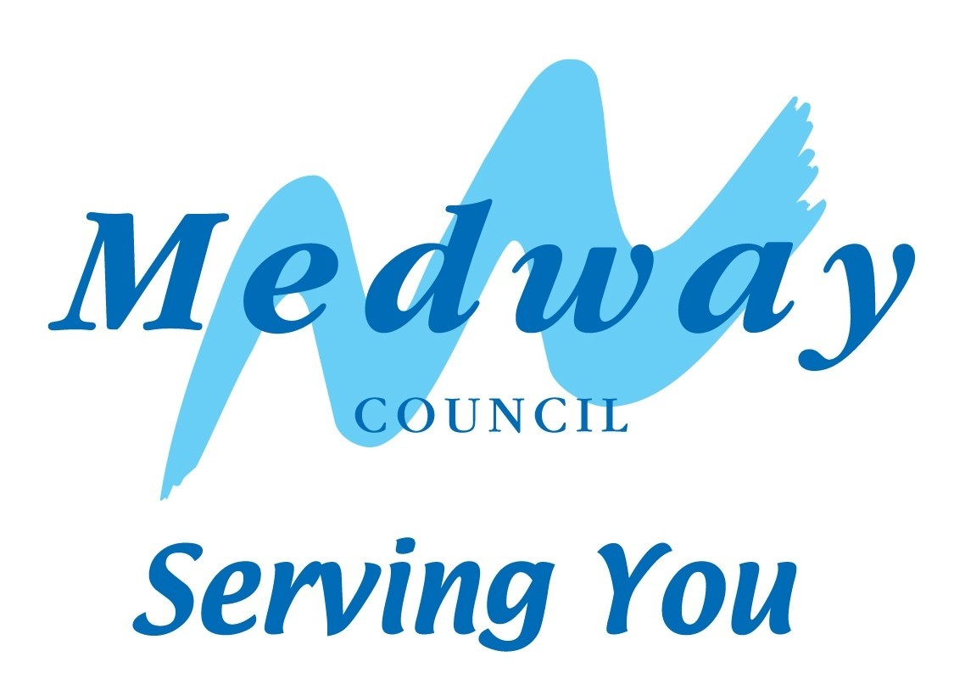
It is recommended that you read the enclosed information before completing the questions below. Please complete the questionnaire and return it to the council (no stamp required) to reach us by Monday 23 December 2019. The questionnaire can also be completed online at www.medway.gov.uk/SMIconsultation. If you need further information or wish to discuss the controlled parking zone proposals, please contact parkingdesign@medway.gov.uk.

- Would you like a controlled parking zone installed on St Mary’s Island?

Yes | ✓ | No | ✓

- At what times would you prefer a zone to operate?

1 hour in the morning (9am-10am) | ✓ | All day  (8am-6pm) | ✓  ✓ | All day and evenings (8am-10pm) |  | (Tick the one option you prefer most)

- On which days would you prefer a zone to operate?

Mon-Fri | ✓ | Mon-Sat | ✓  ✓ | Mon-Sun |  | (Tick the one option you prefer most)

- Comments
……………………………………………………………………………………………………………………

……………………………………………………………………………………………………………………

……………………………………………………………………………………………………………………

……………………………………………………………………………………………………………………

- Personal details

All fields marked with a * must be completed in order for your views to be considered.
Please complete the following section using BLACK or BLUE ink and using CAPITALS.

Name* …………………………………………………………………………………………………...

Address*…………………………………………………………………………………………………

Post code*…………………………… Telephone………………………………………………….

Email address…………………………………………………………………………..………………

Signed*…………………………………………………….. Date*……………………………….

Data Protection Act 1998: The data you have supplied will be used by Medway Council for the purposes of the proposed changes. Under the Data Protection Act you have a right of access to your personal records. Should you wish to exercise this right, please write to The Data Protection Officer, Medway Council, Gun Wharf, Dock Road, Chatham, Kent, ME4 4TR. A fee will be charged for this service.



Parking Consultation

Medway Council
Frontline Services
Regeneration, Culture, Environment and Transformation
Gun Wharf, Dock Road
CHATHAM
ME4 4TR

