# Medway Authority Monitoring Report 2018

Medway City Estate

# Volume 3 - Local Aggregate Assessment 2017 December 2018

**Executive Summary**

This is the sixth Local Aggregate Assessment (LAA) produced for Medway, in line with the requirements set out in the National Planning Policy Framework 2018 (NPPF) and in the Planning Practice Guidance (PPG). The report covers the 2017 calendar year and is circulated to Minerals Planning Authorities throughout the South East and neighbouring areas, industry representatives and other key stakeholders for comments.

The council has considered a range of data sources in compiling information on the demand for aggregates and supply options available; with the annual aggregate monitoring produced by the South East England Aggregates Working Party (SEEAWP) based on a survey of local operators being a key source of data. Due to the size of Medway and the limited number of minerals sites and wharves, there are some areas where it is not possible to publish sales data due to commercial confidentiality.

**Land‐won Aggregate**

Currently, sand and gravel is the only land‐won aggregate actively being extracted in Medway. In the past this has also included other minerals such as clay, chalk and brickearth; however recent demand for the extraction of these has been limited in Medway.

There are currently two permitted quarries for the extraction of sand and gravel in Medway, one inactive and the other commencing extraction in 2017. Whilst recording a relatively low level of sales in 2017, it is anticipated that this will increase significantly with the first full year of operation in 2018.

**Recycled and Secondary Aggregate**

Sales of recycled and secondary aggregate rose from 2016 to 2017, which is reflected in the increases in both the 3‐year and 10‐year sales averages. This is the third consecutive increase in sales since 2014.

**Marine‐won sand and gravel**

Medway’s wharves continue to demonstrate their regional importance, reporting 1.794Mt of marine‐won sand and gravel sales in 2017. Whilst this represents a 9% decrease on 2016, it is the second highest level of sales in the last 10 years. No sales of marine‐won soft sand were reported in 2017.

**Crushed Rock**

The rail depot at Grain reported a significant decrease in importation of crushed rock to Medway; however sales of crushed rock through the wharves have increased by 4% since 2016. This is supported in‐part by the opening of an additional aggregates wharf at London Thamesport in 2017.

**Demand**

The council has analysed a range of sources to project any trends that may be emerging that would influence demand. The population of Medway is projected to increase by c 13% from 2018 to 2035 and house builders are reporting increased workloads and planning permissions nationally, indicating a potential increase in demand over the coming years. A number of significantly large regional infrastructure projects (such as Crossrail 2 and HS2) are also expected to substantially increase demand.

Current permitted reserves of sand and gravel is 1.310Mt, providing a landbank of 135 years based on 3‐year average sales data. This position is further supported by Medway’s wharves and increasing rate of supply of recycled and secondary aggregate.

**Conclusion**

Medway plays a strategic role in regional aggregates supply most notably through the wharves located on the rivers Medway and Thames.

The council will plan positively for the steady and adequate supply of aggregate through the emerging Local Plan in order meet the needs of the local and regional markets.

|  |  |  |  |  |  |  |  |  |  |
| --- | --- | --- | --- | --- | --- | --- | --- | --- | --- |
|  | Sales (Mt) | 10 year average sales (Mt) | 3 year average sales (Mt) | Trend | LAA Rate (Mt) | Reserve (Mt) | Land bank (years) | Capacity (Mtpa) | Comments |
| Sharp Sand and gravel | C | 0.006 | 0.009 | Up | 0.009 | 1.195 | 135 | >0.200 | 2 quarries, one inactive. |
| Soft sand | 0 | 0 | 0 | n/a | 0 | 0 | 0 | 0 | No known reserves. |
| All sand and gravel | C | 0.006 | 0.009 | Up | 0.009 | 1.195 | 135 | >0.200 | 2 quarries, one inactive. |
| Crushed rock | 0 | 0 | 0 | n/a | 0 | 0 | 0 | 0 | No known reserves. |
| Recycled / secondary aggregates | C | 0.067 | 0.065 | Up | n/a |  |  | >0.075 | Current temporary permissions may impact upon future supply. |
| Marine sharp sand and gravel | 1.794 | 1.415 | 1.790 | Down | n/a |  |  | 4.150 | Established importation and distribution facilities with potential for growth. The capacity is combined total for all wharves across all aggregate types. |
| Marine soft sand | 0 | 0.074 | 0.100 | Down | n/a |  |  | 4.150 | Established importation and distribution facilities with potential room for growth. The capacity is combined total for all wharves across all aggregate types. |
| Rock imports by sea | 0.945 | 0.901 | 0.981 | Up | n/a |  |  | 4.150 | Established importation and distribution facilities with potential room for growth. The capacity is combined total for all wharves across all aggregate types. |
| Rail depot sales (sand and gravel) | 0 | 0 | 0 | n/a | n/a |  |  | 0.100 | Established aggregates rail depot. Sales data not published due to commercial confidentiality. |
| Rail depot sales (crushed rock) | C | 0.018 | 0.005 | down | n/a |  |  | 0.100 | Established aggregates rail depot. Sales data not published due to commercial confidentiality. |

## Aggregate Supply Summary Table Medway 2018

## Comments

The supply of aggregates in Medway is currently sufficient, with the existing importation facilities providing a high percentage of aggregates for the wider London and South East area. With extraction of sand and gravel from the quarry at Kingsnorth commencing in 2017, the supply of aggregates from Medway is expected to increase.

In common with much of the south east, there is high demand for housing in Medway. The population is projected to grow to 317,500 by 2035, with potentially over 1,310 homes needing to be built each year to meet the projected housing demand across the Local Plan period to 2035.

Other major construction projects proposed in the wider South East region include Ebbsfleet Garden City, Lower Thames Crossing, Thames Tideway tunnel, Crossrail 2, HS2 and the London Underground Northern Line extension.

c denotes where sales data is not published due to commercial confidentiality.

**1. Introduction**

1.1. This is the sixth LAA produced for Medway. It has been prepared in line with requirements set out in the NPPF (Paragraph 207) and the PPG. Paragraph 207 of the NPPF states Minerals Planning Authorities should prepare: *‘an annual Local Aggregate Assessment, either individually or jointly, to forecast future demand, based on a rolling average of 10 years’ sales data and other relevant local information, and an assessment of all supply options (including marine dredged, secondary and recycled sources)’.* The LAA then needs to be submitted to the regional Aggregate Working Party and through this to the National Aggregate Coordinating Group. The national group will then consider whether the totals provided by the area Aggregate Working Parties make appropriate provision to maintain a steady and adequate supply of aggregate. This process seeks to ensure the coordination of minerals planning at a strategic level.

1.2. LAAs play an important role in the coordination of planning for the supply of minerals to meet the country’s needs. Aggregate minerals such as soft sand, sand and gravel and crushed rock are used as construction materials, and therefore are intrinsic to the nation’s development, maintaining infrastructure and supporting economic growth.

1.3. Much of the data used in the preparation of this LAA comes from the annual monitoring of aggregates sales in Medway on behalf of the South East England Aggregate Working Party (SEEAWP). The annual Aggregate Monitoring survey collects sales data from active mineral extraction sites, minerals wharves, minerals rail depots and recycled aggregate processing sites.

1.4. Due to the size of Medway, and the limited number of minerals sites and wharves, some sources of data are restricted and cannot be disaggregated to a Medway level for reasons of commercial confidentiality and agreements made with industry operators. This is reflected in how and what data is presented in this report.

**2. Land‐won Aggregate**

**Geology of Medway**

2.1. The sand and gravel deposits in the Medway area are primarily concentrated on the Hoo Peninsula as a result of post‐glacial melt water outwash deposition found in a series of ‘river terraces’, trending roughly from north west to south east across the peninsula’s ridge, and on the Isle of Grain. There are also more recent water‐lain deposits covering areas of land on the eastern and north‐western marshes of the peninsula that include some sand and gravel seams. The deposits have not been significantly reworked by natural processes since their deposition, and have a sand to gravel ratio and particle characteristics that makes them generally attractive for high specification value added concrete production. An overview of Medway’s geology is provided in figure 1.

Figure 1: The geology of Medway

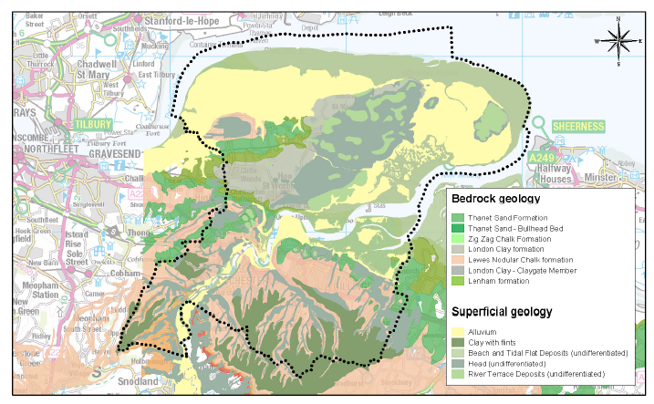

**Environmental and Landscape Designations**

2.2. Medway covers an area of 26,886ha (including rivers and coastal areas), and within this area are several landscape and environmental designations that could constrain where minerals extraction could take place. These designations include: Special Protection Areas, Ramsar sites, Special Areas of Conservation, Areas of Outstanding Natural Beauty, Green Belt, Sites of Special Scientific Interest, Marine Conservation Zones, National Nature Reserves and Local Nature Reserves. The extents of the environmental and landscape designations in Medway are provided in figure 2.

**Figure 2: Environmental and Landscape designations in Medway**

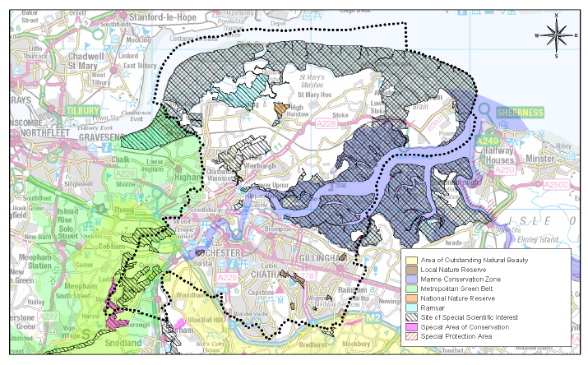

**Extraction of Minerals**

2.3. Contained within Medway’s geology there are a range of minerals that have the potential to be economically viable for extraction. These deposits include sand and gravel, chalk, London clay and brick clay. Extraction for these minerals has predominantly taking place around the rivers’ edge and across the Hoo Peninsula in the past, but there have only been limited operations in recent years for the extraction of London clay and sand and gravel.

2.4. The present total permitted reserve of sand and gravel for extraction in Medway is 1.195Mt. This is derived from Kingsnorth Quarry to the south east of the village of Hoo St Werburgh, and a small remaining reserve at Perry’s Farm in Grain, operated by Clubb, but is currently inactive. The locations of the permitted quarries are provided in figure 3 (overleaf).

2.5. Kingsnorth Quarry is operated by Tarmac and has planning permission for the extraction of 1.2Mt of sand and gravel, and includes a ready‐mix concrete plant on‐site. Extraction commenced in 2017 and cumulatively 200,000 tonnes per annum of material can be removed from the site. It is currently the only operational quarry in Medway.

2.6. Research to support mineral planning work in Kent and Medway has provided an indication of significant available reserves in the area to help meet future demand.

Figure 3: Quarries in Medway

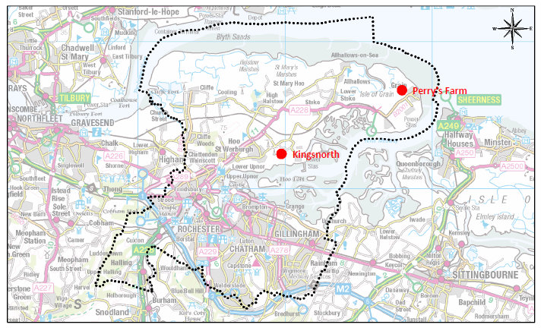

2.7. Due to the limited number of quarrying sites in Medway, it has not been previously possible to publish annual levels of sales of locally won sand and gravel. However the council has been able to use data provided to the Aggregates Monitoring survey to produce a 3‐year and 10‐year average sales figure.

2.8. The current 10‐year average sales for aggregates from quarries in Medway are 0.006Mtpa and the 3‐year average sales is 0.009Mtpa. The 3‐year and 10‐year average sales data for land‐won aggregate since 2007 is presented in table 1.

**Table 1: 3‐year and 10‐year average sales (Mt) for land‐won aggregate in Medway**

|  |  |  |
| --- | --- | --- |
| Year | 3 year average sales (Mt) | 10 year average sales (Mt) |
| 2007 | 0.033 | n/a |
| 2008 | 0.027 | n/a |
| 2009 | 0.018 | n/a |
| 2010 | 0.010 | n/a |
| 2011 | 0.003 | n/a |
| 2012 | 0 | n/a |
| 2013 | 0 | n/a |
| 2014 | 0 | 0.013 |
| 2015 | 0.003 | 0.010 |
| 2016 | 0.003 | 0.006 |
| 2017 | 0.009 | 0.006 |

2.9. Table 1 demonstrates how the average 10‐year sales have gradually decreased due to the decline in minerals extraction over the longer term; whilst the increase in the 3‐year average reflects the more recent commencement of extraction at Kingsnorth Quarry. This increase is expected to also be reflected in the 10‐year average sales over the coming years.

**Landbank**

2.10. Medway is required to maintain a 7‐year land bank for sand and gravel. Permitted reserves are considered to be 1.310Mt. The current landbank calculated using the 3‐year average sales is 135 years, and using the 10‐year average sales the landbank increases to 212 years. With the increased activity in extraction more recently, it is considered appropriate to use the 3‐year average sales to inform the LAA rate, as this better reflects the current status of land‐won aggregates in Medway.

2.11. Due to Medway’s geology, it is not necessary to maintain a landbank for land‐won rock; or a separate landbank for soft sand from that of sand and gravel.

**3. Recycled and Secondary Aggregates**

3.1. Materials defined as recycled or secondary aggregates are derived from demolition and construction waste, industrial by‐products such as power station ash, colliery spoil, and blast furnace slag and slate. These materials can be used as substitutes for aggregates, such as in concrete production, or as fill.

3.2. The use of recycled and secondary aggregates is critical to the sustainable management of primary mineral resources. In‐line with government policy to secure the valuable finite resources of materials required for development, Medway Council promotes the use of alternatives to primary aggregates.

3.3. Facilities exist within Medway for the recycling of construction, demolition and excavation (CD&E) waste at fixed sites. However there is additional capacity, as it is understood that significant amounts of material are dealt with on site by mobile plant as part of demolition and construction processes. Due to the low number of returns received from operators to the Aggregates Monitoring Survey 2017, it is likely that there are other fixed‐site operators within Medway whose sales are not currently being recorded.

3.4. Commercial confidentiality prevents sales data from being published; however 3‐year and 10‐year average sales data provide a valuable insight into the position of the current market. In 2017 the 3‐year average sales rose by 47%; with a smaller increase of just 5% over the 10‐year average sales when compared to 2016. In 2017, the sales comprised 100% of recycled material. Table 2 provides full breakdown of recycled and secondary aggregate sales and the trend in figure 4.

**Table 2: Sales (Mt) of recycled and secondary aggregate in Medway**

|  |  |  |
| --- | --- | --- |
| Year | 3 year average sales (Mt) | 10 year average sales (Mt) |
| 2007 | 0.073 | n/a |
| 2008 | 0.110 | n/a |
| 2009 | 0.110 | n/a |
| 2010 | 0.106 | n/a |
| 2011 | 0.045 | n/a |
| 2012 | 0.051 | n/a |
| 2013 | 0.040 | n/a |
| 2014 | 0.025 | 0.069 |
| 2015 | 0.029 | 0.057 |
| 2016 | 0.044 | 0.064 |
| 2017 | 0.065 | 0.067 |

**Figure 4: Sales (Mt) of recycled and secondary aggregate in Medway**

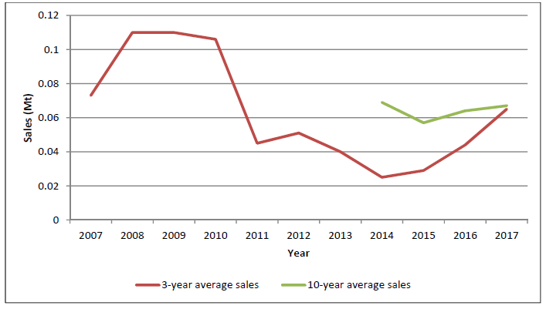

3.5. It is worth noting that a number of recycling facilities (including those that handle recycled aggregate) are currently subject to temporary planning permission due to forming part of the wider long‐standing regeneration programme for the area. Work to identify alternative sites for such uses is being pursued through the Local Plan.

**4. Wharves and Rail Depots**

**Marine‐won Sand and Gravel**

4.1. Medway makes a critical contribution to the south east’s infrastructure for the importation of aggregates, particularly marine dredged sand and gravel. The scale of the importation makes Medway’s wharves of regional and national significance. There are four currently in operation:

* Grain Terminal, Isle of Grain (wharf and rail depot): operated by Aggregate Industries.
* North Sea Terminal, Cliffe, Rochester: operated by Brett Aggregates.
* Euro Wharf, Frindsbury, Rochester: operated by Hanson Aggregates.
* London Thamesport, Isle of Grain: operated by Medway Aggregates.

The location of the wharves and the rail depot in Medway is provided in figure 5.

**Figure 5: Wharves and rail depots in Medway**

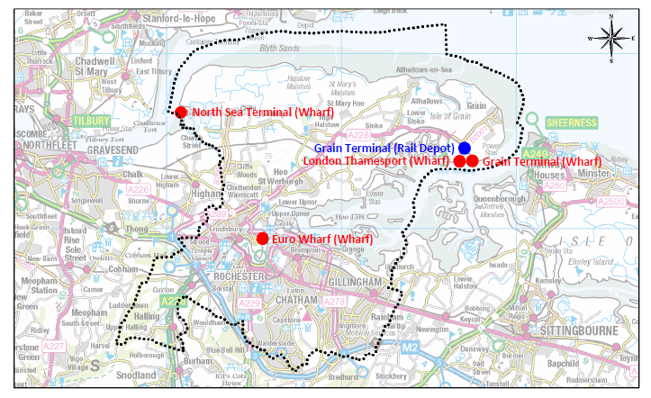

4.2. Collectively, these five facilities make a significant contribution to the importation of minerals into the region. Medway’s wharves are amongst the largest in Kent and Medway, and have the greatest capacity. The wharves are operating within their capacity levels which offer the ability to increase production in response to market demand. **North Sea Terminal (Wharf) Euro Wharf (Wharf) London Thamesport (Wharf) Grain Terminal (Wharf) Grain Terminal (Rail Depot)**

4.3. Medway receives sand and gravel from a number of dredging regions; those of which that are located in British waters have their minerals rights owned by the Crown Estate. The nearest of these dredging regions is the Thames Estuary and which accounts for around 5% of the sand and gravel imported into Medway’s wharves, with the East Coast region accounting for 28%, South region 19% and East Channel region 14%. The remainder is either not reported by operators through the Aggregates Monitoring Survey, or arrives from further afield.

4.4. The sale of marine‐won sand and gravel in Medway is presented in table 3 and figure 6. In 2017 the level of sales was recorded at 1.794Mt, whilst this is a 9% decrease on the sales recorded in 2016, it remains 0.22% above the average 3‐year sales of 1.790Mt, and 27% above the 10‐year average sales of 1.415Mt.

**Table 3: Sales (Mt) of marine‐won sand and gravel through wharves in Medway**

|  |  |  |  |
| --- | --- | --- | --- |
| Year | Annual sales (Mt) | 3 year average sales (Mt) | 10 year average sales (Mt) |
| 2007 | 1.565 | 1.286 | n/a |
| 2008 | 1.518 | 1.502 | n/a |
| 2009 | 0.740 | 1.274 | n/a |
| 2010 | 1.152 | 1.231 | n/a |
| 2011 | 1.167 | 1.020 | n/a |
| 2012 | 1.215 | 1.178 | n/a |
| 2013 | 1.400 | 1.261 | n/a |
| 2014 | 1.586 | 1.400 | 1.264 |
| 2015 | 1.597 | 1.527 | 1.336 |
| 2016 | 1.978 | 1.720 | 1.392 |
| 2017 | 1.794 | 1.790 | 1.415 |

**Figure 6: Sales (Mt) of marine‐won sand and gravel through wharves in Medway**

Figure 6: Sales (Mt) of marine‐won sand and gravel through wharves in Medway


**Marine‐won Soft Sand**

4.5. It is possible that the demand for soft sand in the South East will increasingly need to be met by imports into the area and from marine won sources due to its scarcity, and moreover by constraints upon its extraction. To help provide a detailed analysis of soft sand supply in the region, sales figures of marine‐won soft sand are now separated out from those of marine‐won sand and gravel.

4.6. No sales of soft sand were recorded in 2017 which is reflective of the sporadic nature of the historic sales data, with sales occurring in just 4 of the previous 11 years. This may indicate that material is imported for a particular project or use where it is suitable to use marine‐won soft sand in place of land‐won. Further discussions with aggregates operators may provide insight into its use and the fluctuating nature of the sales data. A breakdown of the sales of marine‐won soft sand for the past 11 years is presented in figure 7.

**Figure 7: Sales (Mt) of marine‐won soft sand through wharves in Medway**

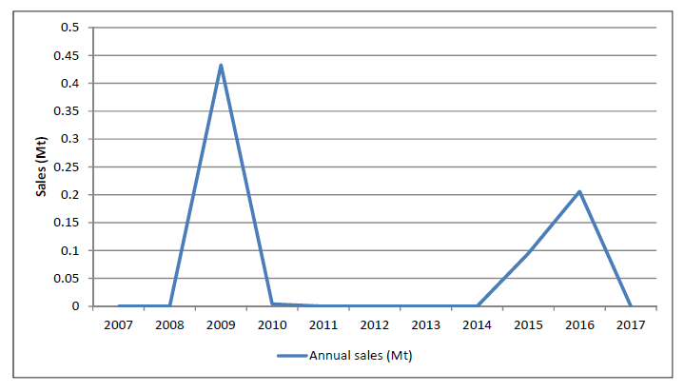

**Crushed Rock**

4.7. Medway does not have any natural hard rock resources and therefore relies on imports of crushed rock such as limestone and granite to meet demand for this type of aggregate.

4.8. Crushed rock arrives in Medway through both the wharves and a rail depot at Grain; with granite arriving through the wharves from Scotland and Norway, and limestone by rail from Somerset.

4.9. Due to commercial confidentiality, sales from the rail depot cannot be broken down other than by a 3‐year and 10‐year sales average; and due to the records of sales only beginning in 2013, only 3‐year average sales can be published currently.

4.10. Sales data for crushed rock through wharves and the rail depot are presented in table 4 and figure 8. In 2017 sales of crushed rock through Medway’s wharves was recorded at 0.945Mt; an increase of 4% of the sales recorded in 2016. The 2017 sales are 4% below the average 3‐year sales of 0.981Mt, but 5% above the 10‐year average sales of 0.901Mt.

**Table 4: Sales (Mt) of crushed rock through wharves and rail depots in Medway**

|  |  |  |  |  |
| --- | --- | --- | --- | --- |
| Year | **3‐year average sales (Mt): Rail depot** | **Annual sales (Mt): Wharves** | **3‐year average sales (Mt): Wharves** | **10‐year average sales (Mt): Wharves** |
| 2007 | n/a | 1.756 | 1.437 | n/a |
| 2008 | n/a | 1.240 | 1.511 | n/a |
| 2009 | n/a | 0.696 | 1.231 | n/a |
| 2010 | n/a | 0.909 | 0.948 | n/a |
| 2011 | n/a | 0.833 | 0.813 | n/a |
| 2012 | n/a | 0.761 | 0.834 | n/a |
| 2013 | n/a | 0.856 | 0.817 | n/a |
| 2014 | n/a | 0.775 | 0.797 | 1.038 |
| 2015 | 0.056 | 1.086 | 0.906 | 1.045 |
| 2016 | 0.025 | 0.912 | 0.924 | 0.982 |
| 2017 | 0.005 | 0.945 | 0.981 | 0.901 |

**Figure 8: Sales (Mt) of crushed rock through wharves and the rail depot in Medway**

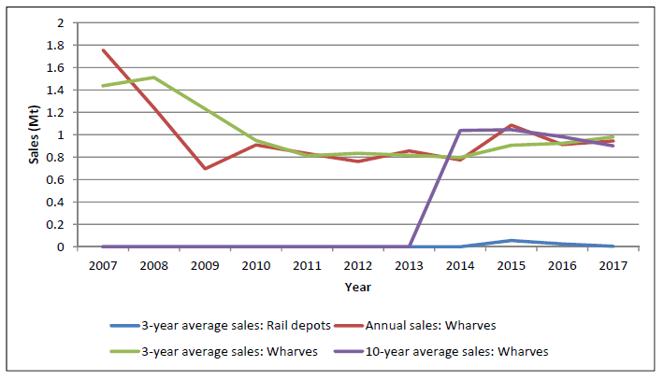

**5. Overview of Aggregate Sales**

5.1. In order to provide a picture of complete data, average 3‐year sales of aggregates in Medway have been amalgamated and presented in figure 9.

5.2. The sales of aggregates appear to follow the same overall trend, with the exception of crushed rock imported through the rail depot. All sales decreased between 2008 and 2011; where since then the overall sales trend has been generally upward. Sales of land‐won sand and gravel decreased further past 2011 until 2015 when sales restarted; this upward trend is expected to increase with the commencement of extraction at Kingsnorth Quarry.

**Figure 9: Amalgamated average 3‐year sales (Mt) for aggregates in Medway**

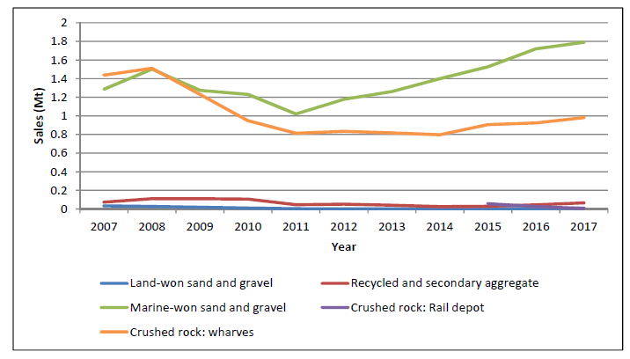

**6. Future Aggregate Supply**

6.1. In 2015 Medway jointly commissioned the North Kent Strategic Housing and Economic Needs Assessment with Gravesham Borough Council to provide an evidence base for housing, employment and retail needs in Medway over the plan period. This research showed a need over the plan period (2012‐2035) for:

* 29,463 homes.
* 49,943m2 of B1 office space; 155,748m2 of B2 industrial land; and 164,263m2 of B8 warehousing land.
* 44,100m2 of comparison retail floor space and 13,200m2 of convenience (supermarket) retail space up to 2031.

The new local plan will also identify supporting infrastructure needs. With further government policy changes, the council is reviewing the level of housing needs, in order to determine the housing target for the plan. This will be updated in the next LAA.

6.2. The delivery of housing in Medway, like many other areas of the country, experienced challenging market conditions with the construction of 680 houses completed in 2017/18, against an annual target of 1,000 homes. Figure 6 outlines the completions of new homes in Medway over the last few years.

**Figure 10: Annual housing completions compared to annual housing requirement in Medway**

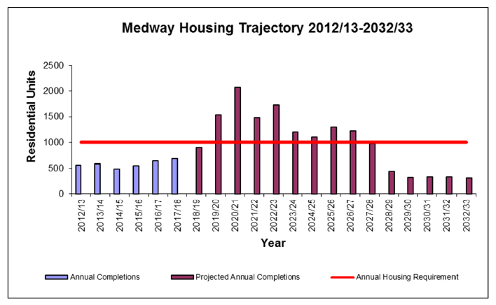

6.3. Regionally, a number of planned infrastructure projects are likely to put increased pressure on the supply of aggregates through Medway, including:

**• The Lower Thames Crossing:** A 13‐mile new road and bored tunnel crossing under the River Thames between the east of Gravesend and Tilbury.

**• Crossrail 2:** A proposed major new rail route through London between Surrey and Hertfordshire.   
**• Thames Tideway Tunnel:** A 16‐mile drainage and sewerage tunnel currently in construction under much of the tidal section of the River Thames through central London.

**• Northern Extension Line:** An extension to the London Underground Northern Line to Battersea.

**• High Speed Rail 2:** A planned high‐speed rail link between London and initially Birmingham (Phase 1), but later Manchester, Sheffield and Leeds (Phase 2).

**• Ebbsfleet Garden City:** A planned development of up to 15,000 homes and 45,000m2 of commercial floor space.

**• Housing and infrastructure delivery across Kent:** Includes in the region of 178,600 additional homes (2011‐2031) and the provision of 163 extra form entries for schools (2017‐2023).

6.4. In order to deliver the projects noted above, Medway will endeavour to maintain a landbank and ensure that its aggregates infrastructure, essential for its distribution, is safeguarded through the application of appropriate planning policy.

**Landbank**

6.5. As reported in Section 2, the current landbank for land‐won sand and gravel is 135 years, based on the 3‐year sales average; this increases to 212 years when applying the 10‐year sales average. The landbank is anticipated to shorten substantially over the coming years as Kingsnorth Quarry becomes fully operational.

6.6. Significant deposits of sand and gravel exist across the Hoo Peninsula; the council will actively plan to safeguard these areas through the emerging Local Plan to help ensure that a steady and adequate supply of aggregates is maintained.

**Capacity**

6.7. As part of the Aggregate Monitoring Survey in 2016, site capacity was included for the first time. This was repeated in 2017 and it is hoped that by understanding current capability of sites through their capacity, that this information can be used to assist planning for future demand. Details of capacity against the recorded 3‐year average sales are detailed in table 5 (overleaf).

6.8. Sales against capacity data collected across the past 2 years indicate sufficient headroom to accommodate a significant level of demand, with a capacity gap at the wharves of 34%. There is potential for capacity to be substantially increased with space available for additional wharf facilities at London Thamesport.

**Table 5: Sales of aggregates (Mt) against capacity (Mt)**

|  |  |  |  |
| --- | --- | --- | --- |
|  |  | 2016 | 2017 |
| Land-won sand and gravel | Average 3-year sales of land-won sand and gravel (Mt) | 0.003 | 0.009 |
| Land-won sand and gravel | Total annual capacity (Mt) | >0.200 | >0.200 |
| Land-won sand and gravel | Percentage of sales against capacity (%) | <1.5 | <4.5 |
| Recycled and secondary aggregates | Average 3‐year sales of recycled and secondary aggregate (Mt) | 0.044 | 0.065 |
| Recycled and secondary aggregates | Total annual capacity (Mt) | >0.100 | >0.100 |
| Recycled and secondary aggregates | Percentage of sales against capacity (%) | <44 | <65 |
| Wharves | Sales through wharves (Mt) | 3.096 | 2.739 |
| Wharves | Total annual capacity (Mt) | 4.000 | 4.150 |
| Wharves | Percentage of sales against capacity (%) | 77 | 66 |
| Rail Depot | Average 3‐year sales through rail depot (Mt) | 0.025 | 0.005 |
| Rail Depot | Total annual capacity (Mt) | 0.100 | 0.100 |
| Rail Depot | Percentage of sales against capacity (%) | 25 | 5 |

6.9. The capacity picture is less clear with regard to recycled and secondary aggregate where limited capacity and sales data has been received from operators. Capacity is anticipated to increase in the near future however, with the granting of permission for a production plant for Hydraulically Bound Material (HBM) from recycled aggregates at Malmaynes Hall Farm in Stoke. The plant is expected to have an operational capacity of 0.075Mtpa.

**7. Conclusion**

7.1. This LAA indicates that Medway plays a strategic role in regional aggregates supply most notably through the wharves located on the rivers Medway and Thames. The ability to handle large vessels and their proximity to markets in the wider south east and London elevates the wharves’ importance to a regional level. Furthermore, the current surplus handling capacity allows for flexibility and provides assurance in their ability to respond to increased market demand.

7.2. A new Medway Local Plan is currently being prepared, with an anticipated submission date of 2019 for examination. Draft policy approaches were consulted on throughout 2018 and will be used to inform minerals policy production in the draft Local Plan, due for publication in summer 2019.

7.3. It is considered that Medway is making sufficient provision to ensure the steady supply of aggregates from a range of sources, and that it can continue to make an effective contribution to meeting local and wider needs for aggregates. The council will continue to actively participate in the work of SEEAWP and maintain cooperative working with neighbouring Minerals Planning Authorities and industry operators.