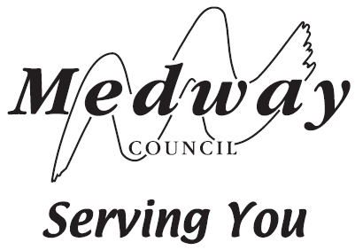
Contact: 01634 332803
Date: January 2024

Customer and Business Support
Gun Wharf
Dock Road
Chatham
Kent ME4 4TR

«Tenant_Name»
«Tenant_Address1»
«Tenant_Town»
Kent
«Tenant_Post_Code»
I N V O I C E

Your allotment invoice is due for payment within 42 days of the above date.

The way you can pay has changed.

You need to act now.

Want to keep your allotment? Want to cancel your allotment?

Pay by 22nd February 2024.
To do this:
- Get your customer reference number ready - this MUST be your 2024 Invoice number

- Pay online by visiting www.medway.gov.uk and searching for Allotments; or

- Call 01634 332803. Lines are open Monday to Friday, 9am to 5pm.

Please note we are not accepting payment via cheque or bank transfer

Terminate your allotment contract in writing (email or letter):

allotments@medway.gov.uk or

Allotments, CABS Team 2, Gun Wharf, Dock Road, Chatham, Kent ME4 4TR

Please remember to detail your customer reference number and plot number

If you do not pay you are at risk of allotment termination.

Unable to pay:
email allotments@medway.gov.uk

Invoice/Ref No: 12345
Invoice Date: January 2024
VAT Registration No: GB 680 1382 45

Allotment Invoice for the Period January 2024 to December 2024
For Allotment Site: «SiteName» Plot Number: «PlotID»
Plot Size: «Area»
Special Concession: None

Rent | Water | Shed/Container | Total For Period
£ 0.00 | £ 0.00 | £ 0.00 | £ 0.00

