Road Safety
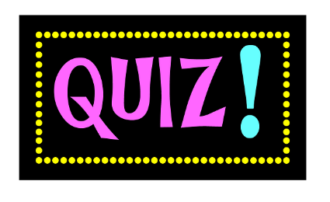

1. What is the first thing to do when you are crossing the road?
A Listen B Look C Stop

2. What word lights up when you press the button on the box at a
pelican crossing?
A Stop B Wait C Go D Think

3. What colour clothing should you wear when riding your bike?
A Black B Dark Blue C Brown D Bright Yellow

4. What is the speed limit outside your school?
A 30 MPH B 20 MPH C 40 MPH

5. What is written on a lollypop sign?
A STOP B STOP CARS C STOP CHILDREN

6. How many metres does it take a car to stop when driving at 30 MPH?
A 10 m B 23 m C 35 m D 50m

7. Is running across the road safer than walking?
A Sometimes B Never C Always

8. In the back seat of a car do you need to always wear a seat belt?
A Yes B No

9. At what age does the law say you will have to pay the £100 penalty for not wearing a seat belt?
A10 B14 C16 D18
Answers:
1. C
2. B
3. D
4. A
5. A
6. B
7. B
8. A
9. B

