Cycle Safety
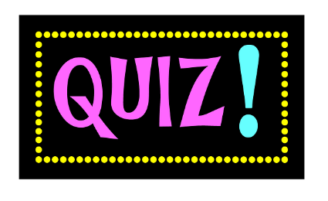
1. What is important to wear when you go cycling?
A Helmet B Socks C Headphones

2. What colour reflector should you have on the back of your bike?
A White B Green C Red

3. What colour clothing should you wear when riding your bike?
A Black B Dark Blue C Brown D Bright Yellow

4. What does this sign mean?
A Cycle route ahead B Cycle parking C No Cycling

5. What is usually written on this sign?
A STOP B Give Way C DANGER

6. What does the amber light at the traffic lights mean?
A Get ready to go B Stop C Get ready to stop

7. What side of the road should you cycle on?
A Left B Right C Middle

8. What should you lubricate your chain with?
A Oil B Water C Juice

9. How many metres does it take a car to stop when driving at 30 MPH?
A 10 m B 23 m C 35 m D 50 m

10. When doing an emergency stop on a cycle should you
A Put the back brake on B Put the front brake on C Put both brakes on.

