**OPPOSITES WORKSHEET**

**Look at the picture and fill in the blanks using the words below.**

| Safe | Stop | Fast | Go | Slow | Dangerous |
| --- | --- | --- | --- | --- | --- |

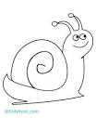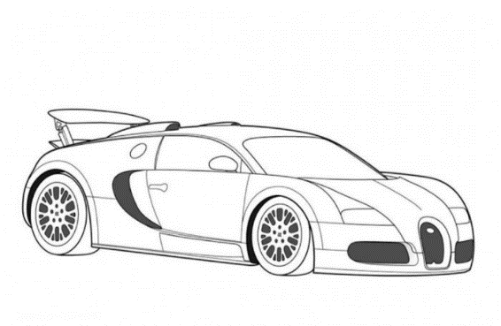

**F __ __ T**

**S __ __ W**

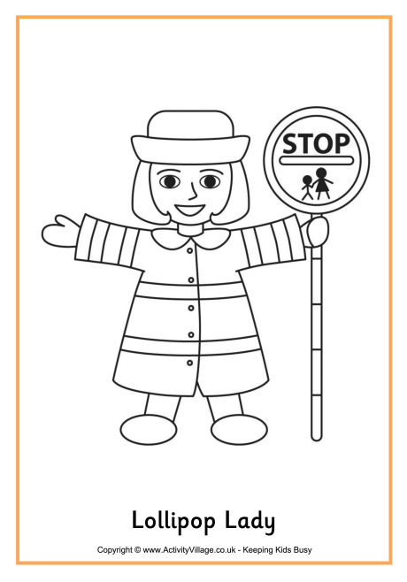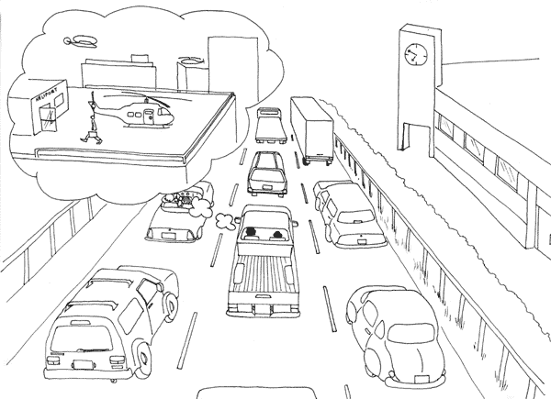

**S __ __ E**

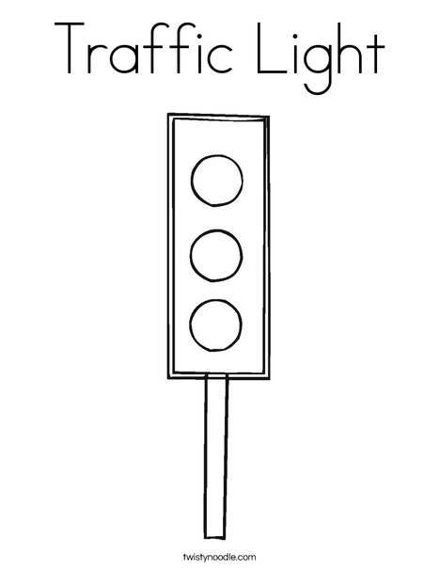

**G __**

**S __ __ P**