OPPOSITES WORKSHEET
Look at the picture and fill in the blanks using the words below.
Safe | Stop | Fast | Go | Slow | Dangerous
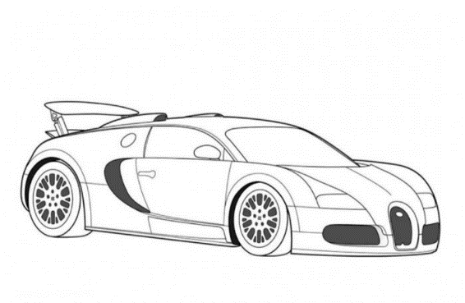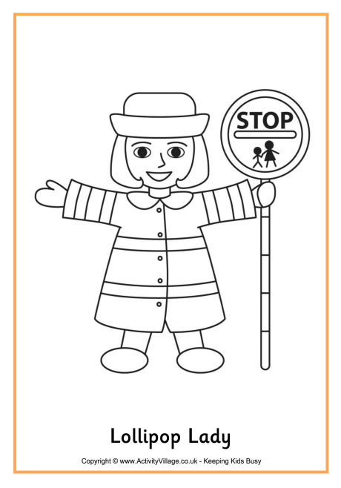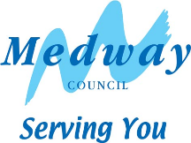CROSSING THE ROAD: VOCABULARY WORKSHEET
F __ __ T
S __ __ W
S __ __ E
G __
S __ __ P
(YR 1 & 2)

Fill in the missing words in the sentences below, using these words:
look | hold | walk | traffic | wait | think | listen | hand | stop | kerb

1) When we are out walking we should always _ _ _ _ our grown-ups _ _ _ _ , to keep us safe.

2) The edge of the pavement nearest the road, is called
the _ _ _ _.

3) When we need to cross the road we should always,
_ _ _ _, _ _ _ _ , _ _ _ _ _ _ and _ _ _ _ _ !

4) If there is any _ _ _ _ _ _ _ travelling towards us when we need to cross the road, we should _ _ _ _ and let it pass, before we
_ _ _ _ across the road.

IDENTIFYING TRAFFIC WORKSHEET:
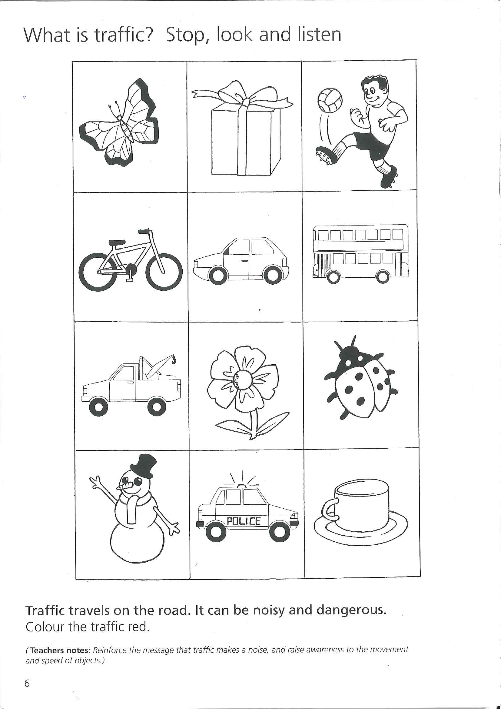Find the traffic and colour it in RED

