50

Move in a healthy direction
Mental Health and Wellbeing: An Employer's Guide
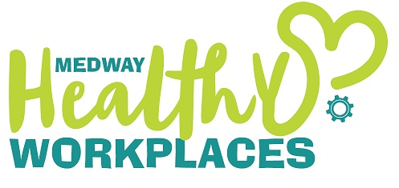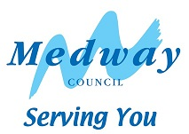

Mental Health and Wellbeing: An Employer's Guide

Introduction

Mental health and wellbeing has been rising on the agenda for some time. With 1 in 6 people in the workplace experiencing a common mental health condition at any one time, it will likely affect all workplaces at some point. The strong link between mental wellbeing, staff motivation and productivity also makes good mental health critical for thriving businesses.

What do we mean by Mental Health and Wellbeing?
Mental health is not just the absence of a mental illness or disorder. Mental health includes our emotional, psychological and social wellbeing. It makes a difference to how we think, feel and act. A state of good mental wellbeing allows individuals to respond to life’s ups and downs.
We all have mental health, as we all have physical health. Staying in good mental health helps us to cope with the pressures of life, work productively, have positive relationships, make good decisions and realise our true potential. It’s important for individuals, families, organisations and society as a whole. Mental health can fluctuate between good and poor. Mental health problems can affect anyone, regardless of age, ethnicity, background, social standing. Mental health problems can affect our work lives, our personal lives or both, with the negative impacts touching all areas of a person’s life. It’s important to remember work and personal lives may also have a positive or negative impact on our mental wellbeing and it is the purpose of this document to consider how this can be assisted.
Above all when considering mental health and wellbeing we must remember it is not a static concept. It is possible to have a diagnosed mental illness but live well with the right management of the condition. As it is also possible for anyone to have “off” day where our mental wellbeing is not optimal even if we don’t have a mental health condition. In both instances our mental wellbeing can be influenced and improved.

Why should employers worry about mental health?

According to the Mental Health Foundation, Mental health issues are estimated to cost UK businesses £2.4 billion a year. Mental Health issues account for 70 million lost working days, in addition to management time and 300,000 workers each year who leave their jobs because of mental ill health.

In addition to sick leave and turnover, staff who experience mental health problems can feel disengaged with the workplace, which affects productivity. 90% of people with mental health problems believed that they experience stigma and 40% of employees did not think that their employer would take mental health concerns seriously. Where people did disclose mental health issues to their employer 29% felt discriminated against as a result.

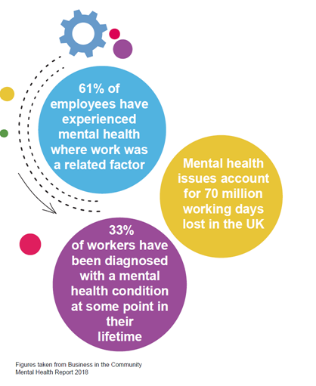

Links between Mental Health and other conditions
There is a clear link between mental health and other conditions we may experience which could harm our wellbeing. For example, people living with musculoskeletal disorders often experience chronic pain and a loss of independence. This in turn can effect self-esteem, and lead to stress and low mood or even the development of depression. One third of people living with a long term health condition are known to experience depression and anxiety. Stress can also manifest in the form of musculoskeletal, bowel and other physical pains and disorders. Employers may also notice mental health as an issue in the workplace in the areas of alcohol and substance misuse, eating habits and smoking. Mental health and its impact should be considered when planning workplace initiatives for any topic.

Mental Health and Workplace Health and Safety

Workplace health and safety includes mental health. Stress at work can lead to ill health and can exacerbate existing mental health conditions. Stress is a reaction to events of experiences in someone’s life, and can be caused through either work or personal circumstances.
The Health and Safety Executive (HSE) place a duty of care on employers to make sure that they manage and prevent stress by improving conditions in the workplace. The employer also has a role in making reasonable adjustments to help someone manage a mental health issue at work. The HSE have produced the Management Standards to Stress which is a framework to aid employers in tackling work-related stress, and therefore reducing the prevalence and impact of mental health at work.
Employers should make sure proper risk assessments are carried out in the workplace, and it is recommended to use a stress risk assessment. Job design and the workplace environment should be considered when looking at mental health in the workplace.
As well as managing stress in the workplace, employers can also play a vital role in breaking down the stigma around mental health and preventing discrimination. The Equality Act 2010 gives employees the right to challenge any discrimination, and under the act, some mental health conditions can be classes as a disability. You can read more about disability discrimination and mental health on the Mind website.

Six Ways to Wellbeing

The Six Ways to Wellbeing are an evidence-based approach to managing stress. Promoting and encouraging these in the workplace and for staff to implement in their everyday lives can help to maintain and boost wellbeing as well as mitigate stress. Inclusion of these principle should be considered a cornerstone of prevention strategies which aid positive mental wellbeing and its maintenance.

The Five Ways to Wellbeing are:

Be Active – Keep Learning – Give – Connect – Take Notice

- Being active, going for a walk or run, playing a game, dancing and regular exercise helps you to feel good.

- Keeping learning keeps the mind active and helps to take our minds of immediate stresses and thoughts. Try something new, or rediscover an old interest. Try learning an instrument, language or a new skill. Learning something new can boost confidence and therefore wellbeing.

- Give does not have to mean giving money. Volunteering, doing something nice for a friend, family member or your community can boost wellbeing and provide a sense of purpose.

- Connect with people around you. Having a phone call, or meeting up with friends and family or through other social circles can give us encouragement and a sense of belonging.

- Take Notice means being curious, being present in the current moment. Take in the scenery you have near to where you live or work. Be aware of the world around you, for example noticing the changing seasons.

The Five Ways to Wellbeing all support good functioning which lead to improved wellbeing and improved mental capital (that is resilience, self-esteem, cognitive capacity and emotional intelligence) helping us to cope better with the stresses of life. If we feel stressed or low, it can be easy to stop doing our usual activities, which in turn can lower our wellbeing and reduce our mental capital.

What employers can do to help

Employers can implement several things to support the mental health of their staff. Here are some suggestions based on latest Health and Wellbeing research and best practice. This guide has focused particularly on mental health although many of these initiatives will support and promote better health and wellbeing in general.
- Open communication with staff will encourage them to come forward and report concerns regarding their own health and wellbeing, as well as health and safety within the organisation. Enabling staff to speak up and seek help can make a big difference to managing conditions and prevent them from worsening. Consult with staff when changes are being made in the workplace, and if you have a workplace union involve them in discussions too. Ask about wellbeing in appraisals so that this becomes a normal part of conversations.
- Have clear expectations and goals for people, decided where possible with mutual discussion. Communicate clear values for the organisation.
- Include mental health information at on-boarding so staff are aware of the help available from day one. A good on-boarding programme can also help new team members to connect with colleagues, supporting mental health in the future.
- Ensure senior management are on board with health and wellbeing initiatives. Having senior managers speak out about their own experience, particularly if they have lived experience of mental ill health. This can encourage staff to speak up.
- Investigate engaging an employee assistance provider (staff counselling). If this is not an option, promote local support services available. Set up a notice board either in a staff room or on the company shared drives to promote good health messages and signpost staff to sources of support.
- Carry out return to work interviews to ensure staff are supported when returning to the workplace after absence.
- Use stress risk assessments to evaluate stress in the workplace and reduce it where reasonably practicable. Do not make them just a tick box exercise.
- Make good use of reasonable adjustments for staff who need adaptations to their working practices
- Encourage initiatives in the workplace so that people can implement the Six Ways to Wellbeing in their lives.
- Encourage staff to take suitable rest breaks, allowing them to switch off from work and come back to the workplace with a fresh mind.
- Look at the workplace environment. Check it is suitable for staff to carry out their duties and provides space for breaks and where practical access to natural light with good ventilation.
- Take part in various campaigns, which can improve Mental Health awareness. These activities can help to break down stigma and will improve knowledge in the workforce and increase understanding towards colleagues living with long-term health conditions. A third of people with long-term health conditions do not feel that their colleagues understand their health needs.
- Offer mental health awareness training. Separate training is available for line managers, which will help them in better supporting their staff.
- Appoint mental health first aiders or mental health champions. These colleagues can provide a listening ear to colleagues, help signpost them to sources of support and be an asset in running initiatives for awareness campaigns.
- Promote social and volunteering activities as a way for staff to give to others and connect with colleagues.

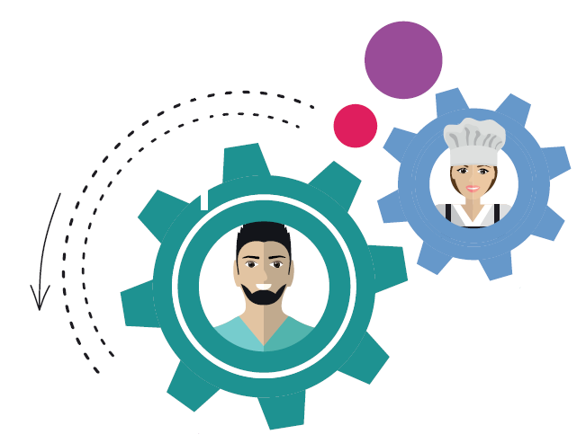

Sole traders and entrepreneurs

Sole traders and entrepreneurs can face different challenges in managing their mental health. Flexibility of working for yourself can help with attending appointments and balancing work and life commitments but working alone can lead to increased isolation. The self-employed and entrepreneurs are in their nature quite self-sufficient but attention should be paid to stress and taking time out from the workplace. For more information on healthy workplaces for sole traders, please contact us.

Mental health and working from home

Many of the health benefits of work (other than financial) come from its ability to increase our social connectedness and sense of purpose or belonging like that felt when part of a team. Working from home or remotely away from colleagues can be a challenge to many.. It is therefore important for organisations to consider its impact on staff. For more information on working from home you can read our guide to working remotely.

Additional Useful Resources
- A Better Medway - local health improvement advice and support for Medway
- One You Kent: local health improvement advice and information for Kent
- Access to work programme for support and equipment at work when you have long term health condition or disability https://www.gov.uk/access-to-work
- Business in the Community Public Health England Toolkits: Mental Health toolkit for employers
- Every Mind Matters Mental Health information from the NHS and Public Health England
- For Better Mental Health at Work
- Live Well Kent: Mental Health and Emotional Wellbeing Support for Kent and Medway
- Release the Pressure: Kent and Medway wide helpline for mental health support, 24/7, 365 days a year. Call 0800 107 0160 or text “Medway” or “Kent” to 85258
- Health and Safety Executive – HSE Management Standards, Advice for Managers on Mental Health Conditions
- Mental Health First Aid – Line Manager’s Resource 
- Mind: https://www.mind.org.uk/
- NHS for information on various conditions and healthy lifestyles: https://www.nhs.uk/
- NHS One You for healthy lifestyle advice: https://www.nhs.uk/oneyou/

Case studies

At Dovetail Games we employ the best talent sourced from around the UK & Europe. In doing this we assist the candidates with both financial and logistical support to help with their move. We understand that moving away from your friends and family can be difficult and could possibly be lonely so we have schemes in place to help avoid this.
From the initial job offer, the recruitment team keep in regular contact with the candidate offering any assistance we can with house hunting and advice. This starts building a rapport that will help for their first day. Their new line manager also sends an email to the candidate before their start date as a “we look forward to you starting”. On their first morning with us, the new employee meets with the HR & Recruitment team for their induction morning, learning where everything is, how to book holiday and learning about health & safety etc. We have an info point with loads of information ready to pass on, including who our First Aiders and Mental Health First Aiders are. We have a “buddy scheme” in place for their first few days which ensures they are looked after and lunchtimes are filled with meeting new people.
As a company we really pride ourselves on our regular 1:1’s and communication with new members of staff. It really is important to make sure the wellbeing and mental health of them is cared for, especially if they have relocated to join us.
We believe that our caring approach really helps us stand out as an employer.
Fiona Turner, CSR Exective, Dovetail Games

MTS Cleansing Services Limited (MTS) is a family business based in Medway. As part of Healthy Workplace programme, MTS received support to improve mental wellbeing in their organisation and for their employees. Part of the support provided has been Mental Health First Aid Training. Mental Health First Aiders are able to spot signs and symptoms of mental health problems and know how to support people to get help, should they need it. Over the last year, six employees from MTS have attended this training, and become trained as Mental Health First Aiders. MTS have promoted wellbeing services within their organisation and now have colleagues that can support each other with their wellbeing.

An employee at MTS said, “The Mental Health First Aid training was a great help in dealing with the employees who approached me to discuss personal issues and mental health struggles. I was very pleased that they felt able to talk to me. I felt more confident in listening and signposting those to further help, using the guidance from the training. I think that being able to train a range of people in Mental Health First Aid across the business, really widens the net of employees who feel comfortable in using this support”. Those from the business who attended the training also talked about the positive impact the training has had on their own wellbeing. One individual said, “Personally, having the Mental Health First Aid training behind me has helped me to give support and guidance to employees. It has helped my own wellbeing in what can be a stressful situation in dealing with other people’s personal issues and stresses”.

Jackie Hall, Web and Communications Officer, MTS Cleansing Services

Contact
For a no obligation meeting to get the Workplace Health programme started in your business, or for further information please contact:
By email workplacehealth@medway.gov.uk. By telephone 01634 334307 or visit the website.

Thank you to all those who have contributed to this guide: Members of the Public Health Team, Dovetail Games and MTS Cleansing Services Limited.
The following sources of information were consulted in the production of this guide:
Business in the Community Public Health England Toolkits: Mental Health toolkit for employers: http://wellbeing.bitc.org.uk/all-resources/toolkits/
HSE Stress Management Standards
^{Connect 5 Training Slides}
^{Mind – Mental Health at Work}

