

**Move in a healthy direction**

Musculoskeletal Health in the Workplace: An Employer's Guide

Logo, Medway Healthy Workplaces

 image box showing three logos.  1) kent and medway healthy workplace programme, 2) Kent county council logo and 3) Medway Council

Musculoskeletal Health in the Workplace: An Employer's Guide

### **Introduction**

Musculoskeletal (MSK) Health conditions cover a broad range of health disorders that affect the bones, joints and muscles and include pain syndromes and rarer conditions linked to the immune system. You are likely to be more familiar with some types of MSK conditions than others such as osteoarthritis or rheumatoid arthritis, tendinitis, osteoporosis but there are many other conditions. This guide is not intended to give you in depth information about individual conditions, but rather some guidance for your organisation as to what you can do to support good MSK health in the workplace. At the end of this booklet you will find useful links to find our more about MSK conditions and what you can do in your workplace.

### **Why should employers worry about musculoskeletal health?**

Poor MSK is costly for the health service and the country as a whole. Public Health England figures show that 20% of the UK population visit their GP for MSK issues each year. The most common issues are bad backs and neck pain. In 2017 MSK was the second biggest cause of sickness absence in the UK, costing 28 million working days at a cost to UK business of £7billion a year. One third of all long term sickness absence in England is attributed to MSK. The highest rates of MSK disorders are found in agriculture, logistics and transport, warehousing and storage, construction and health and social care. However does also occur in other industries such as banking, customer services and retail.

As the population ages, the likelihood of poor MSK in the workplace is set to rise with 7 million people in the workforce likely to be living with an MSK disorder by 2030.

1 in 8 people of working age report having an MSK disorder

Furthermore, someone developing an MSK condition in the workplace may need to have some re-training to continue in their role, or to move to a more suitable job. The costs aren't just borne by employers and the health system. As much as 40% of people of working age with an MSK condition are unemployed adding costs to the state in benefits. Many people living with long term MSK disorders also experience poor mental health, loss of independence and extra pressures on family members in terms of care and support.

### **The musculoskeletal system and ageing**

The musculoskeletal system consists of our bones, cartilage, ligaments, tendons, joints, muscles and the parts of the nervous system that links these to the brain. As the MSK system is a large part of our bodies, it's not surprising that there are many MSK disorders.

MSK disorders increase with age but don't need to be an inevitable part of ageing. Leading a healthy lifestyle throughout life helps to prevent MSK disorders in later life. By the age of 70 the average adult has lost 40-50% of the muscle strength they had when they were younger, and once lost these muscle fibres can not be replaced. However regular exercise and a healthy diet protect remaining muscle and improves the strength of it. Tendons also age, losing elasticity. Persistent tendon diseases are most common in the over 50s.

As well as muscle mass declining with age, bone density also decreases with age. Lower bone density leads to increased risk of fractures, particularly if osteoporosis is present. Bone strength in younger years effects bone loss and strength in later life. Some medications also affect bone loss, such as some prescribed for Irritable bowel Syndrome.

Foundations for good musculoskeletal health are laid in the womb, which highlights the importance of good maternal health. Maximum bone density is reached in early adulthood.

### **Healthy lifestyles for good Musculoskeletal health**

Leading a healthy lifestyle is the best protection against MSK disorders.

### **Physical Activity**

It is well know that regular physical activity is good for health. The Chief Medical Officer recommends 150 minutes of moderate activity, or 75 minutes of vigorous activity for adults aged 19-64.

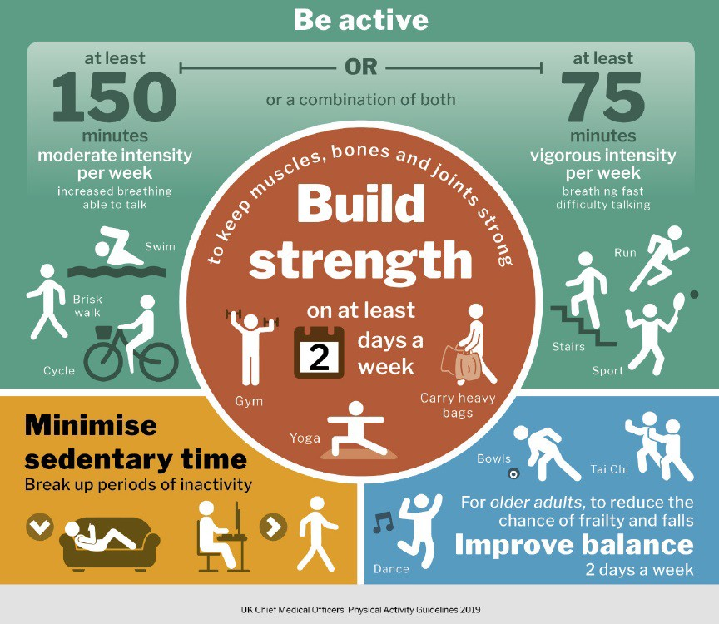

Physical activity is good for our heart health and also for our mental wellbeing. Age related MSK issues are also noticeably reduced by moving more and sitting less. A lack of physical activity leads to a loss of fitness and mobility and this happens quite quickly. Whilst life expectancy has increased significantly compared with 200 years ago, healthy life expectancy (that is years in later life free from illness and disease) has not increased by the same amount. Scientists believe that our bodies are pre-programmed to wind down from our mid-30s.

Evidence shows that managing weight and activity levels and can improve our quality of life as we age and give us as many as 20 years more free of illness and disease.

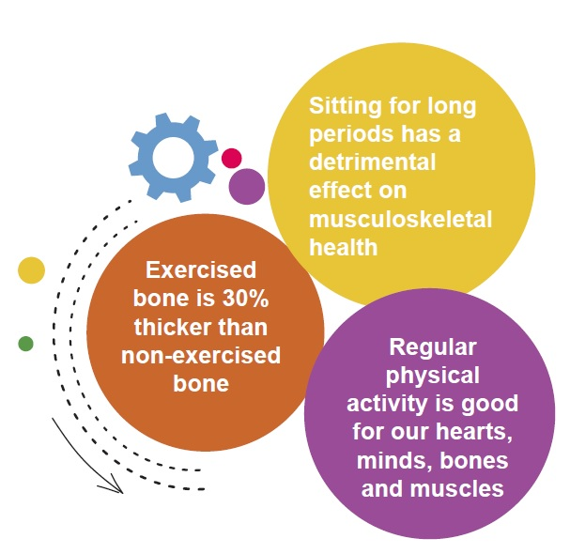

Our musculoskeletal system also benefits greatly from physical activity. The skeleton responds to exercise. Exercised bone is 30% thicker than non-exercised bones. The skeleton responds when bones are loaded in exercise, so weight bearing and strengthening exercise is particularly good for bone health. Even short periods of exercise (20 minutes) have been shown to have a positive impact on bone health.

As you move less, you lose muscle function. If you have ever broken an arm or leg, you might remember how the muscle had thinned whilst the plaster cast was on. Lifting weights and resistance training can help to maintain muscle strength as we age.

Aerobic exercise (such as brisk walking, cycling and aerobics classes) also benefits the musculoskeletal system by improving blood flow to the bones and muscles. Aerobic exercise also improves blood flow and circulation to the tendons and joints.

Sedentary behaviour (that is sitting for too long or long periods of inactivity) is a risk to musculoskeletal health, as well as heart health. Increased sedentary behaviour leads to a loss of the benefits of physical activity as well as higher fat and glucose levels in the blood and higher levels of inflammation. Insufficient physical activity also leads to increased likelihood of bone thinning.

According to the World Health Organisation (WHO) the lack of physical activity is one of four leading causes of preventable death worldwide, ahead of high cholesterol, alcohol and drug abuse.

The UK Organisation, Get Britain Standing gives 10 risks caused by sedentary behaviour. You can read the full list on their [website](http://www.getbritainstanding.org/health-risks.php) but here we have listed the reasons linked to musculoskeletal health:

* Diabetes
* Weight Gain
* Back/Neck Pain
* Muscle Degeneration
* Osteoporosis
* Mortality

Even small amounts of physical activity have a benefit to health. If 150 minutes seems a lot, try to think of it in half hour blocks. Even 10 to 20 minutes of activity has a benefit to health so start small and build up. You should seek medical advice from your GP or health professional if you are new to exercise.

### **Healthy lifestyles for good Musculoskeletal health**

We are familiar with the saying "You are what you eat" and that's certainly true where MSK health in concerned. Our MSK system, includes our bones. Bones are made of calcium phosphorous and collagen and therefore a diet rich in calcium, vitamin D and protein is essential for healthy bones. We also need adequate protein, vitamins and minerals such as iron and zinc for healthy muscles. Maintaining a healthy weight is also important for good MSK. Obesity and being overweight puts extra pressure on joints and bones. 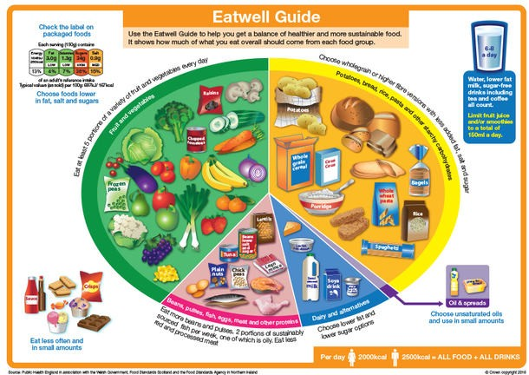

Following the [NHS Eat Well Guide](https://www.nhs.uk/live-well/eat-well/the-eatwell-guide/) will provide you with optimum nutrition for health, including good MSK health.

As well as adequate protein and energy we need vitamin D for good MSK health. The recommended daily is 10 micrograms per day. Public Health England (based on the findings of a SACN review) recommend that:

* The majority of the UK will have sufficient vitamin D intakes during the spring and summer through safe sunlight exposure on the skin combined with the vitamin D consumed within a healthy, balanced diet
* During autumn and winter, it is difficult for people to meet the 10 micrograms per day vitamin D recommendation just by consuming foods naturally containing or fortified with vitamin D. It is therefore recommended that individuals consider taking a daily supplement of 10 micrograms of vitamin D during the autumn and winter months
* People whose skin has little or no exposure to the sun are at increased risk of vitamin D deficiency and therefore need a vitamin D supplement throughout the year
* Minority ethnic groups with dark skin may also not get enough vitamin D from sunlight in the summer and therefore should consider taking a daily supplement all year round

### **Smoking**

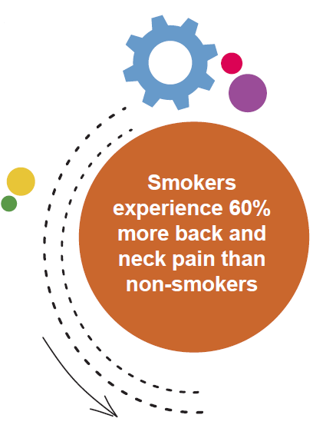

Smoking is harmful to musculoskeletal health although the harm caused can be partially reversed by quitting smoking. Research carried out for Public Health England found that smokers and ex-smokers experience 60% more pain in the back, neck and legs and 114% increase in disabling lower back pain.

Smoking is bad for MSK health as it has a negative impact on bone mineral density, reducing calcium absorption

and lowering levels of vitamin D. Studies undertaken demonstrated that lower bone mineral density was apparent among men as young as 18-20 and that smoking particularly impacted bone density for post-menopausal women.

The researchers found that smokers experienced more bone fractures and slower healing and is associated with up to a 40% increase in the risk of hip fractures among men. Smoking is also a contributing factor of rheumatoid arthritis and osteoporosis, and reduces the impact of treatment.

Much of the harm done to the MSK system occurs in the middle years (40s and 50s) although some evidence shows that smoking as a teenager affects skeletal development.

Find out more about quitting on our website [www.abettermedway.co.uk/smokefree](https://medway2.sharepoint.com/sites/Workplacehealthprogramme/Shared%20Documents/General/Employer%20Guides%20to%20be%20added%20to%20website/www.abettermedway.co.uk/smokefree) or call 0800 234 6805.

**MSK Health and Mental Health**

There is a clear link between good MSK health and good mental wellbeing. For people living with MSK conditions, chronic pain and a loss of independence can effect self-esteem, and lead to stress and depression. One third of adults with an MSK condition experience persistent anxiety, and one fifth suffer with depression. Stress can also manifest in the form of musculoskeletal pain and cause tension. Any musculoskeletal initiatives in the workplace should consider mental health support. For more information on being a mentally healthy workplace, please see the resources at the end of this guide.

### **Musculoskeletal Health and Workplace Health and Safety**

The Health and Safety Executive (HSE) makes it clear that by law, employers are responsible for health and safety management. Employees and those who are self-employed have important responsibilities too.

The employer has a duty to protect the health, safety and welfare of their employees and other people who might be affected by their business. Employers must do whatever is reasonably practicable to achieve this. This will vary depending on the nature of the business and work carried out. It means that the employer ensures that their team’s workers and others are protected from anything that may cause harm, effectively controlling any risks to injury or health that could arise in the workplace, including MSK health.

For further information on the basics of what employers must to, visit [https://www.hse.gov.uk/simple-health-safety/](https://www.hse.gov.uk/simple-health-safety/index.htm) index.htm

Manual handling injuries and upper limb disorders are among the main cause of MSK issues in the workplace. Awkward posture, previous and existing injuries and pre- existing conditions, repetitive work using the hands and arms, insufficient rest breaks and excessive use of hand held power tools are are all risk factors in developing MSK conditions. It is vitally important to carry out adequate risk assessments for work tasks so that manual handling is avoided, assessed and reduced as much as is reasonably practicable. This should include DSE (Display Screen Equipment) assessments. An employer is still responsible for a worker’s health if they are working at home, and therefore staff working at home should still carry out a DSE Assessment and any needs rising from this be addressed.

Employees should report any signs and symptoms of an MSK to their employer at an early stage so that steps can be taken to reduce further risks and injury. It is best practice to seek advice from an occupational health professional when an employee has symptoms of an MSK condition.

Employees should follow the health and safety systems in their workplace, use equipment provided, attend training and co-operate with their employer on health and safety matters. They should also work in a manner which does not put others at risk.

Some workers are considered more at risk than others, and include new or expectant mothers, people living with disabilities, people returning to work after ill health or injury, inexperienced and temporary workers.

Find out more about Health and Safety for MSK in the useful resources guide at the end of this guide.

### **What employers can do to help**

There are several things that employers can do to support their staff. Here are some suggestions based on latest Health and Wellbeing research and best practice. This guide has focused particularly on musculoskeletal health although many of these initiatives will support and promote better health and wellbeing in general.

* Open communication with staff will encourage them to come forward and report concerns regarding their own health and wellbeing, as well as health and safety within the organisation. Enabling staff to speak up and seek help can make a big difference to managing conditions and prevent them from worsening. Consult with staff when changes are being made in the workplace, and if you have a workplace union involve them in discussions too.
* Ensure senior management are on board with health and wellbeing initiatives. Having senior managers speak out about their own experience can encourage staff to speak up.
* Consider the demographics of your workforce. Are there particular groups which need special consideration, training or guidance?
* Use a staff noticeboard, either in a staff room or on the company drives to promote good health messages and signpost staff to sources of support.
* Carry out return to work interviews to ensure staff are supported when returning to the workplace after absence.
* Carry out suitable risk assessments and revisit these regularly, don't make them just a tick box exercise. Include regular DSE Assessments, even for home workers.
* Make good use of reasonable adjustments for staff who need adaptations to their working practices
* Encourage physical activity in the workplace. Not everyone is a gym lover so consider wider initiatives. Introducing lunchtime walks, walking meetings, physical activity challenges or discount on purchasing trainers and exercise equipment will support staff to move more and improve their physical and mental health. Set up an exercise equipment or DVD library for staff to swap items amongst themselves.
* Encourage staff to take suitable rest breaks, which encourage movement and allow sufficient rest.
* Ensure an up to date training programme is in place for manual handling and health and safety refreshers. Conside what training line managers need to support their teams.
* Promote local stop smoking services and take part in national campaigns such as Stoptober and National No Smoking Day.
* Encourage healthy eating by looking at menus where on site catering is provided.
* Offer healthy options when catering is provided for training or work based functions.
* Use stress risk assessments to evaluate stress in the workplace and reduce it where reasonably practicable.
* Ensure proper equipment is provided for manual or repetitive tasks.
* Take part in various campaigns, which raise awareness of Musculoskeletal conditions and disabilities. This will improve knowledge in the workforce and increase understanding towards colleagues living with long-term health conditions. A third of people with long-term health conditions do not feel that their colleagues understand their health needs.

### **Sole traders and entrepreneurs**

Sole traders and entrepreneurs can face different challenges in managing their MSK health. Flexibility of working for yourself can help with attending appointments but often risk assessments for desks and work equipment can be forgotten. Leading a healthy lifestyle and ensuring health and safety guidance is used will help. For more information on healthy workplaces for sole traders please contact us.

### **Useful Resources**

* [A Better Medway](http://www.abettermedway.co.uk) - local health improvement advice and support for Medway
* [One You Kent:](https://www.kent.gov.uk/social-care-and-health/health/one-you-kent) local health improvement advice and information for Kent
* Access to work programme for support and equipment at work when you have long term health condition or disability [https://www.gov.uk/access-to-work](http://www.gov.uk/access-to-work)
* Access to work programme for support and equipment at work when you have long term health condition or disability [https://www.gov.uk/access-to-work](http://www.gov.uk/access-to-work)
* ARMA - the Arthritis and Musculoskeletal Alliance: [http://arma.uk.net/](http://www.arma.uk.net/)
* Arthiritis Information: [https://www.versusarthritis.org/](http://www.versusarthritis.org/)
* [Back Care UK](http://www.backcare.org.uk)
* Business in the Community Public Health England Toolkits: [Mental Health toolkit for employers](http://wellbeing.bitc.org.uk/all-resources/toolkits/)
* [Every Mind Matters](https://www.nhs.uk/oneyou/every-mind-matters/) Mental Health information from the NHS and Public Health England
* [For Better Mental Health at Work](https://www.mentalhealthatwork.org.uk/)
* [Health and Safety Executive](http://www.hse.gov.uk) - Manual Handling at work, Upper Limb disorders, Risk Assessments, Vibration at Work, Display Screen Equipment, Lifting and Carrying, Working with Loads.
* Making Every Contact for Back Pain [Count:http://meccback.co.uk/back-pain-the-facts/](https://www.mentalhealthatwork.org.uk/)
* Mental Health First Aid – [Line Manager’s Resource](https://mhfaengland.org/line-managers-resource/) 
* Mind: [https://www.mind.org.uk/](http://www.mind.org.uk/)
* NHS for information on various condtions and healthy lifestyles: [https://www.nhs.uk/](http://www.nhs.uk/)
* NHS One You for healthy lifestyle advice: [https://www.nhs.uk/oneyou/](http://www.nhs.uk/oneyou/)
* Royal Osteoporosis Society: [https://theros.org.uk/](http://www.theros.org.uk/)

### **Case Studies**

At Lustre Consulting, we recognise that a large amount of time at work can be spent at a desk using a computer. When we moved to our new office in 2019, we wanted to ensure that every person had a safe and comfortable place to work. Desk assessments were carried out for each person using a Work Station Set Up guide and they are repeated if any significant changes to the workstation take place.

The health and wellbeing of all Lustre staff is of great importance and our organisation strives to maintain good health and wellbeing as part of an effective work-life balance. Lustre understands the numerous benefits associated with physical activity and as such we aim to break down barriers to participation, provide support and encourage all employees to be active both during and outside the working day. We have done a few simple things such as allowing staff to store clothing, shoes etc. in the workplace to enable staff to engage in physical activity before or after work. In our new office building, they are also able to access showers for use after exercise.

We also make a small contribution to the cost of a gym membership or other activities. This year we have seen a bit uptake in this physical activity initiative. Our employees have used the contribution for a range of activities from rock climbing, to gym classes and cycling. We have seen the benefit of the physical activities on the overall wellbeing of our staff.

Ariel Rapson, Office Manager, **Lustre Consulting Limited**

National Grid, Grain LNG have always encouraged staff to be physically active either in the workplace or outside of work. Many events have been organised over the years, which include regular community days, cycle rides, or Fitbit challenges to name but a few. During working hours staff are encourage to take regular breaks from workstations. There has even been a mile route mapped out around our carpark for staff to walk. However, as active as we are, Grain LNG realised the impact a poorly set up workstation can have on our employees' musculoskeletal health (MSK). For a long time in industry, MSK and digital display screen (DSE) have been overlooked whilst manual handing has been focused on. In some aspects, DSE was viewed upon as a bit of a joke or a tick box exercise. Although National Grid already have a robust DSE approach via an online where extreme cases can be referred to occupational health, we wanted to tailor the approach for us with face to face assessments. These wouldn’t replace the online system but enhance knowledge to the problem.

Firstly we held educational town halls where a physiotherapist explained the dangers of poorly set up workstations. After the initial education we employed a small local company to attend site to conduct face to face assessments, this reinforced the importance of correct posture. Included in the assessment for those who wish is a 10 minute desk massage, this has become a hit with our staff with many asking when they are coming to site next. Introducing this this approach has led to a proactive approach to MSK and expelled some of the ‘it won’t happen to me’ attitude within our staff. MSK is a hidden danger with symptoms sometimes not developed until it’s too late.

Education, knowledge and action can drastically improve quality of life for our staff now and in the future.

Stuart Clack, PEx Practitioner / Electrical Technician, **National Grid Grain LNG**

### **Posture tips**

Poor posture can lead to neck and back pain. These simple tips can help you to maintain a good posture and avoid what is commonly known as "tech neck": Avoid slouching when you sit down. Slouching can increase tension in the muscles, which may cause pain. make sitting correctly a good habit. You may find it helps to use exercises to strengthen your core and buttock muscles, and back extensions, will help correct a slouching posture.

Spending long periods sitting down can also contribute to a flat back. A flat back also tends to make you lean your neck and head forwards, which can cause neck and upper back strain. Exercises to strengthen your core, buttocks, neck and rear shoulder muscles, and back extensions, are recommended to help correct a flat back.

Try to get up from your desk regularly, or stand when making phone calls. Leaning over your lap top or PC may make your head lean forward, which can lead to poor posture.

Using a mobile can cause similar problems dubbed "tech neck". Try to avoid looking down at your device screen for long periods. When standing, avoid leaning to one side for too long. Doing this often can lead to muscle

imbalances around the pelvic area, which can cause muscular strainind the lower back and buttocks. Other causes of uneven hips include carrying heavy backpacks on one shoulder, and parents carrying toddlers on one hip.

To improve this posture, try to get into the habit of standing with your weight evenly distributed on both legs.

Thank you to all those who have contributed to this guide: Members of the Public Health Team, National Grid Grain LNG, Lustre Consulting, Medway Community Healthcare

The following sources of information were consulted in the production of this guide:

Business in the Community Public Health England Toolkits: Musculoskeletal Health in the Workplace and Mental Health toolkit for employers: http://wellbeing.bitc.org.uk/all-resources/toolkits/

https://www.futurelearn.com/courses/musculoskeletal/

https://fingertips.phe.org.uk/profile/msk

Department of Health and Social care working with Public Health England and Department for Work and Pensions - Musculoskeletal Health: A 5 year strategic framework for prevention across the lifecourse

Musculoskeletal Health: applying All Our Health - Public Health England

HSE INDG143 Manual handling at work A brief guide

HSE INDG71 Managing upper limb disorders in the workplace

NHS Eat Well Guide and https://www.nhs.uk/conditions/vitamins-and-minerals/vitamin-d/

Care First - posture tips and tech neck.

**Contact**

For a no obligation meeting to get the Workplace Health programme started in your business, or for further information please contact:

By email [workplacehealth@medway.gov.uk](mailto:workplacehealth@medway.gov.uk). By telephone 01634 334307 or visit the [website.](http://www.medway.gov.uk/healthyworkplace)