Move in a healthy direction
Women’s Health: An Employer's Guide

Women’s Health: An Employer's Guide

Introduction

Almost 73% of women aged 16-64 in the UK are in employment. The equalisation of the state pension age has seen the number of women aged over 60 in employment rise in the last few years. In this guide, we will look at issues affecting women in the workplace, which in turn have an impact on their employers. The guide will focus on the Menopause. However, we have also included some brief information about reproductive health, cervical screening, female cancers and fertility. How employers support women and their partners through these issues can make a big difference to staff engagement, absence and retention. You will find further information through the useful resources links at the end of the booklet. Throughout this leaflet we will refer to women, however these conditions can also affect all individuals who were assigned female at birth.

What is the Menopause?
The menopause occurs between the ages of 45 and 55 years of age as a woman's oestrogen levels decline. It is a natural part of ageing for women. The menopause lasts between 4 and 8 years, although for some individuals it can last 12 years. The menopause happens when is when a woman’s periods stop and she is no longer able to become pregnant naturally.
Symptoms can occur in both the day and night and may interfere with work. Common symptoms include hot flushes, night sweats, difficulty sleeping, low mood or anxiety, reduced libido and problems with memory and concentration.
During the menopause, oestrogen levels fall, and remain lower, resulting in ovulation and periods stopping. If a woman is over 50 and does not have a menstrual period for 12 months, health professionals consider her to have gone through the menopause.
Prior to reaching the menopause, women will go through a phase called the Perimenopause. During this period (usually around 4 years), the body starts to prepare for the menopause. Oestrogen levels will fall and then rise again causing irregular monthly cycles as well as mood swings, stomach cramps and other symptoms associated with the menstrual cycle.
Reproductive Health and Fertility
In addition to the effects of the menopause and perimenopause of women in reproductive health, issues can also affect women of working age. Around 1 in 7 couples will experience infertility, with a variety of causes.
1 in 20 women also live with a condition called PMDD (or Premenstrual Dysphoric Disorder). PMDD is sometimes referred to as an extreme version of PMS (Premenstrual Syndrome) which can cause many emotional and physical symptoms during the woman’s monthly cycle. PMDD is a hormone-based disorder affecting moods, thought to be caused by an adverse reaction to the fluctuating levels of hormones in the monthly cycle.
Common symptoms include difficulty concentrating, depression, anxiety, sadness, hopelessness, anger, lethargy, loss of interest in normal day to day activities, food cravings and insomnia or hypersomnia (excessive daytime sleepiness), joint or muscle pain and feeling bloated.

Cervical Screening
Cervical screening (a smear test) checks the health of the cervix. The cervix is the opening to the womb. It is not a test for cancer, but can help to prevent cancer. All women and people with a cervix aged 25 to 64 should be invited by letter to attend a screening appointment. Early detection of abnormal cells, and early treatment can prevent cervical cancer from developing. Allowing female staff to attend their screening appointments will encourage uptake of the screening programme. Employers can commit to the Time to Test Pledge with Jo’s Cancer Trust will show your commitment to female staff accessing screening appointments. You may also consider allowing attendance at other screening such as bowel screening or testing for all staff members.

Female Cancers
There are around 55,000 new cases of breast cancer diagnosed each year in the UK, with breast cancer likely to affect 1 in 20 females in the UK in their lifetime. Experts believe that almost a quarter of these could be avoided by leading a healthy lifestyle. Breast Cancer makes up 15% of all cancer cases in the UK and is second most common cause of death for females (after heart disease). Breast Cancer survival rates are improving, particularly if diagnosis is made early.
There are around 7400 cases of Ovarian Cancer diagnosed each year in the UK, and if the sixth most common cancer to affect women in the UK. Rates expected to increase by 15% over the next 10-15 years.
Being diagnosed with cancer, or any sort, whether female or male is a frightening experience and having an understanding and supportive employer can make all the difference.

Why should employers implement support for Women’s Health in the Workplace?

Women make up a large proportion of the workplace, with some industries such as health and social care, education, retail and secretarial or office based occupations having some of the highest proportion of female staff.

In terms of the menopause, studies have shown that symptoms can have a significant impact on attendance and performance in the workplace. As our population are now living longer and working longer, it is of vital importance that staff are supported to stay well and thrive in the workplace.

Issues affecting women’s health are not just female issues. They affect the whole organisation. Awareness on these topics are fundamental and reducing the stigma attached to them and enabling women, and their families to be supported through these life events. The CIPD (Chartered Institute for Personnel and Development) carried out a survey with YouGov, finding that almost two thirds of women had difficulty concentrating because of menopausal symptoms, 30% took sick leave to manage their symptoms and a third felt embarrassment when raising their issues with managers.
With 1 in 3 workers likely to be over the age of 50 by 2030, the numbers of women affected by the menopause whilst working is set to rise.
Having appropriate and supportive policies in place, with absence management systems can keep staff engaged and save absence costs.
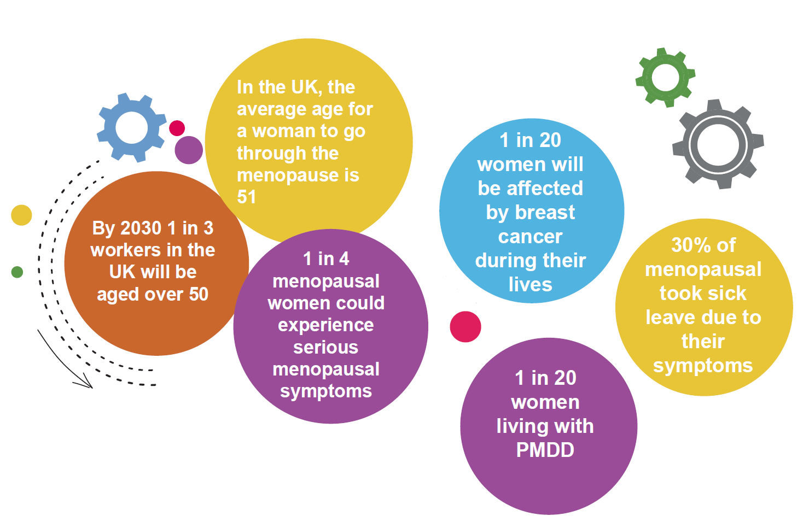

Links to other conditions
As we have read, health issues such as PMDD and living through the menopause can affect mental and physical health. Mental Health should always be considered when tackling other health issues in the workplace. Equally, leading a healthy lifestyle can reduce the risk of cancers and help to manage menopausal symptoms. It is therefore important to include wider healthy promotion messages in any activities planned for the workplace.

Menopause, Reproductive Health and Workplace Health and Safety Law

The Health and Safety Executive (HSE) states that under health and safety law, employers must ensure the health and safety of all their employees, irrespective of age as much as it is reasonably practical to do so. Employers must also provide adequate information, instruction, training and supervision to enable their employees to carry out their work safely. Employers have a duty of care to make suitable and sufficient assessments of risks in the workplace, and special consideration should be made to groups of workers who could be particularly at risk, which may include older workers, new or expectant mothers and those undergoing treatment for medical conditions. In addition, employers should not discriminate on grounds of age, gender, or sex. (Equality Act 2010).

What employers can do to help

Employers can implement several things to support the women’s health amongst their staff group. Here are some suggestions based on latest Health and Wellbeing research and best practice. This guide has focused particularly on menopausal or reproductive health although many of these initiatives will support and promote better health and wellbeing in general.
- Open communication with staff will encourage them to come forward and report concerns regarding their own health and wellbeing, as well as health and safety within the organisation. Enabling staff to speak up and seek help can make a big difference to managing conditions and prevent them from worsening. Consult with staff when changes are being made in the workplace, and if you have, a workplace union involve them in discussions too. Ask about wellbeing in appraisals so that this becomes a normal part of conversations.
- Mention your provision for health and wellbeing at on boarding so staff are aware of the help available from day one. A good on-boarding programme can also help new team members to connect with colleagues, supporting health and wellbeing in the future.
- Ensure senior management are on board with health and wellbeing initiatives.
- Investigate engaging an employee assistance provider (staff counselling). If this is not an option, promote local support services available. Set up a notice board either in a staff room or on the company shared drives to promote good health messages and signpost staff to sources of support.
- Carry out return to work interviews to ensure staff are supported when returning to the workplace after absence.
- Ensure that risks assessments are up to date and take into account needs of specific staff groups, such as new and expectant mothers, older workers and those with health conditions.
- Make good use of reasonable adjustments for staff who need adaptations to their working practices, for example adjusting working hours. Follow correct procedures for any changes to work, even for the short term. Allow some home or hybrid working to allow staff to manage their symptoms if practical for their duties.
- Manage changes in performance with care. Ensure reasonable adjustments and performance reviews are carried our fairly for all staff.
- Look at absence management policies and be clear on time away from the workplace for medical appointment, including fertility appointments.
- Provide colleagues with someone to talk to other than their immediate line manager. You could offer them to talk to a member of the HR team if you have one, another manager or a colleague who is a health champion.
- Look at the workplace environment. Check it is suitable for staff to carry out their duties and provides space for breaks and that suitable sanitary disposal provisions are in place for female staff and visitors.
- Take part in various campaigns, which can improve health awareness such as breast cancer month, ovarian cancer awareness and PMDD month. These activities can help to break down stigma and will improve knowledge in the workforce and increase understanding towards colleagues living with long-term health conditions. A third of people with long-term health conditions do not feel that their colleagues understand their health needs.
- Promote healthy lifestyles. Being smoke-free, eating healthily and keeping active will help to prevent cancers and help in managing symptoms of other conditions.
- Offer training for managers. This is available from various organisations, including ACAS and will help equip them to better support their teams.
- Offer sanitary products in wash rooms for staff to use to avoid unnecessary embarrassment if an unexpected period occurs, or if they experience heavy bleeding.
- Allow staff to take additional breaks, and if reasonably practical provide a light and airy restroom, or allow staff to go for a short walk which can help in alleviating hot flush symptoms
- Consider adapting uniforms to make the more comfortable, if possible to do so.
- Set up a quiet and confidential area for staff to take or make calls regarding appointments, which sometimes have to take place in working hours.

Useful Resources
- A Better Medway - local health improvement advice and support in Medway
- Access to work programme for support and equipment at work when you have long term health condition or disability https://www.gov.uk/access-to-work
- One You Kent: local health improvement advice and information for Kent
- Access to work programme for support and equipment at work when you have long term health condition or disability
- Business in the Community Public Health England Toolkits: Mental Health toolkit for employers
- Every Mind Matters Mental Health information from the NHS and Public Health England
- For Better Mental Health at Work
- ACAS: Menopause at Work Guidance, Menopause Training for Managers
- CIPD: Let's talk Menopause
- Health and Safety Executive – HSE Management Standards, Advice for Managers on Mental Health Conditions
- Mental Health First Aid – Line Manager’s Resource 
- Mental Health Charity Mind.
- International Association for Premenstrual Disorders.
- Daisy Network at www.daisynetwork.org.
- See Her Thrive Workplace Wellbeing for Women
- NHS for information on various conditions and healthy lifestyles: https://www.nhs.uk/
- NHS Better Health Campaign, for healthy lifestyle advice.
- Cancer Research UK
- Breast Cancer UK
- Ovarian Cancer Action UK
- Jo’s Cancer Trust

Contact
For a no obligation meeting to get the Workplace Health programme started in your business, or for further information please contact:
By email workplacehealth@medway.gov.uk. By telephone 01634 334355 or visit the website.

Thank you to all those who have contributed to this guide: Members of the Public Health Team,
The following sources of information were consulted in the production of this guide:
Business in the Community Public Health England Toolkits: NHS Employers: Menopause and the Workplace, ACAS Menopause at Work Guide, CIPD, Office of National Statistics, Cancer Research UK, Breast Cancer Care, Ovarian Cancer Action, See Her Thrive, Mind and NHS One You

