Waste and Recycling End

Destinations Report 2019 – 2020

Table of Contents

1. Introduction |  | Page 2
2. How to find out more information |  | Page 2
3. How to contact us with questions and comments |  | Page 2
4. 2018/19 Waste & Recycling End Destinations Table |  | Page 3
5. Geographical Location of Waste & Recycling Reprocessing |  | Page 7
6. Proportion of Waste Streams Collected in 2018/19 |  | Page 9
7. Frequently Asked Questions |  | Page 10

1. Introduction

In a bid to be more transparent and maintain confidence in Medway’s waste and recycling services, Medway Council now release an annual report summarising the end destinations of waste and recycling materials.

This report is the third annual release covering the period April 2019 until March 2020 which details all waste materials collected by Medway’s contractors through:

- Kerbside collections
- Recycling centres (Capstone, Cuxton and Gillingham)
- Bring sites
- Street cleansing crews.

2. How to find out more information

Local authorities in the UK have a statutory duty to report all waste tonnages and destination information to www.wastedataflow.org.

This is a publicly available database to which anyone can register to view the information for individual local authorities.

If you would like to view more detailed information including waste tonnages, you can register for public access using the link below:

https://www.wastedataflow.org/Register.aspx

Local authority waste data is reported three months in arrears. Reporting deadlines are as follows:

Period |  | Data available by
April to June |  | 30th September
July to September |  | 31st December
October to December |  | 31st March
January to March |  | 30th June

3. How to contact us with questions and comments

If you have any questions or comments regarding this report or the information contained within please contact us via:

wastedisposalteam@medway.gov.uk

4. 2019/20 Waste & Recycling End Destinations Table

Process | Company | Address | Material Sent | Source
Biomass | MVV Environment Ridham Limited | Ridham Dock Biomass Facility,  Lord Nelson Road, Ridham  Dock, Sittingbourne, Kent ME9  8FQ | Dirty Wood (unsuitable for recycling) | HWRCs
Composting | Countrystyle Recycling | Kemsley Fields Business Park,  Ridham Dock Rd., Iwade,  Sittinbourne. ME9 8SR | Garden waste | HWRCs
Composting | Envar, Cambridge | Cheffins, The Heath,  Woodhurst, Huntingdon,  Cambridgeshire, PE28 3BS | Organic (brown bin) waste | Kerbside collection
Composting | West London Composting | Newyears Green Lane,  Harefield, Middlesex, UB9 6LX | Organic (brown bin) waste | Kerbside collection
Energy recovery | Allington | Kent Enviropower, 20/20  Busoness Park, Laverstoke  Road, Allington, ME16 0LE | Residual waste (black sack) | All sources
Energy recovery | Cory Riverside  Resource  Recovery Ltd | Norman Road  Belvedere  Kent  DA17 6JY | Residual waste (black sack) | All sources
Energy recovery | Greenwich RDF | Veolia Greenwich RDF  Nathan Way  Plumstead Marsh  Thamesmead  London  SE28 0AW | Residual waste (black sack) | All sources
Energy recovery | Kemsley ERF | Wheelabrator Kemsley WtE  Sittingbourne, Kent ME10 2TD | Residual waste (black sack) | All sources
Energy recovery | Marchwood ERF | Poles Lane, Otterbourne,  Winchester, Hampshire SO21 2EA | Residual waste (black sack) | All sources
Energy recovery | Newhaven Energy Recovery | Veolia ES South Downs,  Newhaven Energy Recovery  Facility, North Quay,  Newhaven, East Sussex, BN9  0HE | Residual waste (black sack) | All sources
Energy recovery | Quick Waste Ltd | Quick Waste Ltd, Waste  Transfer Station, Sittingbourne  ME10 3RR | Residual waste (black sack) | All sources
Energy recovery | SELCHP | South East London Combined Heat and Power, The Kennels  Site, Landmann Way,  Lewisham, SE14 5RS | Residual waste (black sack) | All sources
Energy recovery | SITA  Sittingbourne | Sittingbourne Waste Transfer  Station, Units 5 And 6, West Lane, West Lane Trading  Estate, Sittingbourne, Kent,  ME10 3TT | Residual waste (black sack) | All sources
Energy recovery | Southwark MBT | Southwark Intergrated Waste  Management Facility, 43 Devon  Street, South East London,  ME16 0LE | Residual waste (black sack) | All sources

Process | Company | Address | Material Sent | Source
Energy recovery | SSSI Ltd | Berth 6 Basin 3, Chatham  Docks, Gillingham, Kent ME4  4SR | Residual waste (black sack) | Bulky collections & fly tipping
Energy recovery | Veolia East Kent | Veolia ES, East Kent RDF facility, Unit 3, Canterbury Industrial park , Island Road,  Hersden, Kent, CT3 4HQ | Residual waste (black sack) | All sources
Hazardous  Waste Disposal | Environmental Resource Group | Alchemy House, Coppice Side  Industrial Park, Brownhills,  West Midlands WS8 7EU | Chemicals | HWRCs
Hazardous  Waste Disposal | Pinden | Pinden Quarry, Green Street,  Green Road, Longfield, Dartford, DA2 8EB | Asbestos | HWRCs
Hazardous  Waste Disposal | Tradebe | Tradebe, Medway City Estate, Strood, Kent ME2 4LY | Clinical Waste | Booked household collection
Landfill | Ockenden | Ockendon Landfill, Medebridge Road, Grays, RM16 5TZ | Mattresses | Bulky collections & fly tipping
Landfill | Rainham Landfill | Rainham Landfill, Coldharbour  Lane, Off Ferry Lane, Rainham, Essex RM13 9DA | Residual waste (black sack) | All sources
MRF Recycling | Bywaters | Bywaters MRF, Lea Riverside,  Twelvetrees Crescent, London  E3 3JG | Comingled Reyclate (white bags) | Kerbside collection
MRF Recycling | Southwark MRF | Southwark MRF, 43 Devon Street, London, SE15 1AL | Comingled Reyclate (white bags) | Kerbside collection
MRF Recycling | Viridor Waste Management | Viridor Waste Management,  Century Wharf, Crayford Creek, Dartford , Kent DA1 4QG | Comingled Reyclate | HWRCs
Other disposal | Rainham  Roadsweepings | Rainham Landfill, Coldharbour Lane, Rainham, RM13 9BJ | Street sweepings | Street cleaning
Recycling | Ace UK | The Alliance for Beverage  Cartons and the Environment (ACE UK)  S33, The Innovation Centre  Sci-Tech Daresbury, Daresbury  Warrington WA4 4FS | Cardboard beverage packaging | Bring banks
Recycling | Blue Samaritans | Unit 27 Chamberlains Farm, Sporehams Lane, Danbury,  Sandon, Chelmsford CM3 4AJ | Textiles | Bring banks
Recycling | Countrystyle Recycling | Kemsley Fields Business Park,  Ridham Dock Rd., Iwade,  Sittinbourne. ME9 8SR | Glass bottles | HWRCs
Recycling | Countrystyle Recycling | Kemsley Fields Business Park,  Ridham Dock Rd., Iwade, Sittinbourne. ME9 8SR | Scrap metal | HWRCs
Recycling | Countrystyle Recycling | Kemsley Fields Business Park,  Ridham Dock Rd., Iwade, Sittinbourne. ME9 8SR | Paper & card | HWRCs

Process | Company | Address | Material Sent | Source
Recycling | Countrystyle Recycling | Ridham Dock Gypsum Facility,  Ridham Dock Rd., Iwade,  Sittingbourne. ME9 8SR | Plasterboard | HWRCs
Recycling | Countrystyle Recycling | Ridham Dock Gypsum Facility,  Ridham Dock Rd., Iwade,  Sittingbourne. ME9 8SR | Wood | HWRCs
Recycling | Day Group | Day Group, Murphys Wharf,  Lombard Wall, London SE7  7SH | Glass bottles | Bring banks
Recycling | Easy Load Ltd | Lee Yard, Old Rochester Way, Dartford, Kent DA1 3QU | Hardcore & Rubble | Fly-tipping
Recycling | EMR | 111, Fordham Road, Snailwell,  Newmarket CB8 7ND | Car batteries | HWRCs
Recycling | EMR | EMR Rochester  Whitewall Road, Medway City  Industrial Estate,  Strood, ME2 4DZ | Scrap metal | Bulky collections & fly tipping
Recycling | Gallagher  Aggregates Ltd | Hermitage Quarry, Hermitage  Lane, Maidstone, Kent. ME16 9NT | Hardcore & Rubble | HWRCs
Recycling | Greenworld | Unit 15, The Hayes Trading  Estate, Folkes Road,  Stourbridge, West Midlands  DY9 8RG | Textiles | Bring banks
Recycling | JMP Wilcox & Co  Ltd | Beldray Works, Beldray Rd,  Bilston, West Midlands WV14 7NH | Textiles | HWRCs
Recycling | Living Fuels | Living fuels, Coaches Drove,  Hockword, Thetford, Norfolk, IP26 1JQ | Cooking oil | HWRCs
Recycling | LM Barry | Brittania Mill, North Crescent, London. E16 4TG | Textiles | HWRCs
Recycling | LW Saits | LW Saits & Sons textiles banks  41 Springvale, Wigmore, Gillingham ME8 0JG | Textiles | Bring banks
Recycling | Matt UK | Berth 6 Basin 3, Chatham  Docks, Gillingham, Kent ME4 4SR | Mattresses | All sources
Recycling | MDJ Light Brothers | MDJ Light Brothers, Greystone  Quarry, Southerham, Lewes,  East Sussex, BN8 6JN | Fridges, Freezers and  other cooling appliances | All sources
Recycling | Palm Recycling Ltd, Kings Lynn | Former British Sugar Site,  Poplar Avenue, Kings Lynn, Norfolk PE34 3AL | Paper & card | Kerbside collection
Recycling | Pountney Tyres, | Unit 1, Meadow road Industrial Estate, Dale Road, Worthing.  BN11 2RU. | Tyres | HWRCs
Recycling | Recolight | New Building, Maurice Gaymer Road, Gaymers Ind Est,  Attleborough, Norfolk NR17  2QZ | Fluorescent tubes & light bulbs | HWRCs

Process | Company | Address | Material Sent | Source
Recycling | S&P Tyres | Gary & Valerie Pilcher, Bobbing  Car Breakers, Corbiere,  Sheppey Way, Bobbing,  Sittingbourne, ME9 8QX | Tyres | Fly-tipping
Recycling | Salvation Army | Salvation Army Trading  Company Ltd (SATCoL) Unit 1,  Pytchley Lodge Industrial  Estate, Pytchley Lodge Road, Kettering Northants. NN15 6JQ. | Textiles | Bring banks
Recycling | Slicker Oil | Hollywells Site, Cliff Quarry, Ipswich IP3 0BE | Mineral oil | HWRCs
Recycling | SOEX | SOEX House 16 Perrywood  Business Park Honeycrock  Lane Redhill Surrey RH1 5JQ | Textiles | Bring banks
Recycling | Sweeep  Kuusakoski Ltd | Sweeep Kuusakoski Ltd, Gas  Road, Sittingbourne, Kent ME10 2QB | Televisions and other screens | All sources
Recycling | Sweeep  Kuusakoski Ltd | Sweeep Kuusakoski Ltd, Gas  Road, Sittingbourne, Kent ME10 2QB | Small electrical appliances | All sources
Recycling | Sweeep  Kuusakoski Ltd | Sweeep Kuusakoski Ltd, Gas  Road, Sittingbourne, Kent ME10 2QB | Large electrical appliances | All sources
Recycling | Synergy Recycling | Synergy Recycling, Merton  Farm, Merton Lane,  Canterbury, CT4 7BA | Gas Bottles | HWRCs
Recycling | Take Back Ltd | 39, Brunel Way, Thetford,  Norfolk. IP24 1HP | Ink cartridges | HWRCs
Recycling | URM (UK) Limited | URM Tilbury, Unit 46 Berth,  Tilbury Docks, Tilbury, Essex  RM18 7EH | Glass bottles | Bring banks
Recycling | Waste Care | Richmond House, Selby Road, Leeds. LS25 1NB | Household batteries | HWRCs  and  Libraries
Reuse | Abacus Furniture Project | Walderslade Rd, Chatham, ME5 9LR | Furniture, bikes, bric a brac | HWRCs
Reuse | BHF Reuse Banks | British Heart Foundation stores | Books | Bring banks

5. Geographical Location of Waste & Recycling Reprocessing

5.1. Figure 1 below summarises where all waste and recycling that Medway Council collected was sent for reprocessing between April 2019 and March 2020.

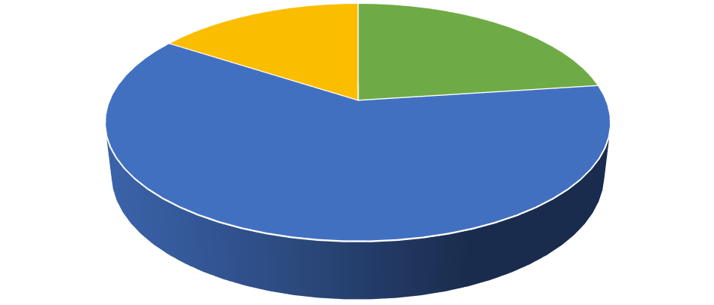

%
23
%
61
%
16
Kent
UK (outside of Kent)
Abroad

Figure 1 – Where Medway sent all household waste and recycling 2019/20

5.2. Figure 2 below summarises the kerbside recycling (blue and white bags) that Medway Council collected and where it was reprocessed between April 2019 and March 2020.

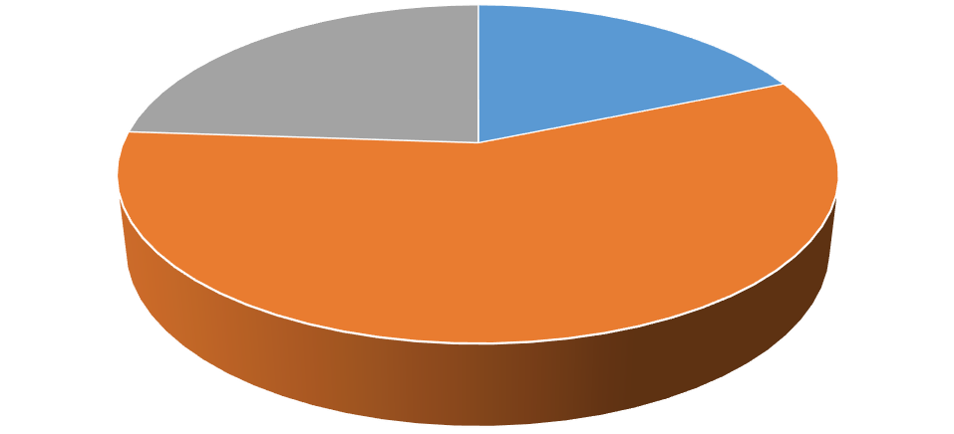

19
%
57
%
24
%
Kent
UK (outside of Kent)
Abroad

Figure 2 – Where Medway sent kerbside recycling 2019/20

5.3. Figure 3 below summarises the kerbside organic recycling (brown bins, caddies and garden waste bags) that Medway Council collected between April 2019 and March 2020. All of this material was reprocessed in UK facilities.

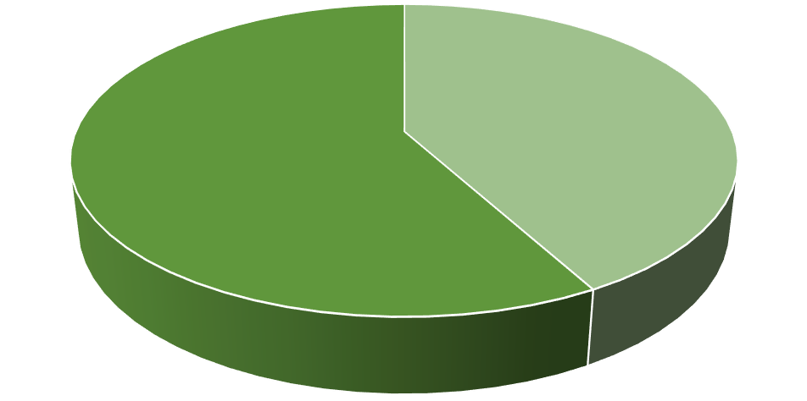

42
%
58
%
Envar Cambridge
West London Composting

Figure 3 – Where Medway sent kerbside organic waste 2019/20

5.4. Figure 4 below summarises the residual waste (black sacks, fly tipping, litter and road sweepings) that Medway Council collected and where it was sent for processing between April 2019 and March 2020.

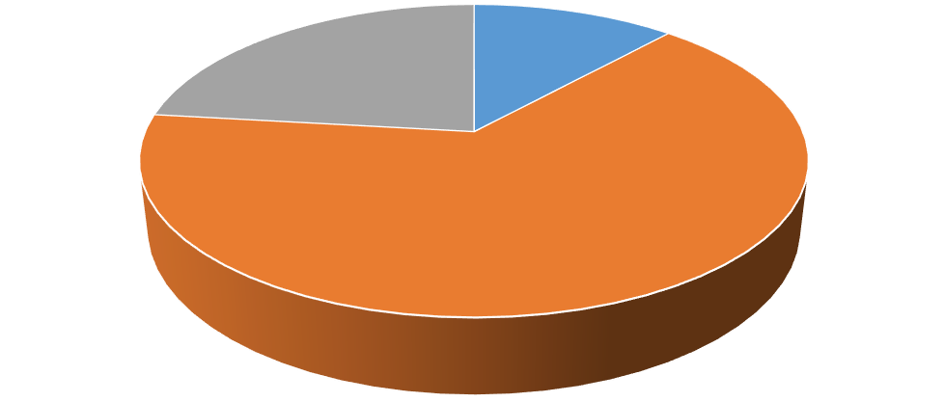

12
%
65
%
23
%
Kent
UK (outside of Kent)
Abroad
Figure 4 – Where Medway sent residual waste 2019/20

6. Proportion of Waste Streams Collected in 2019/20

6.1. Figure 5 below provides a visual summary of all household waste collected by Medway Council in 2019/20.

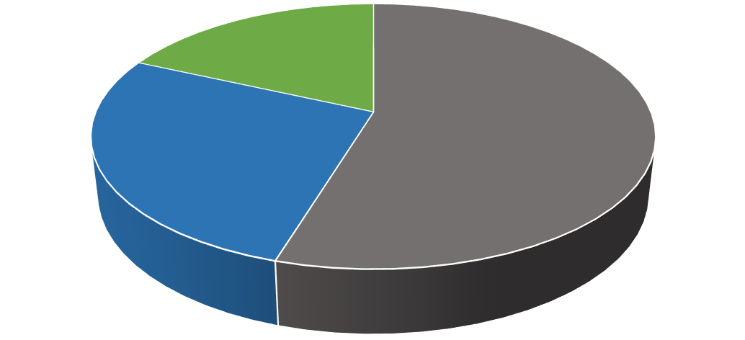

55
%
27
%
18
%
Residual
Recycling
Composting

Figure 5 – Proportion of Medway waste streams collected 2019/20

6.2. Figure 6 below provides a visual summary of all Medway’s waste by processing method. Further information on each disposal point are detailed in the table on pages 3 to 6.

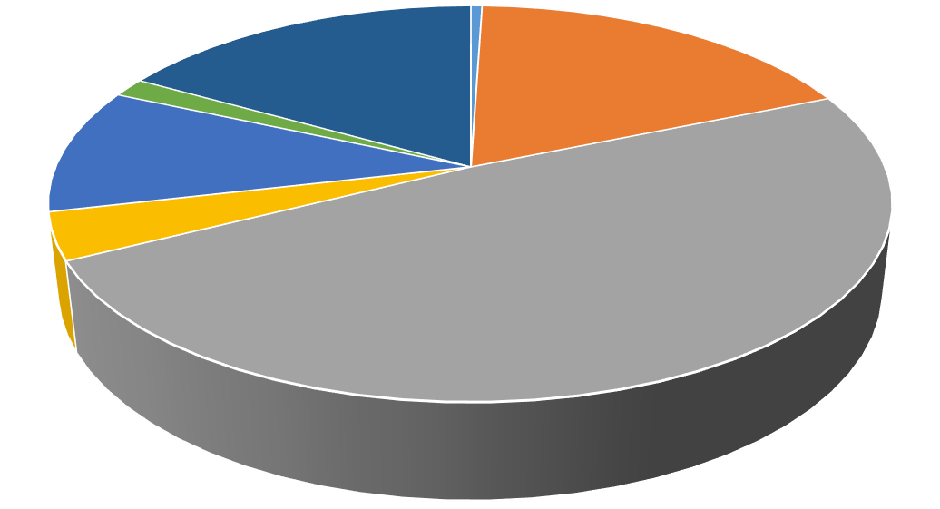

1
%
18
%
%
49
%
4
%
10
%
2
%
17
Biomass
Composting
Energy recovery
Landfill
MRF Recycling
Roadsweeping
Other Recycling
Figure 6 – Proportion of Medway waste by processing method 2019/20

7. Frequently Asked Questions

The frequently asked questions below are based on the most common questions we have been asked this year.

If you have a question that is not covered below please contact us using the details on page 2 of this document.

7.1. Why do some waste materials go overseas?

During 2019/20, 84% of the waste we collected in Medway remained in the UK for re-processing. Waste may be sent abroad where there is not available treatment capacity or a market available for it here in the UK.

Where treatment capacity or a market is not available, it is more environmentally friendly to ship the material to a foreign market where there is demand in comparison to landfill. Waste is only sent to approved and licensed re-processors.

7.2. What happens to contaminated kerbside recycling?

Some of the material received at the Materials Recycling Facility (MRF) will be ‘contaminated’ and not fit for recycling.

Contamination occurs when waste is placed in the recycling bags that cannot be recycled. Types of contamination we see regularly at the MRF are:

- Nappies and sanitary products
- Heavily soiled food packaging
- Batteries
- Electrical items (such as toasters or hairdryers)
- Non-recyclables mistaken for recyclables (such as glassware or metal kitchen utensils such as knives)
- Plastic bags placed in the cardboard/paper recycling

When the material is not fit for recycling it will be separated and either sent for further recycling if possible or be sent for energy recovery (incineration).

We want to make sure the recyclable waste we collect is not contaminated and of a high quality.

If you want to find out more on what can and cannot go into your recycling bags please use the link below:

https://www.medway.gov.uk/info/200132/waste_and_recycling/77/what_goes_in_my_rubbish_bins_or _bags/1

  - What checks are in place to ensure waste is recycled?

Medway Council and all its waste contractors take their duty of care very seriously and only work with fully licensed and approved waste re-processing facilities.

Waste re-processing facilities are audited to the highest standards with regular spot checks being made to ensure your waste is recycled properly.

The movement of waste, the manner in which a waste or recycling facility operates, the exporting of waste and the standard to which materials are recycled are all heavily regulated in the UK. This is to ensure illegal waste operations and movements can be prevented.

Every time waste is moved, whether that is locally, nationally or internationally, it is tracked via a
‘Waste Transfer Note’ that ensures a fully auditable paper trail.

  - Has material continued to be recycled during the Covid-19 pandemic?

Whilst this report covers the period prior to the Covid-19 pandemic we understand residents have some concerns over whether material collected has been recycled since lockdown begun in late March 2019.

Waste services are an essential service and as such all facilities have remained fully operational during this period meaning all collected recycling has been processed in the way it would have been previously.

