

**Move in a healthy direction**

Financial Wellbeing:

An Employer's Guide

Logo, Medway Healthy Workplaces

 image box showing three logos.  1) kent and medway healthy workplace programme, 2) Kent county council logo and 3) Medway Council

Financial Wellbeing: An Employer's

Guide

# Introduction

Research carried out by Salary Finance found that 36% of UK workers experience ongoing financial concerns. The Joseph Rowntree Foundation reports that 1 in 8 workers are living in poverty. Financial worries impact staff engagement, productivity, and staff retention. Employees affected by these concerns were more likely to have sleepless nights, be distracted during work hours, have increased absence, and look for other jobs. The Organisation for Economic Co-operation and Development reported that 11.5 million people in the UK have less than £100 in savings and 9 million often borrow to pay for food or bills. 9 million adults over-indebted (missing payments or finding that keeping up with payments is a heavy burden) and 22 million do not know enough to plan for retirement. 5.3 million Children do not get a meaningful financial education.

In early 2019 the UK Government launched its first strategy to address the nation’s financial wellbeing concerns. Through the Money and Pensions Service (MaPs), an arm's length department of the Department for Work and Pensions which incorporates The Money Advice Service and the Pensions Wise. It is the largest source of free debt advice in England and working with partners across the UK. A financially healthy nation is good for individual, communities, business, and the economy. Their strategy include improving financial wellbeing education in schools, encouraging more people to save, seek debt advice and plan for their finances in later life.

The Corona Virus pandemic and the effects on the economy and jobs makes financial wellbeing an even more important part of a holistic workplace wellbeing programme.

In this guide we will look at Financial Wellbeing, what it is and what employers can do to help.

# What is financial wellbeing?

Financial wellbeing is about a sense of security and feeling as though you have enough money to meet your needs. It's about being in control of your day-to-day finances and having the financial freedom to make choices that allow you to enjoy life. Financial wellbeing is not just about understanding pensions and retirement planning but should include elements of understanding pensions and retirement planning. It does need to consider any issues that colleagues are facing in the present, and identifying where the workplace can make a real and practical difference. The tips provided in this guide do not constitute financial advice, and if you or colleagues are experiencing financial worries you should seek support from registered professionals. Details are provided at the end of this guide.

# Why should employers worry about financial wellbeing?

It’s not just healthy eating, exercise, alcohol intake and not smoking that have an effect on our health and wellbeing. Our level of health is connected to our socioeconomic wellbeing. Many health issues are determined by social factors. Economic, environmental, and social inequalities can determine people's risk of getting ill, their ability to prevent sickness, or their access to effective treatments.

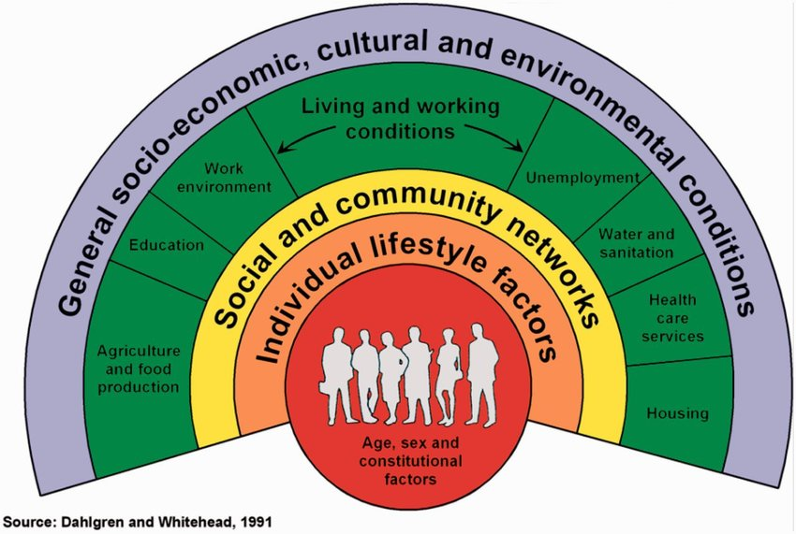

Dahlgren and Whitehead’s Wider Determinants of Health shows that employment, housing, living, and working conditions, as well as our social and community networks all impact our health. All these factors are affected by our finances. In addition, our finances affect the types of activities and food we can purchase, further impacting our health.

Financial wellbeing can lead to increased stress, with more people today stressed about money than relationships and health. 29% of employees surveyed by Salary Finance reported running out of money before pay day. Almost one fifth of people living with mental health problems have debt, and 1 in 4 of us can be affected by mental health at any one time. Poor mental health makes managing money harder, and worrying about money makes managing our mental health more difficult.

The Trussell Trust, the charity that runs the network of Food Banks in the UK, reported that 1 in 6 of their clients are in work. Increases in living costs, benefits freezes, the COVID outbreak and changes to personal circumstances have impacted people’s finances. Typically staff on lower wages have experienced more financial stress but this doesn’t mean that high earners aren’t affected. Since most people live to their means a sudden loss of income or unexpected bill can affect people from all income groups.

36% of UK employees have financial worries. Those living with these worries are 14.6 times more likely to have sleepless nights, 12.4 times more likely not to finish daily tasks, 7.7 times more likely to have troubled relationships with work colleagues and 1.5 times more likely to be looking for a job. This same group is more likely to suffer from poor mental health, they are 4.6 times more likely to be depressed and 4.1 times more likely to be prone to panic attacks. The Money and Pensions Advice Service found that 6.5m people are carers, which can add to financial concerns and 20% adults have been a victim of financial abuse. These statistics make compelling reasons for businesses to include financial wellbeing as a theme of their wellbeing strategy so that they benefit from the significant impact on productivity, quality, absenteeism, and retention.

# The Gender Pay Gap

# The gender pay gap is an equality measure that shows the difference in average earnings between women and men. The UK gender pay gap is at its lowest level ever - just over 18 per cent. The gender pay gap does not show differences in pay for comparable jobs. Unequal pay for men and women has been illegal for 45 years. The government is keen to address the gender pay gap and eliminate it within a generation. The government is addressing this by asking large employers, including the public sector to publish their gender pay gap, and gender bonus gap. They have also sought to address the issue improving access to funded childcare, extending the rights to request flexible working to all employees, and introducing shared parental leave. Work to encourage girls into a wider range of careers is ongoing. Addressing the gender pay gap should improve financial wellbeing for women and families across the UK.

# Financial Wellbeing and Gambling

# It’s estimated that there are 430,000 problem gamblers in the UK, with an additional 2 million people at risk. Several factors can but people more at risk of becoming a problem gambler, including past neglect or trauma, alcohol and substance misuse, the availability of gambling, having peers that are problem gamblers, a history of depression, social isolation, and low self-esteem. It is shown that men, and younger people are also more likely to become problem gamblers.

# Gambling in the workplace is easier than ever before with people using smart phones, having more online access. Workplace gambling such as sweep stakes and fantasy football leagues are commonplace. Problem gamblers may have low performance and motivation or increased absence in the workplace which can also be signs of other issues. It is worth remembering that not everyone with financial worries has gambled, and not everyone who gambles ends up with financial problems. Gambling should be considered as part of a financial wellbeing plan, and there are excellent resources and support available from the national charity GamCare. Please see the useful resources at the end of this guide.

# Sole traders and entrepreneurs

Sole traders and entrepreneurs can face different challenges in managing their financial wellbeing. Pressures of running a business and providing for your staff can mount up. Seek help before the stress affects your mental wellbeing. Business financial advice and support is available from local Business Growth Hubs, as well as the Chamber of Commerce. If financial worries are affecting your mental wellbeing seek support. A problem shared is a problem halved.

# What employers can do to help?

There are several things that employers to their overall wellbeing strategy which will support financial wellbeing. Our suggestions are based on the latest guidance and best practice. Many of these initiatives will support and promote better health and wellbeing in general.

* Open communication with staff will encourage them to come forward and report concerns regarding their own health and wellbeing.
* Consult with staff when changes are being made in the workplace particularly if these will have financial implications, and if you have a workplace union involve them in discussions too.
* Ensure senior management are on board with health and wellbeing initiatives. Having senior managers speak out about their own experience can encourage staff to speak up.
* Use staff surveys to find out what initiatives will help staff, what financial wellbeing means to them and to take feedback from them to evaluate the effectiveness of these.
* Consider the demographics of your workforce. There may be groups which need special consideration, such as workers approaching retirement, younger workers who might be living away from home for the first time, graduates paying off student debt.
* Signpost staff to sources of support. Having posters available on staff noticeboards, or on digital platforms will let staff know that organisations exist that can help them through difficult times. See the resources section at the end of this guide.
* Revisit your existing employee benefits. Look at the take up of these and see if these can be revised, enhanced, or better promoted to support financial wellbeing. Having access to discounts for large purchases, employee savings schemes, computer or bike purchase schemes and so on can all help.
* Increase financial education in your workforce. Running lunch and learn sessions with a speaker such as an authorised financial adviser, e-learning or promoting websites where people can learn to budget, understand credit, and pensions can all help to improve their financial wellbeing.
* If you have an Employee Assistance Provider, find out what financial wellbeing support they can offer, including information, training and workshops or counselling.
* Signpost staff to local Carer support services, so that if they have caring responsibilities, they can make sure that they are getting the financial benefits that they need.
* Social events can be great for team wellbeing, but if staff are expected to foot the bill for an expensive night out it can add pressure to existing worries. If you can’t subsidise socials, keep them varied so that some offer lower cost options, or set up payment plans to help people budget for them in advance.

# Financial Wellbeing Tips for Employees

# People experiencing financial worries may be affected by different financial worries, however sharing some top tips in your staff newsletters or through staff digital communication channels can help people to make steps in the right direction, and seek help when they need it:

* Don’t ignore debt – unchecked it will only get worse, and it won’t go away on its own. Access debt advice if you need to. Debt advice is available for free from Citizens Advice and charities such as Step Change or Christians Against Poverty.
* Explain your problems to someone you trust. Talking through issues can help you in dealing with these issues, and having a listening ear can be very supportive. If your employer has a staff counselling line, use them.
* Be sure to get expert independent advice and use reputable sources when seeking help, either from an organisation or online.
* Take control of your money and spending – make a budget and stick to it. The Money Advice Service offers a helpful budgeting tool. Save regularly and manage credit.
* Plan – retirement, home purchases and other big financial changes need planning. Seeking the right advice is paramount in getting it right and reducing stress.

Useful Resources

* [A Better Medway](http://www.abettermedway.co.uk/) - local health improvement advice and support in Medway
* [One You Kent](https://www.kent.gov.uk/social-care-and-health/health/one-you-kent) – local health improvement advice and support in Kent
* [Live Well Kent](https://livewellkent.org.uk) – mental health and wellbeing support
* [Money Advice Service](https://www.moneyadviceservice.org.uk/en)
* [Money and Pensions Service](https://moneyandpensionsservice.org.uk/)
* Support for Carers from [Carers First](https://www.carersfirst.org.uk/), [Carers East Kent](https://carersek.org.uk/), [Involve Carers West Kent](https://www.involvekent.org.uk/services/carers), [Imago Community for North Kent and Swale](https://www.imago.community/)
* [Business in the Community Public Health England Wellbeing Toolkits](https://www.bitc.org.uk/toolkit/)
* [ACAS](https://www.acas.org.uk) for employee and employment advice
* [Every Mind Matters](https://www.nhs.uk/oneyou/every-mind-matters/)
* [For Better Mental Health at Work](https://www.mentalhealthatwork.org.uk/)
* Mental Health First Aid – [Line Manager’s Resource](https://mhfaengland.org/line-managers-resource/)
* Mental Health Charity [Mind](https://www.mind.org.uk/)
* [Gamcare](https://www.gamcare.org.uk/) support for problem gambling
* [Royal Society Psychiatrists](https://www.rcpsych.ac.uk/mental-health/problems-disorders/debt-and-mental-health)
* [Kent Invicta Chamber of commerce](https://www.kentinvictachamber.co.uk/)
* [Kent and Medway Growth Hub](https://southeastbusiness.org.uk/kent-medway/)
* Debt Advice: [Stepchange](https://www.stepchange.org/)
* Debt Advice: [Christians Against Poverty](https://capuk.org/i-want-help)
* Debt Advice and Benefits information: [Citizens Advice](https://www.citizensadvice.org.uk/)

# Contact

For a no obligation meeting to get the Workplace Health programme started in your business, or for further information please contact:

By email workplacehealth@medway.gov.uk. By telephone 01634 334307 or visit the [website.](http://www.medway.gov.uk/healthyworkplace)

The following sources of information were consulted in the production of this guide:

* Salary Finance: The Employer’s Guide to Financial Wellbeing 2019-20
* Business in the Community: Ensuring Everyone Benefits Employment Toolkit
* Mercer Employee Benefits: Financial Wellbeing Toolkit
* Money and Pensions Service online.
* Royal College of Psychiatrists
* Gender pay gap, gov.uk