Medway Local Access Forum Newsletter

October 2020
The role of the Medway Local Access Forum is to represent our local communities in the management and maintenance of rights of way and access in Medway. In effect, we are an advisory Forum for all bodies, including the Council, with control over our rights of way and access. We provide advice and guidance on all issues relating to the improvement of access for open-air recreation and enjoyment in our community. Interestingly, this also includes non-powered watercraft as well!
The advice we give allows for a proper implementation of the Countryside and Rights of Way Act 2000 (the CRoW Act) and other guidance, such as the Local Access Forum (England) Regulations 2007 and Statutory Guidance from Defra.
I have started this introduction to our second newsletter in a fairly formal way in order to stress the importance of the LAF. The role of our legal rights of way and the importance of informal open-air recreation and the enjoyment of our greenspaces has been highlighted more than ever in the last few months of the COVID-19 crisis. The need for fresh air, the need to stay active and yet socially distanced for both our physical and mental health during the “lockdown” has demonstrated in no uncertain way how important access is for our community.
Even though we have not been able to meet, the work of the LAF members has continued. In this latest newsletter we learn about the progress of the Rights of Way Improvement Plan and the England Coastal Path. The Council has now received a significant amount of funding from the Department of Transport from its Active Travel Fund and we can see how this is being spent.
Other great news is the creation of the new Community Park near Hoo and the latest on the work of the Council in the Horsted Valley.
The Ramblers Association and the Medway Urban Greenspaces Forum will also be providing us with updates on the work they have been doing over the summer months. We are currently improving how we communicate as a Forum with plans for a regular newsletter and new improved web site.
Now more than ever the need to keep our rights of way open and functioning is essential to the health and wellbeing of our community and the work of the LAF members is key to this. So thank you to all for the work you are doing to make Medway a better place for all.
Simon – Chair of Medway Local Access Forum
Web Site Update!
We need a simple punchy strapline for the LAF explaining what we do. If any Forum member has any ideas, please could they email Simon or Annmarie with their thoughts
The new LAF website is now being developed with the help of the Greenspace Development and Digital Teams of Medway Council. A new logo is being created and once the initial designs are ready it will be shared with members for their comments.

Ramblers Association

History of the Ramblers
Medway Ramblers is a local group of the national Ramblers Association (RA). The RA was established in the mid 1930’s. It has championed the interests of walkers with a current strapline of “Ramblers at the heart of walking”. It has acted as a pressure group for various pieces of legislation and initiatives with the funding needed for their implementation. Amongst other things the RA has been instrumental in establishing the current Public Rights of Way framework.

Current Projects Being Promoted by Ramblers

English Coastal Path
Possibly the most visible current initiative being promoted by the Ramblers is the England Coast Path project. The RA promoted the project and have been very active in commenting on the detail.

Lost Ways Project
The ramblers are very active in their “Lost Ways” project that aims to ensure that the definitive maps are complete with as few lost paths as possible (most of these would continue an existing path that unexpectedly terminates on the current definitive map). They are lobbying for the cut-off date for this project to be extended by 5 years.

Wider Legislation
Finally, the ramblers are also turning their attention to the new Environment and Agricultural Bills needed because of BREXIT to ensure that the interests of walkers are protected.

Local Group interests
Medway Ramblers have nearly 300 members most of whom are more interested in the provision of a full programme of local walks and social events.
In normal times Medway Ramblers provide a led walk every Sunday and on a few other days (mostly Wednesdays). These walks are typically between 4 and 10 miles and are well supported. Our members value the supported access to the countryside, the health benefits and the pleasant company.
Initial walks with the ramblers are open to anyone, however after 3 walks as a non-member they are required to join the RA, so as not to invalidate RA Insurance Terms.
Their subscription supports the central initiatives, provides a regular Walking Magazine, funding for our local group and discounts in a number of local outdoor shops. The RA provide insurance cover mainly to protect the interests of our leaders.

Our place in the Local Community
We see our programme as supporting the Walking for Health Programme. People on the Health Walks may want to move on to more challenging walks. And we may get people who would fit in better, at least for a time, on some of the shorter Health Walks.

Current Situation (Covid 19)
Unfortunately, our activities are currently somewhat restricted as we keep people safe.
  - People have to book and we are usually only accepting 12 people on a walk. This is so that we can ensure that social distancing etc can be maintained.
- Currently our programme is less complete than usual but we hope to get our full programme running in October
- We will accept more walkers when government advice permits.
- Interestingly we have had several new members over recent months.
Finally, I should emphasise that the Ramblers support careful use of the countryside –
- We are appalled at the behaviour of a significant minority of people who are thoughtlessly littering and despoiling our countryside.
- We never knowingly drop litter or leave a gate open.
- We encourage dogs to be kept on a lead and under strict control to protect the livestock and birds that are in abundance on the marshes.
We keep to PROWs, ensure that livestock are not frightened and that crops are not damaged.

Cuxton Countryside Group
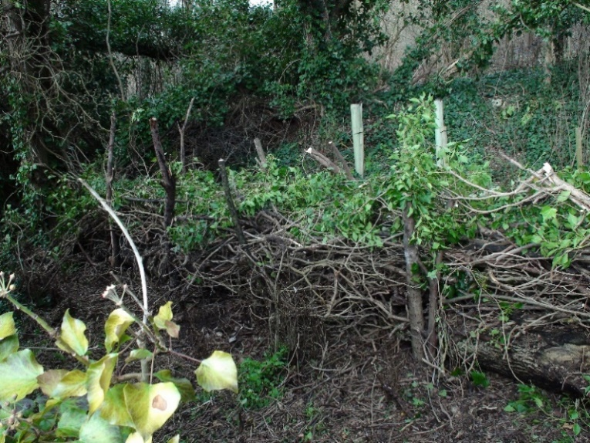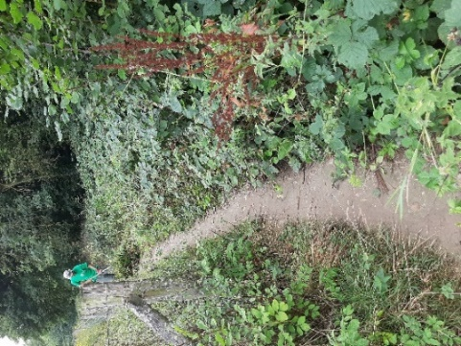
Although Covid-19 has severely restricted our work activities, we were able to devise ways to keep our 17km network of footpaths open for its parishioners, and for Medway inhabitants, to enjoy our spectacular countryside. Because of reduced volunteer outings, we had to set up a Thursday Group to tackle smaller projects, such as the repair and reinstatement of undergrowth and sapling tree replacement in an area disturbed by rail contractors, during their access work. This entailed sourcing very local ivy roots and small, but established, trees for the understorey.
We were also called upon to cut back encroaching brambles from some of our paths, to the dismay of walkers who enjoy “sampling” their fruits on their strolls and clearing some brashings and timber for re-laying them into a useful dead hedge.

RS206
As members are aware, there is a Cuxton project to divert a footpath from one side of the railway tracks to the other, then back, via an underpass, onto the riverside to connect the path with Strood, without using the main busy A228 road. This has been “active” for 20 years now, but a recent DoT government funding initiative, means Medway Council have been able to submit a request for this integrated transport scheme. This funding is based on a Covid-19 government reaction to the need for increased usage of footpaths and cycle paths, for the health and safety of its inhabitants.
Network Rail had originally virtually completed its support of this scheme in 2009, but, subsequently, it somehow became lost within their organisation. A decision on the funding is expected before the end of September.

England Coast Path
The Medway section of the England Coast path is divided into two sections; Grain to Woolwich (GWO) and Iwade to Grain (IGR).
A contractor has been chosen for the establishment works between Cliffe and Grain (GWO), this involves replacing stiles with self-closing gates, new signage and steps.
The majority of work has involved complex paperwork to obtain consent to work on Environment Agency flood defenses, SSSI permissions contractor quotes.
Work was expected to begin mid-September, however, owing to C19, there has been a shortage of materials for the gates and signage and work is now expected to begin in October.
The second section, IGR, the route has been walked and the PROW team are working on a specification for the required works. A small section of IGR involves the construction of a footpath at Grain and is involving unexpected expensive ecology works.
Work on this new footpath is expected to begin November and into December, provided no Water Voles or Great Crested Newts are found during the ecology works. The aim is to have all works completed for both sections by the Spring of 2021.

Department for Transport Emergency Active Travel Funding for PROW
Funding to widen footpaths as part of the emergency funding from the Department for Transport has been spent and identified paths have been cleared by the contractor Avondale. The picture below show the extent of widening undertaken on key paths.
The principal volunteers from the Medway Towns Footpath Group, have been reduced from six to two volunteers which has impacted on the excellent work they do. This year the PROW team were fortunate to receive some of the emergency funding to help fill the void left by our shielding volunteers but it is hoped next year, the volunteers will be back.

Improving Cycling and Walking Routes across Medway
Medway Council has created new cycle lanes, installed new cycle racks and widened 11 miles of well-used public footpaths thanks to active travel funding from the Department for Transport (DfT).
The government announced the £225million fund earlier this year following an increase in the number of people walking and cycling across the UK during the coronavirus pandemic. The funding aims to help encourage more people to choose alternatives to public transport and make roads across the country safer for both pedestrians and cyclists.
Earlier this summer the council received an active travel grant of £242,000 and used the funding to:
- Improve the on-road cycle lane in Dock Road, Chatham, from the Wood Street roundabout to Western Avenue
- Implement temporary closures of Rochester High Street to traffic to help residents and visitors socially distance, when non-essential shops were allowed to reopen, in line with government advice
- Installing new cycle racks in Chatham town centre
- Creating a pedestrian zone at the bottom of Chatham High Street
- Temporarily widening 11 miles of well-used footpaths across Medway to enable social distancing and promote walking routes
- Install 10 dropped kerbs at different junctions with a further eight due to be installed in September and October
The council is now bidding for up to £1,236,000 further active travel funding from the Department for Transport (DfT) to continue to expand and improve Medway’s walking and cycling paths.
If successful, the funding could be used to explore a range of schemes including: creating a new pedestrian and cycling route to link Darland to Capstone, continuing into central Chatham; providing a cycle and pedestrian route through Rochester High Street and to create cycle lanes on A2 Chatham Hill.
The council is expecting to find out if the funding bid has been successful later this month.

Rights of Way Improvement Plan
The Rights of Way Improvement Plan was approved earlier this summer and now informs the direction for improving the PROW service.
One of the biggest issues to be realised as a result of the process of writing this document, was that an up to date snapshot of the PROW network is needed, to assess its current condition.
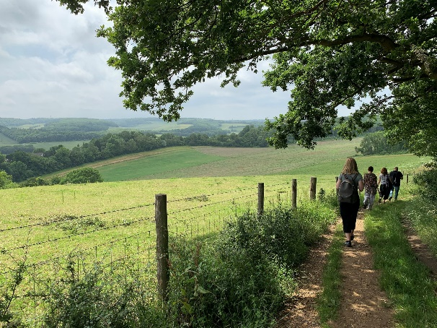
Some funding was secured and a survey of the network is now underway, with estimated completion by the end of March 2021.
This will allow prioritisation of the modest PROW budget alongside any extra funding acquired, to ensure spending is made where it is needed the most.
From this survey a two year rolling plan will be created for improvements to the PROW resource.

Medway Urban Greenspaces Forum
I-tree training for volunteers was carried out to help map the tree cover in Medway to support the development of the council’s first tree strategy. Volunteers got stuck in and the tree cover was mapped far faster than anyone expected! The consultant undertaking the tree strategy will be asked if they can feedback the results at the next MUGs forum meeting in November.
MUGS successfully held their first Forum meeting via Zoom on 8th August 2020.
The Urban Tree Challenge Fund bid results are due any day. If successful, it will pay for planting thousands of small whips in different locations across Medway. A major tree planting effort is planned for National Tree Week at the end of November.
Two more new Friends groups have been forming over the last few months, Friends of Rainham Recreation Ground and Friends of Luton Millennium Green.

Riverside Country Park
Greenspace Development are undertaking a public consultation on Riverside Country Park to help them better understand how this country park is currently used, any barriers to use and any improvements the public would like to see. The results will feed into a new masterplan for the park and guide future improvements. The link will be shared with the LAF members when it goes live.

Date of the next meeting:
Thursday 3 December 2020, 3.45-6.00pm, Room 12, Gun Wharf

Medway Local Access Forum web page

