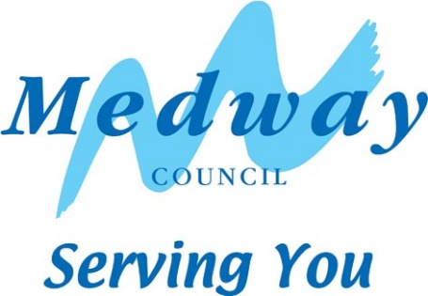­

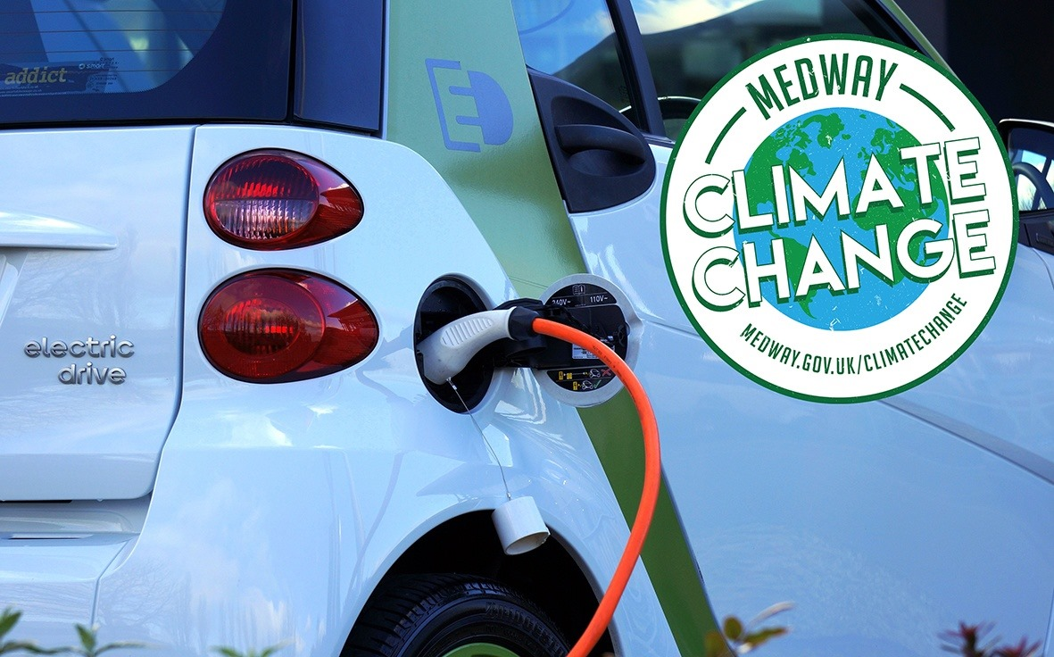

Electric Vehicles

Frequently Asked Questions

**2020 – 2021**

**www.medway.gov.uk/climatechange**

| Electric Vehicles – Frequently Asked Questions | Page |
| --- | --- |
| What is an Electric Vehicle? | 5 |
| What is the range of an Electric Vehicle? | 5 |
| What types of charger are there? | 5 |
| What is Government Policy on Electric Vehicles? | 6 |
| What do chargers look like? | 7 |
| Do Electric Cars cost more than regular cars? | 7 |
| Why do we need an Electric Vehicle Strategy? | 8 |
| Why is this strategy focusing on Electric Vehicles, not all Ultra Low Emission Vehicles, such as Hydrogen? | 8 |
| Why do you have an aspiration for a public land solution? | 9 |
| If you want to see an increased uptake, will Medway Council be buying me an Electric Vehicle? | 9 |
| How do Electric Vehicles help save Carbon? | 9 |
| How do Electric Vehicles help Air Quality? | 9 |
| Can't I just install my own charger? | 9 |
| Will there be disruption when chargers are installed? | 10 |
| Appendix 1Electric Vehicle User Survey – Results Summary (September 2020) | 11 |
| Appendix 2Electric Vehicle – Existing Commercial Charging Point locations in Medway | 14 |

## **Glossary**

BEV - Battery electric vehicle

DfT - Department for Transport

EST - Energy Savings Trust

EV - Electric vehicle

OLEV - Office for Low Emission Vehicles

ORCS - On-street Residential Chargepoint Scheme

PHEV - Plug-in hybrid electric vehicle

KCC - Kent County Council

ULEV - Ultra low emission vehicle **Status of Document**

This Electric Vehicle Frequently Asked Questions document supports strategies that form part of Medway Council’s Climate Change agenda, including the Medway Council Electric Vehicle Strategy (currently under development), Refit programme, Medway Council Air Quality Action Plan and the statutory Local Transport Plan 2011 – 26.

If you have any comment on the content of this document, please contact the Transport and Parking Service at Medway Council. Our contact details are as follows:

[Website](http://www.medway.gov.uk/climatechange) www.medway.gov.uk/climatechange

Email [sustainabletransport@medway.gov.uk](mailto:sustainabletransport@medway.gov.uk);

Address Sustainable Transport Team

Transport and Parking Service

Frontline Services

Regeneration, Community & Culture Directorate

Medway Council, Gun Wharf

Dock Road, Chatham

ME4 4TR

 [Facebook](http://www.facebook.com/tfmedway)

 [Twitter](http://twitter.com/RoadSafetyMC)

## What is an Electric Vehicle?

Electric vehicles are made up of two main types: battery electric vehicles (BEV), and plug-in hybrid electric vehicles (PHEV).

The key differences are that battery EVs have no combustion engine, relying only an on-board battery which provides energy to an electric motor. Plug-in hybrid EVs have an electric powertrain together with an on-board combustion engine, which enables operation in full-electric mode, using conventional fuel, or a blend of both.

## What is the range of an Electric Vehicle?

Most electric vehicles have a real-world driving range of 100-250 miles on a single charge, depending on the model. As a result, electric cars are well suited for use as private cars and short-range delivery vehicles. Fully electric vehicles are perfect for city driving, commuting, regular delivery routes, and all short- to medium-distance trips which are predictable. Successful use of a BEV typically requires access to a home or workplace recharging unit and, to permit longer journeys, access to the public charging network.

## What types of charger are there?

There are three main types of EV charging – rapid, fast, and slow. These represent the power outputs, and therefore charging speeds, available to charge an EV.

| Charge point type and power output | likely installation location | specific connection requirements | network considerations | likely charge time for a 35kWh charge |
| --- | --- | --- | --- | --- |
| slow up to 3kW | domestic | none - connects via household plug/socket | none | 12 hours |
| slow 3.7kW | domestic or street side | dedicated household circuit or on street equivalent | in some cases limited local reinforcement is required | 9 hours |
| fast 7kW | domestic or street side | dedicated household circuit or on street equivalent | likely upgrade to service cable and local mains | 5 hours |
| fast 22kW | street side or public charging location | three phase dedicated supply point | requirement for three phase connection and likely local mains upgrade | 1.5 hours |
| rapid 43kW | public charging location | three phase dedicated supply point | requirement for three phase connection and likely local mains upgrade | 45 minutes |
| super 130kW or multiple rapid chargers | public charging location | supply point from dedicated transformer | in most cases a new transformer will be established | 15 minutes |

Rapid chargers (50kW) will charge the majority of EVs to 80% in around 30-60 minutes (depending on battery capacity). Fast chargers (7-22kW) typically fully charge an EV in 3-5 hours. Slow (3kw) usually take between 6 and 12 hours.

Rapid AC chargers provide power at 43 kW (three-phase, 63A) and use the Type 2 charging standard. Rapid AC units are typically able to charge an EV to 80% in 20-40 minutes depending the model’s battery capacity and starting state of charge.

Slow charging is a method of charging electric vehicles used by some owners to charge at home overnight. However, slow units aren’t necessarily restricted to home use, with workplace and public points also able to be found. If a vehicle remains stationary for a long period, such as at a Park & Ride or office car park, slow charging may provide the optimum solution. Because of the longer charging times over fast units, slow public charge points are less common and tend to be limited to street furniture that has a limited supply capacity.

Most slow charging units are rated at up to 3kW with some lamp-post chargers being rated at 6kW. Charging times vary depending on the charging unit, the LV supply capacity to the charger unit and EV being charged, but a full charge on a 3kW unit will typically take 6-12 hours. Most slow charging units are untethered, meaning that a cable is required to connect the EV with the charge point.

While slow charging can be carried out via a three-pin socket using a standard 3-pin socket, because of the higher current demands of EVs and the longer amount of time spent charging, it is strongly recommended that those who need to charge regularly at home or the workplace get a dedicated EV charging unit installed.

A close up of a device
A close up of a device

Icon
Icon
Icon
Icon


## What is Government Policy on Electric Vehicles?

In its Air Quality Plan, published in 2017 the UK Government set a target to ban the sales of new petrol and diesel cars by 2040. In 2018 Government released its Road to Zero Strategy outlining a pathway towards achieving this. Key points are:

* The strategy sets out ambition for at least 50% — and as many as 70% — of new car sales to be ultra-low emission by 2030.
* Government will take steps to enable massive roll-out of infrastructure to support an electric vehicle revolution.
* The strategy sets the stage for the biggest technology advancement to hit UK roads since the invention of the combustion engine.

You can [find the strategy online](https://www.gov.uk/government/publications/reducing-emissions-from-road-transport-road-to-zero-strategy)

## What do chargers look like?

Chargers vary a lot in appearance. Fast chargers range from wall mounted chargers (mostly commonly used on people’s homes) to chargers that resemble bollards. Rapid charging units tend to be bigger and have a more standard appearance.

A car parked in front of a brick building

## Do Electric Cars cost more than regular cars?

Electric Cars do currently cost more than a comparable petrol or diesel car. But it is generally predicted that as the EV market develops, battery costs – and therefore vehicle prices – will continue to drop. In the last five years battery production costs have fallen by almost 80%. The battery is one of the largest and most expensive elements of an EV, and with production costs dropping, the time when an EV costs the same as a comparable conventional model (or even less) is predicted by some in the industry to be only a few years away.

Deloitte published research in January 2019 that predicts that EVs will achieve cost parity with conventional vehicles in the UK as early as 2021. From this point, cost will no longer be a barrier to purchase, and owning an EV will become a realistic, viable option for more people.

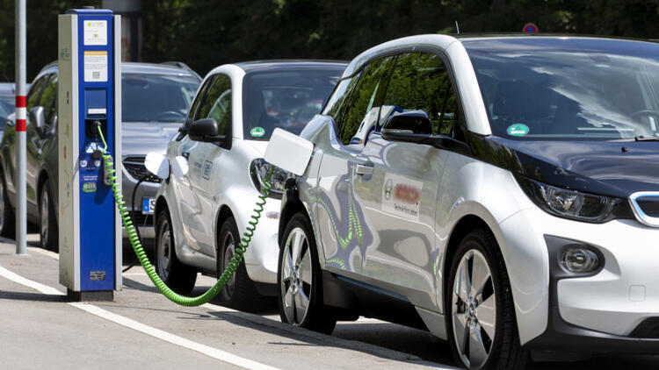

## Why do we need an Electric Vehicle Strategy?

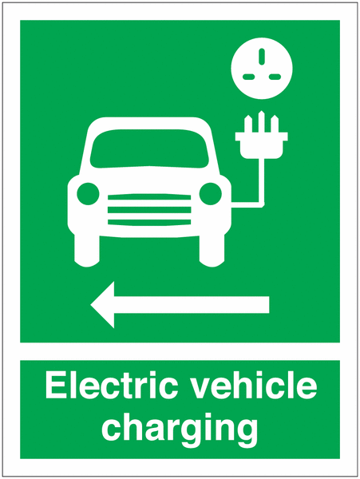

The Council’s preferred approach to providing EV charging points is to develop a strategy that sets out clearly what our long-term ambition is, our priorities for action, and is clear on our requirements.

In developing the strategy we are listening to residents views on their preferences for charging locally, through the completion of an online survey (link below) and will be modelling what different electric vehicle uptake scenarios will look like across Medway. We are seeking to understand both the number of vehicles that would be involved and the number of charging points that might be required to support them.

By doing this we hope to ensure that investment is used wisely with chargers installed in the right places that are fit for purpose.

To complete the survey, visit [Medway’s Electric Vehicle Charge Point Survey](https://www.medway.gov.uk/info/200161/travel/1130/electric_vehicle_charging_points).

Please refer to Appendix 1 to view a results summary based upon the EV Charging Point Survey feedback received between June and September 2020.

## Why is this strategy focusing on Electric Vehicles, not all Ultra Low Emission Vehicles?

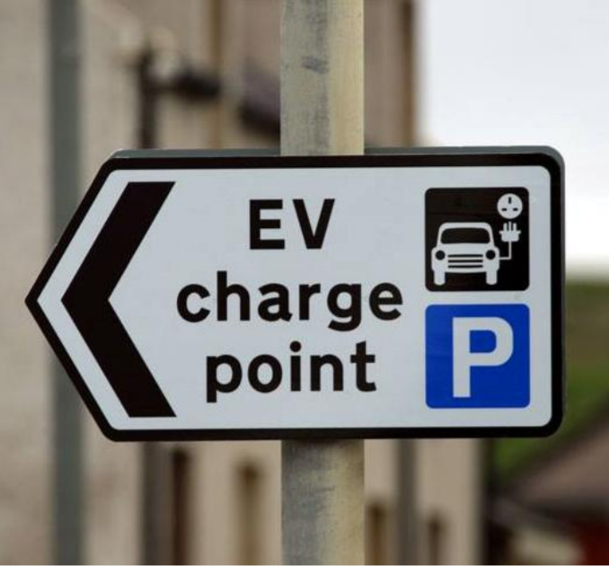 Our strategy will focus on solutions where we can make the biggest impact on the Medway’s carbon emissions.

We have looked at the Department for Transport’s current and future predictions of the carbon generated by road transport in Medway, and 79% would be attributable to cars and small vans.

There is still much debate as to which fuel will become the long-term solution for vehicles of the future, but we have taken a view that we need to take action.

Currently electric vehicle technology is the most advanced for cars and small vans, and people will be able to make the switch now, or in the very near future. If we need to develop an alternative fuel strategy in later years, we will do so.

## Why do you have an aspiration for a public land solution?

Our strategy will consider a comprehensive and cohesive public charging solution on public land. We believe that if we can consider all public land when planning a charging network there would be significant benefits including:

* providing a joined-up solution, which looks, and is accessed in, the same way across Medway and the wider county of Kent, making it easier for people to use;
* providing chargers in the best locations for the users, rather than in the places we have the land / space to do it;
* enabling chargers to be delivered faster across the whole county as the chances of finding more feasible and achievable sites will be increased if we maximise potential “in scope” public land;
* accessing significantly more government funding than acting alone, and thereby deliver more infrastructure within Medway.

## If you want to see an increased uptake, will Medway Council be buying me an Electric Car?

No, we won’t be buying individuals EV cars.

We will be considering different EV uptake scenarios to understand the likely number of cars that we will see in Medway, and the number of public chargers that is required to serve them.

We are concentrating on enabling the provision of chargers so that when people are replacing their vehicles they feel able to switch to electric.

## How do Electric Vehicles help save Carbon?

Electric Vehicles have no exhaust emissions. However, carbon emissions are produced during the generation of electricity, the amount will vary depending how the energy is generated.

Electric vehicles charged using standard UK electricity will show a significant reduction in emissions; analysis on current vehicles suggest a reduction of around two thirds compared to an average conventional car. Larger carbon reductions are likely in the future as the UK grid continues to decarbonise.

If renewable or green tariff electricity is used, then life cycle greenhouse gas emissions are effectively zero.

## How do Electric Vehicles help Air Quality?

The main cause of poor air quality is nitrogen oxides (NOx). The main cause of this pollution is vehicle emissions. Electric Vehicles have no exhaust emissions, so switching diesel and petrol vehicles to electric will improve local air quality significantly.

## Can't I just install my own charger?

If you have access to off road parking, you can install your own charger to charge an electric car. There are Government Grants to help you do this, such as the Electric Vehicle Home-charge Scheme (EVHS).

The Grant is a 75% contribution towards the cost of one chargepoint and its installation up to a maximum of £350 (including VAT) per household/ per eligible vehicle for installations that take place on or after the 1st of April 2020. A second chargepoint can be claimed if an individual can evidence keepership of two eligible electric vehicles.

There are certain criteria you must meet to receive the Grant, including the use of an accredited installer. For more information about the EVHS opportunity, please visit [EVHS guidance for customers](https://assets.publishing.service.gov.uk/government/uploads/system/uploads/attachment_data/file/873887/evhs-guidance-for-customers.pdf)

The Workplace Charging Scheme (WCS) is a voucher-based scheme that provides support towards the up-front costs of the purchase and installation of electric vehicle chargepoints. For further details, please visit: [workplace charging scheme guidance for applicants, installers and manufacturers](https://www.gov.uk/government/publications/workplace-charging-scheme-guidance-for-applicants-installers-and-manufacturers).

Our strategy will focus on providing access to public chargers for those people who can’t charge at home, and to reduce the concern of range anxiety by ensure that electric vehicle users can be confident they can charge across Medway.

## Will there be disruption when chargers are installed?

Installing chargers will involve digging trenches to place wiring. The intention will be to work with our suppliers to reduce the disruption as much as possible and to make every effort to use opportunities to combine on-going works.

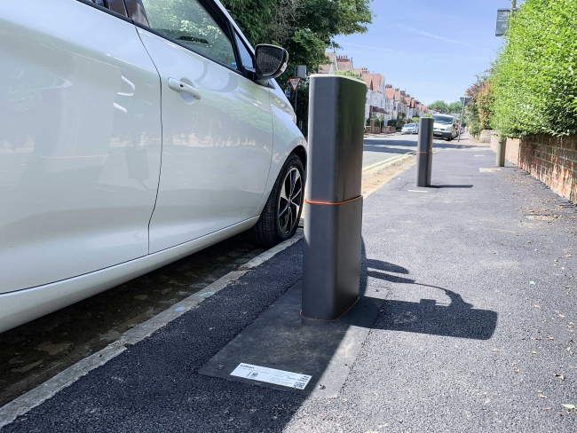

**Appendix 1**

### Electric Vehicle Charging Points – Survey Results 2020

In June 2020, an online survey was published on the Medway Council website to explore the demand for electric vehicle charging points across Medway. This was intended to help Medway Council to consider charging locations and to demonstrate the local need when applying for funding.

Participants were asked whether they currently own an electric vehicle or plug-in hybrid, or indeed considering purchasing one. In addition, the survey provided opportunity for any suggested locations for on-street charging points to be made.

The survey results summarised below were based upon 126 user responses over the course of an eight-week period, between Tuesday 16 June and Sunday 27 September 2020.

### Q1. Do you currently own an electric vehicle?

| Response | Response amount | Percentage |
| --- | --- | --- |
| Yes | 48 | [38.10%] |
| No | 75 | [59.52%] |
| No response | 3 | [2.38%] |

### Q2. What do you think the biggest barriers to purchasing an electric vehicle are?

*[NOTE: Participants able to select multiple answers]*

| Response | Response amount |
| --- | --- |
| The cost of an electric vehicle | 46 responses |
| The time to charge the battery | 34 responses |
| Lack of electric vehicle models | 7 responses |
| Lack of charging points in Medway | 116 responses |
| Lack of charging points where I travel to | 42 responses |
| The cost of replacement batteries | 14 responses |
| The distance travelled on one charge | 35 responses |
| I don't know about electric vehicles | 1 response |
| There are no barriers | 0 response |
| Other reasons | 5 responses |
| The time to charge the battery | 34 responses |
| Lack of electric vehicle models | 7 responses |
| Lack of charging points in Medway | 116 responses |
| Lack of charging points where I travel to | 42 responses |
| The cost of replacement batteries | 14 responses |
| The distance travelled on one charge | 35 responses |
| I don't know about electric vehicles | 1 response |
| There are no barriers | 0 response |
| Other reasons | 5 responses |

### Q3. What type of electric vehicle do you own?

| Response | Response amount |
| --- | --- |
| Fully electric | 32 responses |
| Plug in hybrid | 15 responses |
| Self-charging hybrid | 1 response |

### Q4. Which of the following best describes where you most often charge up your vehicle?

*[NOTE: Participants able to select multiple answers]*

| Response | Response amount |
| --- | --- |
| At home | 19 responses |
| At my place of work | 8 responses |
| In a public car park | 5 responses |
| At a retail premises car park | 12 responses |
| At a car dealership | 0 response |
| Not applicable | 1 response |
| Other location | 3 responses |

### Q5. When do you most often charge your vehicle up?

| Response | Response amount |
| --- | --- |
| During the day | 21 responses |
| Overnight | 11 responses |
| Both during the day and at night | 15 responses |
| Not applicable | 1 response |

### Q6. Are you planning to buy an electric vehicle in the next twelve months?

| Response | Response amount |
| --- | --- |
| Yes | 43 responses |
| No | 9 responses |
| Don’t know | 23 responses |
| Not applicable | 1 response |

### Q7. What type of electric vehicle do you hope to buy?

| Response | Response amount |
| --- | --- |
| Fully electric | 29 responses |
| Plug in hybrid | 10 responses |
| Self-charging hybrid | 3 responses |

### Q8. Which of the following best describes where you plan to charge up your vehicle most often?

| Response | Response amount |
| --- | --- |
| At home | 31 responses |
| At my place of work | 2 responses |
| In a public car park | 3 responses |
| At a retail premises car park | 1 responses |
| At a car dealership | 0 response |
| Not applicable | 0 response |
| Other location | 2 responses |

### Q9. When are you most often likely to charge your vehicle up?

| Response | Response amount |
| --- | --- |
| During the day | 4 responses |
| Overnight | 24 responses |
| Both during the day and at night | 14 responses |
| Don’t know | 1 response |

### Q10. Please tell us where you think we should consider locating charging points:

Vast majority gave personal addresses.

Public locations requested in Medway to date include:

* Twydall Green x2
* Dockside Outlet, Chatham
* Hempstead Valley Shopping Centre
* All over the towns, incl. Gillingham High Street
* Riverside car park, Chatham

### Q11. How far would you be willing to walk to charge an electric vehicle?

| Response | Response amount |
| --- | --- |
| Less than 3 minutes | 37 responses |
| 3 to 5 minutes | 36 responses |
| 6 to 10 minutes | 21 responses |
| 11 to 15 minutes | 11 responses |
| More than 15 minutes | 2 responses |
| I wouldn't be willing to walk to charge my vehicle | 16 responses |

### Other comments about EV charging points:

* Make them widely available across the town centres, public car parks, retail parks, sport centres, country parks, business parks, railway stations, libraries, hospitals, etc.
* Lack of available on-street parking to accommodate charging points.

* Government incentives for switching to EV. Lower vehicle tax noted by one user.
* All parking spaces should have them for easy access.
* EV drivers charging in car park should be exempt from paying additional parking fee.

* Residents to pay for their own dedicated on-street charging point facility.

* Introduce near residential properties to accommodate residents with no off-road parking.
* Lamp post, bollards and reserved parking bay charging points for EV owners.
* Further communication required around charging point costings and timings.
* Importance of investing in high quality, secure and reliable charging points over the long term as opposed to upgrading every couple of years.
* Stipulating EV charging points as a condition within planning applications

**Appendix 2**

**Electric Vehicle – Existing Commercial Charging Point locations in Medway**

| Where | Address | Type of charger | Brand |
| --- | --- | --- | --- |
| Chatham Historic Dockyard | Main Gate Road, Chatham, Kent, ME4 4TZ | 2x 3kW 13A 3-square pin | VendElectric |
| Evision Supercars | Whitewall Road, Strood, Rochester, Kent, ME2 4DZ | 1x 7kW 32A Type 2 mennekes | Other |
| Medway Campus | 30 Pembroke Court, Chatham, Kent, ME4 4UF | 2x 7kW 32A Type 2 mennekes | Pod point |
| Morrisons Strood | Knight Road, Rochester, Kent, ME2 2AA | 1x 43kW 63A Type 2 mennekes 1x 50kW 125A JEVS (CHAdeMO) 1x 50kW 125A CCS (Combo) | Genie Point |
| Asda Gillingham | Chatham Docks, Pier Road, Gillingham, Kent, ME7 1RZ | 4x 7kW 32A Type 2 mennekes | POLAR |
| Tesco Superstore Strood | Charles Street, Strood, Rochester, Kent, ME2 2DE | 4x 7kW 32A Type 2 mennekes | Pod point |
| Diggerland Kent | Medway Valley Lesiure Park, Rochester, Kent, ME2 2NU | 1x 7kW 32A Type 2 mennekes 1x 11kW Tesla Type 2 | Tesla Destination |
| Morrisons Chatham | Dove Close, Chatham, Kent, ME5 8BA | 1x 22kW 32A type 2 mennekes 1x 50kW 125A JEVS (CHAdeMO) 1x 50kW 125A CCS (combo) | Genie Point |
| Motorline Nissan Medway | Gillingham Business Park, Grovesnor Road, Gillingham, Kent, ME8 0SA | 1x 50kW 125A JEVS (CHAdeMO) | Nissan Dealerships |
| Gillingham Retail Park | Ambley Road, Gillingham, Kent, ME8 0PU | 1x 22kW 32A Tesla type 2 | Tesla Destination |
| Gillingham Retail Park | Ambley Road, Gillingham, Kent, ME8 0PU | 2x 3kW 16A Type 2 mennekes | POLAR |
| Bridgewood Manor | Walderslade Woods, Chatham, Kent, ME5 9AX | 1x 3kW 13A 3-square pin 1x7kW 32A Type 2 mennekes | POLAR |
| Buckmore Park Kent Circuit | Maidstone Road, Chatham, Kent, ME5 9QG | 1x 43kW 63A Type 2 mennekes 1x 50kW 125A JEVS (CHAdeMO) 1x 50kW 125A CCS (Combo) | POLAR |
| Medway services M2 (Eest) | M2 Junction 4-5, Gillingham, Kent, ME8 8PQ | 1x 43kW 63A Type 2 mennekes 2x 50kW 125A JEVS (CHAdeMO) 1x 50kW 125A CCS (Combo) | Ecotricity |
| Medway services M2 (West) | M2 Junction 4-5, Gillingham, Kent, ME8 8PQ | 1x 43kW 63A Type 2 mennekes 1x 50kW 125A JEVS (CHAdeMO) | Ecotricity |
| Hyundai Medway | London Road, Rainham, Gillingham, Kent, ME8 8PT | 2x 7kW 32A Type 2 mennekes | Hyundai Dealerships |

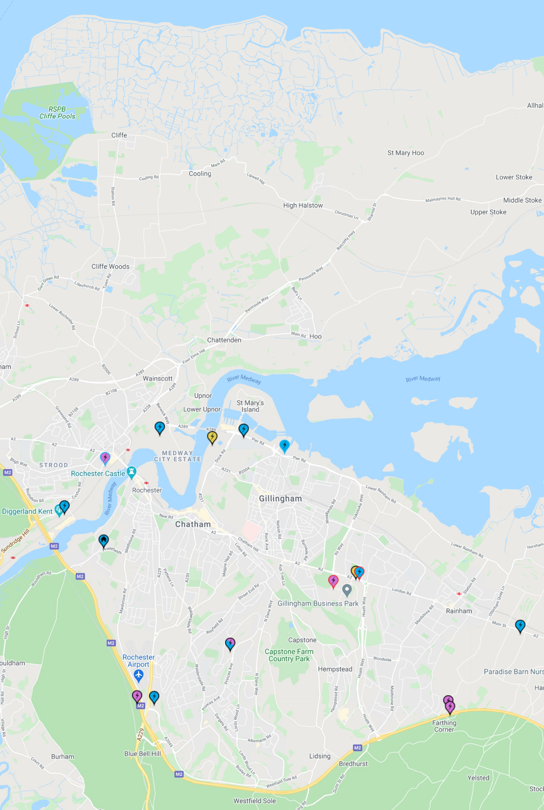

For further details, please visit [Zap Map](https://www.zap-map.com/).