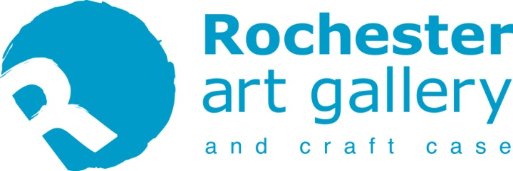
Out of Sight, Not Out of Mind
10 Oct to 14 Nov 2020
Rochester Art Gallery

'Out of Sight, Not Out of Mind’ has been devised in response to lockdown by the MESS ROOM, who up until March regularly connected with people with sight loss to nurture their creative talents.

This exhibition features the work of 38 artists and volunteers who seized the opportunity to express how they were feeling through art and show that their creativity can continue and thrive from the comfort of their homes.

Wendy Daws, Ambassador and volunteer for the Kent Association for the Blind and lead for the art groups, is the driver behind the project;

“Our groups have been meeting and making great art since 2006. But the opportunity to create and try new things is not the only reason to attend, our face to face sessions also served as an essential moment for people with a variety of visual impairments, to form new friendships and discuss their shared issues in a supportive setting. Suddenly losing this creative, but moreover, social time has been tough for members, so that’s why this project is so vital to help them both stay in touch and continue to give them a platform. We have had group chats online and I've visited each participant to give them their art resource packs, but it’s become so much more than that, with people saying the project has been a lifesaver for them.”

The show includes films of interviews with project participants, created as part of Electric Medway. It is also fitting that the exhibition celebrates the Kent Association for the Blind’s 100th Anniversary year.

Visit www.messroom.org to download a large print copy of this information.
Braille copies are also available from the front desk to use and return.

#OutOfSightNotOutOfMind2020 @rochesterartgallery @messroommedway @wendydaws #KAB100

This project has been made possible, thanks to the wonderful support of many local organisations, notably;

- The Test Bed Fund Medway Voluntary Action
- Medway Council Befriending Together
- Age Medway UK Hyde
- Carers First NHS Medway Clinical Commissioning Group
- Rochester Riverside Countryside Properties
- Kent Association for the Blind MESS ROOM
- Sun Pier House Sparked Echo

