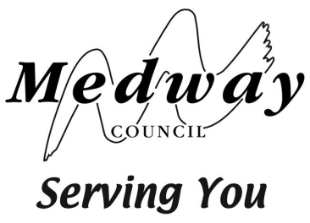

TRANSFER TO SECONDARY SCHOOL – SEPTEMBER 2021

FORM R1 - MEDWAY TEST ACADEMIC REVIEW REQUEST

IMPORTANT:
Please read the information at www.medway.gov.uk/admissionsnextsteps before submitting this form.

Your completed and signed form must be received by Medway Council School Admissions & Transport by no later than 4pm Monday 9 November 2020. Any requests received after this time will not be considered.

Return your form to: medwaytest@medway.gov.uk OR School Admissions & Transport, Medway Council, Gun Wharf, Dock Road, Chatham, ME4 4TR

The review is of academic work only. You can provide a statement overleaf, but this is for context and may not be considered in the review decision making process. The decision of the panel is based on the work provided by your child’s school. Please do not send any additional/attached information with this request form, as it will not be considered by the review panel.

The review decision will be notified to you by 24 November 2020.

Child forename
Child surname
Date of birth

Child’s current school name
Current school address

Current school headteacher name

Parent/Carer name
Home address

Telephone no.
Email address

Please state here your reasons for requesting a review of the decision:

Signed*
Name
Date

* I have read and understood the information about the review process in the non-grammar assessed information found at www.medway.gov.uk/admissionsnextsteps

