Thames Estuary Trail

Route 6

Gillingham
Isle of Sheppey
Oare
Faversham
Seasalter
Herne Bay
Margate
Broadstairs
Ramsgate

22 May to 13 June 2021
Estuary 2021 is the second edition of the large-scale arts festival that celebrates the lives, landscapes and histories of the spectacular Thames Estuary. Taking place online, and in the landscape along 107 miles of Thames Estuary Trail, contemporary artworks, discussion and events explore and respond to powerful themes resonant to the estuary. Alongside a map that shows the full trail, we have created six, smaller sections of the route with accompanying details of the artworks and events to be found as you explore. Route 6 of 6 can be enjoyed across a long weekend or as three days out.

Estuary 2021 Margate Hub
Open Wednesday to Sunday 10am to 5pm (Bank Holiday Monday 31 May 11am to 4pm)
Call by for more information on the festival, and to pick up Estuary publications, and activity sheets for children and young people. Located at the Thanet Visitor Information Centre, The Droit House, Stone Pier CT9 1JD.

Events

The Sea View Has Me Again (72)

Patrick Wright & Shona Illingworth

A radio programme, made by writer Patrick Wright and artist Shona Illingworth, marking the publication of Patricks The Sea View Has Me
Again - Uwe Johnson in Sheerness (Repeater, June 2021) Includes readings from Johnson’s descriptions of the ‘moral utopia’ he found on Sheppey made with local arts organisation Big Fish. Broadcast on Sheppey FM, 92.2FM, on Sun 23 May (and listen again on the Estuary website).

Sonic Atlas (79)

Caroline Bergvall

Sonic Atlas is poet and artist Caroline’s most ambitious work to date, an immersive audio-visual work with multiple languages and a new composition by Gavin Bryars, drawing on the nomadic histories and ancient multilingual routes of medieval love poetry, and representing them against a current political backdrop of division. The Sonic Atlas Evening Work event will take place Autumn 2021, see website for more details.

Thames Estuary Trail Walk

Tom King
The author of Thames Estuary Trail: A Walk Round the End of the World, leads a walk from Hampton Pier, to Reculver. Limited places, advance booking essential, see website for more information. 10 June 1pm to 2pm

Jezreel’s Tower

John Walter
A new virtual reality film telling the story of James Jershom Jezreel, his apocalyptical cult and the building of their headquarters in Gillingham. Watch the film on the Estuary website (with or without VR headset).

Full details for booking on Estuary 2021 website.
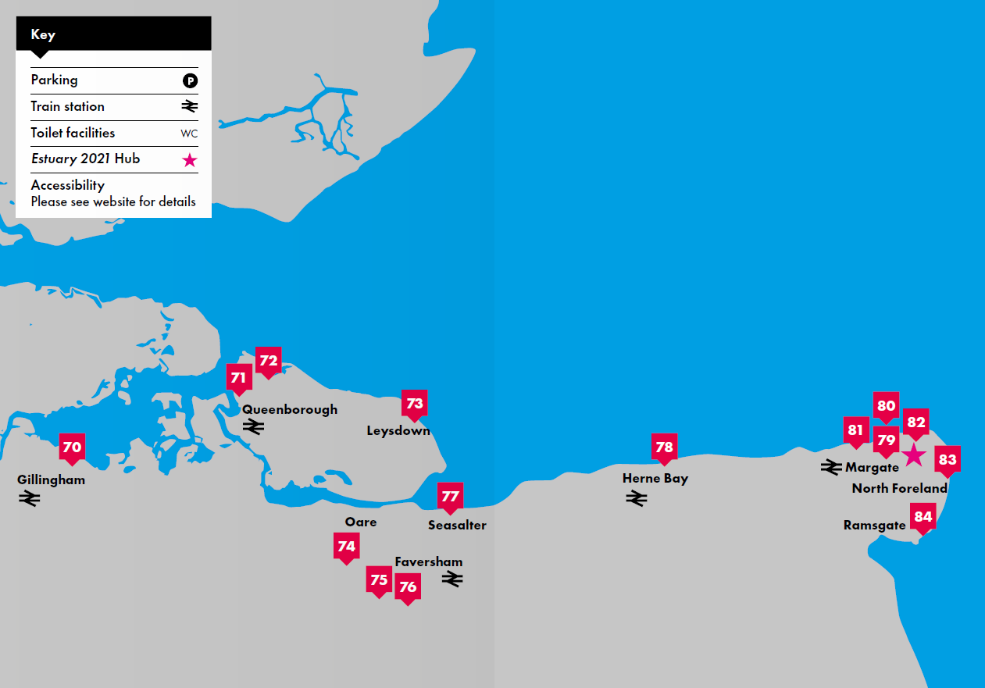

Gillingham

Escaping with Magwitch (70)

Carol Donaldson & Stephen Turner
After a long winter in lockdown, writer Carol Donaldson and artist Stephen Turner are escaping to the North Kent Marshes in a small inflatable boat called Magwitch. Before they set out, they recorded a conversation at Horrid Hill, touching on their in-depth knowledge of the fragile edgelands of the North Kent marshes. Find the sign at Horrid Hill, Riverside Country Park ME7 2XH to download the conversation and visit the Estuary website to find out more information about Stephen and Carol’s voyage.

Isle of Sheppey

Crude Britannia No 3 (71)

Platform
Map sited at the Admiral’s Arm Micropub, Queenborough ME11 5AD, detailing the history, present and future of energy across the expanse of the Estuary. Part of a wider project including online events, marking the publication of Crude Britannia – How oil shaped a nation by James Marriott and Terry Macalister (Pluto Books 2021) - see website for more details.

Watermark (73)

Maria Amidu
A series of eight artworks to mark the 107 mile walk described in Tom King’s Thames Estuary Trail have been created by artist Maria Amidu. They chronicle her enjoyment in discovering both the book and the places referred to along the trail. All are located at great stopping places to either eat, rest or visit. The sixth is hosted by The Coffee Pot, in Leysdown, ME12 4QB.

Faversham

Lissener (74)

Feral Practice and Esi Eshun
New darkly comic audio work responding to the ruined Oare Gunpowder Works, Oare Creek and Oare Marshes. Oare’s explosive past intertwines with diverse natural histories in this watery world, disturbing the expected hierarchies between species and states of being. The creaturely cast of characters includes Noctule bats, wading birds, a Bamboo Worm and a Southern Hawker dragonfly. Download the work from Oare Gunpowder Works Country Park, ME13 7UD.

Our Time (75)

Marcus Coates
A series of six clock towers along the North Kent coastline have the songs and calls of locally threatened bird species, to be heard as clocks would chime, on the hour. This one is hosted by Faversham Guildhall, Market Place. Every day from 7am to 11pm.

Trolley Reef (76)

Something & Son
A fold out poster blueprint to be found in Faversham cafes, with details of a new oyster reef planned for North Kent, made from recycled shopping trolleys.

Seasalter (77)

Watermark

Maria Amidu
See above. The seventh Watermark is hosted by The Sportsman, Seasalter, CT5 4BP.

Herne Bay

Our Time (78)

Marcus Coates
A series of six clock towers along the North Kent coastline have the songs and calls of locally threatened bird species, to be heard as clocks would chime, on the hour. This one is hosted by Herne Bay, Central Parade. Every day 7am to 10pm.

Margate
Margate train station, Market Street Car Park, CT9 1ED

Our Time (80)

Marcus Coates
A series of six clock towers along the North Kent coastline have the songs and calls of locally threatened bird species, to be heard as clocks would chime, on the hour. This one is hosted by Thanet Visitor Information Centre. Every day 6am to 11pm.

26 Days on the Southern Ocean (81)

Simon Faithfull
Text-based work, diary entries from a journey to Antarctica with the British Antarctic Survey on Margate’s Harbour Arm. See also No 14 on the route one map.

And the thing is (82)

Maggie Harris
A fold out poster of and the thing is, award-winning poem by Broadstairs based Maggie Harris, to be found in Margate cafes. Visit the website to hear Maggie reading the poem.

Broadstairs

Watermark

Maria Amidu
See No 73. The eighth Watermark is to be found near the North Foreland Lighthouse, CT10 3NN.

Ramsgate

Crude Britannia No 4

Platform
Map sited at the Royal Harbour Brasserie, detailing the history, present and future of energy across the expanse of the Estuary. Part of a wider project including online events, marking the publication of Crude Britannia – How oil shaped a nation by James Marriott and Terry Macalister (Pluto Books 2021) - see website for more details.

Please visit our website for details of our Online Programme - and the wide range of estuary themed programme listed in the Associated Programme.

Social Media
Facebook: @estuaryfestival
Instagram: #estuaryfestival
Website: www.estuaryfestival.com

Principal partners

Supported using public funding by:

Major partners

