Thames Estuary Trail

Route 5

Gravesend
Hoo Peninsula
Rochester
Chatham

22 May to 13 June 2021
Estuary 2021 is the second edition of the large-scale arts festival that celebrates the lives, landscapes and histories of the spectacular Thames Estuary. Taking place online, and in the landscape along 107 miles of Thames Estuary Trail, contemporary artworks, discussion and events explore and respond to powerful themes resonant to the estuary. Alongside a map that shows the full trail, we have created six, smaller sections of the route with accompanying details of the artworks and events to be found as you explore. Route 5 of 6 can be enjoyed across a long weekend or as three days out.

Estuary 2021 Hubs
Call by for more information on the festival, and to pick up Estuary publications, and activity sheets for children and young people.

Chatham Hub
Open Everyday 11am to 5pm
Located at the Draw Hope Pavilion, outside Chatham Library, Dock Rd, ME4 4TX

Gravesend Hub
Open Everyday 11am to 5pm
Located at Gravesend Town Pier and Pontoon, DA11 OBJ

Events

SILTings

3 to 6 June 2021
As part of the Estuary 2021 Associated Programme, SILTings, organised by LV21, will bring the forgotten stories and histories of Gravesham to life. For more information see lv21.co.uk Commissioned by Creative Estuary.

Ebb and Flow Festival
21 to 23 May
As part of the Estuary 2021Associated Programme, Ebb & Flow, organised by Sun Pier House CIC and Intra Arts, will explore the past, present and future of Chatham Intra. For more information see ebbandflowfest.co.uk Commissioned by Creative Estuary

Art in Transit (56)(67)

Lata Upadhyaya
Lata is touring the Estuary in the white transit van she has transformed into a travelling art and conversation space. Visit at Gravesend and Chatham, and pick up a book. Suitable for all ages.

Saturday 29 May and Sunday 30 May 11am to 5pm on the green near Chatham Library, ME4 4TX.

Mon 31 May 11am to 5pm at Guru Nanak Darbar Gurdwara, Gravesend DA12 1A

50 Golden Years (50)

Sadie Hennessy
A golden ice-cream van hosting a DJ booth, encrusted with musical instruments and gadgets, will be playing people’s favourite songs live on Saturdays, as part of Sadie’s Golden Years. If you can tell the DJ the memories and stories behind your favourite record, they’ll play your song. St George’s Shopping Centre, DA11 OTA. Every Saturday 11am to 4pm.
Full details for booking on Estuary 2021 website.

The World’s Largest Gathering of People Dressed as David Bowie

Sadie Hennessy
An attempt to enter the Guinness World Records, event to be held September, see website for how to get involved.
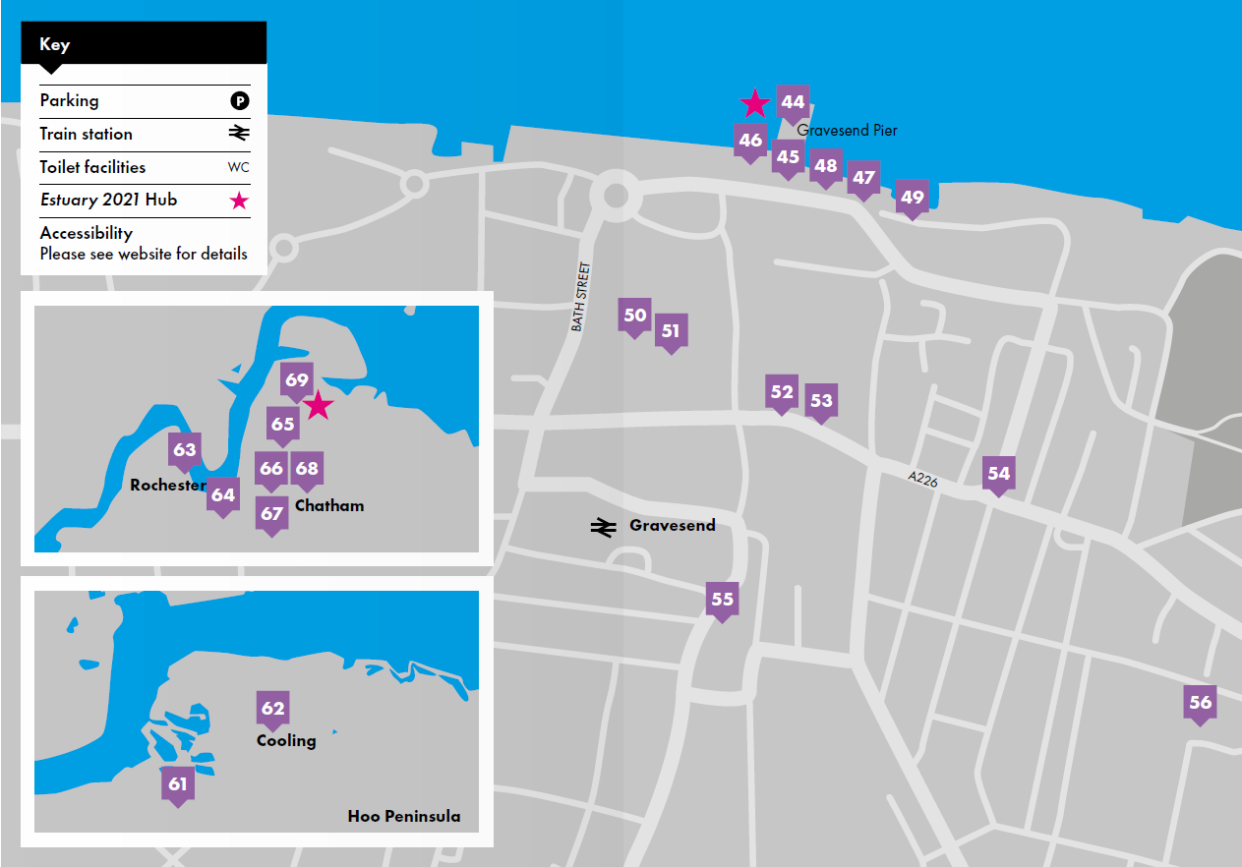

Gravesend

The first thing I did was to kiss the ground (44)

Jasleen Kaur
Sculpture and sound work on Gravesend’s Town Pier, co-commissioned by Turner Contemporary and Cement Fields as part of England’s Creative Coast and Estuary 2021. In situ until 7 November. Open Mon-Sat.

Watermark (45)
A series of eight artworks to mark the 107 mile Thames Estuary Trail walk, created by artist Maria Amidu. The fifth is hosted by the Three Daws, DA11 OBJ.

The first thing I did was to kiss the ground (46)(47)

Jasleen Kaur
Two geocaches to discover, see GeoTour GT4A5, part of an art-based geotour along the SE coast.

Crude Britannia No 2 (48)

Platform
Map sited at the Three Daws, detailing the history, present and future of energy across the expanse of the Estuary. Part of a wider project, see website for more details.

Unctuous between fingers (49)

Bryony Gillard
New moving image work that explores an archive of pressed seaweeds and algae collected mainly by women, in
the 1800s. At St Andrew’s Church on the riverfront. Book in advance through the website or just turn up.

Golden Years (50)

Sadie Hennessy
Inspired by the pop culture collections of Peter Blake, Sadie is filling shop windows at St George’s Shopping Centre with local people’s collections and the stories behind them. Open every day. Co-commissioned by Gravesham Borough Council and Cement Fields.

Markers (52)

Webb-Ellis
Publication of letters exchanged discussing language, the body, our present moment and possible futures. Pick up a copy from The Gr@nd on King Street Mon-Fri, or order from website.

ZED (53)
The Gen Z group worked with artists Ania Bas and Rose Nordin to produce their own zine. Pick up a copy at The Gr@nd Mon-Fri. In partnership with The Gr@nd and GYG.

Our Time (54)

Marcus Coates
A series of six clock towers along the North Kent coastline have the songs and calls of locally threatened bird species, to be heard as the clocks would chime, on the hour. This one is hosted by Gravesend’s clock tower on Milton Road. Every day 06:00-23:00.

Identity (55)

Cohesion Plus
New film and audio work, written and produced by Cohesion Plus working with 42 South Films, examines what makes us who we are, looking at how things like race, faith, immigration, the arts, and sport shape our identities.

Hoo Peninsula

No Ordinary Protest (61)

Mikhail Karikis
Film made with young people, asking whether sound can mobilise socio-political and physical change. St Mary’s medieval church, Higham ME3 7LS.

In the Mouth of the River: Water, Empire & Rebellion (62)

Dzifa Benson
Contemporary poems to be heard in the cockle shell vestry of St James’ C13th church, Cooling ME3 8DQ. Inc Hafsah Aneela Bashir, Leo Boix, Kayo Chingonyi, Sasha Dugdale, Mimi Khalvati & Yomi Sode.

Rochester

Our Time (63)

Marcus Coates
See No 54. This clock tower is at Rochester Guildhall Museum, on the High Street ME1 1PY. Every day 8am to 10pm.

The Water Replies (64)

Estuary 2021
Inspired 100 creative journals made by Thames Estuary residents, part of a wider project led by poets Caroline Bird and Selina Nwulu. See a small display of journals at Rochester Library, ME1 1EW.

Chatham
Chatham Train Station: Riverside car park, ME4 4SL
Dockyard car park: ME4 4TZ

Draw Hope (65)

Bob & Roberta Smith
The Draw Hope pavilion is an outdoor gallery and art-making space sited on the green outside Chatham Library. Everyone is invited to come and make their mark on the pavilion, which will gradually develop over the festival into a collective portrait of Chatham, focusing on love and hope. Open every day.

Draw Hope Workshops (66)
Take part in workshops with Medway artists Rosa Ainley, Lalita Bailey, Liz Bylett, Wendy Daws, Christopher Sacre, and Hannah Whittaker. See website, or call in at the pavilion, open every day.

The Water Replies (68)
See No 64, a small display of journals at Chatham Library, ME4 4TX.

Grain (69)

Phil Coy
Assembled from interviews, and multi-channel audio recordings made along the Thames Estuary,
this immersive sound installation is sited at No 3 Slip, Historic Dockyard Chatham ME4 4TX. NB Booking in advance is essential, entry charge to the Dockyard applies. Open every day.

Please visit our website for details of our Online Programme - and the wide range of estuary themed programme listed in the Associated Programme.

Social Media
Facebook: @estuaryfestival
Instagram: #estuaryfestival
Website: www.estuaryfestival.com

Principal partners

Supported using public funding by:

Major partners

