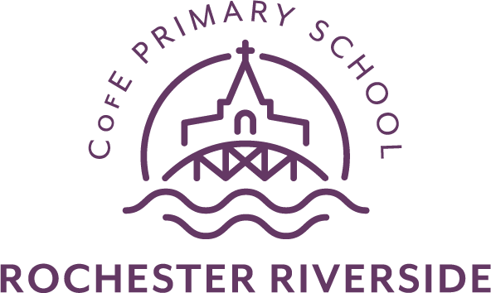

REQUEST FOR AN ADMISSION APPEAL
YEAR R – SEPTEMBER 2022 ENTRY

COMPLETED FORMS MUST BE RETURNED TO THE SCHOOL/ACADEMY BEING APPLIED BY THE FRIDAY, 13TH MAY 2022

Important
Medway Council provides a ‘Next Steps Guide to Parents/Carer’. This information is available on the Medway Council website to assist you in making your decision regarding the next steps to take
www.medway.gov.uk/primaryadmissions

Please complete the form in block capitals

Child’s Name
Gender

Date of Birth
Home Address
E-mail
Parent/Carer  Name(s) | Title: Mr /Mrs / Miss / Ms / other (please delete as appropriate)
Telephone Number
Child’s Current School/Nursery
School Being Appealed For | Rochester Riverside Church of England Primary School
IMPORTANT:
The Pilgrim Multi Academy Trust is its own admissions authority
The form once complete should be returned to Rochester Riverside
c/o The Pilgrim School, Warwick Crescent, Borstal, Rochester, Kent. ME1 3LF.
Email: pilgrimmat.office@pilgrm.medway.sch.uk

Please state clearly your reasons for appeal:
Signed

Name
(Please Print)
Date

Please continue on a separate sheet if necessary or attach evidence you wish to be considered

