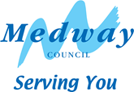

Skid Resistance Policy

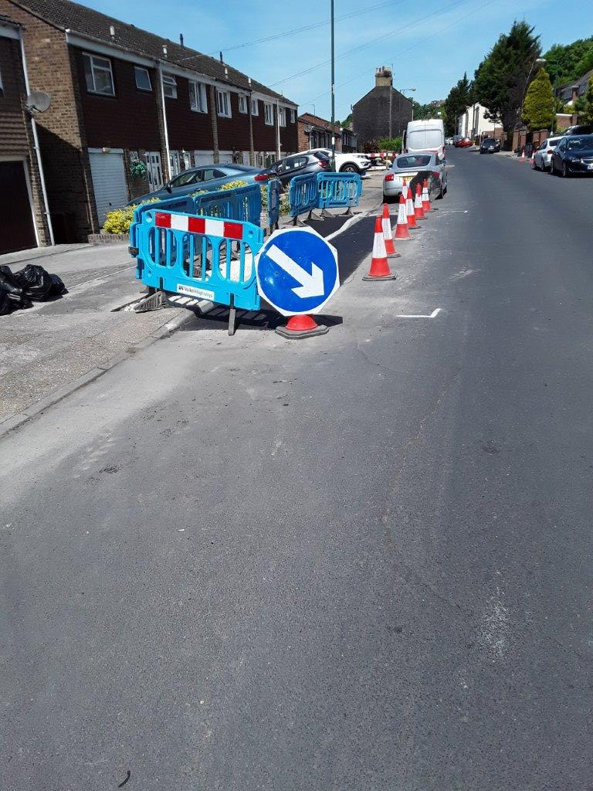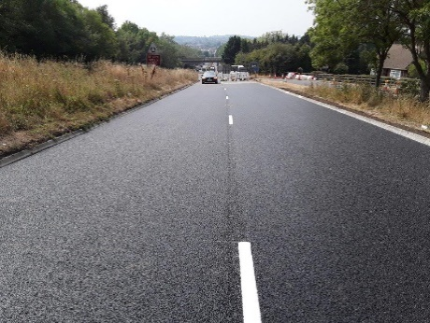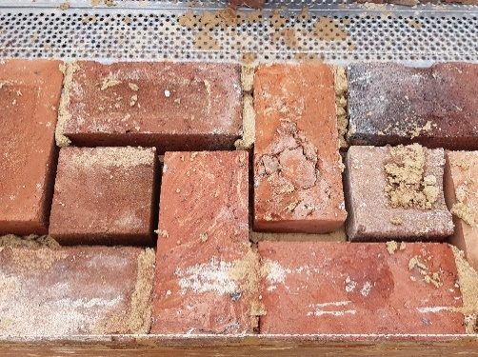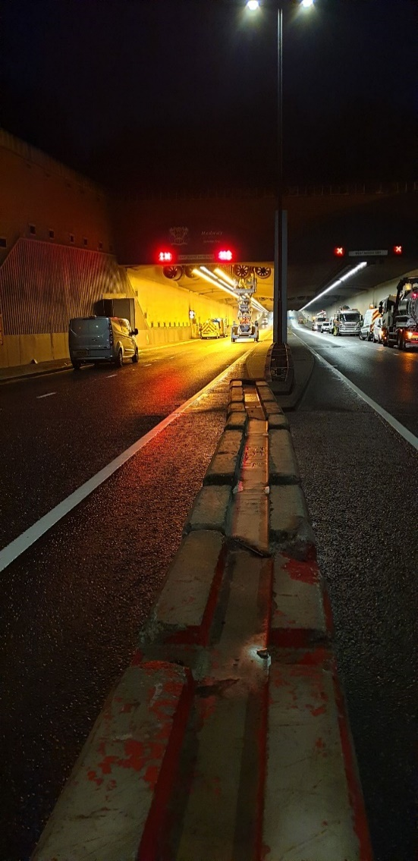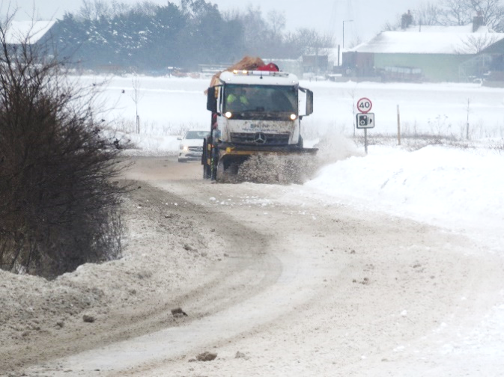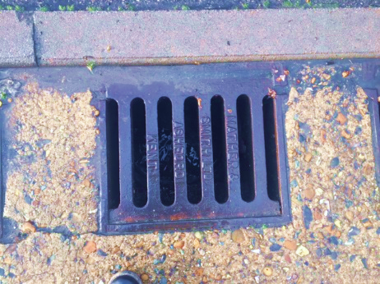

# Date: November 2024 Version: 2024

|  |  |
| --- | --- |
| Document title | Skid Resistance Policy |
| Author | Hyperion Infrastructure Consultancy |
| Principal Owner | Medway Council Highways |
| Document status | Final |

# Reviewer list

| Name | Role | Version 2021 | Version 2024 |
| --- | --- | --- | --- |
| DW | Transport Engineering Manager | ✓ | ✓ |
| JM | Senior Engineer, Highway Operations | ✓ |  |
| KR | Senior Engineer, Highway Operations |  | ✓ |

# Approvals

| Name | Role | Date | Versions |
| --- | --- | --- | --- |
| JA | Principal Engineer, Highways Asset Management | 30/06/2021 | 2021 |
| KT | Acting Head of Highways | 13/11/2024 | 2024 |

# Revision history

| Version | Date | Description | Author |
| --- | --- | --- | --- |
| First Issue | 30/06/2021 | Initial Compilation and Publication | CS |
| 2024 | 13/11/2024 | Review and Publication | KR |

This Policy will be reviewed every three years and will be made available to all employees and the public.

# Contents

1 Introduction 1

2 Policy Objectives 1

3 Management of Skid Resistance 1

## Introduction

Medway Council has a statutory duty under Section 41 of the Highways Act 1980 to ‘maintain highways that are maintainable at public expense’. Although the formal management of highway skid resistance is not a legal requirement, skid resistance is an important property relating to the safety of highway users, particularly in wet conditions, and it is considered good practice to implement a formal skid resistance policy.

Medway Council’s Skid Resistance Policy provides the framework for the management of skid resistance, with the aim of ensuring that the properties of road surfaces are appropriate for their expected use and maintain network safety.

## Policy Objectives

The objectives of the Skid Resistance Policy are to:

* reduce the number of wet skidding collisions on the Medway Council’s road network;
* ensure Medway Council maintains its duty of care in relation to Section 41 of the Highways Act (1980);
* ensure that a robust process is in place to identify and prioritise maintenance activities in order to mitigate the risk of wet skidding collisions;
* enable Medway Council to robustly defend third party claims against the Council in line with Section 58 of the Highways Act (1980).

## Management of Skid Resistance

Medway Council will follow a risk-based approach to the management of skid resistance, in line with the principles of Well Managed Highway Infrastructure: A Code of Practice (UK Roads Liaison Group, 2016). In order to achieve this approach alongside the policy objective, Medway Council will:

1. formalise processes for monitoring skid resistance, across the road network, on the basis of risk;
2. carry out proactive skid resistance surveys, on priority routes, that have been determined as presenting the greatest risk, to identify sites for further investigation1;
3. use collision data on sites identified for further investigation to determine whether inadequate skidding resistance could be a factor;
4. carry out detailed site investigations where appropriate;
5. recommend appropriate actions to mitigate risks, including the use of warning signs;
6. ensure improvements to skid deficient sites are prioritised on a risk basis for consideration as part of the annual highway maintenance works programme.

By applying this procedure, Medway Council will ensure that skid resistance across the highway network continues to be monitored and managed appropriately.

Medway Council’s approach to managing skid resistance is described in detail within Medway Council’s **Skid Resistance Management Procedure**.

1 On those parts of the network where skid resistance surveys are not routinely undertaken, Medway Council will take a reactive approach in response to reported wet skidding incidents.