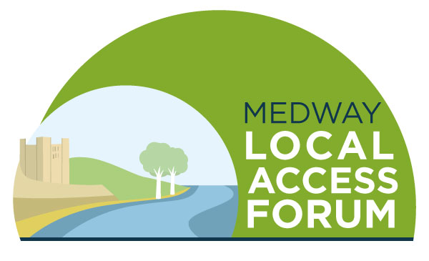

Agenda
Tuesday 30 November 2021

Welcome and introductions

Minutes of the last meeting and matters arising

Horsted Valley – Emilia Ayms

- Ranscombe Farm – Ben Sweeney

Round table catch up and good news stories / issues arising

Updates from Officers

Boosting the website

AOB

Date of next meeting – to be discussed

