Business Support

Overview and Scrutiny Committee
Briefing note 2/21
Date: 22 July 2021

Briefing paper to: All Members of the Business Support Overview & Scrutiny Committee

Purpose: To inform Members of the council’s digital journey.

______________________________________________________________________

Background

At Business Support Overview and Scrutiny Committee on 30 March 2021, members reviewed Q3 2020/21 Council Plan Performance Monitoring and the Risk Register.

There was a discussion on digital and internet poverty, and it was agreed that a briefing note would be provided, giving a breakdown of data on digital access, including the data source; take up and dropout rates; demography; and a comparison with other forms of customer interaction.

Introduction

The Medway Council Plan states the ambition to:

“Find the best digital innovation and use it to meet residents’ needs” including:

- We are committed to transforming the way we provide services, the way we operate and the way we interact with residents.
- We will take advantage of the opportunities provided by digital technology to make it quicker and easier for customers to access our services online, to suit their lifestyles and expectations, while delivering value for money.
- We will provide support, including education and access to technology, for those who can’t go online at the moment.

The council is committed to providing information and access to services to meet customer needs.

With the ever-increasing prevalence of smartphones, most of our customers now expect to be able to transact with the council online, at a time to suit them, often outside of business hours. See Office of National statistics data, below.

Even before Covid, many business transactions and social interactions were easily conducted online. Covid has increased that shift to digital technology (see statistics below), including Zoom chats with grandparents, applying for Universal Credit through the Department for Work and Pensions, renewing a driving licence on GOV.UK, shopping on Amazon and booking flights on EasyJet.

The 2021 Census was a digital-first census where everyone was encouraged to respond online if they could. Help was available via phone, web chat, email, social media or text and census support centres, of which Medway Libraries were one. Figures for online completion rates will be made available during 2022.

As well as being convenient and available 24/7, transacting online is the most cost-effective way for residents to transact with the council. Contact via the web is cheapest compared with face to face or phone contact (SOCITM on GOV.UK, 2012). We have already made significant resource reductions in anticipation of receiving fewer phone calls.

Digital access - the national picture

The Office of National Statistics (ONS) - Internet usage
The Labour Force Survey, conducted quarterly by the ONS, asks UK residents for information on employment, education and household characteristics, including internet usage. The survey is representative, meaning responses can be extrapolated to reliably reveal trends in local areas.

Internet usage in Medway has increased year-on-year since 2014.

Internet usage data from January to March 2020 (the latest available) shows nearly 96% of Medway residents aged 16 and over had used the internet in the 3 months previous; roughly 201,000 Medway residents, a 13 percentage-point increase in internet usage since 2014.

The percentage of residents who had either not used the internet in the past 3 months or have never used the internet has decreased over time. As of 2020, just over 4% of Medway residents were non-users or infrequent users of the internet, or roughly 9,000 residents.

Percentage values are used to account for population changes over time, and to allow for comparisons between areas of unequal population size.

This increasing internet use is consistent with trends seen in Kent, the South East and United Kingdom (see appendix 1).

Ofcom Internet availability and speed
Ofcom provides data on fixed broadband availability and the number of households who can and cannot receive different levels of fixed broadband. These findings are from the latest Connected Nations report, from January 2021.

In Medway, 97.1% of properties have at least Superfast Broadband (30Mbit/s or greater) availability; most premises can connect to the internet and achieve a reasonable download speed.

Of all Kent districts, Medway has the greatest percentage of premises able to achieve 30Mbit/s. See appendix 2 for more detail.

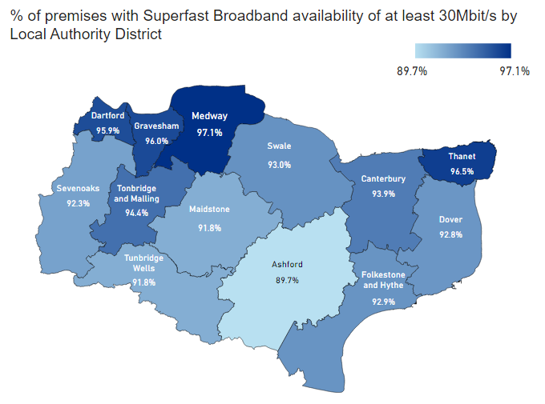
However, 2.7% of premises in Medway are unable to receive download speeds between 10 and 30 Mbit/s download speeds, equivalent to 3243 premises.

A further 0.2% of premises do not have access to download speeds at or below 10Mbit/s, equivalent to 246 premises.

Ofcom also provides information on mobile phone coverage, from 2G to 4G provided by the 4 main mobile communications operators. 3G coverage allows wireless access to the internet on mobiles, and allows bigger files to be sent

As of January 2021, 82.7% of premises had at least 3G in doors while around 78.9% had 4G coverage from all operators indoors.

About 95.9% of outdoor land areas in Medway had 4G coverage from all operators, the 4th highest percentage outdoor coverage in Kent.

Overview of the council’s online offer

Medway.gov.uk is the council’s primary customer contact channel and saw its highest number of visits to the site last year.

During Covid (between 3 March 2020 and 2 March 2021), there were 18,644,040 page views to Medway.gov.uk, compared with just over 10,542,000 in the same period the previous year.
During that time, Medway.gov.uk saw a 77% increase in page views, a more than 30% increase in visits and 36% more users compared with the same period the year before.

Inclusivity and accessibility online
While 96% of Medway residents use the internet as part of their daily lives (ONS, 2020), we also know that not everyone can, whether that’s through lack of access to technology, skill or need.

When we design new information or new online transactions, we try to research, design and test with the target audience. An example is talking to customers where they usually transact e.g. the parking office when we designed online parking permits. Our research extends to understanding their propensity to go online to use the new service. The testing aims to ensure our proposed solution meets customer needs.

When we make live new online services (transactions such as apply/book/pay) on Medway.gov.uk, alternative channels such as telephone or face to face still exist for these services.

We continually update Medway.gov.uk to meet the latest accessibility standards so that as many people as possible can access our online services. This is the law, which was made more stringent in September 2020.

Our Digital Service Standards follow industry best practice and set out our approach to ensuring Medway.gov.uk is usable and inclusive. For example, we know the average national reading age in the UK is 9 and so we write in plain English to make our online information understandable.

The council also offers assistance, face to face and via the telephone, for those who cannot currently go online.

At our hubs and libraries, volunteers and staff support customers to use our computers and access services online. Our libraries team also offers courses to upskill those who lack knowledge or confidence.

See below for examples of our assisted offer in operation.

Overview of telephony

Telephone contact continues to be popular for some, although the overall direction shows a reduction in phone calls. This allows officers more time to assist those customers who genuinely cannot go online.

Pre-recorded messages that our customers hear when they call us are intended to inform and to help customers to make choices. Messages provide service information and how this can be accessed online for those who prefer. But there is an option to speak with an operator if they need assistance with, for example completion of a form, transaction or where they need to speak with an officer.

To illustrate the use of telephones, average monthly call volumes covering the past 3 years are reflected below. Bear in mind that calls in 2020/21 were much reduced, most likely due to Covid 19. Early signs suggest call volumes are returning again, in April and May 2021.

Average monthly call volumes

Queue name | 2018/19 | 2019/20 | 2020/21
Environment (comprising many services including Trading Standards, Greenspaces, Highways and Safer Communities) | 7,007 | 5,780 | 3,756
Waste and bulky waste | 3,088 | 3,070 | 2,987
Council Tax | 9,578 | 7,949 | 4,698
Blue Badge | 1,214 | 858 | 550
(data source: IPFX Telephony Reporting Suite)

Within these numbers, some of our popular telephone transactions are:

Queue Name | Popular transactions
Environment | Tree maintenance and preservation status  Grass cutting  Signposting to consumer advice  Stray dogs and warden enforcement  Highway maintenance and emergency reports  Healthy safety reports including licensing and food safety  Noise and nuisance reports
Waste including bulky waste | Missed household refuse and bulky collections  Recycling and bin orders  Street cleaning and fly tipping  Household Waste Recycling Centre bookings and related enquires  Bulky bookings, cancellations and amendments
Council Tax | Bill enquiries  Payment plans including date changes  Council Tax registration  Council Tax reminders and court summonses
Blue Badge | New applications and renewal enquiries  Payments  Blue Badge misuse
(Information provided from CABS demand analysis and call monitoring).

CABS strive to achieve a minimum of 80% of calls answered and that target has been exceeded through 2020/21.

If customers abandon, it can be due to phone lines being exceptionally busy which can be caused by a variety of situations and where calls outstrip resources. Examples could include severe weather and government Covid announcements/ changes or disruptions to council services. Some customers may abandon and call back later, whereas others may hang up in response to information given in our front-end messages and perhaps access a service on-line. When call demand is high, there is an opportunity for customers who do not want to wait in the telephone queue, and who cannot access services digitally to leave a call back request.

Assisted digital offer in 2020/21
We know the importance of making our services available to everyone who needs them. In 2019, the head of BASS (as was) wrote an assisted strategy which followed best practice and made use of our existing offline channels.

The strategy covered various channels of support for those who couldn’t go online, through friends and family, our hubs and libraries, and our telephone lines.

While making services available online, unlike other organisations, we have not yet switched off any telephone or face to face offer.

Any decision to do so would follow a rigorous assessment of customer needs.

Popular tasks

The services selected below are a mix of the highest volume service requests and some used by the most vulnerable in society. The show how these services are accessed and the offline or assisted offer in place.

Caveats to some of the data are show alongside the statistics.

Bulky waste
Online is the preferred method for customers to book bulky waste collections.

Two-thirds of bookings were made online in 2020/21, a 10 percentage-point increase since 2019/20.

The increase in online bookings primarily saw a reduction in telephone bookings.

Whilst the Covid-19 restrictions would have impacted the ability to make face-to-face bookings, only 2% were made in this way during 2019/20.

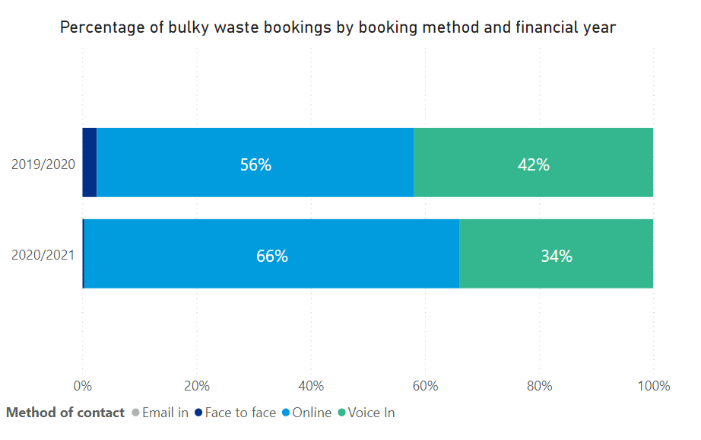

Complaints
The council’s corporate complaints procedure provides an opportunity for continuous improvement.

Customers have several ways of registering complaints, to ensure this is accessible to all.

The online form remains the most preferred method for our customers. Of 885 complaints, 520 or nearly 60% were lodged online. And this appears to be increasing. See appendix 3 for more detail.

Channel | Q1 | Q2 | Q3 | Q4 | Total
Email | 15 | 24 | 21 | 34 | 94
Online | 71 | 158 | 125 | 166 | 520
Phone | 26 | 67 | 47 | 89 | 229
Post | 8 | 18 | 11 | 5 | 42

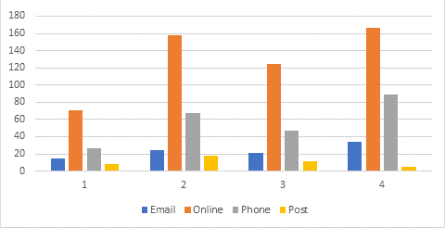

The council continues to provide digital assistance for logging of complaints, via the telephone.

Blue Badge applications
Of 5,092 Blue Badge applications made in 2020/21, 3,697 (or 73%) were made by customers or organisations online.

Channel | Q1 | Q2 | Q3 | Q4
Email | 4 | 3 | 10 | 6
Online | 791 | 1,002 | 879 | 1,025
Phone | 290 | 380 | 321 | 349
Post | 3 | 4 | 8 | 12
Face to face | 0 | 3 | 2 | 0

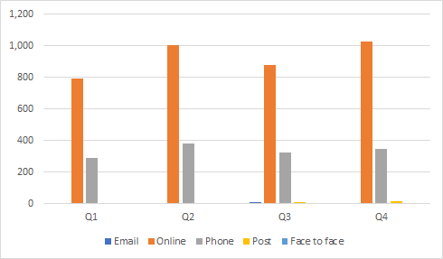

On average, 116 Blue Badge applications per month are completed by CABS assisting customers who cannot self-serve, compared with 308 applications where customers completed the form themselves (data source: Jadu /CRM).

Of 9,907 online Blue Badge applications started, 3,723 (or 38%) were submitted. See appendix 3 for more detail.

Caveats
This is a high-level measure for completion rate of the online form. It is not possible to:

- ascertain the number of customers that began a form despite being ineligible. Dependent on an individual's circumstances, ineligible customers are dissuaded from submitting the form based on information they have supplied during the online application process, and as such this will register as an incomplete submission.
- track whether individual customers were ultimately successful in submitting their application online. For example, a customer may have started a form several times prior to submitting a form, to check the information or evidence they are required to provide prior to gathering it. One way of making this simpler will be for customers to register for an account, allowing them to save and return to an application later. We anticipate this feature will be made available to blue badge customers in Q2.

Older person’s bus pass applications
In 2020/21, of 6,388 older person's bus pass applications, 3,831 (or 60%) were made by customers online.

Older person’s bus pass applications 2020/21
Channel | Q1 | Q2 | Q3 | Q4
Email | 14 | 15 | 3 | 1
Online | 690 | 1,164 | 850 | 1,127
Phone | 284 | 438 | 442 | 548
Post | 109 | 133 | 68 | 70
Face to face | 6 | 221 | 164 | 41

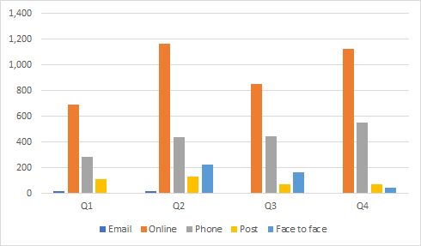

Of 5,779 online older person’s bus pass applications started, 3,843 (or almost 66%) were submitted. See appendix 4 for more detail.

As with blue badges, this is a high-level measure for completion rate of the online form, with the above-mentioned caveats.

Disabled person’s bus pass applications
In 2020/21, of 1,014 disabled person's bus pass applications, 681 (or 67%) were made by customers online.

Disabled person’s bus pass applications 2020/21
Channel | Q1 | Q2 | Q3 | Q4
Email | 14 | 20 | 5 | 5
Online | 108 | 196 | 146 | 168
Phone | 59 | 82 | 58 | 54
Post | 20 | 30 | 28 | 8
Face to face | 0 | 10 | 3 | 0

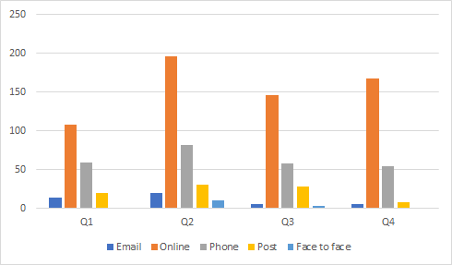

Of 1,961 online disabled bus pass applications started, 624 (or almost 32%) were submitted. See appendix 5 for more detail.

This is as a high-level measure for completion rate of the online form, with the above-mentioned caveats.

Household waste and recycling centre (HWRC) bookings
In 2020/21, of 275,401 HWRC bookings made, 272,258, or 99% were made by customers online.

Channel | Q1 | Q2 | Q3 | Q4
Email | 0 | 0 | 0 | 0
Online | 136,074 | 49,420 | 40,340 | 46,424
Phone | 293 | 994 | 976 | 880
Post | 0 | 0 | 0 | 0
Face to face | 0 | 0 | 0 | 0

During Q1 of 2020, the online booking form was also available to KCC residents through a partnership agreement. But subsequently, this was limited to just Medway’s three HWRCs, with Cuxton re-opening slightly later.

Owing to the nature of the service, to provide managed access to the highly popular HWRCs during Covid-19 (and only on a week-to-week basis), the option to book a visit by email, post or face-to-face was not made available to the public.

Of 572,382 online household waste and recycling centre bookings started, 275,312 (or 48%) were submitted. See appendix 6 for more detail.

A customer may have made a number of attempts to start the form, for example to check availability at their desired household waste and recycling centre before booking.

Successful completion of the form has a dependency on the availability of booking slots within the centres themselves, including the KCC sites that were available for booking during Q1.

Digital inclusion strategy

In 2020, many council services moved from face-to-face to online engagement due to Covid-19 restrictions, and while it’s clear this will form part of the ‘new normal’, it’s important to understand how this would impact customers.

A multi-agency working group was recently formed, comprising Medway Council, Kent County Council, the Kent and Medway NHS foundation trust and North East London Foundation Trust.

A survey to understand the extent, causes and solutions to digital exclusion was created and completed by 710 people, online and face to face.

Key findings are:
- The greatest reason for digital exclusion reported was a lack of access to digital devices caused by an inability to afford them;
- The main solution that residents felt they needed was access to a digital device with internet connectivity;
- 39% of respondents reported having difficulties with at least one out of a range of common digital skills;

As well as access to our hubs and libraries computers, a pilot project involving KCC and Medway is starting to tackle these issues. Devices are being loaned to individuals who need to stay in contact with the council, for example for health and wellbeing services.

The multi-agency working group is now looking to gather more data to build on this insight and gain a deeper understanding of the digital exclusion in Kent and Medway.

The group is working with organisations such as Citizens Online and taking best practice from companies such as BT, 100% Digital Leeds and Age UK to promote existing information and reduce the digital divide.

The group is identifying funding streams to support targeted interventions to increase digital inclusion and is focussed on addressing the greatest barriers to inclusion such as access to devices and increasing skills.

Conclusion
Both the national and local pictures show an increasing trend to use online services as people’s access to technology, skills, and awareness increases.

But there will always be some who cannot go online, and they will not be left behind. Through greater use of customer data as we design services, we will continue to ensure channels of communication remain open for all our residents.

Lead officers:
Anna Marie Lawrence, Head of Corporate Performance and Business Intelligence - annamarie.lawrence@medway.gov.uk or 01634 332406

Catherine Iles, Head of Digital – catherine.iles@medway.gov.uk or 01634 332763

Jeremy Shelton, Head of Customer and Business Support (CABS) -
jeremy.shelton@medway.gov.uk or 01634 334834

David Holloway – Corporate Business Intelligence Lead

Lewis Bridger – Process Change Manager (Digital)

Appendices

Appendix 1 – Percentage of residents aged 16 and over who have used the internet in the past 3 months by areas:

Increasing internet usage among Medway’s residents is consistent with trends seen in Kent, the South East, and United Kingdom. Nationally, internet usage is increasing year-on-year. The latest findings show that the percentage of residents using the internet in Medway is slightly higher than in Kent (all districts), the south east, and the United Kingdom.

Appendix 2 - Mobile phone coverage and percentage of 4G coverage (all operators) by local authority district:
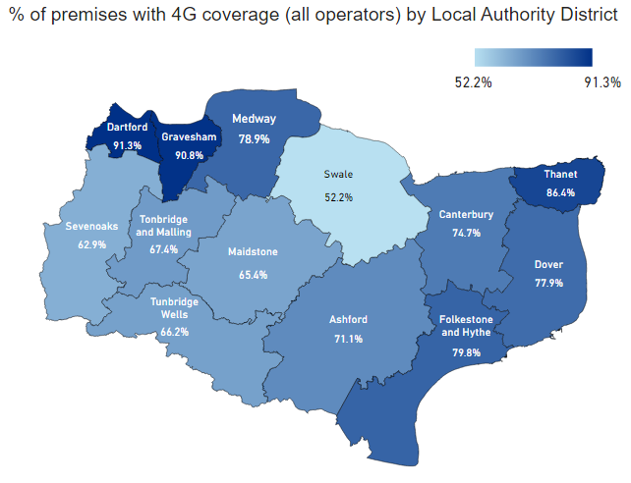

Percentage of land area with 4G coverage (all operators) by local authority district:
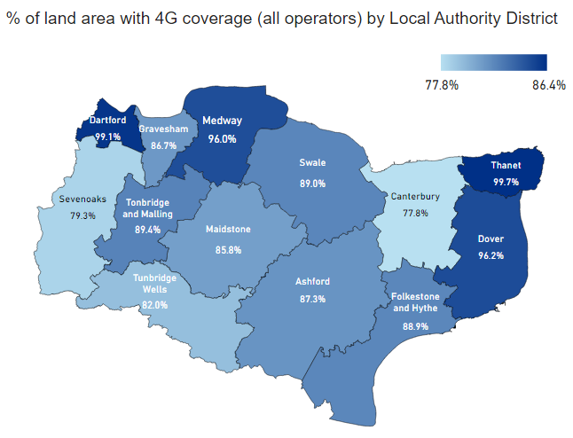

Appendix 3: Blue badge online applications 2020/21:

Completion status | Q1 | Q2 | Q3 | Q4
Submitted | 794 | 1,004 | 890 | 1,035
Incomplete | 1,210 | 1,867 | 1,407 | 1,700

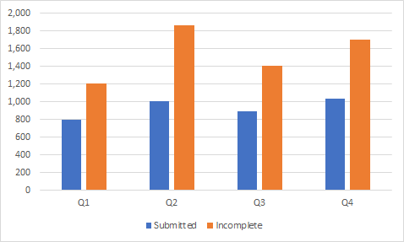

Appendix 4: Online older person’s bus pass applications 2020/21:

Completion status | Q1 | Q2 | Q3 | Q4
Submitted | 694 | 1,169 | 851 | 1,129
Incomplete | 330 | 557 | 446 | 603

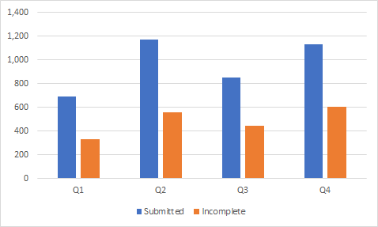

Appendix 5: Online disabled persons bus pass applications 2020/21:

Completion status | Q1 | Q2 | Q3 | Q4
Submitted | 108 | 196 | 147 | 173
Incomplete | 256 | 469 | 271 | 341

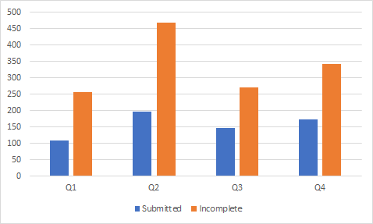

Appendix 6: HWRC online bookings 2020/21:

Completion status | Q1 | Q2 | Q3 | Q4
Submitted | 138,439 | 50,099 | 40,341 | 46,433
Incomplete | 187,925 | 58,980 | 22,691 | 27,474

