Nathaniel Prodger
Medway Council

Medway Air Quality: Student Pack
Table of Contents
Introduction to Air Quality: 2
What is air? 2
Why is air important to us? 2
What is air pollution? 4
Where does air pollution come from? 5
Gases: 5
Particulates: 6
Activity 1: Sources of air pollution: 8
Activity 2: Particulate capture: 9
Rough guide to particulate identification: 10
Air pollution and health: 11
Reducing the risk of poor air quality 13
Brief history lesson: 14
Monitoring Air Quality: 18
Continuous Monitoring: 18
Short-term, targeted monitoring: 19
Weather factors: 19
Activity 3: Weather effects on pollution: 20
Tackling poor air quality: 21
Nationally: 21
Locally: 21
What can you do? 22
Activity 4: How I get to school: 22
Anti-idling: 23
Raising awareness: 23
Activity 5: Taking the message home: 25
Additional activities: All just for fun! 26
Activity 6: Air quality wordsearch, can you find all the words? 26
Activity 7: Quiz: See how much you can remember: 27
Activity 8: Design a poster: 29
Glossary: 30

Student Pack

Introduction to Air Quality:

What is air?
Air is all around us, you can’t see it or hold it, smell or taste it, yet air is vital to your existence and the existence of every living thing around you. Air makes up the Earths atmosphere; it helps to control the temperature of the Earth and stops it getting too hot or too cold. Oxygen in the air provides the fuel for your body to move and grow, and without air, laughing, singing and talking would be impossible. Air is made up of a mixture of different gases and particles.
Components of air
- Nitrogen – 78%
- Oxygen – 21%
- Remaining 1% made up of:
  - Ozone
  - Carbon Dioxide
  - Argon
  - Water vapour
  - Other trace gases
  - Particles (Dust, Pollen, Etc.)

Why is air important to us?
Take a deep breath and hold it…
Your lungs can hold about 3 litres of air, which is about 2 squash bottles full, and you breathe in about 16 breaths per minute or 23,000 times a day!
Fun Fact! 46,000 litres of air pass into your lungs every day, that’s about the size of a lorry trailer!
(You can breathe out now)!
When you breathe in, a large muscle under your lungs called the diaphragm, moves down, allowing you to suck in air from the atmosphere. This air travels down your windpipe into your lungs where it flows along large tubes called Bronchi, these split into narrower tubes or bronchioles, and at the end of each bronchioles are tiny air sacs called Alveoli. Here, the oxygen in the air can pass through the walls of the alveoli and into your bloodstream. The oxygen is then transported around your body to your cells, where it helps to produce the energy needed to do all those things we enjoy.
Fun Fact! There are over 600 million alveoli in your lungs!
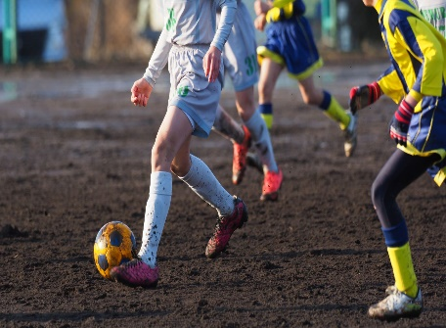
Once the oxygen is used, carbon dioxide is produced as a waste product. The blood transports this waste back to the lungs, your diaphragm moves up, and the carbon dioxide is pushed out into the atmosphere when you breathe out.

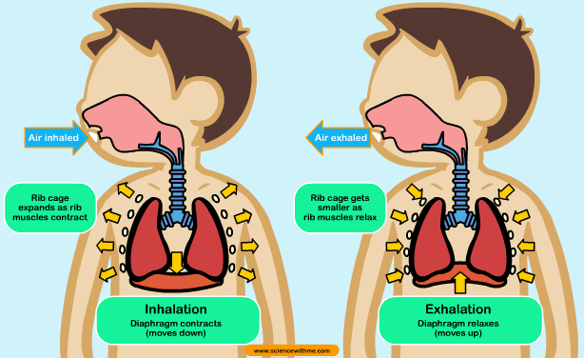
Understandably, it is very important that the air you breathe is clean, but sometimes there are things in the air that are not good for you, this is called pollution.

What is air pollution?
Things that can cause the air to be dirty, or reduce air quality, can come from a variety of sources both natural and man-made. UK law says that air pollution is a mixture of gases and particles that have been emitted (released) into the atmosphere by man-made processes. Pollution is a mix of gases and particulates, mixed within clean air, that can cause harm to both human or any other living thing.
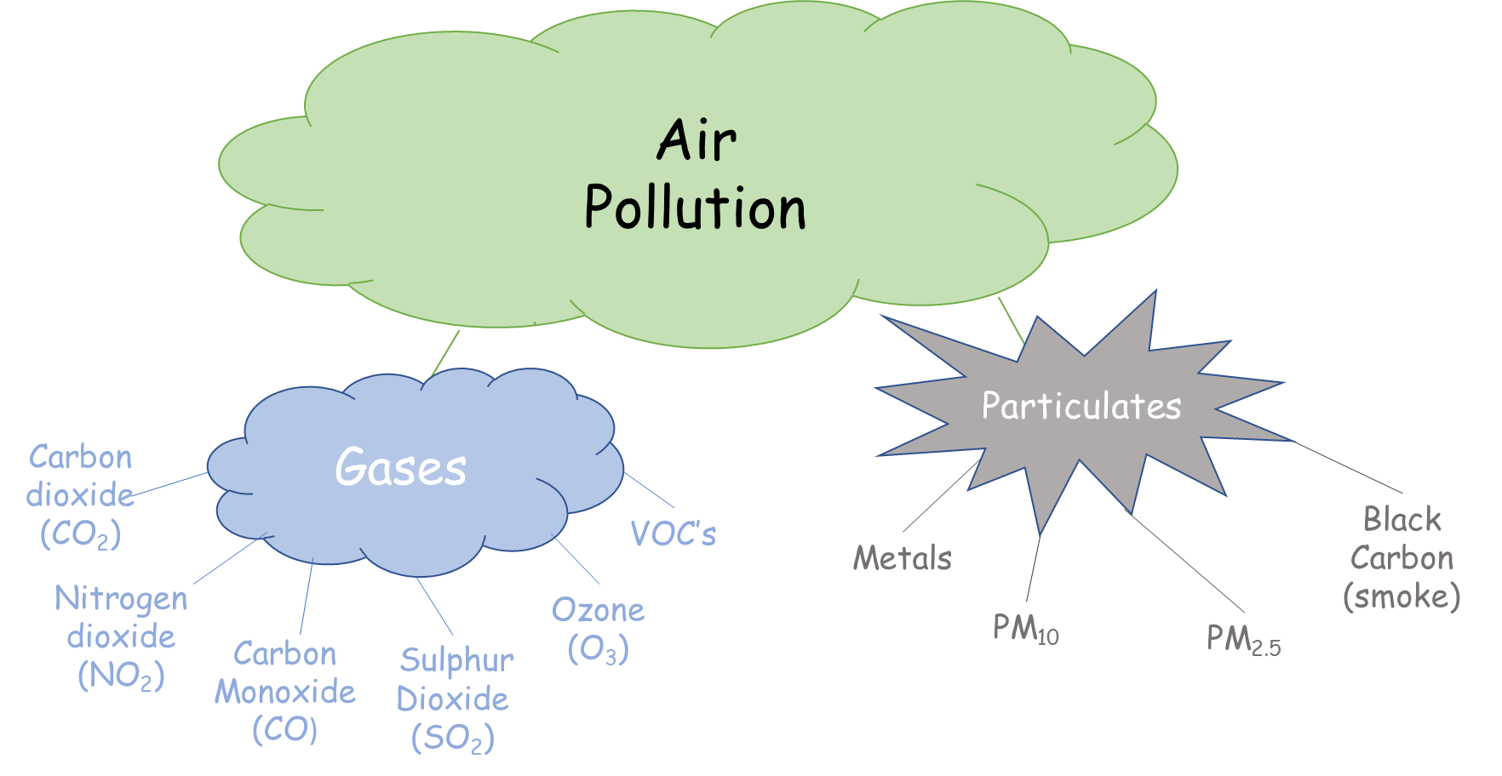
Figure 1: Common air pollutants.

Where does air pollution come from?
So, what are these pollutants and where do they come from?

Gases:
Carbon dioxide: Colourless gas created during the burning of fossil fuels such as petrol, diesel, and oil, as well as wood and other industrial processes. Carbon dioxide occurs naturally through volcanic processes, forest fires and is produced by living organisms.
Fact: Carbon dioxide is the gas found in the bubbles in fizzy drinks!
Nitrogen oxides – nitrogen dioxide: Nitrogen oxides are formed through the burning of fossil fuels such as petrol, diesel, and oil. Nitrogen dioxide comes from the reactions between nitrogen oxides and oxygen present in the air. Nitrogen dioxide is also formed naturally by lightning.
Carbon monoxide: This colourless, odourless and tasteless gas is formed though the incomplete burning of fuels such as wood, coal, gas, petrol and diesel.
Sulphur dioxide: Colourless but stinky poisonous gas created when sulphur containing materials such as coal and oil are burnt. Natural sources include volcanic activity. Used in industrial processes to create sulphuric acid, also creates acid rain when released to the atmosphere.
Fact: The clouds on Venus are made of sulphur dioxide!
Ozone: A poisonous and highly reactive pale blue gas that has a very distinctive smell at high concentrations. Formed though chemical reactions between emissions from industrial and transportation sources and sunlight. Occurs naturally at high altitudes where it protects the earths surface from rays from the Sun by converting almost all of the harmful ultraviolet rays from the Sun into heat in the upper atmosphere.
Volatile Organic Compounds (VOC’s): VOC’s are a group of chemical molecules that have a very large variety of sources, they are the main thing our noses detect when we smell anything. They can be released by industrial processes, aerosols, paints, cleaning products and fossil fuels. Naturally, they occur though plant and animal processes.

Particulates:
Metals: Metallic particulates have several man-made sources including industrial processes, rust, mechanical wear and tear and brake dust from vehicles, natural sources include weathering from natural deposits, and sea spray.
PM₁₀: Particulates in the air are described by their size and PM₁₀ is the unit of measurement for Particulate Matter of sizes of 10 micrometres and less or about one fifth the width of a human hair. These can be made up of natural and man-made particles such as ash, smoke and soot, pollen, dust, unburnt fuel, fungal spores, sand, and sea salt.

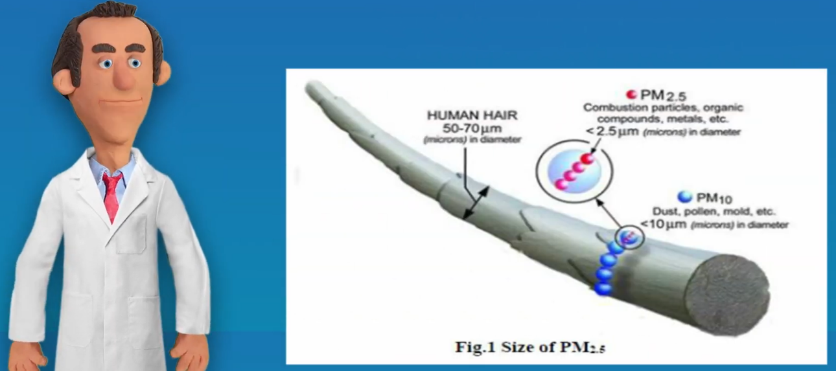
PM_{2.5}: Much smaller particles which can include organic chemicals, metals and soot of 2.5 micrometres and less or about one twentieth the width of a human hair! All vehicles produce particles of this size and they also originate from industrial processes. Natural sources include forest fires, windborne dust and even rain, which can bounce particles from the floor back into the air.

Black carbon: This is the collective name for all sizes of soot and smoke which comes from unburnt fuel sources, both man-made and natural. Sources can include barbeques, wood burning stoves, diesel and petrol engines, bonfires, forest fires.
The list above shows that most of the man-made pollution from gases and particulates comes from the burning of fossil fuels such as petrol, diesel, coal and oils. We use these fuels in many processes from powering our vehicles to the production of electricity to light and heat our homes. In Medway the main source of air pollution is from road transport sources.
Fun Fact! Many of these pollutants also contribute to global warming and climate change. By reducing pollution emissions, we can help to combat climate change as well! To find out more about climate change go to www.medway.gov.uk/climatechange

Activity 1: Sources of air pollution:
Using the list above to help, tick the boxes to show where air pollution comes from;
 | Nitrogen oxides | Carbon dioxide | Particulates | Sulphur Dioxide | Black Carbon | VOC’s
Volcanoes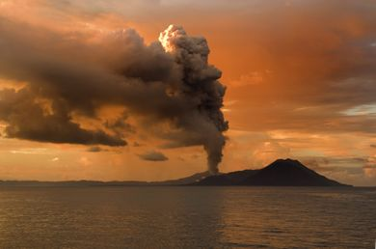
Sea Spray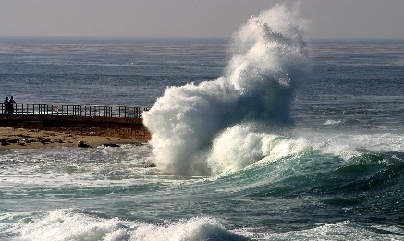
Dust Storm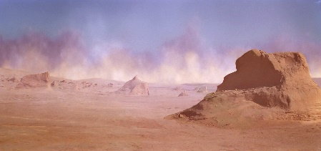
Forest fires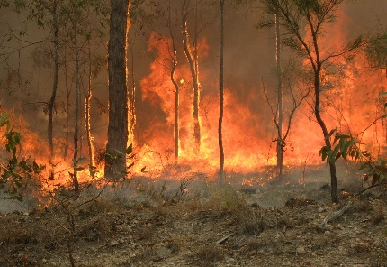
Lightning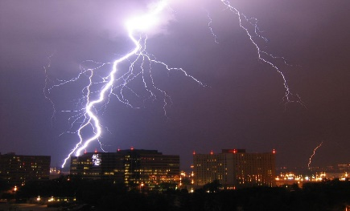
Transport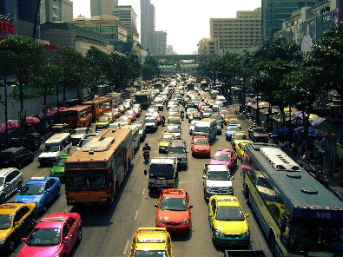

Activity 2: Particulate capture:
What you will need:
- A4 card
- Ruler
- Pencil
- Scissors
- Sticky tape
- Microscope/magnifying glass
- Notebook or activity pack to record findings
How to prepare:
- On a sheet of card draw out an oblong 10cm high by 20 cm wide.
- Cut the oblong out.
- Fold the card in half along its length and open it back out so it is flat.
- Draw three circles, evenly spaced out, on each half of the card. The circles must be smaller than the width of the sticky tape.
- Cut out the circles.
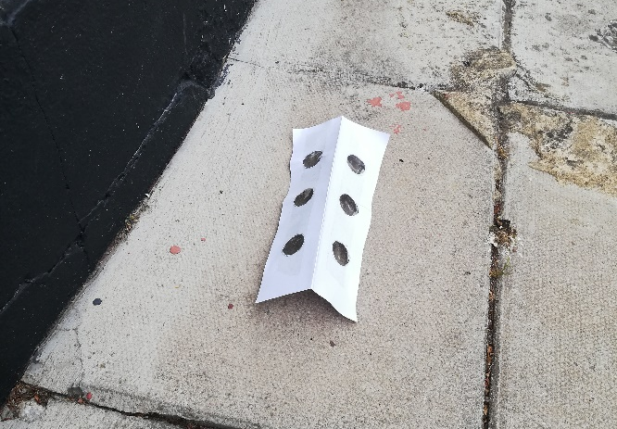
- Stick the sticky tape over the holes.
- Fold the card in half again so that the smooth side of the sticky tape is on the inside of the card.
- Stand the cards up in different locations with the sticky side pointing outwards. Leave the card for a day.
- At the end of the collection period put some more sticky tape on the outside of the card, covering the original sticky part, this traps the particulates collected and makes sure no others can get stuck.
- Using a microscope or a magnifying glass look and record what you have found!

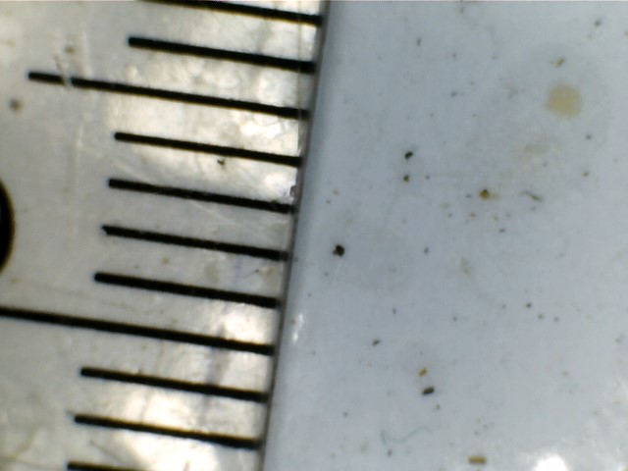

Rough guide to particulate identification:
Features | Colour | Source
Very small, often round, joined in long chains which may give a rough speck look | Dark black | Soot from vehicles
May look like tiny sand or rocks | Mostly brown | Inorganic dust
Looks like tiny seeds, spikey balls or smooth organic shapes | Yellow, red, or green | Pollen
Jagged edges, with enough sample may smell faintly of bonfires | Light brown, grey | Soot from wood smoke
Long, thin threads | Variety of colour | Fibres from fabrics, hair, fur
Bug like shapes, looks like a bit of an insect | Translucent yellow, brown | Bugs, insects and bits of bugs!

Air pollution and health:

As you have seen, there are many types of gases and particles that can have an effect on air quality and they are produced from many different sources. Pollution is specified as emissions from man-made processes, and the biggest source of that pollution is from the burning of fossil fuels and transport. But why are these pollutants a concern?
Well, it’s due to the effect they have on our bodies. You know when your skin gets a bit irritated and you scratch it, the itchiness usually goes away? Unfortunately, the gaseous pollutants enter the lungs and aggravate the lining. So, the lungs get irritated and sore, this can lead to inflammation (swelling) of the lining and an increase of sticky mucus and phlegm which can clog up the little airways in our lungs, both of which can lead to difficulty breathing.
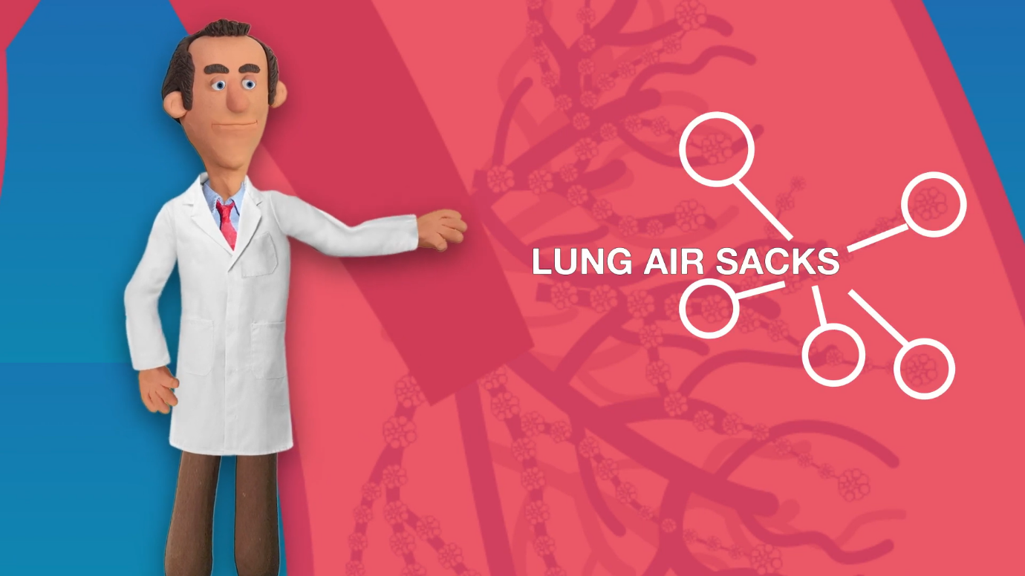

With particulates, the sizes are important. Large particles, those that are bigger than PM₁₀, will normally get filtered out of the air by our noses (and become bogies) before they reach the lungs.

Particles the size of PM₁₀ and smaller, can get into the lungs and get stuck, scratching and irritating them, what happens then? Big coughs! This can lead to inflammation, an increase in mucus and phlegm, and may also physically scar the lungs, causing long term damage. The smaller particulates, PM_{2.5} and smaller, can enter the blood stream and travel to your other organs such as the liver, heart and even the brain, where it is thought to cause all sorts of nasty problems.

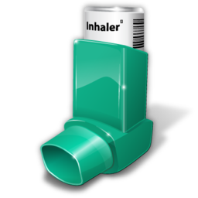
Those people with existing health problems are particularly vulnerable. A common lung condition called Asthma causes the little air sacks (Alveoli) in the lungs to not work properly, making it difficult to breathe. Special medicines and treatments are often needed to help the person breathe easier. Nitrogen dioxide in the air can make the symptoms of asthma worse, meaning that asthma sufferers may have more attacks, or have more serious attacks and end up in hospital.
Fact: Over 8 million people in the UK have been diagnosed with Asthma. (BLF, 2020)
Scarring in the lungs can lead to a nasty disease called Pulmonary Fibrosis, this disease gets worse over time and can greatly affect your ability to breathe. Unfortunately, while treatments can slow the progress, there is no cure for Pulmonary Fibrosis. Air pollution can make the symptoms worse and make the sufferer feel even worse.

Reducing the risk of poor air quality
So what can we do to protect our bodies against poor air quality? The best advice is to stay active and to eat healthily. Going outside, running round, doing exercise, playing with your friends, all of that will help to improve your fitness and help your body fight off any problems that can be caused by air pollution.
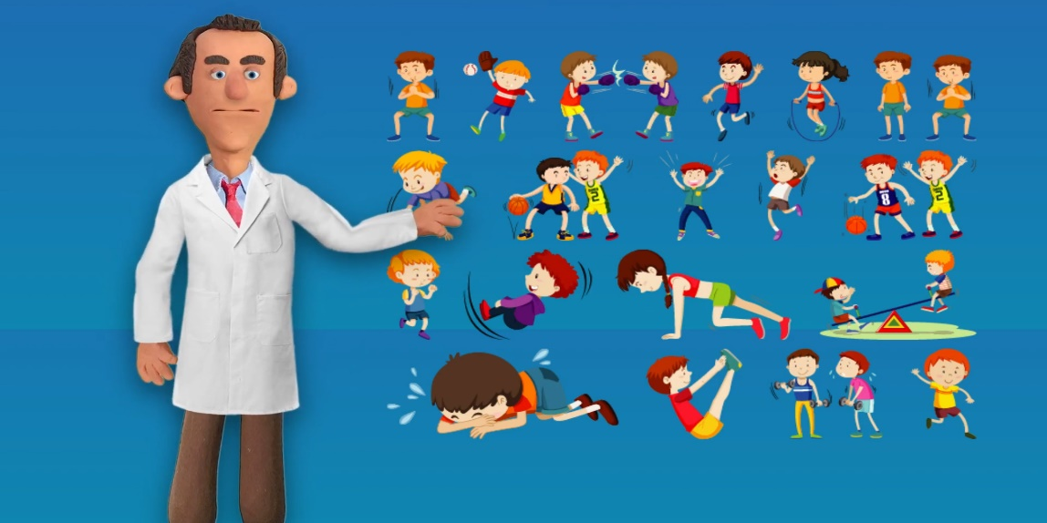

Another tip is to try to avoid roads that you know are going to be busy, whether you are walking, cycling or being driven, try to take a route where the traffic isn’t always stopped at the lights or really heavy, try to encourage your adults to go a different way to school or to the shops if the route they normally take is really busy.
Be aware of when air quality in your area is likely to be poorer and plan around the risk.
Ask your adults to sign up to Medway Councils free air quality email alert at https://kentair.org.uk/home/ForcastEmail

Brief history lesson:
The great smog of London, 1952:

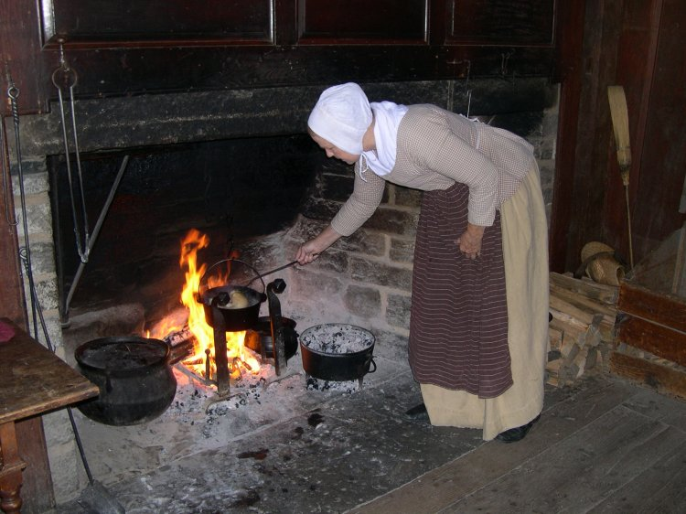
London has always suffered from air pollution problems. As early as 1306, laws were written that banned the use of a certain type of coal as it produced a lot of smoke when burnt. The laws were passed to control smoke from the many people living closely together, all of whom were reliant on open fires for heating, lighting and cooking as well as the many small industries in London at the time. Despite these laws, coal continued to be the main source of fuel for heating and cooking in homes for centuries after.
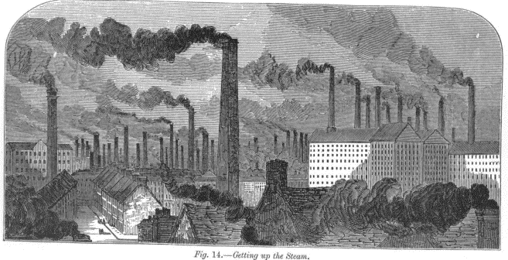
The 18th Century saw a rapid increase in coal use with the dawn of the industrial revolution. Large scale industries and factories were built in towns and cities, and people moved from the countryside to follow the jobs these created. New technologies saw steam driven trains and ships, powered by coal, chugging into the cities. Factory chimneys sprang up across the skyline, belching smoke and steam from the engines and furnaces inside. More coal was mined from the ground and shipped to cities like London to be burned to power the industries as well as provide heat and cooking fuel to the workers. Smoke from burning fuel mixed with the naturally occurring fogs to create thick smog that the Londoners called ‘peasoupers’, due to its resemblance to the thick green soup popular in London at the time.
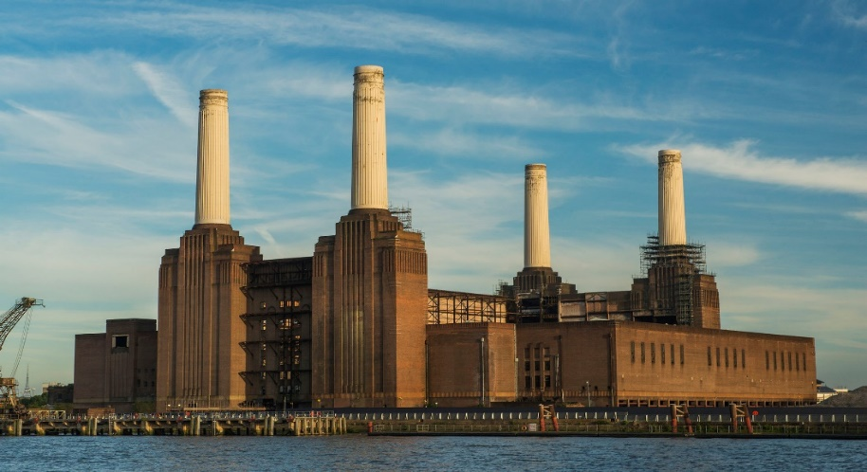
Harnessing electrical power caused power stations to be built along the Thames, the smoke from the burning of fuel to create electricity streamed out of the large chimneys and mixed with the already polluted air. Industry and population continued to grow and rely on the power provided by burning coal.
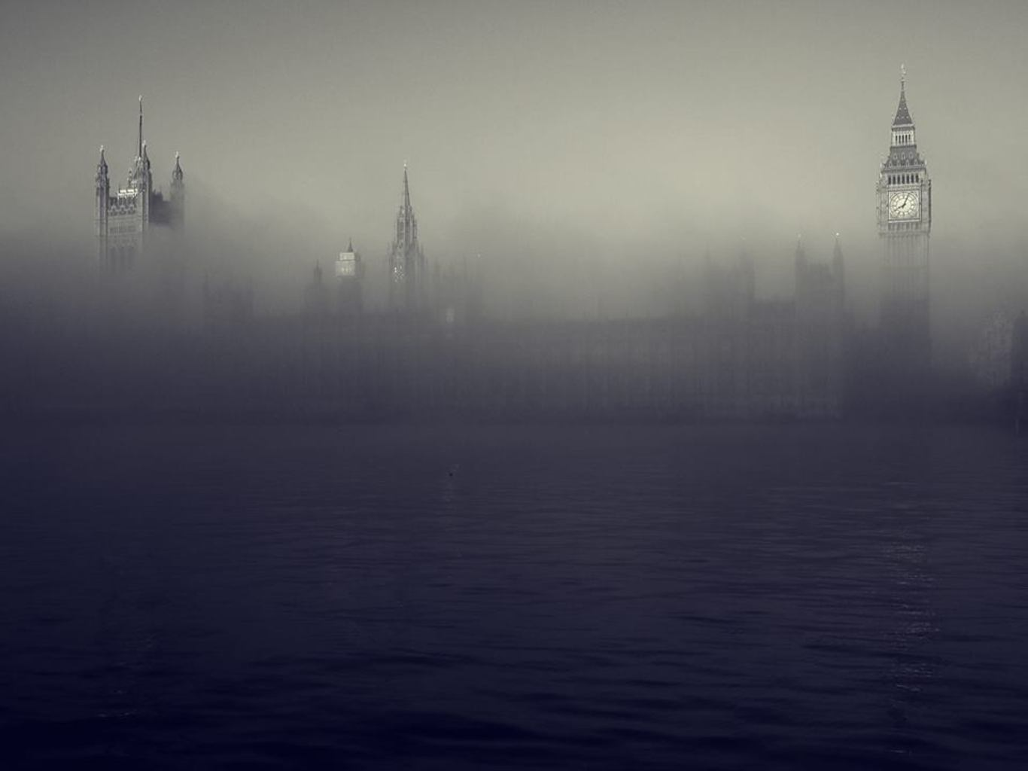
In December 1952, during a cold snap which lasted 4 days, a bubble of cold air formed over London. which trapped the air inside stopping the normal mixing of air by the winds. Airborne pollution mixed with the usual fog from the Thames creating a thick, cloying smog.

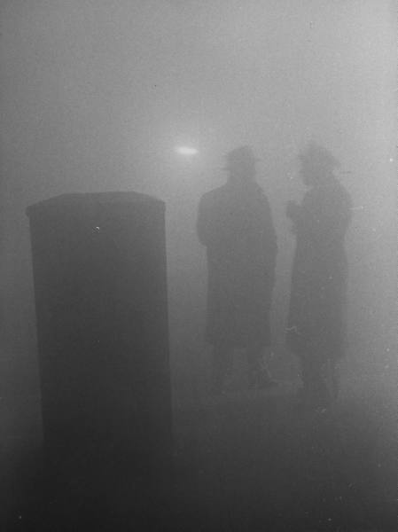
The pollution came from the widespread burning of coal for both industry and for heating and cooking at home. The smog created wasn't just the thick grey colour seen in these photographs, it was also a bit 'earwax' yellow, or 'bogey green'... and it smelled like rotting eggs, or burnt matches... now, would you want to breathe that in?
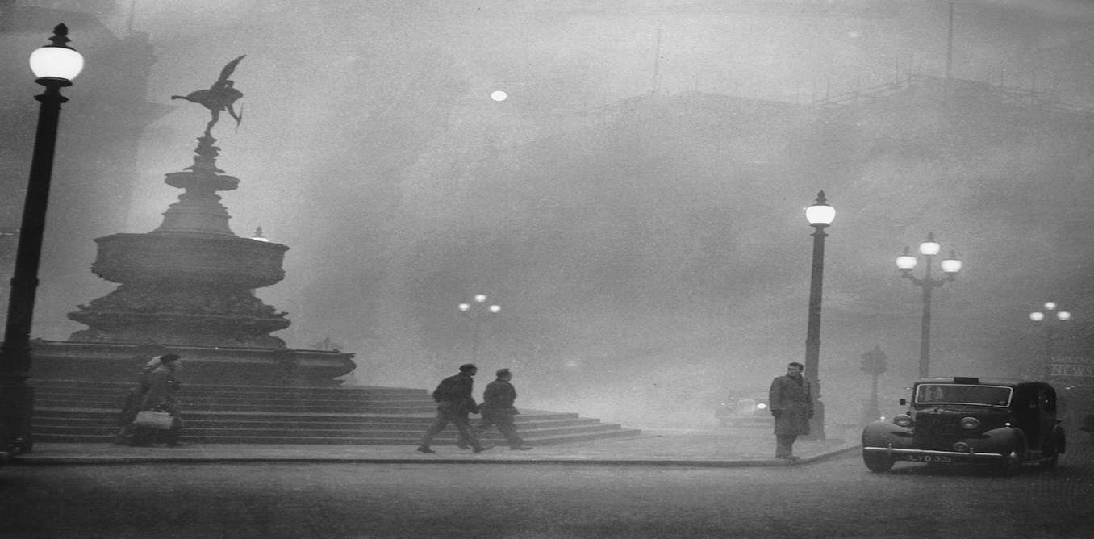
The problem with the smog wasn’t just that you couldn’t see through it, the smog also contained lots of pollution. Different gases, such as sulphur dioxide, given off from the burning of fuels, stung the eyes making them red and swollen and irritated the lungs causing nasty coughs and long term lung damage. Over 4 days it was estimated that the smog had caused about 4000 deaths and over 100,000 more people became ill. However, newer estimates put the total number of deaths caused over those four days through poor air quality closer to 12, 000 people.

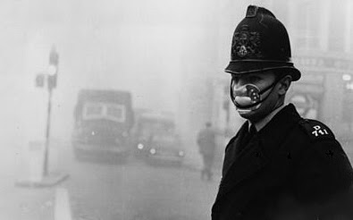
The government decided that action was required and passed the Clean Air Act in 1956. Amongst other measures, the Act encouraged householders to move to 'cleaner' fuels such as gas and electricity, the Act removed coal fired power stations from the centre of cities and away from centres of populace.
It also created the need for people like me, people who monitored air quality and came up with ideas to help further improve the cleanliness of the air.

So, with the creation of the Clean Air Act, was that the end of pollution in our cities? Unfortunately, no. New technologies in transportation, new fuels and new ways of living have meant that different pollutants are now commonplace and have become the new focus of our schemes to improve air quality.

Monitoring Air Quality:
The first step in tackling air quality is to identify where pollutants are concentrated and how much of that pollutant there is in that area. We know that pollution is mainly formed through the burning of fossil fuels and so we look for those areas where the most fuel is being burnt. In Medway, we monitor what is present in the air in two ways.

Continuous Monitoring:
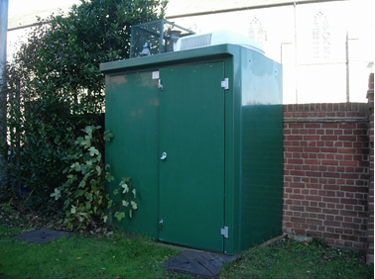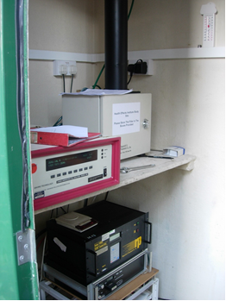
This allows us to see continuous monitoring over a long period of time and to be able to compare this nationally in real time. We have two such monitoring sites within Medway, one next to a busy main road through Medway and one in a rural area. These stations measure nitrogen dioxide, sulphur dioxide, ozone, VOC’s and particulate concentrations at the same time. Data is then uploaded to the national database for analysis. You can find the data of Medway’s air quality at www.kentair.org Where you can compare your local area to others in Medway and Kent.

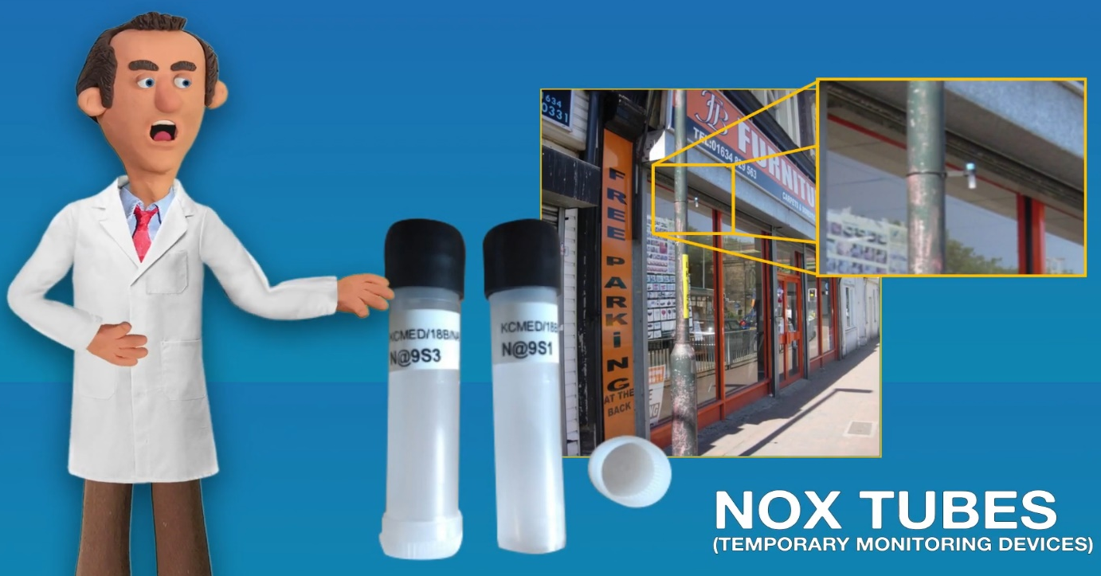
Short-term, targeted monitoring:
These are temporary monitoring devices called diffusion tubes. We place these along busy main roads and change them once a month. These collect nitrogen dioxide from the air, the more gas, the more polluted an area is. Next time you find yourself along a busy road, have a look at the lamp posts and you may see one hard at work!
This monitoring allows us to see where pollution is concentrated and then we can start to look at solutions to the problems.

Weather factors:
When monitoring air quality it is very important to record what the weather was like as the type of weather can greatly affect the results!
Sunshine: Ground level ozone is formed from chemical reactions between sunlight and emissions from vehicles and industry.
Wind: Blows pollution to new areas away from the source. Gases are mixed and scattered more quickly in higher winds.
Clouds: Sunlight drives the formation of ozone, clouds block sunlight reducing ozone concentrations.
Temperature: Warm temperatures speed up the evaporation of liquid solvents, which react in the air to form ozone and particulates.
Cold temperatures can trap smoke and other pollutants close to the ground.
Inversions: Related to temperature. Cold air is trapped close to the surface by a layer of warmer air preventing normal mixing of the air – pollution can build up in this ‘bubble’ of cold air (The Great Smog of London, 1952)
Humidity: High humidity can increase particulates in the air. Particulates also absorb water in the air causing the particulates to swell and get bigger.
Rain: Removes larger particles but is not very good at removing smaller particles.
Atmospheric pressure: High pressure brings certain weather conditions that have high pollution levels. Low pressure = lower pollution levels.

Activity 3: Weather effects on pollution:
Have a look at this week of crazy weather, complete the table below and mark if you think the weather conditions may make pollution levels higher or lower.
 | Monday | Tuesday | Wednesday | Thursday | Friday | Saturday | Sunday
Weather |  |  | 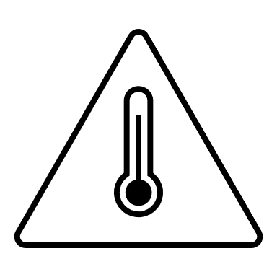
Higher pollution levels
Lower pollution levels

Tackling poor air quality:
Through monitoring we have found that in the UK a major source of pollution comes from road transport. This is especially noticeable in towns and cities where the amount of vehicles on the road are high and congestion is very likely. Let’s have a look at a few of the things that National and Local Governments do to reduce the pollution caused by transport.

Nationally:
Provide funding for research and new schemes to improve air quality, this includes car scrappage schemes, clean air zones and research into alternative fuels such as electricity and hydrogen.
Introducing new laws regarding pollution, for example; banning certain vehicles such as diesel powered cars and setting pollution targets.
The UK Government has introduced a ban on the sale of all new petrol and diesel cars from 2030.
Planning new and improving national transport links so that alternative transport is available to more people.

Locally:
Develop local plans to improve road systems and ensure new housing is protected from poor air quality.
Ensure housing developers include sustainable transport solutions such as electric vehicle charging points, and cycle schemes, into their building plans.
Educate and inform local residents on air quality and how to reduce pollution, for example, asking people to switch off their engines when their vehicle is stationary.
Encourage local residents to use alternative transport such as cycling, for short journeys.

What can you do?
First, fill out this short survey and pass to your teachers:

Activity 4: How I get to school:
Tick all that apply.
Day | Car | Walk | Bus | Train | Cycle | Skate/scoot | Walking bus | Park and stride* | Other
Monday
Tuesday
Wednesday
Thursday
Friday
*(driven then park and walk a bit from a few roads away)
Now, have a think of any ways that you can change your way of getting to school to make your journey less polluting. So, if you take a car every day, is there any way that you could walk or cycle one day a week or more?
Find out if your school has a Walking Bus service and join it if possible.
For more information about the Walking Bus Service, visit: www.medway.gov.uk/info/200160/roads_and_pavements/511/walking_bus

If you and a friend both get driven into school, could you share a ride so that only one car is used?
If you have to use the car to get to school, are there any ways of reducing emissions around the school? Well, yes. Your driver can park further away from the school and you can continue the journey on foot, this means that there are less cars around the school gates.
Remind your driver to turn their car engine off when stationary.

Anti-idling:

Leaving the engine running when not moving is called idling. It is a big contributor to air pollution at places like traffic lights, railway crossings and school gates. By turning the engine off when not moving drivers can reduce emissions and save money.
An idling car can fill about 150 balloons with exhaust emissions in just one minute! Five cars idling for five minutes could fill enough balloons to fly your teacher!
An idling car is the least efficient car on the road as it gets zero miles to the gallon of fuel!
Idling for more than 10 seconds uses more fuel than simply restarting the engine. It is cheaper to turn the engine off while you wait than it is to keep it running.

Raising awareness:
While you may not have that much say in the decision to walk to school or in which type of vehicle your adults use, there is something far more important that you and your classmates can do. That is to raise awareness of the importance of air quality. This can be in your class, in your school, in your home or even in the wider community.
Here are some ideas for projects you can do in school or at home to help raise awareness of the importance of having clean air. Speak to your teachers or adults to see what you can do.
- Poster competitions – Raise awareness in your school by designing bright, informative posters to display.
- Walk to school days – Ask your school to promote a ‘Walk to School’ day. Take a survey of the pupils to see how many usually take a vehicle and see how many you can get to walk to school on that special day.
- Write an article for the school newsletter – Write about how air quality can affect your health and what you are looking to do to improve air quality in your area.
- Include some of your projects on the school’s social media – Ask the school to include photographs and a write-up on your projects.
- Run an anti-idling campaign – Idling is when a vehicles engine is left running while the vehicle is not moving and it is a big contributor to pollution at places like school gates, traffic lights and railway crossings. Asking drivers to turn their engines off with the use of posters or other media is a great way of cutting pollution.
- Traffic surveys – Find out how many vehicles and of what type pass your school at different times during the day. From a safe distance use a tally chart to see what kind of traffic passes your school. Create graphs to show the different types of vehicles.
- Make and fly kites – have a kite competition at school or make your own kite and fly it at home.
- Support Clean Air Day - Clean Air Day is the UK’s largest air pollution campaign. To find out more information and how to get involved, visit: www.cleanairday.org.uk
- Form an ‘eco-club’ in the school or get involved in the activities that your schools eco-club already run – Ask your teacher if the school has an ‘eco-club’ and see what you can do to get involved.
- Plant a tree or make a school garden
- Keep the Environmental Protection Team at Medway Council informed of what your school is doing.

Activity 5: Taking the message home: Cut out the card below. Fold in the middle. Colour in the picture and write your message. Put some air quality facts inside the card.

Additional activities: All just for fun!

Activity 6: Air quality wordsearch, can you find all the words?
F | G | E | B | E | S | F | U | E | L | H | W | P | D | P
A | S | M | O | G | W | Y | V | M | X | W | R | F | Y | E
N | G | R | O | P | O | L | L | U | T | I | O | N | E | T
Y | N | T | D | A | I | T | H | L | K | C | D | C | P | R
N | U | I | I | R | H | T | O | W | D | F | H | Y | B | O
V | L | T | D | T | U | I | R | Z | O | E | W | C | F | L
M | V | I | L | I | A | S | R | B | O | M | L | L | K | J
O | L | P | I | C | T | W | H | F | B | N | I | I | G | D
Y | O | I | N | U | M | U | L | E | P | I | E | N | K | Y
T | R | H | G | L | B | L | U | R | A | S | H | G | B | C
K | R | N | Y | A | N | E | R | D | F | L | J | R | I | A
M | Y | T | S | T | V | S | O | L | M | H | T | I | R | R
D | M | F | N | E | B | E | Y | W | A | L | K | H | S | E
G | T | O | I | S | P | I | S | A | E | T | I | R | Y | S
E | D | I | X | O | I | D | N | E | G | O | R | T | I | N

AIR | LUNGS
CAR | NITROGEN DIOXIDE
CYCLING | OZONE
DIESEL | PARTICULATES
FUEL | PETROL
HEALTHY | POLLUTION
IDLING | SMOG
LORRY | WALK

Activity 7: Quiz: See how much you can remember:

- Air is mainly made from three gases, nitrogen, argon and …? ………………………………………………………………………………………………………..

- Our lungs can hold 12 litres of air in one breath. True or false?
………………………………………………………………………………………………………..

- Which organ does air go into when we breathe in?
………………………………………………………………………………………………………..

- All the gases in the air are good for our health. True or false?
………………………………………………………………………………………………………..

- What is the gas found in bubbly drinks called?
………………………………………………………………………………………………………..

- Poor air quality can be caused by natural sources. True or false?
………………………………………………………………………………………………………..

- The main source of pollution in Medway comes from?
………………………………………………………………………………………………………..

- Particulates are sorted into sizes called?
………………………………………………………………………………………………………..

- Nitrogen dioxide can make the symptoms of which lung condition worse?
………………………………………………………………………………………………………..

- What is the best way of protecting our bodies from air pollution?
………………………………………………………………………………………………………..

- When was the Great Smog of London?
………………………………………………………………………………………………………..

- What fuel was the main contributor of the Great Smog?
………………………………………………………………………………………………………..

- What colours were the Smog?
………………………………………………………………………………………………………..

- How many people died from poor air quality during the Great Smog of London?
………………………………………………………………………………………………………..

- When was the Clean Air Act passed?
………………………………………………………………………………………………………..

- What are the little tubes we use to monitor air quality called?
………………………………………………………………………………………………………..

- The weather can both increase and decrease air pollution. True or False?
………………………………………………………………………………………………………..

- What is idling?
………………………………………………………………………………………………………..

Activity 8: Design a poster:
Design a poster to raise awareness about how important air quality is.

Glossary:

Air – Alternative name for the atmosphere and the gases that surround us and that we breathe.
Air pollution – A mixture of gases and particulates released to the atmosphere through man-made processes which reduce the quality of air.
Air quality – A measure of how clean the air we breathe is.
Alveoli – Air sacks in the lungs which allow for the transfer of oxygen to the blood stream.
Argon – An inert gas that makes up 1 per cent of earths atmosphere.
Asthma – A long-term health condition that affects the airways in the lungs.
Atmosphere – Collective name for all the gases that surround earth or other planets.
Black carbon – partially burnt or unburnt particles from the burning of fossil fuels. Visible as soot and smoke.
Bronchi – Large air tubes in the lungs through which air travels from the windpipe through to the bronchioles.
Bronchioles – smaller air tubes in the lungs which lead to the alveoli
Carbon Dioxide – A greenhouse gas produced naturally and through man-made processes.
Carbon monoxide – A gas produced through the incomplete burning of fuels, it is very harmful to health.
Cells – The smallest functional part of an organism and basic building blocks of larger organisms.
Diaphragm – A thin muscle that pulls air into the body then it contacts, air is exhaled when the diaphragm relaxes.
Diffusion tubes – Monitoring tool used to measure nitrogen dioxide levels.
Emissions – The production and release of waste products such as gases or particulates during certain processes such as the burning of fossil fuels.
Fossil fuels – Naturally occurring materials such as coal, oil and gases can be processed to produce fuels when burnt. Called fossil fuels because they are formed through geological processes from ancient organisms.
Gases – A state of matter with no fixed shape or volume. Gases make up earths atmosphere.
Idling – Allowing an engine to run while the vehicle is not moving.
Lungs – Organs within the body that allows the transfer of oxygen to, and the emission of carbon dioxide from, the blood system.
Man-made processes – Any processes that are caused by human-beings or do not occur naturally, may be industrial, domestic or agricultural.
Metals – A solid material that can be found as tiny particles in the atmosphere through natural processes of weathering or from made-made processes.
Nitrogen – An unreactive gas that makes up approximately 78 per cent of earths atmosphere.
Nitrogen dioxide – A poisonous gas formed through the burning of fossil fuels.
Nitrogen oxides – Different chemical molecules that contain nitrogen atoms and oxygen atoms, e.g. nitrogen dioxide contains one atom of nitrogen and two atoms of oxygen.
Oxygen – A reactive gas which is vital to life. Makes up about 21 per cent of earths atmosphere.
Ozone – A poisonous gas formed through chemical reactions between man-made emissions and sun light. Occurs naturally high in the atmosphere where it absorbs almost all of the harmful UV rays from the sun.
Particles – Microscopic bits of solid matter.
Particulates – Microscopic bits of solid or liquid matter.
PM₁₀ – Unit of measurement for particulate sizes of 10 micrometres and less, approximately one fifth the width of a human hair.
PM_{2.5} - Unit of measurement for particulate sizes of 2.5 micrometres and less, approximately one twentieth the width of a human hair.
Pollutants – A substance introduced to an environment that has the potential to cause harm and other undesired effects on the environment.
Pollution – A collective name for all pollutants that are introduced into an environment.
Pulmonary Fibrosis – A serious lung condition caused by scarring in the lungs formed by breathing in harmful substances including pollution.
Sulphur dioxide – A smelly, poisonous gas formed through the burning of sulphur containing materials such as coal. Used in industry to form Sulphuric acid. Forms acid rain if released to the atmosphere.
Trace gases – The combination of gases that make up less than one per cent of the Earths atmosphere.
Volatile Organic Compounds (VOC’s) – Organic chemicals responsible for scents and odours.
Walking Bus – A sustainable method of travelling to school where children walk with adult volunteers along a set route and are picked up or dropped off at certain ‘bus stops’.
Water vapour – The gaseous form of water.

