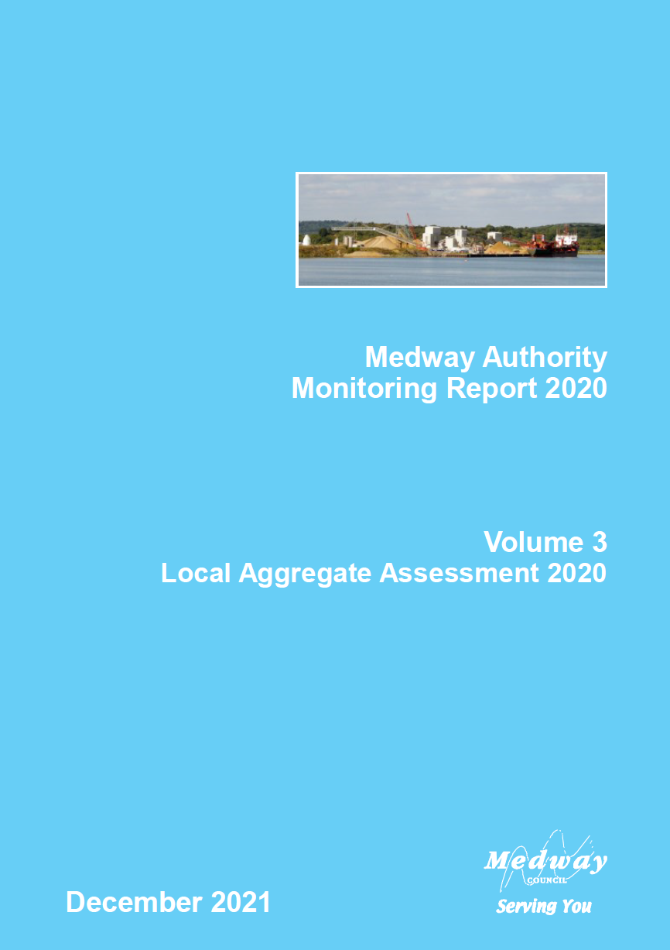

Executive Summary
This is the ninth Local Aggregate Assessment (LAA) produced for Medway, in line with the requirements set out in the National Planning Policy Framework (NPPF) and in accordance with the Planning Practice Guidance (PPG).
This draft report covers the 2020 calendar year is circulated to Minerals Planning Authorities throughout the South East and neighbouring areas, industry representatives and other key stakeholders for comments.
The council has considered a range of data sources in compiling information on the demand for aggregates and supply options available; with the annual aggregate monitoring produced by the South East England Aggregates Working Party (SEEAWP) based on a survey of local operators being a key source of data. Due to the size of Medway and the limited number of minerals sites and wharves, there are some areas where it is not possible to publish sales data due to commercial confidentiality.
This report also takes account of the latest four yearly Aggregate Monitoring Survey that took place in 2020 which surveyed aggregate sales in 2019.

Land-won Aggregate
Currently, sand and gravel is the only land-won aggregate actively being extracted in Medway.
There are currently two permitted quarries for the extraction of sand and gravel in Medway, one inactive and the other commencing extraction in 2017, becoming fully operational in 2018.
Current permitted reserves of sand and gravel is 574,000 tonnes, providing a significantly reduced landbank of 4.3 years based on 3-year average sales data.

Recycled and Secondary Aggregate
It is thought that there was only one site producing secondary aggregates in 2020 though a survey return from the secondary aggregate operator was not received for operations in 2020.
A separate Waste Needs Assessment undertaken in 2020 suggests that in 2019 two sites were producing recycled aggregate with a combined peak output of 135,000tpa.

Marine-won sand and gravel
Medway’s wharves continue to demonstrate their regional importance, reporting 1.786 Mt of marine-won sand and gravel sales in 2020, an increase of at least 300,000t in 2019.
As with 2019, no sales of marine-won soft sand were reported in 2020.

Crushed Rock
No return was received from the main operator importing crushed rock through the wharves in Medway in 2020. A conservative estimate based on sales in previous years suggests a decrease although this runs counter to year on year increases seen between 2016 and 2019.
Total annual sales from wharves in the last five years is estimated to average 2.8 million tonnes.

Demand
The council has analysed a range of sources to project any trends that may be emerging that would influence demand. The population of Medway is projected to increase significantly, while house builders are reporting increased workloads and planning permissions nationally, indicating a potential increase in demand over the coming years. 1,130 new homes were delivered in Medway in 2019/20 which was the highest level seen since the council was created in the late 1990s. Housing delivery at this high level is expected to continue in the short to medium term. A number of significantly large regional infrastructure projects are also expected to increase demand.

Conclusion
Medway plays a strategic role in regional aggregates supply through the wharves located on the Medway and the Thames.
Land won reserves of sand and gravel are rapidly depleting, however the decreasing landbank is compensated for by increased levels of imports at Medway’s wharves.
The council will plan positively for the steady and adequate supply of aggregate through the emerging Local Plan in order meet the needs of the local and regional markets.

Summary – Medway Council (for the calendar year 2020)
Quarry  Sales | 2020 Sales (Mt)  & Trend¹ | Average  (10-yr) Sales  & Trend¹ | Average  (3-yr) Sales  & Trend¹ | LAA Rate (Mt)² | Reserve (Mt) | Landbank (years) | Allocations (years) | Capacity (Mtpa) | Comments³
Soft Sand |  |  |  |  |  |  |  |  | No known reserves
Sharp Sand & Gravel | c | 0.043 | 0.134 | 0.134 | 0.574 | 4.3 | n/a | >0.200 | Two quarries, one inactive
All Sand & Gravel⁴ | c | 0.043 | 0.134 | 0.134 | 0.574 | 4.3 | n/a | >0.200 | Two quarries, one inactive
Crushed Rock |  |  |  |  |  |  |  |  | No known reserves

Aggregate Infrastructure Sales | 2020 Sales (Mt)  & Trend¹ | Average  (10-yr) Sales  & Trend¹ | Average  (3-yr) Sales  & Trend¹ | LAA Rate² (Mt) | Reserve (Mt) | Landbank (years) | Allocations (years) | Capacity (Mtpa) | Comments³
Recycled / Secondary Aggregates⁵ | c | 0.04 | 0.017 | n/a |  |  |  | 0.135 | Current temporary permissions may impact future supply. Closed Kingsnorth Power Station may be a source of coal derived fly ash
Marine Sand & Gravel | 1.786 | 1.478 | 1.347 | n/a |  |  |  | 4.150 | Established importation and distribution facilities with potential for growth. The capacity is combined total for all wharves across all aggregate types
Rock Imports by Sea | 1.277 | 1.03 | 1.379 | n/a |  |  |  | 4.150 | Established importation and distribution facilities with potential for growth. The capacity is combined total for all wharves across all aggregate types
Rail Depot Sales (Sand & Gravel) | c | n/a | n/a | n/a |  |  |  | n/k | Established aggregates rail depot.
Rail Depot Sales (Crushed Rock) | c | n/a | 0.002 | n/a |  |  |  | 0.100 | Established aggregates rail depot. Estimate based on previous years.

General Comments⁷
The supply of aggregates in Medway is currently sufficient, with the existing importation facilities providing a high percentage of aggregates for the wider London and South East area. A Waste Needs Assessment carried out in 2020 suggests there is 135ktpa recycled aggregate production capacity in Medway. Extraction of sand and gravel from the quarry at Kingsnorth has resulted in levels of land won sales not seen for over ten years this is not expected to last for more than three more years. The Local Plan allows for additional reserves but no interest has been shown by industry. The emerging Local Plan seeks to safeguard resources and infrastructure and identify Areas of Search for sand and gravel extraction.
In common with much of the South East, there is high demand for housing in Medway. The government’s assessment of Local Housing Need in Medway is for almost 29,000 new homes by 2037.
Other major construction projects proposed in the wider South East region include Ebbsfleet Garden City, Lower Thames Crossing, Thames Tideway Tunnel, Crossrail 2, HS2 and the London Underground Northern Line extension.

Notes:
- Trend – indicates whether the average sales are (compared with the previous year’s LAA average sales) increasing (upwards arrow), declining (downwards arrow) or no change (level arrow).
- LAA Rate – The LAA Rate is the level of sales used to estimate future requirements and is based on historic sales and other relevant local information. Another term for 'LAA Rate’ is ‘Aggregate Provision Rate’.
- Comments – Comments explain possible anomalies e.g. peculiarities about current sales, landbank limitations, important infrastructure changes, soft sand sales at wharves, origins of aggregate imports by sea/rail etc.
- All sand and gravel – soft sand and sharp sand and gravel taken together.
- Sales data relates to secondary aggregates only i.e. recycled aggregates sales are not shown (but capacity is)
- Shading applied where aggregate supply source is not relevant.
- General Comments – this provides the overall picture with reference to demand, factoring in export requirements and sustainability of supply – landbank, allocations, infrastructure capacity - to meet this. This includes whether an appropriate contribution is being made to what are understood to be the aggregate supply that is required of the area and an analysis of the adequacy of the current local plan and whether this should be reviewed.
- ‘c’ denotes where sales data is not published due to commercial confidentiality.

- Introduction

  - This is the ninth Local Aggregate Assessment (LAA) produced for Medway. As the Mineral Planning Authority for Medway, Medway Council is obliged to prepare an LAA for the area in line with requirements set out in the NPPF (Paragraph 213) and the PPG. Paragraph 213 of the NPPF states Minerals Planning Authorities should prepare: ‘an annual Local Aggregate Assessment, either individually or jointly, to forecast future demand, based on a rolling average of 10 years’ sales data and other relevant local information, and an assessment of all supply options (including marine dredged, secondary and recycled sources)’. The LAA then needs to be submitted to the regional Aggregate Working Party which prepares an annual report for the National Aggregate Coordinating Group. The national group should consider whether the totals provided by the area Aggregate Working Parties make appropriate provision to maintain a steady and adequate supply of aggregate. This process seeks to ensure the coordination of minerals planning at a strategic level, however the national group has not met for several years.

  - LAAs play an important role in the coordination of planning for the supply of minerals to meet the country’s needs. Aggregate minerals such as soft sand, sand and gravel and crushed rock are used as construction materials, and therefore are intrinsic to the nation’s development, maintaining infrastructure and supporting economic growth.

  - Much of the data used in the preparation of this LAA comes from the annual monitoring of aggregates sales in Medway undertaken by Medway Council on behalf of the South East England Aggregate Working Party (SEEAWP). The annual Aggregate Monitoring (AM) survey collects sales data from active aggregate extraction sites, minerals wharves, minerals rail depots and recycled and secondary aggregate processing sites.

  - Due to the size of Medway, and the limited number of minerals sites, some sources of data are restricted and cannot be disaggregated to a Medway level due to agreements made with industry operators concerning commercial confidentiality. This is reflected in the data is presented in this report.

- Land-won Aggregate

Geology of Medway
  - The sand and gravel deposits in the Medway area are primarily concentrated on the Hoo Peninsula as a result of post-glacial melt water outwash deposition found in a series of ‘river terraces’, trending roughly from north west to south east across the peninsula’s ridge, and on the Isle of Grain. There are also more recent water-lain deposits covering areas of land on the eastern and north-western marshes of the peninsula that include some sand and gravel seams. The deposits have not been significantly reworked by natural processes since their deposition, and have a sand to gravel ratio and particle characteristics that makes them generally attractive for high specification value added concrete production. An overview of Medway’s geology is provided in Figure 1. Note that the sand and gravel deposits considered of economic interest are those shown as ‘River Terrace Deposits (undifferentiated)’.
Figure 1: The Geology of Medway
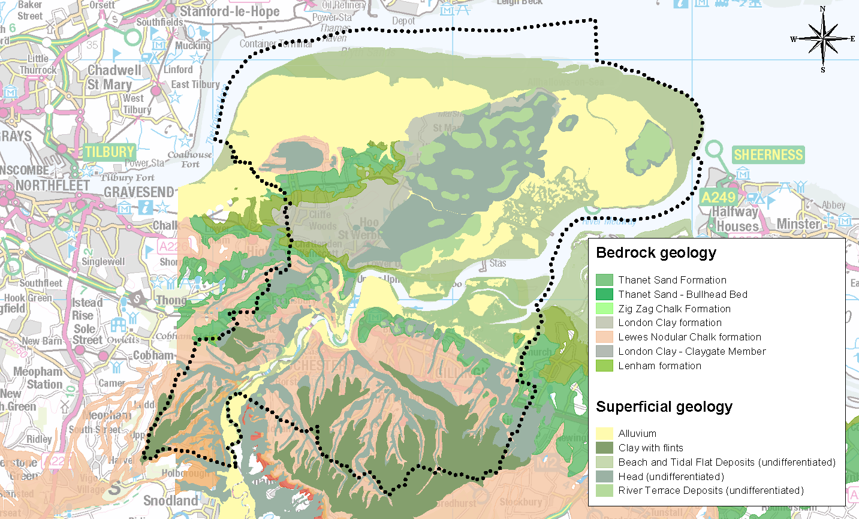

Environmental and Landscape Designations
  - Medway covers an area of 26,886 hectares (including rivers and coastal areas), and within this area are several landscape and environmental designations that could constrain where minerals extraction could take place. These designations include: Special Protection Areas; Ramsar sites; Special Areas of Conservation; Areas of Outstanding Natural Beauty; Green Belt; Sites of Special Scientific Interest; Marine Conservation Zones; National Nature Reserves; and, Local Nature Reserves. The extents of the environmental and landscape designations in Medway are provided in Figure 2.
Figure 2: Environmental and Landscape Designations in Medway
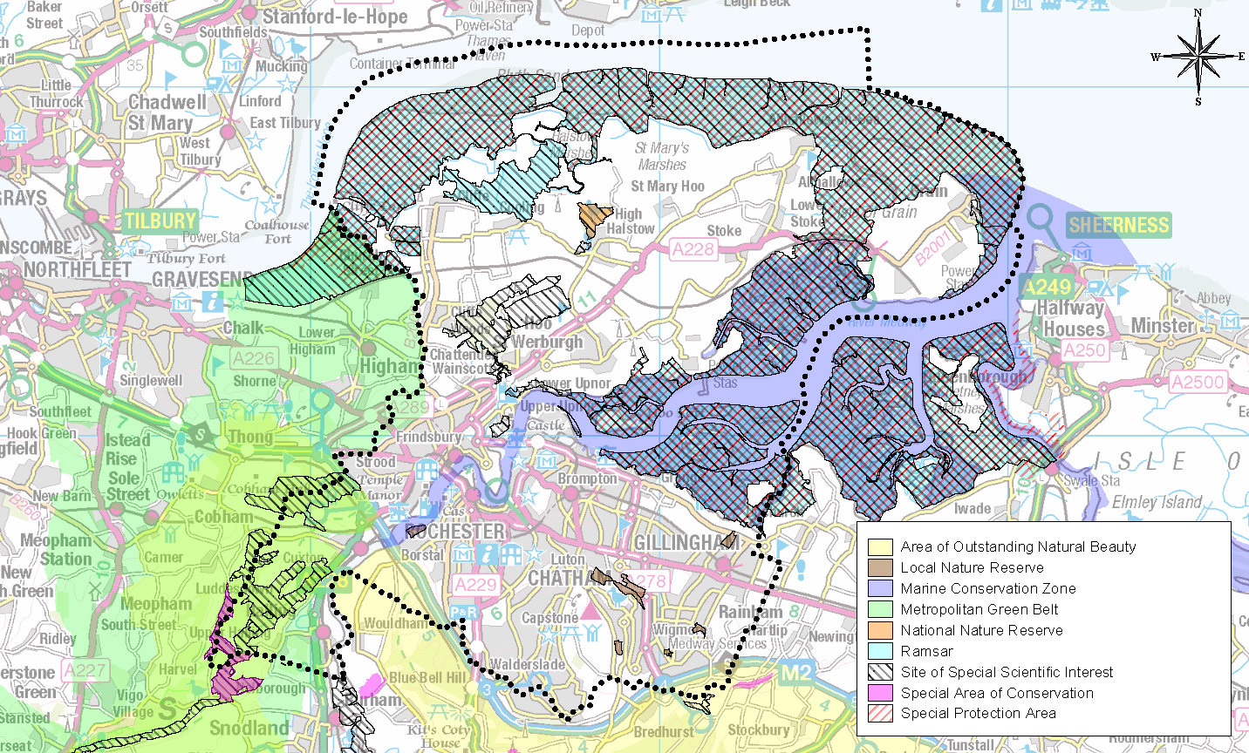

Extraction of Minerals
  - Contained within Medway’s geology there are a range of minerals that have the potential to be economically viable for extraction. These deposits include sand and gravel, chalk, London clay and brick clay. Extraction for these minerals has predominantly taken place around the river edge and across the Hoo Peninsula, but there have only been limited operations in recent years for the extraction of London clay and sand and gravel.

  - The present total remaining permitted reserve of sand and gravel for extraction in Medway is 0.574 Mt. This is derived from Kingsnorth Quarry to the south east of the village of Hoo St Werburgh operated by Tarmac, and a small remaining reserve at Perry’s Farm in Grain, operated by J Clubb Ltd., that is currently inactive. The locations of the permitted quarries are provided in Figure 3.

  - Kingsnorth Quarry is operated by Tarmac and includes a ready-mix concrete plant on site. Extraction commenced in 2017 and cumulatively 200,000 tonnes per annum of material can be removed from the site. It is currently the only operational quarry in Medway. It is anticipated that extraction at this site will be complete within three years.

  - Research to support mineral planning work in Kent and Medway has provided an indication of significant available reserves in the area to help meet future demand.
Figure 3: Quarries in Medway
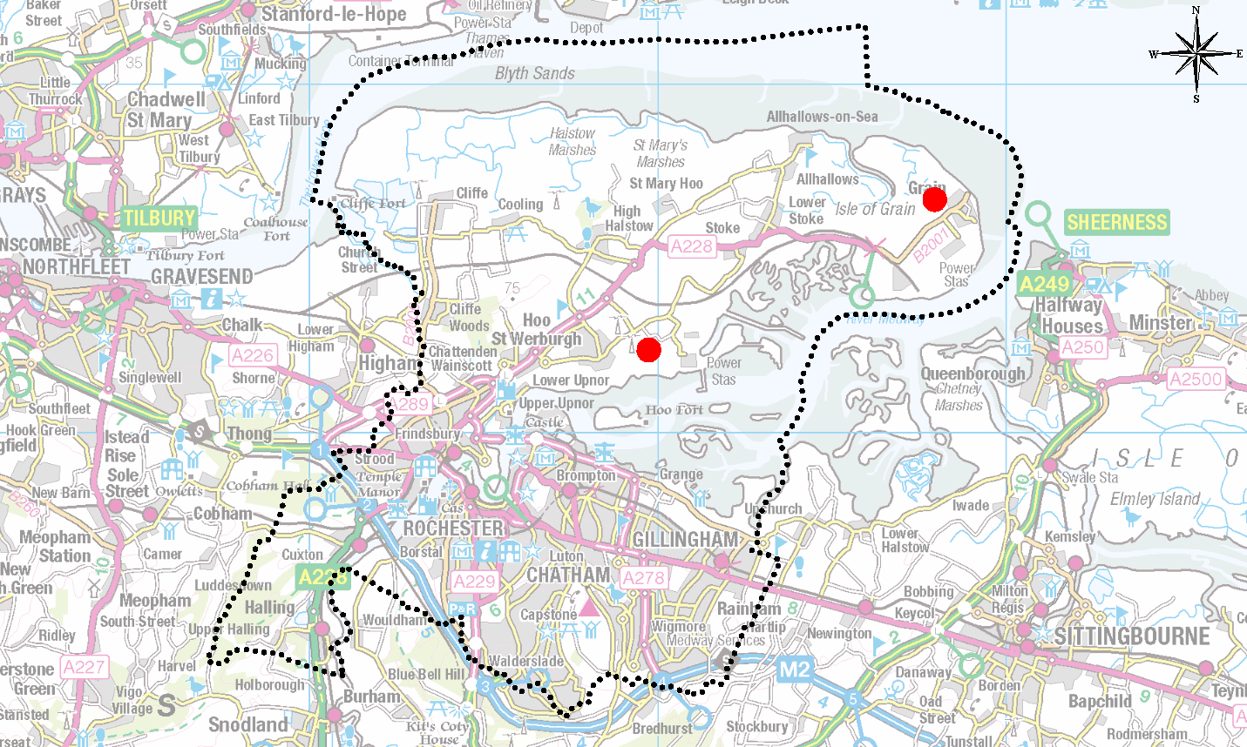
Kingsnorth
Perry’s Farm

  - Due to the limited number of quarrying sites in Medway, it has not been possible to publish annual levels of sales of locally won sand and gravel. However, the council has been able to use data provided to the Aggregates Monitoring survey to produce a 3-year and 10-year average sales figure.

  - The current 10-year average sales for aggregates from quarries in Medway are 0.043 Mtpa and the 3-year average sales is 0.134 Mtpa. The 3-year and 10-year average sales data for land-won aggregate since 2007 is presented in Table 1.
Table 1: 3-year and 10-year average sales (Mt) for land-won aggregate in Medway
Year | 3-year average sales (Mt) | 10-year average sales (Mt)
2007 | 0.033 | n/a
2008 | 0.027 | n/a
2009 | 0.018 | n/a
2010 | 0.010 | n/a
2011 | 0.003 | n/a
2012 | 0 | n/a
2013 | 0 | n/a
2014 | 0 | 0.013
2015 | 0.003 | 0.010
2016 | 0.003 | 0.006
2017 | 0.009 | 0.006
2018 | 0.050 | 0.017
2019 | 0.1 | 0.031
2020 | 0.134 | 0.043

  - Table 1 demonstrates how the average 10-year average sales gradually decreased due to the decline in minerals extraction to 2014. More recent increases in the 3-year and 10-year average sales to levels not seen for well over 10 years reflect the commencement of extraction at Kingsnorth Quarry in 2017.

Landbank
  - Medway is required to maintain a 7-year land bank for sand and gravel. Permitted reserves are considered to be 0.574 Mt. The current landbank calculated using the 3-year average sales has reduced significantly in the last few years and is now 4.3 years. Using the 10-year average sales the landbank increases to 13.4 years. With the increased activity in extraction more recently, it is considered appropriate to use the 3-year average sales to inform the LAA rate, as this better reflects the current status of land-won aggregates in Medway.

  - Medway’s geology means there are no soft sand or crushed rock resources and therefore, it is not possible to maintain a landbank for land-won crushed rock or a separate landbank for soft sand from that of sand and gravel.

- Recycled and Secondary Aggregates

  - Materials defined as recycled or secondary aggregates are derived from demolition and construction waste, industrial by-products such as power station ash, colliery spoil, and blast furnace slag and slate. These materials can be used as substitutes for aggregates, such as in concrete production, or as fill.

  - The use of recycled and secondary aggregates is critical to the sustainable management of primary mineral resources. In line with government policy to secure the valuable finite resources of materials required for development, Medway Council promotes the use of such alternatives in place of primary aggregates.

  - It is understood that of the two main secondary and recycled aggregate producers in Medway, one stopped operating in 2020. A return was not received from the other operator and so an estimate of production has been made based on its last three years’ returns. A recent Waste Needs Assessment prepared to support the Medway Local Plan suggests that the permitted capacity for recycled aggregates production in Medway is around 135,000tpa.

  - Other facilities exist within Medway for the recycling of construction, demolition and excavation (CD&E) waste at fixed sites which may produce some recycled aggregate. In addition to this it is understood that significant amounts of material are processed on site by mobile plant as part of demolition and construction activity which results in the production of recycled aggregate.

  - Commercial confidentiality prevents annual sales data from being published; however, 3-year and 10-year average sales data provide an insight into the position of the current market. In 2020, both the 3-year and 10-year average sales decreased. These decreases are estimates only but decreases are likely to have occurred due to the closure of one of the secondary aggregate producers. Table 2 provides the average sales since 2007 and this is presented as a line chart in Figure 4.
Table 2: Sales (Mt) of recycled and secondary aggregate in Medway
Year | 3-year average sales (Mt) | 10-year average sales (Mt)
2007 | 0.073 | n/a
2008 | 0.110 | n/a
2009 | 0.110 | n/a
2010 | 0.106 | n/a
2011 | 0.045 | n/a
2012 | 0.051 | n/a
2013 | 0.040 | n/a
2014 | 0.025 | 0.069
2015 | 0.029 | 0.057
2016 | 0.044 | 0.064
2017 | 0.065 | 0.067
2018 | 0.067 | 0.044
2019 | 0.046 | 0.044
2020 | 0.017 | 0.040

Figure 4: Average Sales (t) of Recycled and Secondary Aggregate in Medway

  - It is worth noting that a number of recycling facilities (including those that handle recycled aggregate) are currently subject to temporary planning permission as part of the wider long-standing regeneration programme for the area. The emerging Local Plan includes policies which allow new sites to be developed.

  - Coal-derived fly ash is a secondary aggregate that can be used in various applications including those related to the construction of housing and infrastructure. A change to the National Planning Policy Framework in July 2021 recognised Coal-derived fly ash in single use deposits as a mineral resource of local and national importance. The UK Quality Ash Association has identified the disused Kingsnorth Power Station as a location where such a deposit exists.

- Wharves and Rail Depots

  - Medway makes a critical contribution to the South East’s infrastructure for the importation of aggregates, particularly marine dredged sand and gravel. The scale of the importation makes Medway’s wharves of regional and national significance. There are four currently in operation:

- Grain Terminal, Isle of Grain (wharf and rail depot): operated by Aggregate Industries.
- North Sea Terminal, Cliffe, Rochester (wharf and rail depot): operated by Brett Aggregates.
- Euro Wharf, Frindsbury, Rochester: operated by Hanson Aggregates.
- London Thamesport, Isle of Grain: operated by Medway Aggregates.
The location of the wharves and rail depots in Medway is provided in Figure 5.
Figure 5: Wharves and Rail depots in Medway
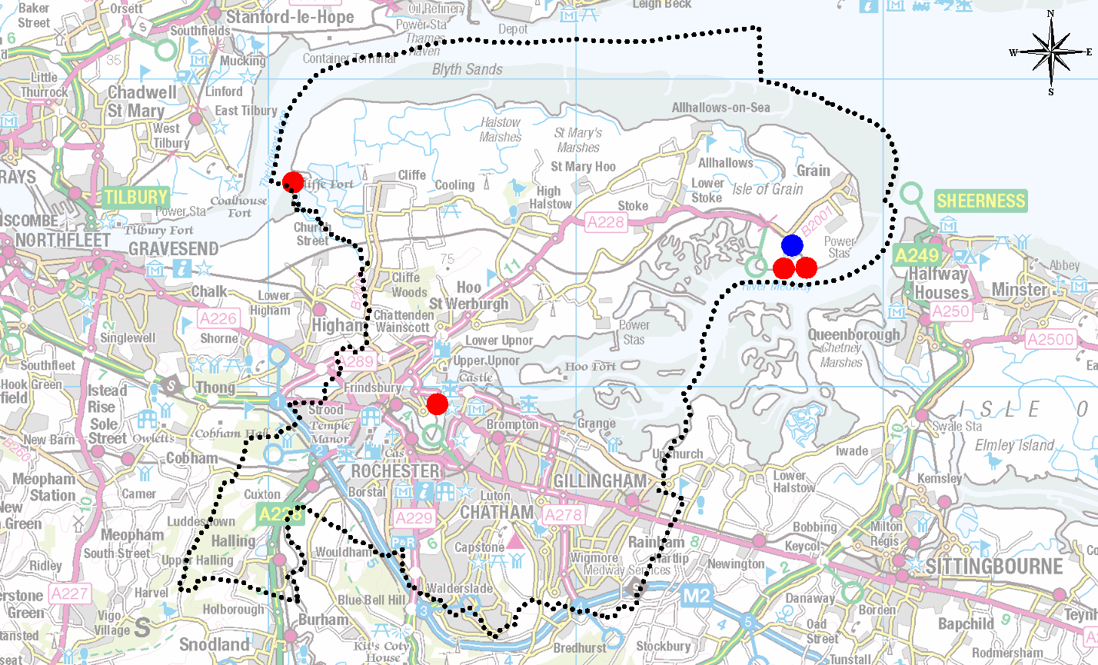
North Sea Terminal (Rail Depot)
Grain Terminal (Wharf)
London Thamesport (Wharf)
Euro Wharf (Wharf)
North Sea Terminal (Wharf)
Grain Terminal (Rail Depot)
  - Collectively, these six facilities make a significant contribution to the importation of minerals into the region.

  - Medway’s wharves are amongst the largest in Kent and Medway, and have the greatest capacity (approximately 4.15 million tpa). The wharves are operating within their capacity levels and so offer the ability to increase production in response to market demand. Figure 6 shows sales at wharves since 2007.

Figure 6: Sales (Mt) of Aggregates through Wharves in Medway

  - The table below provides an indication of the role wharves in Medway play in the importation of aggregate to wharves in the south east.

Table 3: Marine aggregates sales and landings: 2020 (thousand tonnes)

Mineral planning authorities | Sales 2020 | Sales 10-year av. | Sales  3-year av. | Lettings 2020 | Lettings 3-year average
Medway and Kent | 3208 | 3158 | 2.659 | 2,811 | 3,135
East and West Sussex | 1151 | 1,540 | 1.267 | 1,135 | 1,236
Hampshire and Isle of Wight | 2100 | 1472 | 2190 | 1,287 | 1,428
South East England | 6459 | 6,413 | 6116 | 5,233 | 5,799
Source: South East England Aggregates Working Party Annual Report 2020 (Draft)

Marine-won Sand and Gravel

  - Medway receives sand and gravel from several dredging regions; those of which that are located in British waters have their minerals rights owned by the Crown Estate. The region most proximate to wharves in Medway is the Thames region. In 2021 the Crown Estate reported that the Thames dredging region currently has around 24 years of permitted aggregate production capacity.

  - The sale of marine-won sand and gravel in Medway is presented in Table 3 and Figure 7. In 2020, the level of sales was recorded at 1.786 Mt, representing a significant increase on the previous year and above both the 3-year and 10-year average sales.

Table 4: Sales (Mt) of Marine-won Sand and Gravel at Wharves in Medway
Year | Annual sales (Mt) | 3-year average sales (Mt) | 10-year average sales (Mt)
2007 | 1.565 | 1.286 | n/a
2008 | 1.518 | 1.502 | n/a
2009 | 0.740 | 1.274 | n/a
2010 | 1.152 | 1.231 | n/a
2011 | 1.167 | 1.020 | n/a
2012 | 1.215 | 1.178 | n/a
2013 | 1.400 | 1.261 | n/a
2014 | 1.586 | 1.400 | 1.264
2015 | 1.597 | 1.527 | 1.336
2016 | 1.978 | 1.720 | 1.392
2017 | 1.794 | 1.790 | 1.415
2018 | 1.213 | 1.662 | 1.384
2019 | 1.115 | 1.374 | 1.422
2020 | 1.786 | 1.372 | 1.485

  - The Aggregates Monitoring Survey return for the North Sea Terminal at Cliffe reported a significant increase in annual sales compared to the last two years.

Figure 7: Sales (Mt) of Marine-won Sand and Gravel through Wharves in Medway

  - The 2019 national Aggregate Minerals Survey states that in 2019, of all the marine won sand and gravel landed at wharves in South East, 23% was landed at wharves in Medway. Of the sand and gravel landed, 32% was utilised in Kent and Medway, 10% in the South East and 14% elsewhere (44% was not allocated a destination).

Marine-won Soft Sand
  - It is likely that the demand for soft sand in the South East will increasingly need to be met by imports into the area and from marine won sources due to its scarcity and moreover by constraints upon its extraction. To help provide a detailed analysis of soft sand supply in the region, sales figures of marine-won soft sand are separated out from those of marine-won sand and gravel.

  - A breakdown of the sales of marine-won soft sand from wharves in Medway since 2007 is shown in Figure 6. No soft sand sales were reported in 2020. Figure 6 shows that such sales have been sporadic and this may indicate that material is imported for a particular project or use where it is considered suitable to use marine-won soft sand in place of land-won material. Further discussions with aggregates operators may provide insight into its use and the fluctuating nature of the sales data.

Crushed Rock
  - Medway does not have any natural hard rock resources and therefore relies on imports of crushed rock such as limestone and granite to meet demand for this type of aggregate. Other areas similarly rely on imports and Medway’s wharves and rail depots help facilitate supply.

  - Crushed rock arrives in Medway through both the wharves and the rail depot at Grain; with granite arriving through the wharves from Scotland and Norway, and limestone by rail from Somerset. Crushed rock is also distributed to other areas by road and rail.

  - Due to commercial confidentiality, sales from the rail depot cannot be broken down other than by a 3-year sales average. Due to the records of sales only beginning in 2013, a 10-year average sales value is unavailable. To avoid double counting of supply from Medway, the reported sales from rail depots relate solely to aggregate that has been imported by rail and not that which is exported from Medway where the sales are already reported as landings at associated wharves.

  - Sales data for crushed rock through wharves and the rail depot are presented in Table 4 and Figure 8. In 2020, sales of crushed rock through Medway’s wharves was estimated as 1.277 Mt; a decrease in the sales recorded in 2019. The 2020 sales are lower than the average 3-year sales but higher than the 10-year average sales.

Table 5: Sales (Mt) of crushed rock through wharves and rail depot in Medway
Year | 3-year average sales (Mt): Rail depot | Annual sales (Mt): Wharves | 3-year average sales (Mt): Wharves | 10-year average sales (Mt): Wharves
2007 | n/a | 1.756 | 1.437 | n/a
2008 | n/a | 1.240 | 1.511 | n/a
2009 | n/a | 0.696 | 1.231 | n/a
2010 | n/a | 0.909 | 0.948 | n/a
2011 | n/a | 0.833 | 0.813 | n/a
2012 | n/a | 0.761 | 0.834 | n/a
2013 | n/a | 0.856 | 0.817 | n/a
2014 | n/a | 0.775 | 0.797 | 1.038
2015 | 0.056 | 1.086 | 0.906 | 1.045
2016 | 0.025 | 0.912 | 0.924 | 0.982
2017 | 0.005 | 0.945 | 0.981 | 0.901
2018 | 0.004 | 1.247 | 1.035 | 0.902
2019 | 0.003 | 1.611 | 1.268 | 0.994
2020 | 0.002 | 1.277 | 1.379 | 1.030

Figure 8: Sales (Mt) of crushed rock through wharves and the rail depot in Medway

- Overview of Aggregate Sales

  - In order to provide a picture of complete data, average 3-year sales of aggregates in Medway have been amalgamated and presented in Figure 9.

  - The sales of aggregates appear to follow the same overall trend, with the exception of crushed rock imported through the rail depot and marine won sand and gravel. Sales of land-won sand and gravel decreased further past 2011 until 2015 when sales restarted; this upward trend is expected to continue with the commencement of extraction at Kingsnorth Quarry. While sales of marine won sand and gravel have shown a recent declining trend, data for 2020 shows that actual sales rebounded from lower levels in 2018 and 2019.

Figure 9: Amalgamated average 3-year sales (Mt) for aggregates in Medway

- Future Aggregate Supply

  - The government’s assessment of Local Housing Need for Medway is 28,611 (1662 units per annum) for the new 2020-37 plan period.

  - At the start of the new Local Plan process, the Council commissioned an assessment of housing needs in 2014 that concluded an annual need for 1,000 dwellings. It increased with the introduction of the standard method, and it is now 1,586 dwellings per year needed to meet the five-year housing land supply but increases to 1,903 when a buffer of 20% is added due to past under delivery identified by the Housing Delivery Test.

  - Although rates of housebuilding are currently below the level of identified housing need, there was a dramatic increase in 2019/20 when the net number of homes delivered increased from 647 in 2018/19 to 1,130. This signals a change in the progression of sites in Medway and the Council is confident that the increased level of delivery will be sustained in 2020/21.

  - The latest Medway Housing Delivery Test Action Plan (July 2021) report suggests that, based on the housing trajectory published in the Council’s Authority Monitoring Report (AMR) 2019/20, there is the potential to pass the Housing Delivery Test figure by 2023. However, this recognises the need to have a sustained increase in housing delivery to achieve this, as is currently proposed by developers. The report states that early signs for 2020/21 indicate delivery will again be above 1,000 units. The trajectory in the last AMR did reflect a slowdown in the number of homes in the next couple of years to reflect the impact of Covid-19 and uncertainty about how that would affect delivery in the medium to long term. However, it is clear that the efforts to permit larger greenfield sites has left Medway well placed to continue delivering new homes, even if at a slower rate and this has contributed to a step change in the number of homes being delivered each year.

  - Figure 10 shows the completions of new homes in Medway since 2012/13.
Figure 10: Annual housing completions compared to annual housing requirement in Medway
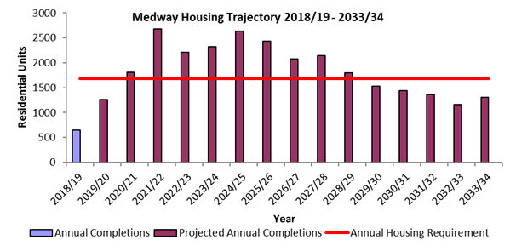

  - In addition to housing, the North Kent Strategic Housing and Economic Needs Assessment indicates the scale of employment and retail needs in Medway over the plan period. This research showed a total need for:

- 50,000m² of B1 office space. 155,000m² of B2 industrial land and 165,000m² of B8 warehousing land.
- 44,000m² of comparison retail floor space and 13,000m² of convenience (supermarket) retail space up to 2031.
The new local plan will also identify supporting infrastructure needs.

  - Regionally, a number of planned infrastructure projects are likely to put increased pressure on the supply of aggregates through Medway, including:

- Lower Thames Crossing: A 13-mile new road and bored tunnel crossing under the River Thames between the east of Gravesend and Tilbury.
- Crossrail 2: A proposed major new rail route through London between Surrey and Hertfordshire.
- Thames Tideway Tunnel: A 16-mile drainage and sewerage tunnel currently in construction under much of the tidal section of the River Thames through central London.
- Northern Extension Line: An extension to the London Underground Northern Line to Battersea.
- High Speed Rail 2: A planned high-speed rail link between London and initially Birmingham (Phase 1), but later Manchester, Sheffield and Leeds (Phase 2).
- Ebbsfleet Garden City: A planned development of up to 15,000 homes and 45,000m² of commercial floor space.
- Housing and infrastructure delivery across Kent: Includes in the region of 178,600 additional homes (2011-31) and the provision of 163 extra form entries for schools (2017-23).
- The London Resort: Development of a 465-hectare brownfield site on the Swanscombe Peninsula between Dartford and Gravesend for a theme park and housing.
- Project Cavendish: Hydrogen production facility on the Isle of Grain

  - In order to deliver the projects noted above, Medway will endeavour to maintain a landbank and ensure that its aggregates infrastructure, essential for its distribution, is safeguarded through the application of appropriate planning policy.

Landbank
  - As reported in Section 2, the current landbank for land-won sand and gravel is 4.3 years, based on the 3-year sales average; this increases to 13.4 years when applying the 10-year sales average. As predicted by previous LAAs, the landbank has shortened substantially as Kingsnorth Quarry has become fully operational.

  - Significant deposits of sand and gravel exist across the Hoo Peninsula; the council will actively plan to safeguard these areas through the emerging Local Plan to help ensure that a steady and adequate supply of aggregates is maintained.

Capacity
  - The Aggregate Monitoring Survey includes a survey of site capacity to assist planning for future demand. Details of capacity against the recorded 3-year average sales are detailed in Table 5.

  - Sales against capacity data indicate sufficient headroom to accommodate a significant level of demand, with a capacity gap at the wharves of 34%. There is potential for capacity to be substantially increased with space available for additional wharf facilities at London Thamesport.
Table 6: Sales of aggregates (Mt) against capacity (Mt)
 | 2016 | 2017 | 2018 | 2019 | 2020
Land won sand and gravel Average 3-year sales (Mt) | 0.003 | 0.009 | 0.050 | 0.100 | 0.134
Land won sand and gravel Total annual capacity of (Mt) | >0.200 | >0.200 | >0.200 | >0.200 | >0.200
Land won sand and gravel Percentage of sales against capacity (%) | <1.5 | <4.5 | <25 | <50 | <67
Recycled and secondary aggregates Average 3-year sales of (Mt) | 0.044 | 0.065 | 0.067 | 0.046 | 0.017
Recycled and secondary aggregates Total annual capacity (Mt) | >0.100 | >0.100 | >0.075 | >0.135 | >0.135
Percentage of Recycled and secondary aggregates sales against capacity (%) | <44 | <65 | <89 | <35 | <12
Sales through wharves (Mt) | 3.096 | 2.739 | 2.462 | 2.727 | 3.062
Wharves total annual capacity (Mt) | 4.000 | 4.150 | 4.150 | 4.150 | 4.150
Wharves percentage of sales against capacity (%) | 77 | 66 | 59 | 66 | 74
Average 3-year sales through rail depot (Mt) | 0.025 | 0.005 | n/k | 0.003 | 0.002
Rail Depot total annual capacity (Mt) | 0.100 | 0.100 | n/k | n/k | n/k
Rail Depot percentage of sales against capacity (%) | 25 | 5 | n/k | n/k | n/k

  - With regard to recycled and secondary aggregate, it is estimated that current permitted capacity for recycled aggregates production in Medway is around 135,000tpa. Capacity is anticipated to increase in the near future with the granting of permission for a production plant for Hydraulically Bound Material (HBM) from recycled aggregates at Malmaynes Hall Farm, Stoke. The plant is expected to have an operational capacity of 0.075 Mtpa.

  - Exports of aggregate from the rail depot at the North Sea Terminal site at Cliffe suggest that the depot has capacity of at least 550,000tpa. However, this depot appears to be used exclusively for the export of aggregate landed at the associated wharf.

- Conclusion

  - This LAA indicates that Medway plays a strategic role in regional aggregates supply, notably through the wharves located on the Medway and Thames. The ability to handle large vessels and their proximity to markets in the wider South East and London elevates the wharves’ importance to a regional level. Furthermore, the current surplus handling capacity allows for flexibility and provides assurance in their ability to respond to increased market demand.

  - A new Medway Local Plan is currently being prepared, with an anticipated submission date of 2022 for examination. Draft policy approaches were consulted on throughout 2018 and will be used to inform minerals policy production in the draft Local Plan, due for publication in 2021. The LAAs have been used to inform the content of the Local Plan.

  - Although land won reserves of sand and gravel are now depleting rapidly, it is considered that Medway is making sufficient provision to ensure a steady supply of aggregates, and that it can continue to make an effective contribution to meeting local and wider needs. The council will continue to actively participate in the work of SEEAWP and maintain cooperative working with neighbouring MPAs and industry operators.

London clay and brick clay are not aggregate minerals. Chalk may have uses as an aggregate but is generally not extracted for this purpose.
http://www.ukqaa.org.uk/wp-content/uploads/UKQAA_SECONDARY_MATERIAL.pdf
https://www.thecrownestate.co.uk/media/3945/2021-capability-portfolio-report.pdf
Crown Estate data for landings of marine won aggregate indicates that 1,336,864 tonnes was landed in 2020. N.B. landings and sales are not the same.
https://www.gov.uk/government/publications/aggregate-minerals-survey-for-england-and-wales-2019
A return from the operator of the Grain Terminal was not received.
Value taken from BGS AMS 2019
The ‘Housing Delivery Test’ compares the number of new homes delivered over the previous three years with the authority’s housing requirement

