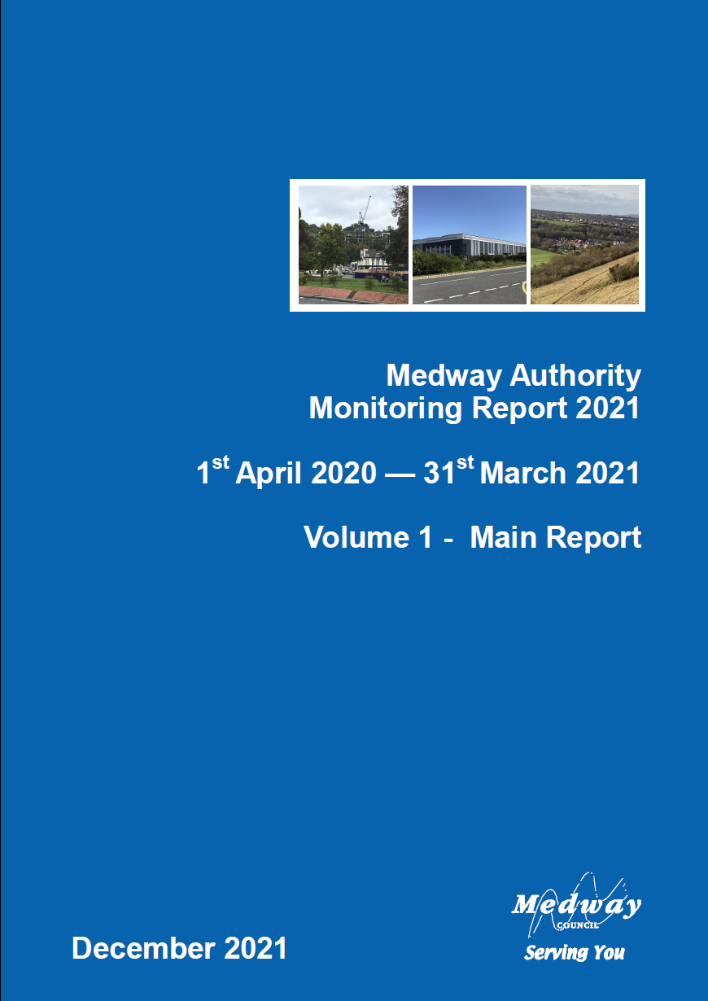
Executive summary 5

Introduction 7

Planning Context 9

Medway Local Plan 9
Local Development Scheme 9
Key milestones for Medway Local Plan 10
Local Plan Evidence Base 10
Strategic Land Availability Assessment (SLAA) 10
Strategic Transport Assessment 11
Viability Assessment 11
Developer contributions and obligations 12
Development Briefs and Masterplans 12
Local Development Order (LDO) for Innovation Park Medway 12
Hoo Development Framework 12
Town Centre parking study 13
Neighbourhood Plans and Neighbourhood Development Orders 13
Local Aggregate Assessment 14
Waste Needs Assessment 14

Duty to Cooperate 16

Delivering Development 19

Development and Regeneration 22

Local Enterprise Partnership Funding 22
Brownfield Land Register 23
Regeneration Sites - update 24
Development Management Planning Statistics 27
Planning applications 27
Managing planning applications process 28
Appeals against planning decisions 28
Population 29

Mid-year estimate 2020 29
Population by broad age group – 2020 30
Migration 31
Future growth - Population projections 33
Indices of Deprivation 35
Housing 36

Net additional dwellings a) in previous years b) for reporting year c) in future years 36
Number of new and converted dwellings on previously developed land 36
Housing Trajectory 2020/21 – 2035/36 37
Property prices 39
Housing affordability 40
House price to earnings 40
Affordable Housing 41
Gross affordable completions (count) 41
Affordable completions as proportion of all completions 41
Residential completions by property type and size 42
Lodgement Completions - Energy Performance Certificates (EPCs) 42
‘Other’ 44
New Homes Bonus 45
Gypsies, Travellers and Travelling Showpeople 46
Net additional pitches (Gypsy and Traveller) 48
Self-Build and Custom Housebuilding Register 49
Economy and Employment 50

Amount and type of completed employment floor space 50
Amount and type of employment floor space coming forward on Previously Developed Land (PDL) 51
Amount and type of employment land available 51
Amount of floor space for town centre uses 51
Job Seekers Allowance and Universal Credit claimant rate 52
Employment 53
Economic activity 53
Income and employment deprivation 55
Fuel Poverty 56
The River Medway - Port cargo traffic 57
Retail and Town Centres 59

Town Centre (TC) and Non-Town Centre GROSS retail floor space completions A1-A5 (sq.m) 60
Net completions in town centres 60
Town centre development – 2020/21 60
Non Town Centre Activity 61
Natural and Built Environment 62

Greenspace regeneration projects 62
Green Flag Awards 64
Air Quality 65
Ultra Low Emission Vehicle Licensing 66
Built Environment - Heritage at Risk 66
Health and Communities 68

Life expectancy 68
Mortality 70
Hot food takeaway guidance 71
A Better Medway 72
Health Deprivation 73
Infrastructure 74

Education 74
GCSE attainment scores 74
Education, Skills and Training Deprivation 77
Developer Contributions 78
Transport 79

Local Transport Plan 79
External Funding 79
Estimated traffic flows for cars and all vehicle types 80
Passenger journeys on local bus services 81
Railway Stations 81
Minerals, Waste and Energy 83

Minerals 83
Waste 83
Energy 84

Glossary 86

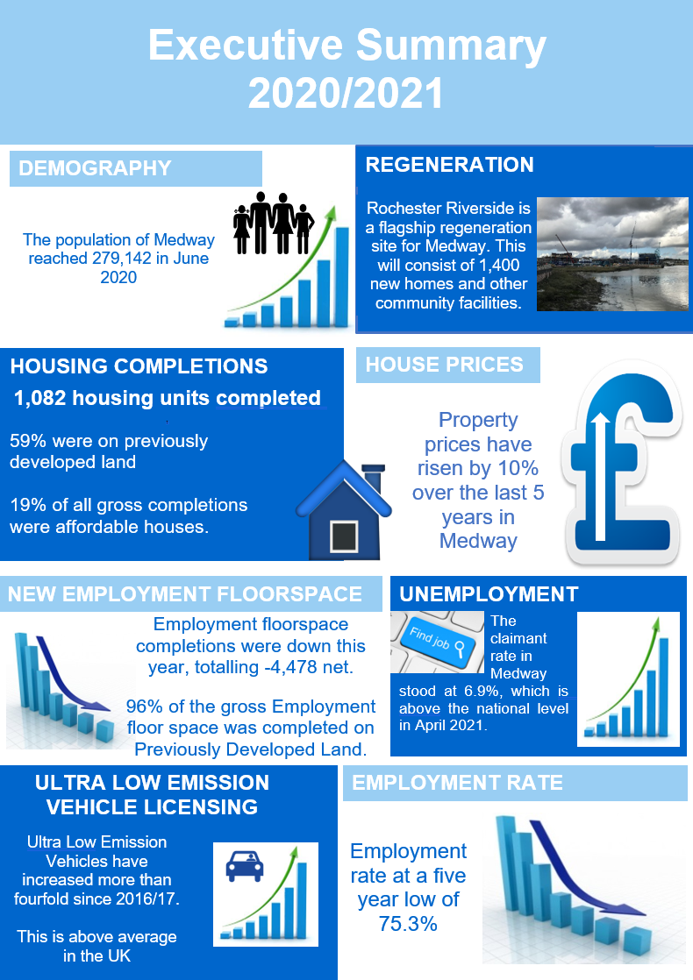
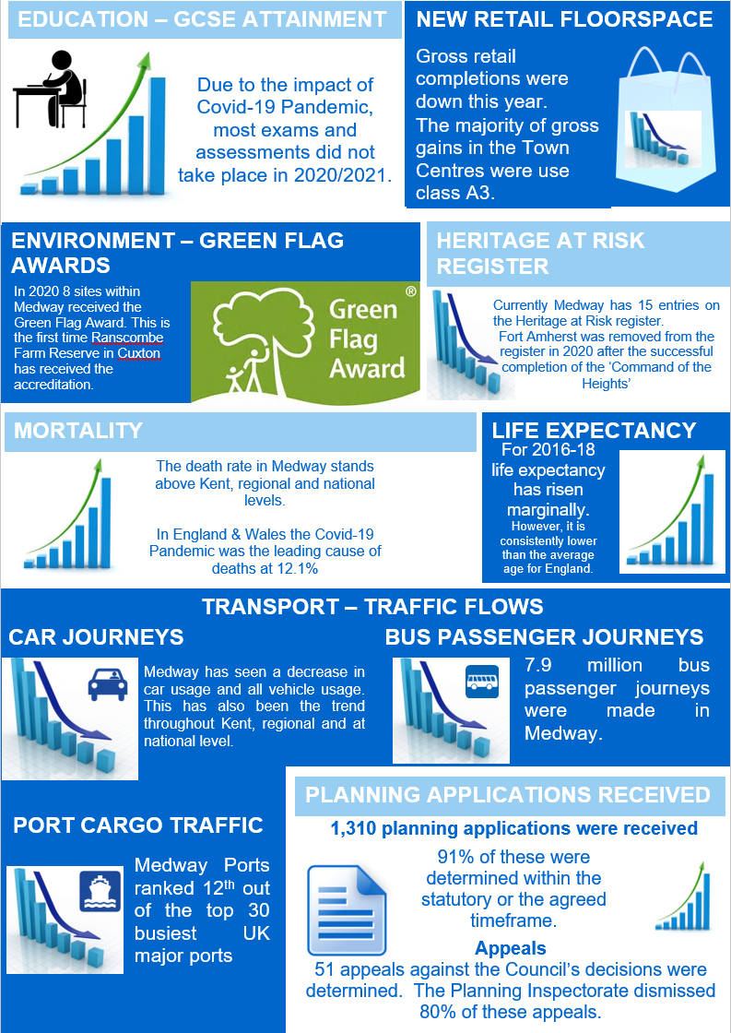

Introduction

This report has been prepared in late 2021, in the experience of the Covid pandemic, presenting monitoring information for the period April 2020 to March 2021. Therefore much of the reporting reflects the wide ranging impacts that the pandemic has had on our communities, economy and environment.

Medway has changed significantly over the past few decades, with regeneration and new infrastructure contributing to the development of a modern city. The Council is preparing a new Local Plan to manage Medway’s growth up to 2037. The emerging plan is being developed in the context of pressures on the housing market, infrastructure and key services, structural changes in retail, and increasing awareness of the climate emergency. The Council is working to the publication of the draft local plan, to set out a positive and ambitious vision and strategy for Medway’s future.

The draft plan will take forward our aspirations for the regeneration of Medway’s urban waterfront and town centres, building on our regeneration strategy, Medway 2035, town centre masterplans and our High Streets investment programmes. It will also seek to realise the opportunities provided by the £170m investment in transport and environmental programmes through the Housing Infrastructure Fund to support the growth of a rural town on the Hoo Peninsula.

Despite the current context of Covid, this monitoring report can demonstrate good progress in several aspects of sustainable development in Medway. In particular, high rates of housebuilding have been sustained in 2020-21, helping to meet housing needs.

This Authority Monitoring Report is produced on an annual basis to provide an overview of the context of development in Medway. It gives details of economic, social and environmental data to measure how Medway is performing as an area and understanding its needs. It is a key mechanism for the Council’s Planning Service in assessing the progress being made towards achieving its goals for economic growth, protecting the natural and historic environment, and meeting the needs of its communities. It provides information for the council and those interested in Medway to assess how we are performing in meeting the aims of our local plan, and our ambitions for sustainable development. It is a reference point in identifying the key issues that the new local plan must address to secure successful growth.

The Council has followed the established protocol for producing this Monitoring Report on an annual basis in December for the preceding financial year. This report provides monitoring information and statistical data for the period April 2020 – March 2021, with references to previous years for comparison purposes. The report has been informed by data gathered from planning applications determined at 31st March 2021. The sections on Planning Context, Duty to Cooperate, and Development and Delivery take account of information available up to November 2021.

The report is presented in two volumes. This is Volume 1 of the report which provides an overview of the key indicators of development and contextual issues in Medway. This includes short reports on the progress made in preparing the new Local Plan, and how the council has engaged with other authorities in planning for cross border strategic matters through the Duty to Cooperate. It also outlines the Council’s work in supporting development in Medway, and its actions to promote housing delivery and investment locally.

Detailed data on development statistics, such as the supply of land for housing and employment uses, is set out in Volume 2. This forms an important aspect of the evidence base for key planning measures, such as defining the authority’s position on housing land supply and monitoring detailed changes in land use that inform policy in the new Local Plan.

Also included at the end of Volume Two the Medway Local Aggregate Assessment for 2020, which specifically considers the supply of minerals for the aggregates sector and supports the strategic planning for industrial minerals. This is prepared in conjunction with the South East England Aggregates Working Group.

These reports are available at:

Authority Monitoring Report | Local Development Scheme and monitoring | Medway Council

Local Aggregates Assessment | Local Development Scheme and monitoring | Medway Council

Planning Context

This section of the report considers updates in policy up to November 2021. This extends beyond the standard reporting period of April 2020 to March 2021, to take account of key changes in government planning policy and guidance that are relevant to the preparation of the Medway Local Plan.

Following updates to National Planning Policy Framework (NPPF) in 2018, 2019, and 2021 the government has continued to progress its ambitions for the reform of the planning system. There have been a number of changes to Permitted Development Rights and the Use Class Order and updates to Planning Practice Guidance. In August 2020, the government consulted on two major documents – the Planning White Paper, ‘Planning for the future’ and ‘Changes to the current planning system’. The government introduced the Planning Bill in the Queen’s Speech in Spring 2021, but progress has paused with the appointment of a new Secretary of State for Levelling Up, Housing and Communities. The government has also yet to publish its substantive responses to the consultations on planning reforms in 2020. However, in December 2020, the government confirmed the criteria for the standard method for calculating Local Housing Need. The formula retained use of the 2014 based household projections.

The Community Infrastructure Levy (CIL) regulations came into force on 1 September 2019. The CIL amendments were introduced to make the system of developer contributions simpler, more flexible, fairer, and more transparent. The regulations removed the pooling restrictions which limit the number of planning obligations that can be used to fund a single infrastructure project and introduced the requirement for an annual Infrastructure Funding Statement (IFS) to report on what has been received and spent through developer contributions. As the Council uses section 106 agreements to collect developer contributions, it was required to publish its first IFS by 31 December 2020. The IFS will be published with this monitoring report in December 2021 at this location:

https://www.medway.gov.uk/info/200149/planning_policy/597/local_development_scheme_and_monitoring/5

Medway Local Plan
Medway Council is preparing a new Local Plan covering the period 2021-2037. The Local Plan will cover the whole of Medway and will be prepared in conformity with national planning legislation, specifically the National Planning Policy Framework, 2021. On adoption it will replace the saved policies from the Medway Local Plan 2003. The Local Plan is a Development Plan Document (DPD). The focus of work over the last year has been completing the assembly of a comprehensive evidence base, specifically the Strategic Transport Assessment, Sustainability Appraisal and Habitats Regulation Assessment, and preparing the draft plan for Regulation 19 consultation.

Local Development Scheme
The Local Development Scheme sets out the programme for the production of the new Medway Local Plan. The new plan will comprise of strategic level policies, including provision for waste and minerals; targeted development management policies; land allocations and a policies map. On adoption it will replace the saved policies of the Medway Local Plan 2003.
In 2021, the Council approved an update to the Local Development Scheme. This Scheme programmed the publication of the draft plan at Regulation 19 for late 2021. A key milestone for this programme was the report on the pre-Submission draft Local Plan to the meeting of Full Council on 7 October 2021. However, the report was not presented on that date, and arrangements for a revised date are to be confirmed shortly. It is the intention that the draft is published for consultation at Regulation 19 in early 2022 and submitted for examination later in 2022.

Local Plan Evidence Base
The council is finalising the content of the draft plan for publication. A broad evidence base informs the plan. Details of evidence base documents are available on the council’s website at:

https://www.medway.gov.uk/info/200149/planning_policy/519/future_medway_local_plan/2

The Planning Service is completing the technical evidence base to support the draft Local Plan. This has involved a number of key work streams progressed over the last year:

Strategic Transport Assessment
The Strategic Transport Assessment (STA) forms a key part of the transport evidence base. Given pressures on the existing transport networks and the scale of development needs, it is essential to demonstrate that growth can be delivered sustainably in locations and sites identified as allocations in the draft plan.

The STA establishes strategic infrastructure needs and mitigation measures required to mitigate the transport impacts of new development. Initial work provided a high-level assessment of the scenarios presented in the Development Options and Development Strategy consultations. Further stages have been carried out in more detail to inform identification of preferred sites to be allocated for development, and to assess the impacts of proposed development, with consideration of potential mitigation measures. This work incorporates a complementary assessment of the associated vehicle emissions within Medway’s adopted Air Quality Management Areas. This information will be used in the Habitats Regulation Assessment of the draft Local Plan.

The Council has worked with Highways England throughout the year in preparing the STA that will accompany the draft Local Plan. It has responded constructively to Highways England’s advice on the assessment of the proposed Lower Thames Crossing within the evidence base for the Local Plan. This extended work will also be used by the Council in preparing its Local Impact Report to the examination of the Development Consent Order for the Lower Thames Crossing. The Council has also liaised with Kent County Council as the neighbouring local highways authority, and our neighbouring local planning authorities.

This evidence base will be published with the draft plan.

Infrastructure Planning
The sustainable development of Medway is dependent on infrastructure improvements to provide the capacity to serve the needs of the area’s growing population. The council published an Infrastructure Position Statement in January 2017, to set out the baseline condition of infrastructure across Medway and has since published an Infrastructure Delivery Plan as part of the Draft Local Plan evidence base. The council has engaged on an iterative basis with infrastructure and service providers as part of the preparation of the draft plan and is working with neighbouring authorities on strategic infrastructure matters. These include consideration of the impacts of the Lower Thames Crossing and proposed developments on Medway’s boundaries. This engagement work will be progressed into Statements of Common Ground supporting the publication of the draft Local Plan.

The Planning Service has continued to work with colleagues delivering the £170m Housing Infrastructure Fund programme to consider strategic growth plans on the Hoo Peninsula, and how this will be supplemented by funds from development. This has determined the infrastructure needed to support strategic growth of a rural town, and the preparation of a Hoo Development Framework to guide potential growth. This has involved wider engagement with service providers, local communities and developers promoting sites on the Hoo Peninsula. The draft Infrastructure Delivery Plan has informed work on the Medway Local Plan Viability Assessment.

Viability Assessment
The Council must carry out a whole plan viability assessment to demonstrate that the proposed policies and allocations can deliver sustainable growth, and do not lead to unviable development. It has commissioned a report that has involved an assessment of the land values across Medway, and the different types of development being promoted in the plan.
Updates to national planning policy and guidance have increased the importance of the local plan viability assessments, which are intended to reduce areas of challenge on viability grounds at development management stage. The report will be published with the draft plan at Regulation 19.

Developer contributions and obligations
The Council is updating its evidence base on infrastructure needs as part of the preparation of the Local Plan, as outlined above. This includes consideration of the development contributions to providing for sustainable growth. The Infrastructure Delivery Plan and the Viability Assessment will provide an updated evidence base to support the Council’s policy.

The Medway Developer Contributions and Obligations Guide was revised and adopted in May 2018, with updates to charges made in April 2021. Further updates are anticipated in line with the local plan examination. This is a Supplementary Planning Document which summarises the requirement for developer contributions to ensure that the impacts of growth on services are adequately mitigated as set out in the Local Plan. This is available to view at:

https://www.medway.gov.uk/downloads/file/2746/medway_guide_to_developer_contributions_and_obligations_2018

The Council has published its second Infrastructure Funding Statement in December 2021. This reports on how S106 contributions were spent on upgrading infrastructure in 2020/21. It also provides information on contributions received and agreements entered into in that year. The statement indicates future infrastructure funding priorities, based on emerging information on the Local Plan evidence base and spatial strategy. The Statement can be found here:

https://www.medway.gov.uk/info/200149/planning_policy/597/local_development_scheme_and_monitoring/5

Development Briefs and Masterplans
Medway has a well-established urban regeneration programme and much of the development in the last year has taken place on brownfield sites in town centres and urban waterfront sites. The council recognises that regeneration sites can be complex to develop. The council supports measures that can provide greater certainty to the market. It has led on the preparation of supplementary planning documents and wider planning guidance to promote available development opportunities and set out additional guidance on design. Further information is available on the council’s website at:

https://www.medway.gov.uk/info/200149/planning_policy/146/current_planning_policies/4

Local Development Order (LDO) for Innovation Park Medway
The Council is working with partners, including Tonbridge and Malling Borough Council to bring forward a successful high quality business park near Rochester Airport, known as Innovation Park Medway. Following consultation in 2019, the Council worked closely with the statutory consultees, Highways England and Natural England to address issues raised. The Council adopted the LDO in December 2020. Further details are available on the council’s website:

https://www.medway.gov.uk/info/200177/regeneration/738/innovation_park_medway/3

Hoo Development Framework
The successful HIF bid facilitates strategic growth on the Hoo Peninsula. A rural town based around Hoo could provide for an important component of Medway’s development strategy. The council has commissioned consultants to produce a development framework setting out the key principles and approach to growth. This work supported the HIF business case through showing the development potential.

Following consultation in 2020 on ‘Planning for Growth on the Hoo Peninsula’, the Council has continued to work on the preparation of the Hoo Development Framework. This includes a masterplan to support a strategic growth allocation in the draft plan, key principles for sustainable development, development phasing and infrastructure delivery. The Planning Service held a number of engagement workshops in 2021 to inform the preparation of the Hoo Development Framework. A draft of the framework has been published on the Local Plan evidence base webpages:

https://www.medway.gov.uk/downloads/200542/medway_local_plan_2021_to_2037

Development Needs
The Council, working with Gravesham Borough Council, has commissioned an update to the development needs assessments which inform the Local Plan evidence base. Two separate commissions were undertaken, a Local Housing Need Assessment (LHNA – Sept 2021) and an update on employment land needs (Oct 2020). The LHNA considers housing needs, including the mix needed to reflect demographic changes over the local plan period. The employment land need commission has considered the potential impacts in the longer term resulting from Covid, and changes in businesses’ needs for employment floorspace and locations. Further advice has also been commissioned on retail needs over the plan period, which will be published with the draft Local Plan.

Neighbourhood Plans and Neighbourhood Development Orders
A neighbourhood plan is a community led framework for guiding future development, regeneration, and conservation of an area. Neighbourhood Plans were introduced in the Localism Act in 2011. They are not compulsory, but when duly prepared they are a statutory document that forms part of the development plan. Neighbourhood plans must be in general conformity with the strategic policies of the adopted local plan and have regard to any emerging local plans or relevant development plan documents. Communities in Medway have shown increased interest in preparing neighbourhood plans for their local areas. Once the plans are ‘made’, or adopted, they will form part of the development plan for Medway.

Currently there are four Neighbourhood Areas designated in Medway, for the purpose of producing a neighbourhood plan:

Hoo St Werburgh - designated December 2018
Cliffe and Cliffe Woods - designated June 2015
High Halstow - designated June 2018
Arches (Chatham) - designated August 2019

Three of the groups have progressed on to complete the Regulation 14 consultation on their draft plans and continue to amend their plan for the next stage of consultation. Following this consultation, the draft plans will be submitted to Medway Council to progress to independent examination, referendum and adoption.

Hoo St Werburgh
Hoo St Werburgh Neighbourhood Plan group continue to engage on its plan proposals and anticipate holding their Regulation 14 consultation in early 2022. Medway Council is supporting the group with mapping and development data to support their evidence base and are liaising with the group to provide comments on their emerging draft plan proposals and to coordinate with the draft Medway Local Plan.

Cliffe and Cliffe Woods
The Parish Council completed its Regulation 14 consultation and has submitted the draft plan to Medway Council to arrange further consultation at Regulation 16. The council will continue to liaise with the group during this consultation period and in making subsequent arrangements for the examination of the draft plan.

High Halstow
High Halstow Parish Council prepared a draft plan and started a Regulation 14 consultation in August 2021. The consultation has been extended to 31 December with the publication of a draft Design Code to support the draft plan. The council continues to liaise with the group and will work to support in the next consultation.

Arches (Chatham)
Arches (Chatham) Neighbourhood Planning Forum have now completed their Regulation 14 Consultation period which ran from 26 February 2021 to 7 May 2021. The group are now preparing a Neighbourhood Development Order and are currently at the masterplanning stage. The group are holding public workshops to support this, in preparation for their evidence base and the council continues to liaise with the group through this process.

For further details and updated on all neighbourhood plans in Medway and support available from the council, please visit the council’s website at:

https://www.medway.gov.uk/info/200149/planning_policy/142/neighbourhood_planning

Local Aggregate Assessment
In line with the requirements of the National Planning Policy Framework and government guidance in the Planning Practice Guidance on the Managed Aggregate Supply System, the Council has prepared a Local Aggregate Assessment summary covering operations and sales in 2020. This provides an assessment of the demand and supply for aggregate minerals to meet local and wider strategic needs, and any environmental and economic constraints that may influence this. The key information collected for 2020 is set out at the end of Volume 2 of 2019/20’s Monitoring Report.

The Medway Local Aggregate Assessment 2020 has been reviewed by members of the South East England Aggregates Working Party (SEEAWP), and its content agreed. The Local Aggregate Assessment at the end of Volume 2 of the AMR is available to view at:

https://www.medway.gov.uk/info/200149/planning_policy/597/local_development_scheme_and_monitoring/4

Waste Needs Assessment
Following a technical ‘health check’ on the emerging evidence and policy for waste and minerals for the draft Medway Local Plan, the council commissioned a Waste Needs Assessment. This has considered the waste management capacity and needs for the different waste streams over the plan period. The Waste Needs Assessment will ensure that the need for waste management facilities is considered alongside other spatial planning concerns. The Council is following up on this work with neighbouring waste planning authorities through the Duty to Cooperate. This evidence base has been published on the Council’s website to support work on the draft plan:

https://www.medway.gov.uk/downloads/200542/medway_local_plan_2021_to_2037

Medway Green and Blue Infrastructure Framework
The Council has prepared a consultation draft of a Green and Blue Infrastructure Framework to support the environmental aspects of the draft Medway Local Plan, and wider corporate ambitions for Medway’s urban and rural areas. The document has been published on the evidence base pages of the Council’s website:

https://www.medway.gov.uk/downloads/200542/medway_local_plan_2021_to_2037

Duty to Cooperate

From the outset of its work in preparing a new Medway Local Plan, the council has built in the need to meet the ‘duty to cooperate’, as integral to a legally compliant development plan. The duty to cooperate requires the council to ‘engage constructively, actively and on an ongoing basis’ with other Local Planning Authorities and Public Bodies to address ‘strategic matters’. In particular the duty to cooperate requires the Council to work with neighbouring authorities, including Kent County Council, to address strategic issues that ‘cross administrative boundaries’ for example the provision of infrastructure or meeting housing needs. The government has provided details on the Statements of Common Ground requirements, to provide greater clarity on strategic cross border matters to be considered, and how local planning authorities should approach these issues.

Medway Council has collaborated with neighbouring authorities, where there have been opportunities, in the preparation of evidence base documents. The council jointly commissioned work with Gravesham Borough Council on a North Kent Strategic Housing and Economic Needs Assessment at the outset of the plan making process, and more recently on an update to its local housing needs assessment, retail needs assessment, and employment land needs assessment. The Council has gathered information from neighbouring local planning authorities to inform its evidence base documents, such as the Strategic Transport Assessment. Medway Council has also provided information to neighbouring authorities to assist their plan making processes

The Council has taken steps to progress strategic cross border working through constructive engagement with neighbouring authorities and statutory consultees. It has participated in the North Kent Strategic Development and Planning group, that brings together senior officers and members from local authorities in north and mid Kent, and representatives of statutory consultees, including National Highways and Natural England, to reflect on key strategic matters across the sub region, including the Lower Thames Crossing and London Resort proposals. Officers also regularly attend meetings of the Kent Planning Policy Forum, and the Kent Planning Officers Group. The Council is also a member of the regional planning groups for waste and minerals.

Work is advanced in drafting Statements of Common Ground with neighbouring authorities and statutory consultees to support the publication of the draft plan. A draft Statement of Common Ground between Medway Council and Maidstone Borough Council has been published with the materials for the Regulation 19 consultation on the Maidstone Local Plan Review.

Plan Making
The Council has continued to engage with neighbouring authorities both at key stages in plan making, and on an ongoing basis in relation to strategic projects, and through sub-regional working groups and committees. During 2021, meetings have been held with individual neighbouring Local Authorities to address duty to co-operate requirements, the drafting of statements of common ground on an iterative basis, and the consideration of key strategic cross boundary matters. Duty to co-operate meetings have been convened with statutory organisations to consider the strategic focus of statements of common ground. Work on the emerging local plan’s development strategy has also included active engagement of statutory organisations on the Hoo Development Framework and evidence base work.

The government is considering reforms to the planning system through the Planning Bill 2021. Although there is no certainty on when and if these proposed changes will be implemented, consultations on proposed reforms created a heightened awareness of the challenges in planning for sustainable growth. Neighbouring authorities continued to progress to publication of their Regulation 18 and 19 draft plans in 2021, and the Council has provided representations on cross boundary matters, including impacts for Medway arising from proposed development allocations close to its administrative boundary. These matters are also being addressed within a duty to co-operate context and by drafting of iterative statements of common ground with individual neighbouring local authorities. The Council will continue to engage with neighbouring authorities with the objective of securing sustainable development.

The Council has progressed the Hoo Development Framework in consultation with statutory and non-statutory organisations and has continued its HIF programme work with statutory bodies. The Council has been engaging with Natural England (NE) on specific considerations in planning for development on Hoo Peninsula, including work on a Cumulative Ecological Impact Assessment. This forms part of the evidence base for the draft Local Plan and HIF programme.

Engagement with neighbouring authorities and other public bodies takes place through a variety of different established forums and processes:

Bespoke Duty to Cooperate meetings
Meetings have been arranged to specifically discuss strategic matters, evidence base work and plan making with neighbouring planning authorities in Swale, Gravesham, Maidstone, Dartford, Tonbridge and Malling, and Kent County Council. The Council has also held a number of meetings with Natural England, National Highways, Historic England, and the Environment Agency in relation to the preparation of the new Medway Local Plan, A key area of work for Medway Council over the year continues to be transport, and the Council has engaged with National Highways through the process of the Strategic Transport Assessment and major schemes, and the draft Local Plan’s proposed site allocations. Improving health and wellbeing is a key objective of the emerging Local Plan. The Council has therefore continued its contact with the NHS Foundation Trust and the Kent and Medway Clinical Commissioning Group, to strengthen links between the Local Plan, service planning, and improved health outcomes. Focused work has contributed to infrastructure planning and preparing a Health Impact Assessment on the draft plan.

Consultations & Representations
Officers monitor publications and consultations by neighbouring authorities and other public bodies, making formal representations where appropriate. This has included representations on neighbouring local authorities R18 consultations and R19 draft local plans.

Regular Partnership and Project Meetings
Regular liaison meetings take place with our neighbours through the Kent Planning Officer Group and the Kent Planning Policy Forum, which take place every other month. As well as providing a formal forum for debate, these meetings also provide an important opportunity for sharing information and holding discussions with officers from neighbouring authorities. Medway has participated in Planning Advisory Service events with neighbouring authorities on plan making. Medway is a member of the Wider South East group of local authorities that provides a mechanism for engagement and information exchange in relation to strategic planning matters in London. The review of the London Plan has been a key matter for consideration in assessing potential implications for the local area.

Waste and minerals are of particular significance to strategic planning. The Council is an active member of the South East England Aggregates Working Party (SEEAWP) and the South East Waste Planning Advisory Group (SEWPAG). These provide a basis for exchange of information on minerals and waste planning matters, and in establishing consistent and coordinated approaches to minerals and waste planning. SEEAWP has a role in the production of the annual Local Aggregates Assessment (LAA) and has provided a formal sign off for Medway’s LAA. The Council has progressed Duty to Cooperate activities with neighbouring waste planning authorities following up on the Medway Waste Needs Assessment, which forms part of the Local Plan’s evidence base

On environmental issues, the council participates in the North Kent Environmental Planning Group, which seeks to develop shared evidence and integrated best practice in planning for the internationally important estuaries and marshes of the Thames, Medway and Swale. This led to the development of the Birdwise programme. A Management Board with representatives of councils and voluntary organisations across north Kent, oversees the implementation of the North Kent Strategic Access Management and Monitoring scheme (SAMMS). This works on a strategic approach to managing and mitigating the potential impact resulting from recreational disturbance to the Special Protection Areas and Ramsar sites of the Thames, Medway and Swale estuaries and marshes.

The council is also a member of the Kent Downs Area of Outstanding Natural Beauty Joint Advisory Committee. During 2021, the Council agreed to adopt the Kent Downs AONB Management Plan 2021-26, subject to the agreement of the other eleven local authorities party to the Plan. This forms part of a statutory duty to conserve and enhance the designated landscape of the Kent Downs. The management plan was formally adopted on 16 November 2021.

In addition, Medway Council participates in work coordinating planning for the natural environment, such as the Kent Nature Partnership. This has included work in preparing for the implementation of Biodiversity Net Gain. A strategic approach to the natural environment will be further strengthened through work on local nature recovery networks, Green and Blue Infrastructure Frameworks, and Medway Council will work with statutory bodies, neighbouring authorities and community and voluntary groups to progress related biodiversity initiatives

Medway Council is a member of the Greater North Kent partnership (GNKP), which is the successor body to the Thames Gateway Kent Partnership, which closed during 2021.GNKP will continue to coordinate regeneration work across north Kent.

The council has continued to work with Tonbridge and Malling on cross border planning issues for Innovation Park Medway, including the adoption of the Local Development Order.

Delivering Development

The council published an updated Housing Delivery Test Action Plan in July 2021. The action plan was produced in response to the Housing Delivery Test (HDT) results published in January 2021 because delivery was below the 95% threshold.

The HDT is a measure of the number of homes delivered in the preceding three years compared with the defined local housing need. It was introduced to encourage local authorities to take action to address the causes of low rates of housing delivery and it supports the government’s target of delivering 300,000 new homes a year by the mid-2020s.

 | 2016-17 | 2017-18 | 2018-19 | Total | Percentage result
Number of homes required | 1,334 | 1,672 | 1,550 | 4,556 | 55%
Number of homes delivered | 669 | 647 | 1,181 | 2,498

This action plan:
- Considers Medway’s development context and reviews historic performance on housing delivery.
- Explains measures the council has already adopted to monitor and encourage housing delivery.
- Reviews actions supporting delivery from the last plan and their impact
- Has gathered evidence on strategic sites with planning permission to understand the build out rate and the barriers that are preventing these homes being built (and at a quicker rate).
- Proposes measures to contribute to increasing the amount and speed of delivery of new housing.
- Sets out measures to continue monitoring housing delivery and understanding factors influencing delivery rates.
- Includes a timetable to review this plan.

The council has recognised the importance of housing delivery for many years and works with stakeholders to encourage the delivery of homes. The council is working corporately towards maximising regeneration and economic growth, and this includes progressing the local plan and engaging with developers and landowners. The council is also delivering sites through Medway Development Company (MDC) and via its Housing Team. The preparation of this action plan has been informed by the work the Planning Service has been undertaking on housing delivery and the preparation the new local plan.

The action plan considers Medway’s context. Regeneration and new infrastructure have contributed to significant change to the area. Much of the development potential is on brownfield sites and whilst successful at transforming the urban landscape, has taken longer to build out. The council continues to promote regeneration and reuse of brownfield sites but has recognised the need to deliver greenfield sites outside the Local Plan boundaries to meet the identified local housing need.

The report also considers how Medway will perform in future HDTs based on the housing trajectory published in last year’s Authority Monitoring Report (AMR) (2019/20). This shows that there is the potential to pass the HDT by 2023.
2018 | 2019 | 2020 | 2021 | 2022 | 2023 | 2024
47% | 46% | 55% | 61% | 87% | 102% | 117%
1st action plan and 20% buffer | 2nd action plan and 20% buffer | Action plan, 20% buffer and presumption in favour of sustainable development | Action plan, 20% buffer and presumption in favour of sustainable development | Action plan and 20% buffer | No imposed measures | No imposed measures

However, this recognises the need to have a sustained increase in housing delivery to achieve this, as is currently proposed by developers. Delivery in 2020/21 was above 1,000 units again so the significant increase seen in the last monitoring year has been sustained. The trajectory in the last AMR did reflect a slowdown in the number of homes in the next couple of years to reflect the impact of Covid-19 and uncertainty about how that would affect delivery in the medium to long term. However, it is clear the efforts to permit greenfield sites has left Medway well placed to continue delivering homes new homes, even if at a slower rate and this has contributed to a step change in the number of homes being delivered each year.

The report details progression of actions in the 2020 Action Plan, as well as other activities the council has undertaken this year that will support housing delivery.

There is a detailed examination of areas of direct and indirect influence. It reviews the internal processes in the Planning Service, covering both policy and development management. The report then looks at wider factors affecting housing supply and demand. It considers how the council can encourage leadership, improve the attraction of Medway and other possible entrepreneurial actions it could take to promote the housing investment in the area.

In many of these areas, the council has been proactive in taking steps that help promote housing delivery. There is much to be applauded and continued but we have also identified some areas with scope for improvement where the council can take action to address under delivery of housing. Some actions will see immediate results. Others will take longer to show impact but are essential for medium to long term delivery.

Key conclusions from the analysis
There has been an increase in the number of planning permissions for dwellings in recent years, but this is still not at a high enough level to deliver the level of identified local housing need. The defined local housing need has increased significantly, and the council has taken action to permit more schemes including larger schemes on greenfield sites. This is now having a positive effect on the number of new homes being built. This needs to be sustained to increase the rates of delivery and pass the HDT in coming years.

A key action is publication of the new local plan as it will provide the spatial strategy to meet the local housing need. There has been detailed work carried out on site assessment to demonstrate that development can be delivered, is viable and can come forward in a timely way to provide for a five-year housing land supply. This is shown in the most recent Strategic Land Availability Assessment and Brownfield Land Register.

The analysis shows that communication with stakeholders through ongoing engagement activities is an important part of Medway’s influence over the delivery of housing.

There is a breadth of work happening across the council that will have a positive impact on the delivery of housing including within the Planning Service. The delivery of projects such as HIF will ensure the council can continue to meet its own regeneration aspirations and housing delivery whilst supporting the development sector to continue delivering in Medway.

Many of the factors influencing housebuilding are external to the Planning Service and Medway Council, such as mortgage rates and lending criteria. The implementation of the action plan will be monitored with more work being done to understand how to increase housebuilding. The council continues to promote Medway as a successful and attractive place in which to live, work, learn and visit.

Development and Regeneration

Medway is a leading conurbation in the south east and has a high profile regeneration programme that is transforming redundant brownfield sites. This is most notable in the Chatham Maritime area and the wider urban waterfront areas, such as Rochester Riverside. However, there are also clear signs of redevelopment in more central areas including Chatham, as an important component of establishing Medway’s contemporary urban character. The council champions this growth that is delivering investment in new homes, jobs and services and opening up opportunities for residents. There is increasing confidence in the market, attracted by the spectacular settings of our waterfront sites and the leadership and investment provided by the council to bring forward key locations, such as Strood Riverside. Medway 2035, our regeneration strategy, sets out our further ambitions for the area’s successful future. Strategic brownfield sites can take longer to develop and are more costly. Many sites in Medway have benefitted from investment, such as land decontamination and flood defences, to facilitate delivery. The council has led on this work over the last 20 years and continues to establish the conditions for successful development.

The Council is committed to securing investment that can deliver its vision for Medway, as a leading waterfront learning city. Funding has been secured through the South East Local Enterprise Partnership to improve infrastructure and boost the economy. The council successfully secured £170m from its bid to the Housing Infrastructure Fund to invest in the strategic infrastructure that is critical to Medway’s ability to accommodate the scale of projected development needs in the emerging Local Plan.

Medway Council has been working in partnership to address the wider and longer term impacts arising from Covid. This includes a joint action plan from an Economy and Infrastructure recovery cell, that brings together universities and training providers, the public sector, charities and businesses. This work links to corporate strategies, including the new Local Plan, and new programmes such as the Future High Streets Fund, that is focused on managing change and development in Chatham.

Local Enterprise Partnership Funding

From 2014 to 2021 Central Government allocated funding for various projects to Local Enterprise Partnerships across the UK. Medway’s funding was issued and managed by the South East Local Enterprise Partnership (SELEP). Medway has been granted Local Growth Fund and Getting Building Fund grant investment for eleven schemes totalling £44.5m (this includes the recently awarded Getting Building Fund investment at Britton Farm Mall and Innovation Park Medway).

In 2021, Government introduced the Levelling-Up Fund, which will replace LGF and GBF investment. Medway Council submitted three bids in June 2018, totalling £34m.

Scheme | Grant
Chatham Town Centre and Public Realm Package  The Chatham town centre project focussed on improving the Gateway link between Chatham railway station and Chatham town centre and waterfront area. A high quality environment has now been delivered, providing for a more pleasant and convenient experience for pedestrians. | £4 m
A289 Four Elms Roundabout to Medway Tunnel  Journey Time and Network Improvements  See the Transport section for more information. | £11.1 m
Medway City Estate Connectivity Improvement Measures  See the Transport section for more information. | £2 m
Strood Town Centre Journey Time and  Accessibility Enhancements  See the Transport section for more information. | £9 m
Medway Cycling Action Plan  See the Transport section for more information. | £2.5 m
Innovation Park Medway (Rochester Airport Technology Park) – four schemes  This supports the development of a major new employment site, whilst also safeguarding the future of the airport. | £10.4m
Civic Centre Flood Defences  Flood mitigation works at the former Civic Centre site in Strood are now complete. | £3.5 m
Britton Farm – Learning, Skills and Employability Hub  Work to transform part of the disused supermarket mall began in 2021. | £1.99m

Brownfield Land Register
The regeneration of brownfield sites forms the core of Medway’s development strategy. The council supports the effective use of land that has been previously developed to promote sustainable development and meet the wider objectives of ambitions for Medway’s growth. As well as seeking investment to bring forward key regeneration sites, the council promotes greater awareness of the availability of brownfield sites for development.

Local Planning Authorities are required to publish and maintain a Brownfield Land Register. The purpose of the register is to encourage use of previously developed land and help boost the supply of housing. The Register is published every winter – the list published in December 2020 consisted of 79 sites, with capacity for just under 2,300 homes. 53 of these sites already had planning permission for just over 1,000 dwellings.

The current Medway Council Brownfield Land Register is available to view at:

https://www.medway.gov.uk/info/200149/planning_policies/140/brownfield_land_registers

Regeneration Sites - update

Rochester
Rochester Riverside is a flagship regeneration scheme for Medway. Medway Council and Homes England signed an agreement with Countryside and the Hyde Group to deliver a £400m development consisting of 1,400 new homes, a primary school, workspace, retail, leisure and health care facilities over the next 10 years.

The landmark and award-winning regeneration site is now well underway with a further 117 dwellings competed in 2020/21.

Further details are available at:

www.rochesterriversidecommunity.com/

Permission was granted in October 2020 to construct new buildings and to convert the former St Bartholomew’s Hospital into 155 dwellings, which are expected to be completed within the next 5 years.

Further details are available at:

https://www.wardsofkent.co.uk/new-homes/development/1150/st.-bartholomews-place-rochester/

Chatham Waters
A mixture of development on this 14.6 ha site has already been completed in recent years (Waterfront University Technical College, Asda store and petrol filling station and the Mast & Rigging restaurant). Work is well underway on the residential flats, with 199 completed this year 2020/21 and 193 expected to be completed 2021/22 (pictured below). When complete, the site will have delivered 950 new homes in total.

The next phases of development will consolidate this area as a new urban quarter, alongside St Mary’s Island and Gillingham Waterfront (Victory Pier).

Further details are available at:

http://www.chathamwaters.co.uk/

Chatham Maritime
The development at St Mary’s Island is nearing completion in the next few years, with just over 130 dwellings left to build on the 1,760 dwelling regeneration site, which to date has also provided a Primary School, doctor’s surgery, play areas and a community centre.

Further details are available at:

https://www.countrysideproperties.com/all-developments/kent/azure

The former Colonial Mutual site (Chatham Quayside) delivered 59 new dwellings this year 2020/21.

Further details are available at:

https://www.persimmonhomes.com/new-homes/south-east/colonial-wharf

Hoo Peninsula
There has been increasing interest in development sites on the Hoo Peninsula in recent years. Much land is being promoted through the Local Plan, but a limited number of planning applications have also been approved in and around Hoo St Werburgh. Delivery is already well underway on some of these sites with a total of 131 units being delivered in 2020/21 on sites at Street Farm Stoke Road (now all complete), the land south of Stoke Road, and the former Sports Ground at Bells Lane. Further permissions totalling 286 dwellings on sites at Stoke Road Business Centre, land at White House Farm and Hillcrest are expected to deliver in the next few years. Further development in this area will be subject to the new Local Plan and the delivery of major infrastructure investments.

Strood
Redrow Homes are well underway with their development at the Temple Waterfront site with a further 47 dwellings delivered in 2020/21.

Further details are available at:

https://www.redrow.co.uk/developments/temple-wharf-strood-212375

Kitchener Barracks
67 dwellings in total have been delivered on site as at 31/3/2021. When complete, 302 new homes will be provided, both by refurbishing the barracks building alongside new modern methods of construction with a move-in ready standard.

More details available at:

https://kitchenerbarracks.com/

Gillingham
Medway Development Company received permission to construct a 5 storey block of 44 affordable flats at Britton Farm Car Park in Jeffery Street. Construction of these is expected to be complete by 2022/23.

Chatham Waterfront and Centre

Chatham Waterfront is a mixed-use development by Medway Development Company (MDC), comprising 176 apartments and over 1,000 square metres of commercial floorspace, along with significant public open space enhancements. Construction of this commenced in 2020/21 and will transform the waterfront of Chatham’s town centre when it has been completed, which is expected to be by 2023/24.

Further details are available at:

https://www.medway.gov.uk/info/200177/regeneration/460/regeneration_in_chatham

Medway Development Company (MDC) has also commenced another of their projects this year, to redevelop the former car park at Whiffen’s Avenue Chatham with 115 flats. This is expected to be completed in 2022/23.

A further Medway Development Company (MDC) project at Mountbatten House is expected to deliver a further 112 residential flats around 2024/25.

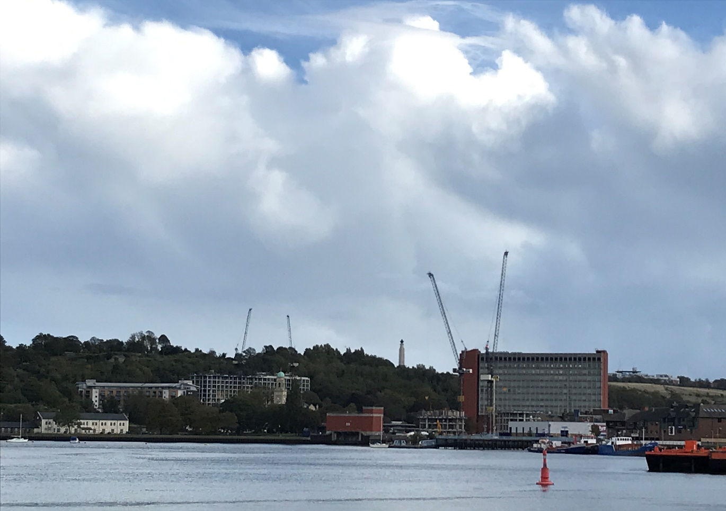
Chatham Waterfront – cranes on the left for the Whiffen’s Avenue development and cranes on the right for the Chatham Waterfront development

Development Management Planning Statistics

Planning applications

In 2020/21 1,310 planning applications were determined.

Table: Number of applications determined and percentage processed within the statutory timescale or the agreed timeframe

 | 2017/18  Nos | 2017/18  % | 2018/19  Nos | 2018/19  % | 2019/20  Nos | 2019/20  % | 2020/21  Nos | 2020/21  %
Major | 55 | 85% | 53 | 79% | 62 | 98% | 67 | 90%
Minor | 355 | 90% | 224 | 81% | 356 | 96% | 299 | 87%
Other | 1079 | 97% | 817 | 95% | 989 | 96% | 944 | 95%

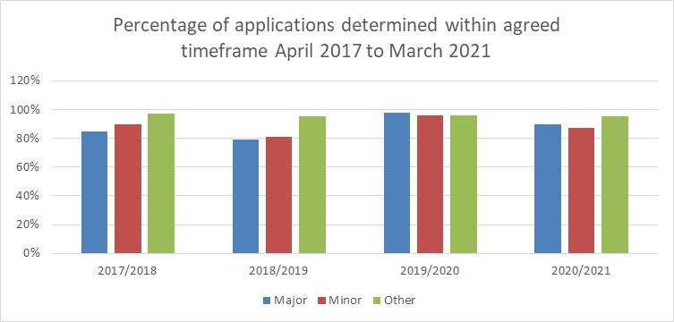

Major
Large-scale major developments - where the number of residential units to be constructed is 200 or more or 1,000 square metres of industrial, commercial or retail floor space.

Small-scale major development - where the number of residential units to be constructed is between 10 and 199 inclusive.

Minor
Is where the number of dwellings to be constructed is between 1 and 9 inclusive. A site area of less than 0.5 hectares should be used as the definition of a minor development. For all other uses, a minor development is one where the floor space to be built is less than 1,000 square metres or where the site area is less than 1 hectare.

Other
Covers minerals processing, change of use, householder developments, advertisements, listed building consents, conservation area consents, certificates of lawful development and notifications.

Managing planning applications process

Extensions of time
The general view when processing planning applications is to focus on achieving a positive, pro-growth planning system. It is considered better to take extra time and get a better quality result, than to rush the decision and get a poor result. The Government introduced the use of Planning Performance Agreements (PPA’s) and Planning Extension Agreements (PEA’s), whereby applicants and Local Planning Authorities can agree an appropriate timeframe for the determination of an application, subject to there being a programme and clear end date for the determination.

Planning Performance Agreement (PPA)
A PPA is a framework agreed between a local planning authority and a planning applicant for the management of complex development proposals within the planning process. A PPA allows both the developer and the local planning authority to agree a project plan and programme, which will include the appropriate resources necessary to determine the planning application to an agreed timetable.

Planning Extension Agreements (PEA’s)
A PEA is used to develop a bespoke timetable, whereby the timetable can be extended beyond 8, 13 or 16 weeks so long as the council and the applicant agree. Provided the council is able to meet the new agreed date, an application will be counted as satisfying the timeliness requirement for applications.

Appeals against planning decisions
During the year 2020/21, 51 appeals against the Council’s decisions were determined.
The Planning Inspectorate dismissed 80% of these appeals, putting Medway in the top 20 most successful Local Planning Authorities at defending appeals for 5+ homes between 2018-21 (source, Planning magazine analysis of COMPASS data).

Table: Percentage of Dismissed Appeals

Year | Percentage Dismissed
2017-2018 | 83%
2018-2019 | 65%
2019-2020 | 63%
2020-2021 | 80%

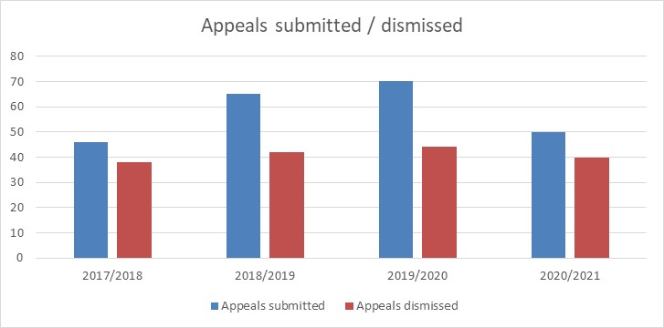

Population

Mid-year estimate 2020

Medway’s growth rate in 2020 at +0.21% was below the level seen in 2019 and continues the trend of relatively low growth in Medway over the last four years.

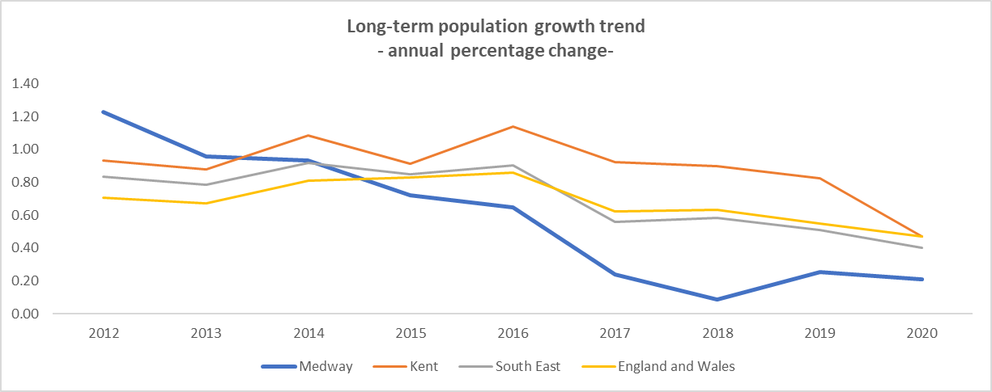

For the sixth consecutive year, Medway has a lower rate of growth than Kent, the Southeast and England & Wales. Medway’s growth peaked in 2012, after the 2011 Census.

Table: Population growth

Year | MYE numbers | Medway numbers | Medway percent change | Kent Percent change | South East percent change | Eng & Wales percent change
2012 | 268,130 | 3,245 | 1.23 | 0.93 | 0.83 | 0.71
2013 | 270,689 | 2,559 | 0.95 | 0.88 | 0.78 | 0.67
2014 | 273,212 | 2,523 | 0.93 | 1.08 | 0.92 | 0.81
2015 | 275,176 | 1,964 | 0.72 | 0.91 | 0.85 | 0.83
2016 | 276.957 | 1,781 | 0.65 | 1.14 | 0.90 | 0.86
2017 | 277,616 | 659 | 0.24 | 0.92 | 0.56 | 0.62
2018 | 277,855 | 239 | 0.10 | 0.90 | 0.58 | 0.63
2019 | 278,556 | 701 | 0.25 | 0.82 | 0.51 | 0.55
2020 | 279,142 | 586 | 0.21 | 0.47 | 0.40 | 0.47

Source: Mid 2020 Population Estimates, Office for National Statistics.

Further information on Medway’s population is available via this webpage:
https://www.medway.gov.uk/downloads/file/5388/demography_population_2020

Population by broad age group – 2020

Medway has a younger population than nationally, with proportionally more younger people and working-age residents and fewer older people. The variation is most marked in the younger and older age categories. Just over twenty-one percent of Medway’s population is aged under sixteen – representing just under fifty nine thousand 0-15s - and sixteen percent are over retirement age.

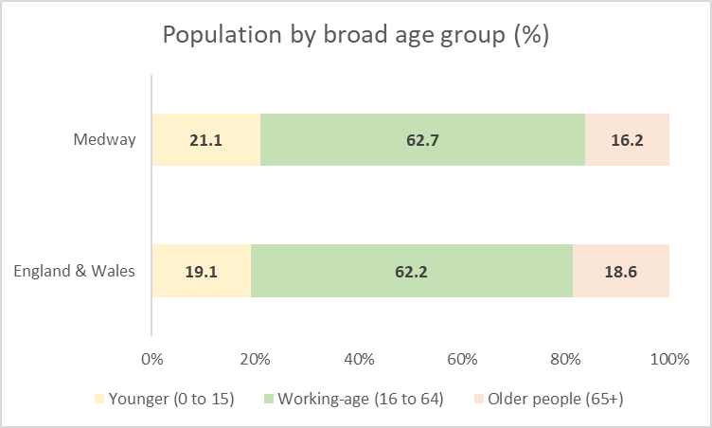

Table: Population by broad age group – 2020

 | 0-15 | 16-64 | 65+
Medway Numbers | 58,777 | 175,092 | 45,273
Medway Percent | 21.1 | 62.7 | 16.2
England & Wales Percent | 19.1 | 62.2 | 18.6

Source - Mid-Year Estimate 2020, Office for National Statistics licensed under the Open Government Licence. © Crown copyright 2021.

Further information on population estimates is available at:

https://www.ons.gov.uk/peoplepopulationandcommunity/populationandmigration/populationestimates

Migration

Natural growth remains Medway’s main source of growth, however significant outward migration from Medway - most notably to parts of Kent - has reduced the overall level of growth in recent years

In 2020, 11,666 people moved out of Medway, which exceeded the inflow of 12,115. This resulted in a net loss of 449 residents via migration flows within the UK.

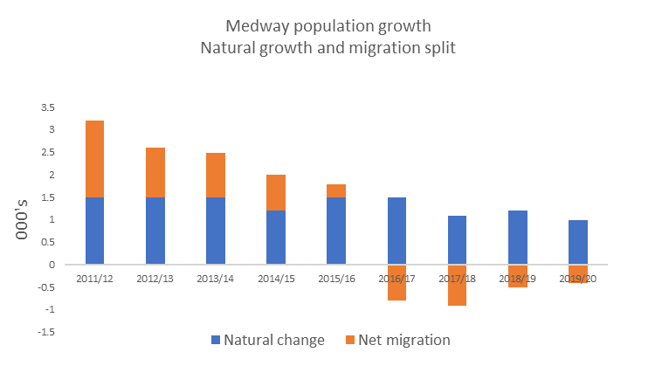

Medway had previously seen a trend of net inward flows up to 2016, which made a significant contribution to Medway’s growth.

Table: Medway migration flows 2020

Internal Migration within UK to  Medway | Internal Migration within UK From  Medway | Internal Migration within UK Net | International Migration  To  Medway | International Migration  From  Medway | Net
11,666 | 12,115 | -449 | 1,209 | 1,130 | 79

Table: Population trend – 2011/12 to 2019/20 (000’s)

 | Previous  MYE | Live births | Deaths | Natural change | Internal  migration  (net) | Inter-  national  migration  (net) | Net migration & other changes | Annual change (numbers) | Annual change (running average) | Current  MYE
2011/12 | 264.9 | 3.6 | 2.1 | 1.5 | 1.5 | 0.1 | 1.7 | 3.2 | 2.7 | 268.1
2012/13 | 268.1 | 3.5 | 2.1 | 1.5 | 1.0 | 0 | 1.1 | 2.6 | 2.6 | 270.7
2013/14 | 270.7 | 3.6 | 2.1 | 1.5 | 0.4 | 0.5 | 1.0 | 2.5 | 2.5 | 273.2
2014/15 | 273.2 | 3.6 | 2.4 | 1.2 | 0.3 | 0.5 | 0.8 | 2.0 | 2.4 | 275.2
2015/16 | 275.2 | 3.6 | 2.2 | 1.5 | -0.5 | 0.7 | 0.3 | 1.8 | 2.1 | 277.0
2016/17 | 277.0 | 3.6 | 2.2 | 1.5 | -1.1 | 0.4 | -0.8 | 0.7 | 2.7 | 277.6
2017/18 | 277.6 | 3.5 | 2.3 | 1.1 | -1.2 | 0.3 | -0.9 | 0.2 | 1.9 | 277.9
2018/19 | 277.9 | 3.5 | 2.3 | 1.2 | -0.7 | 0.3 | -0.5 | 0.7 | 1.8 | 278.6
2019/20 | 278.6 | 3.3 | 2.4 | 1.0 | -0.4 | 0.1 | -0.4 | 0.6 | 1.6 | 279.1
Total growth |  | 28.5 | 17.7 | 11 | -0.3 | 2.8 | 2.7 | 13.7 | - | -

Migration outflows

The main destinations for movers out of Medway in 2020 were to: Swale, Maidstone, Tonbridge & Malling, Canterbury and Gravesham.

Table: Top 5 destinations

Swale | 1,338
Maidstone | 1,082
Tonbridge & Malling | 614
Canterbury | 483
Gravesham | 434

Migration Inflows

The main origin areas of movers to Medway were: Gravesham, Swale, Maidstone, Bexley, then Greenwich.

There was a significant flow of migrants from London, with 4,350 people moving to Medway from London. The largest flow to Medway were from areas of South East London.

Flows to Medway from London were down slightly on the previous year. Migration from London tends to fluctuate annually, however over the past six years, on average, annually around 4,500 people moved to Medway from London.

Table: Top 5 origins

Gravesham | 807
Swale | 705
Maidstone | 668
Bexley | 587
Greenwich | 555

Source: Mid-Year Estimate 2020, Office for National Statistics licensed under the Open Government Licence. © Crown copyright 2021.

Future growth - Population projections

The 2018-based population projections which were published in March 2020 show a significant change in the predicted level of growth for Medway compared to previously published series. This reflects variations in growth rates in recent years, and a change in the methodology used in the projections. The reference period of 5 years excludes the earlier years in the 2010s when Medway experienced particularly high rates of growth. The calculation also uses a shorter reference period for migration patterns.

Medway’s population is predicted to grow by 3.7% to 2037, the previous series (2016-based) showed a 13% growth rate.

The new growth rate is just over a quarter of the previous growth level and just over a fifth of the 2014-based growth figure.

 | Population estimate 2019 | Population estimate 2037 | Growth in Numbers | Growth in percentage
2018 based SNPP | 279,310 | 288,772 | 10,179 | 3.7
2016 based SNPP | 283,929 | 321,137 | 37,208 | 13.1
2014 based SNPP | 288,000 | 335,000 | 47,000 | 16.3

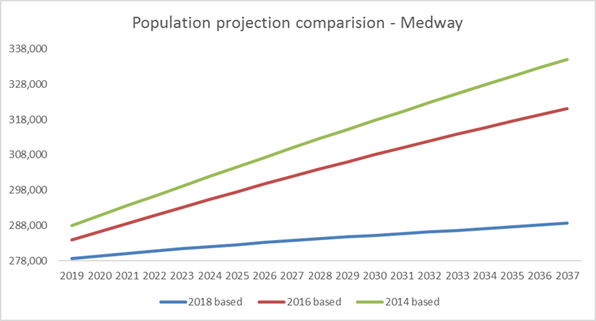

Source – Subnational population projections for England: 2018 based, Office for National Statistics (ONS).

Further information on population projections is available at:

https://www.ons.gov.uk/releases/subnationalpopulationprojectionsforengland2018based

The age profile of Medway is likely to change considerably by 2037.

The number of older persons in Medway will increase significantly, with an extra 12,600 older residents by 2037. By then a fifth of the population will be aged 65+.

Younger people see the largest decrease with around 2,850 fewer younger residents.

The working-age population will drop in size over this period, to represent just under 61% of the population by 2037.

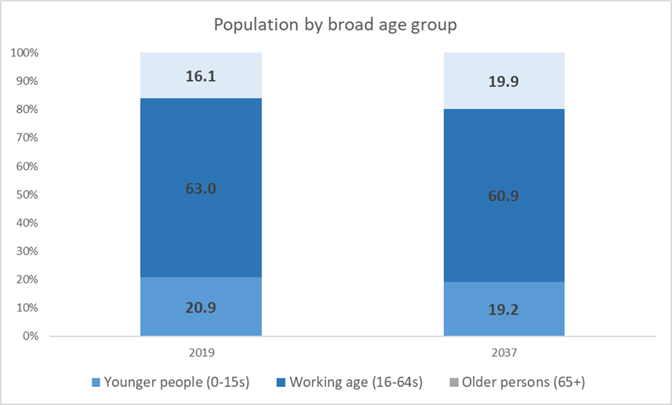

Indices of Deprivation

The Indices of Deprivation are a unique measure of relative deprivation at a small local area level (Lower-layer Super Output Areas) across England. These bring together a range of data sets and are published in a linked set every 3-4 years. The latest set of indices were published in 2019.

The Indices of Deprivation consist of the following seven themes: Income, employment, education, health, crime, barriers to housing & services and the living environment. Full details of the Indices of Deprivation 2019, the themes and the different datasets, or indicators used to calculate these are available via on the MHCLG website:

https://www.gov.uk/government/statistics/english-indices-of-deprivation-2019

Medway is ranked in the 30% most deprived local authorities nationally in the 2019 Indices of Deprivation (IoD), in 2015 it was ranked in the 37% of most deprived local authorities nationally. Medway is ranked 93rd most deprived local authority of 317 in England in the latest indices.

Medway now has fourteen neighbourhoods ranked in the 10% most deprived and thirty-seven in the 20% most deprived nationally.

Medway appears to fair worst in the crime domain, ranking in the most deprived 10% of local authorities nationally for crime.

Medway has an additional two areas in the most deprived 10% nationally and an additional five in the most deprived 20% nationally since the IoD 2015.

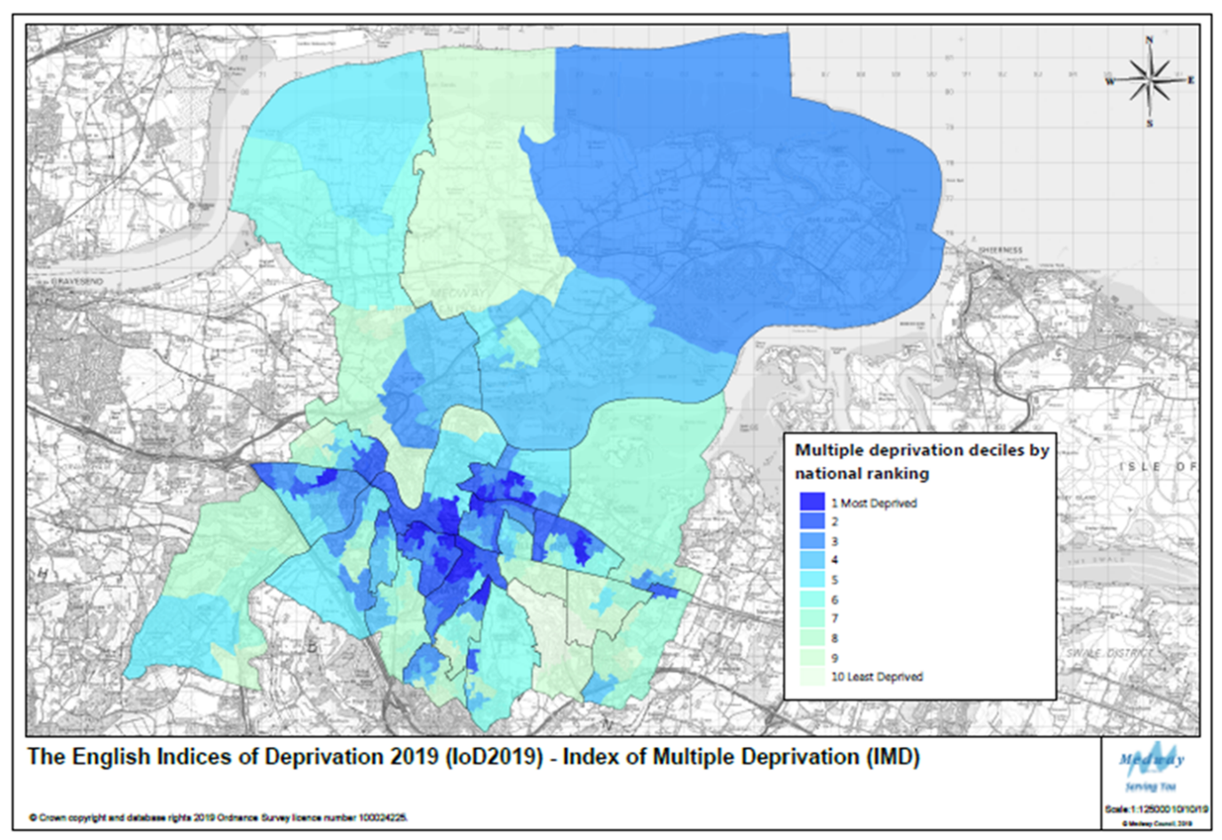

More information on the IoD can be found in the Economy & Employment, Health & Communities and Infrastructure (Education) sections of this report.

Housing

The preparation of the new Local Plan involves defining a housing target to address the development needs of Medway’s communities up to 2037. Government has stated that it expects local planning authorities to use its Standard Method with 2014 based household projections for calculating local housing needs. This was confirmed in December 2020, following consultation on a proposed alteration to the formula.

The current Standard Method formula for calculating Local Housing Need indicates a need for 1,586 homes a year.

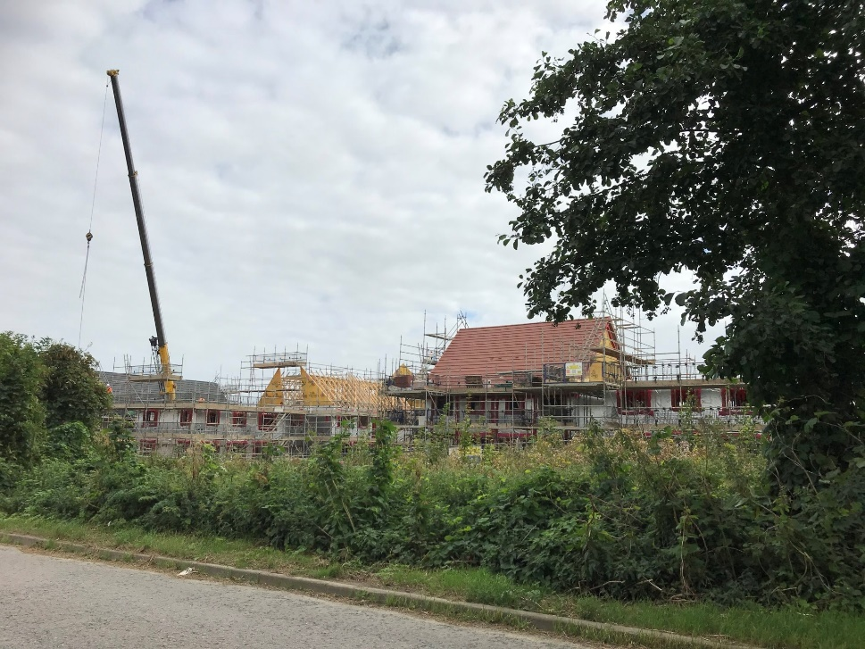
Persimmon development at Otterham Quay Lane, Rainham

Net additional dwellings a) in previous years b) for reporting year c) in future years

In 2020/21 1,082 units were completed, which was the second highest number of homes delivered in a year in Medway since it became a Unitary Authority in 1998. However, it was still 504 dwellings below the requirement of 1,586.

- Table: Net additional dwellings
 | Completions | *Requirement | Deficit
2018/19 | 647 | 1,683 | -1,036
2019/20 | 1,130 | 1,662 | -532
2020/21 | 1,082 | 1,586 | -504
*defined by the Government’s standard method of calculating local housing need

Number of new and converted dwellings on previously developed land

In 2020/21, 59% of all residential completions were on previously developed land (PDL).

Housing Trajectory 2020/21 – 2035/36

The housing trajectory shows phasing over the period 2021/22-2035/36 (15 years), as well as contributions from completions this year 2020/21 when the current housing target of 1,586 started. Phasing is made up of sites with planning consent, new emerging Local Plan site allocations and windfalls. A detailed breakdown of the trajectory is set out in Volume 2 of the AMR. It is recommended that this is also read alongside the Strategic Land Availability Assessment December 2019 review.

Planning officers consult with developers on larger sites annually to check the projections on phasing for development. This information is then used to produce the development trajectory. Officers from Planning, Regeneration and Housing services meet to critically assess the realistic prospects of proposed trajectories on large sites, based on past performance rates and current market circumstances. There has been a good level of input by developers this year and this was used alongside current knowledge on phasing to forecast housing supply. The work this year included updated information from developers that considered any changes that they had made resulting from the impacts of Covid on the market.
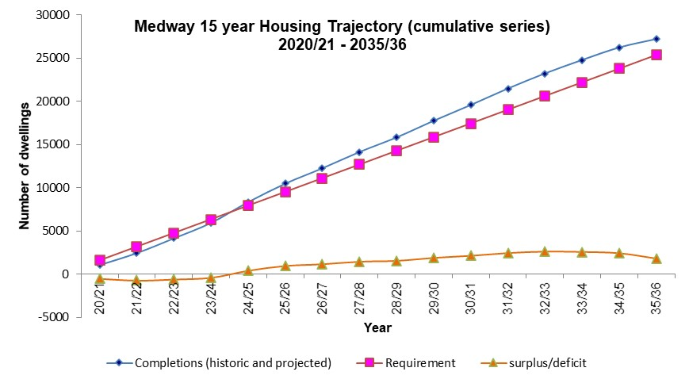
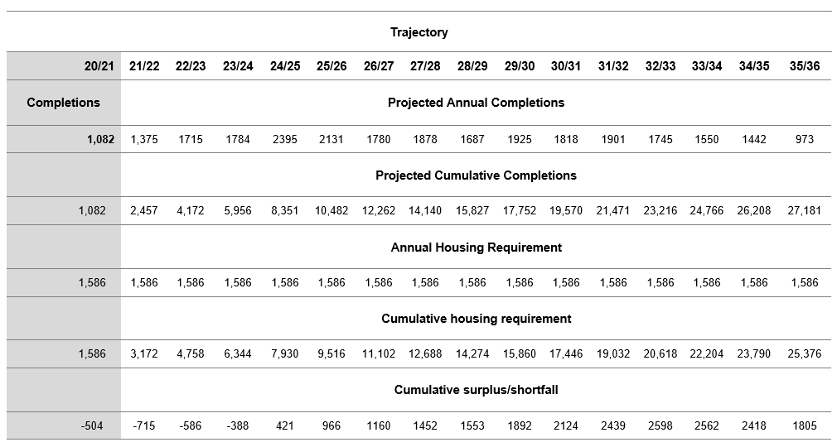

Property prices

Medway generally has a lower value development market than neighbouring districts, but there is marked variation in land values and residential property prices across the area.

During the last year Medway house prices have increased by a far higher percentage (7.4%) than normal from year to year, although at not quite so high a rate as Kent (7.8%) and England (9%). During this period in an effort to prevent the coronavirus pandemic slowing the housing market, the government reduced Stamp Duty Land Tax rates in England and Northern Ireland, which is likely to have made an impact on house prices. This reduction ceased on 30 September 2021.

Despite a 1.8% fall in house prices between March 2019 and March 2020, over the last 5 years the average cost of buying a home in Medway has risen by just over 10%.

Table: The percentage change in average prices of all properties

 | March 2017 | March 2018 | March 2019 | March 2020 | March 2021 | % Difference between March 2020 and March 2021
Medway | £232,243 | £242,000 | £243,664 | £239,359 | £257,189 | 7.4
Kent | £275,579 | £289,553 | £290,914 | £291,604 | £314,557 | 7.8
South East | £310,447 | £319,876 | £317,129 | £323,167 | £346,148 | 7.1
England | £231,760 | £240,428 | £242,982 | £249,121 | £271,640 | 9

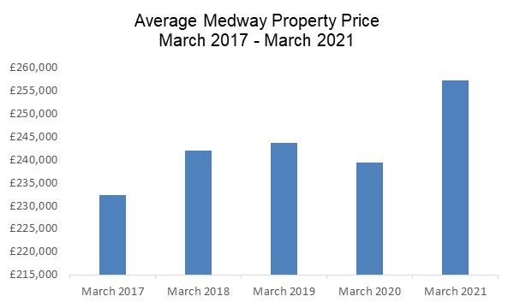

Source: Crown copyright Land Registry Property Prices 6th October 2021 – please note this data is subject to change and amendments which is why some figures may not match those published in previous AMRs
https://landregistry.data.gov.uk/app/ukhpi

Housing affordability

House price to earnings

Housing affordability ratios provide an indication of the relative financial accessibility of an area’s housing market to local workers. It is calculated by dividing house prices by annual earnings and has been a key element used in the Government’s standard method for calculating housing need.

In 2020 the housing affordability ratio in Medway stood at just over 7.5, meaning that the average property in Medway costs a little over seven and a half times the average annual salary. Housing in Medway is more affordable than nationally (7.84), than Kent (9.82) and across the South East region (9.92).

Housing affordability in 2020 has improved for a second year running in Medway, having dropped from 8.67 in 2018 and 8.43 in 2019. This is a trend which is seen nationally, regionally and across Kent.

This slight improvement in property affordability in 2020 is as a result of continued annual median earnings growth since 2013. This should be seen within the context of housing becoming more expensive within the same time period (for example, the median house price in Medway in 2013 was £159,000 whereas in 2020 it was £250,000)

 | 2013 | 2014 | 2015 | 2016 | 2017 | 2018 | 2019 | 2020 | 2019-2020 ratio change
Medway | 6.24 | 6.3 | 6.9 | 7.93 | 8.28 | 8.67 | 8.43 | 7.57 | -0.86
Kent | 7.82 | 8.36 | 8.81 | 9.52 | 10.23 | 10.49 | 9.89 | 9.82 | -0.07
South East | 8.26 | 8.56 | 9.13 | 9.76 | 10.25 | 10.37 | 10.05 | 9.92 | -0.13
England | 6.76 | 7.09 | 7.52 | 7.72 | 7.91 | 8.04 | 7.88 | 7.84 | -0.04

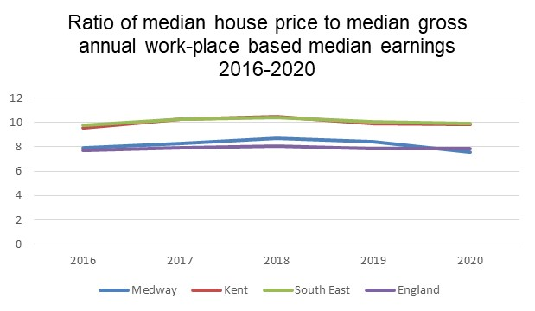
Source – Further information available at:
https://www.ons.gov.uk/peoplepopulationandcommunity/housing/bulletins/housingaffordabilityinenglandandwales/latest

Affordable Housing

A significant proportion of the population is unable to afford the cost of purchasing a home outright. As such it is important to maintain an adequate supply of ‘affordable housing’ to ensure that the whole population has a satisfactory place to live. The Council’s current target is to seek at least 25% of homes to be affordable homes on any site meeting the Council’s size thresholds.

Gross affordable completions (count)

Affordable completions as proportion of all completions

Affordable housing data is collected and reported by the council’s Housing Team and is reported as gross numbers. Therefore, for consistency with our analysis they are compared to the gross total completions number and not the net (for which there is a difference - the net figure is lower because it takes into accounts dwellings that have been lost through demolition or conversion).

The number of affordable completions has fallen to 19% of all gross completions, back to the same level as in 2017/18.

For sites built out in the year 2020/21 the breakdown of houses and flats by number of bedrooms is shown in the table below. Around 2.5 times as many flats than houses were completed. The majority of new properties were for smaller households providing 1 and 2 bedrooms, although there were also a large number of 3 bedroom properties completed.

Table: Affordable Completions (gross) by property type and number of bedrooms 2020/21
Number of bedrooms | Houses/Bungalows | Flats
One | 0 | 55
Two | 33 | 82
Three | 27 | 17
Four or more | 2 | 0
Total | 62 | 154
Total % split | 29% | 71%

Table: Gross affordable completions
 | Gross affordable completions | Number of gross  completions | As % of all gross  completions
2016/17 | 91 | 675 | 14%
2017/18 | 132 | 695 | 19%
2018/19 | 181 | 695 | 26%
2019/20 | 333 | 1,222 | 27%
2020/21 | 216 | 1,114 | 19%
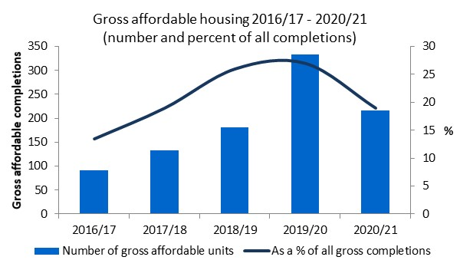

Residential completions by property type and size

There were slightly more houses than flats delivered on fully built out large sites this year, the majority being 3 bedroomed. The majority of flats built were 1 bedroomed.

Table: Completions (gross) on large sites by property type and number of bedrooms 2020/21
Number of bedrooms | Houses | Flats
One | 0 | 39
Two | 26 | 32
Three | 38 | 1
Four or more | 19 | 1
Total | 83 | 73
Total % split | 53% | 47%
Please note, this table only shows sites which have been completely built out; it does not include sites where completions have occurred with the remainder still under construction.

Lodgement Completions - Energy Performance Certificates (EPCs)

A quarterly series of statistics is published by the Ministry for Housing, Communities and Local Government on the energy efficiency of domestic and non-domestic buildings in England and Wales that have been constructed, sold or let since 2008. This data comes from Energy Performance Certificates (EPCs) which are produced at the time of completion or sale.

Comparing EPC lodgement completions with Medway’s Annual Housing Completions

Each type of dwelling is referred to as a lodgement. The number of lodgements is different to the number of actual completions per year due to differences in the EPC requirements and definitions used when counting completions for the annual survey. Using the EPC figures can give an early indication as to what the housing completion figures might be for each year, although last year 2019/20 the difference between the two was larger, which could be due to the challenge of being able to survey sites during the Coronavirus epidemic. This year 2020/21 the difference reduced to 30, resulting in a difference over the last 5 years of 158 dwellings.

Year | Total Number of Lodgements | Annual completions | Difference
2016/17 | 660 | 642 | 18
2017/18 | 708 | 680 | 28
2018/19 | 653 | 647 | 6
2019/20 | 1,206 | 1,130 | 76
2020/21 | 1,112 | 1,082 | 30
Total | 4,339 | 4,181 | 158
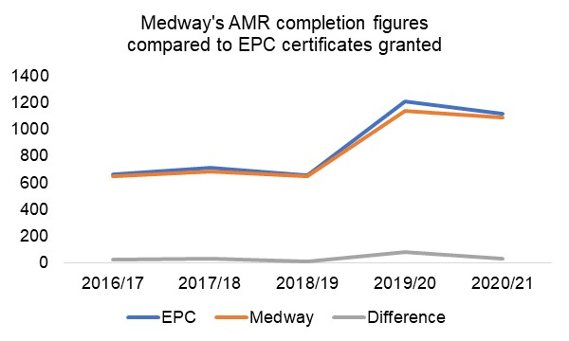
Annual Completions by property type

From Medway Council’s annual housing survey, it is usually not possible to monitor the completions of property types until the whole site is built out (see above). However, using the EPC statistics, it is possible to produce an approximate breakdown for each year, see the chart below:

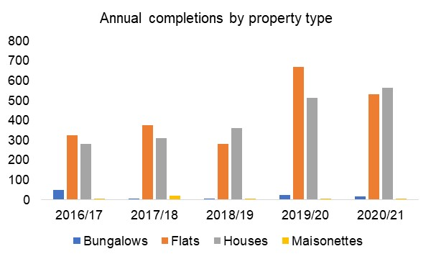

In 2020/21, around half of the dwellings registered with an EPC certificate were houses, followed closed by flats at 48%, largely due to the completion of the X1 flatted development at Chatham Docks.

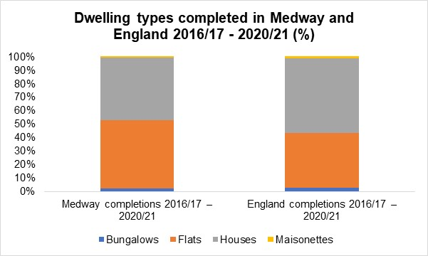

Since 2016/17, the average split of completions has been 47% houses, 50% flats, 2% bungalows and 1% maisonettes. Compared to national figures, this shows that there were a smaller proportion of houses completed in Medway, but a larger proportion of flats. This reflects on the regeneration achievements in Medway in recent years.

Table: Average floor space completed 2016/17 – 2020/21

Type of Dwelling | Medway (sq.m) | England (sq.m)
Bungalow | 76 | 91
Flats | 62 | 62
Houses | 115 | 113
Maisonettes | 79 | 85

The average floor space size for completions of houses and flats in Medway are generally around the same size as those completed nationally in England. However, bungalows and maisonettes completed in Medway are slightly smaller than those built in England.

Source: https://www.gov.uk/government/collections/energy-performance-of-buildings-certificates

‘Other’

Houseboats
Using information gained from Council Tax records, during 2020/21, four houseboats moved into marinas in Medway (Cuxton Marina and Castleview Moorings knight Road), and seven moved out, leaving a net loss of three houseboats.

C2 accommodation (residential institutions)
2020/21 saw a loss of 22 rooms from two separate care homes after they were closed to allow conversion to residential use (9 dwellings in total) in Hempstead and Hoo. No new rooms were completed in 2020/21, however it is expected that a further 127 net rooms will be completed within the next 5 years.

Student accommodation
No new student accommodation was completed in 2020/21, however 17 rooms are expected to be completed in 21/22.

New Homes Bonus

The New Homes Bonus is a grant paid by central government to local councils to reflect and incentivise housing growth in their areas.

It is based on the amount of extra Council Tax revenue raised for new-build homes, conversions and long-term empty homes brought back into use. There is also an extra payment for providing affordable homes.

Table: New Homes Bonus Allocations

2016/17 | 2017/18 | 2018/19 | 2019/20 | 2020/21
£7.5m | £5.3m | £2.5m | £2.0m | £1.2m

The New Homes Bonus is not ring-fenced and is treated as part of the overall Medway Council aggregate finance, alongside Revenue Support Grant, Council Tax and Business Rates.

The government consulted on the Future of the New Homes Bonus between 10 February and 7 April 2021. More information on the consultation can be found here:

https://www.gov.uk/government/consultations/the-future-of-the-new-homes-bonus-consultation?utm_medium=email&utm_campaign=govuk-notifications&utm_source=bb718755-65e1-4d03-8c96-f5617b6df99e&utm_content=daily

Source: https://www.gov.uk/government/publications/new-homes-bonus-final-allocations-2020-to-2021

Gypsies, Travellers and Travelling Showpeople

In 2017, the council commissioned Opinion Research Service (ORS) to produce an updated Gypsy, Traveller and Travelling Showpeople Accommodation Assessment (GTAA) to assess requirements from 2017-2035, as part of the evidence base for the new Local Plan. The report is available to view at:

https://www.medway.gov.uk/downloads/file/3371/gypsy_traveller_and_travelling_showpeople_accommodation_assessment

In 2015 the definition of a ‘traveller’ (gypsy, traveller and travelling showperson) changed with the publication of the Planning Policy for Traveller Sites (PPTS). Due to the change of the definition of a ‘traveller’ the level of need identified excludes cultural need. If the cultural definition were applied there would be an additional 21 pitches needed for gypsy and travellers and 0 plots for travelling showpersons.

 | Gypsy and Traveller Pitches | Travelling Show people  Plots
Total current authorised residential provision (pitches/plots) as at 31/3/2020 | 34 | 29
Residential need 2017-2035 (pitches/plots) | 36 | 3
Completions  1/4/2017 – 31/3/21 | 10 | 0
Remaining need to 2035 | 26 | 3

In conjunction with the new definition of the ‘traveller’ the PPTS required Local Planning Authorities to maintain a 5 year supply of housing as they do for standard housing.

Outlined in the tables separately below is the current 5 year supply position for gypsy and travellers and then travelling showpersons. The figures quoted are as at 31st March 2021.

The new Local Plan is making provision to meet the needs for specialist form of accommodation. An update to the assessment should be available by the time the next AMR is published for 2021/22.

5 year land supply for Gypsy and Travellers (2021-2026)

Stages of 5 year land supply calculation | Pitches
- Overall target 2017-2035 from GTAA 2018 | 36
- 5 year target 2017-22 from GTAA | 24
- 5 year target 2022-27 from GTAA | 4
- Annual pitch requirement 2017-22 (B/5) | 4.8
- Annual pitch requirement 2022-27 (C/5) | 0.8
- Completions (1st April 2017 to 31st March 2021) | 10
- Shortfall (D*4) – F | 9.2
- 5 year target 2021-2026 (D*1) + (E*4) + G | 17.2
- Total deliverable supply | 0
- Land supply in years I / (H/5) | 0

Table: 5 year land supply for Travelling Showpeople 2021 - 2026

Stages of 5 year land supply calculations | Pitches
- Overall target 2017- 2035 from GTAA 2018 | 3
- 5 year target 2017-22 from GTAA | 0
- 5 year target 2022-227 from GTAA | 1
- Annual pitch requirement 2017-22 (B/5) | 0
- Annual pitch requirement 2022-27 (C/5) | 0.2
- Completions (1st April 2017 – 31st March 2021) | 0
- Shortfall (D*4) – F | 0
- 5 year target 2021 – 2026 (D*1) + (E*4) + G | 0.8
- Total deliverable supply | 0
- Land supply in years I / (H/5) | 0

Net additional pitches (Gypsy and Traveller)

Bi-annual counts of Gypsy and Traveller Caravans are made by the Planning Service, Housing Management and Strategic Housing every January and July, before being submitted to MHCLG and subsequently published. A count of Travelling Showpeople is also made annually each January. Due to COVID-19 restrictions, no count was carried out during July 2020 or January 2021.

In the latest data from January 2020, there were 61 caravans in Medway, of which 10 were socially rented, 41 on authorised sites with permanent/temporary permission and a further 10 on unauthorised sites without planning permission. In addition to this, there were 20 Travelling Showpeople caravans counted.

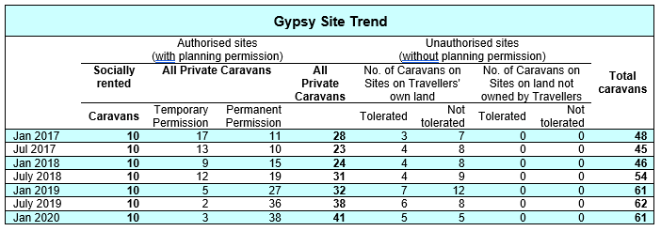

Planning applications

Year | Permitted Permanent* | Permitted Temporary | Refused
2016-17 | 0 | 2 | 0
2017-18 | 3 | 1 | 0
2018-19 | 3 | 0 | 3
2019-20 | 1 | 1 | 2
2020-21 | 0 | 1 | 0
*including retrospective and lawful development certificates

During the year 2020/21 there was one approval granted (retrospective) for an extension to an existing site at Scarlett Meadow in Matts Hill Road, Rainham (extension of one mobile home and day room).

Self-Build and Custom Housebuilding Register

From 1 April 2016, the council has had a duty to hold a register of people and associations interested in a serviced plot of land that could be used to build their own home.

The register operates in ‘base periods’; The first base period ran from the date the register was first established (1 April 2016) until 30th October 2016, then subsequent base periods run from 31 October to 30 October the following year.

At the end of each base period, relevant authorities have three years in which to permission an equivalent number of plots of land, which are suitable for self-build and custom housebuilding, as there are entries for that base period.

Table: Number of applications on the Register – Demand for self/custom build plots

Base Period | Individuals* | Associations | Need to have enough permissions granted by | Permissions granted within 3 years of end of base period
One (1/4/2016 – 30/10/2016) | 14 | 0 | 30/10/2019 | 11
Two (31/10/2016 – 30/10/2017) | 38 | 0 | 30/10/2020 | 0
Three (31/10/2017 – 30/10/2018) | 13 | 1 | 30/10/2021 | 3
Four (31/10/2018 – 30/10/2019) | 12 | 1 | 30/10/2022 | -
Five (31/10/2019 – 30/10/2020) | 16 | 0 | 30/10/2023 | -
Six (31/10/2020 – 30/10/2021) | 12 | 0 | 30/11/2023 | -
TOTAL PLOTS REQUIRED INDIVIDUALS | 105 | -
TOTAL PLOTS REQUIRED ASSOCIATIONS | - | 2

* these numbers may be different to previously reported due to some applicants later requesting to be removed from the Register

The council promotes opportunities for self-build and custom housebuilding with developers and notifies applicants on the register when plots become available.

The council will have regard to the register when preparing the local plan, and in making decisions on planning applications. Emerging Neighbourhood Plans in Medway are also promoting policies for self-build and custom housing. More information can be found at:

https://www.medway.gov.uk/info/200149/planning_policies/144/self-build_and_custom_housebuilding_register

Economy and Employment

Medway Council supports the development of a diverse, high quality local economy, to provide a wide range of employment options for the community as a whole.

Market conditions broadly reflect a combination of national economic circumstances and local supply and demand factors. much of the commercial space is ‘second-hand’ and not of the configuration, type and condition of new space that may come forward in the future, therefore lower rents are more likely than for new property in a convenient well accessed location with car parking and that is well suited to the modern business environment.

The Council’s Regeneration Strategy, Medway 2035 sets out the regeneration aims and objectives for Medway across eight priority areas.

- Destination and Placemaking
- High Value Jobs and Productivity
- Inward Investment
- Local Employment
- Innovation
- Business Accommodation
- Sector Growth
- Improving Employability

The new Local Plan is addressing the supply of employment land to meet the needs of businesses in Medway up to 2037. An updated evidence base is being prepared and the Planning Service is liaising with wider services in planning for recovery and responding to change from the impacts of Covid on the economy.

The planning use classes were updated part way through the year on 1st September 2020. Class B1 now falls within new use class E(g): uses which can be carried out in a residential area without detriment to its amenity. Use classes B2 and B8 remain the same. For the purpose of monitoring this year 2020/21, we have continued to use the former B1 use class throughout the year which includes any applications which have been made under the new use class E(g).

Amount and type of completed employment floor space

2020/21 – although there were gains made in B1, B2 and B8 employment floorspace this year, this was outweighed by losses. B1 gains include a further new unit at London Medway Commercial Park at Kingsnorth, B2 gains include a new MOT bay at Priory Road in Strood and B8 gains include a new builder’s merchant and storage yard at Medway City Estate. The largest single B1 loss was made at Prince Regent House in Chatham Maritime, which is being developed for residential use. Other B1 losses are split between providing residential dwellings and new commercial uses. 4,050 square metres of B8 floorspace was lost at Bredgar Road in Gillingham to make way for a new combined ambulance make ready centre, emergency operations centre and 111 clinical assessment centre. See Volume 2 for more information on individual gains and losses.

Table: Amount and type of completed employment floor space (sq.m) – 2020/21

 | B1 | B2 | B8 | Mixed B | Total
Gross | 3,438 | 1,058 | 4,713 | 0 | 9,209
Net | -2,282 | -424 | -1,772 | 0 | -4,478

Table: Amount of completed employment floor space (sq.m) 2016/17- 2020/21

 | 2016/17 | 2017/18 | 2018/19 | 2019/20 | 2020/21
Gross | 12,838 | 11,950 | 60,733 | 3,552 | 9,209
Net | 517 | -25,513 | 53,685 | -2,429 | -4,478

Amount and type of employment floor space coming forward on Previously Developed Land (PDL)

96% of employment floor space (gross) was completed on previously developed land during 2020/21.

Amount and type of employment land available

The amount of available floor space for B1/B2/B8/Mixed B with planning permission (not started plus under construction) net of potential losses is 822,343 sq.m, however, only approx. 650,000 sq.m is expected to be delivered in the next 15 years. This is because it includes floorspace totalling 464,685 sq.m at Grain Business Park from an outline permission granted in 2010 but a new masterplan accompanying a reserved matters application in 2015 on part of the site reduced this overall amount to 298,973sq.m, which is expected to be delivered by 2037. A full breakdown between the use classes can be found in of Volume Two of the AMR.

Amount of floor space for town centre uses

The monitoring data shows that the town centres losses continue in all sectors. The council recognises High Streets have been undergoing significant changes over the last decade, and these structural changes have accelerated in the last year.

The new Local Plan will set out strategy and policies for securing the future of Medway’s town centres, including a mix of land uses. Medway 2035, our Regeneration Strategy also promotes the vitality of centres. The council has invested in Chatham and Strood over the last few years to improve the public realm and to increase attractiveness of the town centres. Further work continues with the Future High Streets Fund, SELEP investments in Gillingham and Covid recovery programme.

Table: Floor space (sq.m) completed for town centre uses (A1/A2/B1/D2) – 2020/21

 | A1 Gross | A1  Net | A2 Gross | A2  Net | B1 Gross | B1  Net | D2 Gross | D2  Net | Gross Total | Net Total
Town Centre | 817 | -518 | 37 | -719 | 15 | -282 | 0 | 0 | 869 | -1,519
Rest of Medway | 436 | -3,700 | 85 | -187 | 3,423 | -2,000 | 2,658 | 1,897 | 6,602 | -3,990
Total | 1,253 | -4,218 | 122 | -906 | 3,438 | -2,282 | 2,658 | 1,897 | 7,471 | -5,509

Table: Total floor space (sq.m) for town centre use 2016/17-2020/21

Year | Town centre Gross | Town centre Net | Rest of Medway Gross | Rest of Medway Net | Total Gross | Total Net
2016/17 | 1,034 | -430 | 17,584 | 6,665 | 18,618 | 6,235
2017/18 | 540 | -4,579 | 10,542 | -11,412 | 11,082 | -15,991
2018/19 | 576 | -1,734 | 15,324 | 9,236 | 15,900 | 7,502
2019/20 | 577 | -3,333 | 6,848 | -8,089 | 7,425 | -11,422
2020/21 | 869 | -1,519 | 6,602 | -3,990 | 7,471 | -5,509

Job Seekers Allowance and Universal Credit claimant rate

The claimant rate in Medway reached 6.9% in April 2021 and stands above the rate for Kent, the South East and Great Britain.

In April 2021 the claimant count in Medway reached 12,030 claimants, having increased by twenty-nine percent since April 2020, compared to a twenty-five percent increase nationally.

Table: Claimant rate – 2016-2021

 | Medway | Kent | South East | Great Britain
Apr-16 | 2.1 | 1.6 | 1.1 | 1.9
Jul-16 | 1.9 | 1.5 | 1.0 | 1.8
Oct-16 | 2.0 | 1.6 | 1.1 | 1.8
Jan-17 | 1.9 | 1.6 | 1.1 | 1.8
Apr-17 | 2.0 | 1.7 | 1.2 | 2.0
Jul-17 | 1.9 | 1.6 | 1.1 | 1.9
Oct-17 | 1.9 | 1.7 | 1.2 | 1.9
Jan-18 | 1.9 | 1.8 | 1.2 | 2.0
Apr-18 | 2.0 | 2.0 | 1.4 | 2.2
Jul-18 | 1.9 | 1.9 | 1.3 | 2.1
Oct-18 | 2.2 | 2.0 | 1.4 | 2.2
Jan-19 | 2.4 | 2.2 | 1.6 | 2.4
Apr-19 | 2.8 | 2.4 | 1.7 | 2.7
Jul-19 | 3.0 | 2.5 | 1.8 | 2.8
Oct-19 | 3.1 | 2.7 | 2.0 | 2.8
Jan-20 | 3.2 | 2.7 | 2.0 | 2.9
Apr-20 | 5.3 | 5.0 | 3.9 | 5.1
Jul-20 | 6.8 | 6.1 | 5.2 | 6.3
Oct-20 | 6.6 | 5.8 | 5.1 | 6.2
Jan-21 | 6.6 | 5.8 | 5.1 | 6.2
Apr-21 | 6.9 | 5.8 | 5.2 | 6.3

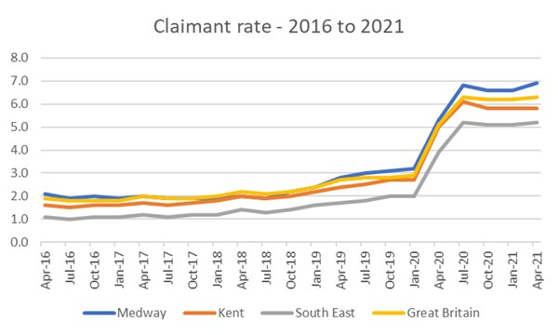

The Claimant Count measures the number of people claiming benefit principally for the reason of being unemployed. The Claimant Count includes all Universal Credit claimants who are required to seek work and be available for work, as well as all JSA claimants.
Most of the Universal Credit claimants in the Claimant Count will be unemployed but a small number will be in work with very low earnings.
The Claimant Count estimates provide the best available estimates of the number of people claiming unemployment-related benefits in the UK.

Source - Jobcentre Plus administrative system, via Nomis, ONS.

Employment

In 2021 the employment rate in Medway dropped to 75.3% from 77.3% in the previous year. The employment rate in Medway peaked in 2018 when it reached 78%.

The Medway employment rate in 2021 stands below the national level having dropped by two percentage points. While all areas (Kent, South East & GB) saw a decrease, the drop in Medway was largest.

Table: Employment rate

 | 2016/17 | 2017/18 | 2018/19 | 2019/20 | 2020/21
Medway | 75.8 | 78 | 77.5 | 77.3 | 75.3
Kent | 74.3 | 76.2 | 76.5 | 78.5 | 77.9
South East | 77.6 | 78.5 | 78.4 | 79.6 | 77.7
Great Britain | 74.2 | 75.0 | 75.4 | 76.0 | 78.7

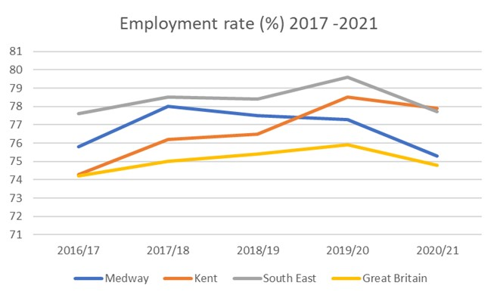

Source: Annual Population Survey, ONS. Available via NOMISweb.

Economic activity

The economic activity level in Medway dropped in 2021 to 78.4%. While all areas saw a decrease in economic activity, the drop in Medway is twice the scale of that seen at regional level.

The economic activity rate in Medway now stands below the national rate for the first time in five years.

Table: Economic activity rate

 | 2016/17 | 2017/18 | 2018/19 | 2019/20 | 2020/21
Medway | 80.1 | 82.0 | 81.1 | 80.8 | 78.4
Kent | 78.2 | 79.7 | 79.6 | 81.6 | 81.3
South East | 80.8 | 81.2 | 81.1 | 82.3 | 81.1
Great Britain | 77.9 | 78.4 | 78.7 | 79.1 | 78.7

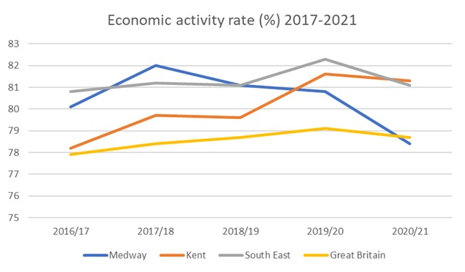

The economically active are people who are either in employment or unemployed.

Source: Annual Population Survey, ONS. Available via NOMISweb.

For further information on economic activity and employment go to:

https://www.ons.gov.uk/employmentandlabourmarket/peopleinwork/employmentandemployeetypes/bulletins/uklabourmarket/september2020

Income and employment deprivation

The Indices of Deprivation (IoD) are a unique measure of relative deprivation at a small local area level (Lower-layer Super Output Areas) across England.

Medway ranks 103rd most deprived local authority for income deprivation. In the 2019 IoD, 13.4% of the Medway population were estimated to be experiencing income related issues. This was down on the IoD 2015, when 15.3% of the population of Medway were estimated to be income deprived.
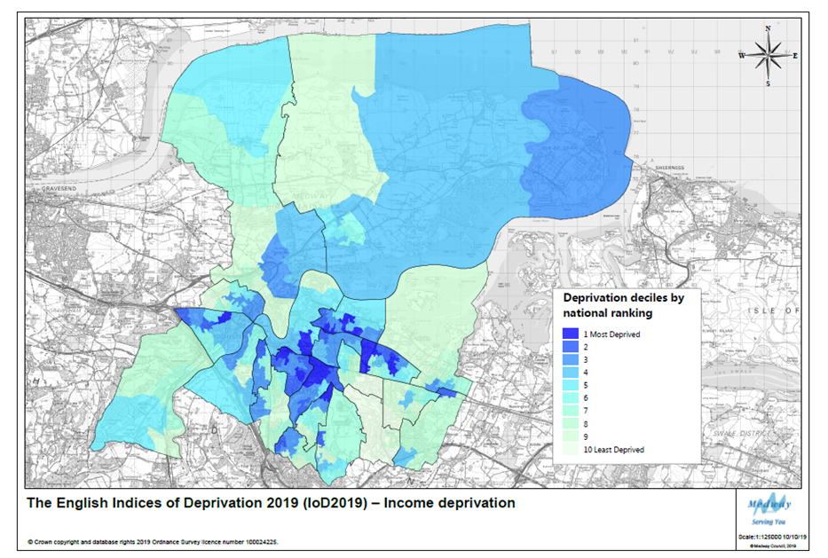
Low income is closely linked to issues of employment deprivation. Medway is the 98th most deprived local authority in England for employment, with 10.4% of the population experiencing employment related issues. Despite a relatively better employment ranking in 2015, at 107th most deprived, a higher proportion of the Medway population experienced employment related issues at 12.3%.
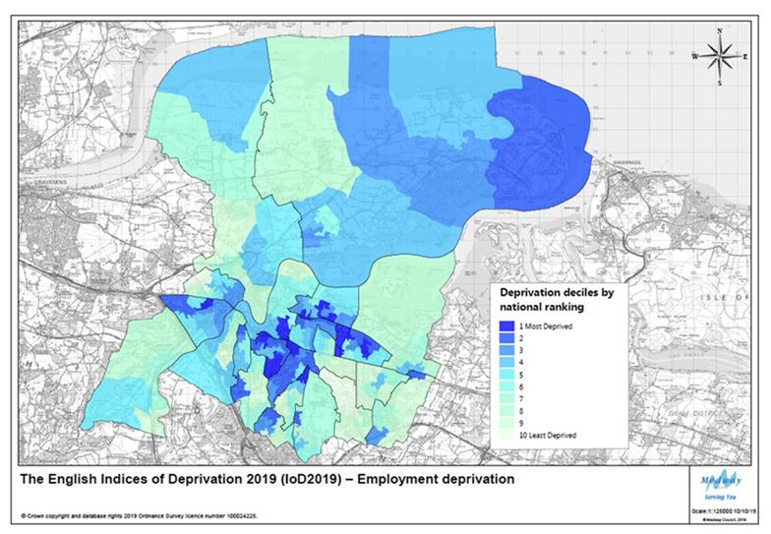
More information on the IoD can be found in the Population, Health and Communities and Infrastructure (Education) sections of this report.

Fuel Poverty

Living in fuel poverty is defined as being on a lower income and living in a home which cannot be kept warm at reasonable cost.

Fuel poverty in England is measured using the Low Income High Costs (LIHC) indicator, which considers a household to be fuel poor if:

• they have required fuel costs that are above average (the national median level); and
• were they to spend that amount, they would be left with a residual income below the poverty line.

Percentage of households living in fuel poverty 2014-2018

 | 2014 | 2015 | 2016 | 2017 | 2018
Medway | 9.2 | 11.5 | 10.1 | 10.3 | 9.0
Kent | 8.9 | 9.9 | 9.6 | 9.5 | 8.9
South East | 8.3 | 9.4 | 9.0 | 8.7 | 7.9
England | 10.5 | 11.0 | 11.1 | 10.9 | 10.2

Compared with the rest of Kent, the South East and England there seems to have been a spike in Medway in 2015. It is not clear why this occurred, but the latest statistics from 2018 show that across all regions the percentage of households living in fuel poverty has fallen to lower than it was 5 years previously. Medway’s current percentage (9%) is less than nationally recorded (10.2%), similar to the rest of Kent (8.9%), but higher than the South East (7.9%).

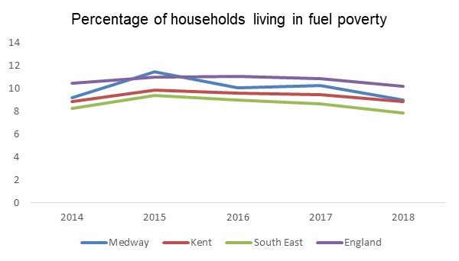
Out of the thirteen Kent Authorities, five are worse than Medway (an increase of two more from last year). These being Swale at 9.2%, Canterbury and Dover at 10.1%, Folkestone and Hythe at 10.2% and Thanet at 10.7%.

Source:
https://www.gov.uk/government/statistics/sub-regional-fuel-poverty-data-2020

The River Medway - Port cargo traffic

Medway built up around the river and its estuary, and its history and industries reflect these links. Although some traditional industries have declined as part of structural changes, there are still a number of marine based businesses active in Medway.

The docks and wharves around Medway support local businesses and provide a strategic role for the movement of goods and materials. This includes the importation of aggregates that support the construction industry. (More information on aggregates importation is available at the end of Volume 2 of the AMR).

London Thamesport on the Isle of Grain can handle a variety of deep and shallow-drafted vessels; other ports in Medway include the Scotline Terminal on the Medway City Estate and the National Grid's Liquefied Natural Gas Importation terminal at Grain.

Data is published for Medway Ports that include Chatham Docks and the port of Sheerness, both managed by Peel Ports. Medway Ports ranked 12th out of the top 30 UK ports – with the cargo handled representing 2.3%. The reports do not provide separate information for Chatham.

Medway Ports cargo tonnage has fallen since last year, but similarly all traffic in England and Wales has generally fallen. This can be due to a variety of reasons, but a blockage at the Suez Canal in March 2021 contributed to delays in cargo around the world. The majority (94%) of cargo traffic transported via Medway Ports is inward.

Table: Medway Ports traffic cargo – tonnage (000’s)

 | 2016 | 2017 | 2018 | 2019 | 2020
All traffic | 9,170 | 8,694 | 10,204 | 13,141 | 9,694
Inward | 8,087 | 7,854 | 9,602 | 12,476 | 9,102
Outward | 1,084 | 839 | 602 | 665 | 592

Table: All Majors UK ports traffic cargo – tonnage (000’s)

 | 2016 | 2017 | 2018 | 2019 | 2020
All traffic | 472,772 | 470,683 | 472,056 | 471,739 | 428,994

Table: Medway Ports – Ship Arrivals – cargo vessels only

 | 2016 | 2017 | 2017  new basis | 2018  new basis | 2019  new basis | 2020 new basis
Arrivals | 2,834 | 2,179 | 1,797 | 1,788 | 1,735 | 1,492

From 2017 onwards, the data sources used to estimate vessel arrivals changed. The primary source of data is now the Maritime and Coastguard Agency CERS system, though data from ferry companies, ports and shipping agents collected by DfT is also still used. As a result, the 2018 figures are not directly comparable with those for earlier years (in 2017 figures using the previous and new sources of data were produced).

Table: Bulk type Medway Ports – 2020

 | Tonnage (000’s)
Liquefied gas | 2,707
Oil products | 1,114
LIQUID BULK TOTAL | 3,821
Ores | 49
Agricultural Products | 119
Other dry bulk | 3,209
DRY BULK TOTAL | 3,377
Forestry products | 1,015
Iron and steel products | 236
General cargo and containers <20’ | 269
OTHER GENERAL CARGO | 1,521
CONTAINERS TOTAL | 309
ROLL ON/ROLL OFF (self-propelled) Import/export of motor vehicles TOTAL | 372
ROLL ON/ROLL OFF (non self-propelled) TOTAL | 295
TOTAL TRAFFIC | 9,694

In 2020, liquid bulk was the largest cargo type handled by Medway Ports at 3,821,000 tonnes – but that is around half of that handled in the previous year (6,650,000 tonnes). Liquid bulk includes liquefied gas and oil products - Medway Ports were ranked third in the UK for handling liquified gas. Medway Ports were ranked the top in the UK for handling forestry products, with nearly 1,015,000 tonnes imported, an increase on the previous year (which was around 900,000 tonnes).

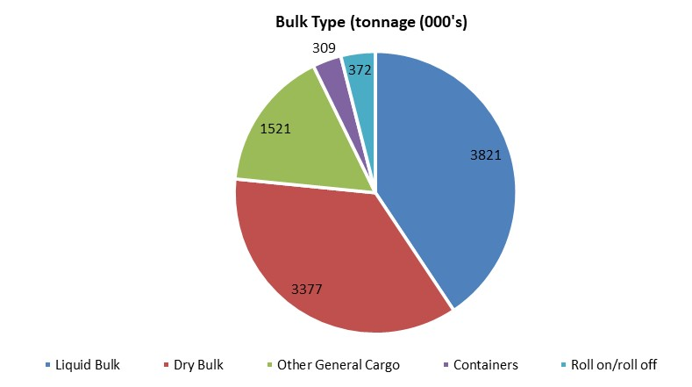

Source: DfT Port Freight statistics, tables Port 0303 (top 30), Port 0602 (arrivals) and Port0400 (bulk type tonnage)
Further information available at:
https://www.gov.uk/government/statistics/port-freight-annual-statistics-2020

Retail and Town Centres

Medway Council seeks to maintain and enhance the vitality and viability of its network of urban and rural centres and support the delivery of appropriate comparison and convenience retail, office, leisure, community, entertainment and cultural facilities. In line with structural changes in retail, the town centres in Medway have faced a number of challenges in recent years, including the rise in online shopping. Going forward, new challenges following by the Coronavirus (COVID-19) pandemic will leave a lasting effect on the High Street and Town Centres. The new Local Plan and our Regeneration Strategy, Medway 2035, promotes strategies and policies to secure a vibrant and strong role for Medway’s centres in coming years, recognising the restructuring of retail.

None of the settlements in Medway are regional shopping destinations. The retail and leisure sector is overshadowed somewhat by London and to a lesser extent Maidstone. Additionally, the Bluewater Shopping Centre is a major shopping destination. Beyond the high streets and Hempstead Valley shopping centre, there are several notable features:

- The Dockside Outlet Shopping Centre provides a discount outlet, with a wider leisure offering.
- Gillingham Business Park has several trade counters and larger format retail.
- Horsted and Strood Retail Parks have a range of retail warehouses and stores.
- The towns are busy with a broad range of local shops and services

The planning use classes were updated part way through the year on 1st September 2020. Classes A1/2/3 now fall within new use classes E(a,b,c) and A4/5 are now defined as Sui Generis. Class D1 was split out and replaced by the new classes E(e-f) and F1. Class D2 was split out and replaced by the new classes E(d) and F2(c-d) as well as several newly defined Sui Generis classes. For the purpose of monitoring this year 2020/21, we have continued to use the former use classes throughout the year which includes any applications which have been made under the new use classes.

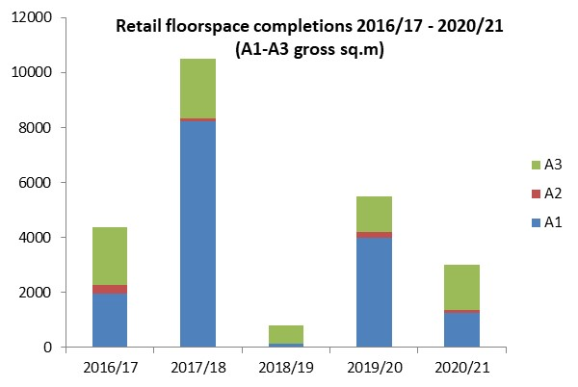

The majority of gross gains in the Town Centres this year were use class A3, cafes and restaurants, including the conversions of former shops into Tick Tocks Cafe in Rainham and Lounge 44, a restaurant serving West-African cuisine in Chatham High Street. A new German kitchen shop was also opened in Rainham High Street (Kutchenhaus) in place of a former financial and professional service.

Town Centre (TC) and Non-Town Centre GROSS retail floor space completions A1-A5 (sq.m)

 | 2016/17 | 2017/18 | 2018/19 | 2019/20 | 2020/21
A1 TC | 227 | 194 | 64 | 235 | 817
A1 Non TC | 1,728 | 8,021 | 50 | 3,745 | 436
A1 Total | 1,955 | 8,215 | 114 | 3,980 | 1,253
A2 TC | 202 | 70 | 0 | 54 | 37
A2 Non TC | 103 | 64 | 0 | 182 | 85
A2 Total | 305 | 134 | 0 | 236 | 122
A3 TC | 671 | 419 | 61 | 550 | 1,163
A3 Non TC | 1,434 | 1,728 | 628 | 717 | 471
A3 Total | 2,105 | 2,147 | 689 | 1,267 | 1,634
A4 TC | 107 | 60 | 0 | 448 | 147
A4 Non TC | 119 | 331 | 78 | 0 | 401
A4 Total | 226 | 391 | 78 | 448 | 548
A5 TC | 36 | 47 | 115 | 0 | 88
A5 Non TC | 67 | 58 | 280 | 451 | 139
A5 Total | 103 | 105 | 395 | 451 | 227
A1-A5 TC | 1,243 | 790 | 240 | 1,287 | 2,252
A1-A5 Non TC | 3,451 | 10,202 | 1,036 | 5,095 | 1,532
A1-A5 Total | 4,694 | 10,992 | 1,276 | 6,382 | 3,784

Net completions in town centres

There were increases seen in new retail floor space provision (A1/A2/A3/A4/A5/D1) in the town centres, however overall there were net losses in A1 and A2. The majority of changes have been to premises swapping to other town centre uses, however just under 40% of the total floorspace lost in town centres this year was to residential use (a gain of 18 dwellings).

Town centre development – 2020/21

Use | Losses  (sq.m) | Gains  (sq.m) | Net change  (sq.m) | Total development in town and non town centres Gross (sq.m) | Proportion of gains in town centres (gross) out of total
A1 | -1,335 | 817 | -518 | 1,253 | 65%
A2 | -756 | 37 | -719 | 122 | 30%
A3 | -580 | 1,163 | 583 | 1,634 | 71%
A4 | -37 | 147 | 110 | 548 | 27%
A5 | 0 | 88 | 88 | 227 | 39%
D1 | 0 | 123 | 123 | 2,633 | 5%
D2 | 0 | 0 | 0 | 2,658 | 0%
Total | -2,708 | 2,375 | -333 | 9,075 | 26%

Within Medway there has been a steady net loss of drinking establishments/public houses in recent years with the loss of 12 establishments in 2017/18, with all but one of these being lost to residential use. A year later in 2018/19 a further five pubs went, of which only one remained in retail use. Last year a further two pubs were lost, one to a mixed-use development retaining some retail use (A1/A3) as well as residential; the other pub was lost to residential entirely. However, this year 2020/21, although Medway saw the loss of Past and Present micropub to a pasta take-away and The Good Intent pub in Rochester to residential use, there has actually been a net gain in A4 use with the completion of 3 new drinking establishments, including a new micropub ‘Three Sheets to the Wind’ in Rochester.

Non Town Centre Activity

Large gains were made in D1 and D2 floorspace outside the town centre including the completion of a new gymnastics club in Strood and an indoor soft play area at Dockside shopping centre in Chatham Maritime.

The X1 development at Chatham Waters was completed which included 600sq.m A1-A5 floorspace and 110sq.m D1 floorspace.

Natural and Built Environment

Greenspace regeneration projects

Development of Green Spaces
Working in partnership the aim is to protect and sustain the existing open spaces and create new and improved open spaces by:

- making the best use of our valued open and green spaces
- identifying how we can improve our existing parks and open spaces. There are currently 148 urban parks and 1,900 hectares of open spaces in Medway.
- developing new partnerships and secure funding to make improvements in the future
- encouraging more community involvement
- celebrating our open and green spaces

FY20-21 projects included:

- Play areas improvements
- Cockham Community Parkland
- Berengrave Local Nature Reserve
- Talking Telescopes
- Urban Tree Challenge Fund & Tree Strategy

Play area improvements
9 play areas were improved across Medway in Rainham, Strood, Chatham and Gillingham. These projects were funded by a mixture of capital, revenue and Section 106 contributions. The play area improvements have increased the play value and upgraded the old play equipment.

Cockham Community Parkland
Part of the HIF funding will enable the establishment of a Strategic Environmental Management Scheme (SEMS), which will deliver a network of new public open spaces. These spaces are designed to provide recreational space for local residents and reduce pressure on more sensitive existing habitats around the Hoo Peninsula.

Cockham Community Parkland is the first of these new spaces to be brought forward. The Council consulted the public on thoughts on the emerging proposals in summer 2020. The new parkland would create a large public open space offering benefits for the local community and wildlife. A planning application for the parkland was submitted in January 2020.

Features could include:
- providing safe and attractive routes connecting Main Road to Vicarage Lane for dog walkers, walkers and cyclists
- creating new wildflower meadows, hedges and wooded areas where wildlife can flourish
- creating a new orchard and space for a visitor centre in the future
- providing space for picnics, play and woodland trails
- offering outstanding views of the estuary, the river and Medway

https://www.medway.gov.uk/cockhamcommunityparkland

Berengrave Local Nature Reserve (pictured)
This little gem in Rainham is an important habit but is prone to flooding. A feasibility study is underway to look at different options to improve access around the site. A consultation will then take place to ask local residents and visitors for their thoughts. Also, ecology surveys and interpretation improvements are being carried out at the reserve.

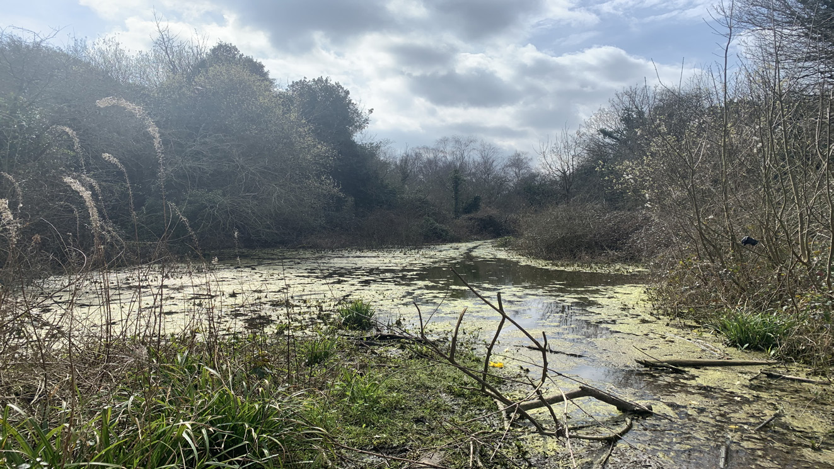

Talking Telescopes
This two year Lottery funded project (HLF Young Roots) was completed and celebrates the history of the Strand. The Talking Telescopes project raised awareness of The Strand’s importance and capture people’s memories of its heyday in the 1950’s and 60’s and included Mid Kent College, Medway Plus and local volunteers. The project did this by recording oral histories and making these available through the medium of three talking telescopes, one of which is accessible for everyone, including those with disabilities. A celebration day to recreate a 1950s day out took place as well as new interpretation panels and a mural.

Urban Tree Challenge Fund & Tree Strategy
Medway was successfully awarded funding from the Forestry Commission to plant over 10,000 trees across Medway to improve diversity. Planting of native trees took place in spring 2021 at 9 sites and links in with Medway’s emerging Tree Strategy.

Green Flag Awards

The Green Flag Award scheme recognises and rewards well-managed parks and green spaces, setting the benchmark standard for the management of recreational outdoor spaces across the United Kingdom and around the world.

The winners of the Green Flag award are announced each year.

In 2020 eight sites received the Green Flag award. It is the first year that Ranscombe Farm Reserve in Cuxton, which is managed by Plantlife, has received the accreditation. Other sites include The Vines, Riverside Country Park, Hillyfields, Capstone Farm Country Park, Broomhill Park, Great Lines Heritage Park, Gillingham Park and Ranscombe Farm Reserve

Table: Green flag sites – year awarded

July 2016 | 6
July 2017 | 7
July 2018 | 7
July 2019 | 7
July 2020 | 8

Medway’s thriving towns are surrounded by beautiful parks and countryside, which Medway Council works hard to maintain so people can enjoy the area’s open spaces throughout the year. The Council has invested in improving footpaths and cycle routes across Medway, giving people more access to enjoy the impressive green spaces. Recognising beautifully maintained parks the Green Flag international award, now into its third decade, is a sign to the public that the space boasts the highest possible environmental standards, is exceptionally well maintained and has excellent visitor facilities.

http://www.greenflagaward.org.uk/

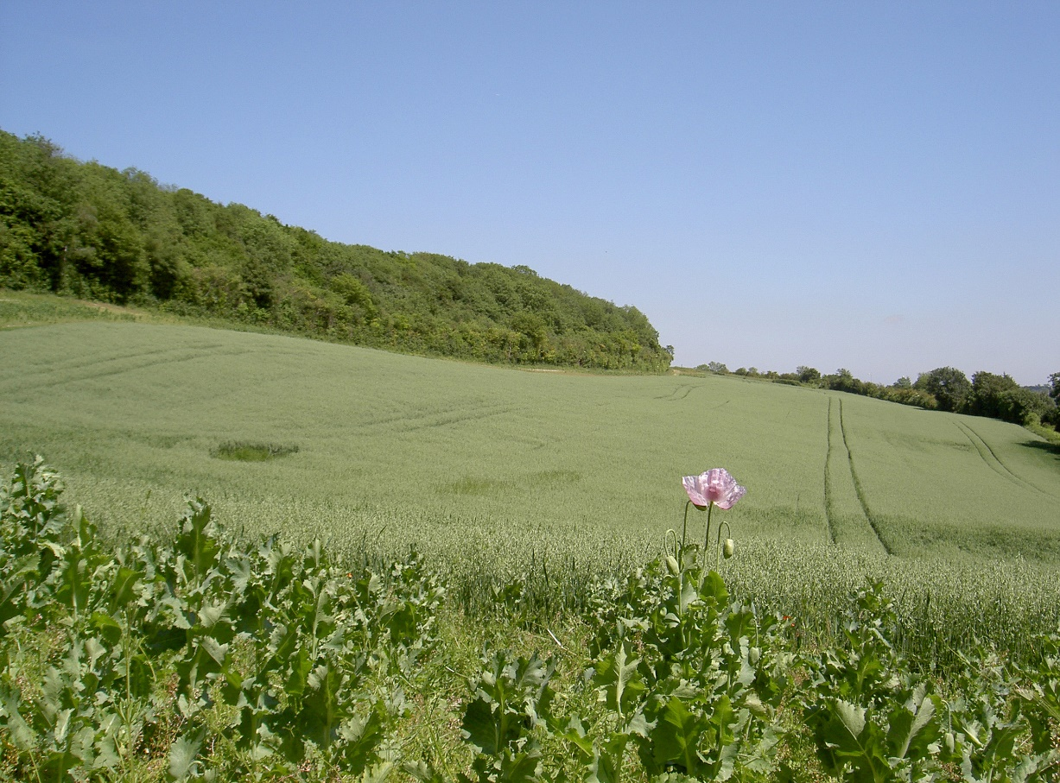
Ranscombe Farm Country Park, awarded Green Flag Status for the first time in 2020

Air Quality

Medway has declared four Air Quality Management Areas (Central Medway AQMA, High Street Rainham AQMA, Pier Road Gillingham AQMA and Four Elms Hill Chattenden AQMA), all for exceedances of the annual mean nitrogen dioxide objective. Medway Council has developed an Air Quality Action Plan (AQAP) (Medway Council, 2015), which includes measures to improve air quality in Medway. In January 2018, Medway Council developed the Air Quality Communications Strategy; this plan details a series of recommended communications activities and is designed to support the Medway AQAP by raising awareness and influencing behavioural change. Recent focus has been on working closely with schools in Medway through the KM Green School Awards to raise awareness of the sources, impacts and solutions to reducing air pollution.

Many challenges still lie ahead for Medway Council in terms of making a positive contribution to improving air quality. Road transport is the dominant source of pollution within Medway’s AQMAs, and reducing road traffic emissions is, therefore, the key air quality priority, especially with the AQMAs. Another significant challenge is accommodating the large demand for development in Medway. This is likely to put existing areas of poor air quality under additional pressure and could negate the actions that the Council is implementing to improve air quality. For this reason, continuing the implementation of the Medway Air Quality Planning Guidance is a high priority, prior to the adoption of a new Local Plan of Medway.

Medway Council’s priorities for the coming year are to continue with the work on the measures outlined in the AQAP, which will be strengthened by the r adopted Climate Change Action Plan.

The Council is currently developing an Air Quality Action Plan (AQAP) for the Four Elms Hill AQMA. The publishing of the AQAP has been delayed with the approval of Defra, to allow the Plan to be developed in conjunction with the draft Medway Local Plan, using the air quality outputs from the Strategic Transport Assessment. A statutory consultation on the draft AQAP will follow this technical work.

The latest Air Quality Annual Status Report (ASR) for 2020, which contains further information on monitoring results, trends and progress on the AQAP is available here:

https://www.medway.gov.uk/downloads/file/5577/air_quality_annual_status_report_2020

Ultra Low Emission Vehicle Licensing

The Department for Transport publishes statistics on the number of vehicles licensed every quarter. The following table shows the number of Ultra Low Emission Vehicles (ULEVs) licensed in Medway since 2016/17 compared with Kent, South East and the UK. In the past 5 years the number of ULEVs licensed in Medway has increased by 364%, which is a faster pace than Kent and the UK, but slower than the South East (382%).

Table: Number of ULEVs licenced

 | 2016/17 | 2017/18 | 2018/19 | 2019/20 | 2020/21 | % increase since 2016/17
Medway | 813 | 1,273 | 1,799 | 2,527 | 3,768 | 364%
Kent | 6,136 | 9,171 | 12,914 | 17,669 | 25,465 | 315%
South East | 71,337 | 106,768 | 156,294 | 212,052 | 343,511 | 382%
UK | 359,863 | 543,818 | 762,559 | 1,039,306 | 1,610,233 | 348%

Source: Vehicle Licensing statistics table veh0132
https://www.gov.uk/government/collections/vehicles-statistics#vehicle-licensing-statistics

Built Environment - Heritage at Risk

Historic England compiles an annual Heritage at Risk register which identifies Grade I and Grade II* Listed Buildings, Scheduled Monuments and Conservation Areas which are at risk from neglect:

https://historicengland.org.uk/advice/heritage-at-risk/

There are a number of conditions for each type of designation to be included onto the Register:

- Vacant Listed Buildings: In very bad, poor or fair condition

- Occupied Listed Buildings: In very bad or poor condition

- Scheduled Monuments: Depends on their condition, vulnerability, trend of their condition and their likely future vulnerability

- Conservation Areas: Those that are deteriorating or in very bad condition and are not expected to change significantly in the next 3 years.

Currently Medway has 15 entries on the Heritage at Risk register; including 7 Scheduled Monuments, 4 Listed Buildings and 4 Conservation Areas. This number of entries is significantly higher than most of the other Kent local authorities, with a number of the entries comprising more than one building or site per entry.

After a peak of 18 entries on the register in 2015, the number has gradually reduced through work with the owners to undertake repairs and improvements. Fort Amherst was removed from the 2020 Heritage at Risk Register following the successful completion of the ‘Command of the Heights’, a joint project between Medway Council and Fort Amherst Heritage Trust and funded by National Lottery Heritage Fund. The project has transformed areas of historic value including the Barrier Ditch in Chatham, a critical part of Chatham’s historic defences, and Spur Battery within Fort Amherst. More information about Command of the Heights is available here:

https://www.medway.gov.uk/info/200177/regeneration/464/greenspace_regeneration_projects/4

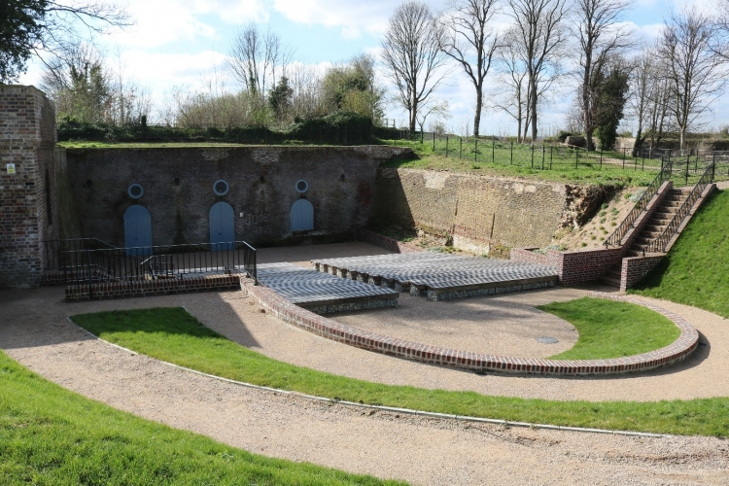
Spur battery amphitheatre within Fort Amherst

The National List of Buildings of Special Architectural or Historic Importance

The most recent national data available from Historic England indicates that Medway has still has 730 entries in the national list of buildings of special architectural or historic importance, but the composition has changed from last year to:

- 49 Grade I Listed Buildings
- 78 Grade II* Listed Buildings
- 524 Grade II Listed Buildings
- 77 Scheduled Monuments
- 2 Historic Parks and Gardens

The changes result from the successful Grade II Listing of a collection of Second World War anti-invasion defensive structures located to the south-east of Hoo St Werburgh which formed part of the ‘Hoo Stop Line’. More information about the Hoo Stop Line is available in the Historic England report:

https://research.historicengland.org.uk/Report.aspx?i=15241

Also benefitting from Grade II Listed status in 2020 was Chatham Ragged School. Constructed in 1858 it stands as a rare surviving example of a purpose-built ragged school which provided free education to the poorest children prior to the Education Act in 1870.

For more information on listings see:

https://historicengland.org.uk/listing/

Health and Communities

Life expectancy

Life expectancy represents the average number of years a person would expect to live based on contemporary mortality rates.

Lifestyle issues including smoking, obesity and alcohol are key contributors to high mortality rates resulting from the major killers in Medway, particularly, circulatory disease, cancer and respiratory disease. These are the focus of many public health campaigns in Medway.

The latest information available at Local Authority level covers the period 2017-2019. In Medway for this period, life expectancy has risen marginally. It is however consistently lower than the average age for England.

Table: Medway life expectancy (years)

 | 2013-15 | 2014-16 | 2015-17 | 2016-18 | 2017-19
Male | 78.4 | 78.4 | 78.8 | 79.0 | 79.1
Female | 82.0 | 82.2 | 82.5 | 82.6 | 82.6

https://fingertips.phe.org.uk/profile/health-profiles

Table: England life expectancy (years)

 | 2013-15 | 2014-16 | 2015-17 | 2016-18 | 2017-19
Male | 79.5 | 79.5 | 79.6 | 79.6 | 79.8
Female | 83.1 | 83.1 | 83.1 | 83.2 | 83.4

Public Health England
https://fingertips.phe.org.uk/search/life%20expectancy

Ward Data

The 2020 data shows that within Medway life expectancy for men and women has remained roughly the same since last year. There is however great variation in life expectancy at ward level – central parts of Medway around the town centres record the lowest life expectancy – most notably for men living in Chatham Central and River. For women, the lowest life expectancies are for those living in Chatham Central and Watling.

Table: Life expectancy at birth by Ward, Male and Female, 2016-2020

Ward | Male | Female
Chatham Central | 74.5 | 79.2
Cuxton and Halling | 84.8 | 84.8
Gillingham North | 76.1 | 80.3
Gillingham South | 76.0 | 80.8
Hempstead and Wigmore | 83.9 | 84.6
Lordswood and Capstone | 81.3 | 84.7
Luton and Wayfield | 76.5 | 82.4
Peninsula | 77.9 | 83.5
Princes Park | 79.5 | 83.2
Rainham Central | 81.7 | 87.9
Rainham North | 81.0 | 85.9
Rainham South | 81.2 | 83.5
River | 75.7 | 84.3
Rochester East | 77.8 | 83.8
Rochester South and Horsted | 78.8 | 80.8
Rochester West | 79.1 | 83.9
Strood North | 79.4 | 82.6
Strood Rural | 80.6 | 83.6
Strood South | 77.4 | 82.0
Twydall | 78.5 | 83.6
Walderslade | 80.6 | 83.9
Watling | 77.9 | 78.7
Medway | 78.7 | 82.6

Sources: NHS Digital Primary Care Mortality Database & ONS LSOA mid-year population estimates (2016-2020)

Produced by Natalie Goldring, Medway Public Health Intelligence Team, 2021-10-12

See glossary for ‘life expectancy’ definition.

Mortality

The death rate in Medway as measured by the Age-Standardised Mortality Ratio (ASMR – see glossary for definition) stands above the Kent, regional and national levels. Rates in all areas have all increased since last year.

In England and Wales the COVID-19 pandemic was the leading cause of deaths at 12.1%, followed by dementia and Alzheimer disease at 11.5%, then Ischaemic heart diseases at 9.2%.

Table: Age-Standardised mortality rates (per 100,000 population)

 | 2018 | 2019 | 2020
Medway | 1063.6 | 1,016 | 1,164.2
Kent | 956.7 | 911.4 | 1,028.3
South East | 880.9 | 845.8 | 940.9
England/Wales | 965.4 | 925.0 | 1,048.3

Table: Medway – Age-Standardised mortality rate by gender (per 100,000 population)

 | 2018 | 2019 | 2020
Male | 1,238.9 | 1,209.8 | 1,403.6
Female | 919.4 | 872.2 | 965.9

Source table 2a:
https://www.ons.gov.uk/peoplepopulationandcommunity/birthsdeathsandmarriages/deaths/bulletins/deathsregistrationsummarytables/2020

For more detailed information on health in Medway go to:
http://www.medwayjsna.info/

Hot food takeaway guidance

In order to promote a healthier Medway, in February 2014 Medway Council produced a Hot Food Takeaway Guidance Note for use in considering planning applications:

https://www.medway.gov.uk/downloads/file/2333/hot_food_takeaways_in_medway_-_a_guidance_note

The purpose of this guidance was to manage the potential proliferation of hot food takeaways, to help reduce obesity particularly among children, create a healthier environment, more vibrancy in town centres and to assist the creation of a more diverse offer in retail areas. The guidance supports a 400m buffer around schools to manage the siting of takeaways and the restriction on hours of operation. It is part of a wider package of measures to improve health.

Obesity and poor diet can lead to serious health issues for our local population. In 2019/20 71.6% of adults in Medway were overweight or obese, compared to an England average of 62.8%. The rates of overweight children in both reception (25.5%) and year 6 (36.9%) are higher than the England averages (23% and 35.2%, respectively). Medway Council has set out ambitions to improve the health and associated life chances of local people.

Table: Percentage classified as overweight or obese

 | 2015/16 | 2016/17 | 2017/18 | 2018/19 | 2019/20
Medway Reception  (age 4/5) | 21.8 | 22.6 | 23.4 | 24.0 | 25.5
South East Reception  (age 4/5) | 20.9 | 21.4 | 20.6 | 21.2 | 21.9
England Reception  (age 4/5) | 22.1 | 22.6 | 22.4 | 22.6 | 23.0
Medway Year 6  (age 10/11) | 33.8 | 35.5 | 34.0 | 36.2 | 36.9
South East Year 6  (age 10/11) | 30.8 | 30.6 | 30.8 | 30.3 | 31.7
England Year 6  (age 10/11) | 34.2 | 34.2 | 34.3 | 34.3 | 35.2
Medway Adult 18+ | 67.8 | 64.6 | 69.2 | 69.6 | 71.6
South East Adult 18+ | 59.7 | 59.7 | 60.3 | 60.9 | 61.5
England Adult 18+ | 61.3 | 61.3 | 62.0 | 62.3 | 62.8

Source: https://fingertips.phe.org.uk/profile/public-health-outcomes-framework
Section C Health improvement, Tables CO9a Reception: Prevalence of overweight (including obesity), CO9b Year 6: Prevalence of overweight (including obesity) and C16 Percentage of adults (ages 18+) classified as overweight or obese

The aim is to reduce the concentration and clustering of hot food takeaways in core retail areas/town centres and reduce the prevalence of takeaways to prevent proliferation. The proposals apply only to new hot food takeaways seeking planning permission.

Use of guidance:

The planning guidance note has been used in 3 applications during 2020/2021.

2 of the applications were refused and the third approved.

The following table shows the number of applications relating to hot food takeaways that were received during the year (3 applications):

Table: Application theme 2014/16 – 2020/21

 | New takeaway | Change of use | To extend hours | Other | Total number of applications
2016-17 | 0 | 8 (89%) | 1 (11%) | 0 | 9
2017-18 | 0 | 13 (81%) | 3 (19%) | 0 | 16
2018-19 | 1 (14%) | 4 (57%) | 2 (28%) | 0 | 7
2019-20 | 0 | 1 | 0 | 0 | 1
2020-21 | 0 | 3 | 0 | 0 | 3

Table: Application outcome – 2014/16/ - 2020/21

 | Approved | Approved with conditions | Refused | Total number of applications
2016-17 | 2 (33%) | 1 (17%) | 3 (50%) | 6
2017-18 | 10 (71%) | 1 (7%) | 3 (21%) | 14
2018-19 | 0 | 2 (28%) | 5 (71%) | 7
2019-20 | 0 | 0 | 1 | 1
2020-21 | 0 | 1 | 2 | 3

A Better Medway

This supports the local population to live a healthier lifestyle. Current programmes include:

- Get Active – health walks, cycling and cycling groups and Man vs Fat – a football league for men who have a body mass index (BMI) that is 27.5 or higher
- Quit smoking – services to assist and support this are provided
- Healthy Way - healthy way is a free programme that supports residents to adopt a healthier lifestyle through diet, stress management and behaviour change
- Healthy Mind – supporting mental health
- Healthy child – breastfeeding, school programmes, family cookery classes, early years
- Suicide prevention (Ask. Listen. Stop suicide)
- Alcohol and your health – substance misuse support
- NHS Health checks, sexual health, oral health
- Lose weight – courses are offered to help both adult eight loss and family weight management (Tri for you and FitFix)
- Healthy Workplace – this programme helps businesses of all sizes become healthier places to work
- access to sports centres offering swimming and a number of fitness classes.

Further details on the programmes, information and support are available at:
https://www.medway.gov.uk/homepage/48/a_better_medway

To read The Director of Public Health for Medway’s Annual Report 2019-20 ‘Healthy Minds, Healthy People’ click on the link below:

https://www.medway.gov.uk/downloads/download/417/public_health_reports

Health Deprivation

The Indices of Deprivation are a unique measure of relative deprivation at a small local area level (Lower-layer Super Output Areas) across England.

Medway ranks in the 38 % most deprived local authorities nationally for health. Seven areas rank in the most deprived 10% nationally for health and 20 rank in the most deprived 20% nationally.

Health deprivation is measured as the risk of premature death and the impairment of quality of life through poor physical or mental health.

There has been a relative worsening in health deprivation, with Medway seeing an extra four areas in the most deprived 10% nationally and an extra eight areas in the most deprived 20% nationally. While the most severely affected areas for health deprivation are spread across a number of wards in Gillingham, Chatham and Rochester, Gillingham North stands out as having two areas in the most deprived 10% for health, while River stands out as having the most deprived area for health in Medway. Medway’s most deprived area – located in River Ward overall for multiple deprivation is ranked in the most deprived 1% of neighbourhoods for health nationally.

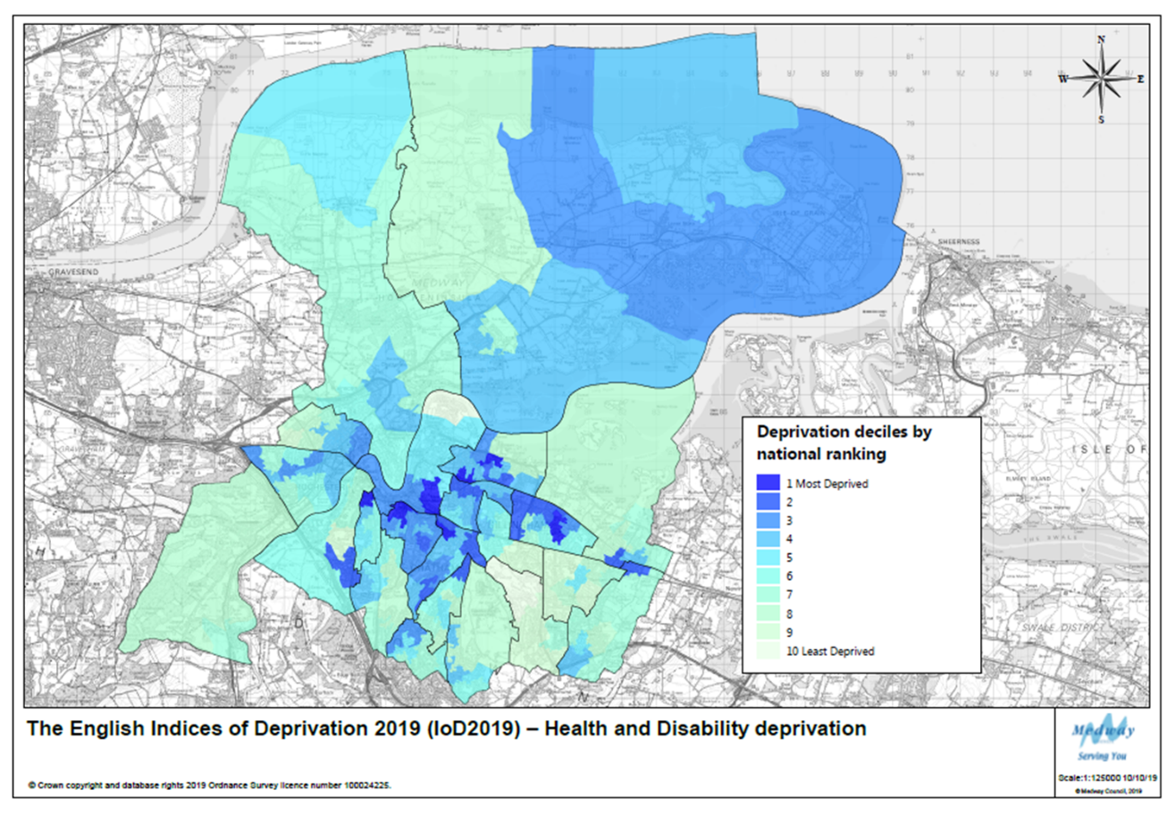

More information on the IoD can be found in the Population, Economy & Employment and Infrastructure (Education) sections of this report.

Infrastructure

Education

GCSE attainment scores

A new grading system was introduced in 2017; for further information see link below:

https://assets.publishing.service.gov.uk/government/uploads/system/uploads/attachment
_data/file/800507/GCSE_factsheet_for_parents__final_.pdf

A school's attainment 8 score is the average of all of its students' scores. Students do not have to take 8 subjects, but they score zero for any unfilled slots. For comparison the England and Medway scores are set out below. Both England and Medway have improved over the 3 years, with Medway performing slightly above the England average.

Table: Average attainment score 8 per pupil

 | 2017 | 2018 | 2019 | 2020
Medway | 45.7 | 46 | 46.6 | *
England | 44.6 | 44.5 | 44.7 | *

* Due to the impact of the COVID-19 pandemic, most exams and assessments did not take place in 2019/20. As a result of this, the government announced that it would not publish school or college level results data in Autumn 2020.

Source:
https://www.compare-school-performance.service.gov.uk/schools-by-type?step=default&table=schools&region=887&la-name=medway&geographic=la&for=secondary&basedon=Attainment%208&show=All%20pupils

Planning Applications for Schools

On 31/3/2021 construction was well underway to build a brand new secondary school (The Leigh Academy) in Rainham with access from Otterham Quay Lane, together with associated car parking and drop-off area, pedestrian access, drainage, landscaping, sports pitches and areas for formal and informal outdoor play. It opened for the first cohort of year 7 children in September 2021.

During the year a number of schools have submitted and had approved planning applications to improve and upgrade their buildings and facilities, these are set out in the table below.

As well as these schools listed, a number of others have ongoing schemes and have had amended plans and details approved to existing schemes. They include:

- St Andrews School, 28 Watts Avenue, Rochester
- Abbey Court School, Cliffe Road, Strood, Rochester
- Rochester Grammar School for Girls
- Sir Joseph Williams Mathematical School, Maidstone Road, Rochester
- Brompton Academy, Marlborough Road, Gillingham

Application Number | Address | Works/Description
MC/19/3159 | Chatham Grammar School for Girls | Construction of a two-storey teaching block providing seven classrooms with associated WC’s, storage, circulation and offices together with alterations to the existing car parking areas and the provision of a new parking area (demolition of three existing teaching blocks)
MC/19/3288 | Hoo St Werburgh Primary School And Marlborough Centre Pottery Road Hoo St Werburgh Rochester | Construction of an extension to front with associated alterations to existing parking layout (removal of existing canopy)
MC/19/0493  superseded by:  MC/20/2838 | Rochester Riverside | Reserved matters application for the construction of a 2 storey 1- form entry primary school and nursery school with 2- form entry core facilities together with a multi-use games area and sports facilities; temporary landscaping; transport infrastructure and access roads – superseded by:  Reserved matters application for the construction of a 2 storey, 2-form entry primary and nursery school building, together with a multi-use games area and sports facilities; hard and soft landscaping including temporary landscaping; and transport infrastructure and access roads.
MC/20/0484 | The Howard School Derwent Way Rainham | Demolition of two teaching blocks and construction of a two storey teaching block together with landscaping and other ancillary works
MC/20/1336 | Hempstead Junior School, Birch Grove, Hempstead | Engineering works to raise land levels to facilitate a proposed multi use games area with fencing
MC/20/1253 | Greenacre Academy, 157 Walderslade Road, Walderslade | Construction of a single storey extension to provide an additional two classrooms with associated WC's
MC/20/1522 | The Thomas Aveling School, Arethusa Road, Rochester | Erection of a canopy over the existing hard surfaced sports court
MC/20/1774 | The Hundred of Hoo Academy, Main Road, Hoo St Werburgh | Construction of a two storey classroom block located in-place of an existing single-storey modular classroom building to provide additional teaching classrooms for special educational needs
MC/20/2356  superseded by  MC/21/0292 | The Robert Napier School Third Avenue Gillingham | Removal and replacement of existing kitchen extraction unit
MC/21/0096 | Bradfields School, Churchill Avenue, Wayfield, Chatham | Construction of a detached building for use as a new two classroom teaching block
MC/21/0220 | Rainham Mark Grammar School, Pump Lane Rainham | Continued siting of a mobile unit for a temporary period of up to 3 years

Education, Skills and Training Deprivation

The Indices of Deprivation are a unique measure of relative deprivation at a small local area level (Lower-layer Super Output Areas) across England.

Medway ranks in the 22% most deprived local authorities nationally for education, this is Medway’s second weakest theme after crime. Eighteen areas rank in the most deprived 10% nationally for education and forty-two rank in the most deprived 20% nationally.

Wards most severely affected by education deprivation are Luton & Wayfield, Strood South, Chatham Central, Gillingham North and Twydall.

Luton & Wayfield stands out as having five areas ranked in the most deprived 10% nationally, while Chatham Central contains the most educationally deprived area (LSOA 022B), which ranks in the 1% most deprived areas nationally.

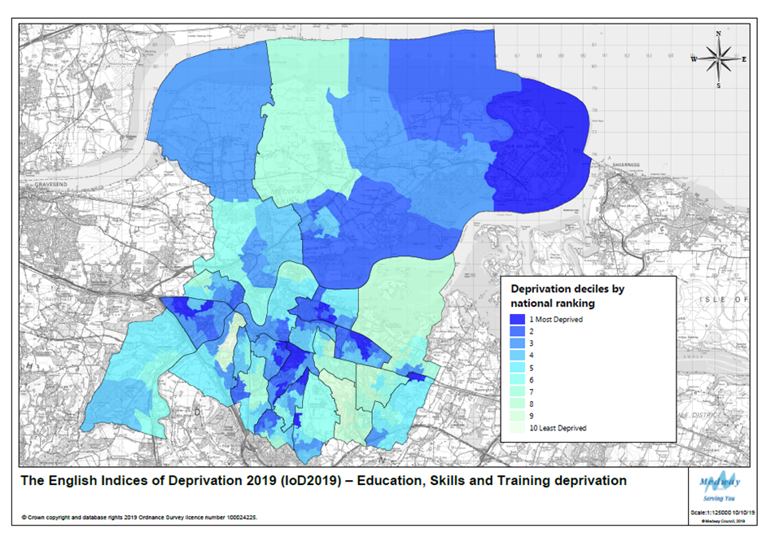

More information on the IoD can be found in the Population, Economy & Employment and Health & Communities sections of this report.

Infrastructure

Developer Contributions

The government requires all local authorities to publish an Infrastructure Funding Statement (IFS) on an annual basis. This covers information on developer contributions/obligations relating to Section 106 agreements.
The IFS will be published by end December 2021

- All developer contributions received 01/04/2020 – 31/03/2021
- All expenditure of developer contributions during 01/04/2020 – 31/03/2021
- Information on Affordable Housing provision
- Information on future infrastructure provision

The IFS will be published on the Medway Council website Planning Policy pages:

https://www.medway.gov.uk/info/200149/planning_policy/597/local_development_scheme_and_monitoring/5

Transport

As a transport authority, Medway Council is responsible for the local highway network, public rights of way and other transport related infrastructure. This includes 840 km of adopted highway and 293 km of public rights of way, plus the Medway Tunnel.

Local Transport Plan

Medway’s third Local Transport Plan (LTP) provides the transport strategy for the period 2011 to 2026. The LTP contains five priorities, with key actions for the Council and partners under each priority:

1. Regeneration, economic competitiveness and growth
2. The natural environment
3. Connectivity
4. Equality of opportunity
5. Safety, security and public health

More information can be found here:

https://www.medway.gov.uk/info/200161/travel/545/transport_plans_and_policies/2

External Funding

As outlined within the Development and Regeneration section, Medway has successfully secured funding for various local schemes. Updates on the some of the key transport projects are set out below:

Housing Infrastructure Fund - £170m secured from Homes England to invest in highways improvement and increased capacity at Four Elms, and access to/from the Hoo Peninsula and the introduction of passenger rail services to Hoo. There has been a programme of consultation on the proposed projects, and ongoing project development work.

Medway City Estate connectivity improvement measures
This project will deliver an integrated package of infrastructure measures aimed at addressing the existing barriers to movement to, from and within the Medway City Estate. Interventions already successfully implemented under Phase 1 of the project include the provision of new traffic signals on the westbound entrance to Medway Tunnel. The traffic signals are operational and testing has identified the most effective manual operation of the signals to offer the most benefit to users of Medway City Estate while minimising disruption to the remainder of the road network.

Consultation was carried out with businesses and employees on the Estate to inform the development of Phase 2 of the project. £1.7 million was secured from the government’s Local Growth Fund (LGF), through the South East Local Enterprise Partnership (SELEP), to create a new slip road to bypass the roundabout from Medway City Estate onto Berwick Way. The improvement works aim to help traffic leave the estate more easily during peak times.

Strood town centre journey time and accessibility enhancements
The Strood town centre project has continued to deliver journey time and accessibility enhancements to the town centre including changes to the road layout to improve traffic flow and installation of new crossing points to enhance pedestrian safety. Further improvements are being made to pedestrian routes and road surfacing. The final stages of the project will see the installation of feature lighting and the completion of landscaping to make the town greener. The installation of energy efficient LED street lights will also continue. The project is due for completion in 2021.

Medway Tunnel – nearly £5m secured from the Department for Transport to replace and upgrade critical assets relating to the Medway Tunnel. These include new ventilation fans, crash barriers, a vehicle monitoring system and slip road improvements over the next five years. These works will be carried out over the next 5 years.

Medway Cycling Action Plan
The delivery of a package of measures, to improve access to cycling in Medway (as outlined in the Medway Cycling Action Plan document), was completed by March 2019. A total of 13.8km of new cycle routes have been introduced. In addition, a further 2.8km of existing cycle routes have been improved as part of the delivery of the plan. Cycle parking counters have been installed on all completed cycle routes. Funding has been secured for a new cycle rail hub in Chatham.

Estimated traffic flows for cars and all vehicle types

Table: Car Traffic – Million miles

 | *2016 | *2017 | *2018 | 2019 | 2020 | % change 2019–2020
Medway | 741 | 747 | 743 | 751 | 598 | -20%
Kent | 7,353 | 7,423 | 7,461 | 7,507 | 5,710 | -24%
South East | 44,934 | 45,361 | 45,168 | 45,571 | 33,732 | -26%
England | 226,805 | 231,496 | 234,388 | 239,780 | 181,219 | -24%
*Estimates for the period since 2010 have been revised to take into account the minor road benchmarking exercise so will therefore be different to the figures published in previous AMRs. Further details available at:
https://www.gov.uk/government/publications/road-traffic-statistics-minor-road-benchmarking

After last year when both the car traffic figure and the motor vehicle traffic figure in Medway had risen to the highest levels since records began in 1993, they then fell to the lowest levels for the past 20 years due to the effects of the lockdown restrictions during the COVID-19 pandemic. This is broadly consistent on a regional and national level.

Motor Vehicle Traffic – Million miles

 | *2016 | *2017 | *2018 | 2019 | 2020 | % change 2019-20
Medway | 933 | 943 | 938 | 951 | 788 | -17%
Kent | 9,635 | 9,730 | 9,827 | 9,883 | 7,866 | -20%
South East | 56,657 | 57,185 | 57,152 | 57,666 | 44,712 | -23%
England | 290,270 | 296,338 | 300,138 | 306,524 | 242,051 | -21%
*Estimates for the period since 2010 have been revised to take into account the minor road benchmarking exercise so will therefore be different to the figures published in previous AMRs. Further details available at:
https://www.gov.uk/government/publications/road-traffic-statistics-minor-road-benchmarking

This is a measure of the level of usage of roads in Medway, rather than a reflection of vehicle ownership amongst Medway residents.

Source: DfT transport statistics
Traffic (www.gov.uk/government/organisations/department-for-transport/series/road-traffic-statistics)
Tables TRA8901 & TRA8902

Passenger journeys on local bus services

In 2019/20 7.9 million bus passenger journeys were made in Medway, a fall of 4% in bus usage over the past year. Kent, South East and England all saw falls on the previous year due to the COVID-19 pandemic lockdown restrictions of a similar amount (England even higher at 6%).

Table: Passenger journeys on local bus services - millions

 | 2015/16 | 2016/17 | 2017/18 | 2018/19 | 2019/20 | % change 2018/19 - 2019/20
Medway | 8.8 | 8.7 | 8.2 | 8.2 | 7.9 | -4%
Kent | 56 | 56.7 | 55 | 53.3 | 51.4 | -4%
South East | 353.2 | 355.1 | 348.6 | 347.3 | 332.4 | -4%
England | 4,510.9 | 4,440.5 | 4,348.4 | 4,307.2 | 4,069.5 | -6%

Source: DfT transport statistics
https://www.gov.uk/government/collections/bus-statistics
Table BUS0109a

Bus Service Improvement Plan

The Department for Transport (DfT) published its National Bus Strategy in March 2021. The strategy changes the regulatory framework under which buses have operated for the past 35 years and will be supported by £3 billion of investment across England, along with a commitment to repurpose current funding. The main objective of the strategy is to provide passengers with more frequent, more reliable, easier to use, better coordinated and cheaper bus services. This new approach acknowledges the role the bus can play in achieving a net zero emission society and serves as a commitment to supporting bus and bus rapid transit schemes.

The National Bus Strategy expects all Local Transport Authorities (LTAs) to set up an Enhanced Partnership (EP). An EP is a statutory arrangement under the 2017 Bus Services Act whereby the LTA and local bus operators work together to improve local bus services. It needs to include a clear vision of the improvements that the EP is aiming for and actions to achieve them.

By the end of October 2021, Government expects all LTAs to publish a local Bus Service Improvement Plan (BSIP). This must set out how LTAs will use their EP to deliver an ambitious vision for bus travel, meeting the overarching goal of the National Bus Strategy to grow back patronage after the pandemic and then to increase it and raise the mode share of the bus.

The BSIP covers the whole of the Medway Council area, for which there will be a single Enhanced Partnership. This excludes services covered by the English National Concessionary Travel Scheme, even where these may be registered in the Medway area.

You can find out more about Medway’s Bus Service Improvement Plan here:

https://www.medway.gov.uk/bsip

Railway Stations

Medway has seven train stations within the borough.

Cuxton and Halling are on the Medway Valley line that runs between Strood and Tonbridge and connections at Strood station provide for onward journeys to London or east Kent.

Rainham, Gillingham, Chatham, Rochester and Strood are served by the north Kent line, with links to London. These are the busiest trains and take the bulk of passengers during the early morning and evening rush hours to and from the capital.

Table: Passenger usage per annum - millions

Station | 2015-16 | 2016-17 | *2017-18 | 2018-19 | 2019-20 | % change 2018/19 - 2019/20
Chatham | 2.77 | 2.74 | 2.73 | 2.73 | 2.62 | -4.1%
Cuxton | 0.04 | 0.04 | 0.05 | 0.06 | 0.06 | -2.3%
Gillingham | 2.63 | 2.73 | 2.74 | 2.75 | 2.52 | -8.4%
Halling | 0.06 | 0.07 | 0.09 | 0.1 | 0.09 | -2.7%
Rainham | 1.78 | 1.82 | 1.82 | 1.93 | 1.87 | -3.3%
Rochester | 1.39 | 1.63 | 1.82 | 2.06 | 2.12 | +3.2%
Strood | 1.2 | 1.13 | 1.07 | 1.19 | 1.16 | -2.9%
*figures were revised by Office of Rail and Road in March 2020

Since the 2015-16 data was published Rochester Station has been relocated. There has been a noticeable increase in user numbers each year since then; with the completion of a further 243 dwellings at Rochester Riverside an increase in user numbers of over 52% since the station moved in 2015-16 has been seen.

In recent years a marked increase in use of Halling and Cuxton stations may be linked to new development at St Andrews Park and Peters Village, as well as the high speed train service.

However, this year, all but Rochester station saw a reduction on the previous year’s station usage due to the COVID-19 pandemic lockdown restrictions.

Source:
https://dataportal.orr.gov.uk/statistics/usage/estimates-of-station-usage/
Station usage 2019/20 data

Minerals, Waste and Energy

Minerals

Information on Minerals in Medway can be found in the Local Aggregate Assessment set out at the end of Volume 2. It reports on the extraction of sand and gravel locally, sales of recycled and secondary aggregate, and the importation of marine won aggregates and crushed rock. The full report is available at:

https://www.medway.gov.uk/downloads/download/24/authority_monitoring_report

Waste

As a Waste Planning Authority, Medway has a responsibility to ensure that the need for waste management facilities is considered alongside other spatial planning concerns, recognising the positive contribution that waste management can bring to the development of sustainable communities.

Medway currently benefits from a range of waste management facilities that assist in the delivery of sustainable development. Some facilities have seen significant decreases in volumes of materials processed over the last year. The following information on Medway’s waste management is taken from the Environment Agency Waste Data Interrogators:

Table: Waste received (tonnes)

 | 2017 | 2018 | 2019 | 2020
Hazardous | 25,873.97 | 25,598.97 | 30,060 | 27,889
Household, Industrial and Commercial | 523,579.03 | 629,289.50 | 477,645 | 486,904
Construction, Demolition and Excavation | 109,934.10 | 125,973.45 | 298,745 | 271,527
Total | 659,387.10 | 780,861.92 | 806,450 | 786,320

Table: Waste removed (tonnes)

 | 2017 | 2018 | 2019 | 2020
Hazardous | 16,921.58 | 18,745.55 | 19,185 | 14,660
Household, Industrial and Commercial | 589,191.99 | 598,172.53 | 474,032 | 453,709
Construction, Demolition and Excavation | 19,474.47 | 22,070.99 | 40,364 | 14,098
Total | 625,588.04 | 638,989.07 | 533,581 | 482,467

Source: https://data.gov.uk/dataset/bb40d091-a346-4b75-aa54-df7d347bed93/2020-waste-data-interrogator

Energy

Energy Performance
A quarterly series of official statistics is published by the Ministry of Housing, Communities and Local Government, presenting information about certificates on the energy efficiency of domestic and non-domestic buildings in England and Wales that have been constructed, sold, or let since 2008, and of larger public authority buildings recorded since 2008.

Energy Performance Certificates (EPCs)
Two types of EPCs are issued on the completion of new dwellings – Energy Efficiency (based on fuel costs) and Environmental Impact (based on CO2 Emissions). An EPC gives a property an energy efficiency rating from A (most efficient) to G (least efficient) and is valid for 10 years.

New dwellings - Energy Efficiency (based on fuel costs)
Since 2016/17 the majority of dwellings (84.4% in 2020/21) have been constructed to a B energy efficiency rating (based on fuel costs). This is consistent with the rest of England, although England’s overall percentage of B ratings is lower (81.3%). Medway’s C rating increased this year, although D and E ratings fell. For the third year in a row there were no F or G rated dwellings completed (compared to England’s 0.2 and 0.1% respectively).

Table: % Medway Number of lodgements by energy efficiency rating (based on fuel costs)

Year | A% | B% | C% | D% | E% | F% | G%
2016/17 | 0.8 | 84.2 | 10.5 | 3.0 | 0.9 | 0.5 | 0.2
2017/18 | 0.0 | 90.2 | 4.8 | 2.5 | 0.5 | 0.1 | 0.0
2018/19 | 0.0 | 90.2 | 5.5 | 3.8 | 0.3 | 0.0 | 0.0
2019/20 | 0.2 | 89.6 | 6.2 | 3.6 | 1.4 | 0.0 | 0.0
2020/21 | 0.1 | 84.4 | 12.6 | 2.7 | 0.2 | 0.0 | 0.0
England  2020/21 | 1.5 | 81.3 | 11.4 | 4.5 | 1.1 | 0.2 | 0.1

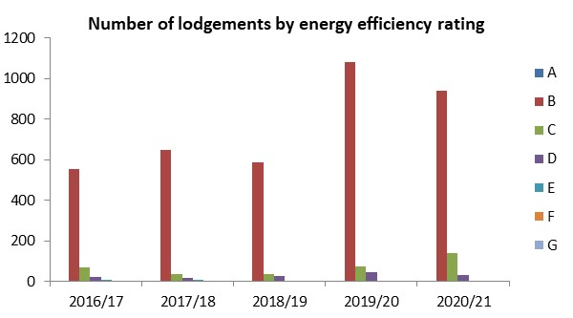

New Dwellings - Environmental Impact (based on CO2 Emissions)
Similar to the energy efficiency rating based on fuel costs, the majority of new homes have been constructed to a B rating. This year 2020/21 saw the second highest percentage of A ratings delivered in Medway in the last 5 years. Although the percentage of C rated homes rose from last year, this was the first year that no new homes were constructed to an E rating in Medway; all were rating D or above. No G ratings have been built in Medway since records began in 2008. Compared to England, Medway has broadly produced similar building environmental impact ratings, with most new dwellings reporting ratings A, B and C.

Table: Medway New Dwellings - Environmental Impact (based on CO2 Emissions)

Year | A% | B% | C% | D% | E% | F% | G%
2016/17 | 0.9 | 80.6 | 14.4 | 2.9 | 1.1 | 0.2 | 0.0
2017/18 | 0.8 | 91.9 | 4.0 | 2.4 | 0.7 | 0.1 | 0.0
2018/19 | 0.6 | 91.0 | 5.8 | 2.3 | 0.3 | 0.0 | 0.0
2019/20 | 8.0 | 85.5 | 4.1 | 2.2 | 0.2 | 0.0 | 0.0
2020/21 | 4.1 | 87.3 | 5.8 | 2.8 | 0.0 | 0.0 | 0.0
England 2020/21 | 13.3 | 74.7 | 7.1 | 4.0 | 0.7 | 0.2 | 0.1

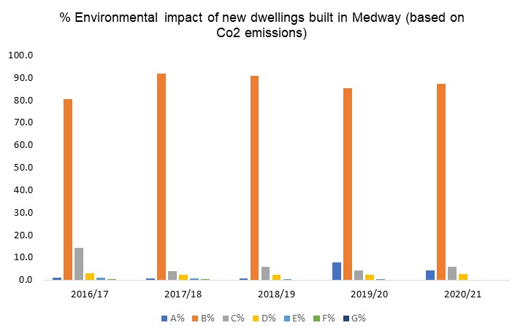
Source:
Tables NB1 and NB2
https://www.gov.uk/government/statistical-data-sets/live-tables-on-energy-performance-of-buildings-certificates

Glossary

Affordable Housing - Social rented, affordable rented and intermediate housing, provided to eligible households whose needs are not met by the market. Eligibility is determined with regard to local incomes and local house prices. Affordable housing should include provisions to remain at an affordable price for future eligible households or for the subsidy to be recycled for alternative affordable housing provision.

Age-Standardised mortality rates – (ASMRs) are used to allow for comparisons to be made between populations that may contain different overall population sizes and proportions of people of different ages. They allow for differences in the age structure of populations and therefore allow valid comparisons to be made between geographic areas, over time and between sexes. It is a statistical measure to allow more precise comparisons between two or more populations by eliminating the effects in age structure by using a "standard population". The higher the number, the higher the mortality rate.

Biodiversity - The whole variety of life encompassing all genetics, species and ecosystem variations, including plans and animals.

Change of Use - A change in the way that land or buildings are used (see Use Classes Order). Depending on the specifics of any proposed change of use, including any building work associated with the proposal, an application for planning permission or prior approval may be required.

Commitments (or committed development) - All land with current planning permission or allocated in adopted development plans for development (particularly residential development).

Community Infrastructure Levy (CIL) - is a system of securing developer contributions from planning permissions which local authorities are empowered but not required to charge on new development in their area. The levy is to be used to support growth.

Duty to cooperate - was introduced in the Localism Act 2011 and amends the Planning and Compulsory Purchase Act 2004. It places a legal duty on local planning authorities, county councils in England and public bodies to engage constructively, actively and on an ongoing basis to maximise the effectiveness of Local and Marine Plan preparation relating to strategic cross boundary matters.

Economic activity - A person is economically active if they are either employed or unemployed i.e. in work or looking for work. A person is economically inactive if they are either not seeking work or are unavailable to start work. This includes people who are looking after a family and people who are on long term sick leave.

Employment Land Availability (ELA) - The total amount of land reserved for industrial and business use awaiting development.

Employment rate - The number of people in employment in the UK is measured by the Labour Force Survey (LFS) and consists of people aged 16 and over who did paid work (as an employee or self-employed), those who had a job that they were temporarily away from, those on government-supported training and employment programmes, and those doing unpaid family work.

English indices of deprivation - identify the most deprived areas across the country. The indices combine a number of indicators, chosen to cover a range of economic, social and housing issues, into a single deprivation score for each small area in England. The indices are used widely to analyse patterns of deprivation, identify areas that would benefit from special initiatives or programmes and as a tool to determine eligibility for specific funding streams.

Greenfield Land or Site - Land (or a defined site) usually farmland, that has not previously been developed.

Life expectancy - at birth is chosen as the preferred summary measure of all cause mortality as it quantifies the differences between areas in units (years of life) that are more readily understood and meaningful to the audience than those of other measures. All cause mortality is a fundamental and probably the oldest measure of the health status of a population. It represents the cumulative effect of the prevalence of risk factors, prevalence and severity of disease, and the effectiveness of interventions and treatment. Differences in levels of all-cause mortality reflect health inequalities between different population groups, e.g. between genders, social classes and ethnic groups.

Localism Act 2011 - introduced in November 2011. The aim of the act was to devolve more decision-making powers from central government back into the hands of individuals, communities and councils.

Outline application - A general application for planning permission to establish that a development is acceptable in principle, subject to subsequent approval of detailed matters. Does not apply to changes of use.

Mixed Use - Developments or proposals comprising more than one land use type on a single site.

National Planning Policy Framework – first published in 2012, revised in 2018, updated in 2019 and then again in 2021, it sets out the government’s planning policies for England.

Neighbourhood Plans - A plan prepared by a Parish Council or Neighbourhood Forum for a particular neighbourhood area (made under the Planning and Compulsory Purchase Act 2004, as amended).

Planning Permission - Formal approval sought from a local planning authority allowing a proposed development to proceed. Permission may be sought in principle through outline planning applications or be sought in detail through full planning applications.

Previously Developed Land or 'Brownfield' land - Land which is or was occupied by a permanent structure, including the curtilage of the developed land (although it should not be assumed that the whole of the curtilage should be developed) and any associated fixed surface infrastructure. This excludes: land that is or was last occupied by agricultural or forestry buildings; land that has been developed for minerals extraction or waste disposal by landfill, where provision for restoration has been made through development management procedures; land in built-up areas such as residential gardens, parks, recreation grounds and allotments; and land that was previously developed but where the remains of the permanent structure or fixed surface structure have blended into the landscape.

PROW – Public Rights of Way

Renewable and Low Carbon Energy - Includes energy for heating and cooling as well as generating electricity. Renewable energy covers those energy flows that occur naturally and repeatedly in the environment – from the wind, the fall of water, the movement of the oceans, from the sun and also from biomass and deep geothermal heat. Low carbon technologies are those that can help reduce emissions (compared to conventional use of fossil fuels).

S106 - A Section 106 is a legal agreement between an applicant seeking planning permission and the local planning authority, which is used to mitigate the impact of a new home on the local community and infrastructure.

Self-Build and Custom Housebuilding - Self-build is generally where the owner is directly involved with/manages the design and construction of their new home, whereas custom housebuilding means the owner commissions the construction of their home from a developer/builder/contractor/package company who builds the property to the owner’s specifications. With custom build the occupants do not usually carry out any of the physical construction work but still make key design decisions.

Site of Special Scientific Interest (SSSI) - A site designated by Natural England under the Wildlife and Countryside Act 1981 as an area of special interest by reason of any of its flora, fauna, geological or physiographical features (plants, animals and natural features relating to the Earth's structure).

Super Output Areas (SOAs) - a geography designed for the collection and publication of small area statistics. They are used on the Neighbourhood Statistics site and across National Statistics. Lower Super Output Areas (LSOAs) which are used as the unit to present data on deprivation, were originally built using 2001 Census data from groups of Output Areas and contain on average 1,500 residents.

Supplementary planning document (SPD) - provides additional information on planning policies in a development plan.

Strategic Land Availability Assessment (SLAA) - assesses the suitability, availability and deliverability of sites to meet a requirement for residential, employment, retail and other uses.

Sustainable drainage systems (SUDS) - surface water drainage systems which consider quantity, quality and amenity issues.

ULEV – Ultra Low Emission Vehicle – emits extremely low levels of motor vehicle emissions compared to other vehicles.

Use Class - classes of land and building use as categorised by the Town and Country Planning (Use Classes) Order 1987 as amended.

Current use classes
On 1st September 2020, the following use classes were updated to replace those which had gone before:

Class B
- B2 General industrial - Use for industrial process other than one falling within class E(g) (previously class B1) (excluding incineration purposes, chemical treatment or landfill or hazardous waste)
- B8 Storage or distribution - This class includes open air storage.

Class C
- C1 Hotels - Hotels, boarding and guest houses where no significant element of care is provided (excludes hostels)
- C2 Residential institutions - Residential care homes, hospitals, nursing homes, boarding schools, residential colleges and training centres
- C2A Secure Residential Institution - Use for a provision of secure residential accommodation, including use as a prison, young offenders institution, detention centre, secure training centre, custody centre, short term holding centre, secure hospital, secure local authority accommodation or use as a military barracks
- C3 Dwellinghouses - This class is formed of three parts
  - C3(a) covers use by a single person or a family (a couple whether married or not, a person related to one another with members of the family of one of the couple to be treated as members of the family of the other), an employer and certain domestic employees (such as an au pair, nanny, nurse, governess, servant, chauffeur, gardener, secretary and personal assistant), a carer and the person receiving the care and a foster parent and foster child
  - C3(b) covers up to six people living together as a single household and receiving care e.g. supported housing schemes such as those for people with learning disabilities or mental health problems
  - C3(c) allows for groups of people (up to six) living together as a single household. This allows for those groupings that do not fall within the C4 HMO definition, but which fell within the previous C3 use class, to be provided for i.e. a small religious community may fall into this section as could a homeowner who is living with a lodger
- C4 Houses in multiple occupation - Small shared houses occupied by between three and six unrelated individuals, as their only or main residence, who share basic amenities such as a kitchen or bathroom.

Class E - Commercial, Business and Service
In 11 parts, Class E more broadly covers uses previously defined in the revoked Classes A1/2/3, B1, D1(a-b) and ‘indoor sport’ from D2(e):
- E(a) Display or retail sale of goods, other than hot food
- E(b) Sale of food and drink for consumption (mostly) on the premises
- E(c) Provision of:
  - E(c)(i) Financial services,
  - E(c)(ii) Professional services (other than health or medical services), or
  - E(c)(iii) Other appropriate services in a commercial, business or service locality
- E(d) Indoor sport, recreation or fitness (not involving motorised vehicles or firearms or use as a swimming pool or skating rink,)
- E(e) Provision of medical or health services (except the use of premises attached to the residence of the consultant or practitioner)
- E(f) Creche, day nursery or day centre (not including a residential use)
- E(g) Uses which can be carried out in a residential area without detriment to its amenity:
  - E(g)(i) Offices to carry out any operational or administrative functions,
  - E(g)(ii) Research and development of products or processes
  - E(g)(iii) Industrial processes

Class F - Local Community and Learning
In two main parts, Class F covers uses previously defined in the revoked classes D1, ‘outdoor sport’, ‘swimming pools’ and ‘skating rinks’ from D2(e), as well as newly defined local community uses.
- F1 Learning and non-residential institutions – Use (not including residential use) defined in 7 parts:
  - F1(a) Provision of education
  - F1(b) Display of works of art (otherwise than for sale or hire)
  - F1(c) Museums
  - F1(d) Public libraries or public reading rooms
  - F1(e) Public halls or exhibition halls
  - F1(f) Public worship or religious instruction (or in connection with such use)
  - F1(g) Law courts
- F2 Local community – Use as defined in 4 parts:
  - F2(a) Shops (mostly) selling essential goods, including food, where the shop’s premises do not exceed 280 square metres and there is no other such facility within 1000 metres
  - F2(b) Halls or meeting places for the principal use of the local community
  - F2(c) Areas or places for outdoor sport or recreation (not involving motorised vehicles or firearms)
  - F2(d) Indoor or outdoor swimming pools or skating rinks

Sui Generis
'Sui generis' is a Latin term that, in this context, means ‘in a class of its own’.
Certain uses are specifically defined and excluded from classification by legislation, and therefore become ‘sui generis’. These are:
- theatres
- amusement arcades/centres or funfairs
- launderettes
- fuel stations
- hiring, selling and/or displaying motor vehicles
- taxi businesses
- scrap yards, or a yard for the storage/distribution of minerals and/or the breaking of motor vehicles
- ‘Alkali work’ (any work registerable under the Alkali, etc. Works Regulation Act 1906 (as amended))
- hostels (providing no significant element of care)
- waste disposal installations for the incineration, chemical treatment or landfill of hazardous waste
- retail warehouse clubs
- nightclubs
- casinos
- betting offices/shops
- pay day loan shops
- public houses, wine bars, or drinking establishments – from 1 September 2020, previously Class A4
- drinking establishments with expanded food provision – from 1 September 2020, previously Class A4
- hot food takeaways (for the sale of hot food where consumption of that food is mostly undertaken off the premises) – from 1 September 2020, previously Class A5
- venues for live music performance – newly defined as ‘Sui Generis’ use from 1 September 2020
- cinemas – from 1 September 2020, previously Class D2(a)
- concert halls – from 1 September 2020, previously Class D2(b)
- bingo halls – from 1 September 2020, previously Class D2(c)
- dance halls – from 1 September 2020, previously Class D2(d)
Other uses become ‘sui generis’ where they fall outside the defined limits of any other use class.
For example, C4 (Houses in multiple occupation) is limited to houses with no more than six residents. Therefore, houses in multiple occupation with more than six residents become a ‘sui generis’ use.
Revoked Use Classes
Class A was revoked from 1 September 2020. Class A 1/2/3 were effectively replaced with Use Class E(a,b,c). A4/5 uses were not covered by Use Class E and became defined as ‘Sui Generis’
- A1 Shops - Shops, retail warehouses, hairdressers, undertakers, travel and ticket agencies, post offices, pet shops, sandwich bars, showrooms, domestic hire shops, dry cleaners, funeral directors and internet cafes
- A2 Financial and professional services - Financial services such as banks and building societies, professional services (other than health and medical services) and including estate and employment agencies. It does not include betting offices or pay day loan shops - these are now classed as “sui generis” uses (see below)
- A3 Restaurants and cafés - For the sale of food and drink for consumption on the premises - restaurants, snack bars and cafes
- A4 Drinking establishments - Public houses, wine bars or other drinking establishments (but not night clubs) including drinking establishments with expanded food provision
- A5 Hot food takeaways - For the sale of hot food for consumption off the premises.
B1 Business was revoked from 1 September 2020. It is effectively replaced with the new Class E(g).
- B1 Business – Uses which can be carried out in a residential area without detriment to its amenity. This class was formed of three parts:
  - B1(a) Offices - Other than a use within Class A2 (see above)
  - B1(b) Research and development of products or processes
  - B1(c) Industrial processes
Use Classes B2 and B8 remain valid (see 'Current Use Classes' above).
Use Classes B3 (revoked in 1992), and B4 to B7 (revoked in 1995) were used to call out specific industrial uses'
Class D was revoked from 1 September 2020. D1 was split out and replaced by the new Classes E(e-f) and F1. D2 was split out and replaced by the new Classes E(d) and F2(c-d) as well as several newly defined ‘Sui Generis’ uses.
- D1 Non-residential institutions - Clinics, health centres, crèches, day nurseries, day centres, schools, art galleries (other than for sale or hire), museums, libraries, halls, places of worship, church halls, law court. Non-residential education and training centres
- D2 Assembly and leisure - Cinemas, music and concert halls, bingo and dance halls (but not night clubs), swimming baths, skating rinks, gymnasiums or area for indoor or outdoor sports and recreations (except for motor sports, or where firearms are used).

Windfall Site - Sites not specifically identified in the development plan (definition from revised National Planning Policy Framework 24 July 2018.

Target = 22 pitches (GTAA years 2017-22) + 2 pitches from unknown need over plan period GTAA
Lower Output Area 015E

