Medway Council Annual Infrastructure Funding Statement

For Section 106

Reporting Period:
From 01 April 2020 to 31 March 2021

Introduction

  - This Medway Infrastructure Funding Statement reports on the financial year 2020/2021. It provides information on developer contributions to services and infrastructure. It is published in line with government requirements.
  - The timely and effective delivery of infrastructure and enhanced services is critical to sustainable growth. This is recognised in planning legislation and developers are required to address the resulting impacts of housing and commercial schemes on local services and infrastructure. As part of ongoing reforms of the Planning system, the government has introduced some changes to legislation covering developer contributions. Councils are now required to report on developer contributions in a consistent manner, through the publication of an Infrastructure Funding Statement (IFS). All local authorities that receive developer contributions whether through S106, Community Infrastructure Levy or other contribution must prepare an IFS. Government intends that reporting on developer contributions will help local communities and developers see how contributions have been spent and understand what future funds will be spent on, ensuring a transparent and accountable system. This statement must set out:
    - A report relating to the previous financial year (2020-2021) on section 106 planning obligations.
    - A report on the infrastructure projects or types of infrastructure that the authority intends to fund wholly or partly by the contributions.

  - This involves publishing:
    - details of all S106 contributions received;
    - details of all S106 expenditure; and
    - proposals for future infrastructure provision to be funded by S106 contributions.

Developer Contributions Policy

  - Local planning authorities should set out their policy on local standards, including infrastructure contributions and requirements for affordable housing in the Local Plan. Medway Council uses Section 106 agreements to secure contributions to infrastructure and services, in line with the requirements of the Medway Guide to Developer Contributions and Obligations, 20181. This guide is a Supplementary Planning Document to the Medway Local Plan, 2003. The

1 Available at: https://www.medway.gov.uk/downloads/file/2341/guide_to_developer_contributions_and_obligations_ consultation_document

Council collects contributions to a range of services, including Education, Affordable Housing, Waste, Greenspaces, Leisure and Transport. It also collects contributions for the Clinical Commissioning Group that it allocates to primary care health services.
  - The criteria for the use of developer contributions associated with new development are defined in planning policy. All S106 agreements should satisfy the following tests:
    - it must be necessary to make the proposed development acceptable in planning terms,
    - it is directly related to the proposed development,
    - it is fairly and reasonably related in scale and kind to the proposed development.

  - Section 106 of the Town & Country Planning Act 1990 provides that anyone with an interest in land may enter into a planning obligation, which is enforceable by a local planning authority. An obligation may be created by agreement or by the party with an interest in the land making a unilateral undertaking. Obligations may:

    - Restrict the development or use of land
    - Require operations to be carried out in, on, under or over the land
    - Require the land to be used in any specified way; or
    - Require payments to be made to the local planning authority, either in a single sum or periodically.

  - On 1 September 2019 updated CIL Regulations were introduced which included the deletion of the pooling restriction. The pooling restriction meant that only five contributions for each infrastructure project could be requested from April 2010. As the restriction has been removed it enables services and the NHS to request S106 funding for a single project as often as appropriate to support the required infrastructure/project. However, as this is a recent change, the impact is yet to feed through in terms of the S106 spending identified in this report (although it has impacted on S106 funds agreed and received).

  - It is important to note that data on developer contributions is not definitive. This report represents estimates at a given point in time, and can be subject to change, for example, development may not come forward as originally planned, or agreements may be revised. Diagram 1 shows the contribution process and gives an example of triggers which may be used for the collection of contributions. The figures in the IFS represent the most robust data currently available.

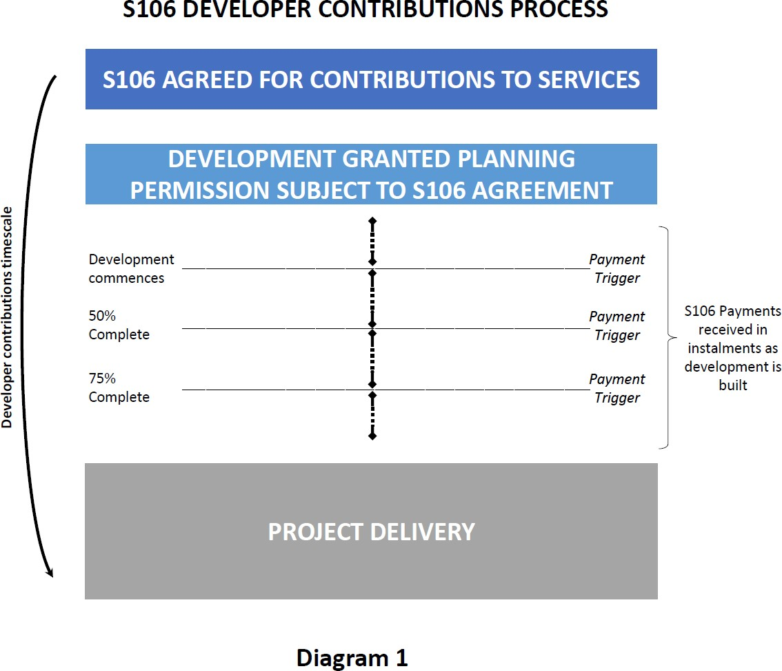

Strategic priorities

  - Medway Council is a forward-looking authority that supports regeneration and sustainable growth. The Council has identified lack of infrastructure capacity as a significant constraint to growth and has worked on securing resources to upgrade key services and infrastructure to support sustainable growth. This statement reflects the development and service needs set out in corporate plans and strategies and evidence base documents for the new Medway Local Plan. These provide a framework for the delivery of the Council’s infrastructure priorities.

  - Government guidance states that the IFS should set out future spending priorities on infrastructure and affordable housing in line with up-to-date or emerging plan policies. The report should form a written narrative describing how developer contributions will be used to deliver relevant strategic policies in the plan as well as future spending priorities on infrastructure and affordable housing in line with up-to-date or emerging plan policies. This will not dictate how funds must be spent but will set out the local authority’s intentions.

  - As part of its work on the new local plan, the Council has produced an Infrastructure Delivery Plan (IDP) that sets out how services and infrastructure will be shaped to achieve the vision for Medway’s growth over the plan period.

The IDP considers the capacity of existing infrastructure and what upgrades are needed to deliver sustainable development. The Infrastructure Delivery Plan and the Viability Assessment will provide an updated evidence base to support the Council’s policy. The Medway Developer Contributions and Obligations Guide was revised and adopted in May 2018, with updates to charges made in April 2021. Further updates are anticipated in line with the local plan examination.

  - It should be noted that services may also refer to government policies which apply to their specific requirements, for example ‘Securing developer contributions for education’ November 2019 published by the Department of Education. This publication refers to borrowing against future S106 receipts.

  - The capital programme is the mechanism to set out future spending on required infrastructure to support development, which may require borrowing against future S106 receipts to ensure the timely delivery of essential infrastructure, as referenced in the paragraph above

Content of Infrastructure Funding Statement

  - This statement firstly provides an overview of developer contributions in 2020/21, and considers three aspects of the process:

- S106 funds spent and remaining in 2020/21: considers contributions which have been spent in the year, including spending of any contributions that may have been agreed and received in previous years.
- S106 funds received from developers in 2020/21: funds received from developers, typically as a result of homes being built and/or occupied, some of which may have already been spent, and some of which remains unspent.
- S106 funds agreed with developers in 2020/21: the majority of which will not yet have been received as development is just beginning or has not yet started. In practice, funding is received as development is built out, and therefore the funds received only reflect a snapshot of what development has taken place in the year, with further funds to be received in future.

  - This report further considers the future spending priorities for infrastructure for Medway Council and partners. This makes reference to the proposed spatial strategy for the new Medway Local Plan and its supporting evidence base.

  - Full data on all S106 contributions relating to the financial year 2020/21 is published in Appendix 1. Please note that the COVID-19 pandemic has had a serious impact on the delivery of developments in 2020 – 2021, which in turn has significantly reduced the level of contributions received.

  - The IFS also reports on bird mitigation to the Strategic Access Management and Monitoring (SAMMS) under Habitat Regulations. The mechanism for the collection of SAMMS payments may be via S106 agreements for major

developments, or through Unilateral Undertakings. For developments which only require SAMMS contributions a SAMMS mitigation contribution agreement form can be utilised. Please refer to our website for further information and clarity. The overall project is known as Birdwise.

Review of infrastructure delivery 2020/21

  - The headline figures for 2020/2021 are:
    - S106 contributions received from developers (this includes SAMMS contributions and monitoring costs): £2,520,435.44
    - SAMMS contributions received via the SAMMS agreement forms : £79,659.68
    - S106 contributions spent : £1,163,501.87 which includes £32,160.84 spent by a 3rd party on behalf of Medway Council
    - S106 contributions remaining unspent : £12,073,640.54 (this figure includes
£295,533.57 which is retained for long term maintenance)
    - S106 contributions included in S106 agreements completed in 2020/21 :
£8,149,796.58.
  - A detailed breakdown is set out at Appendix 1. It should be noted that the COVID-19 pandemic has had a significant effect on the ability of some services to deliver infrastructure projects. Many members of staff were re- assigned duties in vaccine centres and to meet other emergency situations; others were unable to progress existing projects due to having to work from home rather than be out on site. The same constraints on 3rd parties resulted in many projects not progressing for a considerable time.

Funding spent on services and infrastructure in 2020/21
  - The total amount of money from planning obligations spent during the reported year £1,163,501.87. S106 funding was used to develop a range of services in Medway to address the impacts of growth. These included investment in schools; waste management and education; transport schemes; parks, including Great Lines Heritage Park (GLHP) play areas and environmental projects; youth facilities; community facilities; town centre improvements; river wall repairs; and training and workforce development. A full breakdown is set out in Appendix 1 to this report.

  - Funds spent may form part of a wider multi-year spending package, and therefore funds spent is only an annual snapshot of larger infrastructure projects which can take a number of years to deliver. Funds which have not yet to be spent are restricted to the purpose specified in the relevant S106 agreement.

  - Affordable Housing: 144 units were agreed under planning obligations entered into in 2020/2021. 216 units were delivered with 171 of these forming part of S106 obligations directly, with the remainder delivered via other means. Affordable housing delivery included:
    - 58 units provided by Hyde Housing at Rochester Riverside
    - 37 units provided by Optivo at Berengrave Lane, Rainham
    - 18 units provided by Moat at Beaulieu Park, Rainham

    - 67 units provided by MHS Homes at several different sites
    - 36 further units delivered by other providers at various sites
  - Education: Spending on education was a major area of investment for S106 contributions. Key S106 spends on expanding and improving schools included:
    - £37,157.62 for phase 2 expansion at Riverside Primary School
    - £449,068 for expansion of Thomas Aveling school
    - £21,869.69 for improvements at St Marys Island Primary School, St Nicholas Primary School and Greenvale Primary School

  - Spending on other projects included

    - £104,371 for Strood North ward play improvements
    - £49,012 for Rochester Riverside river wall maintenance
    - £28,416 for Chatham Town Centre improvements
    - £93,206 for enhancements to Horsted Valley
    - £250,000 for the Birdwise project under Habitat Regulations (this breaks down as £209,065.76 from S106 agreements and £40,934.24 from SAMMS forms)
  - A number of Section 106 agreements were also signed in 2020/21 which specified non-financial covenant requirements, i.e. where developers provide public benefits and services directly, in-kind, rather than contributing funds for them. These may include the developer providing land or play equipment, setting up a car club, or the provision of travel vouchers.

S106 funding received in 2020/21
  - The total amount of money received from planning obligations during the reported year was £2,520,435.44. Contributions were collected in line with the Council’s policy set out in the Developer Contributions SPD. The chart below illustrates the contributions received by the main infrastructure categories.

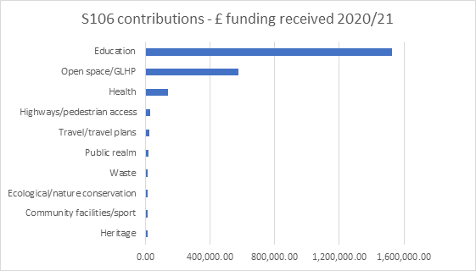

  - A number of services received a relatively low level of contribution during 2020/2021 which prevents the total sums being clearly identified in the chart above. These include libraries, public health and youth services.

S106 funds agreed in 2020/21
  - The total amount of money to be provided under any planning obligations which were entered during the reported year is £8,149,796.55.
  - The chart below shows the contributions agreed for the main areas of infrastructure and services.

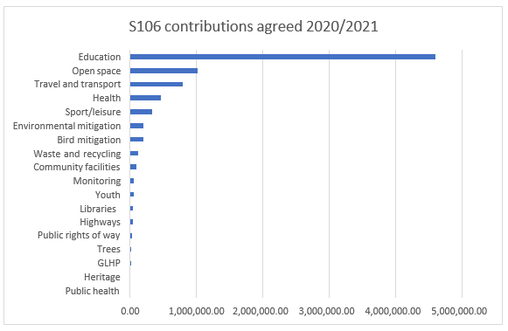

  - The total amount of funding received prior to 1 April 2020 that has not yet been allocated is £7,695,138.89. All contributions must be spent in accordance with the related agreement; the word ‘allocated’ means that the project has been included in the Capital Programme or approved with a third party, for example a Parish Council or the NHS as appropriate.

Future infrastructure spending priorities

  - This section of the report sets out future spending priorities on infrastructure in Medway. It outlines where funding has been agreed through S106 agreements, but not yet spent on those items. It also considers the key infrastructure interventions that will be needed to deliver Medway’s planned growth, in line with the new Local Plan. The IFS makes use of service plans and strategies, the emerging evidence base for the Local Plan and consultation feedback from service providers, local communities, and statutory consultees to map out important aspects of infrastructure planning in coming years. An Infrastructure Delivery Plan (IDP) has been published in preparation for the draft Local Plan, using information collated for the Local Plan evidence base. This provides an indication of future infrastructure priorities to deliver sustainable growth in Medway.

Projected income from S106

  - The Council uses information on existing S106 agreements to estimate projected income for investing in new and improved services. However, it should be noted that this information is subject to change, as it is linked to development that has not yet taken place. Although an agreement is

completed, it is not a guarantee that the obligations will be delivered; where the approved development is not implemented no obligations would be delivered. The sum of agreements signed represents income that is dependent on the relevant development being delivered as planned, including where payments are triggered part way through delivery, and therefore projects to be funded through developer contributions are not agreed before there is reasonable certainty as to the receipt and timing of payments due.
There are a wide range of organisations, both public and private, involved in delivering infrastructure in Medway, including the development sector. As such, the level of information available about future spending allocations and plans varies.

  - The level and timing of S106 funding for infrastructure priorities will depend on which developments come forward in Medway, and there is some uncertainty in the short and medium term surrounding the development market, making longer term forecasting of S106 receipts challenging. Similarly, the level of future receipts from development will also depend on the updated infrastructure policies in the new Local Plan.

  - This report is informed by organisational service plans and strategies, the Council’s Corporate Plan and Capital Strategy, and the growth ambitions set out in Medway 2035 regeneration strategy and the forthcoming Local Plan. The spatial strategy for Medway in coming years continues to deliver on the success of the area’s urban regeneration, as promoted in Medway 2035 and the town centre masterplans approved in 2019. The £170m Housing Infrastructure Fund is investing in transport and environmental projects that facilitate growth on the Hoo Peninsula. The Council introduced proposals for how development of a rural town focused around Hoo St Werburgh may come forward in the Hoo Development Framework. This identified the need for a range of new and enhanced services and infrastructure to meet the functions of a town. This will include new and expanded schools, community and leisure facilities, open spaces, transport services, health facilities, waste and energy services. The Council has been gathering information from service providers to identify the types, timing and level of new infrastructure needed to provide for increased population on the Hoo Peninsula, as well as wider Medway. It has also engaged with potential developers to provide early indications of the Council’s expectations for infrastructure delivery. This includes clear requirements for critical infrastructure to be in place before further housing is built on the Hoo Peninsula.

  - Work on the Local Plan evidence base, particularly the IDP and Strategic Transport Assessment, show that the delivery of infrastructure is critical to the success of Medway’s growth. Technical assessments of the transport network have identified a number of priority areas, such as the strategic links around

the Medway Tunnel and key junctions where investment is needed to increase the capacity to meet growth needs from new development. Details of the mitigations needed have been costed and are included in the IDP, which will form the evidence base for the updated policy on developer contributions..
Thedraft plan and supporting evidence base and updated policy will provide an effective means of securing the necessary and timely delivery of infrastructure in Medway’s planned growth.
  - The Medway Local Plan and supporting evidence base will inform and set out the updated contributions expected from development. This policy update will include the levels and types of affordable housing required, as well as other infrastructure, such as education, transport and open space. The Council has commissioned a Viability Assessment of the emerging draft local plan, to test the potential impact of proposed policies, and the ability to deliver the preferred spatial strategy. This is to ensure that the plan is deliverable, that policies are realistic, and that the total cumulative cost of all relevant policies will not undermine deliverability of the plan. This evidence will inform the updated policy on developer contributions. It recognises the variation in development values and costs across Medway, with the brownfield regeneration sites often having higher build costs than greenfield sites. The updated evidence base will provide clear policy on the requirements for developer contributions, and should reduce the need for such variation of S106 agreements on individual sites, as is currently the case.
Headline planned spending
  - Contributions to services and infrastructure upgrades have been specified in S106 agreements entered into in 2020/21 and previous years, but have not yet been collected, allocated or spent, due to the stage in the development and service planning process as illustrated in diagram 1 above. These agreements have been negotiated in line with the Council’s current policy as set out in the Guide to Developer Contributions and Obligations SPD.
  - Anticipated spending from these S106 agreements, and information on service and infrastructure planning includes the following areas:
Affordable Housing
  - This is delivered in accordance with the Council’s policy. Monitoring information indicates the delivery of over 500 new affordable homes in the next couple of years, which includes use of developer contributions. New sites include at the Britton Farm redevelopment in Gillingham town centre and delivered across Medway as part of larger developments, such as at Rochester Riverside, Otterham Quay Lane, Bakersfield and Berengrave nursery in Rainham and South of Stoke Road in Hoo, at north of Peninsula Way in Chattenden. Updated policy for affordable housing will be set out in the new Local Plan, taking account of recent and upcoming changes in planning legislation and guidance, including First Homes.

Education
  - Central government provides funding for schools, but developers need to contribute towards the additional extra places required due to new housing. S106 is used with wider capital spending to expand schools in Medway. Where appropriate, developer contributions will be sought from new housing schemes to assist with the provision of school places in areas of demographic growth, in line with Planning Practice Guidance2. Developments resulting from the Local Plan will be considered cumulatively to identify the most suitable and wider use of developer contributions or developer provided schools to provide the most benefit.
  - In the next year funding will support the expansion of one primary school and five secondary schools, providing an additional 210 primary school places and around 400 secondary places. In the short to medium term, Medway will require additional secondary places to meet expected demand, and in the medium to longer term more secondary and primary school places, particularly in areas of extensive new builds such as the Hoo Peninsula. It is expected, based upon current phasing plans that 24 form of entry will be required over the period of the Local Plan, with initial costs estimated at around £100m to deliver that provision.

Health

  - S106 funding has been secured towards improvements in health facilities across Medway, including the Healthy Living Centres in Rochester and Rainham, and services in Hoo, Lordswood and St Mary’s Medical Centre. The Covid-19 pandemic and changes in the organisation of health services has had some impact on the process of agreeing future priorities for health infrastructure in Medway. However joint planning continues, including in preparing the IDP supporting the new Local Plan, and detailed planning for growth on the Hoo Peninsula. It is noted that there is significant pressure on primary care services in Medway, particularly access to GP services, and that this is a key area for infrastructure investments.

  - As of April 2020, Kent and Medway Clinical Commissioning Group has the responsibility for commissioning the majority of health services in Medway; Public Health (Medway Council) is also responsible for commissioning a range of services. The impact on the Covid-19 pandemic on health infrastructure and services has been significant, and as a result, longer term planning has been affected. Details on the new Kent and Medway CCG’s future plan will be included in the IDP for the Medway Local Plan.

2 https://www.gov.uk/guidance/planning-obligations

Transport

  - S106 funding is to be used to improve the transport network, together with major investment secured by the Council, including the Housing Infrastructure Fund and from other government programmes. There is significant pressure on the highways network and wider transport services. Medway’s future growth is critically linked to a functioning transport network. This will be a priority area for infrastructure investment, as it represents one of the greatest constraints to development. The Strategic Transport Assessment prepared for the Local Plan has identified some critical areas, including the highways network around the Medway Tunnel, and key junctions such as M2 Junction 3. The assessment is also considering the potential impact of the proposed Lower Thames Crossing on Medway. Work has been commissioned to prepare a Local Impact Report to present Medway’s representations to the examination of the Development Consent Order for the Lower Thames Crossing. Details on road mitigation measures to address strategic growth in Medway will be determined through the Strategic Transport Assessment being produced as part of the Medway Local Plan and will inform policy and developer contributions. Medway Council supports the use and increased patronage of sustainable forms of transport and will require improvements to bus services alongside developments coming forward, including on the Hoo Peninsula. Further work is being progressed through a Hoo Peninsula Area Wide Travel Plan. The Council is also working with Kent County Council in bringing forward plans and securing investment for improvements to Blue Bell Hill and the key links into the motorway network and Medway and Maidstone.

Open space and leisure
  - 2021-22 improvements include priority play refurbishment at 7 sites across Medway. Developer contributions have improved play sites in Cliffe Woods and Chatham in FY21-22. Also improvements are moving forward at Town Hall Gardens, Rede Common, Northcote Recreation Ground, Berengrave Nature Reserve, Great Lines Heritage Park and Cherry Trees with developer contributions. Investment in our 8 Green Flag Award winning parks continues as part of the management plans for the 8 sites. Funding will be used for public realm improvements in Chatham town centre. Sports facilities at Splashes will be enhanced. The development of a new sports centre on the Hoo Peninsula is viewed by Medway Council as integral to its vision for a sustainable rural town. Future priorities will be informed by evidence base studies such as the Medway Playing Pitch Strategy action plan, and Medway Sports Facility Strategy and action plan. New open space provision for new development will need to meet the requirements set out in the Medway Local Plan.
Community facilities

  - S106 funding has been earmarked for new village community facilities on the Hoo Peninsula. The Council has also secured further external investment to improve heritage, cultural and community facilities in Medway. A new cultural strategy will provide the basis for planning further investments in arts and community infrastructure. Neighbourhood plans in Medway will also help to identify community infrastructure priorities in future. Draft neighbourhood plans for Arches (Chatham), Cliffe and Cliffe Woods, and High Halstow have been published for consultation in 2021.
Flood and water management

  - £4.5m has been secured through S106 for upgrades to the river wall at Rochester Riverside, and further investment has been made in flood defence works at Strood. Future plans will follow the Environment Agency’s Medway Estuary and Swale Strategy (MEASS). Medway has been identified by the Environment Agency as an area with a significant risk of surface water flooding. Furthermore, climate change could lead to new weather patterns which increase this risk, as well as the risk of water shortages going forwards. As such, Medway Council is committed to ensuring that development has only positive impact on flood risk management in the area and will seek appropriate mitigations and measures.

  - The Medway Surface Water Management Plan will provide more detail including design options for a number of potential approaches, including Sustainable Drainage Systems (SuDs) to addressing surface water management in key areas of Medway.
Green infrastructure

  - Medway’s green and blue corridors are priority areas to improve biodiversity and strengthening of connectivity through habitat improvements. Further policy will be set out in the new Local Plan, together with details on how the Biodiversity Net Gain requirement will be met by developers. Neighbourhood plans in Medway will also help to identify green infrastructure priorities in future, such as through identifying Local Green Space designations. The Council will also continue to collect funding for the Birdwise programme that operates across north Kent to mitigate the risk of recreational disturbance to the protected wildlife of the estuary and marshes arising from new development. Other forms of green infrastructure development and enhancement include tree and other new planting, sustainable urban drainage schemes which function as both green infrastructure and flood and water management systems.

Digital infrastructure

  - Digital infrastructure includes a wide variety of aspects from communications to SMART technology. Telecommunications in particular are intrinsic to how we now live and work, particularly in the context of recent changes to working patterns as a result of the Covid-19 pandemic. Access to good broadband and telephone services are essential for business, learning and communities, and provision of high speed broadband services is a key component of a successful economy. The council seeks to establish Medway as a well- connected smart city that offers a competitive base for businesses and excellent telecommunications services for residents.

  - There are still issues within the provision of the broadband across Medway. Future developments will be expected to provide their own infrastructure connections to the network as part of a policy requirement set out in the Local Plan.

Other Infrastructure

  - The Council is seeking to strengthen the local economy through a wider strategy that has secured external funding. This includes bidding for investment for Chatham town centre through the government’s Future High Street Fund, and the Levelling Up Fund. This is supporting business growth, community and cultural activities. The Docking Station project in Chatham Historic Dockyard will set up a creative and cultural industries hub in Medway. A learning, skills and employment hub will be set up in Gillingham town centre, as part of the redevelopment at Britton Farm. The Council is also planning for a new municipal waste depot.

APPENDIX 1

Medway Council Annual Infrastructure Funding Statement

For Section 106

Reporting Period:
From 01 April 2020 to 31 March 2021

Section 106 Matters
Community Infrastructure Levy Regulations (2019 Amendment) Regulation 121A Schedule 2 Section 3
    - The total amount of money to be provided under any planning obligations which were entered during the reported year is £8,149,796.55. This figure does not consider indexation (inflation/deflation) that may be applied when the money becomes due.

    - The total amount of money received from planning obligations during the reported year was £2,520,435.44. In addition, £79,659.68 was received in SAMMS contributions via the SAMMS agreement form.

    - The total amount of money received prior to the reported year that has not been allocated is £7,695,138.89.

    - During the reported year the following non-monetary contributions have been agreed under planning obligations:

      - The total number of affordable housing units to be provided is 144.
Summary details of all non-monetary contributions agreed within the reported year are as follows:

Covenant Type/Service | MHCLG Type | Deed Signed | Planning Application
Viability  assessment/Planning S106 | Other | 06/08/2020 | MC/19/0886
Open space: play space facilities inc LEAP, NEAP/Open Space, Play Space and Formal Sports | Open Space and Leisure | 13/08/2020 | MC/18/1796
Conservation/Conservation | Other | 07/10/2020 | MC/19/2709
Demolition/Planning S106 | Other | 16/12/2020 | MC/20/1973
Method Statement/Planning S106 | Other | 16/12/2020 | MC/20/1973
Restoration works/Planning S106 | No Mapping Set | 16/12/2020 | MC/20/1973
Restrictive Covenants | Other | 16/12/2020 | MC/20/1973
Open space provision/Open Space, Play Space and Formal Sports | Open Space and Leisure | 14/12/2020 | MC/19/2898
Restrictive Covenants/ | Other | 18/01/2021 | MC/18/1595
Notices/S106 Monitoring | Other | 18/01/2021 | MC/18/1595
Travel: bus service provision/Travel | Transport and Travel | 24/02/2021 | MC/19/0287
Allotments/Open Space, Play Space and Formal Sports | Open Space and Leisure | 24/02/2021 | MC/19/0287
Notices/S106 Monitoring | Other | 24/02/2021 | MC/19/0287
Open space provision/Open Space, Play Space and Formal Sports | Open Space and Leisure | 24/02/2021 | MC/19/0287

    - The total amount of money from planning obligations allocated towards infrastructure during the reported year was £1,438,831.85. Of this amount
£657,035.03 was not spent during the reported year.

    - The total amount of money from planning obligations spent during the reported year was £1,163,501.87. Of this amount £32,160.84 was spent by a third party on behalf of Medway Council.

    - The following items have had money allocated towards them during the reported year with unspent allocations:

Infrastructure | Allocated | Date Allocated | Unspent
Berengrave open space project development | £115,619.83 | 30 November 2020 | £110,546.50
St Mary's Island Primary and  Nursery provision | £299,432.76 | 13 October 2020 | £299,432.76
Star Mill Lane/Ash Tree Lane/A2 junction pedestrian accessibility | £90,099.69 | 01 October 2020 | £90,099.69
Bus service extension | £19,686.27 | 06 August 2020 | £19,686.27
Chatham Station public realm improvement | £19,956.45 | 23 March 2021 | £19,956.45
Greenvale School improvements | £108,599.36 | 01 April 2020 to 10  March 2021 | £108,599.36
Thomas Aveling Secondary School | £8,714.00 | 31 March 2021 | £8,714.00

    - In relation to money which was spent by Medway Council during the reported year:
    - The items of infrastructure that planning obligation money has been spent on and the amount spent are as follows:

Infrastructure | Spent | Date Spent | Spend Description
Darland Banks Nature Conservation Reserve  maintenance | £2,218.00 | 27 November  2020 | *Includes Third Party spending
Berengrave open space project development | £5,073.33 | 31 March 2020 to  31 March 2021 | Ecological surveys regarding wildlife habitats to help inform any new access routes Boardwalk/access feasibility pre application planning advice
Strood North play improvements | £104,371.41 | 31 March 2021 | Play area improvements
Rochester Riverside river wall maintenance 2019/20 | £49,012.00 | 31 March 2020 to  31 March 2021 | River wall maintenance
Rochester Riverside Controlled Parking Zone | £3,241.00 | 31 March 2020 to  31 March 2021 | CPZ  implementation
Transport Study Pear Tree Lane | £452.08 | 31 March 2020 to  31 March 2021 | Speed limit review work
Riverside Primary phase 2 | £37,157.62 | 31 March 2019 to  31 March 2021 | contribution to phase 2 expansion
Bells Lane accessibility | £2,300.61 | 19 February 2015  to 31 March 2021
Highways Bush Road/Station Road/A228 | £28,679.95 | 15 December  2015 to 31 March  2021 | Anti-skid surface renewal
Pedestrian accessibility Kent Road/Station Approach Road | £16,683.62 | 31 March 2019 to  31 March 2021
Star Mill Lane/Ash Tree Lane/A2 junction pedestrian accessibility | £3,417.40 | 31 March 2021
Chatham Town Centre improvements | £28,416.38 | 31 March 2020 to  31 March 2021 | Town Centre Warden and Town Centre support
Horsted gyratory scheme including approach | £10,440.39 | 25 March 2013 to  31 March 2021

Infrastructure | Spent | Date Spent | Spend Description
A2/Mierscourt Road highway improvements | £9,910.14 | 31 March 2021
Horsted Valley Enhancements | £93,206.52 | 10 April 2017 to 31  March 2021 | Horsted Valley enhancements
Public realm improvements - street lighting | £4,393.22 | 23 March 2013 to  31 March 2021
Downland Walk play area | £982.20 | 31 March 2020 to  31 March 2021 | Play area improvements
Jacksons Field and Victoria Gardens | £157.13 | 21 April 2016 to 31  March 2021 | Play equipment improvements
Cliffe Road play area at Goddington Road | £3,367.68 | 22 March 2018 to  31 March 2021 | Improvement of play facilities
Darland Banks Nature Conservation Reserve capital works | £28,000.00 | 06 November  2020 | *Includes Third Party spending
St Mary's Island Primary | £15,851.34 | 31 March 2021 | Improvements at St Mary’s Island Primary
Dockside Chatham Town Centre projects | £4,000.83 | 30 April 2019 to 29  October 2021 | Christmas Tree 2020 including modular lights; Remembrance Day wreath 2020; Hopes and Dream project
Training and Workforce | £35,553.00 | 05 February 2021 | Medway Enterprise  Coordinator
Youth sport Barnfield Rec | £3,856.50 | 05 May 2020 to 18  September 2020 | Sports equipment Outdoor lights
Greenvale School improvements | £3,687.00 | 31 March 2021
St Nicholas Infant to Primary Expansion | £2,331.35 | 31 March 2021
Strood Community Hub public use computers | £889.36 | 31 March 2021 | Public use ICT equipment
Liberty Park public realm | £1,000.00 | 14 September  2020

Infrastructure | Spent | Date Spent | Spend Description
Birdwise 2020/21 | £209,065.76 plus  £40,934.24 from SAMMS  agreements, recorded separately | 09 October 2020  to 09 March 2021 | SPA mitigation measures
Thomas Aveling Secondary School | £449,068.49 | 31 March 2021 | Thomas Aveling bulge year
Tree replacement near Elmsleigh | £1,942.84 | 22 August 2020 | Two replacement trees *Includes Third Party spending
Improvements of pedestrian facilities | £4,774.72 | 31 March 2021

- No planning obligation money spent on repaying money borrowed for items of infrastructure.
- The amount of planning obligation money spent in respect of administration of planning obligations and monitoring in relation to the delivery of planning obligations during the reported year was £53,102.18.
i) The total amount of money retained at the end of the reported year is
£12,073,640.54. Of this amount retained an amount of £295,533.57 has been retained for long term maintenance. Please see the below table for a breakdown of the retained maintenance amount.

Description | Amount
Total collected for long term maintenance | £523,968.34
Total allocated towards maintenance | £228,434.77
Total spent on maintenance | £209,525.00

