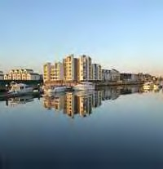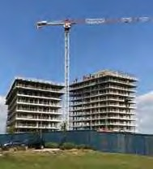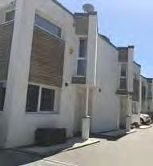

Medway Strategic Land availability assessment (SLAA)

Medway: December 2019

Contents
Executive summary - 4
Introduction - 6
What is SLAA? 6
Policy Context 6
Identified needs 9
Background 10
Stage 1. Site identification 11
Assessment area 11
Site Size 11
Desktop review 11
Call for sites 12
Identifying Broad Locations and sites 12
Screening 13
Site/Broad location survey 13
Stage 2. – Site/broad location assessment 14
Estimating the development potential 14
Residential development 14
Economic development 15
Potential uses 15
Suitability 16
Availability 24
Achievability 24
Phasing 25
Overcoming constraints 25
Stage 3. Windfall Assessment 26
Stage 4. – Assessment Review 27
Review assessment 27
Draft trajectory 28
Conclusions 30
Next steps 30

Appendices

Appendix 1 All sites assessed
Appendix 2 Screening – site screened out of further assessment and amendments to database
Appendix 3 SLAA Stage 2 site/ broad location assessment
Appendix 4 New sites assessed 2018
Appendix 5 SLAA submission pro-forma
Appendix 6 Site survey form
Appendix 7 SLAA site maps
Appendix 8 Broad locations search
Appendix 9 Density analysis
Appendix 10 Windfall assessment
Appendix 11 Overcoming constraints methodology
Appendix 12 Sites permitted and under construction

Executive Summary

The National Planning Policy Framework (NPPF) requires Local Planning Authorities to prepare Strategic Land Availability Assessments (SLAA) to demonstrate the availability of potential development sites within their administrative boundary. This is a key step in the plan making process.
In assessing the supply of potential development sites the SLAA must consider if land is ‘suitable’ for development, ‘available’ and ‘achievable’. Land is considered suitable for development if it is free from development constraints; land is considered available if it is being actively promoted; land is considered achievable if it is financially viable to develop.
Whilst the SLAA indicates the Council’s initial assessment as to whether a site is free of constraints and likely to come forward for development, it does not allocate development sites or grant planning permission. As such the SLAA does not predetermine the Council’s future assessment of sites through the local plan and development management processes.
This is the fourth iteration of the SLAA following the commencement of the preparation of a new Local Plan for Medway. Previous iterations were published in 2015, 2017 & 2018. This assessment was prepared in late 2019, using updated information gathered from site promoters, infrastructure providers, and the emerging evidence base for the local plan.
A total of 228 sites were deemed to be suitable, available and achievable for development. This comprised 148 residential sites, 47 employment sites, 24 mixed use sites and 9 sites for other uses. A list of the sites assessed are set out in Appendix 3. The draft trajectories for housing and employment land are presented below:
Housing | Years 1-5 (2019 – 2024) | Years 6-10 (2024 – 2029) | Years 11-15 (2029 – 2034) | Years 16+ (2034 +) | Total
New Suitable, available and achievable SLAA sites | 3643 | 8331 | 5857 | 1440 | 19271
Large permitted sites  From 2019 AMR | 5793 | 1789 | 0 | 205 | 7787
Small permitted sites  from 2019 AMR | 281 | 1 | 0 | 4 | 286
Windfalls from AMR |  | 950 | 950 | 0 | 1900
Total phasing | 10287 | 11071 | 6807 | 1649 | 29244

Employment | Years 1-5 (2019 – 2024) | Years 6-10 (2024 – 2029) | Years 11-15 (2029 – 2034) | Years 16+ (2034 +) | Total

New SLAA 2019

B1 | 34,377 sq.m | 38,256 sq.m | 14,350 sq.m | 0 sq.m | 86,983 sq.m
B2 | 55,083 sq.m | 77,381 sq.m | 42,783 sq.m | 12,952 sq.m | 188,199 sq.m
B8 | 79,900 sq.m | 140,500 sq.m | 74,500 sq.m | 0 sq.m | 294,900 sq.m
SG | 8,500 sq.m | 8,500 sq.m | 8,500 sq.m | 0 sq.m | 25,500 sq.m
Total | 177,860 sq.m | 264,637 sq.m | 140,133 sq.m | 12,952 sq.m | 595,582 sq.m

Existing sites from 2018 AMR

B1 | 4661 sq.m | 144 sq.m | 8870 sq.m | 144330 sq.m | 158005 sq.m
B2 | 129527 sq.m | 563 sq.m | 2350 sq.m | 144450 sq.m | 276890 sq.m
B8 | 57462 sq.m | 130 sq.m | 5550 sq.m | 159994 sq.m | 223136 sq.m
Mixed B | 8258 sq.m | 22608 sq.m | 7100 sq.m | 0 sq.m | 37966 sq.m
TOTAL | 199908 sq.m | 23445 sq.m | 23870 sq.m | 448774 sq.m | 695997 sq.m

This amounted to a potential for 19,271 new residential units and 595,582 sq. m of employment floorspace across Medway. When added to the existing pipeline of sites Medway SLAA 2019 has identified sufficient land to meet Medway’s anticipated growth needs over the plan period.

Introduction

What is a SLAA?
  - Medway Council is preparing a new local plan to guide the area’s future development. The scale of growth projected for the area is significant, and the new Medway Local Plan is required to identify land to meet the area’s development needs up to 2037. This includes land for housing, employment, retail, services and wider infrastructure. The annual Local Housing Need determined through the use of the government’s defined Standard Method is for 1683 homes in Medway, or 28,611 over the plan period. The Strategic Land Availability Assessment (SLAA) is a key part of the process for identifying land to be included within the Local Plan. It is an important tool to help the council identify land for potential development. It forms part of the evidence base for the Local Plan, as it provides a basis to inform decisions about the most suitable sites and locations to deliver sustainable growth and meet the strategic objectives set for the plan. This work assesses land for housing, employment, retail and community facility uses in Medway. The assessment considers the suitability of land for development, and the likelihood of development coming forward (the availability of land and achievability on the site).

  - A SLAA does not allocate land for development or indicate that land will be granted planning permission in the future. It identifies sites and broad locations with development potential. It lists and maps land which is considered to be available and may be suitable (i.e. that is not constrained by specific factors). The decisions regarding where development should be located in the future will be made through Local Plans (informed by the Sustainability Appraisal and Habitats Regulations Assessment processes, and how potential development could contribute to meeting the vision and strategic objectives set for the plan), and through the development management process when determining planning applications. It is a tool to help identify which sites or broad locations are the most suitable and deliverable for particular types of development.

  - The SLAA is based on the information available (supplied and researched) at a fixed point in time. It is a ‘snapshot’ of the capacity at that point. Therefore the outcome of the assessment of sites may be subject to change over time. This could include variation in site boundaries, constraints may be overcome/mitigated or additional constraints identified, likely development timescales may change, and site capacity or densities may change.

  - The SLAA provides background evidence on the potential availability of land in Medway for development and the choices available for delivering development. It forms part of the evidence base for the Local Plan.

Policy Context
  - In 2012 national planning policy was updated with the introduction of the National Planning Policy Framework (NPPF). In 2014 this was supplemented by the Planning Practice Guidance that provides further direction on the function and importance of the SLAA process. The Framework was revised in July 2018, with a further more limited update in 2019. Further
guidance was published in July 2019 on Housing and economic land availability assessment¹. The Council has followed the latest policy and guidance in preparing this SLAA report.

  - Paragraph 67 of the NPPF states that local planning authorities should:

‘Strategic policy-making authorities should have a clear understanding of the land available in their area through the preparation of a strategic housing land availability assessment. From this, planning policies should identify a sufficient supply and mix of sites, taking into account their availability, suitability and likely economic viability.’
This assessment forms part of the Local Plan evidence base to aid understanding of potential housing land supply.
  - The Planning Practice Guidance provides further detail of this requirement, and outlines the process to be followed. It stipulates that the SLAA should:

    - Identify sites and broad locations with potential for development;
    - Assess their development potential; and
    - Assess their suitability for development and the likelihood of development coming forward (the availability and achievability)².

  - The guidance sets out the methodology for producing a SLAA in a flowchart³, which is provided below. The council has followed the recommended process and has structured this report to align with the key stages in the government’s guidance.
¹ https://www.gov.uk/guidance/housing-and-economic-land-availability-assessment
² Planning Practice Guidance – Housing and economic land availability assessment Paragraph: 001 Reference ID: 3-001- 20190722
³ Planning Practice Guidance - Paragraph: 005 Reference ID: 3-005-20190722

Figure 1 - SLAA flow chart, PPG 2019

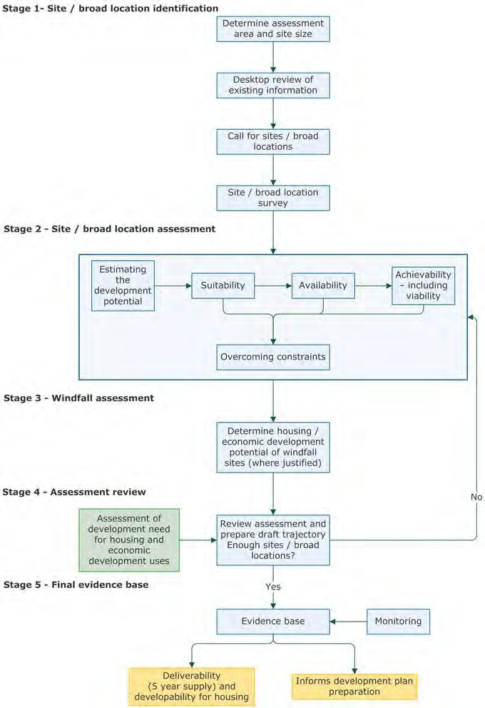

Identified development needs

  - The purpose of the SLAA is to assist in the process of identifying land with the potential to meet the area’s development needs. The main evidence sources on development needs in Medway are the Government’s standard method for Local Housing Need (February 2019) and the North Kent Strategic Housing & Economic Needs Assessment (SHENA) 2015, which provides information on commercial land needs and the mix and range of housing required.

  - The Local Housing Need identified through use of the Standard Method for Medway over the Plan period is 28,611 or 1,683 homes per year.

  - Employment land needs were identified through the Economic Land Needs Assessment component of the SHENA 2015. A total of 90ha of employment land was deemed to be needed to support the forecast growth in Medway. This was divided between office, industrial and warehousing space; specifically 5ha B1, 41ha B2 & 44ha B8. Further work was carried out to determine retail space needs.

  - The aim of this SLAA is to use information gathered over the past year to provide an updated assessment of potential development land, and to consider the contribution that could be made to meeting identified development needs.

2. Background to this SLAA review

  - This Medway SLAA Report 2019 is the latest iteration of work on land availability assessment carried out to support the preparation of the new Medway Local Plan. The council commenced work on a new Local Plan in 2014. Since then the Council has been collating the evidence base for the Local Plan and has undertaken three formal Regulation 18 consultations to inform the emerging plan (Issues & Options 2016, Development Options 2017 & Development Strategy 2018).

  - In this time the Council has produced three SLAA reports that correspond to the three regulation 18 consultations. All the reports indicated that the quantum of land identified as meeting the assessment criteria would not provide sufficient capacity to meet the development needs for Medway’s growth over the plan period. The Council has kept the SLAA process under review, seeking to use new information, particularly where constraints may be addressed.

  - This SLAA assessment has been informed by:

    - An update of national planning policy (NPPF) and national planning guidance (PPG);
    - Further information submitted to support sites as part of the Regulation 18 Development Strategy consultation and responses to the SLAA Further Information Consultation (August 2018) where the Council contacted site promoters to gather additional details to support the site assessment process;
    - Ongoing work on the Local Plan evidence base, including production of town centre masterplans and delivery strategies for Chatham, Gillingham and Strood, and engagement with service providers;
    - Review of site constraints with technical experts;
    - Review of development potential and capacity;
    - Ongoing work on the Sustainability Appraisal for the emerging Local Plan;
    - The successful funding bid to the Housing Infrastructure Framework that provides £170m of investment in transport improvements and environmental measures to support growth on the Hoo Peninsula;
    - Update of identified development needs through the Standard Method for defining Local Housing Need.

3. Assessment Process

  - This section outlines the process followed by the Council in producing this update to the Strategic Land Availability Assessment. It follows the guidance provided by government, and the report presents the work carried out at each stage of the methodology set out at Figure 1 above.

Stage 1. - Site Identification

Assessment Area

  - The assessment area is the Medway Council administrative boundary.

Site Size

  - The government’s planning policy guidance advises on the scale of sites that should be considered in the assessment:
‘Plan makers will need to assess a range of different site sizes from small-scale sites to opportunities for large-scale developments such as village and town extensions and new settlements where appropriate.
It may be appropriate to consider all sites and broad locations capable of delivering 5 or more dwellings, or economic development on sites of 0.25 hectares (or 500 square metres of floor space) and above. Plan-makers may wish to consider alternative site size thresholds.’⁴
  - The council considered that an alternative site size threshold was appropriate. This reflected the urban nature of parts of Medway with smaller brownfield sites suitable for regeneration, and was based on experience of schemes coming forward. As a result the Medway ‘Call for Sites’ set a threshold for sites of 0.15ha, or have the potential to deliver 5 or more dwellings. This threshold and development assumptions were further reviewed at a later stage in the process, responding to advice in the PPG, to ensure the most efficient use of land.⁵

Desktop Review

  - In order to identify as wide a range of sites as possible, a comprehensive desktop review of information sources was undertaken as a starting point to identify potential development land, including:
    - the extant Medway 2003 Local Plan allocations and Development Briefs;
    - planning applications that have been refused, withdrawn or lapsed;

⁴ Available at: Paragraph: 009 Reference ID: 3-009-20190722
⁵ https://www.gov.uk/guidance/housing-and-economic-land-availability-assessment
See Paragraph: 025 Reference ID: 3-025-20190722
    - vacant or underutilised Council land;
    - wider public sector land was identified via the One Public Estate Strategy and included land in the ownership of the Police, Fire and Rescue and Health services;
    - planning permissions that have not yet been implemented and sites that are under construction, but not yet completed.

  - For the preparation of the Medway SLAA 2019 report, information relating to sites under construction and with planning permission came from the Medway Authority Monitoring Report 2019⁶ (AMR) published in December 2019 which reported on the period up to 31 March 2019. The AMR has provided a consistent reference base throughout the SLAA preparation and review process. This review concluded that there were no justifiable grounds to revise the development capacity or land use for sites that were under construction, or with unimplemented planning permissions. For this reason, sites that were under construction, or with unimplemented planning consents as at 31 March 2019 are recorded separately in the SLAA site table. These sites are considered to form the committed development trajectory and are not classified as Suitable, Available and Achievable sites in the 2019 New SLAA Sites table.

Call for Sites

  - In addition to the desktop review the Council carried out a ‘Call for Sites’. The first ‘Call for Sites’ to inform the new plan making process, took place in 2014. The Council has subsequently welcomed further site submissions, specifically in relation to representations made through the Regulation 18 consultations. There was a high volume of responses, with a range of sites in urban, suburban and rural areas promoted as having potential for development.

Identifying Broad Locations and Sites

  - The planning practice guidance encourages the assessment of sites that have not only been submitted to the Council formally, but identified through officers’ analysis and survey of land and development needs in Medway. This particularly presents the opportunity to consider the development of urban extensions and new settlements. In common with many areas facing the challenges of meeting substantial growth needs, and constraints on infrastructure, Medway has considered the potential for strategic scale extensions and settlements as reasonable alternatives to deliver sustainable development. The PPG states:

‘It is important that plan-makers do not simply rely on sites that they have been informed about, but actively identify sites through the desktop review process that may assist in meeting the development needs of an area.’⁷
  - Planning officers have undertaken three processes in order to identify and consider the broadest possible range of sites that could provide for Medway’s growth needs:
⁶ Reports available at: https://www.medway.gov.uk/downloads/download/24/authority_monitoring_report⁷ MHCLG, Planning Practice Guidance, Paragraph: 010 Reference ID:0 3-010-20190722 (July 2019)

    - Village and urban boundary review (2015-16)
    - Spatial options review (2016-17)
    - Urban opportunity areas review (2018-19)

  - Further details of this process are captured in Appendix 8 of this report – Broad Locations search. The purposes of these reviews were to provide for a comprehensive assessment of potential development land. The reviews also responded to the conclusions of the previous assessments in 2016, 2017 and 2018 not providing sufficient sites to meet the development needs over the plan period. Using information brought together from officers’ potential sites review and some additional sites promoted, a small number of new sites were identified for assessing in the 2019 SLAA.

Screening

  - Following the identification and survey of sites, an initial desktop assessment was carried out to remove sites that were in principle unsuitable for further assessment through the SLAA process. This included sites that fell within one of the following categories:

    - Sites less than the size threshold (0.15ha) or would produce less than five dwellings;
    - Sites located in an environmental designation (Special Areas of Conservation, Ramsar, Special Protection Areas, Site of Special Scientific Interest, Marine Conservation Zone, National Nature Reserve, Local Nature Reserve and Ancient Woodland)
    - Sites located entirely within flood zone 3a/b and surface water flood risk where the
Council’s Flood Risk and Drainage Officer advised that issues could not be resolved
    - Sites subject to the Control of Major Accident Hazards regulations

  - The Council also used this stage of the assessment to identify duplicate sites, sites that were in the 2018 SLAA and where development has since been completed, or merged with other sites. This review also provided the opportunity to revisit the database. This included updating records where sites that were originally identified by council officers as having development potential had subsequently received developer interest. Some site references were updated. This ensured the accuracy of the SLAA site database. The full set of sites removed or subject to amendments at this screening stage is presented at Appendix 2.

Site/broad location survey

  - All sites were surveyed as part of the process of SLAA analysis and information was recorded on a proforma to ensure consistency. A copy of the form used is set out in Appendix 6. The site survey process assisted in identifying any further information that may affect suitability or achievability in addition to the findings of the desktop review process or the details provided with the SLAA site submission.

Stage 2. Site/Broad Location Assessment

  - The Council has been proactive in considering sites and land with development potential in Medway. It used the responses received to the Regulation 18 Development Strategy consultation in 2018 to update information on sites in the SLAA database. Following the consultation, the Planning Service contacted site promoters with a SLAA ‘Further Information Consultation’ 2018. This exercise provided an opportunity to identify additional sites and for further information on sites to be submitted to the Council. This has assisted in the assessment of site capacity and the potential to overcome constraints. The Council has used this information to produce this current SLAA report.

Estimating the development potential

  - National planning policy⁸ and guidance⁹ advises that an estimate of the development potential of each identified site should be provided and guided by the existing or emerging plan policy including locally determined policies on density.

  - Where the plan policy is out of date or does not provide a sufficient basis to make a judgement the PPG advises that relevant existing development schemes can be used as the basis for assessment, adjusted for any individual site characteristics and physical constraints.

Residential development

  - There is no saved policy on density in the 2003 Medway Local Plan. The approach used for assessing residential development capacity has developed over time with each SLAA iteration. This iterative process is in accordance with Stage 4 of the SLAA Methodology set out in Planning Practice Guidance 2019. The PPG advises authorities to consider changing assumptions about the development potential of particular sites to ensure that these make the most efficient use of land. ‘This may include applying a range of densities that reflect the accessibility and potential of different areas, especially for sites in town and city centres, and other locations that are well served by public transport’.¹⁰ The Council followed this guidance and carried out further work in assessing potential for development at high density in accessible locations. Further details on how the Council has determined residential development capacity are provided in Appendix 9. The methodology considers the distinct geographies of Medway, and the opportunities for development at higher density supported by sustainable travel options. Typically the highest densities are directed to central urban locations within proximity of rail and bus services. A minimum density of 35 dwellings per hectare was used across Medway outside of the areas that benefitted from better public transport accessibility.

⁸ MHCLG, National Planning Policy Framework, paragraph 122 & 123 (February 2019)
⁹ MHCLG, National Planning Practice Guidance – Paragraph: 016 Reference ID: 3-016-20190722 (July, 2019)
¹⁰ https://www.gov.uk/guidance/housing-and-economic-land-availability-assessment Paragraph:025 Reference ID: 3-025-20190722

  - The Council’s density calculations are summarised in the table below set out at Figure 2, which make reference to zoning criteria used in the methodology. These calculations have been used where a density and capacity figure have not been provided by the site promoter and in cases where the Council considered that the density or capacity provided was not appropriate when assessed against the Council’s capacity typology set out below, and an understanding of the site characteristics and constraints.

Figure 2: Medway SLAA density matrix
Accessibility Zone | Policies Map Label | Dwellings per Hectare
Chatham railway station | A | See Chatham Town Centre Masterplan
Strood Railway Station | B | See Strood Town Centre Masterplan
Gillingham Railway Station | C | 50
Rochester Railway Station | D | 50
Rainham Railway Station | E | 35
Cuxton Railway Station | F | 35
Halling Railway Station | G | 35
High frequency bus corridor | H | 35

Economic Development

  - The development potential of sites for employment uses has been calculated by applying a ‘plot ratio’ to the gross site area, in line with the advice in the Medway Employment Land Needs Assessment 2015¹¹, which reflected national standards used by Homes England. The following plot ratios (Site Area : Floorspace) are considered appropriate assumptions for the purposes of assessing commercial development potential in the SLAA:
    - Office: 1:1
    - Industrial and Warehouse: 1:0.4

Potential uses
  - The Call for Sites process used a proforma (set out at Appendix 5) to gather information on potential development sites. The template requested information on the preferred uses of the promoted site. This was supplemented by the site surveys that reviewed potential uses and made recommendations as to an appropriate use, or uses. From this an officer judgement was made as to the most appropriate use(s) for a site.

  - If the site was identified through a desktop review or broad location assessment, and therefore did not benefit from information provided by a site promoter, then the preferred use was determined through recent developer interest in the site and/or the survey undertaken by the Council.
11
https://www.medway.gov.uk/downloads/file/630/medway_employment_land_assessment_final_report_161 602

Suitability

  - Sites that were previously allocated or identified in planning policy documents, had planning permission or were under construction were generally deemed suitable.

  - The planning practice guidance indicates that the assessment of the remaining sites should be guided by established or emerging local planning policies or national policy/guidance.¹² Due to the age of the existing Medway Local Plan 2003 sites were tested against national policy only.

  - The PPG outlines factors that should be considered when assessing the suitability of a site for development, including:

    - national policy;
    - appropriateness and likely market attractiveness for the type of development proposed;
    - contribution to regeneration priority areas;
    - potential impacts including the effect upon landscapes including landscape features, nature and heritage conservation.¹³

  - The council used the criteria set out above to develop a standard proforma to use in assessing sites. This included:

    - Physical limitations - site access (physical access to sites suitable for vehicles), flood risk, air quality (impact on AQMA), ground contamination, any abnormalities on site (e.g. topography or complex site clearance) ;
    - Potential impacts – reference to landscape impacts, natural environment (ecology and nature designations), heritage designations (Listed Buildings, Scheduled Ancient Monuments, Conservation Areas and archaeology) and impact on agricultural land;
    - Appropriateness and likely market attractiveness – access to infrastructure (local centres, supermarkets, designated open spaces, education facilities), sustainable transport opportunities (access to bus stops and train stations)
    - Contribution to regeneration – supporting development on brownfield sites and within the town centres close to transport hubs;

  - The sites were assessed against these criteria using existing data sources and GIS analysis, and further informed by the findings of the site survey in order to provide a sensitivity checking process to determine the suitability of the sites. The Planning Service sought expert advice from technical services internally, such as Conservation, Landscape, Environmental Protection, Greenspaces, SuDS officers, and made use of a range of databases held within the Council. A traffic light ‘RAG’ rating was applied to every site against each of the defined criteria. An informed judgement concluded on the overall suitability of the site for development.
¹² MHCLG, National Planning Practice Guidance, Paragraph: 018 Reference ID: 3-018-20190722 (July 2019)
¹³ MHCLG, National Planning Practice Guidance, Paragraph: 018 Reference ID: 3-018-20190722 (July 2019)

  - The table at Figure 3 below sets out the process that the Council undertook to assess individual sites in order to reach conclusions on the potential suitability of a site.

Site review assessment criteria and process – desktop

Criteria | Green | Amber | Red | National policy, guidance justification and information source
Access to services and facilities | The majority of the site is located within 400m of services and facilities. | The majority of the site is located within 800m of services and facilities. | No services and facilities are located within 800m of the site. | NPPF:  - Paragraph 103  Services and facilities – local and district centres as defined in the Medway Local Plan 2003, plus education facilities, supermarkets, shopping centres developed since 2003 plan adopted.
Access to open spaces | An open space is located with 400m of the site | An open space is located within 800m of the site | No open space is located within 800m of the site. | NPPF:  - Paragraph 91  Open spaces – protected and proposed open spaces defined in Medway Local Plan 2003 and Medway PPG 17 audit (2012)

¹⁴ Distances of 400m and 800m were chosen as appropriate walking distances, based on guidelines from the Chartered Institution of Highways and Transportation, http://www.ciht.org.uk/en/knowledge/publications/index.cfm/providing-for-journeys-on-foot-2000

Criteria | Green | Amber | Red | National policy, guidance justification and information source
Transport | The site is within 400m of an existing bus stop or 800m of a train station | This site is not within a 400m of a bus stop or 800m of a train station, but is of a size that would warrant the provision of public transport enhancements. | The site is not within 400m of a bus stop or 800m of a train station, and it was considered unlikely that public transport enhancements would be delivered. | NPPF:  - Paragraph 103  - Paragraph 110  Mapped transport infrastructure.
Site access | A (suitable) vehicular access exists | It is likely a (suitable) vehicular access could be created (within site ownership or highways land). | It is unlikely that a (suitable) vehicular access could be created | NPPF:  - Paragraph 110  Details for GIS mapping and photography and site survey, and consideration of information provided in call for sites.
Landscape and environment | Sites that are previously developed land (PDL) , outside of the remit of Medway LCA 2011 or within landscape that has both a poor condition and low sensitivity. Plus there is likely to be minimal ecology value in the site. | Either or both the sensitivity or condition of the landscape is moderate as assessed in the Medway LCA 2011 and there may be ecology interest on site. | The site falls within a landscape of either or both of high sensitivity and good condition in the Medway LCA 2011 and significant ecology interests may exist. Or have an impact of a designated habitat.  Likely to have a detrimental impact on the purposes of AONB and/or green belt designators. | base, designated landscapes and national designated habitats (SSSI, SAC, AONB, Ancient Woodland) & Green Belt
Heritage | Development is unlikely to impact upon any designated heritage assets or archaeology. Site is remote from any heritage assets. | Development may have an impact upon designated heritage assets or archaeology  Site includes or is in close proximity to a heritage asset and may therefore have an impact. | Development is likely to have a significant impact upon designated heritage assets.  Development would be likely to result in complete or partial loss of heritage asset. | NPPF:  - Paragraph 193  Heritage assets - designated (listed buildings, conservation areas, scheduled ancient monuments)

Flood risk | Site is at low risk of flooding. Site is in Flood Zone 1 or 2 and site is not an area of high  risk for surface water flooding. | Site is in Flood Zone 3 or site is in area of high surface water flood risk | Site is in Flood Zone 3 and within in area of high surface water flood risk | NPPF:  - Paragraph 155  Flood zones - Environment Agency flood mapping.  Surface water flood risk - Medway Council Flood Risk & Drainage & Environment Agency flood mapping
Air quality | Site is not within or adjacent to an AQMA; nor is contamination suspected.  Traffic generated by the development is not expected to route through AQMA (or potential AQMA) | Site is not within or adjacent to an AQMA.  Traffic generated by development is expected to route through AQMA (or potential AQMA) but site will accommodate less than 200 units or 1000 sq.m of commercial floorspace¹⁶. | Site is within or adjacent to an AQMA.  Or  Traffic generated by development is expected to route through AQMA (or potential AQMA) and site will accommodate more than 200 units or 1000 sq.m of commercial floorspace. | NPPF:  - Paragraph 181  Other guidance:  - Medway Air Quality planning guidance (2016)  Medway AQMAs: Central Medway, Pier Road, High Street/ Rainham Town Centre and Four Elms Hill.  Therefore, this criterion only applies to sites within or close to these designated areas.  Further work on assessing the impact on air quality will be carried out as part of the strategic transport assessment.

¹⁶ Any scheme above this scale of development will require either an air quality assessment of emissions mitigation assessment as per pp.6-7 of the Medway Air Quality Planning Guidance (2016) - https://www.medway.gov.uk/info/200140/environment_health_and_safety/416/air_quality/3

Contamination | Contamination is not suspected on the site | Contamination is known or suspected on site but remediation is considered to be deliverable | Contamination is known or suspected on the site but remediation is expected to be undeliverable | NPPF:  - Paragraph 170  Contaminated land – reference to Medway Council Environmental Protection records.
Agricultural Land | The site is PDL or within ALC classification urban, non- agricultural, grade 5, grade 4 | ALC grade 3 | ALC Grade 1& 2 | NPPF:  - Paragraph 170  Agricultural land classification – Ministry of Agriculture, Fisheries and Food ALC survey data 1988.
Contribution to regeneration priorities | Meets fully the objectives of the Medway 2035 Regeneration Strategy  Site is previously developed land | Partly meets the objectives of the Medway 2035 and is previously developed land | Does not contribute to any of the objectives in  ‘Medway 2035’. Site is greenfield land | GIS analysis  NPPG:  Paragraph: 018 Reference ID: 3-018-20190722  Adopted development briefs and masterplans.

Sensitivity check
This framework was used to provide a consistent basis for the initial assessment of suitability for development. The process was further developed through use of the results of the site surveys, the emerging evidence base for the new Local Plan, including Sustainability Appraisal work, and officer informed judgement and knowledge regarding individual sites. This included a review of the ‘market appropriateness’ test of the PPG.

Availability

  - The PPG advises that sites are deemed to be available for development, when ‘on the best information available (confirmed by the call for sites and information from land owners and legal searches where appropriate), there is confidence that there are no legal or ownership impediments to development.’¹⁷
  - In preparing the Medway SLAA 2019, sites were deemed to be available based on a number of factors:

- Submitted in response to the ‘Call for Sites’ processes, unless we are aware of lack of developer interest in recent years;

- The site promoter participated in a developer interview or follow up discussions as part of the Call for Sites process or wider plan making processes;

- The site promoter responded to consultation stages supporting the preparation of the new Medway Local Plan indicating interest in development of the site;

- There has been development interest in the site since submission to the Call for Sites process;
- A response was received to the further information consultation on the SLAA in 2018;
- Information gathered in relation to the preparation of the town centre masterplans and delivery strategies in Chatham, Gillingham and Strood and market engagement.

Achievability

  - The PPG states that an achievable site is one where “there is a reasonable prospect that the particular type of development will be developed on that site at a particular point in time”¹⁸ and is essentially a judgement about the economic viability of a site and whether it will be completed in the time period.

The Council has undertaken initial achievability testing, informed by:

- Developer interviews
- Information requested as part of the site submissions
- Any further submissions to the Council regarding sites with specific information on achievability

  - In 2015 the Council undertook developer interviews on those sites submitted in the 2014 Call for Sites and has since then kept an open dialogue on sites with developers. Part of this dialogue has been to understand the achievability of the sites coming forward for development.
¹⁷ MHCLG, National Planning Practice Guidance, Paragraph: 019 Reference ID: 3-019-20190722 (July, 2019)
¹⁸ MHCLG, National Planning Practice Guidance, Paragraph: 020 Reference ID: 3-020-20190722 (July, 2019)

  - The Call for Sites pro forma requested information on possible constraints on the site and asked land owners/developers to identify any market viability and/or legal/ownership issues. Initial work on the Viability Assessment for the new Local Plan has also involved engagement with the development sector to inform assessments of achievability.

Phasing

  - The phasing estimates have been collated by Medway Council’s Planning Policy Team. This work is based on the systems and processes supporting the annual development monitoring work published in the Authority Monitoring Report. Officers use discussions with developers and relevant officers to estimate numbers over the plan period, together with knowledge on likely delivery rates based on experience of sites across Medway. This work has been further developed in 2019, with the appointment of an Implementation Officer, who has been responsible for the production of the Medway Council Housing Delivery Test Action Plan in August 2019. The officer’s role includes ongoing engagement with the development sector to understand causes of delay in implementing planning consents and maintaining up to date records of planned development.

Overcoming constraints – Stage 2a

  - Once a review of suitability, availability & achievability was completed the findings were reviewed to understand if any of the constraints could be overcome.¹⁹ This process considered whether suitable mitigation could be put in place in order to bring forward a site for development. Sites were re-appraised in conjunction with technical specialists in the Council (Heritage, Landscape & Design, Flood Risk & infrastructure) and the emerging Local Plan evidence base to consider whether suitable mitigations could be put in place to satisfactorily address constraints. The results of this work are outlined in Appendix 11. The process followed the updating of site information received through both the Regulation 18 Development Strategy Consultation and the SLAA ‘Further information consultation 2018’.

  - The review that has informed the preparation of the 2019 SLAA report has included the work undertaken for the production of the town centre masterplans and delivery strategies for Chatham, Gillingham and Strood. This work has identified significant development potential in the centres, and also engaged with the development sector in preparing the documents. The council seeks to adopt these documents as part of the evidence base for the new Local Plan at the Cabinet meeting in December 2019. Another key component of evidence that has supported the SLAA process, particularly in overcoming constraints was the successful Housing Infrastructure Fund (HIF) bid. In November 2019, the council was informed that it had secured £170m of investment in strategic transport improvements and environmental measures. This investment facilitates growth on the Hoo Peninsula. Work at earlier stages of the SLAA had identified transport and environmental constraints to development in this location. The Council has used the updated information from the successful HIF bid to re- assess these constraints. This has provided for increased potential land supply in this location.

Stage 3 – Windfall Assessment

  - The Planning Practice Guidance allows for Local Planning Authorities to justify a windfall allowance as part of their housing land supply. ²⁰ Windfalls (consented development sites that have not been specifically identified in the Development Plan) have formed an important component of housing land supply in Medway in recent years. In 2016/17, 36% of the housing completed was delivered on windfall sites. The council has therefore made allowance for a windfall assessment as part of land supply. However it is recognised that the high proportion of development delivered in recent years reflects the age of the current Local Plan. The new Local Plan will provide new allocations for development, and therefore the rates of housebuilding arising from windfall sites will likely be lower than the recent pattern. This is recognised in the methodology used to determine a justified windfall allowance for the new plan period. Further details on the Windfall methodology is set out Appendix 10.

Figure 4: Windfall summary
Financial year | Plan period year | Windfalls
2020 to 2021 | Year 1 | -
2021 to 2022 | Year 2 | -
2022 to 2023 | Year 3 | -
2023 to 2024 | Year 4 | -
2024 to 2025 | Year 5 | -
2025 to 2026 | Year 6 | 190
2026 to 2027 | Year 7 | 190
2027 to 2028 | Year 8 | 190
2028 to 2029 | Year 9 | 190
2029 to 2030 | Year 10 | 190
2030 to 2031 | Year 11 | 190
2031 to 2032 | Year 12 | 190
2032 to 2033 | Year 13 | 190
2033 to 2034 | Year 14 | 190
2034 to 2035 | Year 15 | 190
2035 to 2036 | Year 16 | -
1036 to 2037 | Year 17 | -
 | Total | 1,900
²⁰ MHCLG, National Planning Practice Guidance: Paragraph: 023 Reference ID: 3-023-20190722 (July 2019)

Stage 4 – Assessment Review
  - In the previous iterations of the SLAA (2016, 2017 & 2018), the assessment found a shortfall in suitable, available and achievable sites to meet the identified development needs over the plan period. The Council acknowledged the need to carry out further work to seek to overcome constraints to development, in planning to meet the area’s growth needs. This has informed the approach to this current assessment.

Review assessment
  - The outcome of the Medway SLAA 2019 assessment has found an increased supply of potential development land that is suitable, available and achievable. This is at a scale to meet the scale and range of growth needs identified for the new Local Plan period. It reflects the certainty provided the successful HIF bid to overcome transport and environmental constraints, supporting potential growth at sites on the Hoo Peninsula. The latest assessment has also considered the work of the Town Centre Masterplans and Delivery Strategies for regeneration in the centres of Chatham, Gillingham and Strood, and boost to the confidence in bringing forward development in these locations.

  - The latest housing trajectory for those ‘committed’ sites (planning permissions, under construction and MLP2003 site allocations) was published in December 2019 in the Authority Monitoring Report (AMR). This outlined the position as at 31 March 2019. Sites with permission and under construction are set out in Appendix 12.

  - The trajectory set out below uses the 2019 AMR as a baseline and adds to it the additional
‘new’ sites identified as suitable, available and achievable through the SLAA.

  - In this review ‘committed’ sites were reviewed in order to determine if any further capacity could be found in these. This review found there to be no potential changes relating to a beneficial change of use or readjustment in site capacities.

Draft trajectory
Set out below are the draft housing and employment trajectories for housing and employment land.

Housing | Years 1-5 (2019 – 2024) | Years 6-10 (2024 – 2029) | Years 11-15 (2029 – 2034) | Years 16+ (2034 +) | Total
New Suitable, available and achievable SLAA sites | 3643 | 8331 | 5857 | 1440 | 19271
Large permitted sites  From 2019 AMR | 5793 | 1789 | 0 | 205 | 7787
Small permitted sites  from 2019 AMR | 281 | 1 | 0 | 4 | 286
Windfalls from AMR |  | 950 | 950 | 0 | 1900
Total phasing | 10287 | 11071 | 6807 | 1649 | 29244

Figure 5: Draft housing trajectory

Employment | Years 1-5 (2019 – 2024) | Years 6-10 (2024 – 2029) | Years 11-15 (2029 – 2034) | Years 16+ (2034 +) | Total

New SLAA 2019

B1 | 34,377 sq.m | 38,256 sq.m | 14,350 sq.m | 0 sq.m | 86,983 sq.m
B2 | 55,083 sq.m | 77,381 sq.m | 42,783 sq.m | 12,952 sq.m | 188,199 sq.m
B8 | 79,900 sq.m | 140,500 sq.m | 74,500 sq.m | 0 sq.m | 294,900 sq.m
SG | 8,500 sq.m | 8,500 sq.m | 8,500 sq.m | 0 sq.m | 25,500 sq.m
Total | 177,860 sq.m | 264,637 sq.m | 140,133 sq.m | 12,952 sq.m | 595,582 sq.m

Existing sites from 2018 AMR

B1 | 4661 sq.m | 144 sq.m | 8870 sq.m | 144330 sq.m | 158005 sq.m
B2 | 129527 sq.m | 563 sq.m | 2350 sq.m | 144450 sq.m | 276890 sq.m
B8 | 57462 sq.m | 130 sq.m | 5550 sq.m | 159994 sq.m | 223136 sq.m
Mixed B | 8258 sq.m | 22608 sq.m | 7100 sq.m | 0 sq.m | 37966 sq.m
TOTAL | 199908 sq.m | 23445 sq.m | 23870 sq.m | 448774 sq.m | 695997 sq.m

Figure 6: Draft employment trajectory

Conclusions

  - A total of 228 sites were deemed to be suitable, available and achievable for development. This comprised 148 residential sites, 47 employment sites, 24 mixed use sites and 9 sites for other uses. The sites are detailed in Appendix 3.

  - It is understood that the SLAA provides a high level assessment of the potential of land for development. This assessment has used a range of data sources to determine availability, suitability and achievability. The Council considers that the methodology followed provides for a robust assessment of land, critical to the plan preparation process. However further work on the evidence base, such as the final stage of work on the Strategic Transport Assessment and the Viability Assessment of the plan, will also be critical. The comprehensive evidence base will be used to confirm which sites and locations could deliver sustainable development that meets the vision and objectives of the draft Local Plan, and where key mitigations may be required.

Next Steps
  - Following the publication of the SLAA the information will be taken forward to inform the Sustainability Appraisal and site selection for the Draft Local Plan publication in 2020.

Medway Strategic Land Availability Assessment Report, 2019

APPENDICES

Appendix 1 - All sites assessed

(SLAA stage 1)

Site Name | Site Ref
89 Ingram Road, Gillingham | 3
Layfield Road | 11
Medway House, 277 Gillingham Road | 13
Recreation Ground, Bells Lane, Hoo | 15
Rear of Dial Road, Gillingham | 20
Strand Leisure Park | 32
RSME Kitchener Barracks, Brompton | 33
Retailing In Gillingham,High,Skinner,Jeffrey Strts | 39
Bells Lane | 44
Chattenden Barracks, Chattenden | 50a
Clarendon Drive, Strood | 51
Playing Field at Hilltop Primary School | 71
Former Temple School | 72
Albert Place, Strood | 81
Columbine Close, Strood | 83
Church Green | 87
Strood Riverside, Canal Road | 90
320 - 344 High Street inc. 42 New Road, Rochester | 100
1-35 High Street, Chatham (Grays Garage) | 102
Chatham Historic Dockyard | 104
Former Civic Centre and Janes Creek | 137
Former Bishopcourt Kitchen Garden, Love Lane, Rochester | 141
Adj to 23 Love Lane, Rochester | 142
St Bartholomews Hospital, New Road, Rochester | 144
Sports Ground, Featherby Road | 158
East of Gillingham Golf Course | 164
56A Pump Lane, Rainham | 177
274-276 Station Road Rainham | 182

This table must be read in conjunction with 'Medway Strategic Land Availability Assessment (2019)'
See 'Authority Monitoring Report (2019)' for details of number and phasing
Site Name | Site Ref
Vixen Close, Lordswood | 410
South of Vicarage Road, Halling | 435
Hook Wood & land to the east of North Dane Way | 438
Adjacent to 43 Hill Road, Borstal | 440
Garage court off St Johns Road, Hoo | 441
443 Former Military Site, Lower Upnor | 443
35 Avery Way Allhallows | 454
Police Station Birling Avenue Rainham | 456
1-3 Canal Road Strood | 457
9 Cross Street Chatham | 462
38 London Road Strood | 467
Mid Kent College, Horsted, Maidstone Road | 470
124 Pier Road, Gillingham | 471
Land at St Mary's Island Maritime Way, Chatham | 472
20 Old Road Chatham | 476
54 and 61 Shanklin Close Chatham | 480
Car Park The Terrace Rochester | 484
Safety Bay House, Warwick Crescent, Rochester | 486
Courtsole Farm Pond Hill Cliffe | 488
Land rear of 7-13 New Road CHATHAM | 493
32-34 Roosevelt Avenue Chatham | 502
Rochester Police Station Cazeneuve Street Rochester | 510
Victory Pier, Pier Road, Gillingham | 511
Sandacres, Upnor Road, Lower Upnor | 514
Rochester Riverside | 515
Mercury Close, and adj to 62-72 Shorts Way Borstal | 516
Hoo - North East Bells Lane Hoo | 520
East of Wainscott Road Wainscott | 523

This table must be read in conjunction with 'Medway Strategic Land Availability Assessment (2019)'
See 'Authority Monitoring Report (2019)' for details of number and phasing
Site Name | Site Ref
Southern Water Site, Capstone Road, Chatham | 524
389 High Street CHATHAM | 530
39-41 High Street CHATHAM | 531
94-100 High Street, Chatham | 532
33 Richard Street CHATHAM | 534
22-26 Victoria Street, Rochester | 537
174-176 Canterbury Street GILLINGHAM | 541
77 Station Road Rainham | 544
85 Church Street GILLINGHAM | 547
308 Luton Road Luton | 551
195 Princes Avenue Walderslade | 559
284-286 High Street Chatham | 561
South Thames Regional Health Authority Land | 564
Fort Horsted, Primrose Close, Chatham | 570
47-48 Second Avenue Industrial Estate | 571
Elm Court, Capstone Road, Gillingham | 576
R/O 329 - 377 (Featherstones) High St ROCHESTER | 598
Strood Service Station, 3 London Road, Strood | 603
Walnut Tree Farm, 155 Lower Rainham Road, Rainham | 604
Colonial House | 632
Plot D, Kingsnorth industrial estate | 643
Grain Power Station, Grain Road | 646
Kingsnorth Power Station | 647
Land between Vanguard Way and Anthony's Way | 648
Cliffe Yard, Anthony's Way, Medway City Estate | 649
Wilds Yard, Clipper Close, Frindsbury | 652
Land adjoining Southern House, Anthonys Way | 654
Land South of Kent Terrace, Canterbury Lane, Rainham | 655

This table must be read in conjunction with 'Medway Strategic Land Availability Assessment (2019)'
See 'Authority Monitoring Report (2019)' for details of number and phasing
Site Name | Site Ref
Watermill Wharf, Canal Road, Strood | 657
7 St Mary's Road, Strood | 658
Dial Road, Gillingham | 661
82 Jeffery Street, Gillingham | 663
Alexander Garage & 3 Old Road, Chatham | 666
39-41 Mills Terrace, Chatham | 669
Rear of 5 New Road, Chatham | 673
Cuxton Station, Station Road, Cuxton | 676
Between 142 & 152 Luton Road, Chatham | 680
109 Frindsbury Road, Strood | 684
Temple Waterfront, Roman Way, Strood | 685
Diggerland, Roman Way, Strood | 686
Former gas works site, north of Pier Road, Gillingham | 687
25-33 Corporation Street, Rochester | 688
Hempstead Valley Shopping Centre | 691
West of Meresborough Road | 692
Land at Medway Road, West of 32 Laurel Road | 693
National Grid Property Holdings, Grain Road | 699
Ex Service Stn, adj 86 Corporation Street, Rochester | 700
Former Tug & Shovel, North Street, Strood | 702
31-39 Duncan Road, Gillingham | 703
Carpeaux Close, Chatham | 704
Pit 2, Roman Way, Strood | 705
LIFT site, 551-555 Canterbury Street, Gillingham | 707
Land rear of former St Matthews School, Borstal | 708
Allhallows Holiday Park, Avery Way | 709
North side of Commissioners Road | 711
HMP Rochester, Sir Evelyn Road | 712

Site Name | Site Ref
Land to east of Chattenden Lane | 713
Land to east of Chattenden Lane | 714
Land to West of Church Farm, Church Lane, Hoo | 715
Land to the East of Toad Hall, Main Road, Hoo | 716
West of Tower Hill House, Castle Street Upnor | 717
Bridge Lodge, Four Elms Hill | 718
Land at 506 Lower Rainham Road | 719
90-94 Bush Road, Cuxton | 722
BAE Systems, Rochester | 724
1-21 St Clements House, Corporation Street | 726
Brompton Farm, adj. 66 Brompton Farm Road | 727
10-40 Corporation Street, Rochester | 728
North of Brompton Farm Road | 729
Land North East of Kingsnorth Industrial Estate | 730
46-86 Corporation Street, Rochester | 731
Land at Listmas Road, Chatham | 732
Amenity Land at 45-75 Chatham Grove, Chatham | 733
Garages at Robson Drive, Hoo, Rochester | 734
Upnor Wharf | 735
Former Uniwoi, Fleet House,Upnor Road, Lower Upnor | 736
Land at the former Upnor Quarry, Upnor | 737
Hoo Common, Chattenden | 738
Communal areas, John Street, Hoo | 740
Pattens Place, Rochester | 741
Infill between terraces at Blackman Close, Hoo | 742
Fenced area Lordswood Lane | 743
Land terrier Poplar Road, Strood | 745
Former Earl Community Centre, Albatross Avenue | 746
Site Name | Site Ref
Barn Meadow, Upper Halling | 747
Wooleys Orchard, land south of Lower Rainham Road | 749
Land Between Pump Lane & Bloors Lane, Rainham | 750
BAE Sports & Social Club, Bells Lane, Hoo | 751
North side of Commissioners Road, Strood | 752
Land west of Hoo | 753
Land at Burneys Farm, Lower Stoke | 754
Former Police Station, Chatham | 755
Pentagon, Chatham | 756
Between Cross Street & The Brook, Chatham | 757
Sir John Hawkins Car Park, Chatham | 758
Whiffens Avenue Car Park, Chatham | 759
Former Tesco store, The Brook, Chatham | 760
Parcel 4, Cliffe Wharf, Salt Lane, Cliffe | 762
Parcel 8, Cliffe Wharf, Salt Lane, Cliffe | 763
Land at Holy Trinity Church, Twydall Land, Twydall | 764
St Lukes Church, Sidney Road, Gillingham | 765
Land at Chapel Road, Grain | 767
Land at Green Lane, Grain | 768
Pintail Close garages, Grain | 769
Recreational Centre, Pintail Close, Grain | 770
Port Victoria Road, Grain | 771
81-85 High Street, Chatham | 772
Bridgewood, Rochester | 773
Mill Hill, Grange Road, Gillingham | 774
Bakers Field, Station Road, Rainham | 775
Land at West Motney Way, Rainham | 776
Manor Farm, Lower Rainham Road, Rainham | 778
Site Name | Site Ref
Adj. To Farm Cottages, Lodge Hill Lane, Chattenden | 780
218 Main Road, Hoo | 781
Cuxton Gate, Station Road, Cuxton | 782
Land at Capstone Valley, Darland Farm | 783a
Land at Capstone Valley, Darland Farm | 783b
Land at Capstone Valley, Darland Farm | 783c
Land at Capstone Valley, Darland Farm | 783d
Site A, west of Chapel Lane, Hempstead | 784
Site B, east of Chapel Lane, Hempstead | 785
Site C, land off Hoath Way, Hempstead | 786
Adj Port Victoria Road, Grain | 787
Land at Church Hill, Rochester Road, Cuxton | 788
East of the Old Orchard, Merry Boys Road | 789
Old Chalk Pit, Lower Rochester Road, Frindsbury | 790
Former Equestrian Centre, Walnut Tree Farm Rainham | 791
Port Medway Marina, Station Road, Cuxton | 792
Middle Street Farm, Grain Road, Middle Stoke | 794
Street Farmyard, Stoke Road, Hoo St Werburgh | 795
Rede Court Gravesend Road | 796
Holy Name Church, Lower Rainham Road | 797
Land off Bush Road, Cuxton | 799
Land west of Lower Station Road, Rainham | 800
Land at Chapel Lane, Upper Halling | 801
Chattenden Farm, Lodge Hill Lane | 802
High View Farm, Lordswood Lane | 803
Former Officers Mess, Maidstone Road, Chatham | 804
Land at rear of 212 High Street, Chatham | 806
Beech Lodge, Chapel Road, Grain | 807
Site Name | Site Ref
Queens Court, Chichester Close, Rainham | 808
Junction of Pier Road and Medway Road, Gillingham | 810
The Farmyard, Darland Farm | 811
Adj. Beatty Avenue, Gillingham | 813
Westmoor Farm, Moor Street, Rainham | 814
East side of Vicarage Lane, Hoo | 815
Meeting Hall, Queens Road, Gillingham | 816
Berengrave Nusery, Rainham | 817
J7, Chatham Maritime | 818
Pump House 7, Leviathan Way, Chatham Maritime | 819
Interface Land, Chatham Maritime (northern site) | 820a
Interface Land, Chatham Maritime (southern site) | 820b
Machine Shop 8 Chatham Maritime | 821
Land at Robins and Day | 822
Chatham Docks, Chatham | 824
Land East of Otterham Quay Lane, Rainham | 825
111 Nelson Road, Gillingham | 826
Stonehouse Farm, Dillywood Lane, Frindsbury | 827
Former Conoco Site/Thameside Terminal, Salt Lane | 828
Medway Bridge Marina, Manor Lane, Rochester | 829
Land at Grange Road, Gillingham | 830
2-4 Balmoral Road, Gillingham | 831
Land to the West of North Dane Wood, Lordswood | 832
Medtha Bungalow, Port Victoria Road, Grain | 833
1 Batchelor Street, off the Brook, Chatham | 834
Walnut Tree Farm, r/o Longfield Ave, High Halstow | 835
Land to the East of Church Street | 836
Land to the West of Church Street | 837
Site Name | Site Ref
Pelican Reach, Clipper Close, Medway City Estate | 838
Former Alloy Wheels Priory Road | 839
Land west of Maidstone & Rochester Roads,Rochester | 840
Tesco Store, Rainham Shopping Centre | 841
Tesco, Strood | 843
Amherst Hill, Brompton | 844
Woolmans Wood Caravan Site | 845
Garage Court at Sundridge Drive, Chatham | 846
Siloam Farm, Rainham | 847
Land south of View Road, Cliffe Woods | 848
Bennetts Orchard, Lower Rainham | 849
Chambers Cycle Stores, Rochester | 850
111 Rainham Road (Jezreels), Gillingham | 853
230, High Street, Rochester | 855
240, High Street, Rochester | 856
The Brook (r/o High St and Batchelor St) Chatham | 857
Eldon St, Carpeaux Close and Hards Town, Chatham | 858
Land at High St, Union St and New Road, Chatham | 860
141-151 New Road and land at Union Street, Chatham | 861
296-310 High Street, Chatham | 862
11-31 Cross Street, Chatham | 863
King Street, Chatham | 864
2-8 King Street and 1-11 Queen Street, Chatham | 865
55-105a The Brook & 1, 5, 11 & 13 King St, Chatham | 866
2-14 Railway Street & 142-146 High Street, Chatham | 867
19 New Road Avenue and 3 New Cut, Chatham | 868
Wickes, New Cut, Chatham | 869
Alexandra Hotel, Railway Street, Chatham | 870
Chatham Railway Station | 871
West of Maidstone Road, adj Chatham Rail Station | 872
Rear of 47 High Street/Britton Street, Gillingham | 873
Land at junc. of Marlborough Rd/Brompton Rd, Gill | 874
Retail Core (High St, Jeffrey St, King St) Gillingham | 875
BT Switch Centre, Green Street, Gillingham | 876
208 Canterbury Street Gillingham | 878
R/O 73,75-77 High Street, Rochester | 880
106-108 Delce Road, Rochester | 883
3-7 Mill Road, Gillingham | 886
Stoke Garage, High Street, Lower Stoke | 888
Working Men's Club, 2 Rock Avenue, Gillingham | 889
15,17,19 New Road, Chatham | 896
Garage Block, Witham Way, Strood | 897
208-214 Windmill Road, Gillingham | 899
Coal Yard, 8 Westcourt Street, Brompton | 900
266-268 Chatham Hill | 901
Former School Playing Field Halling | 910
Bridgeside Warwick Crescent, Rochester | 914
5 Otway Terrace Chatham | 915
Shipwrights Arms, 44-45 Hills Terrace Chatham | 956
Lock Up Garage Site Rear of Charles Street Chatham | 959
102 High Street CHATHAM | 963
Petrol Filling Station Railway Street, Gillingham | 976
143-145 Canterbury Street GILLINGHAM | 981
Adjacent to Bus Station Medway Street Chatham - now merged with SLAA site 983 | 984
82 King Street, Rochester | 987
Bridgewood Manor Hotel, Walderslade Woods, Chatham | 993

Site Name | Site Ref
The Grange Ratcliffe Highway St.Mary Hoo | 1005
33 Magpie Hall Road CHATHAM | 1006
Mount Pleasant, Cooling | 1010
Dalham Farm, High Halstow | 1011
OFF Power Station Road, Grain | 1012
Sharnal Street, High Halstow | 1013
Whetstead, Off Grange Road, Lower Twydall | 1014
Off Sundridge Hill, Cuxton | 1015
26-36 Napier Road Gillingham | 1018
Moor Street House | 1027
Mackays Lordswood Industrial Estate | 1033
National Tyre Station Road Strood | 1039
South Eastern Hotel 51 Station Road Strood | 1040
9-11 The Brook | 1041
178 Brompton Farm Road, Strood | 1042
R/O Whitehouse Farm, Stoke Road, Hoo | 1043
East of Whitehouse Farm, Hoo | 1044
Land at Tamarisk, Chattenden | 1045
Former Reservoir, Browndens Lane, Upper Halling | 1046
Land east of Seymour Road, Rainham | 1047
Land at 54 Beacon Road, Chatham | 1048
426 Canterbury Street, Gillingham | 1049
116-118 Twydall Lane, Twydall | 1050
Rear of 636 Mierscourt Road, Rainham | 1051
101 Beacon Road Chatham | 1052
Westmoor Farm (North) Moor Street, Rainham | 1053
Delivery Office, Corporation Street | 1054
South section, Maidstone Road, Rochester | 1055
Site Name | Site Ref
6-11 New Road Avenue, Chatham | 1056
North Side, Priory Road | 1057
R/O Oastview, East of Mierscourt Road, Rainham | 1058
Meresborough Lane & South Bush Lane, Rainham | 1059
Dudley Farm, Matts Hill Farm Road, Hartlip | 1060
South of Lower Rainham Road, west of Pump Lane | 1061
Mierscourt Farm, Rainham | 1063
South of Lower Rainham Road, Mill Hill, Twydall | 1064
South of Main Road, Hoo | 1065a
South of Main Road, Hoo | 1065b
South Ratcliffe Highway, west Vidgeon Avenue, Hoo | 1066
Gilbraltar Farm, Ham Lane, Hempstead | 1067
South of Sundridge Hill, Cuxton | 1068
North Mortimers Avenue, west Town Road | 1069
West of Town Road Cliffe Woods | 1070
South Ladyclose Avenue, West of Town Road | 1071
R/O 250 Main Road, Hoo | 1072
Land at Mill Hill, Grange Road, Gillingham | 1073
North Watling Street and Rede Court | 1074
Land at Rectory Road, Cliffe | 1075
Rear of 28-34 Iden Road Frindsbury | 1076
Adj. Mackays Court Farmhouse, Lower Stoke | 1077
West of Allhallows Road, Lower Stoke | 1078
Land off Church Terrace, Stoke | 1079
Delivery Office Rochester High Street | 1080
Former Gym, C4, North Road, Chatham Maritime | 1081
Land to the west of Cliffe Woods | 1082
Wayside, Meresborough Lane, Gillingham | 1083
Site Name | Site Ref
Land west of Ropers Lane, Hoo | 1084
Land east of Eastcourt Lane, Gillingham | 1085
Westmoor Farm, Moor Street, Rainham | 1086
Land to the East of Berwick Way, Wainscott | 1087
Manor Farm, Parsonage Lane | 1088
Land at Priestfield, Gillingham | 1089
Abbots Court, Stoke Road, Hoo | 1090
1 Port Victoria Road, Grain | 1091
3 Broad Street Cottages, Main Road, Hoo | 1092
Between 102-112 Lower Rainham Road | 1093
Sports Field No 3, Brompton Road, Gillingham | 1094
Collingwood Triangle, Brompton Barracks | 1095
Sports Field No 1, Inner Lines, Brompton Barracks | 1096
146 Canterbury Street, Gillingham | 1098
51 Cuxton Road, Strood | 1099
Greatfield Lodge, Darnley Road, Strood | 1100
Wayne Court, Miller Way, Wainscott | 1101
202 - 204 Station Road, Rainham | 1102
Cooling Road, High Halstow | 1103
North of St James Church Cooling | 1104
Manor Farm, Marsh Road, Halling | 1105
Miles Place, Delce Road, Rochester | 1106
131 City Way, Rochester | 1107
Land at Lower Bloors Lane Rainham | 1108
Steelfields, Danes Hill, Gillingham | 1109
Land at the Alps, Rochester | 1110
North of Rochester Airport | 1111
Samuels Towers, Longhill Avenue, Chatham | 1112
Site Name | Site Ref
Land to east of High Halstow | 1113
Chatham Driving Range | 1114
Commercial Road Car Park Strood | 1115
Car Park Adj 48 High Street Rochester | 1116
Land at J4 Park and Ride at Hempstead | 1117
Community Centre Chestnut Road Strood | 1118
Chattenden Community Centre | 1119
Community Centre, White Road | 1120
Community Centre White Road Chatham | 1120
Deangate Ridge | 1121
Henry Street car park, Chatham | 1122
Car Park, Stoke Road, Hoo | 1123
South side of Nashenden Lane, Borstal | 1124
Land adjacent to 309 Lower Rainham Road | 1125
The Paddock car park, Chatham | 1126
Golf course adj to Kingsmead Park, Allhallows | 1127
Balfour Road, Chatham | 1129
Land at Elm Avenue, Chattenden | 1131
49-51 Balmoral Road, Gillingham | 1132
247-253 High Street Chatham | 1133
13-15 High Street Brompton | 1134
23-29 Seagull Road, Strood | 1135
Lennox Wood, Petham Green, Twydall | 1136
263-267 High Street Chatham | 1138
330 High Street Chatham | 1139
153-155 High Street Chatham | 1140
325 High Street Rochester | 1141
75-81 High Street Strood | 1142
Site Name | Site Ref
Former Chatham Port, Pier Road, Gillingham | 1143
Wyles Road, Chatham | 1144
5 Hillside Avenue, Strood | 1145
Royal Sovereign House, Chatham Maritime | 1146
18-20 Batchelor Street Chatham | 1147
Ampersand House, Parsonage Lane, Strood | 1148
Unit 9 Chariot Way, Strood | 1149
Port Werburgh, Vicarage Lane, Hoo | 1150
The Windmill, Ratcliffe Highway Hoo | 1151
Courteney Road | 1153
JCB Medway, Gillingham Business Park Rainham | 1154
MEMs Power, Beechings Way Ind Est Twydall | 1155
13-15 Borough Road, Gillingham MLP Allocated Site | 1156
Between Ivy Cottage and Providence House Lower Bloors Lane | 1158
Beacon Hill, Chattenden | 1159
Land east of Formby Road, Halling | 1160
Stoke Road, opposite Ropers Lane, Hoo | 1161
Eastcroft Farm Merryboys Road Cliffe Woods | 1162
Pilgrims Road, Halling | 1164
143 Berengrave Lane, Rainham | 1165
West & South of Primary School, Halling | 1166
Woodview House, Perry Hill, Cliffe | 1167
Land adj. Woodview House, Perry Hill, Cliffe Woods | 1168
Land adj to 12 Cooling Road, Cliffe | 1169
Land at Mierscourt Road, Rainham | 1170
Eastcourt Farm, Eastcourt Lane, Lower Rainham | 1171
Land to South of Common Lane, Cliffe | 1172
Bush Road, Cuxton | 1173

Site Name | Site Ref
Land South of Stoke Road, Hoo | 1174
North of Ratcliffe Highway | 1175
Land East of Four Elms | 1176
Land to the west of Shawstead Road, Capstone | 1177
Parcel 2 North of Stoke Road | 1178
Parcel 3 South of Stoke Road | 1179
Medway Maritime Hospital | 1180
Former Gillingham Fire Station | 1181
Rainham Library | 1182
Britton Farm, Gillingham | 1183
Land Surrounding Jacob's Lane, Hoo St Werburgh | 1185
Land East of Vicarage Lane, Hoo | 1186
Plot 1, Anthony's Way, Medway City Estate | 1187
Pier Approach Road Depot | 1188
Orchard Kennels, Rainham | 1189
Acorn Wharf Shipyard | 1190
Land West of 749 Lower Rainham Road | 1191
Masonic Hall, Balmoral Road, Gillingham | 1193
Redvers Cenre, Glencoe Road, Chatham | 1194
Former United Services, 27 Arden Street, Gilligham | 1195
The Fox 124 Ordnance Terrace Chatham | 1196
Livingstone Arms 239 Gillingham Road GILLINGHAM | 1197
Newton Close Resource Centre Sultan Road Lordswood | 1198
46 Orchard Street, Rainham | 1199
Trafalgar Maid 2 Warner Street Chatham | 1200
205-217 New Road Chatham | 1201
259-261 High Street ROCHESTER | 1202
Land south of Stoke Road Hoo | 1203

Site Name | Site Ref
11-17 High Street Strood | 1204
Land at 185 Walderslade Road Walderslade | 1205
13-17 Church Street Chatham | 1206
The Yard 1A Milton Road Gillingham | 1207
Deangate Cottage, Dux Court Road, Hoo | 1209
Binney Farm | 1210
Flanders Farm | 1211
St Andrews Lake | 1212
Site 1 land south of Allhallows | 1213
Site 2 land south of Baytree Farm | 1214
Site 3 Land to North of Baytree Farm | 1215
Site 4 land to the north of Binney Farm | 1216
Site 5 land to the south west of Binney Farm | 1217
Site 6 land to the east of Stoke Road | 1218
Site 1 Land North of the Ratcliffe Highway | 1220
Site 2 Land South of the Ratcliffe Highway | 1221
56-58 Balmoral Road Gillingham | 1227
Yeoman House Princes Street Rochester | 1228
Rookery Lodge, Thatchers Lane, Cliffe | 1229
St Paulinus Church Manor Street Brompton | 1231
21 Berengrave Lane, Rainham | 1234
149-151 High Street, Chatham | 1235
7 The Brook, Chatham | 1236
3 High Street, Gillingham | 1237
90-92 Station Road, Rainham | 1239
94 Station Road Rainham | 1240
The Evening Star 128 Church Street Cliffe | 1241
78 John Street, Rochester | 1242

Site Name | Site Ref
71 Rochester Road Cuxton | 1243
41 Barnsole Road Gillingham | 1244
395 High Street Chatham | 1245
Adj 186 Laburnum Road Strood | 1246
2 and 4 Laburnum Road Strood | 1247
The Bridge Wardens The Tideway Rochester | 1249
Land to the west of Kingsnorth | 1251
Land to the north of Christmas Lane, High Halstow | 1252
Former Dickens World, Chatham Maritime | 1254
Land west of Church Street, Cliffe | 1255
Rear of Marsh Crescent High Halstow | 1256
Christmas Lane, High Halstow | 1257
Land pocket north of Binney Road, Allhallows | 1258
Land West of Lower Stoke | 1259
Land North of Middle Stoke | 1260
Land East of Court Lodge Farm | 1261
Land South of Stoke | 1262
Recreation park adjacent to Corontation Cottages, Stoke | 1263
North Street | 1264
North of Ratcliffe Highway | 1267
Land south of Farm Cottages, Lodge Hill Lane | 1268
East of 42-52 Chattenden Lane, Chattenden | 1269
Land between Peninsula Way, Haig Villas and Main Road Hoo, Chattenden | 1270
Beacon Hill, Chattenden west site | 1271
Arethusa Centre and Boatyard | 1272
Verge adjacent to A289/A228 | 1273
Land southwest Parsonage Lane | 1274
Land west of Upnor Rd, Strood | 1275

Site Name | Site Ref
Fort Borstal | 1276
Jenkins Dale, Chatham | 1277
Land East of Pier Approach Rd, Gillingham | 1278
Land between Grange Farm Lower Rainham Road and A289 | 1279
East of former landfill site off Lower Rainham Road | 1282
West of (lower) Pump Lane Rainham | 1283
Rear of Lower Rainham Road/Station Road Rainham | 1284
Land West of Seymour Road, Rainham | 1286
Conservation Area Seymour Road/Moor Street | 1287
Land West of South Bush Lane, Rainham | 1288
Land south of Siloam Farm | 1289
Cottages off Mierscourt Road, rear of Mierscourt Farm Shop | 1290
Land West of Meresborough Lane, Meresborough | 1291
Land East of Meresborough Road, Rainham | 1292
Land North of Lidsing Road | 1293
Lordswood Leisure Centre | 1294
Sharsted Farm, east of North Dane Way | 1295
Land West of Allhallows | 1296
Land North of Priory Rd, Strood | 1297
Medway City Estate | 1298
Land east of Ropers Lane (SLAA 1009 merged into site) | 1299
Land West of Commercial Rd Strood | 1301
Rear of Angel Cottages, Station Road, Rainham | 1302
Manor Farm, Lower Rainham Road, Rainham | 1303
Land between Lower Rainham Rd & Grange Rd, Gillingham | 1304
3-39 High Street | 1305
Dagenham Motors, Pier Road, Gillingham | 1306
Potential Expansion Area 2 | 1307

Site Name | Site Ref
B&M Bargains, Medway Street, Chatham | 1308
Riverside Gardens, Chatham | 1309
Car Park, Waterfront Way, Chatham | 1310
199 to 233 High Street, Chatham | 1311
Pumping Station, The Brook, Chatham | 1312
279 to 313a High Street, Chatham | 1313
Car park to rear of Centre Theatre, Chatham | 1314
Multi-storey car park, Rhode Street, Chatham | 1315
Riley's Snooker Hall, Green Street, Gillingham | 1316
Railway arches (3) and adjacent land | 1317
Sewage Pumping Station / Travelling Showpeople Site | 1318
Kingswear Gardens | 1319
McDonalds, Car Sales Garage and rear of High Street properties | 1320
2 Station Road | 1321
Cuxton Road Auto Centre | 1322
Highway House, 195 New Road, Chatham | 1325
224-228 Nelson Road, Gillingham | 1326
12 New Road Avenue, Chatham | 1327
346a High Street, Chatham | 1329
21-23 New Road, Chatham | 1330
9-11 The Brook, Chatham | 1332
75 Shanklin Close, Chatham | 1341
Thameside, Cliffe | 1343
Beechings Way Industrial Estate, Twydall | 1351
Firmstart Estate, Twydall | 1352
Courteney Road, Gillingham | 1353
Gillingham Business Park | 1354
Hopewell Drive, Luton | 1355

Site Name | Site Ref
Second Avenue, Luton | 1356
Rochester Aiport Industrial Estate | 1357
Laker Rd Industrial Estate | 1358
Formby Road, Halling | 1359
Ballard Business Park, Strood | 1360
Railway Street Industrial Park, Gillingham | 1361
Vicarage Lane Industrial Estate, Hoo St Werburgh | 1362
Fenn Street Industrial Estate, Rochester | 1363
Castle View Business Park, Rochester | 1364
Temple Industrial Estate, Strood | 1365
Medway Valley Park Industrial Estate, Strood | 1366
Cuxton Industrial Estate, Cuxton | 1367
Bloors Lane, Rainham | 1368
Otterham Quay Lane, Rainham | 1369
Urban boundary review | AL1e
Urban boundary review | CL01
Old Rochester Station | SO23
Urban boundary review | UB1e

Appendix 2 Screening –

Sites screened out of further assessment

Appendix 2 – Screening - Sites screened out of further assessment

Site Name | Site  Ref | Reason for  Screening
Medway House, 277 Gillingham Road | 13 | Complete
Recreation Ground, Bells Lane, Hoo | 15 | Merged in SLAA  Database
Strand Leisure Park | 32 | Duplicate
Bells Lane | 44 | Merged in SLAA  Database
Clarendon Drive, Strood | 51 | Too Small
Playing Field at Hilltop Primary School | 71 | Complete
Former Temple School | 72 | Complete
Columbine Close, Strood | 83 | Too Small
Church Green | 87 | Merged in SLAA  Database
Former Bishopcourt Kitchen Garden, Love Lane,  Rochester | 141 | Complete
Adj to 23 Love Lane, Rochester | 142 | Too Small
Sports Ground, Featherby Road | 158 | Complete
Land off Granary Close, Rainham | 187 | Complete
Rear of Sawyers Court, Chatham | 215 | Too Small
Pattens Place | 289 | Merged in SLAA  Database
Adj to 75 Harvesters Close, Rainham | 306 | Too Small
Adj 2 Hoath Lane | 311 | Too Small
Adj to 38 Almond Grove, Hempstead | 314 | Too Small
Adj to 8 Watermeadow Close | 316 | Too Small
Lordswood Lane | 385 | Merged in SLAA  Database
South of Vicarage Road, Halling | 435 | Open space
Adjacent to 43 Hill Road, Borstal | 440 | Merged in SLAA  Database
Garage court off St Johns Road, Hoo | 441 | Complete
35 Avery Way Allhallows | 454 | Too Small
Police Station Birling Avenue Rainham | 456 | Complete
1-3 Canal Road Strood | 457 | Too Small
9 Cross Street Chatham | 462 | Too Small
38 London Road Strood | 467 | Complete
124 Pier Road, Gillingham | 471 | Complete
20 Old Road Chatham | 476 | Complete
54 and 61 Shanklin Close Chatham | 480 | Complete

Site Name | Site  Ref | Reason for  Screening
Car Park The Terrace Rochester | 484 | Complete
Courtsole Farm Pond Hill Cliffe | 488 | Complete
Land rear of 7-13 New Road CHATHAM | 493 | Too Small
32-34 Roosevelt Avenue Chatham | 502 | Complete
Rochester Police Station Cazeneuve Street  Rochester | 510 | Complete
Sandacres, Upnor Road, Lower Upnor | 514 | Complete
Mercury Close, and adj to 62-72 Shorts Way  Borstal | 516 | Complete
Hoo - North East Bells Lane Hoo | 520 | Complete
East of Wainscott Road Wainscott | 523 | Complete
389 High Street CHATHAM | 530 | Too Small
39-41 High Street CHATHAM | 531 | Complete
33 Richard Street CHATHAM | 534 | Too Small
174-176 Canterbury Street GILLINGHAM | 541 | Complete
77 Station Road Rainham | 544 | Complete
85 Church Street GILLINGHAM | 547 | Too Small
308 Luton Road Luton | 551 | Too Small
195 Princes Avenue Walderslade | 559 | Complete
284-286 High Street Chatham | 561 | Too Small
A1-A5 and F1-F3, Elm Court Estate, Capstone  Road | 576 | Duplicate
Plot D, Kingsnorth industrial estate | 643 | Merged in SLAA  Database
Land between Vanguard Way and Anthony’s Way | 648 | Flood Risk
Cliffe Yard, Anthony’s Way, Medway City Estate | 649 | Complete
Wilds Yard, Clipper Close, Frindsbury | 652 | Complete
Watermill Wharf, Canal Road, Strood | 657 | Complete
7 St Mary’s Road, Strood | 658 | Too Small
Dial Road, Gillingham | 661 | Complete
Alexander Garage & 3 Old Road, Chatham | 666 | Too Small
Rear of 5 New Road, Chatham | 673 | Merged in SLAA  Database
Cuxton Station, Station Road, Cuxton | 676 | Flood Risk
Between 142 & 152 Luton Road, Chatham | 680 | Too Small
109 Frindsbury Road, Strood | 684 | Too Small
25-33 Corporation Street, Rochester | 688 | Too Small
West of Meresborough Road | 692 | Merged in the  SLAA Database
Former Tug & Shovel, North Street, Strood | 702 | Too Small
Carpeaux Close, Chatham | 704 | Complete

Site Name | Site  Ref | Reason for  Screening
Land to the East of Toad Hall, Main Road, Hoo | 716 | Merged in SLAA  Database
Land at 506 Lower Rainham Road | 719 | Merged in SLAA  Database
Brompton Farm, adj. 66 Brompton Farm Road | 727 | Complete
Garages at Robson Drive, Hoo, Rochester | 734 | Complete
Former Uniwoi | 736 | Too Small
Communal areas, John Street, Hoo | 740 | Complete
Infill between terraces at Blackman Close, Hoo | 742 | Too Small
Land terrier Poplar Road, Strood | 745 | Too Small
Former Earl Community Centre, Albatross Avenue | 746 | Complete
Parcel 4, Cliffe Wharf, Salt Lane, Cliffe | 762 | Flood Risk
Parcel 8, Cliffe Wharf, Salt Lane, Cliffe | 763 | Flood risk
Land at Chapel Road, Grain | 767 | Too Small
Pintail Close garages, Grain | 769 | Too Small
Recreational Centre, Pintail Close, Grain | 770 | Too Small
Port Victoria Road, Grain | 771 | Too Small
81-85 High Street, Chatham | 772 | Too Small
Land at West Motney Way, Rainham | 776 | Completed
Manor Farm, Lower Rainham Road, Rainham | 778 | Merged into  1303
Cuxton Gate, Station Road, Cuxton | 782 | Flood Risk
Port Medway Marina, Station Road, Cuxton | 792 | Flood Risk
Land at rear of 212 High Street, Chatham | 806 | Too Small
Beech Lodge, Chapel Road, Grain | 807 | Flood Risk
Queens Court, Chichester Close, Rainham | 808 | Complete
The Farmyard, Darland Farm | 811 | Merge in SLAA  Database
Adj. Beatty Avenue, Gillingham | 813 | Complete
Pump House 7, Leviathan Way, Chatham  Maritime | 819 | Complete
111 Nelson Road, Gillingham | 826 | Complete
Land at Grange Road, Gillingham | 830 | Covered by  submission 264
2-4 Balmoral Road, Gillingham | 831 | Complete
Pelican Reach, Clipper Close, Medway City Estate | 838 | Complete
Amherst Hill, Brompton | 844 | Complete
Chambers Cycle Stores, Rochester | 850 | Too Small
230, High Street, Rochester | 855 | Too Small
240, High Street, Rochester | 856 | Too Small

Site Name | Site  Ref | Reason for  Screening
Eldon St, Carpeaux Close and Hards Town,  Chatham | 858 | Complete
11-31 Cross Street, Chatham | 863 | Under  Construction
Alexandra Hotel, Railway Street, Chatham | 870 | Too Small
106-108 Delce Road, Rochester | 883 | Too Small
3-7 Mill Road, Gillingham | 886 | Too Small
Stoke Garage, High Street, Lower Stoke | 888 | Too Small
Working Men’s Club, 2 Rock Avenue, Gillingham | 889 | Complete
15,17,19 New Road, Chatham | 896 | Complete
Garage Block, Witham Way, Strood | 897 | Complete
208-214 Windmill Road, Gillingham | 899 | Complete
Coal Yard, 8 Westcourt Street, Brompton | 900 | Complete
266-268 Chatham Hill | 901 | Too Small
5 Otway Terrace Chatham | 915 | Too Small
Shipwrights Arms, 44-45 Hills Terrace Chatham | 956 | Too Small
102 High Street CHATHAM | 963 | Complete
143-145 Canterbury Street GILLINGHAM | 981 | Too Small
82 King Street, Rochester | 987 | Complete
Bridgewood Manor Hotel, Walderslade Woods,  Chatham | 993 | Outside of  Medway
The Grange Ratcliffe Highway St.Mary Hoo | 1005 | Complete
33 Magpie Hall Road CHATHAM | 1006 | Complete
Moor Street House | 1027 | Too small
South Eastern Hotel 51 Station Road Strood | 1040 | Too small
9-11 The Brook | 1041 | Complete
426 Canterbury Street, Gillingham | 1049 | Too Small
116-118 Twydall Lane, Twydall | 1050 | Too Small
Rear of 636 Mierscourt Road, Rainham | 1051 | Too Small
Delivery Office, Corporation Street | 1054 | Too Small
Rear of 28-34 Iden Road Frindsbury | 1076 | Too Small
Adj. Mackays Court Farmhouse, Lower Stoke | 1077 | Too Small
1 Port Victoria Road, Grain | 1091 | Flood Risk
146 Canterbury Street, Gillingham | 1098 | Too Small
Wayne Court, Miller Way, Wainscott | 1101 | Complete
202 - 204 Station Road, Rainham | 1102 | Complete
131 City Way, Rochester | 1107 | Complete
Car Park Adj 48 High Street Rochester | 1116 | Too Small
Community Centre Chestnut Road Strood | 1118 | Too Small
Community Centre White Road Chatham | 1120 | Too Small

Site Name | Site  Ref | Reason for  Screening
Henry Street car park, Chatham | 1122 | Too Small
Car Park, Stoke Road, Hoo | 1123 | Too Small
Balfour Road, Chatham | 1129 | Complete
49-51 Balmoral Road, Gillingham | 1132 | Complete
13-15 High Street Brompton | 1134 | Complete
5 Hillside Avenue, Strood | 1145 | Planning  permission expired
Ampersand House, Parsonage Lane, Strood | 1148 | Complete
Unit 9 Chariot Way, Strood | 1149 | Complete
Courteney Road | 1153 | Complete
Land adj to 12 Cooling Road, Cliffe | 1169 | Too Small
Eastcourt Farm, Eastcourt Lane, Lower Rainham | 1171 | Merged into  1303
Masonic Hall, Balmoral Road, Gillingham | 1193 | Complete
46 Orchard Street, Rainham | 1199 | Complete
94 Station Road Rainham | 1240 | Complete
395 High Street Chatham | 1245 | Complete
Old Rochester Station | SO23 | Too Small
Urban boundary review | UB1e | Flood Risk
Urban boundary review | AL1e | Duplicate
Urban boundary review | CL01 | SSSI

Appendix 3 – SLLA Stage 2

Site/broad location assessment

Site Name | Site Area (ha) | Site Ref | Source | Suitability | Achievability | Availability | Overcoming constraints | Inclusion | Housing or employment use | Reasons for exclusion / inclusion - overcoming constraints | Capacity (units or sq.m) | Phasing
Layfield Road | 0.66 | 11 | Call for Sites 2014 | ✗ | ✓ | ✓ | ✗ | ✗ |  | Site is to be retained as open space for amenity purposes
Rear of Dial Road, Gillingham | 0.25 | 20 | Application | ✓ | ✗ | ✓ | ✗ | ✗ |  | Unachievable & unavailable
Retailing In Gillingham,High,Skinner,Jeffrey Strts | 0.66 | 39 | MLP 2003 Allocation | ✓ | ✗ | ✗ | ✓ | ✓ | Housing | Unachievable & unavailable | 18 | yrs 6-10
Chattenden Barracks, Chattenden | 16.61 | 50a | Call for Sites 2008 | ✗ | ✓ | ✓ | ✓ | ✓ | Housing | Transport and environmental impacts to be mitigated by Housing Infrastructure Fund | 515 | yrs 1-5, 6-10
Albert Place, Strood | 0.87 | 81 | Officer | ✗ | ✗ | ✗ | ✗ | ✗ |  | Unachievable & unavailable
Strood Riverside, Canal Road | 7.17 | 90 | Call for Sites 2008 | ✓ | ✓ | ✓ | ✓ | ✓ | Housing |  | 396 | yrs 1-5, 6-10, 11-15
320 - 344 High Street inc. 42 New Road, Rochester | 0.6 | 100 | Call for Sites 2008 | ✓ | ✓ | ✓ | ✓ | ✓ | Housing |  | 111 | yrs 1-5
1-35 High Street, Chatham (Grays Garage) | 0.59 | 102 | Call for Sites 2008 | ✓ | ✓ | ✓ | ✓ | ✓ | Housing |  | 97 | yrs 6-10, yrs 11-15
Former Civic Centre and Janes Creek | 4.73 | 137 | Call for Sites 2008 | ✓ | ✓ | ✓ | ✓ | ✓ | Mixed use - housing & retail |  | 565 | yrs 1-5, 6-10, 11-15
St Bartholomews Hospital, New Road, Rochester | 0.98 | 144 | Information received from landowner (2017) | ✓ | ✓ | ✓ | ✓ | ✓ | Housing |  | 103 | yrs 1-5
56A Pump Lane, Rainham | 0.23 | 177 | Call for Sites 2014 | ✓ | ✓ | ✓ | ✓ | ✓ | Housing |  | 7 | yrs 1-5
274-276 Station Road Rainham | 0.2 | 182 | Call for Sites 2014 | ✓ | ✓ | ✓ | ✓ | ✓ | Housing |  | 7 | yrs 6-10
Orchard Precinct Retailing, Rainham | 1.35 | 196 | Officer | ✓ | ✗ | ✗ | ✗ | ✗ |  | Unachievable & unavailable
352-356 Luton Road, Luton | 0.31 | 213 | MLP 2003 Allocation | ✓ | ✓ | ✓ | ✓ | ✓ | Housing |  | 22 | yrs 6-10
Settington Avenue | 0.54 | 233 | MLP 2003 Allocation | ✗ | ✓ | ✓ | ✗ | ✗ |  | Unsuitable due to harm on open space and access and unachievable
Chatham-Comparison Retailing | 1.36 | 243 | Call for Sites post-2014 | ✓ | ✓ | ✓ | ✓ | ✓ | Mixed use - housing & community facility |  | 59 | yrs 11-15
Sorting Office, The Paddock, Chatham | 0.39 | 249 | Issues & Options consultation | ✓ | ✓ | ✗ | ✗ | ✗
Sir Evelyn Road, Rochester | 1.54 | 282 | MLP 2003 Allocation | ✓ | ✗ | ✗ | ✗ | ✗ |  | Unachievable & unavailable
Sir Evelyn Road, Rochester | 0.67 | 286 | MLP 2003 Allocation | ✓ | ✗ | ✗ | ✗ | ✗ |  | Unachievable & unavailable
Reservoir, Maidstone Road, Rochester | 1.33 | 292 | MLP 2003 Allocation | ✓ | ✗ | ✗ | ✗ | ✗ |  | Unachievable & unavailable
Disused Pit, rear of Mansel Drive, Borstal | 1.03 | 293 | Officer | ✗ | ✗ | ✗ | ✗ | ✗ |  | Unsuitable due to unsustainability of the site. Also unachievable & unavailable
Fort Borstal | 1.6677 | 295 | Officer | ✗ | ✗ | ✗ | ✗ | ✗ |  | Unsuitable due to impact on landscape and local heritage asset of Fort Borstal. Also unachievable & unavailable
Hill Road, Borstal | 1.47 | 296 | Officer | ✗ | ✗ | ✗ | ✗ | ✗ |  | Unsuitable due to need to retain open space. Also unachievable & unavailable
Rear of Wigmore Reservoir, Wigmore Road, Wigmore | 0.49 | 351 | Application | ✓ | ✓ | ✗ | ✗ | ✗ |  | Unavailable as source is a withdrawn planning application

Site information Stage 2 Stage 2a Conclusions

Site Name | Site Area (ha) | Site Ref | Source | Suitability | Achievability | Availability | Overcoming constraints | Inclusion | Housing or employment use | Reasons for exclusion / inclusion - overcoming constraints | Capacity (units or sq.m) | Phasing
Land North of Former Cement Works, Formby Road, Halling | 80.79 | 352 | Call for Sites 2014 | ✗ | ✓ | ✓ | ✗ | ✗
East Cookham Wood, Maidstone Road, Rochester | 2.68 | 375 | Officer | ✗ | ✗ | ✗ | ✗ | ✗ |  | Unsuitable due to the impact on on heritage assets and poor access to the site. Also Unachievable & unavailable
Adj to Fort Horsted, Chatham | 0.69 | 376 | Officer | ✗ | ✗ | ✗ | ✓ | ✗ |  | Unachievable & unavailable
Rochester Airfield | 7.1 | 378 | Call for Sites 2014 | ✓ | ✓ | ✓ | ✓ | ✓ | Employment (B1/B2) |  | B1 - 21700 sq.m & B2 - 52848 sq.m | yrs 1-5, 6-10, 11-15, 16+
Heron Way, Princes Park | 0.51 | 404 | MLP 2003 Allocation | ✗ | ✗ | ✗ | ✗ | ✗ |  | Unachievable, unavailable & unsuitable due to impact on open space
Vixen Close, Lordswood | 0.43 | 410 | MLP 2003 Allocation | ✓ | ✗ | ✗ | ✗ | ✗ |  | Unsuitable due to landscape impacts of development. Also unachievable & unavailable
Hook Wood & land to the east of North Dane Way | 37.36 | 438 | MLP 2003 Allocation | ✗ | ✗ | ✗ | ✗ | ✗ |  | Unachievable, unavailable & unsuitable due to impact on sports provision, Ancient Woodland and landscape
47-48 Second Avenue Industrial Estate | 0.17 | 571 | Expired planning permission | ✓ | ✗ | ✗ | ✗ | ✗ |  | Unachievable & unavailable
Elm Court, Capstone Road, Gillingham | 3.25 | 576 | MLP 2003 Allocation | ✓ | ✓ | ✓ | ✓ | ✓ | Employment |  | No vacant land or potetntial for intensifcation at present
R/O 329 - 377 (Featherstones) High St ROCHESTER | 1.23 | 598 | Call for Sites 2008 | ✓ | ✗ | ✗ | ✓ | ✗ |  | Unachievable & unavailable
Strood Service Station, 3 London Road, Strood | 0.25 | 603 | Call for Sites post-2014 | ✓ | ✓ | ✓ | ✓ | ✓ | Mixed use - housing & employment | Unsuitable due to the unsustainable location resulting from flood risk, contamination, agricultural land loss, environmental and landscape impact, and distances from local services and facilities. | 30 | yrs 1-5
Grain Power Station, Grain Road | 101.02 | 646 | Call for Sites 2014 | ✓ | ✓ | ✓ | ✓ | ✓ | Employment (B2/B8) |  | B2 - 59500 sq.m, B8 - 25500 sq.m & Sui Generis - 85000 sq.m | yrs 1-5, 6-10, 11-15
Kingsnorth Power Station | 190.69 | 647 | Call for Sites 2014 | ✓ | ✓ | ✓ | ✓ | ✓ | Employment (B1c/B2/B8) |  | B1c - 33000 sq.m, B2 - 33000 sq.m, B8 - 264000 sq.m | yrs 1-5, 6-10, 11-15
Land adjoining Southern House, Anthonys Way | 0.5 | 654 | Expired Planning Permission | ✓ | ✗ | ✗ | ✓ | ✗ |  | Unachievable & unavailable
39-41 Mills Terrace, Chatham | 0.25 | 669 | Application | ✓ | ✗ | ✗ | ✗ | ✗ |  | Unachievable & unavailable as source is an expired planning permission
Diggerland, Roman Way, Strood | 8.44 | 686 | Call for Sites 2014 | ✓ | ✓ | ✓ | ✓ | ✓ | Employment (B2/B8) |  | B2 - 14400 sq.m & B8 - 14400 sq.m | yrs 6-10
Former gas works site, north of Pier Road, Gillingham | 2.12 | 687 | Call for Sites 2008 | ✓ | ✓ | ✓ | ✓ | ✓ | Housing | Unachievable & unavailable | 159 | yrs 11-15
Land at Medway Road, West of 32 Laurel Road | 0.38 | 693 | Call for Sites 2008 | ✗ | ✓ | ✓ | ✗ | ✗ |  | Unsuitable due to heritage implications of development and access concerns
National Grid Property Holdings, Grain Road | 538.94 | 699 | Call for Sites 2014 | ✓ | ✓ | ✓ | ✓ | ✓ | Employment (B2/B8/ SG energy related industries) |  | B1c - 52557 sq.m, B2 - 52558 sq.m & B8 -  25208 sq. m | yrs 11-15, 16 +
Former Tug & Shovel, North Street, Strood | 0.1 | 702 | Application | ✓ | ✓ | ✓ | ✓ | ✓ | Housing |  | 14 | yrs 1-5
31-39 Duncan Road, Gillingham | 0.17 | 703 | Application | ✓ | ✗ | ✗ | ✗ | ✗ |  | Unachievable & unavailable due to the source being a refused planning application
Pit 2, Roman Way, Strood | 3.6 | 705 | Call for Sites 2014 | ✓ | ✓ | ✓ | ✓ | ✓ | Employment (B2/B8) |  | B2 - 7300 sq.m & B8 - 7300 sq.m | yrs 6-10
Allhallows Holiday Park, Avery Way | 68.19 | 709 | Call for Sites 2008 | ✓ | ✓ | ✓ | ✓ | ✓ | Caravans for restricted occupancy & leisure uses
HMP Rochester, Sir Evelyn Road | 0.67 | 712 | Call for Sites 2008 | ✓ | ✗ | ✗ | ✗ | ✗ |  | Unachievable & unavailable
Site information Stage 2 Stage 2a Conclusions

Site Name | Site Area (ha) | Site Ref | Source | Suitability | Achievability | Availability | Overcoming constraints | Inclusion | Housing or employment use | Reasons for exclusion / inclusion - overcoming constraints | Capacity (units or sq.m) | Phasing
Land to east of Chattenden Lane | 34.54 | 714 | Call for Sites 2014 | ✗ | ✓ | ✓ | ✓ | ✓ | Housing | Transport and environmental impacts to be mitigated by Housing Infrastructure Fund | 603 | yrs 1-5, yrs 6-10
Land to West of Church Farm, Church Lane, Hoo | 0.19 | 715 | Call for Sites 2008 | ✗ | ✗ | ✗ | ✗ | ✗ |  | Unsuitable due to landscape and potential environmental impact. Also unachievable & unavailable
West of Tower Hill House, Castle Street Upnor | 3.18 | 717 | Call for Sites 2008 | ✗ | ✓ | ✓ | ✗ | ✗ |  | Unsuitable due to potential landscape impact and unsustainable location.
Bridge Lodge, Four Elms Hill | 2.53 | 718 | Call for Sites 2008 | ✗ | ✓ | ✓ | ✗ | ✗ |  | Unsuitable due to the lack of a suitable access to the site
90-94 Bush Road, Cuxton | 0.19 | 722 | Call for Sites 2008 | ✗ | ✗ | ✗ | ✓ | ✗ |  | Unachievable & unavailable
BAE Systems, Rochester | 3.5 | 724 | Call for Sites 2008 | ✓ | ✓ | ✓ | ✓ | ✓ | Employment (B1 & B2) |  | B1 - 5200 sq.m & B2 - 22852 sq.m | yrs 6-10
1-21 St Clements House, Corporation Street | 0.21 | 726 | Call for Sites 2008 | ✓ | ✗ | ✗ | ✗ | ✗ |  | Unachievable & unavailable
North of Brompton Farm Road | 44.4 | 729 | Call for Sites 2014 | ✗ | ✓ | ✓ | ✗ | ✗ |  | Green belt
Land at Listmas Road, Chatham | 0.11 | 732 | Call for Sites 2008 | ✗ | ✗ | ✗ | ✗ | ✗ |  | Unsuitable due to lack of a suitable access to the site. Also unachievable & unavailable
Amenity Land at 45-75 Chatham Grove, Chatham | 0.36 | 733 | Call for Sites 2008 | ✗ | ✗ | ✗ | ✗ | ✗ |  | Unachievable & unavailable
Upnor Wharf | 0.23 | 735 | Call for Sites 2008 | ✓ | ✓ | ✓ | ✓ | ✓ | Housing |  | 8 | yrs 6-10
Land at the former Upnor Quarry, Upnor | 0.77 | 737 | Call for Sites 2008 | ✗ | ✓ | ✓ | ✗ | ✗ |  | Unsuitable due to environmental impact
Hoo Common, Chattenden | 0.56 | 738 | Call for Sites 2008 | ✓ | ✗ | ✗ | ✗ | ✗ |  | Unachievable & unavailable
Pattens Place, Rochester | 0.7 | 741 | Call for Sites 2008 | ✓ | ✗ | ✗ | ✗ | ✗ |  | Unsuitable due to need for the protection of open space and limited opportunities for development on site. Also unachievable & unavailable
Fenced area Lordswood Lane | 0.34 | 743 | Call for Sites 2008 | ✗ | ✗ | ✗ | ✗ | ✗ |  | Unachievable & unavailable
Barn Meadow, Upper Halling | 1.11 | 747 | Call for Sites 2008 | ✓ | ✗ | ✗ | ✗ | ✗ |  | Unsuitable due to Green Belt location. Also unachievable & unavailable
Wooleys Orchard, land south of Lower Rainham Road | 9.26 | 749 | Call for Sites 2008 | ✓ | ✓ | ✓ | ✓ | ✓ | Housing | Unsuitable due to distance from services and facilities and potential landscape impact. | 202 | yrs 1-5
Land Between Pump Lane & Bloors Lane, Rainham | 27.32 | 750 | Call for Sites 2008 | ✗ | ✓ |  | ✗ | ✗
North side of Commissioners Road, Strood | 1.63 | 752 | Call for Sites 2008 | ✓ | ✗ | ✗ | ✗ | ✗ |  | Unsuitable due to impact on landscape and distance from services. Also unachievable & unavailable
Land west of Hoo | 31 | 753 | Call for Sites 2008 | ✗ | ✓ | ✓ | ✓ | ✓ | Housing | Transport and environmental impacts to be mitigated by Housing Infrastructure Fund | 598 | yrs 1-5, 6-10, 11-15
Land at Burneys Farm, Lower Stoke | 0.58 | 754 | Call for Sites 2008 | ✗ | ✓ | ✓ | ✗ | ✗ |  | Unsuitable due to landscape and undefensible boundary
Former Police Station, Chatham | 0.23 | 755 | Call for Sites 2008 | ✓ | ✓ | ✗ | ✗ | ✗ |  | Unachievable & unavailable
Pentagon, Chatham | 2.59 | 756 | Call for Sites 2008 | ✓ | ✗ | ✓ | ✓ | ✓ | Housing |  | 182 | yrs 6-10
Between Cross Street & The Brook, Chatham | 0.76 | 757 | Call for Sites 2008 | ✓ | ✓ | ✓ | ✓ | ✓ | Housing |  | 26 | yrs 11-15

Site information Stage 2 Stage 2a Conclusions

Site Name | Site Area (ha) | Site Ref | Source | Suitability | Achievability | Availability | Overcoming constraints | Inclusion | Housing or employment use | Reasons for exclusion / inclusion - overcoming constraints | Capacity (units or sq.m) | Phasing
Sir John Hawkins Car Park, Chatham | 0.54 | 758 | Call for Sites 2008 | ✓ | ✗ | ✗ | ✗ | ✗ |  | Unachievable & unavailable
Whiffens Avenue Car Park, Chatham | 1.51 | 759 | Application | ✓ | ✓ | ✓ | ✓ | ✓ | Housing |  | 124 | yrs 1-5
Former Tesco store, The Brook, Chatham | 1.34 | 760 | Call for Sites 2008 | ✓ | ✗ | ✓ | ✓ | ✓ | Housing |  | 120 | yrs 11-15
Land at Holy Trinity Church, Twydall Land, Twydall | 0.3 | 764 | Call for Sites 2008 | ✗ | ✗ | ✓ | ✗ | ✗ |  | Unsuitable due to harm on open space
St Lukes Church, Sidney Road, Gillingham | 0.4 | 765 | Call for Sites 2008 | ✗ | ✗ | ✗ | ✗ | ✗ |  | Unsuitabled due to harm on open space. Also unachievable & unavailable
Land at Green Lane, Grain | 0.4 | 768 | Call for Sites 2014 | ✗ | ✓ | ✓ | ✗ | ✗ |  | Unsuitable due to harm on open space
Bridgewood, Rochester | 1.57 | 773 | Call for Sites 2014 | ✗ | ✓ | ✓ | ✓ | ✓ | Employment (B2/B8) |  | B2 - 3140 sq. & B8 - 3140 sq. m | yrs 1-5
Mill Hill, Grange Road, Gillingham | 17.4 | 774 | Call for Sites 2008 | ✗ | ✓ | ✓ | ✗ | ✗
Adj. To Farm Cottages, Lodge Hill Lane, Chattenden | 4.69 | 780 | Call for Sites 2008 | ✗ | ✗ | ✓ | ✗ | ✗
218 Main Road, Hoo | 0.52 | 781 | Call for Sites 2008 | ✓ | ✗ | ✓ | ✓ | ✓ | Housing | Transport and environmental impacts to be mitigated by Housing Infrastructure Fund | 16 | yrs 1-5
Land at Capstone Valley, Darland Farm | 69.57 | 783a | Call for Sites 2008 | ✗ | ✓ | ✓ | ✗ | ✗ |  | Unsuitable due to distance from services and impact on the landscape
Land at Capstone Valley, Darland Farm | 42.15 | 783c | Call for Sites 2008 | ✗ | ✓ | ✓ | ✗ | ✗ |  | Unsuitable due to distance from services and flood risk
Land at Capstone Valley, Darland Farm | 6.14 | 783d | Call for Sites 2008 | ✗ | ✓ | ✓ | ✗ | ✗ |  | Unsuitable due to the landscape impact
Site A, west of Chapel Lane, Hempstead | 14.5 | 784 | Call for Sites 2008 | ✗ | ✗ | ✓ | ✗ | ✗ |  | Unsuitable due to distance from services and impact on the landscape. Likely to be used for community use.
Site B, east of Chapel Lane, Hempstead | 5.78 | 785 | Call for Sites 2008 | ✗ | ✗ | ✗ | ✗ | ✗ |  | Unsuitable impact on the landscape & agricultural land. Also unachievable & unavailable
Site C, land off Hoath Way, Hempstead | 7.74 | 786 | Call for Sites 2008 | ✗ | ✗ | ✗ | ✗ | ✗ |  | Unsuitable due to distance from services and impact on the landscape. Also unachievable & unavailable
Adj Port Victoria Road, Grain | 0.29 | 787 | Call for Sites 2008 | ✗ | ✓ | ✓ | ✗ | ✗
Land at Church Hill, Rochester Road, Cuxton | 5.03 | 788 | Call for Sites 2008 | ✗ | ✓ | ✗ | ✗ | ✗ |  | Green belt
Old Chalk Pit, Lower Rochester Road, Frindsbury | 1.11 | 790 | Call for Sites 2008 | ✗ | ✗ | ✗ | ✗ | ✗ |  | Unsuitable due to impact on agricultural land and landscape. Also unachievable & unavailable
Former Equestrian Centre, Walnut Tree Farm Rainham | 2.13 | 791 | Call for Sites 2008 | ✗ | ✗ | ✗ | ✗ | ✗ |  | Unsuitable due to distance from services and impact on agricultural land and landscape. Also unachievable & unavailable
Middle Street Farm, Grain Road, Middle Stoke | 0.78 | 794 | Call for Sites 2008 | ✓ | ✓ | ✓ | ✗ | ✗ |  | Not in line with development strategy and potential to be served adquately by an improved public transport offer.
Rede Court Gravesend Road | 16.26 | 796 | Call for Sites 2014 | ✗ | ✓ | ✓ | ✗ | ✗
Holy Name Church, Lower Rainham Road | 0.26 | 797 | Call for Sites 2008 | ✓ | ✓ | ✓ | ✓ | ✓ | Housing |  | 9 | yrs 1-5
Land off Bush Road, Cuxton | 11.95 | 799 | Call for Sites 2008 | ✗ | ✗ | ✗ | ✗ | ✗ |  | Unsuitable due to Green Belt location. Also unachievable & unavailable

Site information Stage 2 Stage 2a Conclusions

Site information Stage 2 Stage 2a Conclusions
Site Name | Site Area (ha) | Site Ref | Source | Suitability | Achievability | Availability | Overcoming constraints | Inclusion | Housing or employment use | Reasons for exclusion / inclusion - overcoming constraints | Capacity (units or sq.m) | Phasing
Land west of Lower Station Road, Rainham | 1.89 | 800 | Call for Sites 2008 | ✓ | ✓ | ✓ | ✓ | ✓ | Housing |  | 31 | yrs 1-5
Land at Chapel Lane, Upper Halling | 0.21 | 801 | Call for Sites 2014 | ✗ | ✓ | ✓ | ✗ | ✗ |  | Unsuitable due to landscape impact (AONB) and Green Belt location
Chattenden Farm, Lodge Hill Lane | 5.67 | 802 | Call for Sites 2008 | ✗ | ✓ | ✓ | ✗ | ✗ |  | Unsuitable due to isolation from services and facilities, landscape and heritage impact
Former Officers Mess, Maidstone Road, Chatham | 1.07 | 804 | Call for Sites 2008 | ✓ | ✓ | ✓ | ✓ | ✓ | Employment (B2) |  | B2 - 6000 sq.m | yrs 1-5
Junction of Pier Road and Medway Road, Gillingham | 0.59 | 810 | Call for Sites 2008 | ✓ | ✓ | ✓ | ✓ | ✓ | Mixed use - housing & education |  | 51 | yrs 6-10
Westmoor Farm, Moor Street, Rainham | 13.18 | 814 | Call for Sites 2008 | ✗ | ✓ | ✓ | ✗ | ✗ |  | Unsuitable due to impact on landscape, agricultural land air quality implications on the A2
J7, Chatham Maritime | 0.51 | 818 | Call for Sites 2008 | ✓ | ✓ | ✓ | ✓ | ✓ | Housing |  | 100 | yrs 6-10, 11-15
Interface Land, Chatham Maritime (northern site) | 2.8 | 820a | Call for Sites 2008 | ✓ | ✓ | ✓ | ✓ | ✓ | Mixed use – housing & commercial |  | 400 units & 2,000 sq.m | yrs 1-5, 6-10
Interface Land, Chatham Maritime (southern site) | 2.23 | 820b | Call for Sites 2008 | ✓ | ✓ | ✓ | ✓ | ✓ | Mixed use - housing & employment (B1a) |  | 200 | yrs 1-5
Land at Robins and Day | 0.34 | 822 | Application | ✓ | ✓ | ✓ | ✓ | ✓ | Mixed use - housing & retail |  | 314 | yrs 1-5
Chatham Docks, Chatham | 29.45 | 824 | Call for Sites 2008 | ✓ | ✓ | ✓ | ✓ | ✓ | Mixed use - housing & employment |  | 3000 | yrs 1-5, 6-10, 11-15
Stonehouse Farm, Dillywood Lane, Frindsbury | 1.05 | 827 | Call for Sites 2008 | ✗ | ✗ | ✗ | ✗ | ✗ |  | Unsuitable due to Green Belt location. Also unachievable & unavailable
Former Conoco Site/Thameside Terminal, Salt Lane | 6.77 | 828 | Call for Sites 2008 | ✗ | ✗ | ✗ | ✗ | ✗ |  | Unsuitable due to distance from services and impact on environment and landscape. Also unachievable & unavailable
Land at Grange Road, Gillingham | 1.32 | 830 | Call for Sites 2008 | ✗ | ✗ | ✗ | ✗ | ✗ |  | Unsuitable due to impact on agricultural land and landscape. Also unachievable & unavailable
Land to the West of North Dane Wood, Lordswood | 0.76 | 832 | Call for Sites 2014 | ✗ | ✓ | ✓ | ✗ | ✗ |  | Unsuitable due to impact on open space and trees
Medtha Bungalow, Port Victoria Road, Grain | 0.42 | 833 | Call for Sites 2008 | ✗ | ✓ | ✓ | ✗ | ✗ |  | Unsuitable due to impact on Medtha bungalow that has been suggested to be a non-desginated heritage assest by Historic England in their Hoo Peninsula studies
1 Batchelor Street, off the Brook, Chatham | 0.25 | 834 | Call for Sites 2008 | ✓ | ✗ | ✗ | ✓ | ✓ | Housing |  | 119 | yrs 11-15
Land to the East of Church Street | 11.7 | 836 | Call for Sites 2014 | ✗ | ✓ | ✓ | ✗ | ✗ |  | Unsuitable due to impact on agricultural land and landscape impact.
Land to the West of Church Street | 7.94 | 837 | Call for Sites 2008 | ✗ | ✓ | ✓ | ✗ | ✗ |  | Unsuitable due to impact on agricultural land, landscape and heritage impact.
Former Alloy Wheels Priory Road | 3.01 | 839 | Call for Sites 2014 | ✓ | ✓ | ✓ | ✓ | ✓ | Employment (B2/B8) | Maintained as employment due to the existing surrounding uses of the site being employment and residential amenity would be affected by these if conversion to residential was proposed. | B2 - 14656 sq.m | yrs 15+
Land west of Maidstone & Rochester Roads,Rochester | 1.766 | 840 | Call for Sites 2008 | ✗ | ✓ | ✓ | ✓ | ✓ | Employment (B2/B8) | Landscape concerns due to setting on AONB, but felt that these can be overcome through the development of a buffer on the ridge line and sensitive design in relation to heights. | B2 - 3540 sq.m & B8 - 3540 sq.m | yrs 6-10
Tesco Store, Rainham Shopping Centre | 0.16 | 841 | Call for Sites 2008 | ✓ | ✗ | ✗ | ✗ | ✗ |  | Unachievable & unavailable
Tesco, Strood | 1.21 | 843 | Town Centre Masterplan | ✓ | ✗ | ✗ | ✓ | ✓ | Mixed use |  | 69 | yrs 11-15
Woolmans Wood Caravan Site | 1.76 | 845 | Innovation Park Medway Masterplan | ✓ | ✓ | ✓ | ✓ | ✓ | Employment (B1/B2) |  | B1 - 2000 sq.m & B2 - 8600 sq.m | yrs 1-5, 6-10

Site Name | Site Area (ha) | Site Ref | Source | Suitability | Achievability | Availability | Overcoming constraints | Inclusion | Housing or employment use | Reasons for exclusion / inclusion - overcoming constraints | Capacity (units or sq.m) | Phasing
Garage Court at Sundridge Drive, Chatham | 0.15 | 846 | Officer | ✓ | ✗ | ✗ | ✗ | ✗ |  | Unachievable & unavailable
Siloam Farm, Rainham | 38.99 | 847 | Call for Sites 2014 | ✗ | ✗ | ✓ | ✗ | ✗ |  | Unsuitable due to the loss of high grade agricultural land
Bennetts Orchard, Lower Rainham | 4.17 | 849 | Call for Sites 2014 | ✓ | ✓ | ✓ | ✓ | ✓ | Housing |  | 64 | yrs 1-5
111 Rainham Road (Jezreels), Gillingham | 0.21 | 853 | Call for Sites 2014 | ✓ | ✓ | ✓ | ✓ | ✓ | Housing |  | 7 | yrs 6-10
The Brook (r/o High St and Batchelor St) Chatham | 0.17 | 857 | Town Centre Masterplan | ✓ | ✗ | ✗ | ✗ | ✗ |  | See site 1313
Land at High St, Union St and New Road, Chatham | 0.33 | 860 | Officer | ✓ | ✗ | ✗ | ✗ | ✗ |  | Unachievable & unavailable
141-151 New Road and land at Union Street, Chatham | 0.16 | 861 | Officer | ✓ | ✗ | ✗ | ✗ | ✗ |  | Unachievable & unavailable
296-310 High Street, Chatham | 0.17 | 862 | Town Centre Masterplan | ✓ | ✗ | ✗ | ✗ | ✗ |  | Unachievable & unavailable
King Street, Chatham | 0.4 | 864 | Officer | ✓ | ✗ | ✗ | ✗ | ✗ |  | Unachievable & unavailable
2-8 King Street and 1-11 Queen Street, Chatham | 0.41 | 865 | Town Centre Masterplan | ✓ | ✗ | ✗ | ✗ | ✗ |  | See site 1312
55-105a The Brook & 1, 5, 11 & 13 King St, Chatham | 0.68 | 866 | Town Centre Masterplan | ✓ | ✗ | ✗ | ✓ | ✓ | Housing |  | 23 | yrs 6-10
2-14 Railway Street & 142-146 High Street, Chatham | 0.19 | 867 | Application | ✓ | ✗ | ✗ | ✗ | ✗ |  | Unachievable & unavailable
19 New Road Avenue and 3 New Cut, Chatham | 0.23 | 868 | Application | ✓ | ✓ | ✓ | ✓ | ✓ | Housing |  | 41 | yrs 1-5
Wickes, New Cut, Chatham | 0.9 | 869 | Town Centre Masterplan | ✓ | ✗ | ✗ | ✓ | ✓ | Employment (B1a) |  | B1a - 2355 sq.m | yrs 1-5, 6-10
Chatham Railway Station | 1.52 | 871 | Town Centre Masterplan | ✓ | ✗ | ✗ | ✗ | ✗ |  | Unachievable & unavailable
West of Maidstone Road, adj Chatham Rail Station | 0.54 | 872 | Officer | ✓ | ✗ | ✗ | ✗ | ✗ |  | Unachievable & unavailable
Rear of 47 High Street/Britton Street, Gillingham | 0.23 | 873 | Officer | ✓ | ✗ | ✗ | ✗ | ✗ |  | Unachievable & unavailable
Land at junc. of Marlborough Rd/Brompton Rd, Gill | 0.22 | 874 | Town Centre Masterplan | ✓ | ✗ | ✗ | ✗ | ✗ |  | Unachievable & unavailable
BT Switch Centre, Green Street, Gillingham | 0.41 | 876 | Issues & Options consultation | ✗ | ✗ | ✗ | ✗ | ✗ |  | Unachievable & unavailable
R/O 73,75-77 High Street, Rochester | 0.11 | 880 | Permission | ✓ | ✓ | ✓ | ✓ | ✓ | Mixed use - housing & employment |  | 9 | yrs 1-5
Former School Playing Field Halling | 0.76 | 910 | Call for Sites 2014 | ✗ | ✗ | ✓ | ✗ | ✗ |  | Green belt
Lock Up Garage Site Rear of Charles Street Chatham | 0.14 | 959 | Officer | ✗ | ✗ | ✗ | ✗ | ✗ |  | Unachievable & unavailable
Petrol Filling Station Railway Street, Gillingham | 0.21 | 976 | Application | ✗ | ✗ | ✗ | ✗ | ✗ |  | Unsuitable due to Green Belt location. Also unachievable & unavailable
Mount Pleasant, Cooling | 0.25 | 1010 | Officer | ✗ | ✗ | ✗ | ✗ | ✗ |  | Unachievable & unavailable
Site information Stage 2 Stage 2a Conclusions

Site Name | Site Area (ha) | Site Ref | Source | Suitability | Achievability | Availability | Overcoming constraints | Inclusion | Housing or employment use | Reasons for exclusion / inclusion - overcoming constraints | Capacity (units or sq.m) | Phasing
Dalham Farm, High Halstow | 0.74 | 1011 | Officer | ✗ | ✗ | ✗ | ✗ | ✗ |  | Unsuitable due to isolation from services and facilities and loss of high grade agricultural land
OFF Power Station Road, Grain | 0.9 | 1012 | Officer | ✗ | ✗ | ✗ | ✗ | ✗ |  | Unachievable & unavailable
Sharnal Street, High Halstow | 0.51 | 1013 | Officer | ✗ | ✗ | ✗ | ✗ | ✗ |  | Unachievable & unavailable
Whetstead, Off Grange Road, Lower Twydall | 1.93 | 1014 | Application | ✗ | ✗ | ✓ | ✗ | ✗ |  | Site unsuitable due to its location within the COMAH zone precluding development
Off Sundridge Hill, Cuxton | 0.86 | 1015 | Officer | ✗ | ✗ | ✗ | ✗ | ✗ |  | Unachievable & unavailable
26-36 Napier Road Gillingham | 0.2 | 1018 | Application | ✗ | ✗ | ✗ | ✗ | ✗ |  | Unachievable & unavailable
National Tyre Station Road Strood | 0.13 | 1039 | Application | ✓ | ✗ | ✗ | ✓ | ✓ | Housing | Originally an expired planning permission, but site retested through the town centre masterplanning exercise for design, availability and achievability and can now be brought forward for development. | 10 | yrs 1-5
178 Brompton Farm Road, Strood | 4.06 | 1042 | Call for Sites 2014 | ✗ | ✓ | ✓ | ✗ | ✗
Land at Tamarisk, Chattenden | 1.241 | 1045 | Call for Sites 2014 | ✗ | ✓ | ✓ | ✗ | ✗ |  | Unsuitable due to potential environmental impact on SSSI.
Former Reservoir, Browndens Lane, Upper Halling | 0.25 | 1046 | Call for Sites 2014 | ✗ | ✓ | ✓ | ✗ | ✗ |  | Green belt
Land east of Seymour Road, Rainham | 2.4 | 1047 | Call for Sites 2014 | ✗ | ✓ | ✓ | ✓ | ✓ | Housing | Site tested as unsuitable due to distance from services, however felt that the redevlopment of brownfield site outweighs this. | 49 | yrs 6-10
101 Beacon Road Chatham | 0.41 | 1052 | Call for Sites 2014 | ✓ | ✓ | ✓ | ✓ | ✓ | Housing |  | 13 | yrs 6-10
Westmoor Farm (North) Moor Street, Rainham | 7.7 | 1053 | Call for Sites 2014 | ✓ | ✓ | ✓ | ✗ | ✗ |  | Preferred for education use
South section, Maidstone Road, Rochester | 1.133 | 1055 | Call for Sites 2014 | ✗ | ✓ | ✓ | ✓ | ✓ | Employment (B2/B8) | Landscape concerns due to setting of AONB, but felt that these can be overcome through the development of a buffer on the ridge line and sensitive design in relation to heights. | B2 - 2260 sq.m & B8 - 2260 sq. m | yrs 1-5
6-11 New Road Avenue, Chatham | 0.28 | 1056 | Call for Sites 2014 | ✓ | ✓ | ✓ | ✓ | ✓ | Housing |  | 70 | yrs 6-10, yrs 11-15
North Side, Priory Road | 0.26 | 1057 | Call for Sites 2014 | ✓ | ✓ | ✓ | ✓ | ✓ | Housing | Site is unsuitable due to impact on the setting of the AONB and isolation from local services and facilities. | 19 | yrs 6-10
Meresborough Lane & South Bush Lane, Rainham | 19.85 | 1059 | Call for Sites 2014 | ✗ | ✓ | ✓ | ✗ | ✗ |  | Unsuitable due to isolation from facilities and services, impact on agricultural land and unsustainable location, and transport impact on the surrounding road network, including AQMA.
Dudley Farm, Matts Hill Farm Road, Hartlip | 5.94 | 1060 | Call for Sites 2014 | ✗ | ✗ | ✓ | ✗ | ✗ |  | Site is unsuitable due to the negative impact on the landscape in the AONB.
South of Lower Rainham Road, west of Pump Lane | 25.363 | 1061 | Call for Sites 2014 | ✗ | ✓ | ✓ | ✗ | ✗ |  | Site is unsuitable due to the impact on agricultural land, landscape, heritage and isolation from local services and facilities
Mierscourt Farm, Rainham | 48.55 | 1063 | Call for Sites 2014 | ✗ | ✓ | ✗ | ✗ | ✗ |  | Unsuitable due to loss of high grade agricultural land and landscape
South of Lower Rainham Road, Mill Hill, Twydall | 4.74 | 1064 | Call for Sites 2014 | ✗ | ✓ | ✓ | ✗ | ✗ |  | Unsuitable due to isolation from local services and facilities and impact on agricultural land and landscape.
South of Main Road, Hoo | 63.59 | 1065a | Call for Sites 2014 | ✗ | ✓ | ✓ | ✓ | ✓ | Housing | Transport and environmental impacts to be mitigated by Housing Infrastructure Fund | 1752 | yrs 1-5, 6-10, 11- 15
South of Main Road, Hoo | 49.85 | 1065b | Call for Sites 2014 | ✗ | ✓ | ✓ | ✗ | ✗ |  | Preferred for open space
South Ratcliffe Highway, west Vidgeon Avenue, Hoo | 11.83 | 1066 | Call for Sites 2014 | ✗ | ✓ | ✓ | ✓ | ✓ | Housing | Transport and environmental impacts to be mitigated by Housing Infrastructure Fund | 301 | yrs 1-5, yrs 6-10

Site information Stage 2 Stage 2a Conclusions

Site Name | Site Area (ha) | Site Ref | Source | Suitability | Achievability | Availability | Overcoming constraints | Inclusion | Housing or employment use | Reasons for exclusion / inclusion - overcoming constraints | Capacity (units or sq.m) | Phasing
Gilbraltar Farm, Ham Lane, Hempstead | 22.23 | 1067 | Application | ✗ | ✓ | ✓ | ✗ | ✗ |  | Unsuitable & unacheivable due to impact on landscape, agricultural land, access and transport
South of Sundridge Hill, Cuxton | 3.1 | 1068 | Call for Sites 2014 | ✗ | ✓ | ✓ | ✗ | ✗ |  | Unsuitable due to landscape impact, including setting of AONB
West of Town Road Cliffe Woods | 20.87 | 1070 | Call for Sites 2014 | ✗ | ✓ | ✓ | ✓ | ✓ | Housing | Initial concerns with regards to agricultural land, but these were not considered on the appeal to the application on the site in 2018 and so overcome | 225 | yrs 1-5
South Ladyclose Avenue, West of Town Road | 2.94 | 1071 | Call for Sites 2014 | ✗ | ✓ | ✓ | ✗ | ✗ |  | The site is unsuitable due to the impact on agricultural land and landscape
R/O 250 Main Road, Hoo | 0.67 | 1072 | Call for Sites 2014 | ✓ | ✓ | ✓ | ✓ | ✓ | Housing | Transport and environmental impacts to be mitigated by Housing Infrastructure Fund | 5 | yrs 1-5
Land at Mill Hill, Grange Road, Gillingham | 3.469 | 1073 | Call for Sites 2014 | ✗ | ✓ | ✓ | ✗ | ✗ |  | Unsuitable due to isolation from local services and facilities, agricultural land and landscape
North Watling Street and Rede Court | 1.08 | 1074 | Call for Sites 2014 | ✗ | ✓ | ✓ | ✗ | ✗ |  | Unsuitable due to loss of open space, landscape and green belt
Land at Rectory Road, Cliffe | 3.3 | 1075 | Call for Sites 2014 | ✗ | ✓ | ✓ | ✗ | ✗ |  | Unsuitable due to isolation from local services and facilities, agricultural land, landscape and heritage
West of Allhallows Road, Lower Stoke | 1.4 | 1078 | Call for Sites 2014 | ✗ | ✗ | ✓ | ✗ | ✗ |  | Unsuitable due to the loss of existing open spaces (allotments) and impact on agricultural land
Land off Church Terrace, Stoke | 0.531 | 1079 | Call for Sites 2014 | ✗ | ✗ | ✓ | ✗ | ✗ |  | Unsuitable due to the isolation of the site from local services and facilities
Delivery Office Rochester High Street | 0.16 | 1080 | Call for Sites 2014 | ✓ | ✓ | ✗ | ✗ | ✗
Former Gym, C4, North Road, Chatham Maritime | 0.64 | 1081 | Call for Sites 2014 | ✓ | ✓ | ✓ | ✓ | ✓ | Mixed use- employment & education | Unsuitable for total redevelopment due to impact on heritage assets. However limited development is suitable | B1a - 3500 sq.m | yrs 1-5
Land to the west of Cliffe Woods | 11.12 | 1082 | Call for Sites 2014 | ✗ | ✓ | ✓ | ✗ | ✗ |  | Unsuitable due to impact on agricultural land, transport and landscape
Wayside, Meresborough Lane, Gillingham | 0.233 | 1083 | Call for Sites 2014 | ✗ | ✓ | ✓ | ✗ | ✗ |  | Unsuitable due to isolation from services and facilities, transport implications and impact on heritage.
Land west of Ropers Lane, Hoo | 75.9 | 1084 | Call for Sites 2014 | ✗ | ✓ | ✓ | ✓ | ✓ | Housing | Transport and environmental impacts to be mitigated by Housing Infrastructure Fund | 2071 | yrs 1-5, yrs 6-10, yrs 11-15
Land east of Eastcourt Lane, Gillingham | 4.34 | 1085 | Call for Sites 2014 | ✗ | ✓ | ✓ | ✗ | ✗ |  | Site unsuitable due to impact on agricultural land, landscape and heritage.
Westmoor Farm, Moor Street, Rainham | 0.4 | 1086 | Call for Sites 2014 | ✗ | ✓ | ✓ | ✗ | ✗ |  | Site unsuitable due to the impact on the Conservation Area, and transport.
Land to the East of Berwick Way, Wainscott | 39 | 1087 | Call for Sites 2014 | ✗ | ✓ | ✓ | ✗ | ✗ |  | Site unsuitable due to landscape impact, transport and flood risk.
Manor Farm, Parsonage Lane | 19.06 | 1088 | Call for Sites 2014 | ✓ | ✓ | ✓ | ✓ | ✓ | Housing |  | 150 | yrs 1-5
Land at Priestfield, Gillingham | 2.24 | 1089 | Call for Sites 2014 | ✓ | ✗ | ✓ | ✗ | ✗ |  | Only acceptable if Gillingham FC football ground re-provided.
Abbots Court, Stoke Road, Hoo | 0.23 | 1090 | Call for Sites 2014 | ✗ | ✓ | ✓ | ✗ | ✗ |  | Unsuitable due to isolation from local services and facilities, site access and impact on agricultural land and landscape.
3 Broad Street Cottages, Main Road, Hoo | 0.39 | 1092 | Call for Sites 2014 | ✗ | ✓ | ✓ | ✓ | ✓ | Housing | Transport and environmental impacts to be mitigated by Housing Infrastructure Fund | 12 | yrs 1-5
Between 102-112 Lower Rainham Road | 0.292 | 1093 | Call for Sites 2014 | ✗ | ✓ | ✓ | ✗ | ✗ |  | Unsuitable due to isolation on services and facilities and impact on agricultural land and landscape.
Sports Field No 3, Brompton Road, Gillingham | 7.87 | 1094 | Call for Sites 2014 | ✗ | ✓ | ✓ | ✗ | ✗ |  | Unsuitable as it needs to be retained as open space and impact on heritage assets (conservation area and scheduled ancient monument setting)
Site information Stage 2 Stage 2a Conclusions

Site Name | Site Area (ha) | Site Ref | Source | Suitability | Achievability | Availability | Overcoming constraints | Inclusion | Housing or employment use | Reasons for exclusion / inclusion - overcoming constraints | Capacity (units or sq.m) | Phasing
Collingwood Triangle, Brompton Barracks | 2.36 | 1095 | Call for Sites 2014 | ✗ | ✓ | ✓ | ✗ | ✗ |  | Unsuitable due to heritage implications of development
Sports Field No 1, Inner Lines, Brompton Barracks | 9.96 | 1096 | Call for Sites 2014 | ✗ | ✓ | ✓ | ✗ | ✗ |  | Unsuitable due to the landscape, heritage and open space implications
North of St James Church Cooling | 0.47 | 1104 | Call for Sites 2014 | ✗ | ✓ | ✓ | ✗ | ✗ |  | Unsuitable due to impact on agricultural land, heritage assets, landscape and isolation from local facilities and services.
Manor Farm, Marsh Road, Halling | 1.1 | 1105 | Call for Sites 2014 | ✓ | ✓ | ✓ | ✓ | ✓ | Housing | Site only suitable after further works to ascertain whether there are any further archaeological remains on site | 37 | yrs 6-10
Miles Place, Delce Road, Rochester | 0.31 | 1106 | Call for Sites post-2014 | ✓ | ✓ | ✓ | ✓ | ✓ | Housing |  | 11 | yrs 1-5
Land at Lower Bloors Lane Rainham | 0.88 | 1108 | Call for Sites 2014 | ✗ | ✓ | ✓ | ✗ | ✗ |  | Site is unsuitable due to the isolation from local services and facilities and impact on heritage and landscape.
Steelfields, Danes Hill, Gillingham | 2.41 | 1109 | Officer | ✗ | ✓ | ✗ | ✓ | ✓ | Housing |  | 72 | yrs 11-15
Land at the Alps, Rochester | 3.4 | 1110 | Call for Sites 2014 | ✗ | ✓ | ✓ | ✗ | ✗ |  | Site is unsuitable for development due to the importance of the greenspace
North of Rochester Airport | 2 | 1111 | Call for Sites 2014 | ✗ | ✓ | ✓ | ✗ | ✗ |  | Site is unsuitable for development due to the importance of the greenspace
Samuels Towers, Longhill Avenue, Chatham | 1.28 | 1112 | Call for Sites 2014 | ✓ | ✓ | ✓ | ✓ | ✓ | Housing |  | 45 | yrs 11-15
Land to east of High Halstow | 39.96 | 1113 | Call for Sites post-2014 | ✗ | ✓ | ✓ | ✓ | ✓ | Housing | Transport and environmental impacts to be mitigated by Housing Infrastructure Fund | 760 | yrs 1-5, yrs 6-10
Commercial Road Car Park Strood | 0.29 | 1115 | Town Centre Masterplan | ✓ | ✓ | ✗ | ✓ | ✓ | Housing |  | 21 | yrs 11-15
Land at J4 Park and Ride at Hempstead | 1.24 | 1117 | Officer | ✓ | ✓ | ✗ | ✗ | ✗
Chattenden Community Centre | 0.28 | 1119 | Officer | ✓ | ✓ | ✗ | ✗ | ✗
Community Centre, White Road | 0.584 | 1120 | Call for Sites post-2014 | ✓ | ✓ | ✓ | ✓ | ✓ | Housing |  | 20 | yrs 1-5
Deangate Ridge | 68.54 | 1121 | Call for Sites post-2014 | ✗ | ✓ | ✓ | ✓ | ✓ | Housing |  | 748 | yrs 1-5, 6-10, 11- 15
South side of Nashenden Lane, Borstal | 4.38 | 1124 | Call for Sites post-2014 | ✗ | ✓ | ✓ | ✗ | ✗ |  | Unsuitable due to impact on heritage assets (the setting of Fort Borstal), isolation from local facilities and services and landscape impact and amenity issues.
Land adjacent to 309 Lower Rainham Road | 0.171 | 1125 | Call for Sites post-2014 | ✓ | ✗ | ✓ | ✗ | ✗ |  | Unsuitable due to the isolation from services and facilities and impact on agricultural land, environment and landscape.
The Paddock car park, Chatham | 0.17 | 1126 | Officer | ✗ | ✓ | ✓ | ✗ | ✗ |  | Unsuitable due to the need to retain for town centre car parking
247-253 High Street Chatham | 0.06 | 1133 | Application | ✓ | ✓ | ✓ | ✓ | ✓ | Housing |  | 8 | yrs 1-5
23-29 Seagull Road, Strood | 0.2 | 1135 | Application | ✓ | ✓ | ✓ | ✓ | ✓ | Mixed use - housing & retail |  | 10 | yrs 1-5
325 High Street Rochester | 0.03 | 1141 | Application | ✓ | ✓ | ✓ | ✓ | ✓ | Mixed use - housing & retail | Unsuitable due to the impact in a listed building. | 6 | yrs 1-5
18-20 Batchelor Street Chatham | 0.02 | 1147 | Application | ✓ | ✓ | ✓ | ✓ | ✓ | Housing (student accommodation) |  | 5 | yrs 1-5
MEMs Power, Beechings Way Ind Est Twydall | 0.63 | 1155 | Expired Planning Permission | ✓ | ✓ | ✓ | ✓ | ✓ | Employment (B8) |  | B2 - 2520 sq.m | yrs 1-5

Site information Stage 2 Stage 2a Conclusions

Site Name | Site Area (ha) | Site Ref | Source | Suitability | Achievability | Availability | Overcoming constraints | Inclusion | Housing or employment use | Reasons for exclusion / inclusion - overcoming constraints | Capacity (units or sq.m) | Phasing
Between Ivy Cottage and Providence House Lower Bloors Lane | 0.6 | 1158 | Call for Sites post-2014 | ✗ | ✓ | ✓ | ✗ | ✗ |  | Unsuitable due to isolation from local services and facilities and impact on agricultural land and landscape.
Beacon Hill, Chattenden | 1.98 | 1159 | Call for Sites post-2014 | ✗ | ✓ | ✓ | ✗ | ✗ |  | Unsuitable due to the impact on environmental and landscape features to the south of the site and constrained access to the Four Elms Hill, and air quality. | 1560 sq.m | 2023
Land east of Formby Road, Halling | 0.39 | 1160 | Call for Sites post-2014 | ✓ | ✓ | ✓ | ✓ | ✓ | Housing |  | 10 | yrs 1-5
Stoke Road, opposite Ropers Lane, Hoo | 5.2 | 1161 | Call for Sites post-2014 | ✗ | ✓ | ✓ | ✗ | ✗ |  | Unsuitable for development due to isolation of the site from services, limited access via public transport and impact on agricultural land and landscape.
Eastcroft Farm Merryboys Road Cliffe Woods | 3.19 | 1162 | Call for Sites post-2014 | ✗ | ✓ | ✓ | ✗ | ✗ |  | Unsuitable due to impact on landscape and agricultural land
Pilgrims Road, Halling | 3.04 | 1164 | Call for Sites post-2014 | ✗ | ✓ | ✓ | ✗ | ✗ |  | Unsuitable due to the isolation from local services and facilities, impact on agricultural land, Green Belt and landscape (AONB).
143 Berengrave Lane, Rainham | 2.31 | 1165 | Call for Sites post-2014 | ✗ | ✓ | ✓ | ✓ | ✓ | Housing |  | 9 | yrs 1-5
West & South of Primary School, Halling | 4.38 | 1166 | Call for Sites post-2014 | ✗ | ✓ | ✓ | ✗ | ✗ |  | Unsuitable due to impact on environment, landscape, noise from rail line and vehicular access
Woodview House, Perry Hill, Cliffe | 0.45 | 1167 | Call for Sites post-2014 | ✗ | ✓ | ✓ | ✗ | ✗ |  | Unsuitable due to the impact on agricultural land and landscape.
Land adj. Woodview House, Perry Hill, Cliffe Woods | 2.04 | 1168 | Call for Sites post-2014 | ✗ | ✓ | ✓ | ✗ | ✗ |  | Unsuitable due to the landscape and agricultural land impact
Land at Mierscourt Road, Rainham | 4.45 | 1170 | Call for Sites post-2014 | ✗ | ✓ | ✓ | ✗ | ✗ |  | Unsuitable due to the impact on agricultural land and landscape.
Land to South of Common Lane, Cliffe | 7.22 | 1172 | Call for Sites post-2014 | ✗ | ✓ | ✓ | ✗ | ✗ |  | Unsuitable due to impact of the development on the landscape and environment.
Bush Road, Cuxton | 20 | 1173 | Call for Sites post-2014 | ✗ | ✓ | ✓ | ✗ | ✗ |  | Unsuitable due to landscape (AONB), Green belt and transport impacts
North of Ratcliffe Highway | 8.43 | 1175 | Call for Sites post-2014 | ✗ | ✓ | ✓ | ✓ | ✓ | Housing | Transport and environmental impacts to be mitigated by Housing Infrastructure Fund | 25 | yrs 1-5
Land East of Four Elms | 14.13 | 1176 | Call for Sites post-2014 | ✗ | ✓ | ✓ | ✗ | ✗ |  | Unsuitable due to the impact on heritage asset, agricultural land, landscape, environment, air quality and transport.
Land to the west of Shawstead Road, Capstone | 88.56 | 1177 | Call for Sites post-2014 | ✗ | ✓ | ✓ | ✗ | ✗ |  | Unsuitable due to poor access to facilities and services, landscape impact and poor access to public transport
Parcel 2 North of Stoke Road | 3.14 | 1178 | Call for Sites post-2014 | ✓ | ✓ | ✓ | ✓ | ✓ | Housing | Transport and environmental impacts to be mitigated by Housing Infrastructure Fund | 80 | yrs 1-5, yrs 6-10
Parcel 3 South of Stoke Road | 3.78 | 1179 | Call for Sites post-2014 | ✓ | ✓ | ✓ | ✓ | ✓ | Housing | Transport and environmental impacts to be mitigated by Housing Infrastructure Fund | 108 | yrs 1-5, yrs 6-10
Medway Maritime Hospital | 4.06 | 1180 | Call for Sites post-2014 | ✓ | ✓ | ✗ | ✗ | ✗
Former Gillingham Fire Station | 0.31 | 1181 | Call for Sites post-2014 | ✓ | ✓ | ✓ | ✓ | ✓ | Housing |  | 64 | yrs 1-5
Rainham Library | 0.13 | 1182 | Call for Sites post-2014 | ✓ | ✓ | ✗ | ✗ | ✗
Land Surrounding Jacob's Lane, Hoo St Werburgh | 113.87 | 1185 | Call for Sites post-2014 | ✗ | ✓ | ✓ | ✗ | ✗ | Open space
Land East of Vicarage Lane, Hoo | 3.47 | 1186 | Call for Sites post-2014 | ✗ | ✓ | ✓ | ✗ | ✗ | Open space | Unsuitable due to flood risk, minerals impact and environmental impact on SSSI
Pier Approach Road Depot | 0.93 | 1188 | Call for Sites post-2014 | ✓ | ✓ | ✓ | ✓ | ✓ | Housing |  | 176 | yrs 6-10

Site Name | Site Area (ha) | Site Ref | Source | Suitability | Achievability | Availability | Overcoming constraints | Inclusion | Housing or employment use | Reasons for exclusion / inclusion - overcoming constraints | Capacity (units or sq.m) | Phasing
Orchard Kennels, Rainham | 3.71 | 1189 | Call for Sites post-2014 | ✗ | ✓ | ✓ | ✗ | ✗ |  | Unsuitable due to distance from facilities and services, impact on AQMA and impact on agricultural land and landscape.
Acorn Wharf Shipyard | 1.93 | 1190 | Application | ✓ | ✓ | ✓ | ✓ | ✓ | Housing |  | 106 | yrs 1-5
Land West of 749 Lower Rainham Road | 0.3 | 1191 | Call for Sites post-2014 | ✗ | ✓ | ✓ | ✗ | ✗ | Mixed use – housing & commercial
Deangate Cottage, Dux Court Road, Hoo | 2.17 | 1209 | Call for Sites post-2014 | ✗ | ✓ | ✓ | ✓ | ✓ | Housing | Transport and environmental impacts to be mitigated by Housing Infrastructure Fund | 68 | yrs 1-5, yrs 6-10
Flanders Farm | 25.89 | 1211 | Call for Sites post-2014 | ✗ | ✓ | ✓ | ✓ | ✓ | Employment (B1c/agricultural) |  | B1c - 8800 sq.m | yrs 1-5
St Andrews Lake | 52.92 | 1212 | Call for Sites post-2014 | ✗ | ✓ | ✓ | ✗ | ✗ |  | Green belt
Site 1 land south of Allhallows | 5.64 | 1213 | Call for Sites post-2014 | ✗ | ✓ | ✓ | ✗ | ✗
Site 2 land south of Baytree Farm | 1.53 | 1214 | Call for Sites post-2014 | ✗ | ✓ | ✓ | ✓ | ✓ | Housing | Transport and environmental impacts to be mitigated by Housing Infrastructure Fund | 48 | yrs 1-5, yrs 6-10
Site 3 Land to North of Baytree Farm | 3.02 | 1215 | Call for Sites post-2014 | ✗ | ✓ | ✓ | ✗ | ✗ |  | Loss of agricultural land and landscape impact
Site 4 land to the north of Binney Farm | 1.69 | 1216 | Call for Sites post-2014 | ✗ | ✓ | ✓ | ✓ | ✓ | Housing | Transport and environmental impacts to be mitigated by Housing Infrastructure Fund | 53 | yrs 1-5, yrs 6-10
Site 5 land to the south west of Binney Farm | 0.8 | 1217 | Call for Sites post-2014 | ✗ | ✓ | ✓ | ✗ | ✗ |  | Unsuitable due to impact on agricultural land
Site 6 land to the east of Stoke Road | 1.06 | 1218 | Call for Sites post-2014 | ✗ | ✓ | ✓ | ✗ | ✗ |  | Unsuitable due to isolation from services and facilities and impact on agricultural land
Site 1 Land North of the Ratcliffe Highway | 3.75 | 1220 | Call for Sites post-2014 | ✗ | ✓ | ✓ | ✓ | ✓ | Housing | Transport and environmental impacts to be mitigated by Housing Infrastructure Fund | 118 | yrs 1-5, yrs 6-10
Site 2 Land South of the Ratcliffe Highway | 0.47 | 1221 | Call for Sites post-2014 | ✗ | ✓ | ✓ | ✗ | ✗ |  | Unsuitable due to isolation from services and facilities , limited public transport opportunities and landscape impacts
Land to the west of Kingsnorth | 66.82 | 1251 | Call for Sites post-2014 | ✗ | ✓ | ✓ | ✓ | ✓ | Employment (B1c, B2 & B8) |  | B1c - 12400 sq.m, B2 - 48200 sq.m & B8 - 133700 sq.m | yrs 6-10, 11-15
Land to the north of Christmas Lane, High Halstow | 1.87 | 1252 | Call for Sites post-2014 | ✗ | ✓ | ✓ | ✓ | ✓ | Housing | Transport and environmental impacts to be mitigated by Housing Infrastructure Fund | 59 | yrs 1-5, yrs 6-10
Former Dickens World, Chatham Maritime | 0.55 | 1254 | Call for Sites post-2014 | ✓ | ✓ | ✓ | ✗ | ✗ |  | Preferred for leisure use
Land west of Church Street, Cliffe | 3.97 | 1255 | Officer | ✗ | ✗ | ✗ | ✗ | ✗ |  | Unsuitable due to the impact on residential amenity caused by noise from A228 and need to protect Swale to the north of Haig Villas.
Rear of Marsh Crescent High Halstow | 3.66 | 1256 | Officer | ✗ | ✗ | ✗ | ✗ | ✗ |  | Unsuitable due to the loss of open space and impact as a result on residential amenity
Christmas Lane, High Halstow | 14 | 1257 | Officer | ✗ | ✗ | ✗ | ✗ | ✗
Land pocket north of Binney Road, Allhallows | 0.55 | 1258 | Officer | ✗ | ✗ | ✗ | ✗ | ✗ |  | Unachievable & unavailable
Land West of Lower Stoke | 27 | 1259 | Call for Sites post-2014 | ✗ | ✓ | ✓ | ✗ | ✗ |  | Unsuitable due to isolation from services and facilities, transport on the A228 and resulting air quality deteriation on the Four Elms Hill. Plus the loss of high quality agricultural land
Land North of Middle Stoke | 1 | 1260 | Officer | ✗ | ✗ | ✗ | ✗ | ✗ |  | Unsuitable due to isolation from services and facilities, transport on the A228 and resulting air quality deteriation on the Four Elms Hill. Plus the loss of high quality agricultural land
Land East of Court Lodge Farm | 2 | 1261 | Call for Sites post-2014 | ✗ | ✓ | ✓ | ✗ | ✗ |  | Unsuitable due to isolation of the sites from services and facilities, impact on agricultural land and transport impacts on Stoke Road

Site Name | Site Area (ha) | Site Ref | Source | Suitability | Achievability | Availability | Overcoming constraints | Inclusion | Housing or employment use | Reasons for exclusion / inclusion - overcoming constraints | Capacity (units or sq.m) | Phasing
Land South of Stoke | 12 | 1262 | Officer | ✗ | ✗ | ✗ | ✗ | ✗ |  | Unsuitable due to impact on agricultural land and landscape
Recreation park adjacent to Corontation Cottages, Stoke | 0.2 | 1263 | Officer | ✗ | ✗ | ✗ | ✗ | ✗
North Street | 84 | 1264 | Officer | ✗ | ✗ | ✗ | ✗ | ✗ |  | Unsuitable due to isolation from services and facilities, transport impact on A228 and impact on agricultural land
North of Ratcliffe Highway | 8 | 1267 | Housing Infrastructure Fund | ✗ | ✓ | ✓ | ✓ | ✓ | Housing | Transport and environmental impacts to be mitigated by Housing Infrastructure Fund | 25 | yrs 1-5
Land south of Farm Cottages, Lodge Hill Lane | 0.38 | 1268 | Officer | ✗ | ✗ | ✗ | ✗ | ✗ |  | Unsuitable due to impact on residential amenity of existing properties to the west and also the loss of agricultural land
East of 42-52 Chattenden Lane, Chattenden | 1.21 | 1269 | Officer | ✗ | ✗ | ✗ | ✗ | ✗ |  | Unsuitable due to the impact on agricultural land and isolation from services and facilities
Land between Peninsula Way, Haig Villas and Main Road Hoo, Chattenden | 1.31 | 1270 | Officer | ✗ | ✗ | ✗ | ✗ | ✗ |  | Unsuitable due to the impact on environmental and landscape features to the south of the site and constrained access to the Four Elms Hill
Beacon Hill, Chattenden west site | 1.99 | 1271 | Officer | ✗ | ✗ | ✗ | ✗ | ✗ |  | Unsuitable due to lack of a suitable access and impact on landscape
Arethusa Centre and Boatyard | 2.32 | 1272 | Officer | ✗ | ✗ | ✗ | ✗ | ✗ |  | Unsuitable due to isolation from services and facilities and impact on ancient woodland
Verge adjacent to A289/A228 | 0.78 | 1273 | Officer | ✗ | ✗ | ✗ | ✗ | ✗ |  | Unsuitable due to impact on high quality agricultural land and isolation from services and facilities
Land southwest Parsonage Lane | 3.43 | 1274 | Officer | ✗ | ✗ | ✗ | ✗ | ✗ |  | Unsuitable due to impact of heritage asset of Fort Borstal, site access and landscape impact on the setting of the AONB
Land west of Upnor Rd, Strood | 1.1 | 1275 | Officer | ✗ | ✗ | ✗ | ✗ | ✗ |  | Unsuitable due to develop ability of the site, impact of he air quality on Frindsbury Hill and residential amenity due to the traffic and noise from the A289
Fort Borstal | 3.14 | 1276 | Officer | ✗ | ✗ | ✗ | ✗ | ✗ |  | Unsuitable due to impact on high quality agricultural land
Jenkins Dale, Chatham | 1.12 | 1277 | ELNA 2015 | ✓ | ✓ | ✓ | ✓ | ✓ | Employment (B1/B2/B8) |  | No vacant land or potetntial for intensifcation at present
Land East of Pier Approach Rd, Gillingham | 0.36 | 1278 | Officer | ✓ | ✗ | ✗ | ✓ | ✓ | Housing, B1a |  | 24 | yrs 6-10
Land between Grange Farm Lower Rainham Road and A289 | 1.41 | 1279 | Officer | ✗ | ✗ | ✗ | ✗ | ✗ |  | Unsuitable to the impact on heritage asset of the conservation area and Parish Church of All Saints
East of former landfill site off Lower Rainham Road | 3.11 | 1282 | Officer | ✗ | ✗ | ✗ | ✗ | ✗ |  | Unsuitable due to the impact on the heritage assets
West of (lower) Pump Lane Rainham | 2.82 | 1283 | Call for Sites post-2014 | ✗ | ✓ | ✓ | ✗ | ✗ |  | Unsuitable due to isolation from services and facilities and impact of residential amenity de to noise from A289
Rear of Lower Rainham Road/Station Road Rainham | 0.98 | 1284 | Officer | ✓ | ✗ | ✗ | ✗ | ✗ |  | Unsuitable due to isolation from services and facilities no site access, impact on high quality agricultural land
Land West of Seymour Road, Rainham | 1 | 1286 | Application | ✗ | ✓ | ✓ | ✓ | ✓ | Housing |  | 25 | yrs 1-2, 6-10, 11-15
Conservation Area Seymour Road/Moor Street | 6.69 | 1287 | Officer | ✗ | ✓ | ✓ | ✗ | ✗ |  | Unsuitable due to isolation from services and facilities, impact on high quality agricultural land and impact on heritage assets
Land West of South Bush Lane, Rainham | 22 | 1288 | Call for Sites post-2014 | ✗ | ✓ | ✓ | ✗ | ✗ |  | Unsuitable due to on impact on transport on the A228 and resulting air quality deteriation on the Four Elms Hill. Plus the loss of high quality agricultural land
Land south of Siloam Farm | 4.65 | 1289 | Officer | ✗ | ✗ | ✗ | ✗ | ✗
Cottages off Mierscourt Road, rear of Mierscourt Farm Shop | 5.73 | 1290 | Officer | ✗ | ✗ | ✗ | ✗ | ✗ |  | Unsuitable due to isolation from services and facilities, transport impact on Meresborough Lane and Meresborough Road and impact on agricultural land

Site Name | Site Area (ha) | Site Ref | Source | Suitability | Achievability | Availability | Overcoming constraints | Inclusion | Housing or employment use | Reasons for exclusion / inclusion - overcoming constraints | Capacity (units or sq.m) | Phasing
Land West of Meresborough Lane, Meresborough | 9 | 1291 | Call for Sites post-2014 | ✗ | ✓ | ✓ | ✗ | ✗ |  | Unsuitable due to isolation from services and facilities, transport impact on Seymour Road
Land East of Meresborough Road, Rainham | 8 | 1292 | Call for Sites post-2014 | ✗ | ✓ | ✓ | ✗ | ✗ |  | Unsuitable due to isolation from services and facilities and impact on agricultural land
Land North of Lidsing Road | 3 | 1293 | Officer | ✗ | ✗ | ✗ | ✗ | ✗ |  | Unsuitable due to isolation from services and facilities, transport impact on Meresborough Lane and Meresborough Road and impact on agricultural land
Lordswood Leisure Centre | 2.26 | 1294 | Officer | ✗ | ✗ | ✗ | ✗ | ✗ |  | Unsuitable due to impact on agricultural land and landscape
Sharsted Farm, east of North Dane Way | 10.59 | 1295 | Call for Sites post-2014 | ✗ | ✓ | ✓ | ✗ | ✗ |  | Unsuitable due to impact on high grade agricultural land and landscape
Land West of Allhallows | 22 | 1296 | Housing Infrastructure Fund | ✗ | ✓ | ✓ | ✓ | ✓ | Housing | Transport and environmental impacts to be mitigated by Housing Infrastructure Fund | 389 | yrs 1-5, 6-10, 11-15
Land North of Priory Rd, Strood | 3.23 | 1297 | Town Centre Masterplan | ✓ | ✗ | ✗ | ✓ | ✓ | Mixed use - housing & employment (B1a) |  | 444 & B1a - 10750 sq.m | yrs 6-10, yrs 11-15
Medway City Estate | 103 | 1298 | MLP 2003 allocation | ✓ | ✓ | ✓ | ✓ | ✓ | Employment (B1/B2/B8) |  | No vacant land or potetntial for intensifcation at present
Land east of Ropers Lane (SLAA 1009 merged into site) | 80.76 | 1299 | Call for Sites post-2014 | ✗ | ✓ | ✓ | ✓ | ✓ | Housing | Transport and environmental impacts to be mitigated by Housing Infrastructure Fund | 1879 | yrs 6-10, yrs 11-15
Land West of Commercial Rd Strood | 0.72 | 1301 | Town Centre Masterplan | ✓ | ✗ | ✓ | ✓ | ✓ | Housing |  | 28 | yrs 6-10
Rear of Angel Cottages, Station Road, Rainham | 0.63 | 1302 | Application | ✗ | ✓ | ✓ | ✓ | ✓ | Housing | Taken forward as part of a larger scheme | 27 | yrs 1-5
Manor Farm, Lower Rainham Road, Rainham | 19.58 | 1303 | Call for Sites 2008 | ✗ | ✗ | ✓ | ✗ | ✗ |  | Unsuitable due to distance from services and facilities, heritage & landscape impact
Land between Lower Rainham Rd & Grange Rd, Gillingham | 7.28 | 1304 | Call for Sites post-2014 | ✗ | ✓ | ✓ | ✗ | ✗ |  | Unsuitable due to isolation from services and failities and impact on agricultural land
3-39 High Street |  | 1305 | Town Centre Masterplan | ✓ | ✓ | ✓ | ✓ | ✓ | Housing, B1a |  | 67 | yrs 11-15
Dagenham Motors, Pier Road, Gillingham | 3.4 | 1306 | Officer | ✗ | ✓ | ✓ | ✓ | ✓ | Housing, B1a | Subject to further technical assessment re air quality, flood risk and land contamination | 255 | yrs 6-10, yrs 11-15
Potential Expansion Area 2 |  | 1307 | Housing Infrastructure Fund | ✗ | ✓ | ✓ | ✓ | ✓ | Housing | Transport and environmental impacts to be mitigated by Housing Infrastructure Fund | 304 | yrs 6-10, yrs 11-15
B&M Bargains, Medway Street, Chatham | 0.311 | 1308 | Town Centre Masterplan | ✓ | ✗ | ✗ | ✓ | ✓ | Housing, B1a | Unavailability and unachievability overcome by town centre masterplan work | 197 | yrs 11-15
Riverside Gardens, Chatham | 0.41 | 1309 | Town Centre Masterplan | ✓ | ✗ | ✗ | ✓ | ✓ | Housing, B1a | Unavailability and unachievability overcome by town centre masterplan work | 101 | yrs 6-10, yrs 11-15
Car Park, Waterfront Way, Chatham | 0.51 | 1310 | Town Centre Masterplan | ✓ | ✗ | ✗ | ✓ | ✓ | Housing, B1a | Unavailability and unachievability overcome by town centre masterplan work | 105 | yrs 1-5, yrs 6-10
199 to 233 High Street, Chatham | 0.53 | 1311 | Town Centre Masterplan | ✓ | ✗ | ✗ | ✓ | ✓ | Housing, B1a | Unavailability and unachievability overcome by town centre masterplan work | 119 | yrs 11-15
Pumping Station, The Brook, Chatham | 0.2 | 1312 | Town Centre Masterplan | ✓ | ✗ | ✗ | ✓ | ✓ | Housing, B1a | Unavailability and unachievability overcome by town centre masterplan work | 15 | yrs 11-15
279 to 313a High Street, Chatham | 0.45 | 1313 | Town Centre Masterplan | ✓ | ✗ | ✗ | ✓ | ✓ | Housing, B1a | Unavailability and unachievability overcome by town centre masterplan work | 50 | yrs 6-10
Car park to rear of Centre Theatre, Chatham | 0.21 | 1314 | Town Centre Masterplan | ✓ | ✗ | ✗ | ✓ | ✓ | Housing, B1a | Unavailability and unachievability overcome by town centre masterplan work | 38 | yrs 11-15
Multi-storey car park, Rhode Street, Chatham | 0.41 | 1315 | Town Centre Masterplan | ✓ | ✗ | ✗ | ✓ | ✓ | Housing, B1a | Unavailability and unachievability overcome by town centre masterplan work | 14 | yrs 6-10

Site Name | Site Area (ha) | Site Ref | Source | Suitability | Achievability | Availability | Overcoming constraints | Inclusion | Housing or employment use | Reasons for exclusion / inclusion - overcoming constraints | Capacity (units or sq.m) | Phasing
Riley's Snooker Hall, Green Street, Gillingham | 0.13 | 1316 | Town Centre Masterplan | ✓ | ✗ | ✗ | ✓ | ✓ | Housing | Unavailability and unachievability overcome by town centre masterplan work | 30 | yrs 6-10
Railway arches (3) and adjacent land | 0.49 | 1317 | Town Centre Masterplan | ✓ | ✗ | ✗ | ✓ | ✓ | Housing, B1a | Unavailability and unachievability overcome by town centre masterplan work | 12 | yrs 6-10
Sewage Pumping Station / Travelling Showpeople Site | 0.87 | 1318 | Town Centre Masterplan | ✓ | ✗ | ✗ | ✓ | ✓ | Housing | Unavailability and unachievability overcome by town centre masterplan work | 34 | yrs 11-15
Kingswear Gardens | 1.76 | 1319 | Town Centre Masterplan | ✓ | ✗ | ✗ | ✓ | ✓ | Housing | Unavailability and unachievability overcome by town centre masterplan work | 45 | yrs 11-15
McDonalds, Car Sales Garage and rear of High Street properties | 0.59 | 1320 | Town Centre Masterplan | ✓ | ✗ | ✗ | ✓ | ✓ | Housing, B1a | Unavailability and unachievability overcome by town centre masterplan work | 44 | yrs 11-15
2 Station Road | 0.19 | 1321 | Town Centre Masterplan | ✓ | ✗ | ✗ | ✓ | ✓ | Housing, B1a | Unavailability and unachievability overcome by town centre masterplan work | 5 | yrs 6-10
Cuxton Road Auto Centre | 0.27 | 1322 | Town Centre Masterplan | ✓ | ✗ | ✗ | ✓ | ✓ | Housing, B1a | Unavailability and unachievability overcome by town centre masterplan work | 20 | yrs 6-10
Thameside, Cliffe | 10.8 | 1343 | ELNA 2015 | ✗ | ✗ | ✓ | ✗ | ✗ |  | Unsuitable due to distance from services and facilities and impact on landscape and environment
Beechings Way Industrial Estate, Twydall | 9.22 | 1351 | MLP 2003 Allocation | ✓ | ✓ | ✓ | ✓ | ✓ | Employment (B1/B2/B8) |  | No vacant land or potetntial for intensifcation at present
Firmstart Estate, Twydall | 0.48 | 1352 | MLP 2003 Allocation | ✓ | ✓ | ✓ | ✓ | ✓ | Employment (B1) |  | No vacant land or potetntial for intensifcation at present
Courteney Road, Gillingham | 22.09 | 1353 | MLP 2003 Allocation | ✓ | ✓ | ✓ | ✓ | ✓ | Employment (B1/B2/B8) |  | No vacant land or potetntial for intensifcation at present
Gillingham Business Park | 52.97 | 1354 | MLP 2003 Allocation | ✓ | ✓ | ✓ | ✓ | ✓ | Employment (B1/B2/B8) |  | No vacant land or potetntial for intensifcation at present
Hopewell Drive, Luton | 3.83 | 1355 | MLP 2003 Allocation | ✓ | ✓ | ✓ | ✓ | ✓ | Employment (B1) |  | No vacant land or potetntial for intensifcation at present
Second Avenue, Luton | 5.31 | 1356 | MLP 2003 Allocation | ✓ | ✓ | ✓ | ✓ | ✓ | Employment (B1) |  | No vacant land or potetntial for intensifcation at present
Rochester Aiport Industrial Estate | 18.61 | 1357 | MLP 2003 Allocation | ✓ | ✓ | ✓ | ✓ | ✓ | Employment (B1/B2/B8) |  | No vacant land or potetntial for intensifcation at present
Laker Rd Industrial Estate | 3.74 | 1358 | MLP 2003 Allocation | ✓ | ✓ | ✓ | ✓ | ✓ | Employment (B8) |  | No vacant land or potetntial for intensifcation at present
Formby Road, Halling | 28.7 | 1359 | MLP 2003 Allocation | ✓ | ✓ | ✓ | ✓ | ✓ | Employment (B1/B2/B8) |  | No vacant land or potetntial for intensifcation at present
Ballard Business Park, Strood | 1.67 | 1360 | MLP 2003 Allocation | ✓ | ✓ | ✓ | ✓ | ✓ | Employment (B2/B8) |  | No vacant land or potetntial for intensifcation at present
Railway Street Industrial Park, Gillingham | 1.46 | 1361 | MLP 2003 Allocation | ✓ | ✓ | ✓ | ✓ | ✓ | Employment (B1) |  | No vacant land or potetntial for intensifcation at present
Vicarage Lane Industrial Estate, Hoo St Werburgh | 7.5 | 1362 | MLP 2003 Allocation | ✓ | ✓ | ✓ | ✓ | ✓ | Employment (B1/B2/B8) |  | No vacant land or potetntial for intensifcation at present
Fenn Street Industrial Estate, Rochester | 1.78 | 1363 | ELNA 2015 | ✓ | ✓ | ✓ | ✓ | ✓ | Employment (B1/B2/B8) |  | No vacant land or potetntial for intensifcation at present
Castle View Business Park, Rochester | 0.71 | 1364 | ELNA 2015 | ✓ | ✓ | ✓ | ✓ | ✓ | Employment (B1/B2/B8) |  | No vacant land or potetntial for intensifcation at present
Temple Industrial Estate, Strood | 37.18 | 1365 | ELNA 2015 | ✓ | ✓ | ✓ | ✓ | ✓ | Employment (B1/B2/B8) |  | No vacant land or potetntial for intensifcation at present
Medway Valley Park Industrial Estate, Strood | 5.72 | 1366 | ELNA 2015 | ✓ | ✓ | ✓ | ✓ | ✓ | Employment (B1/B2/B8) |  | No vacant land or potetntial for intensifcation at present

Site Name | Site Area (ha) | Site Ref | Source | Suitability | Achievability | Availability | Overcoming constraints | Inclusion | Housing or employment use | Reasons for exclusion / inclusion - overcoming constraints | Capacity (units or sq.m) | Phasing
Cuxton Industrial Estate, Cuxton | 0.9 | 1367 | ELNA 2015 | ✓ | ✓ | ✓ | ✓ | ✓ | Employment (B1/B2/B8) |  | No vacant land or potetntial for intensifcation at present
Bloors Lane, Rainham | 0.69 | 1368 | ELNA 2015 | ✓ | ✓ | ✓ | ✓ | ✓ | Employment (B1) |  | No vacant land or potetntial for intensifcation at present
Otterham Quay Lane, Rainham | 4.46 | 1369 | ELNA 2015 | ✓ | ✓ | ✓ | ✓ | ✓ | Employment (B8) |  | No vacant land or potetntial for intensifcation at present

Appendix 4 – New sites assessed 2018 to 2019

Appendix 4 - -New sites assessed 2018 to 2019

Site Name | SLAA Ref | Source (Development Strategy Consultation or SLAA  consultation 2018)
Land West of 749 Lower  Rainham Road | 1191 | Development Strategy  Consultation
Land to the North and South of  Peninsula Way | 1192 | Development Strategy  Consultation
217 New Road, Chatham | 1201 | Development Strategy  Consultation
Deangate Cottage, Dux Court  Road, Hoo | 1209 | Development Strategy  Consultation
Binney Farm | 1210 | Development Strategy  Consultation
Flanders Farm | 1211 | Development Strategy  Consultation
St Andrews Lake | 1212 | Development Strategy  Consultation
Site 1 Land of South Allhallows | 1213 | Development Strategy  Consultation
Site 2 Land to South of Baytree  Farm | 1214 | Development Strategy  Consultation
Site 3 Land North Baytree  Farm | 1215 | Development Strategy  Consultation
Site 4 Land to North of Binney  Farm | 1216 | Development Strategy  Consultation
Site 5 Land to South West of  Binney Farm | 1217 | Development Strategy  Consultation
Site 6 Land to east of Stoke  Road | 1218 | Development Strategy  Consultation
Land at Kingsnorth | 1251 | Development Strategy  Consultation
Land North Of Christmas Lane | 1252 | SLAA Consultation 2018
Former Dickens World | 1254 | Development Strategy  Consultation
East of Ropers Lane | 1299 | SLAA Consultation 2018
Sites made up of 0778/1171 | 1303 | Development Strategy  Consultation
Land Btw Lower Rainham Road  & Grange Road | 1304 | Development Strategy  Consultation

Appendix 5 – SLAA submission pro-forma

Appendix 5 - SLAA submission pro-forma

Medway Strategic Land Availability Assessment

Guidance Notes for completing the ‘Call for Sites’ Pro forma
It is a requirement of Government policy for local authorities to produce a Strategic Housing Land Availability Assessment (SLAA) for their housing market area, to ensure that planning policies are based on reliable evidence to assist delivery.
The Council has widened the Strategic Land Availability Assessment beyond just identifying potential housing sites, to also include sites for gypsy, travellers and travelling showpeople’s accommodation, employment, retail, tourism, leisure, waste, minerals or a mix of these uses. The study identifies potential sites, possible development capacity and any constraints that may exist. It will also identify any actions that may be needed to realistically overcome the identified constraints in order to make sites available, suitable and viable for development. If land is identified as having potential, this does not imply that it will be allocated for development.

How to submit a site
Please use the attached ‘call for sites’ pro forma to suggest sites that you think Medway Council should consider for development up to 2035. This should also include sites with current planning permission.
In completing your form, please:
- Submit sites that could accommodate 5 or more dwellings, or measure
0.15 hectares or greater in size
- Include sites with planning permission that are either under construction, or not started;
- Use a separate form for each site (additional forms may be downloaded from http://www.medway.gov.uk/slaa). Only information supplied on a form can be considered;
- Submit sites that are likely to become available for development or redevelopment before 2035, and identify an anticipated timeframe;
- Attach a map (with a 1:1250 scale) outlining the precise boundaries of the whole site and the area suitable for development (if this is less than the whole). Without this mapped information we are unable to register the site.
- Complete the form as comprehensively as possible.

Interactive Map
An Interactive Map which will enable you to print out a map for identifying your site can be found at:
http://maps.medway.gov.uk/webmaplayersext/map.aspx
Instructions on how to use the interactive map are also available via this link.
If you have any queries regarding your site or the Assessment itself please contact Council officers (Tel: 01634 331629).
Please return this form, together with a 1:1250 scale map that clearly identifies the site boundaries, and the area that might be suitable for development to:
Planning Policy, Medway Council, Gun Wharf, Dock Road, Chatham,
Kent ME4 4TR
Email: planning.policy@medway.gov.uk
Please note that the information submitted using this SLAA pro forma will form part of the Local Plan evidence base, and will therefore be publicly available (page one showing the name, address and signature will be kept confidential)

For official use only:

Medway Strategic Land Availability Assessment ‘Call for Sites’ Pro forma

This form should only be completed for sites that could accommodate 5 or more dwellings or are 0.15 hectares or greater in size.
Please include sites with planning permission that are either under construction, or not started.
Please complete the form clearly and legibly.
You must give your name and address for your comments to be considered.
You must attach a 1:1250 scale map showing the precise boundaries of the whole site and the area suitable for development
This form should be sent to the Planning Policy Team at Medway Council

DATA PROTECTION STATEMENT AND FREEDOM OF INFORMATION ACT 2000
The information collected in this response form will be used by Medway Council to inform the Strategic Land Availability Assessment and subsequent components of the Local Plan, for example, land allocations. This first page of the pro forma will be kept confidential but the information given on the remaining pages will be made available to the public in a report published on the website. By signing and dating below you are accepting this statement and giving permission for Medway Council to hold your details on our database. Please address any questions or requests regarding our data processing practices to planning.policy@medway.gov.uk. Please note that forms that are not signed and dated will not be accepted.
Title and name
I am a:  (delete as appropriate) | Agent | Applicant | Developer | Landlord | Occupier | Tenant | Full landowner | Partial landowner | Other (please specify)
Company/organisation:
Contact address:
Email address:
Representing (if applicable)
Signed
Dated

Your details:

Site details:
Site address
Site post code  (insert grid ref if not available) | Postcode:  Easting:  Northing:
What is the estimated area of site? (hectares) (delete as appropriate) | yes  No, please list all land owners.
Does your site have any previous planning history (delete as appropriate) | Yes  No
If yes, what is/are the planning reference number(s)?
Has development started on site yet? (delete as appropriate) | Yes  No

Please attach a map (at 1:1250 scale) outlining the precise boundaries of the whole site and the part that may be suitable for development (if this is less than the whole). Without this mapped information we are unable to register the site.

Market interest: Please choose the most appropriate category below to indicate what level of market interest there is in the site
Site is owned by a developer
Site under option to a developer
Enquiries received
Site is being marketed
None
Not known

Comments:

Current and potential use

What is the current use of the site?

(please tick all that apply)
Housing
Employment
Retail
Tourism
Leisure
Vacant (please state historic use)
Greenfield (please tell us % of coverage)
Waste or minerals site
Other (please state)

Do you think the site would be viable for the following types of development?
Housing
Employment
Retail
Tourism
Leisure
Waste or minerals
Other (please state)

6a. For proposed residential uses:
How many dwellings do you think could be realistically provided on this site?
(taking full account of site constraints and surrounding uses and character?)
What type of dwellings? (for gypsy, travellers and travelling showpeople, please see below) (delete as appropriate) | Houses | Flats | Bungalows | Houseboats | Residential Park Homes | Mixed, please give details
Would the site provide affordable housing (delete as appropriate) | Yes | No  If yes, what percentage? %
Gypsy, travellers and travelling showpeople – please state number of pitches if the site is proposed for this use
Specialist residential uses – please give details if the site is proposed for any other type of residential use, eg. specialist accommodation for the elderly, self build, live/work units

6b. For proposed employment uses

How many business units could be provided on the site?
What floor space could be accommodated in total (sq m)?
Would the site provide affordable housing (delete as appropriate) | Yes | No  If yes, what percentage? %
What type of employment could be accommodated? (delete as appropriate) | Office | General industrial | Storage/distribution

6c. For proposed retail, leisure, tourism, community facilities or other uses:
Please give further details if the proposed use is to contain any of these components. Please include details of floorspace.

6d. For proposed waste facilities or minerals:
Please give further details if the proposed use is to contain any of these components.

Please note, we will follow up with a request for further details for any proposed waste or minerals sites.

Phasing

Please indicate below how many dwellings or how much floorspace you estimate will be completed within each timeframe:
(Within the next 5 years April 2017 to march 2022)
 | Housing (no of units) | Employment (sq. meters) | Retail (sq. meters) | Tourism (sq. meters) | Leisure (sq. meters) | Other  (please specify)
Year 1 (April 2017 to March 2018
Year 2 (April 2018 to March 2019
Year 3 (April 2019 to March 2020)
Year 4 (April 2020 to March 2021)
Year 5 (April 2021 to March 2022)
6 to 10 years (April 2022 to March 2027

11 to 15 years (april 2027 to March 2032)
16 to 20 years (April 2032 to march 2037)
20 + years (April 2037+)

Possible constraints

To the best of your knowledge, are there any constraints that may affect development on the site? Please provide brief details, including whether any technical studies have been undertaken to inform your understanding

 | Please  tick: | Do you believe the constraints on site can site can be overcome? If  so, please explain how and by when:
Access
Contamination
Detrimental impact on Air Quality Management Area
Detrimental impact on Historic Park
Detrimental impact on Landscape
Detrimental impact on Townscape
Cables, pylons, electricity lines, oil
pipelines and gas
Flood Zone
Hazards
Highway
Impact on Residential Amenity
Sewerage / Drainage
Topography / Adverse Ground
Water
Ownership Issues
Legal Issues
Infrastructure/ utility requirements
Market viability
Other considerations

Utilities

Are any of the following utilities available to the site?
Circle as appropriate
Mains water | Yes | No | Unsure
Mains sewerage | Yes | No | Unsure
Electricity | Yes | No | Unsure
Gas | Yes | No | Unsure
Telephone Lines | Yes | No | Unsure
Broadband | Yes | No | Unsure

Have you consulted any infrastructure providers regarding provision of utilities to the site? (delete as appropriate) | Yes | No |  If yes, please provide further details below:

Survey and other issues

If yes, please provide contact details of the person who should be contacted to arrange a site visit. | Yes | No |  If yes, please provide further details below:

- Do you know of any other relevant issues that we should be aware of?

* Please return this form, together with a map (at 1:1250 scale) that clearly identifies the site’s location and boundaries to:
Planning Policy
Medway Council
Gun Wharf
Dock Road
Chatham
Kent
ME4 4TR
Email: planning.policy@medway.gov.uk

Appendix 6 – Site survey form

Site Reference:
Site:
Type of location (delete as appropriate) | Town Centre | Edge of Centre | Urban | Edge of Urban | Village | Edge of Village | Rural
Current use of site (delete as appropriate) | Residential | Employment | B1 | B2 | B8 | Mixed B | Retail/Commercial | Agriculture | Open Space | Other (please specify)
Current use of site (delete as appropriate) | Greenfield | PDL | Mixed
Current use of site (delete as appropriate) | Vacant buildings? Yes | No  Vacant Site? Yes | No
Current use of surrounding area | Residential | Employment | B1 | B2 | B8 | Mixed B | Retail/Commercial | Agriculture | Open Space | Other (please specify)

You can use the back page for any additional notes you wish to make.
If yes, please give details | Yes | no

Boundary Check
Please check site against site plan, Is the site plan accurate? (delete as appropriate) | Yes | No  If not, please draw correct boundary on site plan.

Facilities and connectivity
Transport connections (please delete as appropriate) | Main road (a or b) | Footpaths | Bual carriageway | Cycleways | Dual carriageway | Single | No existing access | country lane

Site potential

Does the site have potential for?
 | Yes | No | Maybe | Reason | Type (i.e. type of dwelling, max height or building. Employment/retail use class etc.) | Environmental/amenity impacts experienced by would be occupiers and neighbouring areas
Housing
Employment
Retail
Mixed Use
Gypsy and traveller
Lesiure
Tourist/ visitor facilities
Residential accommodation for the elderly
Other (please specify)

Constraints (based on observation of site)

Physical constraints

 | Yes | Reason/explanation | Mitigation IS possible | Mitigation IS NOT possible | If yes, by when?
Topography/ adverse ground / steep slopes
Access
Contamination
Impact on residential amenity
Hazards
Condition of buildings

Environmental constraints

 | Yes | Reason/explanation | Mitigation IS possible | Mitigation IS NOT possible | If yes, by when?
Ecology
Impact on landscape/ townscape
trees

Utilities/infrastructure

 | Yes | Reason/explanation | Mitigation IS possible | Mitigation IS NOT possible | If yes, by when?
Electricity
Sewerage/drainage
Water
Infrastructure/utility requirements

Other

 | Yes | Reason/explanation | Mitigation IS possible | Mitigation IS NOT possible | If yes, by when?
Please state any other considerations/constraints

Surveyor names:
Date:
Please use this space for additional drawings and notes.

Appendix 7 – SLAA site maps

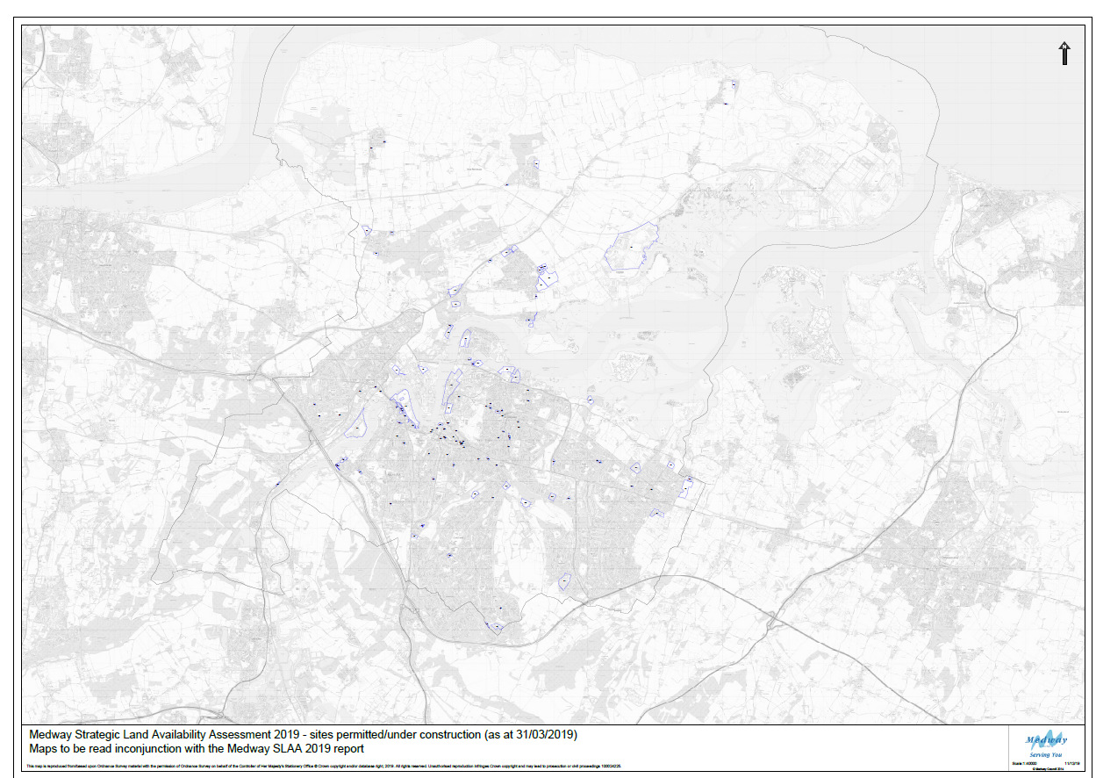
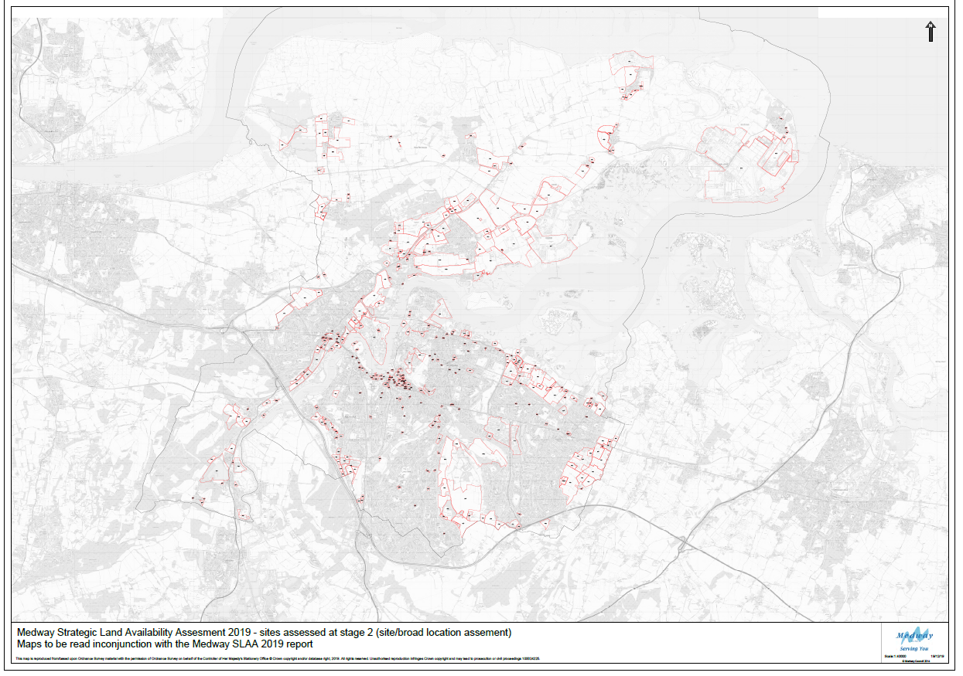
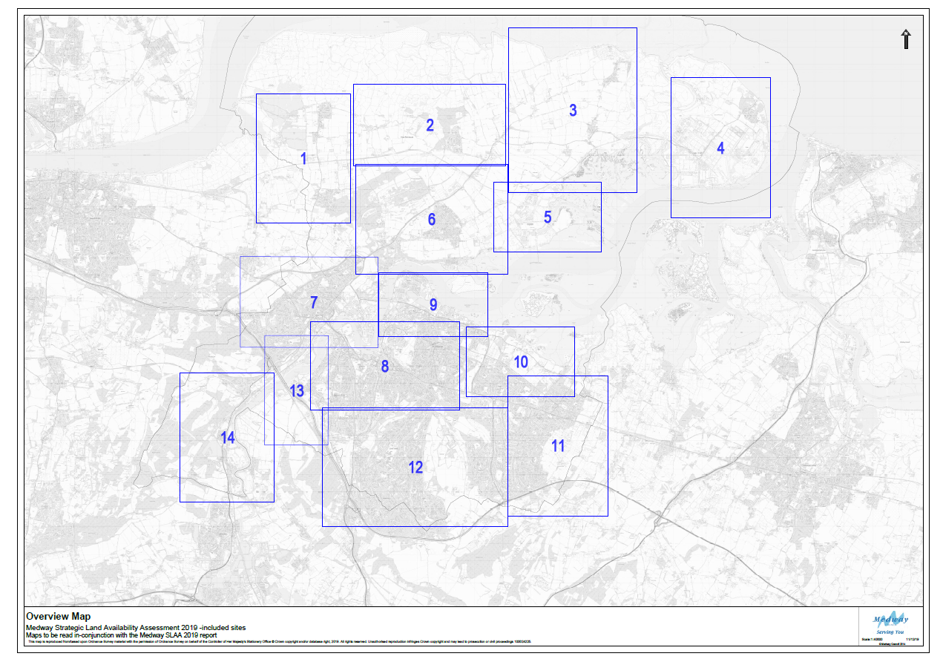
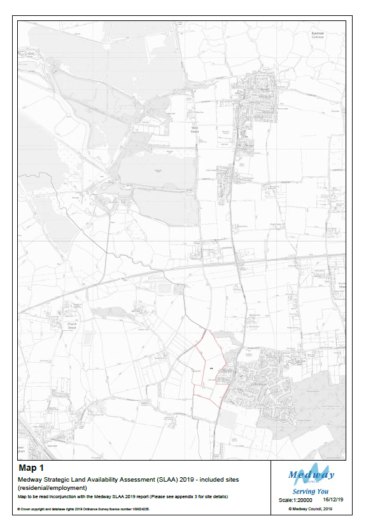

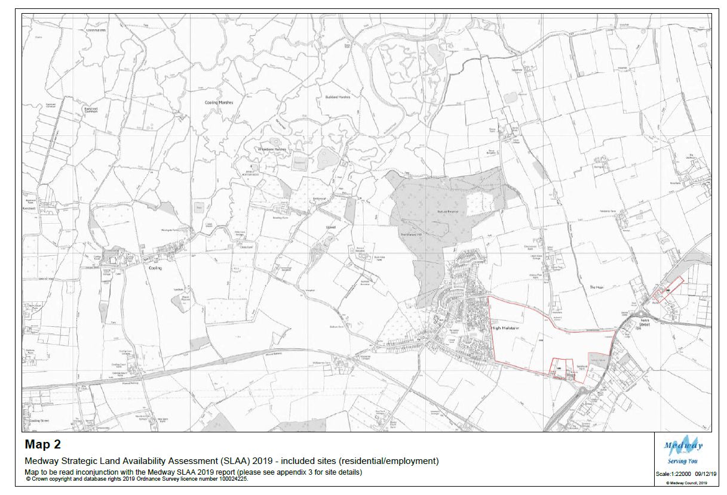
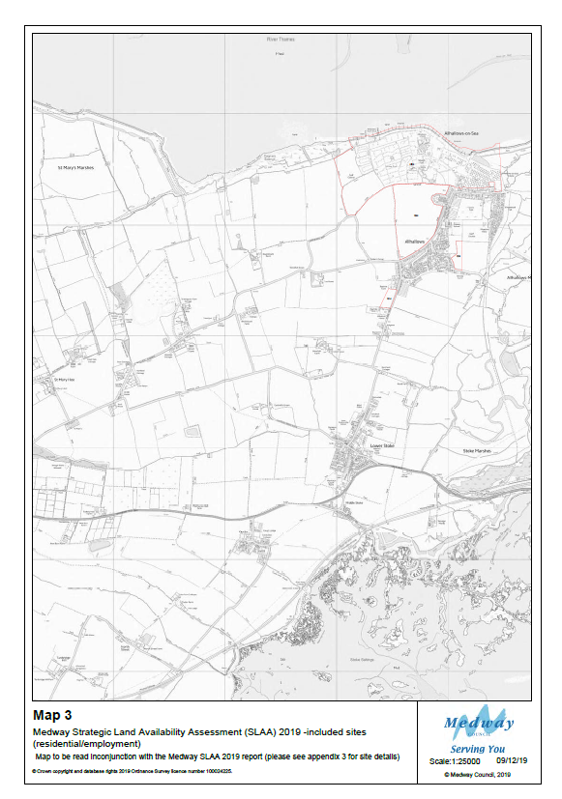

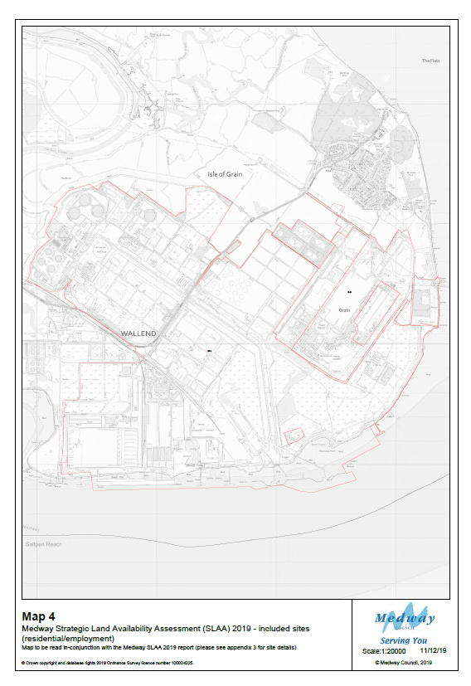

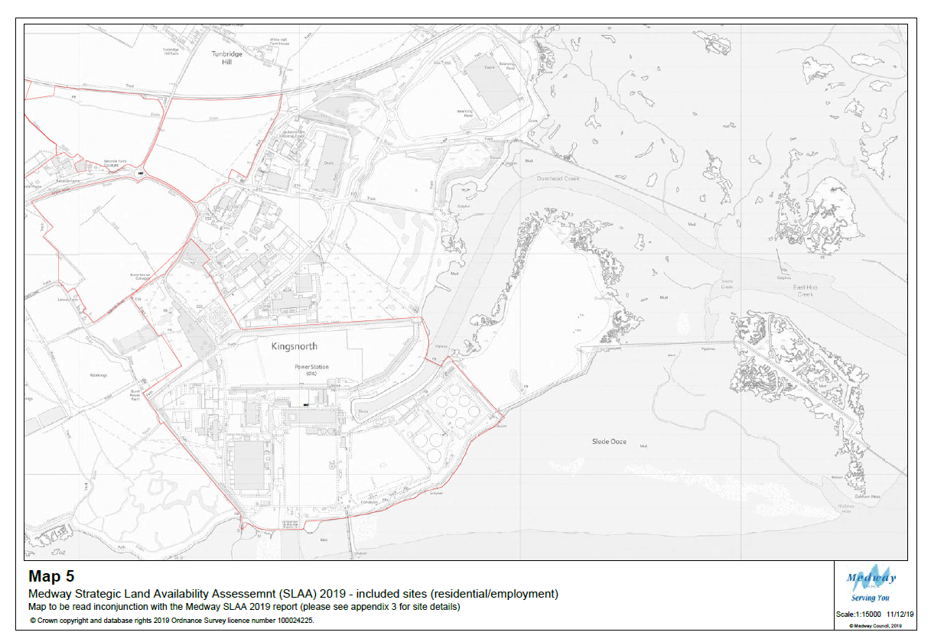
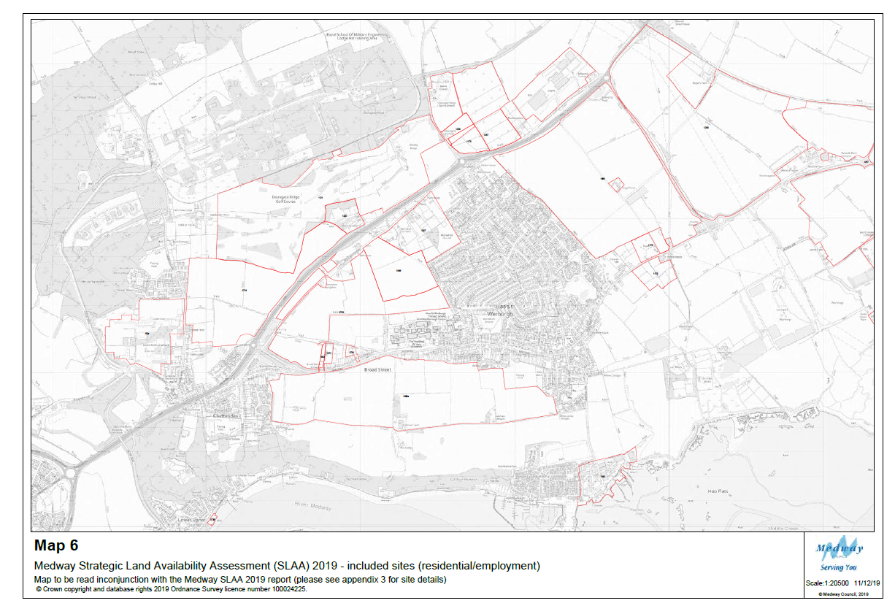
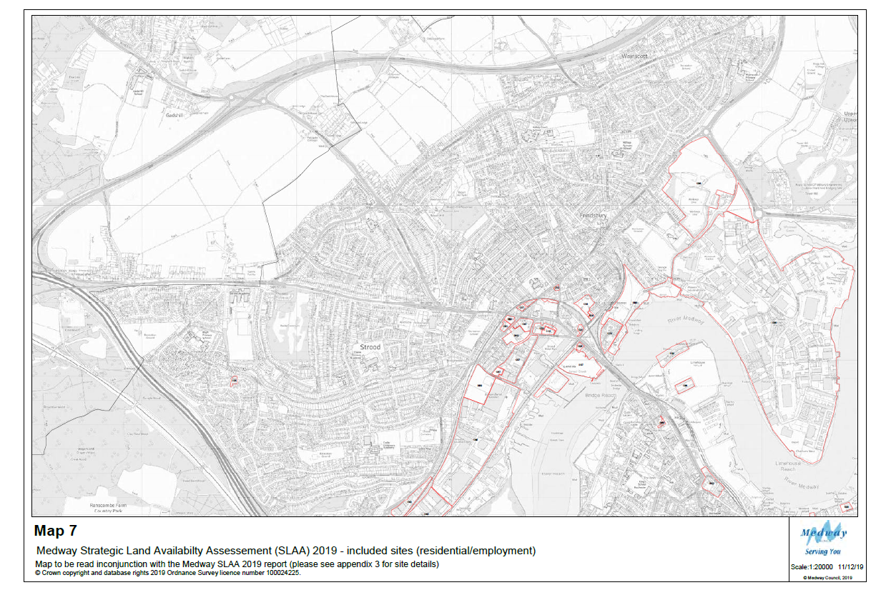
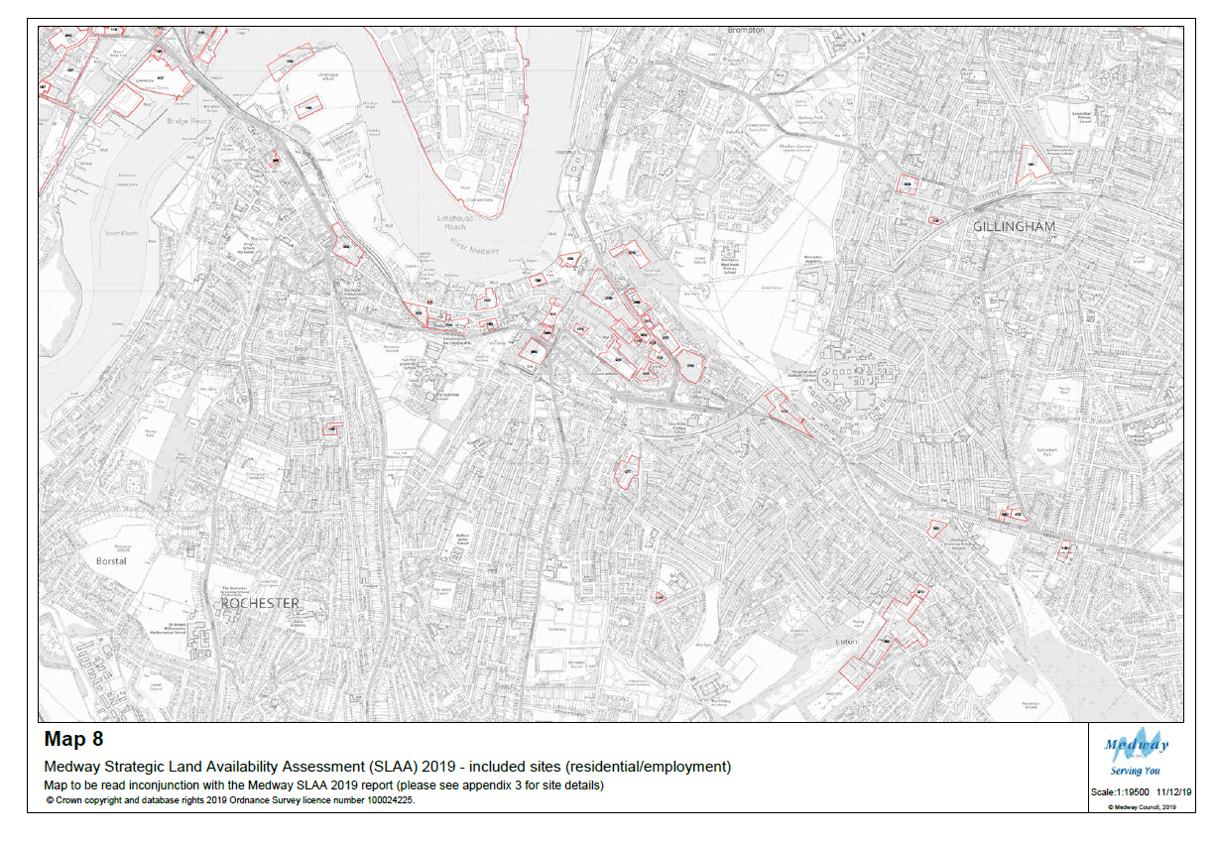
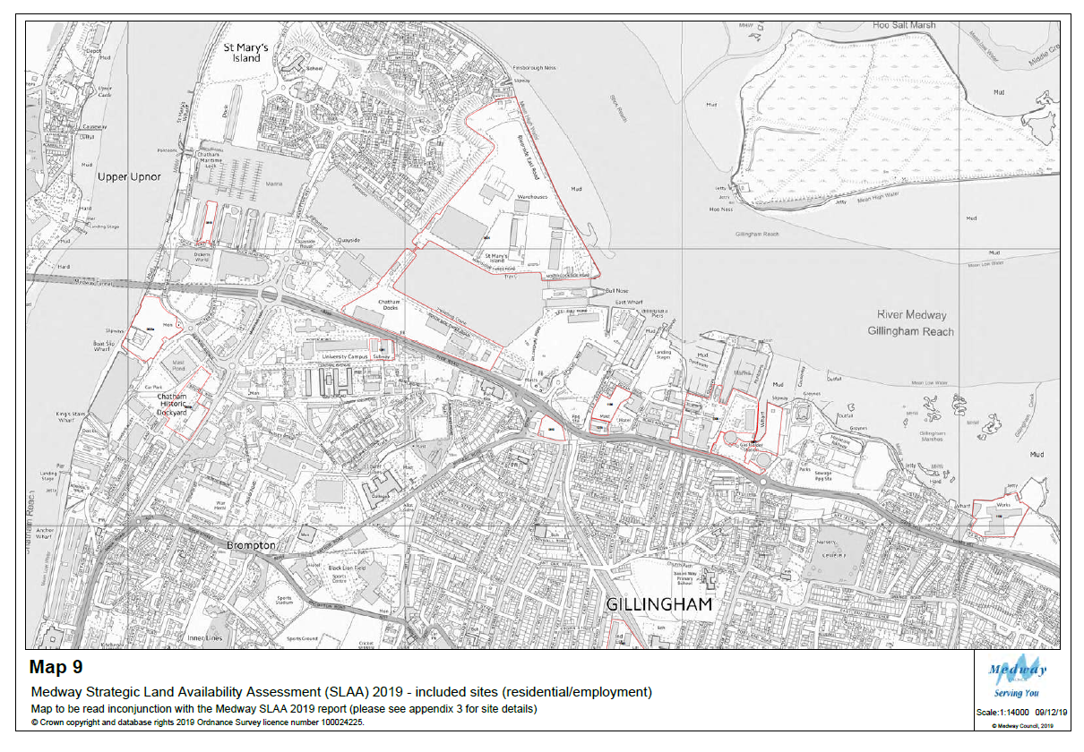
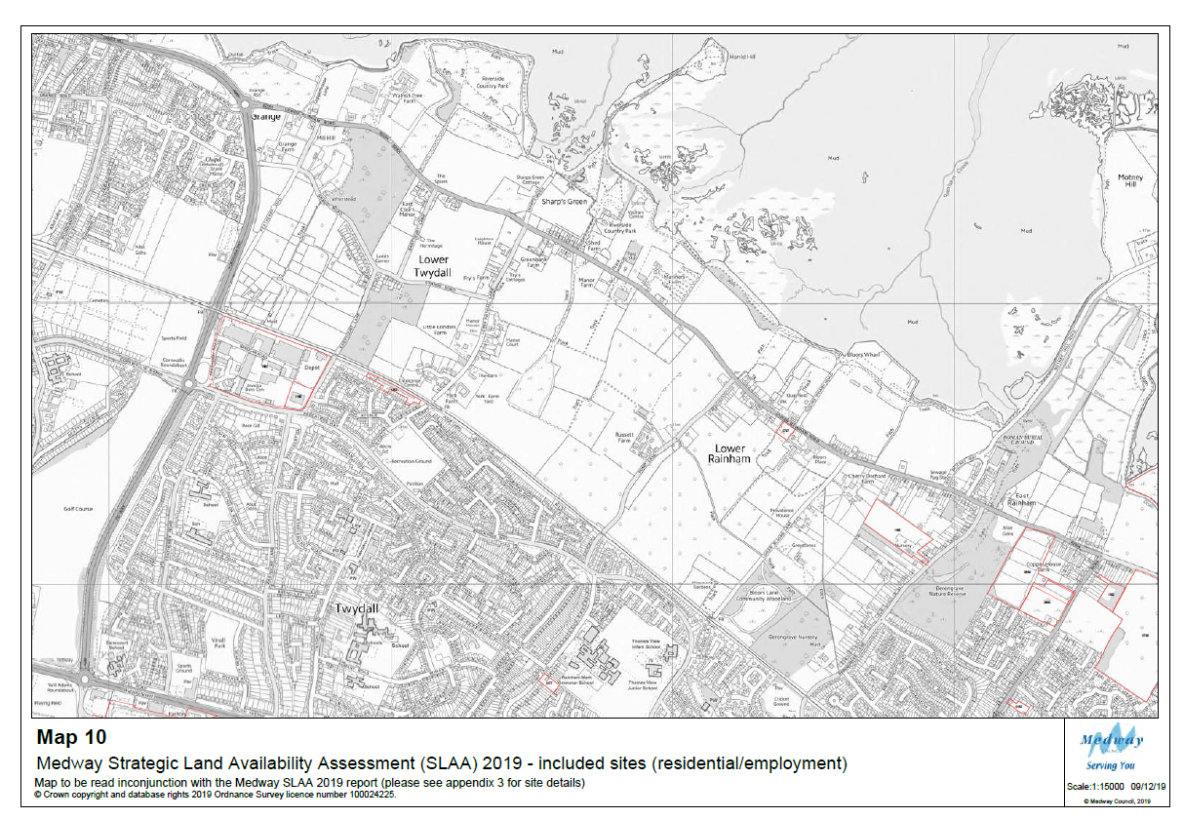

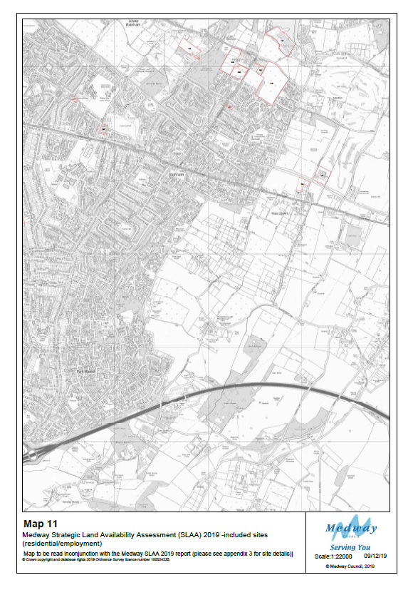

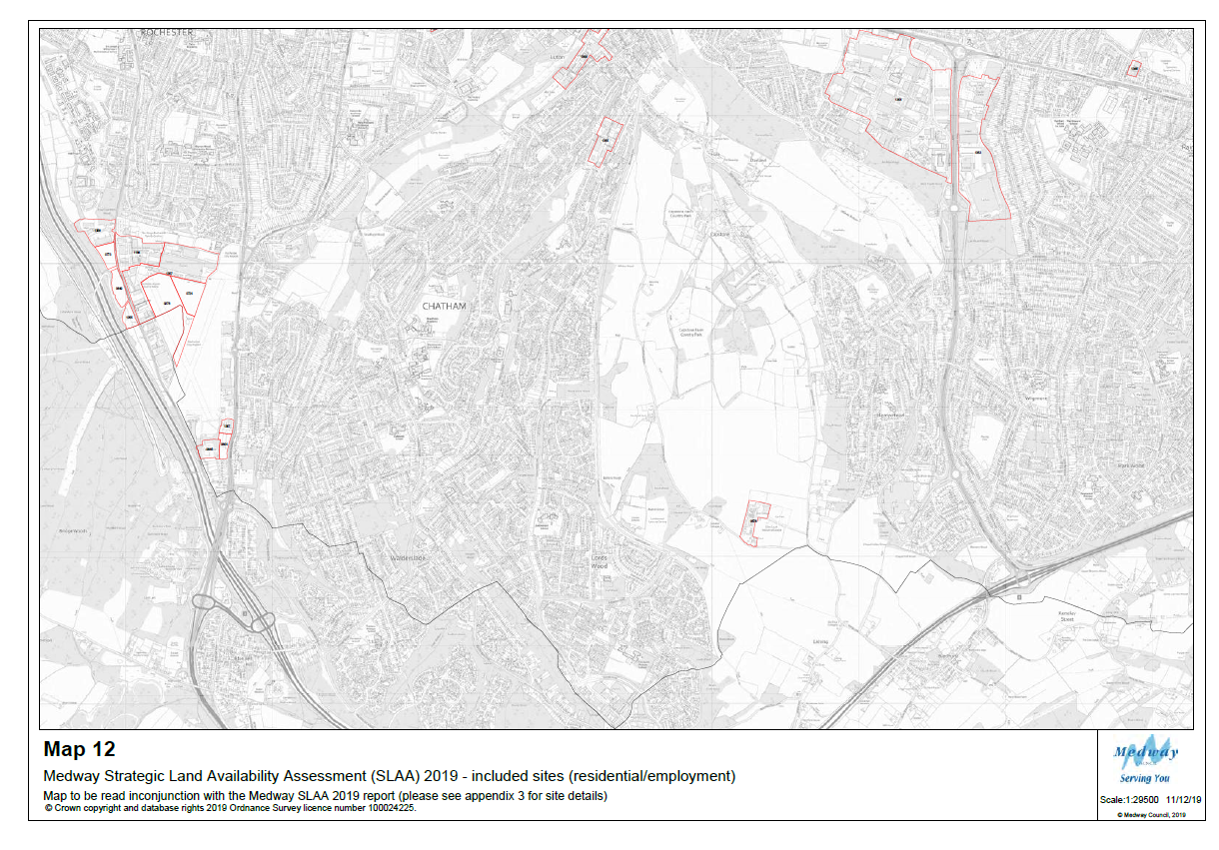
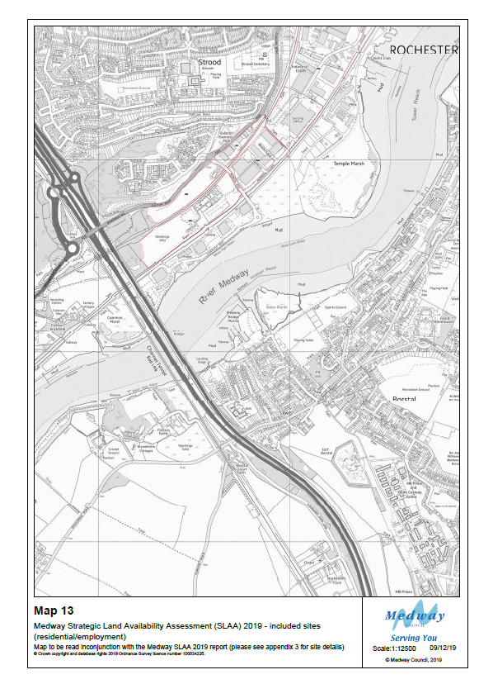

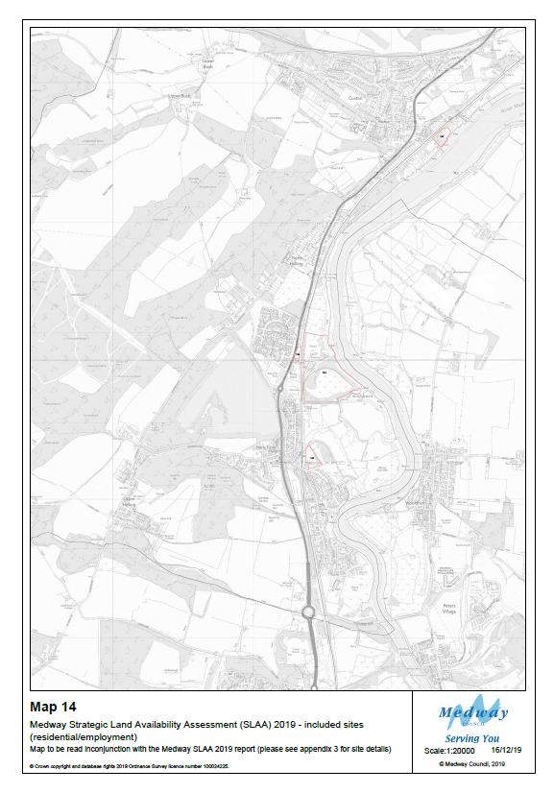

Appendix 8 – Broad locations search

Appendix 8

Broad location search 2014-2019

Introduction
Planning practice guidance states that the Strategic Land Availability Assessment should identify sites and broad locations with potential for development.

Medway Council has carried out broad locations search as part of the process of a comprehensive review of potential land availability for development. This process has developed over time to ensure that the in preparing the Local Plan, the Council considers the broadest possible range of sites and locations for growth. In summary there were three broad workstreams:

  - Urban & village boundary review (2015-16)
  - Spatial options review (2016-17)
  - Urban Opportunity Areas Review (2018-19)

This report has been prepared as an appendix to the Medway SLAA report, 2019. It provides an overview of these reviews and their contribution to the SLAA process.

Medway village & urban boundary review 2015-16
The urban boundary is a tool used to differentiate between the rural and urban area. It enables the Council to manage development sustainably across Medway by aiming to protect undeveloped land and to guide growth to the urban areas. The present urban boundaries were set in the Medway Local Plan 2003.

Over the period 2015-16 the council undertook a review of the urban and village boundaries in Medway as part of the development of the new Local Plan. The aim of the process was twofold:

- to amend boundaries to include/exclude areas with the urban boundary deemed as not appropriate/appropriate. The process involved several stages which are outlined below.

Methodology
There were three key stages to the urban boundary review:

Stage 1 – Desktop Review
The Council firstly mapped and divided the urban boundary and villages. The urban boundary was divided into sections and maps were created for villages (including those which currently have no village boundary).

Information collated for each relevant section of urban boundary or village included:
- Existing defined boundary
- SLAA sites
- Key constraints (ecology designations, AONB, Green Belt, flood zone 3)

If the land was within the Green Belt, the assessment did not progress to the next stage. (Green Belt locations were considered strategically in the Green Belt Review 2018).

Individual land parcels were identified for review by using maps & aerial photos. When assessing these locations the following questions were asked:

  - Are there areas where an obvious “rounding off” or infill development could be
accommodated? Include infill between SLAA sites if appropriate.
  - Does the site relate (visually or functionally) to the urban or rural area?
  - Consider defensible boundaries – new & existing
  - Consider issues of coalescence that might suggest no expansion in some directions
  - Any obvious barriers e.g. major roads, railways, woodlands
  - Any large open areas currently within boundary that should be excluded?
  - Any areas where built development has been excluded and should be included?
  - For rural settlements – is the built up area of a size and character that it should be given a rural settlement boundary?

When land parcels had been identified as suitable for review they were allocated reference numbers, which recorded any areas where there was potential for change (in or out).

Stage 2 – Site Surveys & Recommendations

Areas identified as having potential for change at Stage 1 were visited and surveyed using a standard form. A scoring was then applied:

  - Green highlight = consider whether site could go into urban boundary (or be allocated in association with neighbouring SLAA sites)
  - Pink highlight = consider whether site should be removed from urban boundary
  - Blue highlight = not boundary review, but consider whether has development potential (use SLAA form)

Updated maps were produced to show suggested new boundary and sites that may be suitable for development. This was then reviewed at a team meeting to review site survey and officer judgement through a peer review process, and ensure consistency.

Stage 3 – Follow-up
If the survey identified new sites to be added to the SLAA further site investigation was undertaken to gain more information on the site. This included:

  - Identify & make contact with landowner – would they be willing to consider development of the site and if there any known issues that the Council should be aware of
  - Add to SLAA database and map – consider development potential and what uses would be appropriate
  - Record site notes on SLAA database

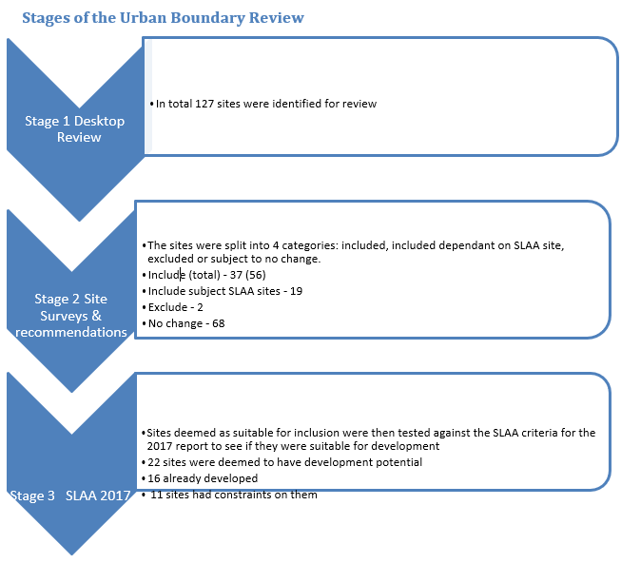

Conclusions
Overall the Urban Boundary Review found there to be a potential for a change in the urban boundary within 60 places across Medway. Proportionally it concluded that overall most sites should remain the same. Where change was deemed acceptable, the assessment was that more sites should be included
(56) rather than excluded (2).

Of the sites deemed suitable for inclusion within the UB only 22 were assessed to have development potential. These represented a potential yield of 1440 extra homes at a density of 29 dph. However a number of sites had strong dependencies to neighbouring SLAA sites. If those sites that relied on SLAA sites to come forward were excluded the development potential was reduced to 624 homes at a density of @29 dph.

3.Medway spatial development options 2016-17
Following the Regulation 18 Issues and Options consultation at an early stage of the plan preparation process, and the SLAA conclusions the Council undertook a review of the broad locations with
development potential. This spatial options review was carried out in 2016-17 and the findings were used to inform the Regulation 18 Development Options Consultation in 2017.

Methodology
The spatial options broad locations search was a desktop and design led process to help inform the four Development Options set out in the Development Options Consultation 2017.

Stage 1 – desktop review
A review of the SLAA 2015 concluded that there was insufficient land identified to meet the scale of development needs set out in the emerging evidence base. The Council recognised that further assessment was needed. There were two broad actions: to have an open call for sites, rather than a specific call, and further broad locations search.

When reviewing the SLAA 2015 the Medway area was sub-divided into spatial option areas for deeper review. The spatial option areas reflected the local geography and:
- Opportunities for growth
- Infrastructure
- Physical separations created by natural or man-made features

Stage 2 – site identification
Within the spatial option locations a gap analysis was undertaken. This analysis reviewed the spatial distribution of submitted SLAA sites and sought geographical gaps free from any major constraints that would have otherwise meant they were screened out of the SLAA process. The areas of land with development potential, which were not being promoted, were then recorded as sites for the purposes of the SLAA with a reference of a SO [Spatial Option]).

Stage 3 – Consultation review
In November 2016 workshops were held in the spatial options areas (Hoo Peninsula, North of Rainham and East of Rainham). These areas were chosen as they did not already have submitted masterplans from the development industry and had the capacity to supply further broad locations of search.

Opportunity areas review 2018-19
Both the SLAA 2017 and SLAA 2018 reports concluded that there was not enough land supply identified to meet the housing need over the plan period, and a further review of sites was needed. The Council sought further opportunities to identify sites and land with development potential. This review work was also informed by ongoing consultation and proposals on the introduction of a standard method for calculating local housing need. In September 2017 the Government announced that a standard method for calculating need was to be used, which was confirmed in February 2019. This has provided the basis for determining levels of housing need over the plan period, and is a reference for the 2019 SLAA.

The Opportunity areas review was a design led approach to make best use of land and support urban regeneration. The review focused on key regeneration areas identified by the Council in the centres of Strood, Chatham & Gillingham. This focus aligned with the regeneration strategy, Medway 2035, and responded to concerns raised in consultation to address structural change in retail and the High
Streets. This urban centre focus represented an opportunity to determine if there were any new sites appropriate to be used in the SLAA analysis. Other potential greenfield locations in suburban and rural areas without statutory constraints had previously been included in the SLAA, and were well represented in the Call for Sites and in the urban boundary review. The regeneration of urban waterfront sites in Medway is progressing, with a number of high profile schemes. The Council, through Medway Development Company, and other developers are now bringing forward town centre development sites. This provides signals of confidence in these locations.

The Council commissioned town centre masterplans and delivery strategies for Chatham, Gillingham and Strood. The brief included the identification of land and sites with development potential, and to set out a strategy to deliver appropriate growth. The preparation of the masterplans included stakeholder workshops, including representatives of the development sector, with interests in these locations. The consultants carried out some market testing of the interest in bringing forward sites. The findings were set out in the delivery strategies that formed part of the outputs of the commission.

Methodology

Stage 1 – Site identification
The regeneration of existing areas is a primary focus of national policy and guidance and due to the large housing need in Medway the Council has undertaken further analysis of three of its town centres (Strood, Chatham & Gillingham). These locations were felt to have the most potential
through a review of previous SLAA’s to identify where there were any gaps and access to services
and facilities helping to make them sustainable.

Stage 2 – Design analysis
The sites identified were then tested by consultants to understand their potential. The analysis was design led that resulted in a preferred use and scale of development.

Stage 3 – Phasing & delivery
The consultants then soft market tested the sites so that their achievability and availability could be tested in the SLAA.

Conclusions
The results of the town centre masterplans analysis are the documents that were published in December 2019. However the outputs need to be further tested for their availability and achievability following publication. This will be supported by the Viability Assessment being carried out for the draft Local Plan.

Appendix 9 – Density analysis

Appendix 9

Minimum Density Standards
Where there is an anticipated shortage of land for meeting identified housing needs, national planning policy expects local policies to include minimum density standards for city, town centres and other locations that are well served by public transport.

Work on the emerging Local Plan is preparing a ‘Minimum density standard’ policy. This policy approach was presented in Regulation 18 consultation documents to inform the new Local Plan. It was originally based on optimum density standards and centred on railway stations, with three zones identified, up to a 20 minute / 1.6 kilometre walk. However, a 10 minute / 800 metre walk has traditionally been regarded as the extent to which people will walk to a railway station.¹
Responses to the Regulation 18 consultation process on the emerging Medway Local Plan highlighted the need to consider high frequency bus corridors. A five minute / 400 metre walk has traditionally been regarded as the extent to which people will walk to a bus stop in residential areas, reducing to under three minutes / 200 metre walk in town centres.² Clearly railway stations are fixed locations, however bus routes can change, and therefore the policy relates to existing high frequency bus corridors and the need to respond to future opportunities.

The evidence base involved an assessment of accessibility to railway stations and high frequency bus corridors. This work defined the following accessibility zones:

  - A – within a 10 minutes / 800 metre walk of Chatham Railway Station
  - B – within a 10 minutes / 800 metre walk of Strood Railway Station
  - C – within a 10 minutes / 800 metre walk of Gillingham Railway Station
  - D – within a 10 minutes / 800 metre walk of Rochester Railway Station
  - E – within a 10 minutes / 800 metre walk of Rainham Railway Station
  - F – within a 10 minutes / 800 metre walk of Cuxton Railway Station
  - G – within a 10 minutes / 800 metre walk of Halling Railway Station
  - H – less than three minutes / 200 metre walk in town centres or within a five minute / 400 metre walk of an existing high frequency bus corridor
Minimum density standards have been applied to the accessibility zones in Table 1:

¹ https://www.ciht.org.uk/knowledge-resource-centre/resources/streets-and-transport-in-the-urban- environment/
² Ibid

Table 1: Minimum Density Standards

Accessibility Zone | Policies Map Label | Dwellings per Hectare
Chatham railway station | A | See Chatham Town Centre Masterplan
Strood Railway Station | B | See Strood Town Centre Masterplan
Gillingham Railway Station | C | 50
Rochester Railway Station | D | 50
Rainham Railway Station | E | 35
Cuxton Railway Station | F | 35
Halling Railway Station | G | 35
High frequency bus corridor | H | 35

The zones are defined as circular zones ‘as the crow flies’; this is considered to be appropriate, given the potential for increased permeability, allowing for more safe and convenient walking routes to access public transport.
The minimum density standards reflect the context, accessibility and potential of different areas. This has also been informed by masterplans commissioned to support the new Local Plan.
The density proposed in the Strood Town Centre Masterplan is approximately 100 dwellings per hectare across the residential-led sites. However, a range of residential typologies and indicative densities is proposed, including mews housing, town houses, maisonettes and mixed use apartment blocks. The residential typologies provide a useful reference for other urban areas in Medway. The masterplan is not intended to be prescriptive, however the principle of providing a range of housing types, in a way that responds to the surrounding context, is considered to be important to support a mixed and diverse community.
The Chatham Town Centre Masterplan indicates a range of building heights across residential-led sites. Reference to the residential typologies set out in the Strood Town Centre Masterplan suggests that 1 to 5 storey buildings would be commensurate with a linear apartment block at 100 to 150 dwellings per hectare, while 11 to 15 storey buildings would exceed the highest density types at 200+ dwellings per hectare. Similarly, the masterplan is not intended to be prescriptive, however the principle of providing a range of housing types, in a way that responds to the surrounding context, is considered to be important to support a mixed and diverse community.
The Gillingham Town Centre Masterplan took a different approach in identifying the potential for residential development. Three sites were identified and considered to be representative of the range of sites across the town centre. The masterplan did not propose a minimum density standard. However, a minimum density standard of 50 dwellings per hectare is appropriate, given the area within Accessibility Zone C and the residential typologies set out in the Strood Town Centre Masterplan.
There are relatively fewer opportunities for growth in Rochester. However, a minimum density standard of 50 dwellings per hectare is appropriate, given the area within Accessibility Zone D and the residential typologies set out in the Strood Town Centre Masterplan. This is a restrained
approach, given Rochester’s heritage and the limited capacity of the transport network.
There are common misconceptions about density, however research has demonstrated how higher densities can be also be achieved in a suburban setting and this is of relevance beyond Medway’s central areas. The ‘Sustainable Suburbia’ study provides a blueprint for a walkable garden suburb by reconciling the aspirations and qualities of suburban housing with the communal benefits of higher densities. Through a combination of house types and layouts, the study identifies a range of densities from detached houses at 35 dph to mews layouts at 75 dph and non-family accommodation in three of four storey flats at 150dph.³ Accessibility zones E to H reflect the detached house typology, however higher densities are encouraged, subject to design quality. All new housing developments outside of the accessibility zones would be expected to deliver 35 dph.

Appendix 10 – Windfall assessment

Appendix 10 Windfall Assessment
- National policy and guidance
In the council’s monitoring of development sites, windfalls comprise sites with planning permission which have not been allocated for development in the adopted Local Plan or identified in a planning document. Garden land development is excluded from the council's monitoring of windfalls.

However, the definition of a windfall site has changed since the publication of the revised National Planning Policy Framework (NPPF).

Windfall sites were originally defined as:
Sites which have not been specifically identified as available in the Local Plan process. They normally comprise previously-developed sites that have unexpectedly become available.⁴
The revised NPPF defines windfall sites as

Sites not specifically identified in the development plan.⁵

Apart from Local Plan allocations, the revised definition implies that sites identified in the Strategic Land Availability Assessment (SLAA) can be considered as potential windfalls.

At paragraph 70, the revised NPPF states that:

Where an allowance is to be made for windfall sites as part of anticipated supply, there should be compelling evidence that they will provide a reliable source of supply. Any allowance should be realistic having regard to the strategic housing land availability assessment, historic windfall delivery rates and expected future trends.⁶
The Planning Practice Guidance sets out a methodology which involves a Windfall Assessment at Stage 3 to determine the housing potential of windfall sites. Specifically:

A windfall allowance may be justified in the anticipated supply if a local planning authority has compelling evidence as set out in paragraph 70 of the National Planning Policy Framework.
Local planning authorities have the ability to identify broad locations in years 6-15, which could include a windfall allowance (using the same criteria as set out in paragraph 67 of the National Planning Policy Framework).⁷
The Windfall Assessment will justify a windfall allowance in years 6 to 15 with regard to paragraph 70 of the NPPF.
⁴ NPPF (2012), Glossary
⁵ NPPF (2019), Glossary
⁶ NPPF (2019), Paragraph 70
⁷ PPG, Paragraph: 023 Reference ID: 3-023-20190722

Strategic Land Availability Assessment
The SLAA provides information on the range of sites available for development. However, it is for the development plan to allocate sites for development.⁸
The emerging development strategy emphasises the regeneration of urban centres and the expansion of Hoo St Werburgh, supported by the successful Housing Infrastructure Fund bid.

Monitoring of windfall development to date has excluded all SLAA sites, in line with the definition of a windfall site in the original NPPF. The revised definition however demonstrates a potential supply of windfalls with the potential to deliver up to five new homes.

Stage 1 of the SLAA requires the identification of sites and broad locations capable of delivering five or more homes. This minimum threshold has been applied in the SLAA, in which some 80 sites were excluded due to their limited capacity of one to four homes. Subject to their suitability for development, these sites could accommodate between 80 to 320 homes. This is indicative only; clearly the SLAA cannot identify all potential sites with the potential to deliver up to five new homes.

Historic windfall delivery
Analysis of historic windfall delivery will inform the windfall allowance. Monitoring of windfall completions in the last five years is shown in Table 1.

Table 1: Net housing completions, 2014/15 to 2018/19

Year | Total net housing completions | Delivered via windfalls | % delivered by windfalls
2014 to 2015 | 483 | 78 | 16%
2015 to 2016 | 553 | 131 | 24%
2016 to 2017 | 642 | 232 | 36%
2017 to 2018 | 680 | 154 | 23%
2018 to 2019 | 647 | 177 | 27%
Total | 3005 | 772 | 26%
Data source: Planning service, Medway Council

Windfall developments have provided a continuous supply of new housing, with over one quarter of total net housing completions delivered through windfalls in the last five years, however this has fluctuated annually. This will inevitably occur due to the unexpected way in which sites come forward for development.
It is acknowledged that the more recent delivery of windfall sites is likely to be overstated due to the age of the current Local Plan, with sites allocated for development in 2003 increasingly built out over time.
Given the scale of Medway’s housing needs, the majority of large sites are likely to be allocated in the new Local Plan. It follows that small and medium sites are more likely to provide a reliable source of windfalls in future. Table 2 compares small and large windfall completions for the last 10 years.
⁸ PPG, Paragraph: 001 Reference ID: 3-001-2019072

Table 2: Windfall completions, 2008/09 to 2018/19
Year | Small windfall completions (1 to 4 homes) | Large windfall completions (5+ homes) | Total
2009 to 2010 | 63 | 244 | 307
2010 to 2011 | 89 | 171 | 260
2011 to 2012 | 42 | 149 | 191
2012 to 2013 | 59 | 141 | 200
2013 to 2014 | 39 | 127 | 166
2014 to 2015 | 45 | 33 | 78
2015 to 2016 | 77 | 54 | 131
2016 to 2017 | 89 | 143 | 232
2017 to 2018 | 62 | 92 | 154
2018 to 2019 | 88 | 89 | 177
Total | 653 | 1243 | 1896
Average (mean) | 65 | 124 | 190
Statistical range | 50 | 211
Data includes Previously Developed Land and greenfield completions
Data excludes sites which were previously identified in the SLAA and garden land development Data source: Planning Service, Medway Council
Table 2 shows that the data for large windfall completions is more dispersed, indicating that small windfall completions have provided a more reliable supply of new homes.
Small windfalls have delivered almost as many new homes as large windfalls in the last 5 years. However, the potential for an unknown large windfall site could deliver a significant number of new homes and therefore large windfalls should not be discounted.
The average number of new homes completed through all windfall sites for the 10 year period is 190.

Smaller developments
Smaller sites (i.e. less than 10 net homes) have and will continue to make a significant contribution towards meeting local housing need. In any one year, just 11 schemes of nine net homes each could deliver over half of the windfall allowance. The continuation of such developments elsewhere will comprise windfalls.
It is conceivable that the remaining windfall allowance could be delivered through an unknown large windfall site, particularly towards the end of the plan period or subsequent review periods as fewer allocated sites remain.
- Expected future trends
It is important to note that the historic windfall delivery followed the post-2008 recession; the Strategic Housing Market Assessment (2015) emphasised that the recession had marked impacts locally, while the return to pre-recession values has been slow.⁹ The period of analysis therefore could reflect suppressed delivery rates and it is reasonable to expect a more favourable market conditions in future.
The council is committed to the regeneration agenda and this is set out in the ‘Medway 2035’ Regeneration Strategy. Further opportunities to deliver new homes will arise during the plan period, such as estate renewal programmes, the continuation of permitted development rights and planning policy to encourage the conversion of underutilised upper floor commercial floorspace to residential use.
Opportunity sites have been identified in the urban and waterfront areas; the availability status of these sites is less certain, having been identified through the town centre masterplans. However, the town centre masterplan for Gillingham did not set out to identify new sites; rather, the development potential of three sites was taken as indicative of similar sites in the town centre.
Urban areas of Gillingham and suburban areas and rural settlements across Medway are therefore more likely to provide a source of windfalls.
The emerging development strategy emphasises the regeneration of urban centres and the expansion of Hoo St Werburgh.

- Conclusion
The windfall allowance is based on evidence from the SLAA, historic windfall delivery and expected future trends.

An annual windfall allowance of 190 has been projected in years 6 to 15, amounting to 1,900 new homes, representing 7 per cent of local housing need over the plan period.
Windfalls are expected to be predominantly delivered in suburban areas and rural settlements across Medway and in urban areas of Gillingham.
⁹ GVA (2015) – paras 1.4, 1.20

Appendix 11 –

Overcoming constraints methodology

Appendix 11 Overcoming Constraints
The Medway SLAA, 2019 has been prepared as an iteration of the assessment last published in 2018. The SLAA 2018 did not identify sufficient land to meet the area’s projected development needs over the plan period. The Council therefore sought to identify the potential for further development land, either through new sites, or reviewing the capacity or use of sites meeting the SLAA criteria.
As many potential sites were rejected in the 2018 SLAA as not being suitable, available and/or achievable, an important strand of work was to consider if identified constraints could be overcome. The Council invited site promoters in 2018 to provide further information about their sites, including constraints, and if the site was capable of mitigation. Planning officers also sought technical advice from internal services, including flood risk, heritage and landscape officers, to consider if constraints identified in the 2018 SLAA could be overcome.
In addition, the Council used its ongoing work on the Local Plan evidence base and wider corporate regeneration and development initiatives to update the assessments. The 2018 SLAA identified constraints on the transport network and potential environmental impacts as grounds for finding potential development sites on the Hoo Peninsula unsuitable. In March 2019, the council submitted a major bid to Homes England for infrastructure funding. The success of the Housing Infrastructure Fund bid for £170m of investment in strategic transport and environmental measures provides for mitigation for a number of sites on the Hoo Peninsula. This was an important source of evidence in producing the 2019 SLAA update, and has provided for increased potential land supply.
As a major urban area, the Council also sought further opportunities to bring forward more development in town centres. It commissioned town centre masterplans for Strood, Chatham and Gillingham. These studies showed both potential for delivering growth and support for regeneration in these areas. There have also been increased signs of market interest and confidence in the urban regeneration sites, led by the Council’s Medway Development Company, which is building out sites in Chatham and Gillingham. The Council has received increased interest in development in urban centres since the 2018 SLAA. The process of preparing the town centre masterplans included stakeholder workshops, involving developer interests, and follow up work in soft market testing. The Viability Assessment for the draft Local Plan is also providing further evidence of the development potential and market in these locations.

Figure 1 shows the three broad stages in the overcoming constraints process.
Figure 1: Overcoming constraints
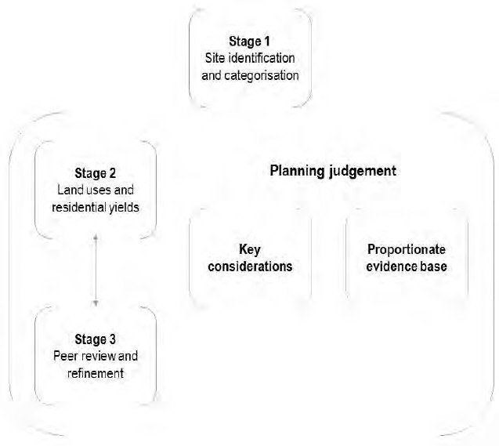

A description of work undertaken for each stage is set out below.

Stage 1: Site identification and categorisation
The site identification stage comprised the development of a comprehensive list of all sites in a Geographic Information Systems (GIS) layer. Sites were identified from the following sources:

  - unimplemented Medway Local Plan 2003 site allocations (as at March 2019);
  - unimplemented planning permissions (as at March 2019);
  - all sites assessed in the SLAA;
  - sites submitted in response to the Regulation 18 ‘Development Strategy’ consultation;
and sites identified through ongoing town centre masterplanning work.
Numerous duplicate sites were identified and removed from the assessment. The GIS attribute data enabled a high-level categorisation of all sites:
  - Grade A comprised sites with unimplemented planning permission as at March 2019. The principle of development on these sites has been established.
  - Grade B comprised sites deemed ‘suitable’, ‘available’ and ‘achievable’ in the SLAA.
  - Grade C comprised sites deemed ‘available’ in the SLAA or subject to a current planning
application.

Stage 2: Land uses and residential yields
Sites intended to accommodate Medway’s employment land need were identified with reference to the Employment Land Needs Assessment (2016) and the development pipeline set out in the Authority Monitoring Report (2018/19).
Sites intended to accommodate new schools were identified through collaborative working with the relevant council officers.
Information submitted to the council in response to the SLAA or previous Local Plan consultations provided an indication as to what the market considered the site to be capable of delivering. The respective residential yields were subject to testing in order to ensure the most efficient use of land. Where this information was unavailable, the potential residential yields were based on the minimum density standards. The net site area was considered to be 60% of the gross site area.
The potential to join adjacent sites or sites in very close proximity was assessed prior to removing sites which were not capable of delivering five or more dwellings, in line with the residential threshold recommended in the PPG (Paragraph: 009 Reference ID: 3-009-20190722, Revision date: 22 07 2019).
Stage 3: Peer review and refinement
Internal workshops with council officers provided an opportunity to consider the site-level opportunities and constraints, informed by the evidence base. This enabled a further categorisation of all sites as follows:
  - 1 – The principle of development has been established.
  - 2 – The site is capable of being mitigated.
  - 3 – The site is not capable of being mitigated. State reason for exclusion with reference to the evidence base.
The sites identified as ‘meeting the SLAA criteria’ are considered to have potential to meet the proposed vision and the strategic objectives of the emerging Local Plan.

Such sites will be subject to ongoing assessment and refinement in response to the emerging evidence base and sustainability appraisal of the new Local Plan.

Appendix 12 - Sites permitted and under construction

Site Name | Site Ref
89 Ingram Road, Gillingham | 3
RSME Kitchener Barracks, Brompton | 33
Chatham Historic Dockyard | 104
East of Gillingham Golf Course | 164
Petham Green Twydall | 193
Borough Road, Gillingham | 219
Dormers, 3 Upper Luton Road, Chatham | 248
443 Former Military Site, Lower Upnor | 443
9 Cross Street Chatham | 462
Mid Kent College, Horsted, Maidstone Road | 470
Land at St Mary's Island Maritime Way, Chatham | 472
Safety Bay House, Warwick Crescent, Rochester | 486
Land rear of 7-13 New Road CHATHAM | 493
Victory Pier, Pier Road, Gillingham | 511
Rochester Riverside | 515
Southern Water Site, Capstone Road, Chatham | 524
389 High Street CHATHAM | 530
94-100 High Street, Chatham | 532
22-26 Victoria Street, Rochester | 537
85 Church Street GILLINGHAM | 547
South Thames Regional Health Authority Land | 564
Fort Horsted, Primrose Close, Chatham | 570
Colonial House | 632
Walnut Tree Farm, 155 Lower Rainham Road, Rainham | 604
Land South of Kent Terrace, Canterbury Lane, Rainham | 655
82 Jeffery Street, Gillingham | 663
Alexander Garage & 3 Old Road, Chatham | 666
Between 142 & 152 Luton Road, Chatham | 680

Site Name | Site Ref
Temple Waterfront, Roman Way, Strood | 685
Hempstead Valley Shopping Centre | 691
Ex Service Stn, adj 86 Corporation Street, Rochester | 700
LIFT site, 551-555 Canterbury Street, Gillingham | 707
Land rear of former St Matthews School, Borstal | 708
North side of Commissioners Road | 711
Land to east of Chattenden Lane | 713
10-40 Corporation Street, Rochester | 728
Land North East of Kingsnorth Industrial Estate | 730
46-86 Corporation Street, Rochester | 731
Former Uniwoi, Fleet House,Upnor Road, Lower Upnor | 736
BAE Sports & Social Club, Bells Lane, Hoo | 751
Bakers Field, Station Road, Rainham | 775
Land at Capstone Valley, Darland Farm | 783b
East of the Old Orchard, Merry Boys Road | 789
Street Farmyard, Stoke Road, Hoo St Werburgh | 795
High View Farm, Lordswood Lane | 803
East side of Vicarage Lane, Hoo | 815
Meeting Hall, Queens Road, Gillingham | 816
Berengrave Nusery, Rainham | 817
Machine Shop 8 Chatham Maritime | 821
Land East of Otterham Quay Lane, Rainham | 825
Medway Bridge Marina, Manor Lane, Rochester | 829
Walnut Tree Farm, r/o Longfield Ave, High Halstow | 835
Land south of View Road, Cliffe Woods | 848
Retail Core (High St, Jeffrey St, King St) Gillingham | 875
208 Canterbury Street Gillingham | 878
R/O 73,75-77 High Street, Rochester | 880

Site Name | Site Ref
Bridgeside Warwick Crescent, Rochester | 914
5 Otway Terrace Chatham | 915
Adjacent to Bus Station Medway Street Chatham - now merged with SLAA site 983 | 984
Mackays Lordswood Industrial Estate | 1033
R/O Whitehouse Farm, Stoke Road, Hoo | 1043
East of Whitehouse Farm, Hoo | 1044
Land at 54 Beacon Road, Chatham | 1048
R/O Oastview, East of Mierscourt Road, Rainham | 1058
North Mortimers Avenue, west Town Road | 1069
51 Cuxton Road, Strood | 1099
Greatfield Lodge, Darnley Road, Strood | 1100
Cooling Road, High Halstow | 1103
Chatham Driving Range | 1114
Golf course adj to Kingsmead Park, Allhallows | 1127
Land at Elm Avenue, Chattenden | 1131
Lennox Wood, Petham Green, Twydall | 1136
263-267 High Street Chatham | 1138
330 High Street Chatham | 1139
153-155 High Street Chatham | 1140
75-81 High Street Strood | 1142
Former Chatham Port, Pier Road, Gillingham | 1143
Wyles Road, Chatham | 1144
Royal Sovereign House, Chatham Maritime | 1146
Port Werburgh, Vicarage Lane, Hoo | 1150
The Windmill, Ratcliffe Highway Hoo | 1151
JCB Medway, Gillingham Business Park Rainham | 1154
13-15 Borough Road, Gillingham MLP Allocated Site | 1156
Land South of Stoke Road, Hoo | 1174

Site Name | Site Ref
Britton Farm, Gillingham | 1183
Plot 1, Anthony's Way, Medway City Estate | 1187
Redvers Cenre, Glencoe Road, Chatham | 1194
Former United Services, 27 Arden Street, Gilligham | 1195
The Fox 124 Ordnance Terrace Chatham | 1196
Livingstone Arms 239 Gillingham Road GILLINGHAM | 1197
Newton Close Resource Centre Sultan Road Lordswood | 1198
Trafalgar Maid 2 Warner Street Chatham | 1200
205-217 New Road Chatham | 1201
259-261 High Street ROCHESTER | 1202
Land south of Stoke Road Hoo | 1203
11-17 High Street Strood | 1204
Land at 185 Walderslade Road Walderslade | 1205
13-17 Church Street Chatham | 1206
The Yard 1A Milton Road Gillingham | 1207
Binney Farm | 1210
56-58 Balmoral Road Gillingham | 1227
Yeoman House Princes Street Rochester | 1228
Rookery Lodge, Thatchers Lane, Cliffe | 1229
St Paulinus Church Manor Street Brompton | 1231
21 Berengrave Lane, Rainham | 1234
149-151 High Street, Chatham | 1235
7 The Brook, Chatham | 1236
3 High Street, Gillingham | 1237
90-92 Station Road, Rainham | 1239
The Evening Star 128 Church Street Cliffe | 1241
78 John Street, Rochester | 1242
71 Rochester Road Cuxton | 1243

Site Name | Site Ref
41 Barnsole Road Gillingham | 1244
Adj 186 Laburnum Road Strood | 1246
2 and 4 Laburnum Road Strood | 1247
The Bridge Wardens The Tideway Rochester | 1249
Highway House, 195 New Road, Chatham | 1325
224-228 Nelson Road, Gillingham | 1326
12 New Road Avenue, Chatham | 1327
346a High Street, Chatham | 1329
21-23 New Road, Chatham | 1330
9-11 The Brook, Chatham | 1332
75 Shanklin Close, Chatham | 1341

