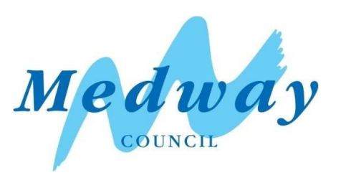

Medway Council

Pier Road, Gillingham, High Street, Rainham, and Central Medway

Air Quality Action Plan 2024-2029

In fulfilment of Part IV of the Environment Act 1995

Local Air Quality Management

2024

| Information | Medway Details |
| --- | --- |
| **Local Authority Officer** | Stuart Steed |
| **Department** | Environmental Protection |
| **Address** | Medway Council, Dock Road, Chatham, ME4 4TR |
| **Telephone** | 01634 331105 |
| **E-mail** | stuart.steed@medway.gov.uk |
| **Report Reference Number** | ED19190 |
| **Date** | 31 May 2024 |

# Executive Summary

This Air Quality Action Plan (AQAP) has been produced as part of our statutory duties required by the Local Air Quality Management framework. It outlines the action we will take to improve air quality between 2024-2029 within the three Air Quality Management Areas (AQMAs) declared in 2010: Central Medway AQMA, Pier Road, Gillingham AQMA, and High Street, Rainham AQMA. Further details on the declared AQMAs are presented on Defra’s UK AIR website[1].

This action plan replaces the previous action plan which ran from 2015-2020. Projects delivered through the past action plan include:

* Review Regional Freight Strategy: Medway Council worked with Kent County Council on a draft revised regional Freight Action Plan (including Medway). Consultation and adoption to be undertaken during 2017. Movement of freight also tackled locally through the Medway draft Network Management Plan for 2017-2020. The draft plan aims to tackle road congestion, and performance indicators, such as journey times, traffic data, cycle count data. Air quality monitoring data can be used as a means of measuring the plans impact against a baseline scenario.
* Development of an Air Quality Communication Strategy.
* Setting up of AQAP Steering Group and book 6-monthly meetings with stakeholders.
* Develop and continue walk or cycle to school scheme and events.

Air pollution is associated with a number of adverse health impacts. It is recognised as a contributing factor in the onset of heart disease and cancer. Additionally, air pollution particularly affects the most vulnerable in society: children and older people, and those with heart and lung conditions. There is also often a strong correlation with equalities issues, because areas with poor air quality are also often the less affluent areas[2],[3].

The annual health cost to society of the impacts of particulate matter alone in the UK is estimated to be around £16 billion[4]. Medway Council is committed to reducing the exposure of people in Medway to poor air quality in order to improve health.

We have developed actions that can be considered under seven broad topics:

* Freight and delivery management
* Policy guidance and development control
* Promoting low emission transport
* Promoting travel alternatives
* Public information
* Transport planning and infrastructure
* Traffic management

Our first priority is to bring about compliance with the Air Quality Strategy objectives across Medway, focusing on NO2 concentrations within the Central Medway, Gillingham, and Rainham AQMAs (as well as the Four Elms Hill AQMA, which is addressed in a separate AQAP). To achieve this, we have included measures in the AQAP which target the key sources of emissions in the borough: diesel and petrol cars, light and heavy goods vehicles, and buses. Medway is also committed to working towards reducing emissions and concentrations of PM2.5 across the borough and has included measures to achieve this in the AQAP.

In this AQAP we outline how we plan to effectively tackle air quality issues within our control. However, we recognise that there are a large number of air quality policy areas that are outside of our influence (such as vehicle emissions standards agreed in Europe), but for which we may have useful evidence, and so we will continue to work with regional and central government on policies and issues beyond Medway Council’s direct influence.

## Responsibilities and Commitment

This AQAP was prepared by the Environmental Protection Team of Medway Council with the support and agreement of the following officers and departments:

* Environmental Protection
* Transport and Parking
* Public Health
* Sustainable Transport
* Regeneration
* Licensing
* Public Transport Planning
* Green Spaces and Rights of Way and Access
* Climate Response

Cabinet will be asked to approve adoption of this AQAP following Statutory Consultation and subsequent finalisation of the plan.

Progress each year will be reported in the Annual Status Reports (ASRs) produced by Medway Council, as part of our statutory Local Air Quality Management duties.

If you have any comments on this AQAP please send them to: [env,planning@medway.gov.uk](mailto:environmental.protection@medway.gov.uk)

Table of Contents

Executive Summary i

**Responsibilities and Commitment iii**

Introduction 1

Summary of Current Air Quality in Medway 2

**1.1 Summary of Current Air Quality in the Pier Road, Gillingham AQMA 3**

**1.2 Summary of Current Air Quality in the High Street, Rainham AQMA 4**

**1.3 Summary of Current Air Quality in the Central Medway AQMA 6**

Medway’s Air Quality Priorities 8

**1.4 Public Health Context 8**

**1.5 Planning and Policy Context 9**

**1.5.1 National policy 9**

**1.5.2 One Medway Council Plan 10**

**1.5.3 Local Plan 11**

**1.5.4 Air Quality Planning Guidance 11**

**1.5.5 Climate Change Action Plan 12**

**1.5.6 Bus Service Improvement Plan 12**

**1.5.7 Local Transport Plan 13**

**1.5.8 Air Quality Communication Strategy 13**

**1.5.9 Local Cycling and Walking Infrastructure Plan 13**

**1.6 Source Apportionment 14**

**1.7 Required Reduction in Emissions 19**

**1.7.1 NOx and NO2 emissions reductions 19**

**1.7.2 Scenario Modelling 20**

**1.8 Key Priorities 21**

Development and Implementation of Medway’s AQAP 22

**1.9 Consultation and Stakeholder Engagement 22**

**1.10 Steering Group 23**

AQAP Measures 24

Appendix A: Response to Consultation 29

Appendix B: Reasons for Not Pursuing Action Plan Measures 30

Appendix C: 2022 Baseline Model, Source Apportionment and Scenario Modelling Study 37

Appendix D: Steering Group Workshop Meeting Minutes 89

Glossary of Terms 106

List of Tables

Table 1 – Annual Mean NO2 Concentrations at point of declaration for AQMAs in Medway 2

Table 2 – Improvement in Annual Mean NO2 Concentrations and road NOx Concentration Required to Meet the Objective 19

Table 3 ‒ Consultation Undertaken 22

Table 4 – Air Quality Action Plan Measures 25

Table A- 1 – Breakdown of modelled NOx emissions at diffusion tube locations within AQMAs (% of total modelled NOx emissions) by source 50

Table A- 2 – Breakdown of measured NO2 concentrations (2022) at diffusion tube locations within AQMAs µg/m3) by source 52

Table A- 3 – Breakdown of modelled PM10 emissions at diffusion tube locations within AQMAs (% of total modelled NOx emissions) by source 56

Table A- 4 – Breakdown of modelled PM2.5 emissions at diffusion tube locations within AQMAs (% of total modelled NOx emissions) by source 60

Table A- 5 – Summary of AQAP measures modelled and associated modelling scenarios 64

Table A- 6 – Comparison of modelled total annual NOx, PM10, PM2.5 and CO2 emissions from road transport (tonnes/yr), across Medway, for the Bus Modelling Scenario 70

Table A- 7 – Comparison of modelled total annual NOx, PM10, PM2.5 and CO2 emissions from road transport (tonnes/yr), across Medway, for the EV Modelling Scenario 70

Table A- 8 – Comparison of modelled annual NOx, PM10, PM2.5 and CO2 emissions from road transport (tonnes/yr), across Medway, for the Freight Modelling Scenario 70

Table A- 9 – Comparison of modelled NO2 concentrations across Medway for the Bus Modelling Scenario 73

Table A- 10 – Comparison of modelled NO2 concentrations across Medway for the EV Modelling Scenario 74

Table A- 11 – Comparison of modelled NO2 concentrations across Medway for the Freight Modelling Scenario 75

Table A- 12 – Comparison of modelled PM10 concentrations across Medway for the Bus Modelling Scenario 79

Table A- 13 – Comparison of modelled PM10 concentrations across Medway for the EV Modelling Scenario 80

Table A- 14 – Comparison of modelled PM10 concentrations across Medway for the Freight Modelling Scenario 81

Table A- 15 – Comparison of modelled PM2.5 concentrations across Medway for the Bus Modelling Scenario 85

Table A- 16 – Comparison of modelled PM2.5 concentrations across Medway for the EV Modelling Scenario 86

Table A- 17 – Comparison of modelled PM2.5 concentrations across Medway for the Freight Modelling Scenario 87

List of Figures

Figure 1 – Summary of air quality monitoring (annual mean NO2 concentrations) at diffusion tube locations within Pier Road, Gillingham AQMA over the last five years 4

Figure 2 – Summary of air quality monitoring (annual mean NO2 concentrations) at diffusion tube locations within High Street, Rainham AQMA over the last five years 5

Figure 3 – Summary of air quality monitoring (annual mean NO2 concentrations) at diffusion tube locations within Central Medway AQMA over the last five years 7

Figure 4 – Stacked bar chart showing NOx source apportionment for road transport and background sources for monitoring locations within Medway’s AQMAs (%), for the baseline fleet, 2022 16

[Figure 5 – Stacked bar chart showing PM2.5 source apportionment for road transport and background sources for monitoring locations within Medway’s AQMAs (%), for the baseline fleet, 2022 17](https://ricardogroup.sharepoint.com/sites/ED19190/Shared%20Documents/Project/2%20Project%20delivery/1%20Reports/ED19190_Medway_AQAP_2024_Issue%202.1.docx#_Toc166753836)

Figure 6 – Stacked bar chart showing PM10 source apportionment for road transport and background sources for monitoring locations within Medway’s AQMAs (%), for the baseline fleet, 2022 18

Figure A- 1 – Model domain and monitoring locations used in the assessment 38

[Figure A- 2 – Modelled NO2 concentrations across Medway in 2022 43](https://ricardogroup.sharepoint.com/sites/ED19190/Shared%20Documents/Project/2%20Project%20delivery/1%20Reports/ED19190_Medway_AQAP_2024_Issue%202.1.docx#_Toc166753824)

[Figure A- 3 Modelled NO2 concentrations across Central Medway AQMA in 2022 44](https://ricardogroup.sharepoint.com/sites/ED19190/Shared%20Documents/Project/2%20Project%20delivery/1%20Reports/ED19190_Medway_AQAP_2024_Issue%202.1.docx#_Toc166753825)

[Figure A- 4 – Modelled NO2 concentrations across Pier Road, Gillingham AQMA in 2022 45](https://ricardogroup.sharepoint.com/sites/ED19190/Shared%20Documents/Project/2%20Project%20delivery/1%20Reports/ED19190_Medway_AQAP_2024_Issue%202.1.docx#_Toc166753826)

Figure A- 5 – Modelled NO2 concentrations across High Street, Rainham AQMA in 2022 46

[Figure A- 6 Workflow and data used to calculate source apportionment 48](https://ricardogroup.sharepoint.com/sites/ED19190/Shared%20Documents/Project/2%20Project%20delivery/1%20Reports/ED19190_Medway_AQAP_2024_Issue%202.1.docx#_Toc166753828)

[Figure A- 7 – Stacked bar chart showing NOx source apportionment for all road transport and background for monitoring locations within Medway’s AQMAs (%), for the baseline fleet, 2022 49](https://ricardogroup.sharepoint.com/sites/ED19190/Shared%20Documents/Project/2%20Project%20delivery/1%20Reports/ED19190_Medway_AQAP_2024_Issue%202.1.docx#_Toc166753829)

[Figure A- 8 – Stacked bar chart showing PM10 source apportionment for all road transport and background for monitoring locations within Medway’s AQMAs (%), for the baseline fleet, 2022 55](https://ricardogroup.sharepoint.com/sites/ED19190/Shared%20Documents/Project/2%20Project%20delivery/1%20Reports/ED19190_Medway_AQAP_2024_Issue%202.1.docx#_Toc166753830)

Figure A- 9 – Stacked bar chart showing PM2.5 source apportionment for all road transport and background for monitoring locations within Medway’s AQMAs (%), for the baseline fleet, 2022 59

# Introduction

This report outlines the actions that Medway Council will deliver between 2024-2029 in order to reduce concentrations of air pollutants and exposure to air pollution; thereby positively impacting on the health and quality of life of residents and visitors to the borough of Medway.

It has been developed in recognition of the legal requirement on the local authority to work towards the Air Quality Strategy (AQS) objectives under Part IV of the Environment Act 1995 and relevant regulations made under that part and to meet the requirements of the Local Air Quality Management (LAQM) statutory process.

This plan will be reviewed every five years at the latest and progress on measures set out within this plan will be reported on annually within Medway’s air quality ASR.

# Summary of Current Air Quality in Medway

Air quality in Medway is reviewed annually as part of the LAQM review and assessment process. The 2023 ASR presents annual mean concentrations monitored in 2022[5].

Medway Council carries out LAQM reviewing and reporting duties in line with the requirements of the Environment Act 1995. All previous years’ reports are available at [KentAir](http://www.kentair.org/).

Medway has declared four Air Quality Management Areas (AQMAs): Central Medway AQMA, High Street, Rainham AQMA, and Pier Road, Gillingham AQMA (declared in 2010), and Four Elms Hill AQMA (declared in 2017). All four AQMAs were declared for exceedances of the annual mean NO2 air quality objective (AQO). The NO2 concentrations at the point of declaration for the AQMA’s is available in Table 1. Further details on the AQMAs are presented on Defra’s UK AIR website[6].

Table 1 – Annual Mean NO2 Concentrations at point of declaration for AQMAs in Medway

| AQMA and year of declaration | NO2 concentration at point of declaration (µgm-3) |
| --- | --- |
| Central Medway (2010) | 58.4 [7] |
| High Street, Rainham (2010) | 52.9 7 |
| Pier Road, Gillingham (2010) | 52.7 7 |
| Four Elms Hill (2017) | 52.0 [8] |

## Summary of Current Air Quality in the Pier Road, Gillingham AQMA

Figure 1 provides a summary of the annual mean NO2 concentrations reported at diffusion tube locations within the Gillingham AQMA for 2018 – 2022, and compares them to the annual mean AQO (40 μg/m3). The three diffusion tubes located within the Gillingham AQMA have not been in exceedance of the annual mean for NO2 over the past five years; concentrations have decreased across all diffusion tubes since 2018 and remained relatively stable around or below 30 μg/m3 from 2020 to 2022. The maximum concentration recorded over the period 2018 – 2022 was 37.9 μg/m3 at DT25 in 2018, and in 2022, the maximum concentration reported in the AQMA was 29.7 μg/m3 at the same diffusion tube – well below the AQO.

Using the most recent population data from the Office of National Statistics[9], for Lower Super Output Areas (LSOAs)[10] within the AQMA, the total population of the LSOAs that are intersected by the Pier Road, Gillingham AQMA for 2021 was 11,733. This is a slight increase from 11,696 persons as recorded in the 2011 Census.

As a result of the sustained improvements in air quality in Gillingham AQMA, and consistent annual mean NO2 measurements below 90% of the AQO, Medway Council will continue to implement measures to improve air quality across the borough, and look to revoke the AQMA in the near future. Any updates will be provided in future ASRs.

Figure 1 – Summary of air quality monitoring (annual mean NO2 concentrations) at diffusion tube locations within Pier Road, Gillingham AQMA over the last five years

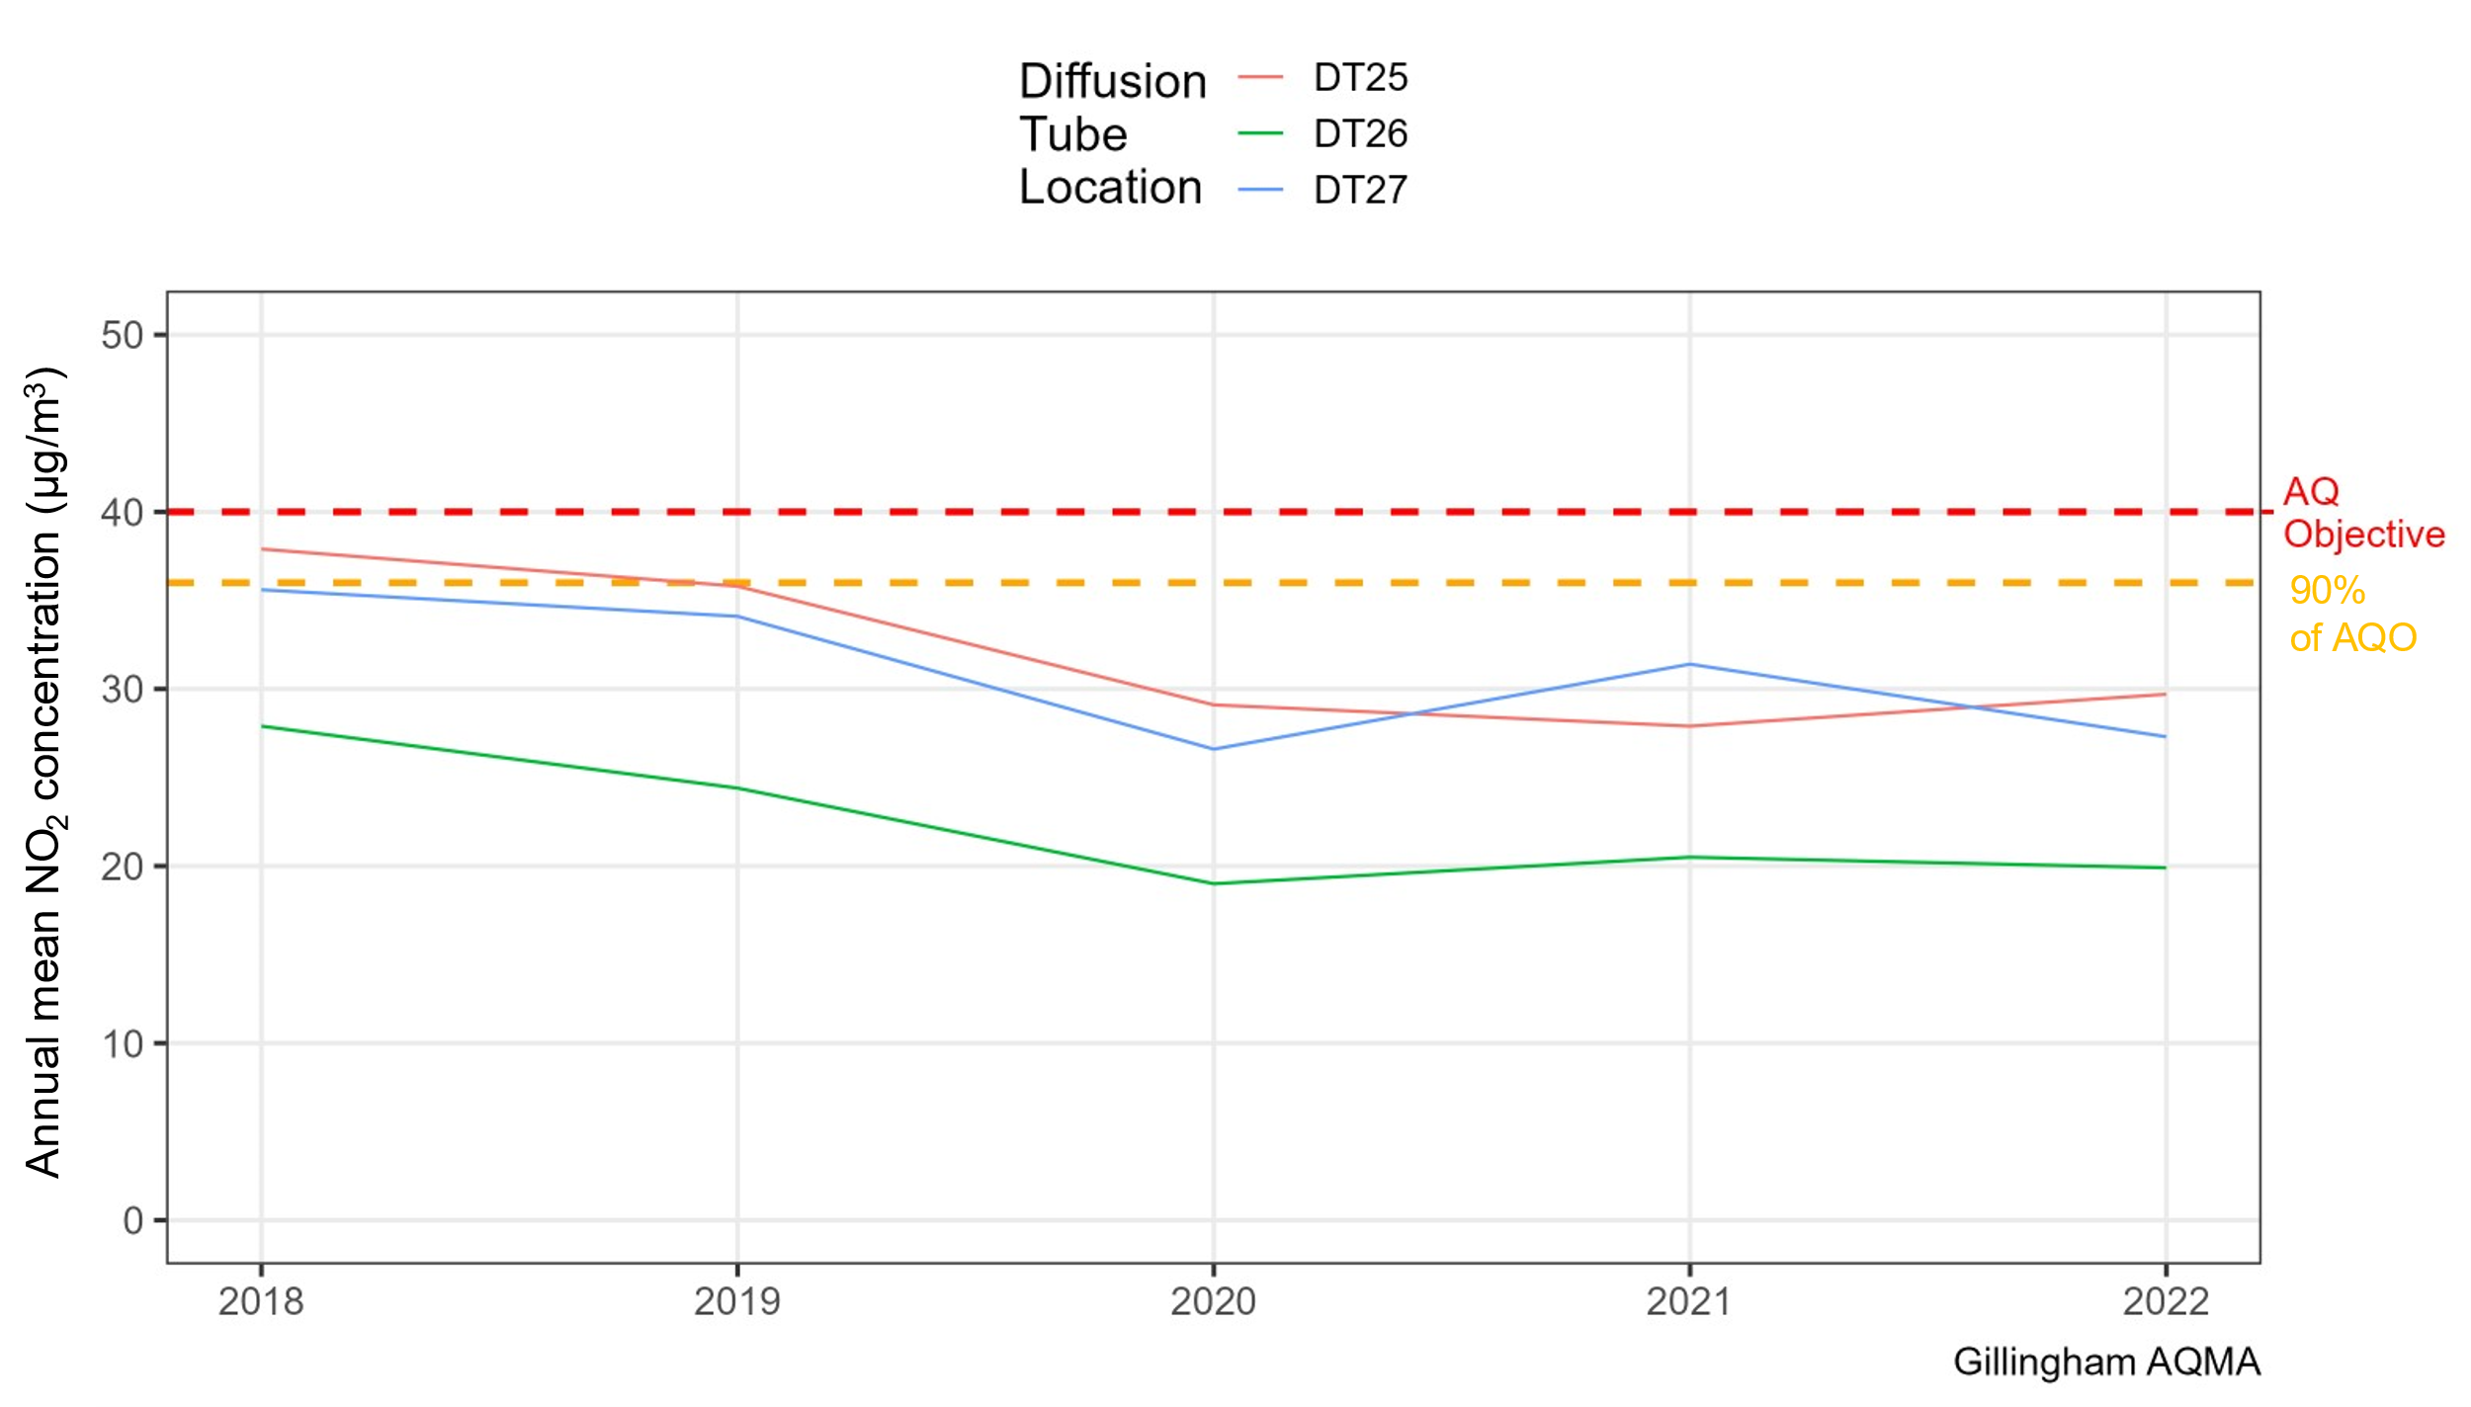

## Summary of Current Air Quality in the High Street, Rainham AQMA

Figure 2 provides a summary of the annual mean NO2 concentrations reported at diffusion tube locations within Rainham AQMA for 2018 – 2022. The three diffusion tubes located within the Rainham AQMA have not been in exceedance of the annual mean for NO2 over the past five years, and have decreased slightly (though not linearly) from 2018 to present. DT15 and DT16 are well below the AQO in 2022, at approximately 30 μg/m3 and 20 μg/m3, respectively. The maximum concentration recorded over the period 2018 – 2022 was 39.3 μg/m3 at DT01 in 2019 (within 10% of the AQO); in 2022, the maximum concentration reported in the AQMA was 34.9 μg/m3 at the same diffusion tube.

Using the most recent population data from the Office of National Statistics[11], for Lower Super Output Areas (LSOAs)[12] within the AQMA, the total population of the LSOAs that are intersected by the High Street, Rainham AQMA for 2021 was 7,757. This is a slight increase from 7,527 persons as recorded in the 2011 Census.

There have been consistent annual mean NO2 measurements below 90% of the AQO in Rainham AQMA, although concentrations have risen slightly from 2020 to 2022. As a result, Medway Council will continue to analyse the concentrations in Rainham AQMA and deliver actions to improve air quality, with the aim of revoking the AQMA in the future.

Figure 2 – Summary of air quality monitoring (annual mean NO2 concentrations) at diffusion tube locations within High Street, Rainham AQMA over the last five years

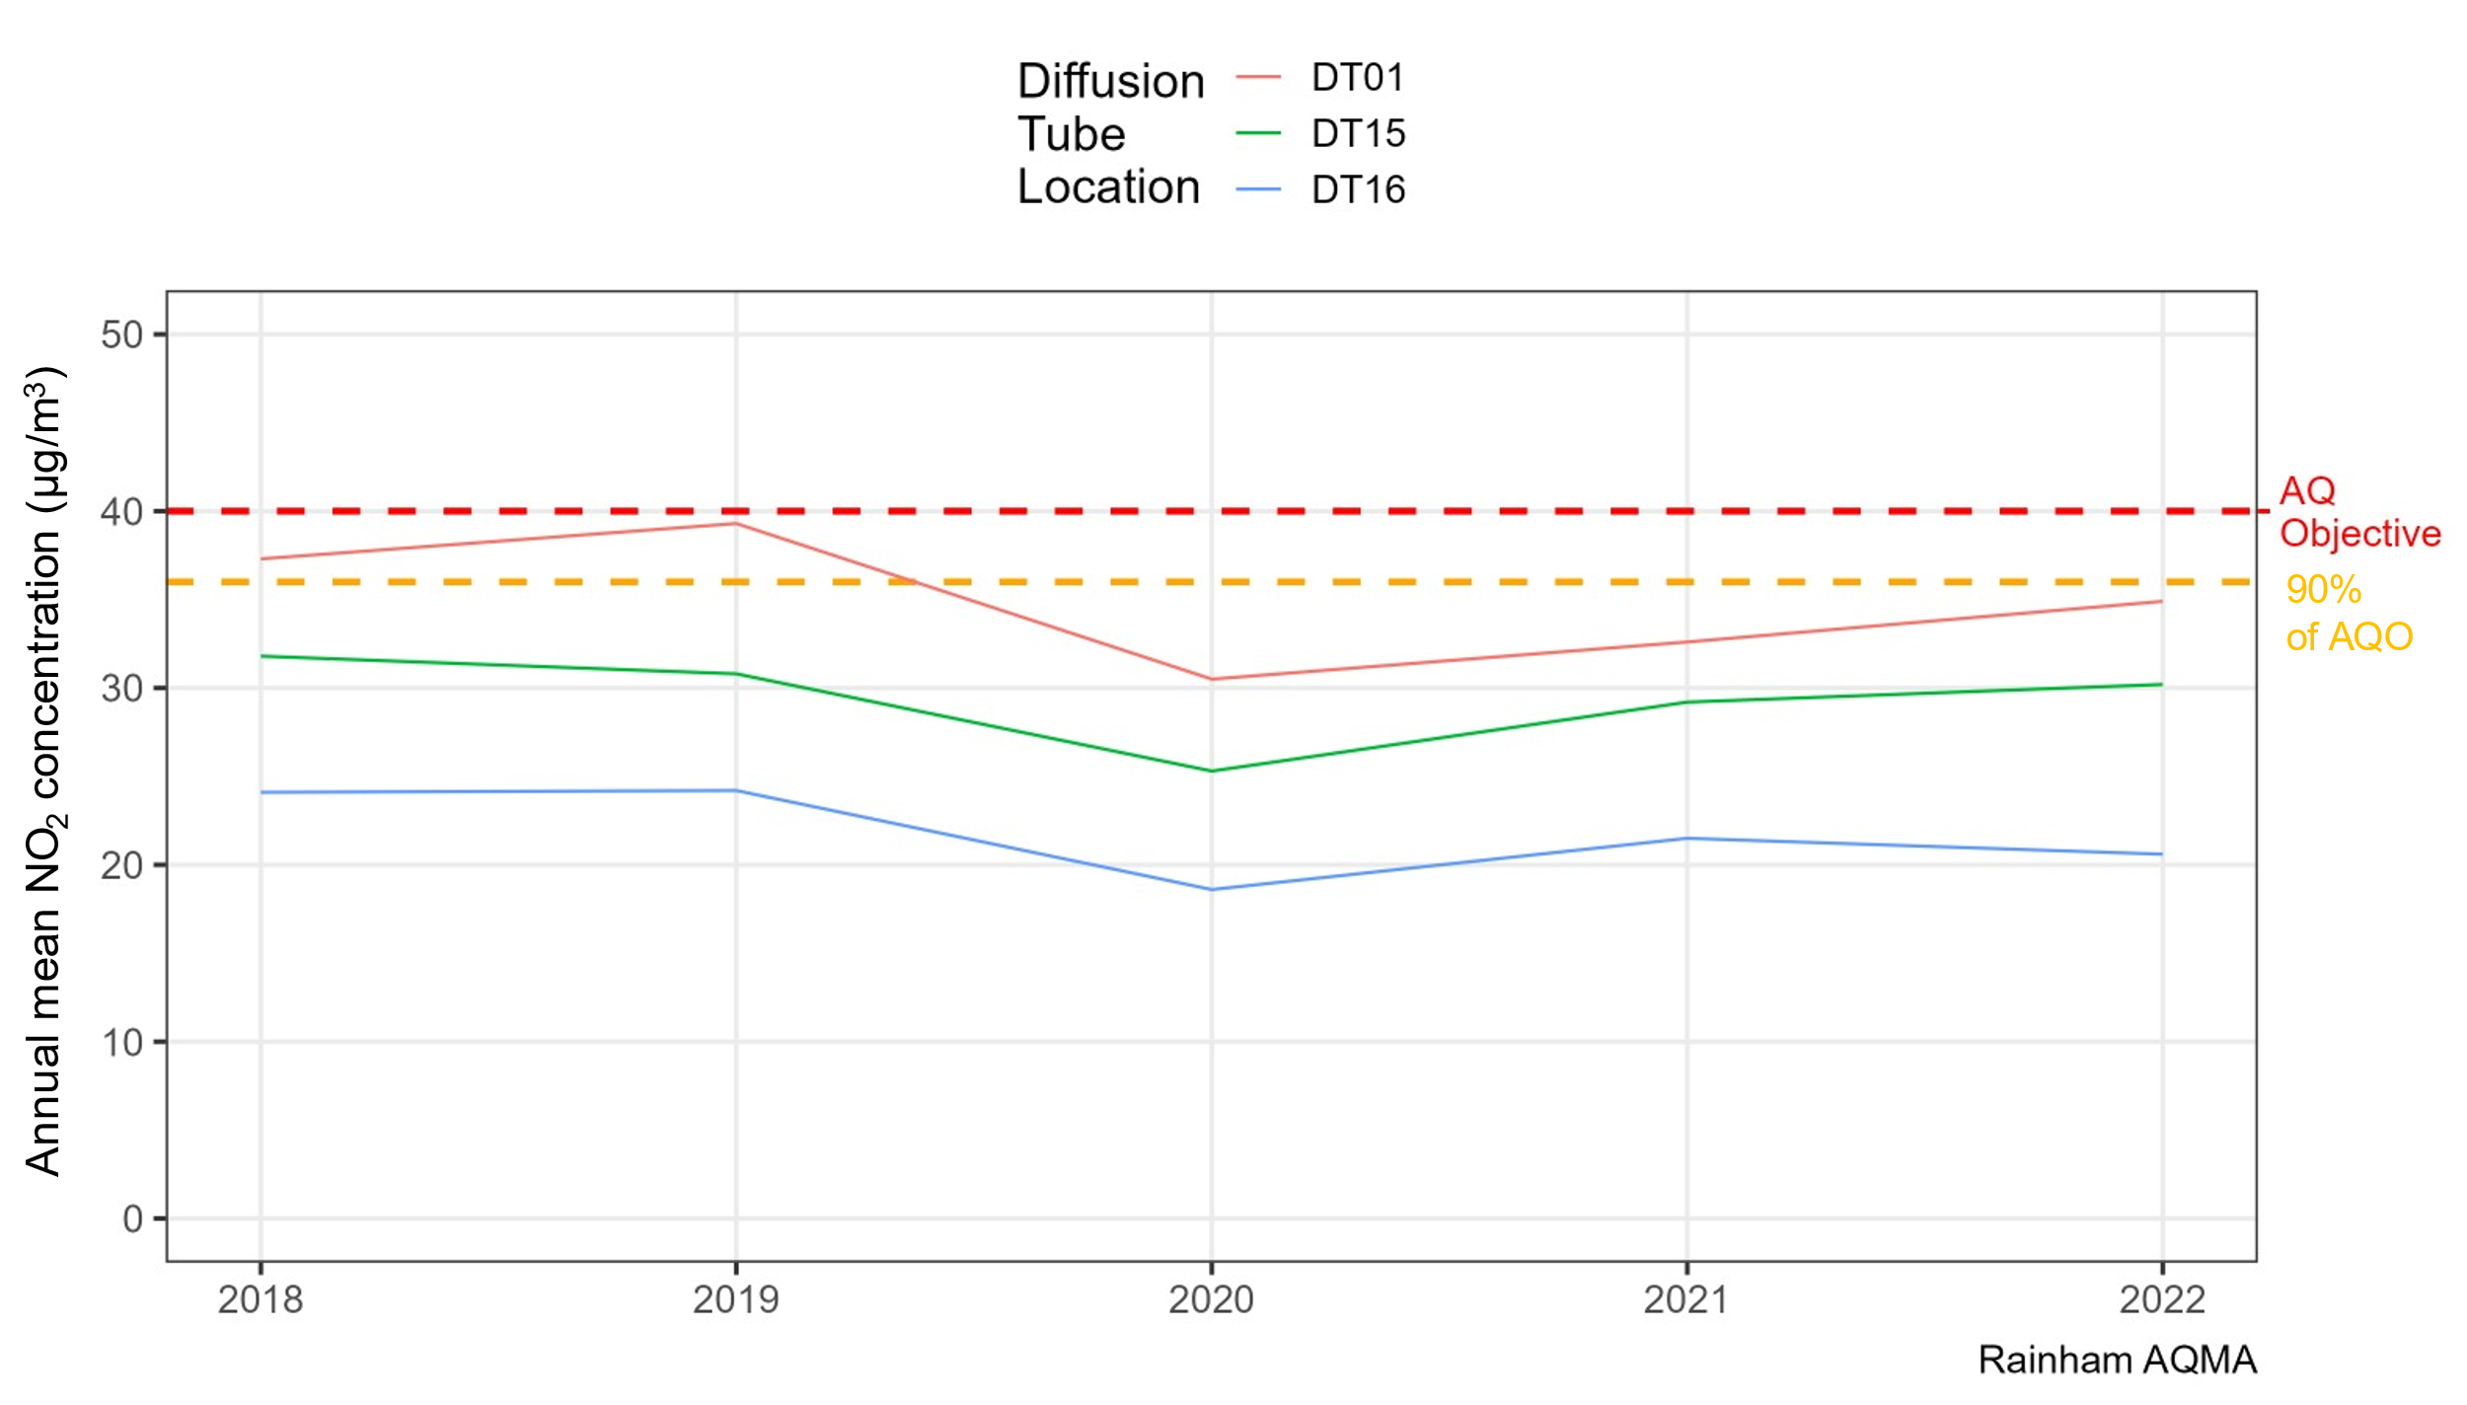

## Summary of Current Air Quality in the Central Medway AQMA

Figure 3 provides a summary of the annual mean NO2 concentrations reported at the 21 diffusion tubes located within Central Medway AQMA, for 2018 – 2022. Concentrations have generally decreased slightly throughout the AQMA since 2018, although not linearly, and small increases in NO2 have been observed from 2020 to 2022 across most locations. As of 2022, there are only two locations, DT06 (Star Hill) and DT44 (High Street, Strood), exceeding the annual mean AQO for NO2 at 43.5 μg/m3 and 42.2 μg/m3, respectively. A further three locations (DT02 and DT03 on the High Street, Strood, and DT19 on London Road, Strood) were within 90% of the AQO in 2022 (measuring 38.6 μg/m3, 38.8 μg/m3, and 36.5 μg/m3, respectively).

One of the two automatic monitoring sites in Medway (CHAT) is located in the Central Medway AQMA; the highest annual mean NO2 recorded at this site over the last five years was 25.4 μg/m3 (in 2018), which is well below the annual mean AQO for NO2.

Using the most recent population data from the Office of National Statistics[13], for Lower Super Output Areas (LSOAs)[14] within the AQMA, the total population of the LSOAs that are intersected by the Central Medway AQMA for 2021 was 46,220. This is an increase from 42,097 persons as recorded in the 2011 Census.

While the majority of the monitoring locations in the AQMA have consistently reported annual mean NO2 measurements below the AQO, at least two locations are still in exceedance, and others are within 90% of the AQO as of 2022. Going forward, Medway Council will continue to monitor air quality in Central Medway AQMA and deliver actions to improve air quality, with the aim of reducing emissions and concentrations and achieving the AQO throughout the borough.

Figure 3 – Summary of air quality monitoring (annual mean NO2 concentrations) at diffusion tube locations within Central Medway AQMA over the last five years

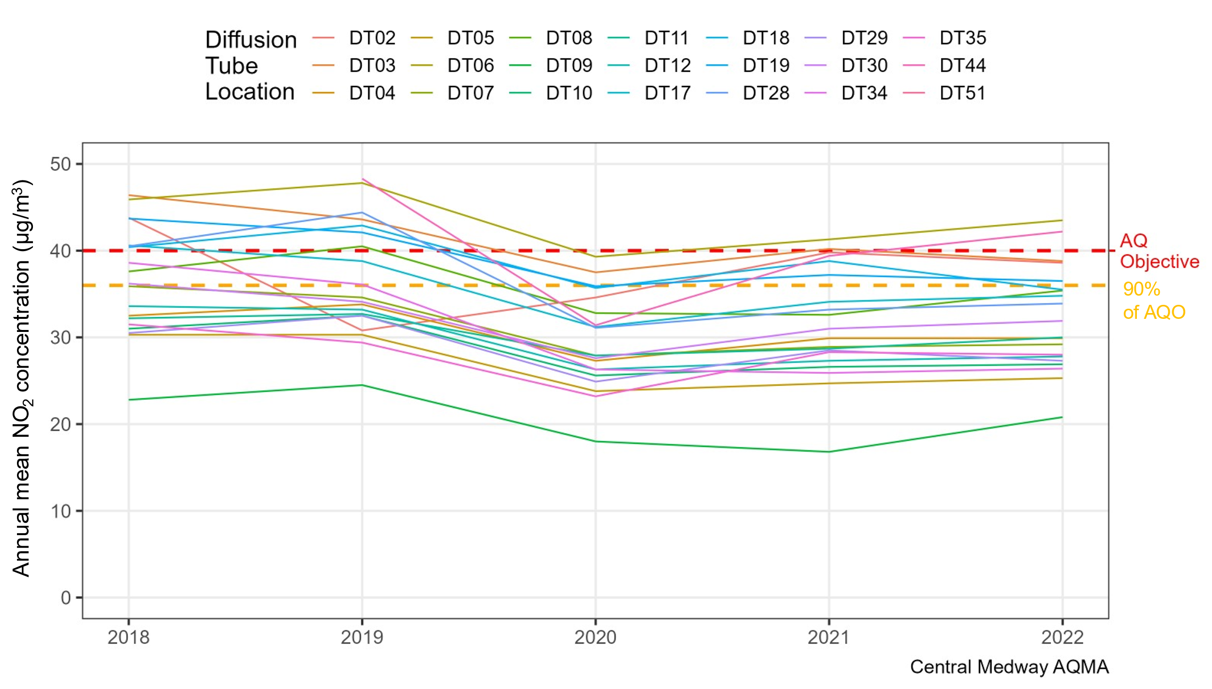

# Medway’s Air Quality Priorities

## Public Health Context

The impact of air quality upon health is unquestionable and has been a major driver in national and international attempts to reduce levels of air pollution. Pollutants such as NO2, ozone, benzene, sulphur dioxide (SO2) alongside PM10 and PM2.5 and other chemicals or compounds by both chronic and acute exposure are linked to increased mortality and morbidity, through their association with the development of cardiovascular disease[15], lung cancer[16], aggravation of asthma and other allergic illnesses[17], reduced quality of life[18] and contribution to low birthweight[19].

In Medway, air quality is generally good and in compliance with the legal concentration levels set by the UK Government. However, there are still potential improvements to be made in light of the air quality targets for 2040 established under the Environment Act 2021[20] and to lower concentrations closer to the World Health Organisation’s (WHO) Global Air Quality Guidelines[21].

The primary pollutant of concern in Medway is NO2, which is primarily caused by traffic congestion and is concentrated along roadsides. Another pollutant of concern in Medway is fine particulate matter (PM2.5), which is largely attributed to background concentrations, as well as local emissions from domestic and commercial combustion.

Medway Council takes action to protect its residents’ health from potential harm emanating from low air quality in a variety of ways. This includes partnership work with colleagues in planning, to mitigate potential for air quality-related harm arising from developments, as well as proactively through communication initiatives identified in the Medway Air Quality Communications Strategy. Such initiatives have included undertaking targeted information campaigns to increase community awareness of means by which individuals can reduce their exposure and contributions to poor air quality or manage their long-term health conditions which may otherwise leave greater susceptibility to harm from low air quality.

## Planning and Policy Context

### National policy

The National Planning Policy Framework (NPPF)[22] provides guidance as to how planning can take account of the impact of new development on air quality. Paragraph 181 of the NPPF states that “*Planning policies and decisions should sustain and contribute towards compliance with relevant limit values or national objectives for pollutants, taking into account the presence of AQMA and Clean Air Zones, and the cumulative impacts from individual sites in local areas*” and “*Planning decisions should ensure that any new development in AQMA and Clean Air Zones is consistent with the local air quality action plan”*.

To support the delivery of the NPPF, Defra has produced National Planning Policy Guidance (NPPG), including one specifically referring to air quality[23]. The NPPG states in Paragraph 005 (Reference ID: 32-005-20191101) “*Whether air quality is relevant to a planning decision will depend on the Proposed Development and its location. Concerns could arise if the development is likely to have an adverse effect on air quality in areas where it is already known to be poor, particularly if it could affect the implementation of air quality strategies and action plans and/or breach legal obligations (including those relating to the conservation of habitats and species). Air quality may also be a material consideration if the Proposed Development would be particularly sensitive to poor air quality in its vicinity*.”

The Government’s Clean Air Strategy[24] published in 2019 sets out the comprehensive actions required across all parts of government and society to improve air quality. The strategy explains that, under the current framework, local authorities must produce an AQAP when local air quality monitoring has identified concentration exceedances against maximum limits. Compliance with maximum limits, however, does not incentivise prevention. New legislation therefore will seek to shift this focus towards prevention. This will enable early action to be taken by local authorities to avoid exceedances against future targets set by national government. This new approach will be instrumental for the government to achieve its objective of improving public health and the environment.

### One Medway Council Plan

Medway has recently published its One Medway Council Plan[25], which sets out the Council’s vision, ambitions, and priorities for the period 2024-2028. The Plan outlines the challenges Medway is currently facing, as well as the values and behaviours that will shape the solutions to these challenges.

There are good synergies between this AQAP and the five priorities in the One Medway Council Plan. Of particular relevance is Priority 3: Enjoying clean, green, safe and connected communities, which includes a focus on providing a well-connected and sustainable travel system across Medway. To achieve this, the Council will increase walking and cycling networks, provide opportunities to use electric vehicles, and work with partners to ensure an integrated, accessible, safe and sustainable public transport system – facilitated by the actions presented in this AQAP.

### Local Plan

Medway Council actively manages the effects of new developments on air quality within its area through the Medway Local Plan (2003)[26] Policy BNE24 ‘Air Quality’, to ensure that new developments do not exacerbate existing air quality issues.

Medway Council is currently preparing its emerging Local Plan 2041[27]. The Council will be publishing its next stage of consultation in June 2024. This will include details of potential development sites and policies to manage Medway’s sustainable growth. The refresh to the vision and strategic objectives strengthens the plan’s role in helping to deliver better outcomes for the environment and health. New policies will build on the existing air quality policy and seek better integration of key objectives across the plan.

The Council has not yet published details of preferred development locations. However, given the scale of growth required over the plan period and the spread of land being assessed for potential development allocations in Medway, it is anticipated that there will be additional traffic on Four Elms Hill from development over the plan period. In considering potential development allocations on the Hoo Peninsula, the Council recognises the importance of effectively mitigating the impacts on transport networks and the environment. Mitigation measures would be required as part of development allocation policies.

### Air Quality Planning Guidance

In conjunction with the Kent and Medway Air Quality Partnership, Medway produced its Air Quality Planning Guidance[28] in 2016 to deal with planning applications that could impact air quality. The guidance was prepared in response to changes in national planning policy, through the NPPF, and was revised in 2021. The guidance uses a method for assessing the air quality impacts of a development which includes the quantification of impacts, calculation of damage costs, and the identification of mitigation measures to be implemented to negate the impact of development on air quality. The guidance provides clarity and consistency of approach for developers, the local planning authority, and local communities.

### Climate Change Action Plan

After declaring a climate emergency in 2019, Medway published its Climate Change Action Plan in 2021[29]. The action plan makes clear a link between reduction in carbon emissions and improvements in air quality. Measure 6 of the climate change action plan aims to reduce emissions from road transport by promoting and facilitating uptake of electric and ultra-low emissions vehicles, encouraging modal shift through enhanced sustainable infrastructure, and tackling congestion hotspots. Progress to this measure will significantly improve air quality as well as reduce carbon emissions.

### Bus Service Improvement Plan

Medway recently published a draft Bus Service Improvement Plan (BSIP) 2021-2026[30]. In order to improve air quality, the plan commits to continue to seek additional funding from government and other available sources to improve fleet standards, whether that be retrofitting to Euro VI, or contributions towards the costs of new low or zero-emission vehicles thus allowing timely improvements to Medway AQMAs.

### Local Transport Plan

Medway adopted its Local Transport Plan in 2011, which will run until 2026[31]. The Plan sets a strategy to deliver transport interventions that contribute to improving air quality. Key interventions focus on more efficient management of the highway network and car parks, together with highway improvements that focus on congestion and air quality hotspots, thereby improving the reliability and environmental impact of the transport network.

### Air Quality Communication Strategy

Medway published its Air Quality Communication Strategy[32] in 2017. The strategy details a series of recommended communications activities to increase the awareness of the health impacts of air pollution amongst key stakeholders and specific local groups affected by air pollution. It also aims to stimulate changes in the way in people and organisations view air pollution and empower them to take action to address this complex challenge.

### Local Cycling and Walking Infrastructure Plan

Medway’s Local Cycling and Walking Infrastructure Plan (LCWIP) sets out a plan for delivering local walking and cycling networks, so that active travel is the preferred choice when travelling in Medway. An increase in walking and cycling journeys will help to reduce travel congestion which has clear benefits for air pollution in Medway. The LCWIP is currently under consultation which runs from Monday 22 January 2024 until Sunday 3 March 2024[33].

## Source Apportionment

The AQAP measures presented in this report are intended to be targeted towards the predominant sources of NOx emissions within the Central Medway, Rainham, and Gillingham AQMAs. By using a combination of local modelling inputs and Defra background concentration maps, a dispersion modelling study and source apportionment exercise was carried out by Ricardo on behalf of Medway Council for 2022 to better understand the pollution scene in Medway. The full technical baseline modelling report can be found in Appendix C: 2022 Baseline Model, Source Apportionment and Scenario Modelling Study.

The source apportionment exercise identified that, within the AQMAs, emissions from road transport contribute significantly to total emissions of the pollutants of concern (NOx, PM10 and PM2.5). Considering the contribution from different vehicle types, diesel cars are responsible for most of the emissions from road transport; buses, and freight vehicles including light goods vehicles (LGVs) and rigid and artic heavy goods vehicles (HGVs) also contribute relatively large proportions of total pollutant emissions.

Figure 4 presents the source apportionment of NOx emissions at monitoring sites within the AQMAs in Medway. Whilst there are variations between receptor sites, the majority have a significant NOx contribution from diesel cars, as well as LGVs. For NOx, road transport generally contributes the majority of emissions at around 60-70%, whereas background NOx only contributes 30-40% of total emissions.

Figure 5 presents the source apportionment of PM2.5 emissions at the same monitoring sites. Again, although there are variations between receptor sites, diesel and petrol cars contribute the most to road transport emissions. Buses, LGVs and HGVs are all contributors, but to a lesser extent. For PM2.5, in contrast to NOx, road transport is responsible for a smaller proportion of total emissions at around 15-25%. Background PM2.5 is the more significant proportion of total emissions, around 75-85%, and is mainly made up of residual[34] and secondary PM.

Finally, Figure 6 presents the source apportionment of PM10 emissions at the monitoring sites. The situation is largely the same as for PM2.5, with diesel and petrol cars contributing the greatest proportions of road transport emissions. Again, buses, LGVs and HGVs all contribute, to a lesser extent. For PM10, as with PM2.5, road transport is responsible for a smaller proportion of total emissions and background PM10 is the more significant proportion of total emissions, mainly consisting of residual and secondary PM.

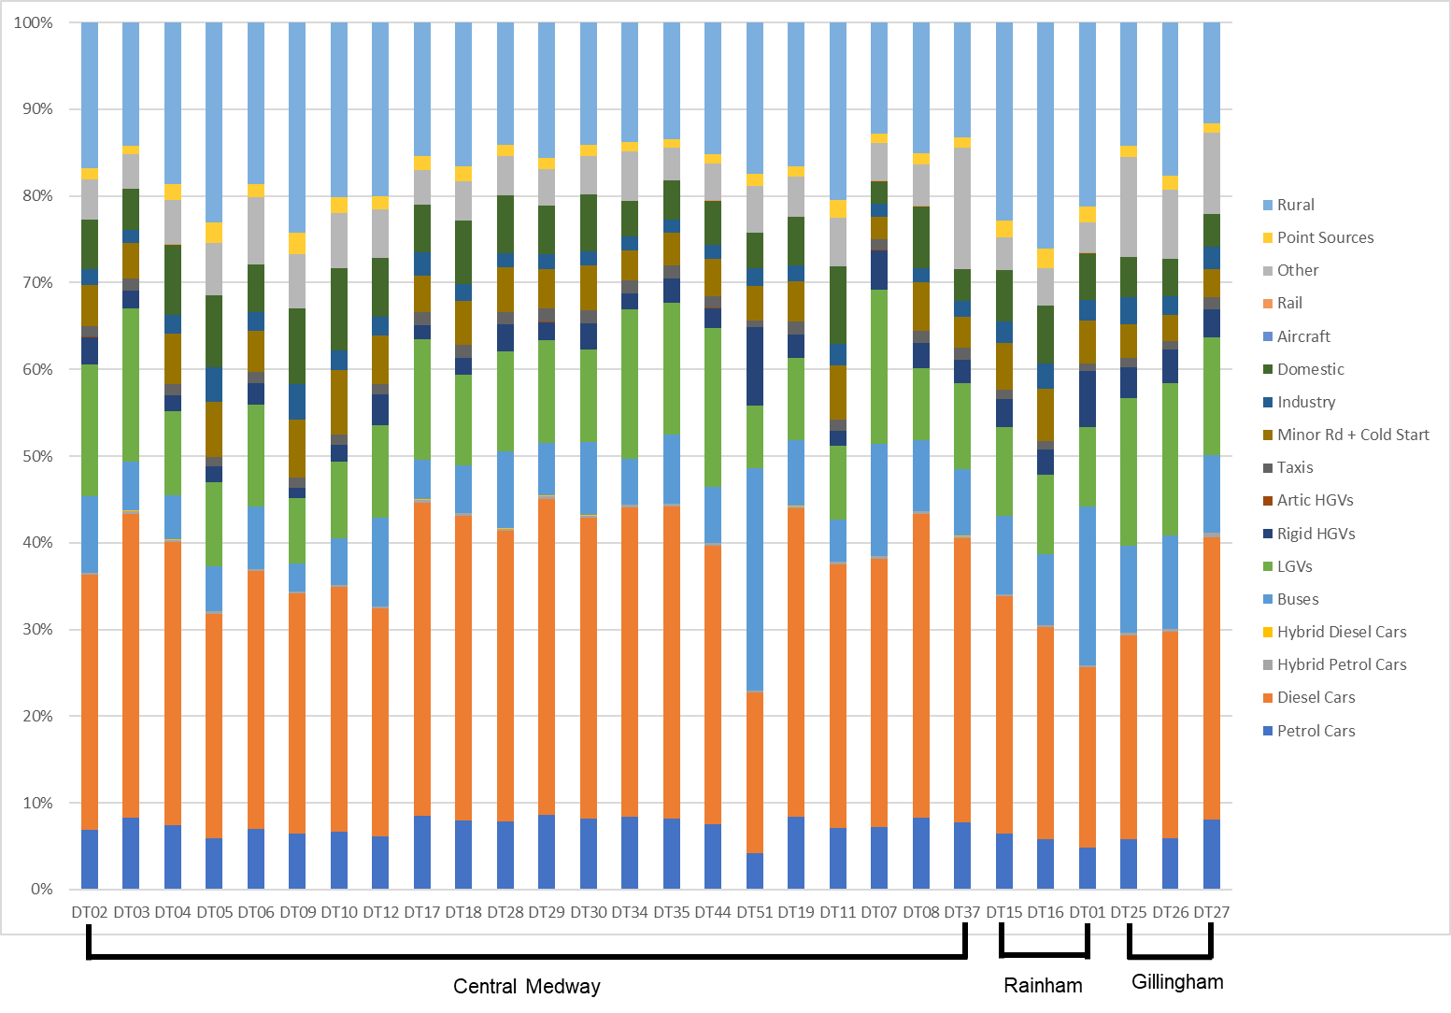Figure 4 – Stacked bar chart showing NOx source apportionment for road transport and background sources for monitoring locations within Medway’s AQMAs (%), for the baseline fleet, 2022

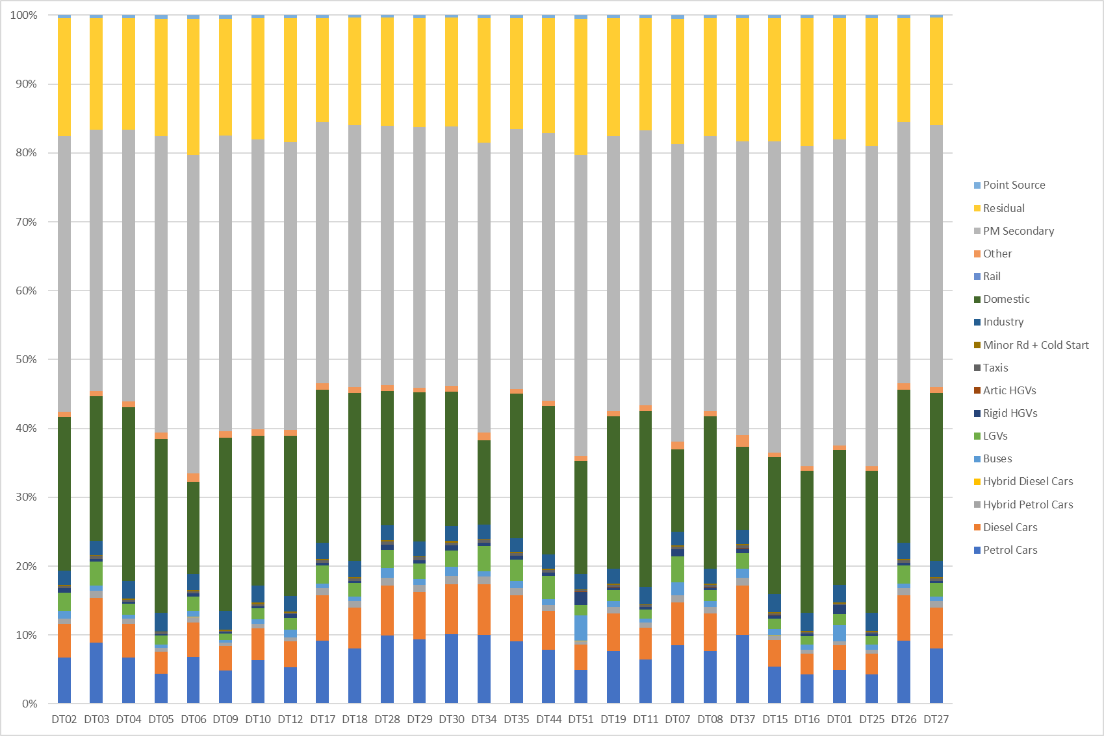

Central Medway

Rainham

Gillingham

Figure 5 – Stacked bar chart showing PM2.5 source apportionment for road transport and background sources for monitoring locations within Medway’s AQMAs (%), for the baseline fleet, 2022

Figure 6 – Stacked bar chart showing PM10 source apportionment for road transport and background sources for monitoring locations within Medway’s AQMAs (%), for the baseline fleet, 2022

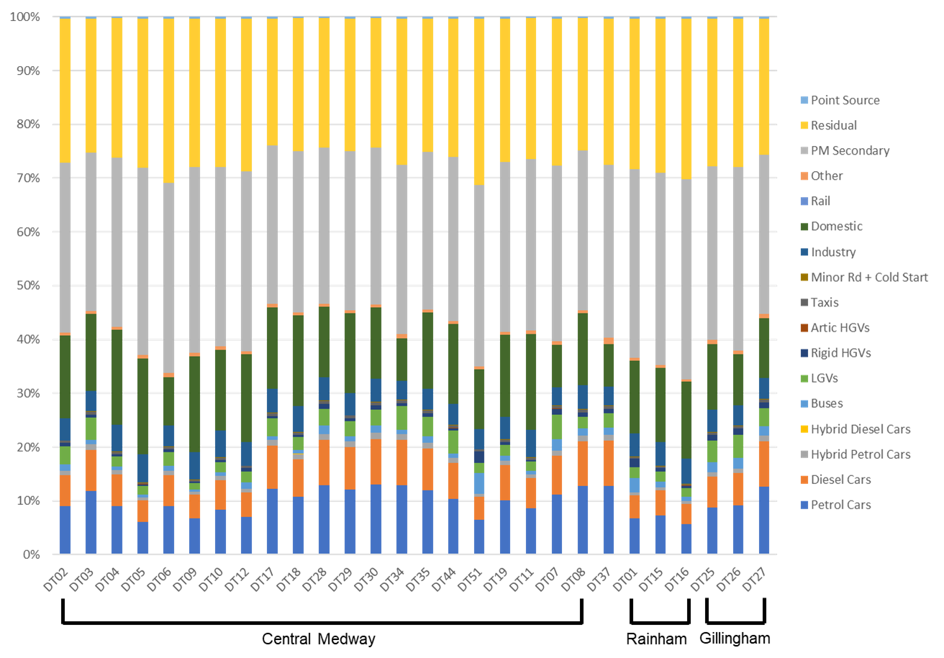

## Required Reduction in Emissions

### NOx and NO2 emissions reductions

Table 2 sets out the required reduction in local emissions of NOX that would be required at the two diffusion tube locations where exceedances were measured in 2022 (both in the Central Medway AQMA), in order for the annual mean NO2 AQO to be achieved.

The degree of improvement needed in order for the annual mean NO2 objective to be achieved is defined by the difference between the highest measured or predicted concentration and the objective level (40 μg/m3). The highest NO2 concentration was measured at DT06 (43.5 μg/m3), requiring a reduction of 3.5 μg/m3 in order for the objective to be achieved. At DT44, a concentration of 42.2 μg/m3, requiring a reduction of 2.2 μg/m3 in order for the objective to be achieved.

In terms of describing the reduction in emissions required, it is more useful to consider NOX. The required reduction in local NOX emission has been calculated in line with guidance presented in Box 7-6 of LAQM.TG(22). Table 2 shows that at DT06, where the highest annual mean concentration was measured, a reduction of 13.0% in local road traffic NOx emissions would be required in order to achieve the objective. At DT44, the required reduction in local road traffic emissions of NOx is 8.4%.

Table 2 – Improvement in Annual Mean NO2 Concentrations and road NOx Concentration Required to Meet the Objective

|  |  |  |
| --- | --- | --- |
| Receptor | Required reduction in annual mean NO2 concentration (μg/m3) | Required reduction in emissions of NOX from local roads (%) |
| DT06 | 3.5 | 13.0% |
| DT44 | 2.2 | 8.4% |

### Scenario Modelling

To understand the impact that different policy measures could have on air quality in Medway, scenarios relating to three of the AQAP actions outlined in Table 4 have been modelled to calculate the likely reduction in emissions:

1. Explore opportunities to support electrification of the bus fleet in Medway, focusing on routes through the AQMAs (Measure 17)
2. Explore opportunities to set up an ECOStars (or similar) Freight Recognition Scheme for Medway (Measure 8)
3. Deliver the EV Strategy 2022-27 (Measure 14)

For each measure, three scenarios were developed to represent increasingly ambitious uptake/implementation of the AQAP measure. Pollutant emissions and concentrations have been calculated for each scenario and compared to the baseline scenario to understand the potential impact of the measure on local air quality in Medway, and whether the required reductions outlined in the section above are able to be achieved.

As the three AQAP measures target different groups of vehicles (buses, freight, and cars), the sum of the predicted reductions in annual emissions can be used as an indicator for the expected changes. If all three of the AQAP measures above were implemented as per the most ambitious “High” scenarios, annual emissions of NOx from road transport could be reduced by almost 30%; CO2 emissions could be reduced by more than 15% and particulate matter emissions could be reduced by around 8%. As shown in Table 2, the expected reduction in NOx emissions required to bring DT06 into compliance is 13.0%, and for DT44 is 8.4%, so there is good confidence that implementation of these measures (as well as the other actions outlined in this AQAP) will enable Medway to achieve compliance with the annual mean NO2 AQO. This is further evidenced by the modelled improvements in NO2 concentrations expected at these diffusion tube locations: overall, implementing the “high” scenario for the three measures is likely to bring diffusion tube **DT06** closer to compliance with the NO2 AQO, with a cumulative reduction of 3.36 µg/m3 (compared to a required reduction of 3.5 µg/m3 to achieve compliance). The cumulative reduction in NO2 from the implementation of the three “high” scenarios could be expected to bring **DT44** into compliance with the NO2, with a cumulative reduction of 4.38 µg/m3 (compared to a required reduction of 3.5 µg/m3 to achieve compliance).

The full set of results for this modelling exercise are provided in Appendix C: 2022 Baseline Model, Source Apportionment and Scenario Modelling Study.

## Key Priorities

The most significant source of NOx emissions in the Central Medway, Gillingham and Rainham AQMA’s is road transport. As discussed in Section 1.6, the source apportionment results show that diesel cars were the largest contributing vehicle type to NOx emissions at diffusion tube monitoring sites.

The key priorities for this AQAP have been determined by Medway Council and the AQAP Steering Group.

* Priority 1 – Bring about compliance with the Air Quality Strategy objectives across Medway, focusing on NO2 concentrations within the Central Medway, Gillingham and Rainham AQMAs (as well as the Four Elms Hill AQMA, which is addressed in a separate AQAP). We are also working on building evidence to demonstrate this to enable the AQMAs to be revoked in the future.
* Priority 2 – Reduce NOxemissions from diesel (and petrol) cars in the Central Medway, Gillingham and Rainham AQMAs, by encouraging use of alternative modes of transport such as active travel and public transport, and by delivering the vision in our Electric Vehicle Strategy.
* Priority 3 – Reduce NOx emissions from buses, by assessing the potential to upgrade a proportion of the bus fleet to electric.
* Priority 4 – Reduce NOx emissions from HGVs, by exploring opportunities to set up a freight recognition scheme in Medway.
* Priority 5 – Reduce NOx emissions from taxis, using the evidence from the study currently being delivered, and working towards upgrading a proportion of the taxi fleet to ultra-low/zero emission vehicles.
* Priority 6 – Reducing emissions of PM2.5 particulate matter across the borough.

# 

# Development and Implementation of Medway’s AQAP

## Consultation and Stakeholder Engagement

In developing this AQAP, we have worked with the local community and relevant Medway Council departments to improve local air quality. We have undertaken the following stakeholder engagement:

* Medway Council internal workshop in February 2024
* Public Consultation to be held during Summer 2024

The response to our consultation stakeholder engagement will be provided in Appendix A: Response to Consultation after the Public Consultation period has concluded.

Schedule 11 of the Environment Act 1995 requires local authorities to consult the bodies listed in Table 3.

Table 3 ‒ Consultation Undertaken

| Consultee | Consultation Undertaken |
| --- | --- |
| The Secretary of State | Being undertaken |
| The Environment Agency | Being undertaken |
| The highways authority | Being undertaken |
| All neighbouring local authorities | Being undertaken |
| Other public authorities as appropriate, such as Public Health officials | Being undertaken |
| Bodies representing local business interests and other organisations as appropriate | Being undertaken |

## Steering Group

Following the publication of Medway’s first AQAP, a Steering Group was established in 2016 to provide oversight, and facilitate further development of the measures included. The Steering Group consists of representatives from key council services including, amongst others, Environmental Protection, Public Health, Planning and Integrated Transport, who have agreed to work together with the shared goal of seeking to improve air quality in Medway through behavioural, strategic and infrastructure change.

The Air Quality Steering Group was convened to help shape the Medway 2024 AQAP, including via a dedicated workshop held in February 2024.

# AQAP Measures

Table 4 shows the Medway AQAP measures. It contains:

* a list of the actions that form part of the plan
* the responsible individual and departments/organisations who will deliver this action
* estimated cost of implementing each action (overall cost and cost to the local authority)
* expected benefit in terms of pollutant emission and/or concentration reduction
* the timescale for implementation
* how progress will be monitored

**NB:** Please see future ASRs for regular annual updates on implementation of these measures.

Table 4 – Air Quality Action Plan Measures

| Measure No. | Measure | Category | Classification | Estimated Year Measure to be Introduced | Estimated / Actual Completion Year | Organisations Involved | Funding Source | Defra AQ Grant Funding | Funding Status | Estimated Cost of Measure | Measure Status | Target Reduction in Pollutant / Emission from Measure | Key Performance Indicator | Progress to Date | Comments / Potential Barriers to Implementation |
| --- | --- | --- | --- | --- | --- | --- | --- | --- | --- | --- | --- | --- | --- | --- | --- |
| 1 | Identify and implement new cycling and walking opportunities | Promoting Travel Alternatives | Promotion of walking | Ongoing | Ongoing | Sustainable Transport | Active Travel Fund investment |  |  |  | Implementation | Low.  Increasing routes will not directly reduce pollutant emissions, however, should encourage more people to walk/cycle more often, indirectly improving air quality. | Increase in number of cyclists;  No. of additional walking / cycling routes created. | Annual walking festival organised in partnership with environmental and walking groups. | Seek to promote and integrate new active travel opportunities in new developments, specifically, strategic site allocations in the new Local Plan. Engage with universities, schools, and other large institutions (e.g. Medway Hospital) to identify and promote safe walking routes. |
| 2 | Work with partners to help develop and enhance National Cycle Routes in Medway | Promoting Travel Alternatives | Promotion of cycling | 2024 | Ongoing | Sustainable Transport |  |  |  |  | Implementation | Low.  Increasing routes will not directly reduce pollutant emissions, however, should encourage more people to walk/cycle more often, indirectly improving air quality. | Increase in number of cyclists / journeys made via bicycle;  No. of additional cycling routes created / no. of routes enhanced. | Medway Council developed the Medway Cycle Map in 2016 and the local cycling and walking infrastructure plan (LCWIP), which follows on from the Medway Cycling Action Plan, is undergoing consultation (Spring 2024). | Medway Council will participate in the development of a sub-regional cycle network and enhancement of the National Cycle Routes, along with partners such as Sustrans. |
| 3 | Maintain and promote existing healthy travel schemes | Promoting Travel Alternatives | Intensive active travel campaign & infrastructure | Ongoing | Ongoing | Public Health | Existing budgets |  |  |  | Implementation | Low.  These schemes will not directly reduce pollutant emissions, however, should encourage more people to walk/cycle more often, indirectly improving air quality. | Increase in number of people walking / cycling;  Continuation of existing schemes. | Medway Health Walks Scheme - Supports walking groups & use of local green spaces.  GP exercise referral scheme - Physical activity and weight management programme encouraging walking instead of using private vehicles. | Promotion can take place via the updated Air Quality Communications Strategy. |
| 4 | Implement improvements recommended in the Local Cycling and Walking Infrastructure Plan (LCWIP) | Promoting Travel Alternatives | Promotion of Walking & Cycling | Ongoing | Ongoing | Sustainable Transport | Existing budgets and external funding sources |  |  |  | Planning | Low.  Improving routes will not directly reduce pollutant emissions, however, should encourage more people to walk/cycle more often, indirectly improving air quality. | Improvements made to targeted cycle routes within / near the AQMAs;  Increase in number of cyclists / journeys made via bicycle. | LCWIP is undergoing public consultation January to March 2024. | Targeted routes identified in the LCWIP that are located within/near AQMAs.  Developing more off-road cycle facilities and on quiet roads. |
| 5 | Work with businesses and educational establishments to implement travel plans | Promoting Travel Alternatives | Workplace Travel Planning / School Travel Plans | 2024 | Ongoing | **Sustainable Transport** |  |  |  |  | Implementation | Medium.  Implementation of travel plans can directly reduce pollutant emissions; however, success of this measure depends on uptake. | No. of local establishments producing active travel plans / workplace promotions / journey planning. | Mode Shift Stars accreditation scheme for school travel plans has been successful.  Good progress being made to develop an integrated travel plan  for Kingsnorth employment area. | Continue Mode Shift Stars accreditation scheme.  Develop a workplace travel plan template. |
| 6 | Review and update the Air Quality Communications Strategy | Public Information | Other | 2024 | 2025 | Public Health, Environmental Protection | Existing budgets and/or external funding sources (e.g. Defra AQ grant) |  |  | <£10k | Planning | Low.  Air quality communications will not directly improve air quality, but will raise awareness and may encourage people to change their behaviour, indirectly improving air quality. | Air Quality Communications Strategy is updated and published. | Discussions to ensure good collaboration with the Climate Change team to reflect AQ and climate change co-benefits. | Review and update the Air Quality Communications Strategy to bring the strategy up to date and reflect current priorities. |
| 7 | Solid fuel burning public information campaign | Public Information | Via the internet | 2024 | 2025 | Public Health, Environmental Protection | External budgets and/or external funding sources (e.g. Defra AQ grant) |  |  | <£10k | Planning | Low.  Development of this campaign will not directly reduce pollutant emissions, but will raise awareness and may encourage people to change their open burning habits, indirectly improving air quality. | Solid fuel burning campaign is published. | Public information campaign to raise awareness and highlight the impacts of open burning on air pollution, with a focus on health impacts.  Highlight Defra’s “Burn Better” Solid Fuel Burning Campaign [Burn Better Breathe Better campaign](https://uk-air.defra.gov.uk/library/burnbetter/)Highlight Medway’s SCA and authorised fuels. | Future ambition: Campaign could also cover bonfires.  Promotion can also take place via the updated Air Quality Communications Strategy. |
| 8 | Explore opportunities to set up an ECOStars (or similar) Freight Recognition Scheme for Medway | Freight and Delivery Management | Other | 2024 | 2025 | Transport and Parking, Environmental Protection, Climate Response | External funding sources (e.g. Defra AQ grant) |  |  | £50k-£100k | Planning | Medium.  Such schemes help businesses to improve their fuel efficiency, reduce fuel consumption & emissions and make cost savings; these all help to reduce emissions of NOx and PM, but success depends on uptake. Modelling results indicate that an increase in fuel efficiency from Freight Management could result in up to: - 1.19% reduction in NO2 concentrations.  - 0.038% reduction in PM10 concentrations.  - 0.058% reduction in PM2.5 concentrations. | Set up freight recognition scheme;  No. of local fleet operators in the scheme. | **Dispersion modelling of potential impacts of uptake undertaken as part of this AQAP.**  This measure is at the scoping stage and aims to look at nearby local authorities that have an ECOStars (or similar) scheme in place, and identify local businesses that would be suitable candidates. | In total, ECOStars schemes have more than 500 members with 14,000+ vehicles [Ecostars website](https://www.ecostars-uk.com/) |
| 9 | Integrate, where appropriate, AQAP targets into internal service plans | Policy Guidance and Development Control | Air Quality Planning and Policy Guidance | 2024 | Ongoing | Business Intelligence |  |  |  |  | Implementation | Low.  Inclusion of AQAP targets in other plans will not directly reduce pollutant emissions, but will help facilitate implementation of other actions to improve air quality. | No. of targets incorporated into other plans / policies. | The 2015 AQAP has been integrated into the Medway Climate Change Action Plan and the Four Elms Hill AQAP and this AQAP will also be integrated. | Future ambition: Integrate 2024 AQAP into upcoming plans e.g. new Local Plan, updated Local Transport Plan, etc. and included within the corporate performance monitoring system |
| 10 | Continue to review and update the Air Quality Planning Guidance 2016 (Revised 2021) | Policy Guidance and Development Control | Air Quality Planning and Policy Guidance | 2021 | 2026 | Environmental Protection |  |  |  |  | Planning | Medium.  The document sets out requirements for air pollution mitigation for developers, which will directly reduce NOx and PM emissions. However, success will be limited by enforcement of planning conditions. | Air Quality Planning Guidance is updated every 5 years (or less). | The revised guidance covers major sized developments and any development within or close to an AQMA and requires developers to include mitigation for air pollution in their developments. | Future ambition: Revise for 2026, or if there are any large developmental changes |
| 11 | Consider expansion of Medway’s Smoke Control Area | Policy Guidance and Development Control | Regional Groups Co-ordinating programmes to develop Area wide Strategies to reduce emissions and improve air quality | 2024 | 2025 | Noise and Nuisance, Environmental Protection | Existing budgets |  |  | £10k-£50k | Planning | Medium.  The expansion of Medway’s Smoke Control Area would help further reduce emissions of NOx and PM. However, success will be limited by uptake / enforcement. | Expansion of the Smoke Control Area. | Parts of Medway Council’s district are [within a Smoke Control Area](https://medwaymaps.medway.gov.uk/SISWebMap9.0.2533.0/Map.aspx?x=575701&y=168599&resolution=6.99999999889764&epsg=277002020&mapname=mms&baseLayer=Light&datalayers=Smoke%20Control%20Zone%2CselectFeaturesControl_container) already. | Future ambition: Consider expanding the SCA to the whole of Medway Council’s District. Include development of a bonfire policy. |
| 12 | Review and update the Medway Local Transport Plan | Policy Guidance and Development Control | Air Quality Planning and Policy Guidance | Ongoing | 2025 | Transport and Parking |  |  |  |  | Implementation | High.  A refreshed Local Transport Plan will drive a shift towards increased public transport patronage and active travel, which leads to a reduction in NOx emissions from roadside traffic. | Updated Local Transport Plan is published. | This action is currently being implemented. The main focus is to create a timetable to refresh Medway’s Local Transport Plan, with a particular focus on Medway’s AQMAs. | New Local Plan timetable may affect delivery timelines. |
| 13 | Taxi and private hire ULEV feasibility study | Promoting Low Emission Transport | Taxi Licensing conditions / Taxi emission incentives | 2022 | 2024 | Licensing, Environmental Protection | DEFRA Air Quality Grant Programme | Yes |  | £100k-£500k | Implementation | High. Depending on the level of uptake, an increase in the proportion of ULEV taxis will directly reduce exhaust emissions of NOx and PM. | Production of implementation plan;  Number of ULEV taxis in Medway. | The study is currently underway, with engagement with the taxi and private hire trade to understand barriers and opportunities for converting to ULEV, as well as modelling the impacts of ULEV scenarios. | Future ambition: Consider recommendations from the feasibility study and produce a plan for implementation. |
| 14 | Deliver the EV Strategy 2022-27 | Promoting Low Emission Transport | Public Vehicle Procurement - Prioritising uptake of low emission vehicles | 2022 | 2027 | EV Officer, Transport and Parking |  |  |  |  | Implementation | Low.  Provision of EV charging and other incentives to switch to EVs will not directly reduce air pollutant concentrations, but will help facilitate EV uptake. Modelling results indicate that an increase in the proportion of electric vehicles in the car fleet from a baseline of 1.89% to 26.56% could result in up to a: - 9.18% reduction in NO2 concentrations.  - 2.15% reduction in PM10 concentrations.  - 1.52% reduction in PM2.5 concentrations. | No. of EV charging points;  Proportion of EVs in private vehicle fleet. | **Dispersion modelling of potential impacts of uptake undertaken as part of this AQAP.**  The council are reviewing strategically located council owned sites for potential installation of rapid charging points for public use, including town centres, residential locations, and other destinations. | Future ambition: Ensure the future long-term sustainability of EV charging by integrating infrastructure into new development, as stipulated within Air Quality Planning Guidance and central government. |
| 15 | Explore opportunities to roll out the findings from the Rainham anti-idling campaign across other AQMAs | Traffic Management | Anti-idling enforcement | 2023 | 2025 | Traffic Management, Street Works, Environmental Protection | Defra AQ Grant and existing budgets | Yes |  | £10k-£50k | Planning | Medium. A reduction in idling will reduce exhaust emissions of NOx and PM, as a result of reduced idling. However, success will depend on uptake. | Implement anti-idling measures within AQMAs. | An anti-idling campaign was carried out across Rainham, and the findings suggest there would be benefits to rolling this out more widely across Medway. | Explore the possibility of extending the most successful aspects of the anti-idling campaign to AQMAs. Implement signage requirements at street works through permit system. |
| 16 | Replace Council fleet of small vehicles with low-emission alternatives at next point of exchange | Promoting Low Emission Transport | Company Vehicle Procurement - Prioritising uptake of low emission vehicles | 2024 | 2027 | Council Fleet Managers, Climate Response | Existing budgets and/or external funding sources |  |  |  | Planning | Medium.  Upgrading vehicles in the Council’s fleet will directly reduce exhaust emissions of NOx and PM, however, the scale of improvements will depend on the number and nature of the vehicles replaced. | No. of low emission small vehicles in Council Fleet. | Replace Council fleet of small vehicles (owned and leased) with electric by end of first carbon budget (2027) or where possible at next point of exchange (latest 2025) and once EV charge points are in place. | Additional staff resourcing is likely required (i.e. EV Strategy Delivery Officer and EV Fleet Manager). Funding is also likely to be the main barrier. |
| 17 | Explore opportunities to support electrification of the bus fleet in Medway, focusing on routes through the AQMAs | Promoting Low Emission Transport | Public Vehicle Procurement - Prioritising uptake of low emission vehicles | TBC | TBC | Transport and Parking, Bus Operators | External funding sources and/or operator investment |  |  | >£10million | Planning | High.  Introduction of zero-emission buses to replace traditional buses in the BTS fleet will directly reduce exhaust emissions of NOx and PM.  Modelling results indicate that upgrading all Euro 2, 3, 4 and 5 buses to electric vehicles could result in up to a: - 11.19% reduction in NO2 concentrations.  - 0.61% reduction in PM10 concentrations.  - 0.93% reduction in PM2.5 concentrations. | No. of zero-emission buses in Medway’s bus fleet. | **Dispersion modelling of potential impacts of uptake undertaken as part of this AQAP.**  Explore opportunities for phased uptake of ULEV on supported bus routes. Engaging with public transport providers. | Strong engagement with public transport providers required. Funding is likely to be the largest barrier to implementation. |
| 18 | Maintain availability and stability of key bus services in Medway | Transport Planning and Infrastructure | Public transport improvement -interchanges stations and services | Ongoing | Ongoing | Transport and Parking, Bus Operators |  |  |  |  | Implementation | Medium.  Increased bus patronage reduces the number of vehicles on the road which also reduces congestion; this helps to reduce emissions of NOx and PM, but success depends on uptake. | Bus service provision;  Bus service frequency and reliability;  Bus patronage. | The Bus Service Improvement Plan (BSIP) was published in 2021; this action aims to improve frequency and reliability of bus services (BSIP target 1). The main actions are to consider traffic management options to enable services to keep running and maintain / improve service quality. | Future ambition:  Development of traffic management schemes that contribute to more reliable bus journey times.  Consideration of bus rapid transport networks. |
| 19 | Improve bus fares and ticketing | Transport Planning and Infrastructure | Public transport improvement -interchanges stations and services | 2023 | Ongoing | Transport and Parking, Bus Operators |  |  |  |  | Implementation | Medium.  Increased bus patronage reduces the number of vehicles on the road which also reduces congestion; this helps to reduce emissions of NOx and PM, but success depends on uptake. | Bus service provision;  Bus patronage. | The BSIP was published in 2021; this action aims to improve bus fares and ticketing (BSIP target 3). A trial of reduced fares was delivered in 2023 and further trials / offers will be delivered in 2024. | Future ambition:  Investigate the potential for lower fares, including offers for children / students / the elderly / other concessions.  Investigate the potential for simplified fares.  Investigate potential to integrate ticketing between operators and transport modes. |

# Appendix A: Response to Consultation

The response to consultation will be added following Public Consultation of the Medway AQAP 2024.

Table A.1 ‒ Summary of Responses to Consultation and Stakeholder Engagement on the AQAP

| Consultee | Category | Response |
| --- | --- | --- |
|  |  | To be completed following consultation |
|  |  | To be completed following consultation |

# Appendix B: Reasons for Not Pursuing Action Plan Measures

Table B- 1 – Action Plan Measures Not Pursued and the Reasons for that Decision

| Action category | Action description | Reason action is not being pursued (including Stakeholder views) |
| --- | --- | --- |
| Traffic Management | **Widen Darnley Arch.** Work with National Rail to widen Darnley Arch, which has been identified as a significant point of constriction on the highway network in Strood associated with poor air quality. | Measure was considered as it was included in the 2015 AQAP, but the opportunity for this has now passed. If a suitable situation arises in the future, the action (or similar) could be revisited. |
| Public Information | **Improve bus service information.** Expansion of the real-time information system and/ or text messaging service to all stops across the bus network, and enhanced promotion of bus services through all forms of media. | BSIP funding received so far has had the caveat of only being allowed for use on revenue-based schemes, which does not include these types of investments. Medway have been able to retain all bus services, unlike many other Councils, and this remains the priority at this time. |
| Public Information | **Promote and support the Kent and Medway Warm Homes Scheme and other domestic energy efficiency and fuel poverty projects.** Focus on projects being delivered through the Kent Energy Efficiency Partnership (KEEP), promote these schemes and advice already available online, highlight links between improving energy efficiency and reducing domestic emissions, thereby improving air quality. | Links more closely to the Housing Strategy and is more appropriately pursued via this. |
| Promoting Travel Alternatives | **Promote Medway Council staff sustainable travel options and expand offering.** Explore improvements to the Gun Wharf shower, changing, and cycle facilities to support improved active travel to work. Explore options to support additional sustainable travel incentives including staff cycle hire schemes, showers, cycle storage and improve the way the Council communicates about existing incentives for staff. | Gun Wharf Office issues. There is appetite to take this forward, but resource is also an issue. Some preparatory work was previously done with the Energy Saving Trust, but unfortunately did not lead to anything further. Ad-hoc promotion of incentives available occurs. |
| Public Information | **Support residents and businesses to improve air quality by promoting funding opportunities and signposting to resources.** Green Homes Grant, Home Upgrade Grant (HUG) 2, LOCASE (Low Carbon Across the South East) grant support programme for local businesses. Highlight links between improving energy efficiency and reducing domestic emissions, thereby improving air quality. | The Green Homes Grant Scheme is no longer running (applications closed in 2022) and neither is the LOCASE scheme. |
| Freight and Delivery Management | **HGV route optimisation.** Review of HGV routes in Medway, with a focus on those through AQMAs, and develop solutions for optimisation. | The three AQMAs covered by this AQAP contain the main routes for HGVs through Medway, and it is not feasible to optimise those routes. This action has been replaced by an additional action to explore development of an ECOStars (or similar) freight recognition scheme for Medway, in the AQAP. |
| Freight and Delivery Management | **HGV Sat Nav Review and monitoring.** DfT data is available for a number of locations on the Medway road network, and includes locations within/near to AQMAs; this monitoring data should be used to supplement the research into HGV route optimisation. | Not being pursued as the action above is not being pursued. In addition, both actions have been replaced by an additional action to explore development of an ECOStars (or similar) freight recognition scheme for Medway, in the AQAP. |
| Policy Guidance and Development Control | **Explore opportunities to support implementation of zero-emissions-only HGVs and LGVs travelling through AQMAs.** Feasibility study for a Low Emission Zone-type system for LGVs and HGVs in Medway / Kent. | This action was considered to ensure alignment with the Four Elms Hill AQAP; however, is specific to the needs of Four Elms Hill and would not be feasible for wider adoption throughout Medway. |
| Policy Guidance and Development Control | **Introduce a Social Value Policy.** Introduce a Social Value Policy, embedding a scoring mechanism that favours emissions reduction. | This measure already sits in the Climate Change Action Plan. Social Value Policy Guidance has been drafted and is available for Council use; this sets the foundation for social value development and allows the list of social values can be amended by officers (as is being employed in the Climate Change team). There is no need to pursue further in this AQAP, but the Social Value Policy Guidance can now be used. |
| Policy Guidance and Development Control | **Review transport provision policies for Home to School Transport and SEND transport functions.** Review transport provision policies, focusing on Home to School Transport and SEND transport functions, and explore the gradual changeover to Ultra Low Emission Vehicles for transportation of pupils under these functions. | Changes were made to the Education Travel Assistance Policy from September 2023; to promote personal development and independence skills and reduce the environmental impact of home to school travel, children and young people will be supported to use public transport wherever possible. This support may include travel training and/or the provision of a walking companion. A travel training service is being commissioned to promote and support walking to school and public transport use.  Those who access shared SEN Transport, have been given the option to receive a bus pass as an alternative as part of the annual reapplication process to further encourage public transport use. Passes are also available to accompanying adults for those who still need support whilst the travel training service is set up.  There are currently no specific timeframes on a gradual changeover to ULEVs for school and SEN Transport. This work is currently contracted out and this change would require significant investment, in an area which is already under significant budgetary pressure. |
| Promoting Low Emission Transport | **Review contractual obligations and assess capability of providers in transitioning to Ultra Low Emission Vehicles.** | Separate actions included in the AQAP are pursuing the uptake of ULEV taxis and ULEV buses, respectively. |
| Traffic Management | **Develop operational protocols to enable UTMC to respond to air pollution episodes.** Development of operational protocols to enable Urban Traffic Management Control (UTMC) to respond to short-term air pollution episodes. | This measure was included in the Local Transport Plan, which is due for review and update, and the action can be revisited at that time. |
| Policy Guidance and Development Control | **Establish a public sector building retrofit programme in partnership with Kent County Council.** Focus on identifying joint initiatives that maximise economies of scale, e.g., shared building and facilities. Determine scope for a cross-sector location-based approach, identifying quick wins and how the Councils can work with private investors to scale up retrofit across Kent and Medway. | This measure is more appropriately pursued via other plans and policies. Air quality could be considered in Medway’s Social Housing Decarbonisation scheme fund, which aims to improve the energy efficiency rating of HRA stock, and can be considered in future phases of the retrofit programme across 12 Council-owned buildings. |
| Public Information | **Develop a bonfire policy.** The Council has a responsibility to investigate complaints of smoke and fumes that could be classed as a 'statutory nuisance'; development of an educational Bonfire Policy could help reduce such incidents. Consider developing a Bonfire Policy to provide guidance for residents to make better decisions around when, where, and how to have their bonfires, by providing guidance; it should also inform residents about the human and environmental health impacts of bonfires. | Information on bonfires is already provided on the Council website; it can be provided in the Solid Fuel Burning Public Information Campaign, which is included as an action in this AQAP, and promoted via the updated Air Quality Communications Strategy, also included as an action in this AQAP. |
| Policy Guidance and Development Control | **Review options for renewable energy generation on Council-owned land**. Explore the potential for large scale solar PV generation on Council-owned land and through the acquisition of land from third parties. | This measure already sits in the Climate Change Action Plan and is more appropriately pursued via this. It is likely to be more impactful as an action in the strategic overview of renewable energy opportunities / local area energy requirements. |
| Promoting Low Emission Transport | **Support local SMES to switch to ULEVs via the Kent REVS and other similar schemes.** The scheme allowed any Kent business to try an electric vehicle for free for two months; Medway ranked 6th (across KCC and the other 12 participating Kent districts), with 26 vehicle loans administered throughout the duration of the trial to Medway businesses (10 for the 2021/22 and 16 in 2022/23). | This 2-year scheme has now ended and hasn’t been replaced. Medway Council will continue to support SMES in accessing future schemes, if the opportunity arises. |
| Policy Guidance and Development Control | **Undertake a renewable electricity and heat energy generation opportunities study for Kent and Medway.** Undertake a review to establish the potential for solar PV within Council owned car parks (solar canopies) and EV charging points, and large-scale sites (i.e., landfill). | Originally this action was driven by the Kent & Medway Energy and Low Emissions Strategy and also supported the need to refresh the 2010 Medway study. There has not been capacity / staffing to develop a further study. However, there are additional actions in the Climate Change Action Plan which would benefit from having a strategic overview of the renewable energy opportunities/local area energy requirements. Discussions with officers responsible for these actions in the Climate Change Action Plan will take place. |
| Alternatives to private vehicle use | **Explore / set up a shared transport scheme.** The shared transport scheme will primarily focus on promoting car clubs, with the aim of reducing the number of cars on roads. | A car share scheme is already available in Medway and is promoted via ongoing communication activity relating to the climate change action plan. |
| Vehicle Fleet Efficiency | **Centralise council vehicle mileage data collection.** Centralise data collection for Council vehicles, including mileage, maintenance, and replacements / upgrades. Use centralised data to inform implementation of emissions-saving measures; for example, fuel efficiency measures, planning for vehicle replacements and upgrades, etc. | This measure already sits in the Climate Change Action Plan, and is progressing well, so there is no need to pursue in the AQAP. |
| Promoting Low Emission Transport | **Ensure that all new technologies and ULEV options are considered when designing the new operations depot (Maidstone Road).** | The depot is not licenced for waste activities so cannot be used for associated fleet decarbonisation. |
| Promoting Low Emission Transport | **Review potential emission reduction options for Refuse Collection Vehicles (RCV) fleet.** Review potential emission reduction options for RCV fleet including impact on service design, available infrastructure, and fuel type. Develop strategy for phased replacement. | Independent assessment in 2021 concluded that electrification of the fleet is not possible at the depot due to grid infrastructure constraints. Subject to cabinet approval the replacement of the 2013 Euro 5 fleet will be see Euro 6 vehicles combined with electric lifts and solar panels with engines optimized to maximise environmental benefits. This configuration was specified above the base models available at the quotation stage and represents the most decarbonizing technology available for this procurement. |
| Promoting Low Emission Transport | **Deliver phased replacement of RCV fleet with alternative fuel technology from 2030.** | Action not being pursued due to limitations described regarding the two actions above. |
| Transport Planning and Infrastructure | **Introduce an Enhanced Bus Partnership with the local bus operator(s).** Maintain productive relationships with local bus operators in line with the delivery of the BSIP via an Enhanced Partnership. Continue discussions with local bus operators as a longer-term ambition for them to move towards ULEV on their services. Work with local bus operators to deliver the BSIP; focus on the introduction of electric buses in Medway, including the identification of funding opportunities at national level. | Action to introduce an Enhanced Bus Partnership is complete, and a separate action in the AQAP looks to explore opportunities to support electrification of the bus fleet, including air dispersion modelling undertaken as part of this AQAP. |
| Transport Planning and Infrastructure | **Improve planning and integration of bus services with other modes of transport.** This measure aims to implement BSIP Target 2 and includes actions such as: integrate services with other transport modes, simplify services, review socially necessary services, consider investment in Superbus networks, and expansion of Quality Public Transport Corridors routes to support services. | BSIP funding received so far has had the caveat of only being allowed for use on revenue-based schemes, which does not include these types of investments. Medway have been able to retain all bus services, unlike many other Councils, and this remains the priority at this time. BSIP targets 1 and 3 are being pursued in the AQAP. |
| Transport Planning and Infrastructure | **Improve bus passenger experience.** This measure aims to implement BSIP Target 4, including actions such as: invest in improved bus specifications, invest in accessible and inclusive bus services, review of bus stop locations and facilities, protect personal safety of bus passengers, improve buses for tourists, and the introduction of bus stop improvements. | BSIP funding received so far has had the caveat of only being allowed for use on revenue-based schemes, which does not include these types of investments. Medway have been able to retain all bus services, unlike many other Councils, and this remains the priority at this time. BSIP targets 1 and 3 are being pursued in the AQAP. |
| Policy Guidance and Development Control | **Review parking standards.** Review current parking standards policies and/or arrangements, and ensure consideration is given to the successful management of EV parking bays as they are rolled out. | There is currently no timeline available for the review of parking standards in Medway. The successful management of EV parking bays can be considered as part of the Medway EV Strategy, which is included in this AQAP. |
| Policy Guidance and Development Control | **Assist in development of the Tree Strategy and Action Plan.** Support the delivery of actions in the Tree Strategy including: ensuring no net loss of Street or Open Space Trees within Medway, continuing to deliver the tree planting programme, and continuing to respond to further funding opportunities to support tree planting outside of the standard programme. Ensure the developing Tree Strategy considers air quality (for example, choice and placement of vegetation). | The Tree Strategy is to be presented to the Cabinet in Spring 2024. Medway will continue to deliver the tree planting programme, and air quality should remain a consideration, however, as the plan is already finalised this does not need to be pursued in this AQAP. |

# Appendix C: 2022 Baseline Model, Source Apportionment and Scenario Modelling Study

# Introduction

Medway Council engaged Ricardo to provide an air quality modelling and source apportionment assessment as part of the process of reviewing and updating the existing 2015 Air Quality Action Plan (AQAP).

This report summarises the findings from the 2022 baseline air quality model and source apportionment, as well as the estimated impacts of scenarios representing three AQAP measures, on emissions and concentrations of nitrogen dioxide (NO2) and particulate matter (PM10 and PM2.5). Total CO2 emissions and reductions are also presented for those measures in comparison with the 2022 baseline modelling.

# 2022 Baseline model

## Model selection

The RapidAir® air quality modelling software was used to predict air pollutant concentrations for this study. This is Ricardo’s proprietary modelling system developed for urban air pollution assessment. RapidAir has been developed to provide graphic and numerical outputs which are comparable with other models used widely in the United Kingdom. The air dispersion modelling approach is based on loose coupling of two elements:

* Convolution of an emissions grid with dispersion kernels derived from the USEPA AERMOD model, at resolutions ranging from 1 m to 20 m. AERMOD provides the algorithms which govern the dispersion of the emissions and is an accepted international model for road traffic studies.
* The kernel based RapidAir model running in GIS software to prepare dispersion fields of concentration for further analysis with a set of decision support tools coded in Python/arcpy.

## Model domain

Figure A- 1 presents the model domain used for the assessment, including the three Medway Air Quality Management Areas (AQMAs) covered by this AQAP (Central Medway; Pier Road, Gillingham; and High Street, Rainham), and the air quality monitoring locations used in the assessment.

Figure A- 1 – Model domain and monitoring locations used in the assessment

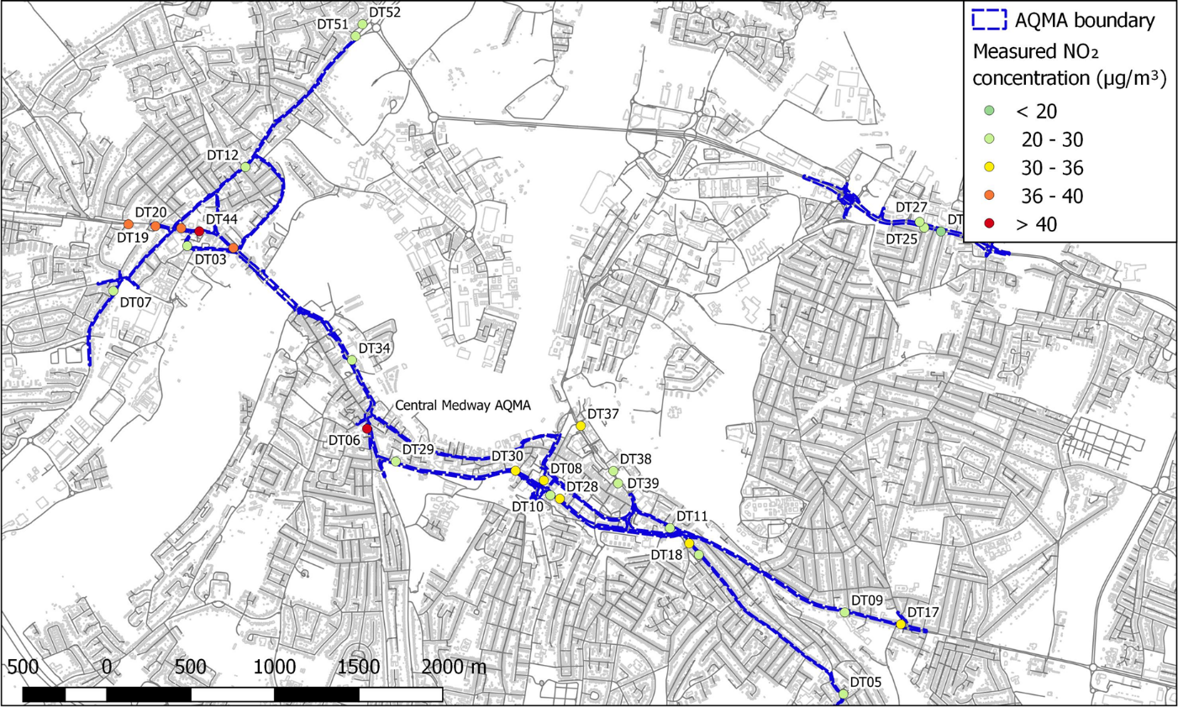

## Base year and meteorological dataset

The 2022 surface meteorological data was obtained from three stations (Biggin Hill, Shoeburyness Landwick, and Southend) and upper air meteorological data was obtained from two stations (Herstomonceux and Larkhill). RapidAir was used to carry out data filling where necessary. Data gaps from the primary meteorological stations (Biggin Hill and Herstomonceux) were first filled using data from the other nearby stations (Shoeburyness Landwick, and Southend for surface stations, and Larkhill for the upper air station). Remaining data gaps were filled based on the persistence method, where a missing value is replaced by the use of data from the previous hour(s), for data gaps up to and including three hours.

## Road locations

A realistic representation of road locations has been modelled by assigning emissions to the road links represented in the local transport model provided by Medway Council. It contains spatially accurate road centreline locations for various road categories (e.g. motorway, A road, B road, minor road, local street, etc.).

## Street canyons

The presence of buildings either side of a road can introduce ‘street canyon’ effects which result in pollutants becoming trapped, leading to increased pollutant concentrations. There are canyon effects present in Medway, which may be contributing to air quality issues in the study area.

Street canyon impacts were modelled using the RapidAir canyon module. Building heights were obtained from the Ordnance Survey MasterMap Topography Layer data.

## Road transport modelling

### Average daily vehicle flow and speeds

Annual average daily traffic (AADT) link flows and daily average speed for each modelled road link were taken from the local traffic model, provided by Medway Council. AADT was adjusted to be representative of the baseline year (2022) using Trip End Model Presentation Program TEMPro growth factors[35].

A typical UK weekday diurnal profile(sourced from the Department for Transport) was assumed and applied as time varying emissions in AERMOD when creating the RapidAir dispersion kernel.

### Vehicle fleet composition

Vehicle fleet composition data for 2022 were applied from the best available local (Medway) and national data, based on best scientific knowledge. Vehicle emissions rates for buses, taxis, coaches, rigid HGVs, articulated HGVs, LGVs, cars and motorcycles have been calculated using the COPERT v5.6 emissions functions contained in the latest version of the Defra Emissions Factors Toolkit (EFT) (v12.0.1)[36].

The traffic model provided vehicle flows for four highway user classes which were: Cars/Taxis, light goods vehicles (LGVs), and heavy goods vehicles (HGVs)/Buses.

The highway user classes for Cars/Taxis and HGVs/Buses were separated using automatic number plate recognition (ANPR) data recorded in Medway during November 2023[37]. A further breakdown of the HGV class into rigid and articulated categories was conducted using the same ANPR study. Similarly, the car class has been further split using the ANPR data into diesel, petrol, and hybrid (plug-in petrol hybrid, full petrol hybrid, plug-in diesel hybrid) vehicles. Taxis within Medway were modelled as either passenger cars (for private hire vehicles; PHVs) or as taxis (for black cabs). The proportion of cars which could be attributed to taxis was again based on the local ANPR study.

## NOx/NO2 conversion

Link-specific NOxand PM emissions factors were calculated using the COPERT v5.3 emission functions for all vehicles up to and including Euro 6/VI. Emissions rates were calculated using the Emissions Factor Toolkit (EFT) (v12.0.1)[38].

The most recent version (v8.1) of the Local Air Quality Management (LAQM) NOxto NO2 conversion toolkit[39] was used to convert road NOx and background NOx into NO2 concentrations where results at discrete receptor locations were required. This includes all roadside and kerbside 2022 NO2 monitoring site locations in proximity to modelled road links.

The borough-wide domain was modelled at a 1 m resolution. When calculating NO2 for large model domains and high-resolution models, using the LAQM NOx to NO2 conversion spreadsheet tool for the conversion is not practical. In this case, a statistical relationship was derived using an ordinary least squares (OLS) regression model. The OLS model was derived by defining background NOx, road NOx and road fNO2 as the independent variables, and total NO2 as the dependent variable.

## Background concentrations

Background NOx and PM values were obtained from background mapping data for local authorities available on the LAQM website.[40] The 2022 background maps (2018 base year) were applied to the study. The contribution from local road transport sources sectors that were included in the air quality model were subtracted from the background maps to avoid double counting. Due to the geographic location of the modelling domain, background concentration data were sourced from the Southern England regional data set.

## Measured concentrations

Medway Council’s 2022 NO2 measurements were applied to the air quality modelling assessment in order to verify the model outputs and to inform the source apportionment analysis. Measurements were applied from 28 monitoring sites which were confirmed as having sufficient data capture for the 2022 base year and in locations where concentrations would be accurately represented in the air quality model. A map showing the sites at which NO2 concentrations were measured during 2022 is presented in Figure A- 1, with a majority of these being located in and around the AQMAs, and on the main road links in Medway.

## Model verification

To evaluate model performance and uncertainty, the Root Mean Square Error (RMSE) for observed vs predicted NO2 annual mean concentrations was calculated, as detailed in Technical Guidance LAQM.TG(22).

A single road NOx (global) adjustment factor of 3.98 was derived from the model verification, and was applied to the calculation of modelled concentrations at specified air quality monitoring locations. In the absence of sufficient PM data for verification, the road NOx adjustment was applied to the modelled road PM10 and PM2.5 outputs. This is the recommended methodology from Technical Guidance LAQM.TG(22).

Total NO2 concentrations at specified receptors were obtained from background and adjusted road NOx concentrations using the NOx to NO2 calculator provided by Defra. Where annual NO2 concentration maps were required, total NO2 was derived using the specified equation. The equation was determined by plotting total modelled NO2 vs total modelled NOx at the specified receptor points:  
  
**(NO2 in μg/m3) = –0.000530 (NOx in μg/m3)2 + 0.500(NOx in μg/m3) + 6.08**

Technical Guidance LAQM.TG(22) indicates that a RMSE of up to 10% of the target limit value (4 µg/m3, considering a 40 µg/m3 limit value for NO2) is ideal, and an RMSE of up to 25% of the target limit value (10 µg/m3) is acceptable. In the global case the RMSE was calculated at 7.02 µg/m3, which is acceptable and shows agreement between the modelled and measured concentrations.

# Baseline Model results – NO2

Figure A- 2 presents a map of modelled NO2 concentrations across Medway for 2022. Air quality in Medway is generally good, and well below the annual mean AQO in most locations. As is to be expected, elevated concentrations of NO2 are found on and surrounding the main roads in Medway, including within the AQMAs.

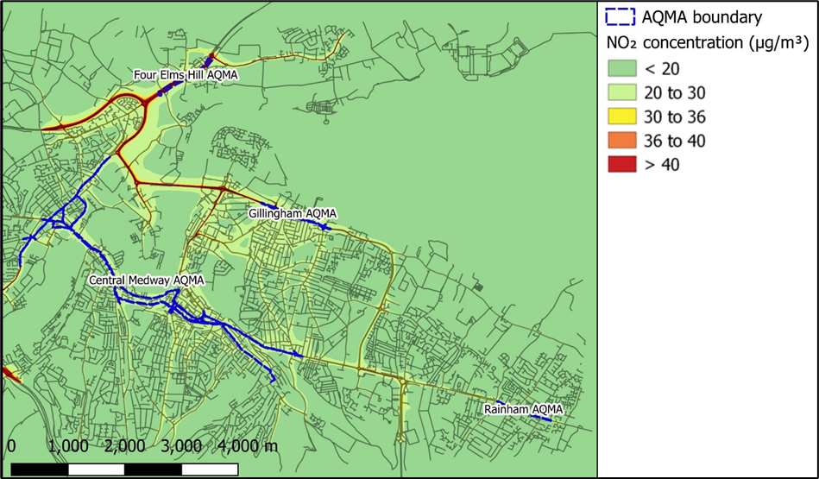

Figure A- 2 – Modelled NO2 concentrations across Medway in 2022

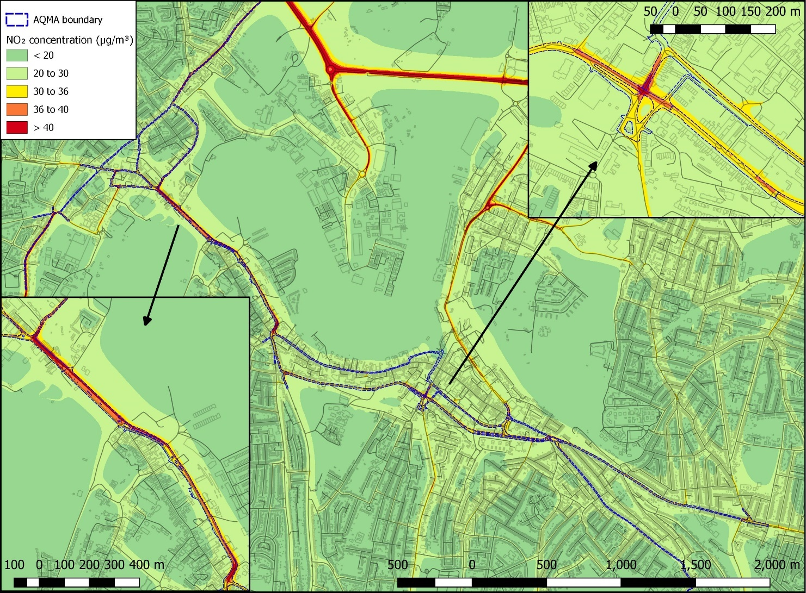Figure A- 3 shows a map of modelled NO2 concentrations across the Central Medway AQMA in 2022. Modelled NO2 concentrations exceed 40 μg/m3 along the majority of the A2. The highest concentrations are found along points of congestion, including where traffic from High Street joins the A2 at Corporation Street (see inset below).

Figure A- 3 Modelled NO2 concentrations across Central Medway AQMA in 2022

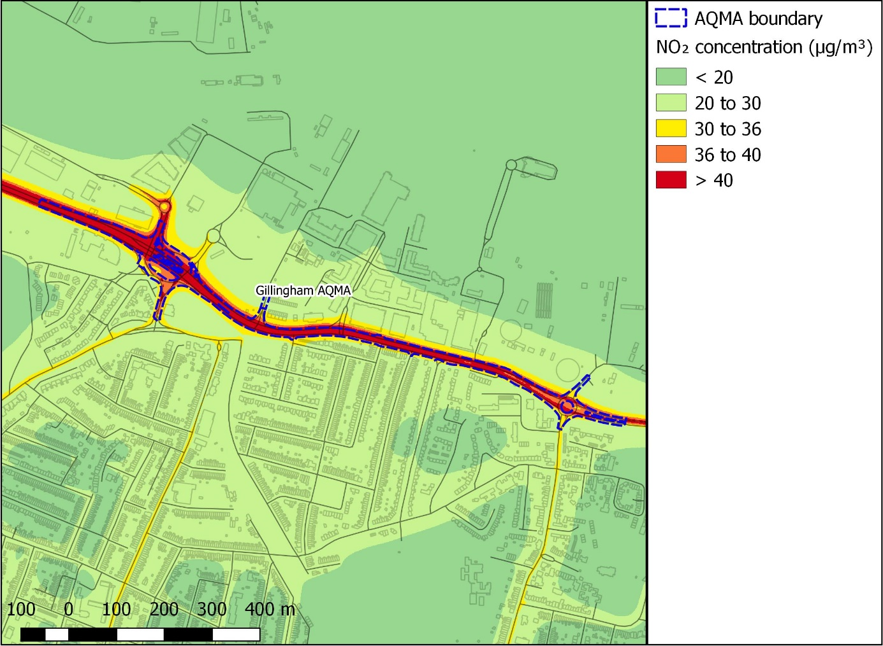Figure A- 4 shows a map of modelled NO2 concentrations across the Gillingham AQMA in 2022. Modelled NO2 concentrations exceed 40 μg/m3 along Pier Road (A289). The highest concentrations are found along points of congestion, for example where the B2004 joins the A289 and at The Strand Roundabout.

Figure A- 4 – Modelled NO2 concentrations across Pier Road, Gillingham AQMA in 2022

Figure A- 5 shows a map of modelled NO2 concentrations across the Rainham AQMA in 2022. Modelled NO2 concentrations are all below 36 μg/m3. The highest concentrations are found along where Orchard Street meets the A2.

Figure A- 5 – Modelled NO2 concentrations across High Street, Rainham AQMA in 2022

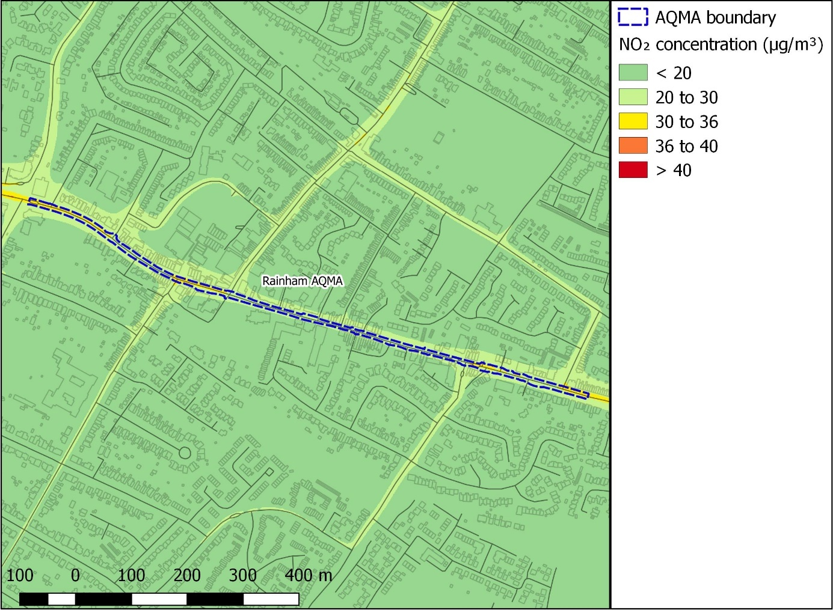

# Source apportionment

## Data sources and methodology

This section provides the data sources and methodology for the source apportionment study performed as part of the Medway AQAP 2024 baseline modelling assessment.

Figure A- 6 provides a schematic of the workflow and data used to inform the source apportionment study. A source apportionment of modelled road emissions was conducted using data from the closest modelled road link(s) to the specified 2022 air quality monitoring locations in Medway. The modelled road link emissions were then separated by vehicle type, based on the 2022 baseline scenario.

Background emissions were included in the source apportionment by assigning each monitoring site to its equivalent Defra background map[41] 1 km x 1 km grid square (based on location of the site across Southern England).

To avoid double counting, the explicitly modelled roads were removed from the Defra background maps; these included motorway, primary and trunk roads, brake and tyre wear, and road abrasion. The remaining background emissions were then included in the source apportionment.

A ratio of road to background emissions was calculated for each monitoring location using the modelled concentration outputs. The calculated ratio was then applied to combine the road and background source apportionment datasets, providing a full source apportionment at each monitoring location.

Finally, an attempt at calculating indicatory concentration values for each source category was performed by multiplying the total measured (where possible) and/or modelled concentrations by the percentage contribution from each source. This helps to provide a clearer picture with regards to the significance of the source at each location.

Figure A- 6 Workflow and data used to calculate source apportionment

Modelled road emissions   
(2022 baseline)

2018 Background maps   
(2022 projections)

Source apportionment by background source

Source apportionment by vehicle type

Proportion of background vs modelled road emissions

Full source apportionment at monitoring locations

## Source apportionment results

The results from the source apportionment calculations are presented in the form of stacked column bar charts in the following figures. This is to illustrate the contributions of each source at monitoring locations within the three AQMAs for each of the pollutants of concern. The results are also presented in tables.

In addition, the measured NO2 concentrations in 2022 at the monitoring locations have been broken down, in order to provide an indication of the NO2 concentration that can be attributed to each source at each monitoring location.



Figure A- 7 – Stacked bar chart showing NOx source apportionment for all road transport and background for monitoring locations within Medway’s AQMAs (%), for the baseline fleet, 2022

Table A- 1 – Breakdown of modelled NOx emissions at diffusion tube locations within AQMAs (% of total modelled NOx emissions) by source

| Site ID | Petrol Cars | Diesel Cars | Hybrid Petrol Cars | Hybrid Diesel Cars | Buses | LGVs | Rigid HGVs | Artic HGVs | Taxis | Minor Rd + Cold Start | Industry | Domestic | Aircraft | Rail | Other | Point Sources | Rural |
| --- | --- | --- | --- | --- | --- | --- | --- | --- | --- | --- | --- | --- | --- | --- | --- | --- | --- |
| DT02 | 6.89% | 29.40% | 0.26% | 0.02% | 8.79% | 15.25% | 3.12% | 0.02% | 1.22% | 4.76% | 1.81% | 5.68% | 0.00% | 0.04% | 4.65% | 1.25% | 16.83% |
| DT03 | 8.24% | 35.13% | 0.31% | 0.02% | 5.63% | 17.71% | 2.00% | 0.01% | 1.46% | 4.01% | 1.53% | 4.78% | 0.00% | 0.03% | 3.92% | 1.05% | 14.16% |
| DT04 | 7.44% | 32.62% | 0.28% | 0.02% | 5.12% | 9.70% | 1.81% | 0.01% | 1.35% | 5.75% | 2.19% | 8.13% | 0.00% | 0.03% | 5.12% | 1.82% | 18.61% |
| DT05 | 5.91% | 25.92% | 0.22% | 0.02% | 5.17% | 9.77% | 1.83% | 0.01% | 1.07% | 6.38% | 3.98% | 8.27% | 0.00% | 0.01% | 6.01% | 2.35% | 23.07% |
| DT06 | 6.97% | 29.74% | 0.26% | 0.02% | 7.23% | 11.65% | 2.56% | 0.02% | 1.24% | 4.75% | 2.14% | 5.50% | 0.00% | 0.03% | 7.70% | 1.54% | 18.65% |
| DT09 | 6.49% | 27.66% | 0.25% | 0.02% | 3.24% | 7.54% | 1.15% | 0.01% | 1.15% | 6.69% | 4.17% | 8.67% | 0.00% | 0.01% | 6.30% | 2.47% | 24.20% |
| DT10 | 6.63% | 28.26% | 0.25% | 0.02% | 5.39% | 8.86% | 1.91% | 0.01% | 1.17% | 7.40% | 2.27% | 9.53% | 0.00% | 0.03% | 6.33% | 1.84% | 20.11% |
| DT12 | 6.16% | 26.27% | 0.23% | 0.02% | 10.25% | 10.57% | 3.64% | 0.02% | 1.09% | 5.68% | 2.16% | 6.77% | 0.00% | 0.04% | 5.55% | 1.49% | 20.05% |
| DT17 | 8.48% | 36.17% | 0.32% | 0.02% | 4.52% | 13.94% | 1.60% | 0.01% | 1.50% | 4.26% | 2.66% | 5.52% | 0.00% | 0.01% | 4.01% | 1.57% | 15.40% |
| DT18 | 8.00% | 35.10% | 0.30% | 0.02% | 5.50% | 10.44% | 1.95% | 0.01% | 1.45% | 5.13% | 1.96% | 7.26% | 0.00% | 0.02% | 4.58% | 1.63% | 16.63% |
| DT28 | 7.85% | 33.48% | 0.30% | 0.02% | 8.89% | 11.52% | 3.15% | 0.02% | 1.39% | 5.20% | 1.60% | 6.69% | 0.00% | 0.02% | 4.45% | 1.29% | 14.13% |
| DT29 | 8.56% | 36.52% | 0.32% | 0.02% | 6.04% | 11.86% | 2.14% | 0.01% | 1.52% | 4.57% | 1.72% | 5.58% | 0.00% | 0.01% | 4.17% | 1.36% | 15.60% |
| DT30 | 8.14% | 34.70% | 0.31% | 0.02% | 8.47% | 10.69% | 3.00% | 0.02% | 1.44% | 5.17% | 1.59% | 6.66% | 0.00% | 0.02% | 4.42% | 1.28% | 14.06% |
| DT34 | 8.38% | 35.72% | 0.32% | 0.02% | 5.24% | 17.22% | 1.86% | 0.01% | 1.48% | 3.51% | 1.58% | 4.06% | 0.00% | 0.02% | 5.68% | 1.13% | 13.76% |
| DT35 | 8.17% | 36.05% | 0.31% | 0.02% | 7.98% | 15.15% | 2.82% | 0.02% | 1.49% | 3.81% | 1.45% | 4.54% | 0.00% | 0.03% | 3.72% | 1.00% | 13.45% |
| DT44 | 7.54% | 32.14% | 0.29% | 0.02% | 6.43% | 18.38% | 2.28% | 0.01% | 1.34% | 4.29% | 1.63% | 5.12% | 0.00% | 0.03% | 4.20% | 1.13% | 15.17% |
| DT51 | 4.18% | 18.56% | 0.16% | 0.01% | 25.70% | 7.17% | 9.08% | 0.06% | 0.77% | 3.98% | 1.97% | 4.12% | 0.00% | 0.02% | 5.39% | 1.36% | 17.48% |
| DT19 | 8.34% | 35.57% | 0.32% | 0.02% | 7.61% | 9.45% | 2.70% | 0.02% | 1.48% | 4.69% | 1.79% | 5.59% | 0.00% | 0.04% | 4.58% | 1.23% | 16.57% |
| DT11 | 7.12% | 30.38% | 0.27% | 0.02% | 4.87% | 8.50% | 1.73% | 0.01% | 1.26% | 6.32% | 2.41% | 8.95% | 0.00% | 0.03% | 5.64% | 2.01% | 20.48% |
| DT07 | 7.25% | 30.93% | 0.27% | 0.02% | 12.89% | 17.80% | 4.57% | 0.03% | 1.29% | 2.49% | 1.54% | 2.65% | 0.00% | 0.02% | 4.40% | 1.00% | 12.84% |
| DT08 | 8.23% | 35.09% | 0.31% | 0.02% | 8.23% | 8.21% | 2.92% | 0.02% | 1.46% | 5.53% | 1.70% | 7.12% | 0.00% | 0.02% | 4.73% | 1.37% | 15.04% |
| DT37 | 7.69% | 32.79% | 0.29% | 0.02% | 7.67% | 9.91% | 2.72% | 0.02% | 1.36% | 3.60% | 1.83% | 3.69% | 0.00% | 0.01% | 14.02% | 1.17% | 13.21% |
| DT15 | 6.42% | 27.37% | 0.24% | 0.02% | 9.09% | 10.18% | 3.23% | 0.02% | 1.14% | 5.30% | 2.53% | 5.88% | 0.00% | 0.01% | 3.75% | 2.02% | 22.81% |
| DT16 | 5.76% | 24.54% | 0.22% | 0.02% | 8.16% | 9.13% | 2.89% | 0.02% | 1.02% | 6.05% | 2.88% | 6.71% | 0.00% | 0.01% | 4.27% | 2.30% | 26.02% |
| DT01NEW | 4.87% | 20.76% | 0.18% | 0.01% | 18.33% | 9.14% | 6.50% | 0.04% | 0.86% | 4.93% | 2.35% | 5.46% | 0.00% | 0.01% | 3.48% | 1.88% | 21.19% |
| DT25 | 5.84% | 23.47% | 0.31% | 0.01% | 10.06% | 16.94% | 3.62% | 0.02% | 1.00% | 3.92% | 3.11% | 4.68% | 0.00% | 0.01% | 11.45% | 1.35% | 14.20% |
| DT26 | 5.93% | 23.83% | 0.32% | 0.01% | 10.71% | 17.59% | 3.85% | 0.02% | 1.02% | 3.01% | 2.20% | 4.21% | 0.00% | 0.01% | 8.01% | 1.67% | 17.61% |
| DT27 | 8.10% | 32.57% | 0.44% | 0.02% | 8.97% | 13.63% | 3.23% | 0.02% | 1.39% | 3.21% | 2.54% | 3.82% | 0.00% | 0.01% | 9.36% | 1.10% | 11.60% |

Table A- 2 – Breakdown of measured NO2 concentrations (2022) at diffusion tube locations within AQMAs µg/m3) by source

| Site ID | Measured NO2 concentration, 2022 (µg/m3) | Petrol Cars | Diesel Cars | Hybrid Petrol Cars | Hybrid Diesel Cars | Buses | LGVs | Rigid HGVs | Artic HGVs | Taxis | Minor Rd + Cold Start | Industry | Domestic | Aircraft | Rail | Other | Point Sources | Rural |
| --- | --- | --- | --- | --- | --- | --- | --- | --- | --- | --- | --- | --- | --- | --- | --- | --- | --- | --- |
| DT01 | 34.9 | 1.70 | 7.25 | 0.06 | 0.00 | 6.40 | 3.19 | 2.27 | 0.01 | 0.30 | 1.72 | 0.82 | 1.91 | 0.00 | 0.00 | 1.21 | 0.66 | 7.40 |
| DT02 | 38.6 | 2.66 | 11.35 | 0.10 | 0.01 | 3.39 | 5.89 | 1.20 | 0.01 | 0.47 | 1.84 | 0.70 | 2.19 | 0.00 | 0.01 | 1.80 | 0.48 | 6.49 |
| DT03 | 38.8 | 3.20 | 13.63 | 0.12 | 0.01 | 2.19 | 6.87 | 0.78 | 0.00 | 0.57 | 1.56 | 0.59 | 1.85 | 0.00 | 0.01 | 1.52 | 0.41 | 5.50 |
| DT04 | 29.9 | 2.22 | 9.75 | 0.08 | 0.01 | 1.53 | 2.90 | 0.54 | 0.00 | 0.40 | 1.72 | 0.66 | 2.43 | 0.00 | 0.01 | 1.53 | 0.54 | 5.57 |
| DT05 | 25.3 | 1.50 | 6.56 | 0.06 | 0.00 | 1.31 | 2.47 | 0.46 | 0.00 | 0.27 | 1.61 | 1.01 | 2.09 | 0.00 | 0.00 | 1.52 | 0.60 | 5.84 |
| DT06 | 43.5 | 3.03 | 12.94 | 0.11 | 0.01 | 3.15 | 5.07 | 1.12 | 0.01 | 0.54 | 2.07 | 0.93 | 2.39 | 0.00 | 0.01 | 3.35 | 0.67 | 8.11 |
| DT09 | 20.8 | 1.35 | 5.75 | 0.05 | 0.00 | 0.67 | 1.57 | 0.24 | 0.00 | 0.24 | 1.39 | 0.87 | 1.80 | 0.00 | 0.00 | 1.31 | 0.51 | 5.03 |
| DT10 | 26.9 | 1.78 | 7.60 | 0.07 | 0.00 | 1.45 | 2.38 | 0.51 | 0.00 | 0.32 | 1.99 | 0.61 | 2.56 | 0.00 | 0.01 | 1.70 | 0.49 | 5.41 |
| DT12 | 27.8 | 1.71 | 7.30 | 0.06 | 0.00 | 2.85 | 2.94 | 1.01 | 0.01 | 0.30 | 1.58 | 0.60 | 1.88 | 0.00 | 0.01 | 1.54 | 0.41 | 5.58 |
| DT15 | 30.2 | 1.94 | 8.26 | 0.07 | 0.01 | 2.75 | 3.08 | 0.97 | 0.01 | 0.34 | 1.60 | 0.76 | 1.78 | 0.00 | 0.00 | 1.13 | 0.61 | 6.89 |
| DT16 | 20.6 | 1.19 | 5.06 | 0.04 | 0.00 | 1.68 | 1.88 | 0.60 | 0.00 | 0.21 | 1.25 | 0.59 | 1.38 | 0.00 | 0.00 | 0.88 | 0.47 | 5.36 |
| DT17 | 34.8 | 2.95 | 12.59 | 0.11 | 0.01 | 1.57 | 4.85 | 0.56 | 0.00 | 0.52 | 1.48 | 0.92 | 1.92 | 0.00 | 0.00 | 1.39 | 0.55 | 5.36 |
| DT18 | 35.5 | 2.84 | 12.46 | 0.11 | 0.01 | 1.95 | 3.71 | 0.69 | 0.00 | 0.52 | 1.82 | 0.69 | 2.58 | 0.00 | 0.01 | 1.63 | 0.58 | 5.90 |
| DT25 | 29.7 | 1.73 | 6.97 | 0.09 | 0.00 | 2.99 | 5.03 | 1.07 | 0.01 | 0.30 | 1.17 | 0.92 | 1.39 | 0.00 | 0.00 | 3.40 | 0.40 | 4.22 |
| DT26 | 19.9 | 1.18 | 4.74 | 0.06 | 0.00 | 2.13 | 3.50 | 0.77 | 0.00 | 0.20 | 0.60 | 0.44 | 0.84 | 0.00 | 0.00 | 1.59 | 0.33 | 3.50 |
| DT27 | 27.3 | 2.21 | 8.89 | 0.12 | 0.01 | 2.45 | 3.72 | 0.88 | 0.00 | 0.38 | 0.88 | 0.69 | 1.04 | 0.00 | 0.00 | 2.55 | 0.30 | 3.17 |
| DT28 | 33.9 | 2.66 | 11.35 | 0.10 | 0.01 | 3.01 | 3.90 | 1.07 | 0.01 | 0.47 | 1.76 | 0.54 | 2.27 | 0.00 | 0.01 | 1.51 | 0.44 | 4.79 |
| DT29 | 27.3 | 2.34 | 9.97 | 0.09 | 0.01 | 1.65 | 3.24 | 0.58 | 0.00 | 0.41 | 1.25 | 0.47 | 1.52 | 0.00 | 0.00 | 1.14 | 0.37 | 4.26 |
| DT30 | 31.9 | 2.60 | 11.07 | 0.10 | 0.01 | 2.70 | 3.41 | 0.96 | 0.01 | 0.46 | 1.65 | 0.51 | 2.12 | 0.00 | 0.01 | 1.41 | 0.41 | 4.48 |
| DT34 | 26.4 | 2.21 | 9.43 | 0.08 | 0.01 | 1.38 | 4.55 | 0.49 | 0.00 | 0.39 | 0.93 | 0.42 | 1.07 | 0.00 | 0.01 | 1.50 | 0.30 | 3.63 |
| DT35 | 28 | 2.29 | 10.09 | 0.09 | 0.01 | 2.23 | 4.24 | 0.79 | 0.01 | 0.42 | 1.07 | 0.41 | 1.27 | 0.00 | 0.01 | 1.04 | 0.28 | 3.77 |
| DT37 | 31.4 | 2.41 | 10.30 | 0.09 | 0.01 | 2.41 | 3.11 | 0.85 | 0.01 | 0.43 | 1.13 | 0.58 | 1.16 | 0.00 | 0.00 | 4.40 | 0.37 | 4.15 |
| DT44 | 42.2 | 3.18 | 13.56 | 0.12 | 0.01 | 2.72 | 7.75 | 0.96 | 0.01 | 0.56 | 1.81 | 0.69 | 2.16 | 0.00 | 0.01 | 1.77 | 0.48 | 6.40 |
| DT51 | 22.8 | 0.95 | 4.23 | 0.04 | 0.00 | 5.86 | 1.64 | 2.07 | 0.01 | 0.17 | 0.91 | 0.45 | 0.94 | 0.00 | 0.00 | 1.23 | 0.31 | 3.99 |
| DT19 | 36.5 | 3.04 | 12.98 | 0.12 | 0.01 | 2.78 | 3.45 | 0.99 | 0.01 | 0.54 | 1.71 | 0.65 | 2.04 | 0.00 | 0.01 | 1.67 | 0.45 | 6.05 |
| DT11 | 30 | 2.14 | 9.11 | 0.08 | 0.01 | 1.46 | 2.55 | 0.52 | 0.00 | 0.38 | 1.90 | 0.72 | 2.68 | 0.00 | 0.01 | 1.69 | 0.60 | 6.14 |
| DT07 | 29.2 | 2.12 | 9.03 | 0.08 | 0.01 | 3.76 | 5.20 | 1.33 | 0.01 | 0.38 | 0.73 | 0.45 | 0.77 | 0.00 | 0.01 | 1.28 | 0.29 | 3.75 |
| DT08 | 35.4 | 2.91 | 12.42 | 0.11 | 0.01 | 2.91 | 2.90 | 1.03 | 0.01 | 0.52 | 1.96 | 0.60 | 2.52 | 0.00 | 0.01 | 1.68 | 0.49 | 5.33 |

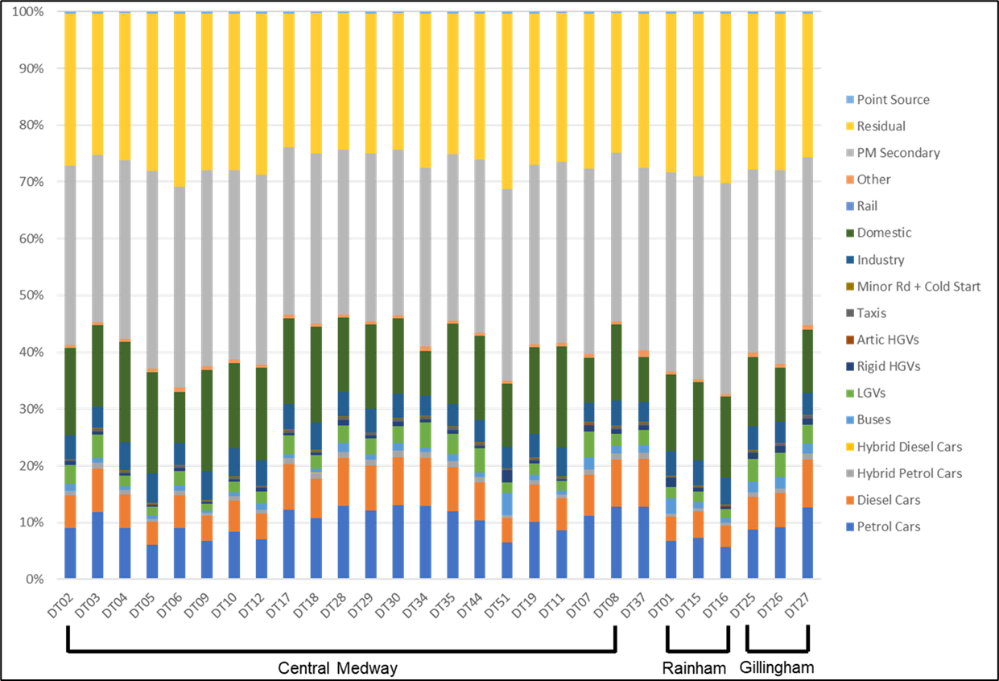

Figure A- 8 – Stacked bar chart showing PM10 source apportionment for all road transport and background for monitoring locations within Medway’s AQMAs (%), for the baseline fleet, 2022

Table A- 3 – Breakdown of modelled PM10 emissions at diffusion tube locations within AQMAs (% of total modelled NOx emissions) by source

| Site ID | Petrol Cars | Diesel Cars | Hybrid Petrol Cars | Hybrid Diesel Cars | Buses | LGVs | Rigid HGVs | Artic HGVs | Taxis | Minor Rd + Cold Start | Industry | Domestic | Aircraft | Rail | Other | Point Sources | Rural |
| --- | --- | --- | --- | --- | --- | --- | --- | --- | --- | --- | --- | --- | --- | --- | --- | --- | --- |
| DT02 | 8.97% | 5.84% | 0.79% | 0.01% | 1.18% | 3.29% | 0.68% | 0.02% | 0.39% | 0.10% | 4.15% | 15.36% | 0.00% | 0.53% | 31.61% | 26.78% | 0.31% |
| DT03 | 11.79% | 7.67% | 1.04% | 0.01% | 0.83% | 4.20% | 0.48% | 0.01% | 0.51% | 0.10% | 3.86% | 14.31% | 0.00% | 0.50% | 29.45% | 24.95% | 0.29% |
| DT04 | 9.02% | 5.90% | 0.79% | 0.01% | 0.61% | 1.98% | 0.35% | 0.01% | 0.39% | 0.11% | 5.03% | 17.62% | 0.00% | 0.60% | 31.44% | 25.87% | 0.28% |
| DT05 | 6.08% | 3.98% | 0.53% | 0.00% | 0.52% | 1.69% | 0.30% | 0.01% | 0.26% | 0.11% | 5.16% | 17.82% | 0.00% | 0.72% | 34.70% | 27.75% | 0.37% |
| DT06 | 8.97% | 5.84% | 0.79% | 0.01% | 0.96% | 2.49% | 0.56% | 0.02% | 0.39% | 0.10% | 3.92% | 8.94% | 0.00% | 0.81% | 35.30% | 30.56% | 0.36% |
| DT09 | 6.73% | 4.39% | 0.59% | 0.01% | 0.35% | 1.30% | 0.20% | 0.01% | 0.29% | 0.11% | 5.13% | 17.72% | 0.00% | 0.72% | 34.51% | 27.60% | 0.36% |
| DT10 | 8.42% | 5.48% | 0.74% | 0.01% | 0.70% | 1.87% | 0.41% | 0.01% | 0.36% | 0.15% | 4.90% | 15.09% | 0.00% | 0.63% | 33.36% | 27.58% | 0.30% |
| DT12 | 7.04% | 4.58% | 0.62% | 0.01% | 1.21% | 2.00% | 0.70% | 0.02% | 0.30% | 0.11% | 4.39% | 16.27% | 0.00% | 0.56% | 33.49% | 28.37% | 0.33% |
| DT17 | 12.29% | 8.00% | 1.08% | 0.01% | 0.68% | 3.35% | 0.39% | 0.01% | 0.53% | 0.09% | 4.38% | 15.15% | 0.00% | 0.62% | 29.51% | 23.60% | 0.31% |
| DT18 | 10.75% | 7.03% | 0.95% | 0.01% | 0.73% | 2.36% | 0.42% | 0.01% | 0.46% | 0.11% | 4.80% | 16.82% | 0.00% | 0.57% | 30.02% | 24.70% | 0.27% |
| DT28 | 12.90% | 8.40% | 1.14% | 0.01% | 1.51% | 3.14% | 0.87% | 0.02% | 0.55% | 0.13% | 4.27% | 13.15% | 0.00% | 0.55% | 29.07% | 24.03% | 0.26% |
| DT29 | 12.14% | 7.91% | 1.07% | 0.01% | 0.88% | 2.79% | 0.51% | 0.01% | 0.52% | 0.10% | 4.14% | 14.81% | 0.00% | 0.49% | 29.65% | 24.66% | 0.29% |
| DT30 | 13.03% | 8.49% | 1.15% | 0.01% | 1.40% | 2.84% | 0.81% | 0.02% | 0.56% | 0.13% | 4.28% | 13.19% | 0.00% | 0.55% | 29.17% | 24.11% | 0.26% |
| DT34 | 12.89% | 8.40% | 1.14% | 0.01% | 0.83% | 4.39% | 0.48% | 0.01% | 0.55% | 0.09% | 3.49% | 7.97% | 0.00% | 0.72% | 31.46% | 27.24% | 0.32% |
| DT35 | 11.94% | 7.82% | 1.05% | 0.01% | 1.13% | 3.73% | 0.65% | 0.02% | 0.51% | 0.09% | 3.85% | 14.25% | 0.00% | 0.49% | 29.32% | 24.84% | 0.29% |
| DT44 | 10.31% | 6.71% | 0.91% | 0.01% | 0.91% | 4.17% | 0.53% | 0.01% | 0.44% | 0.10% | 4.00% | 14.81% | 0.00% | 0.51% | 30.47% | 25.81% | 0.30% |
| DT51 | 6.47% | 4.25% | 0.57% | 0.01% | 3.83% | 1.88% | 2.19% | 0.06% | 0.28% | 0.08% | 3.78% | 11.09% | 0.00% | 0.52% | 33.65% | 30.98% | 0.35% |
| DT19 | 10.06% | 6.55% | 0.89% | 0.01% | 0.95% | 1.89% | 0.55% | 0.02% | 0.43% | 0.10% | 4.14% | 15.33% | 0.00% | 0.53% | 31.53% | 26.72% | 0.31% |
| DT11 | 8.61% | 5.60% | 0.76% | 0.01% | 0.61% | 1.70% | 0.35% | 0.01% | 0.37% | 0.11% | 5.09% | 17.85% | 0.00% | 0.61% | 31.84% | 26.20% | 0.28% |
| DT07 | 11.14% | 7.26% | 0.98% | 0.01% | 2.04% | 4.53% | 1.18% | 0.03% | 0.48% | 0.07% | 3.34% | 7.89% | 0.00% | 0.69% | 32.67% | 27.35% | 0.33% |
| DT08 | 12.76% | 8.31% | 1.12% | 0.01% | 1.31% | 2.11% | 0.76% | 0.02% | 0.55% | 0.13% | 4.36% | 13.44% | 0.00% | 0.56% | 29.72% | 24.56% | 0.26% |
| DT37 | 12.81% | 8.34% | 1.13% | 0.01% | 1.32% | 2.74% | 0.76% | 0.02% | 0.55% | 0.10% | 3.52% | 7.90% | 0.00% | 1.11% | 32.10% | 27.28% | 0.30% |
| DT15 | 6.68% | 4.35% | 0.59% | 0.01% | 2.59% | 2.08% | 1.50% | 0.04% | 0.29% | 0.09% | 4.36% | 13.50% | 0.00% | 0.46% | 35.06% | 28.05% | 0.33% |
| DT16 | 7.22% | 4.70% | 0.64% | 0.01% | 1.05% | 1.90% | 0.61% | 0.02% | 0.31% | 0.09% | 4.45% | 13.78% | 0.00% | 0.47% | 35.78% | 28.63% | 0.34% |
| DT01 | 5.74% | 3.74% | 0.51% | 0.00% | 0.84% | 1.51% | 0.49% | 0.01% | 0.25% | 0.10% | 4.63% | 14.34% | 0.00% | 0.49% | 37.22% | 29.78% | 0.35% |
| DT25 | 8.77% | 5.75% | 0.78% | 0.01% | 1.81% | 4.08% | 1.05% | 0.03% | 0.38% | 0.10% | 4.25% | 12.13% | 0.00% | 0.80% | 32.23% | 27.50% | 0.33% |
| DT26 | 9.15% | 6.00% | 0.82% | 0.01% | 1.98% | 4.35% | 1.15% | 0.03% | 0.40% | 0.06% | 3.84% | 9.52% | 0.00% | 0.60% | 34.13% | 27.60% | 0.36% |
| DT27 | 12.70% | 8.32% | 1.13% | 0.01% | 1.69% | 3.42% | 0.98% | 0.03% | 0.55% | 0.09% | 3.91% | 11.16% | 0.00% | 0.74% | 29.66% | 25.31% | 0.30% |

Figure A- 9 – Stacked bar chart showing PM2.5 source apportionment for all road transport and background for monitoring locations within Medway’s AQMAs (%), for the baseline fleet, 2022

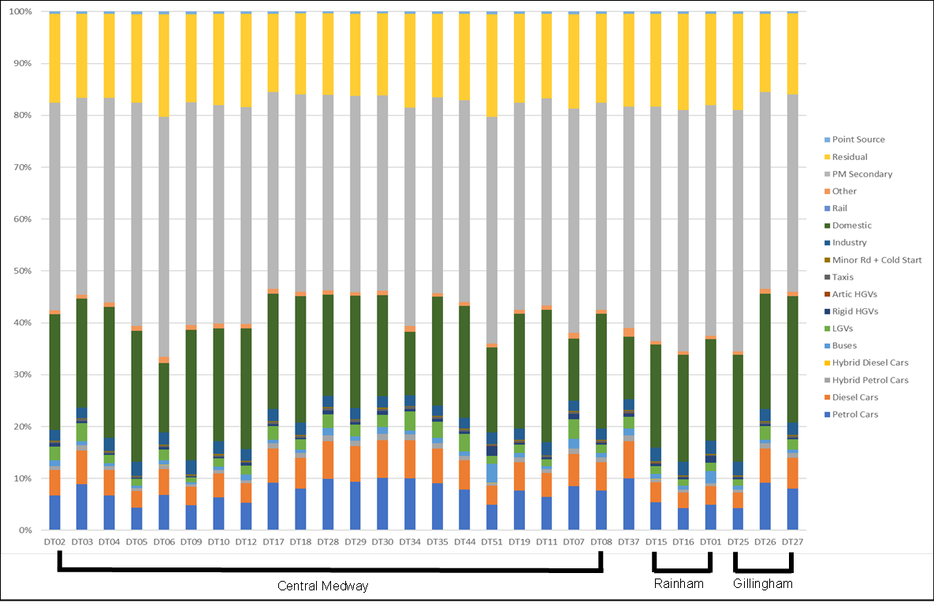

Table A- 4 – Breakdown of modelled PM2.5 emissions at diffusion tube locations within AQMAs (% of total modelled NOx emissions) by source

| Site ID | Petrol Cars | Diesel Cars | Hybrid Petrol Cars | Hybrid Diesel Cars | Buses | LGVs | Rigid HGVs | Artic HGVs | Taxis | Minor Rd + Cold Start | Industry | Domestic | Aircraft | Rail | Other | Point Sources | Rural |
| --- | --- | --- | --- | --- | --- | --- | --- | --- | --- | --- | --- | --- | --- | --- | --- | --- | --- |
| DT02 | 6.60% | 4.79% | 0.60% | 0.01% | 1.08% | 2.60% | 0.57% | 0.02% | 0.29% | 0.15% | 2.16% | 22.39% | 0.00% | 0.77% | 40.30% | 17.26% | 0.43% |
| DT03 | 8.95% | 6.50% | 0.81% | 0.01% | 0.79% | 3.43% | 0.41% | 0.01% | 0.40% | 0.14% | 2.04% | 21.11% | 0.00% | 0.72% | 38.00% | 16.27% | 0.41% |
| DT04 | 6.53% | 4.78% | 0.59% | 0.01% | 0.55% | 1.55% | 0.29% | 0.01% | 0.29% | 0.16% | 2.52% | 25.44% | 0.00% | 0.85% | 39.72% | 16.32% | 0.39% |
| DT05 | 4.61% | 3.37% | 0.42% | 0.00% | 0.50% | 1.39% | 0.26% | 0.01% | 0.21% | 0.16% | 2.69% | 25.10% | 0.00% | 1.01% | 42.79% | 17.01% | 0.48% |
| DT06 | 6.93% | 5.03% | 0.63% | 0.01% | 0.92% | 2.07% | 0.48% | 0.01% | 0.31% | 0.16% | 2.30% | 13.39% | 0.00% | 1.21% | 46.24% | 19.80% | 0.51% |
| DT09 | 5.20% | 3.77% | 0.47% | 0.00% | 0.33% | 1.08% | 0.17% | 0.00% | 0.23% | 0.16% | 2.67% | 24.96% | 0.00% | 1.01% | 42.55% | 16.91% | 0.48% |
| DT10 | 6.09% | 4.42% | 0.55% | 0.00% | 0.63% | 1.45% | 0.33% | 0.01% | 0.27% | 0.22% | 2.50% | 21.97% | 0.00% | 0.90% | 42.49% | 17.73% | 0.42% |
| DT12 | 5.13% | 3.73% | 0.46% | 0.00% | 1.10% | 1.57% | 0.57% | 0.02% | 0.23% | 0.16% | 2.26% | 23.39% | 0.00% | 0.80% | 42.10% | 18.03% | 0.45% |
| DT17 | 9.82% | 7.12% | 0.89% | 0.01% | 0.67% | 2.88% | 0.35% | 0.01% | 0.44% | 0.14% | 2.34% | 21.89% | 0.00% | 0.88% | 37.31% | 14.83% | 0.42% |
| DT18 | 7.80% | 5.71% | 0.71% | 0.01% | 0.66% | 1.85% | 0.34% | 0.01% | 0.35% | 0.16% | 2.44% | 24.59% | 0.00% | 0.83% | 38.40% | 15.78% | 0.38% |
| DT28 | 9.60% | 6.97% | 0.87% | 0.01% | 1.40% | 2.51% | 0.73% | 0.02% | 0.43% | 0.20% | 2.25% | 19.74% | 0.00% | 0.81% | 38.17% | 15.92% | 0.38% |
| DT29 | 8.68% | 6.30% | 0.79% | 0.01% | 0.79% | 2.14% | 0.41% | 0.01% | 0.39% | 0.15% | 2.20% | 22.11% | 0.00% | 0.73% | 38.73% | 16.16% | 0.42% |
| DT30 | 9.61% | 6.97% | 0.87% | 0.01% | 1.28% | 2.25% | 0.67% | 0.02% | 0.43% | 0.20% | 2.26% | 19.84% | 0.00% | 0.81% | 38.38% | 16.01% | 0.38% |
| DT34 | 10.26% | 7.45% | 0.93% | 0.01% | 0.82% | 3.76% | 0.43% | 0.01% | 0.46% | 0.14% | 2.09% | 12.15% | 0.00% | 1.10% | 41.95% | 17.97% | 0.46% |
| DT35 | 8.96% | 6.57% | 0.81% | 0.01% | 1.07% | 3.04% | 0.55% | 0.02% | 0.40% | 0.14% | 2.03% | 21.08% | 0.00% | 0.72% | 37.95% | 16.25% | 0.40% |
| DT44 | 7.69% | 5.58% | 0.70% | 0.01% | 0.84% | 3.35% | 0.44% | 0.01% | 0.34% | 0.15% | 2.10% | 21.74% | 0.00% | 0.74% | 39.13% | 16.76% | 0.42% |
| DT51 | 4.90% | 3.60% | 0.44% | 0.00% | 3.65% | 1.54% | 1.87% | 0.05% | 0.22% | 0.13% | 2.18% | 16.50% | 0.00% | 0.76% | 43.77% | 19.89% | 0.49% |
| DT19 | 7.40% | 5.37% | 0.67% | 0.01% | 0.87% | 1.49% | 0.45% | 0.01% | 0.33% | 0.15% | 2.16% | 22.37% | 0.00% | 0.77% | 40.27% | 17.25% | 0.43% |
| DT11 | 6.09% | 4.42% | 0.55% | 0.00% | 0.53% | 1.30% | 0.28% | 0.01% | 0.27% | 0.17% | 2.55% | 25.78% | 0.00% | 0.87% | 40.25% | 16.54% | 0.40% |
| DT07 | 9.27% | 6.73% | 0.84% | 0.01% | 2.11% | 4.06% | 1.11% | 0.03% | 0.41% | 0.11% | 2.00% | 11.69% | 0.00% | 1.04% | 42.33% | 17.80% | 0.47% |
| DT08 | 9.39% | 6.81% | 0.85% | 0.01% | 1.20% | 1.67% | 0.63% | 0.02% | 0.42% | 0.20% | 2.29% | 20.13% | 0.00% | 0.83% | 38.92% | 16.24% | 0.39% |
| DT37 | 10.11% | 7.34% | 0.92% | 0.01% | 1.30% | 2.33% | 0.68% | 0.02% | 0.45% | 0.16% | 2.10% | 11.98% | 0.00% | 1.68% | 42.60% | 17.88% | 0.45% |
| DT15 | 4.88% | 3.54% | 0.44% | 0.00% | 2.36% | 1.63% | 1.24% | 0.03% | 0.22% | 0.14% | 2.61% | 19.63% | 0.00% | 0.67% | 44.50% | 17.67% | 0.44% |
| DT16 | 5.34% | 3.87% | 0.48% | 0.00% | 0.97% | 1.51% | 0.51% | 0.01% | 0.24% | 0.14% | 2.65% | 19.95% | 0.00% | 0.68% | 45.23% | 17.96% | 0.45% |
| DT01 | 4.22% | 3.06% | 0.38% | 0.00% | 0.77% | 1.19% | 0.40% | 0.01% | 0.19% | 0.15% | 2.73% | 20.57% | 0.00% | 0.70% | 46.64% | 18.52% | 0.47% |
| DT25 | 6.72% | 4.91% | 0.62% | 0.01% | 1.73% | 3.36% | 0.91% | 0.03% | 0.30% | 0.15% | 2.35% | 17.98% | 0.00% | 1.18% | 41.81% | 17.49% | 0.47% |
| DT26 | 7.46% | 5.45% | 0.68% | 0.01% | 2.01% | 3.81% | 1.05% | 0.03% | 0.33% | 0.10% | 2.34% | 13.97% | 0.00% | 0.87% | 43.79% | 17.62% | 0.49% |
| DT27 | 9.90% | 7.23% | 0.91% | 0.01% | 1.63% | 2.87% | 0.86% | 0.02% | 0.44% | 0.14% | 2.20% | 16.81% | 0.00% | 1.10% | 39.09% | 16.35% | 0.44% |

# Scenario modelling of AQAP measures

## Overview

As briefly detailed in 1.7.2, three measures set in out in Medway’s AQAP were selected for the air quality modelling study due to their anticipated positive impact in improving air quality. Three modelling scenarios were developed to represent the relevant AQAP measures as accurately as possible in order to estimate the impact of the measures on emissions and concentrations of air pollutants in Medway. The actions and associated modelling scenarios are outlined in Table A- 5.

For each scenario, pollutant emissions and concentrations have been calculated and compared to the baseline scenario to understand the potential impact of the measure on local air quality in Medway, and whether the required reductions outlined in Section 1.7 are able to be achieved. The results of this modelling are provided in the sections below.

Table A- 5 – Summary of AQAP measures modelled and associated modelling scenarios

| Model Scenario ID | AQAP Measure | Modelling scenario description | Measure ID and Description |
| --- | --- | --- | --- |
| Bus | Explore opportunities to support electrification of the bus fleet in Medway, focusing on routes through the AQMAs (Measure 17) | To represent the increase in uptake of EV buses, the bus fleet travelling on all road links in the model are amended based on three different scenarios of increasing uptake (low, medium, and high). | **Bus_Low** Upgrade all Euro 2 & 3 buses to electric vehicles (approximately 19% of Medway bus fleet).  **Bus_Med** Upgrade all Euro 2, 3 & 4 buses to electric vehicles (approximately 31% of Medway bus fleet).  **Bus_High** Upgrade all Euro 2, 3, 4 & 5 buses to electric vehicles (approximately 54% of Medway bus fleet). |
| Freight | Explore opportunities to set up an ECOStars (or similar) Freight Recognition Scheme for Medway (Measure 8) | To represent the uptake of ECOStars in Medway, the exhaust emissions from HGVs (and LGVs where appropriate) have been reduced as a proxy for increasing fuel efficiency by the same proportion. The brake and tyre wear emissions remain unchanged. Three different scenarios representing different levels of increase in the fuel efficiency of freight vehicles in Medway have been defined (low, medium, and high). | **Freight_Low** 5% increase in HGV fuel efficiency.[42]  **Freight_Med** 10% increase in HGV fuel efficiency.42  **Freight_High** 10% increase in HGV fuel efficiency & 5% increase in LGV fuel efficiency.42 |
| EV | Deliver the EV Strategy 2022-27 (Measure 14) | To represent the delivery of Medway’s EV Strategy, the proportion of EV cars in the Medway fleet have been increased from the baseline scenario (average of 1.89% of all cars) according to three scenarios of increasingly ambitious uptake of EV cars (low, medium, and high). As the proportion of EV cars increases, the proportions of other fuel types for cars (petrol, hybrid, diesel etc) are normalised. | **EV_Low** Increase proportion of electric vehicles in the car fleet to 8.33%.[43]  **EV_Med** Increase proportion of electric vehicles in the car fleet to 17.81%.  **EV_High** Increase proportion of electric vehicles in the car fleet to 26.56%. |

## Scenario modelling methodology

To allow for compatibility with the baseline model, the model setup is consistent with that established in the preceding sections of this report. A single road NOx (global) adjustment factor of 3.98 was derived from the model verification and was applied to the calculation of modelled concentrations at specified air quality monitoring locations. In the absence of sufficient PM data for verification, the road NOx adjustment was applied to the modelled road PM10 and PM2.5 outputs.

The scenario modelling was run for the same year as the baseline model (2022) to capture the direct emissions reductions by implementing the selected measures.

### Freight Recognition Scheme modelling scenario assumptions

The assessment of this measure relies on the assumption that greater collaboration with local businesses, with the aim of encouraging low emission vehicle practices and improvements to the HGV fleet travelling in and around Medway, will reduce emissions from HGVs. Case studies from the ECO Stars® scheme have been used to generate modelled scenarios representing a low, medium, and high uptake of the scheme.

ECO Stars® is a free-to-join scheme targeting buses, coaches, vans, taxis, and HGVs. The scheme provides guidance for making improvements to operational practices and recognition for best practice.[44] The scheme focuses not on replacing and upgrading vehicles in a fleet, but on six key pillars to increase fleet operational efficiency: fleet composition; fuel management; driver skills development; vehicle specification and preventative maintenance; IT support systems; and performance monitoring and management.

ECO Stars® case studies for HGV fleets were investigated to see the sort of improvements in emissions the scheme might have: Hargreaves Logistics showed a fuel efficiency increase greater than 4.5%;[45] the Bidvest 3663 Nottingham Depot gained 5% fuel efficiency;[46] JG Pears increased their average miles per gallon (MPG) by 10%;[47] and Greggs plc increased their MPG by 11%.[48]

The following assumptions were made across the Freight scenarios in Table A- 5:

* All scenarios were modelled for the year 2022.
* Default Euro standards for 2022 (in the EfT v.12.0.1) were used for all vehicle types modelled.
* The exhaust emissions from HGVs (and LGVs where appropriate) were reduced as a proxy for increasing fuel efficiency by the same proportion. The proportions were as follows:
  + Low – 5% increase in HGVs fuel efficiency
  + Medium – 10% increase in HGVs fuel efficiency
  + High – 10% increase in HGVs fuel efficiency and 5% increase in LGVs fuel efficiency
* The brake and tyre wear emissions remained unchanged.

### Electric Vehicle Strategy assumptions

This measure aims to Deliver the EV Strategy 2022 – 27, with the council reviewing strategically located council owned sites for potential installation of rapid charging points for public use, including town centres, residential locations, and other destinations. The assessment of this measure relies on the assumption that the improvement of electric vehicle infrastructure in Medway, including additional charging facilities and preferential parking policies, will result in a change in the fleet composition across the town.

The following assumptions were made across the Electric Vehicle Strategy scenarios in Table A- 5:

* All scenarios were modelled for the year 2022.
* The number of vehicles on each road link (Annual Average Daily Traffic, AADT) remained the same as provided by the transport model used in the 2022 baseline model.
* The total proportion of each vehicle type (i.e. cars, buses, LGVs, HGVs) remained the same as the 2022 baseline scenario for each road link.
* Only the relative percentages of petrol / diesel / hybrid / EV cars were altered under each scenario. The proportions of EV cars were as follows:
  + Low – 8.33% EV cars in the fleet (equivalent to the value for 2025 from the NAEI)
  + Medium – 17.81% EV cars in the fleet (equivalent to the value for 2030 from the NAEI)
  + High – 26.56% EV cars in the fleet (equivalent to the value for 2035 from the NAEI)

Emissions reductions were calculated using the EfT (v.12.0.1). The reduction in NO2 concentrations were calculated using the calculated NOx emissions across the modelling domain and application of this to the main air quality model.

### Electric Buses assumptions

This measure aims to explore opportunities to support electrification of the bus fleet in Medway, focusing on routes through the AQMAs. The assessment relies on the assumption that external funding sources and/or operator investment will replace the traditional buses in the Medway bus fleet.

The following assumptions were made across the Electric Buses scenarios in Table A- 5:

* All scenarios were modelled for the year 2022.
* The number of buses on each road link (Annual Average Daily Traffic, AADT) remained the same as the 2022 baseline scenario.
* The total proportion of each vehicle type (i.e. cars, buses, LGVs, HGVs) remained the same as the 2022 baseline scenario for each road link.
* Only the relative percentages of electric buses and the EURO standards for conventional buses were altered under each scenario. The proportions of buses upgraded were as follows:
  + Low – all EURO 2 and 3 buses upgraded to EV (equivalent to approximately 19% of Medway’s bus fleet)
  + Medium – all EURO 2, 3 and 4 buses upgraded to EV (equivalent to approximately 19% of Medway’s bus fleet)
  + High – all EURO 2, 3, 4 and 5 buses upgraded to EV (equivalent to approximately 19% of Medway’s bus fleet)

## Scenario modelling results – changes in emissions

The results of the scenario modelling in terms of annual average emissions of NOx, PM10, PM2.5 and CO2 from road transport are presented in Table A- 6, Table A- 7, and Table A- 8, which correspond to the three AQAP measures, respectively. The results have been presented in terms of total modelled annual emissions from road transport across the Medway modelling domain, in tonnes per annum.

In each table, the modelled annual emissions from road transport for the year 2022 are shown for the baseline, and the low, medium, and high uptake scenarios for the respective model scenario (i.e. Bus, Freight, EV) representing the individual AQAP measure.

The results show that all three of the AQAP measures modelled are expected to lead to a reduction in annual emissions of all pollutants, with the greatest changes observed for the “high” uptake scenarios:

* The greatest percentage change in emissions, for all measures and scenarios modelled, is observed for NOx, followed (often closely) by CO2. Expected emissions reductions from PM10 and PM2.5 are smaller, both in absolute values and percentage change.
* The greatest emissions savings are observed for the EV scenario, representing delivery of Medway’s EV Strategy. The most ambitious uptake scenario could be expected to reduce NOx emissions from road transport by almost 15%, as well as reducing CO2 emissions by around 13%, and PM10 and PM2.5 emissions by approximately 7% and 6%, respectively. The “medium” uptake scenario could still reduce NOx emissions by almost 10%, and the “low” scenario could be expected to reduce NOx by around 4%.
* The Bus scenario is also expected to deliver significant improvements in NOx emissions from road transport, around 6% for the “Low” scenario, almost 9% for the “Medium” scenario and approximately 13% for the “High” scenario. Predicted changes in emissions of PM10, PM2.5 and CO2 are much smaller, around 1-3% across all scenarios.
* The Freight scenario, representing the potential fuel efficiency improvements that could be achieved from a Freight Recognition Scheme (or similar), is expected to deliver small reductions in all pollutants in comparison to the EV and Bus scenarios. However, this is to be expected as the changes in fuel efficiency modelled are quite small (5-10% for HGVs, and up to 5% for LGVs). Considering the uptake scenarios, the “Low” and “Medium” scenarios assume an increase in fuel efficiency in the HGV fleet of 5% and 10%, respectively. The “High” scenario is the only scenario that assumes an increase in fuel efficiency for LGVs as well as HGVs (10% for HGVs, 5% for LGVs), and is estimated to deliver a greater change in emissions (1.55% reduction in NOx, compared to 0.49% for “Medium” and 0.25% for “Low”). Therefore, Medway Council could consider targeting LGVs more intensely with the scheme, potentially leading to greater improvements in emissions.

As the three AQAP measures target different groups of vehicles (buses, freight, and cars), the sum of the predicted reductions in annual emissions can be used as an indicator for the expected changes in concentrations if all three measures were implemented. Overall, implementing the “high” scenario for the three measures could reduce NOx emissions from road transport by almost 30%; CO2 emissions could be reduced by more than 15% and particulate matter emissions could be reduced by around 8%.

Table A- 6 – Comparison of modelled total annual NOx, PM10, PM2.5 and CO2 emissions from road transport (tonnes/yr), across Medway, for the Bus Modelling Scenario

| Pollutant | Baseline | Bus_Low | % Change | Bus_Medium | % Change | Bus_High | % Change |
| --- | --- | --- | --- | --- | --- | --- | --- |
| NOx | 146.5 | 137.17 | -6.37 | 133.35 | -8.98 | 127.52 | -12.96 |
| PM2.5 | 10.8 | 10.56 | -1.87 | 10.53 | -2.15 | 10.46 | -2.80 |
| PM10 | 19.7 | 19.51 | -1.02 | 19.48 | -1.18 | 19.41 | -1.53 |
| CO2 | 155,791 | 153,720 | -1.33 | 152,474 | -2.13 | 151,858 | -2.52 |

Table A- 7 – Comparison of modelled total annual NOx, PM10, PM2.5 and CO2 emissions from road transport (tonnes/yr), across Medway, for the EV Modelling Scenario

| Pollutant | Baseline | EV_Low | % Change | EV_Medium | % Change | EV_High | % Change |
| --- | --- | --- | --- | --- | --- | --- | --- |
| NOx | 146.5 | 140.93 | -3.81 | 132.69 | -9.43 | 125.10 | -14.62 |
| PM2.5 | 10.8 | 10.60 | -1.55 | 10.35 | -3.83 | 10.12 | -5.94 |
| PM10 | 19.7 | 19.35 | -1.81 | 18.83 | -4.47 | 18.34 | -6.93 |
| CO2 | 155,791 | 150,402 | -3.46 | 142,454 | -8.56 | 135,126 | -13.26 |

Table A- 8 – Comparison of modelled annual NOx, PM10, PM2.5 and CO2 emissions from road transport (tonnes/yr), across Medway, for the Freight Modelling Scenario

| Pollutant | Baseline | Freight_Low | % Change | Freight_Medium | % Change | Freight_High | % Change |
| --- | --- | --- | --- | --- | --- | --- | --- |
| NOx | 146.5 | 146.15 | -0.25 | 145.79 | -0.49 | 144.24 | -1.55 |
| PM2.5 | 10.8 | 10.76 | -0.04 | 10.76 | -0.08 | 10.74 | -0.20 |
| PM10 | 19.7 | 19.70 | -0.02 | 19.70 | -0.04 | 19.69 | -0.11 |
| CO2 | 155,791 | 155,472 | -0.20 | 155,154 | -0.41 | 154,148 | -1.05 |

## Scenario modelling results – changes in annual average NO2 concentrations

The results of the scenario modelling in terms of annual average NO2 concentrations are presented in Table A- 9, Table A- 10, and Table A- 11, which correspond to the three AQAP measures, respectively. The results have been presented in terms of modelled concentrations at diffusion tubes located within the three AQMAs[49].

In each table, the modelled annual mean NO2 concentration is shown for all monitoring sites in Medway for the 2022 baseline scenario. The baseline annual mean is shown alongside the results from the low, medium, and high uptake scenarios for the respective model scenario (i.e. Bus, Freight, EV) representing the individual AQAP measure. The change in concentration from the baseline (both in terms of absolute concentration, and percentage change) is highlighted in green, with vibrancy proportional to the magnitude of the change (darker green corresponding to a decrease in concentration of greater magnitude). For each AQAP measure, the diffusion tube with the greatest percentage reduction in NO2 concentration is underlined and in bold. Furthermore, the two diffusion tubes (DT06 and DT44) that currently exceed the annual mean NO2 AQO (40 μg/m3) are highlighted in blue and in bold.

The results show that all three AQAP measures modelled are expected to lead to a reduction in annual mean NO2 concentrations, with the greatest improvements occurring under the “high” uptake scenario for each of the three measures:

* The “EV_High” scenario is expected to lead to the greatest reduction of annual mean NO2 of 7.61% (improvement of 2.31 µg/m3) averaged across all diffusion tubes. The greatest percentage change for an individual diffusion tube occurs at **DT17**, with a reduction of 9.18% (improvement of 3.23 µg/m3). **DT17** is near the junction between the A2 and Canterbury Street, which experiences a high volume of traffic, and so would be expected to experience a significant improvement in NO2 concentrations as the proportion of EV cars in the Medway fleet increases.
* The “Bus_High” scenario is expected to lead to an average reduction of annual mean NO2 of 6.07% (improvement of 1.81 µg/m3) across all diffusion tubes. The greatest percentage change for an individual diffusion tube occurs at **DT07**, with a reduction of 11.19% (improvement of 3.96 µg/m3).
* The “Freight_High” scenario is expected to lead to an average reduction of annual mean NO2 of 0.72% (improvement of 0.22 µg/m3)across all diffusion tubes. As with the Bus scenario, the greatest percentage change for an individual diffusion tube under the Freight scenarios occurs at **DT07**, with a reduction of 1.19% (improvement of 0.42 µg/m3).

As the three AQAP measures target different groups of vehicles (buses, freight, and cars), the sum of the predicted reductions in annual average concentrations can be used as an indicator for the expected changes in concentrations if all three measures were implemented. Overall, implementing the “high” scenario for the three measures is likely to bring diffusion tube **DT06** closer to compliance with the NO2 AQO, with a cumulative reduction of 3.36 µg/m3 (compared to a required reduction of 3.5 µg/m3 to achieve compliance). The cumulative reduction of NO2 from the implementation of the three “high” scenario measures could be expected to bring **DT44** into compliance with the NO2, with a cumulative reduction of 4.38 µg/m3 (compared to a required reduction of 3.5 µg/m3 to achieve compliance).

Table A- 9 – Comparison of modelled NO2 concentrations across Medway for the Bus Modelling Scenario

|  |  |  |  |  |  |  |  |  |  |  |
| --- | --- | --- | --- | --- | --- | --- | --- | --- | --- | --- |
| **Site ID** | **Annual mean NO2 in 2022 (µg/m3) Baseline** | **Annual mean NO2 in 2022 (µg/m3) Bus_Low** | **Annual mean NO2 in 2022 (µg/m3) Bus_Med** | **Annual mean NO2 in 2022 (µg/m3) Bus_High** | **Change from baseline (µg/m3) Bus_Low** | **Change from baseline (µg/m3) Bus_Med** | **Change from baseline (µg/m3) Bus_High** | **Change from baseline (%)**  **Bus_Low** | **Change from baseline (%)**  **Bus_Med** | **Change from baseline (%)**  **Bus_High** |
| DT02 | 27.79 | 26.93 | 26.58 | 26.05 | -0.86 | -1.21 | -1.74 | -3.09 | -4.35 | -6.26 |
| DT03 | 32.92 | 32.13 | 31.80 | 31.30 | -0.79 | -1.12 | -1.62 | -2.40 | -3.40 | -4.92 |
| DT04 | 27.86 | 27.10 | 26.79 | 26.31 | -0.76 | -1.07 | -1.55 | -2.73 | -3.84 | -5.56 |
| DT05 | 23.42 | 22.92 | 22.72 | 22.40 | -0.50 | -0.70 | -1.02 | -2.13 | -2.99 | -4.36 |
| **DT06** | 26.03 | 25.43 | 25.19 | 24.82 | -0.60 | -0.84 | -1.21 | -2.31 | -3.23 | -4.65 |
| **DT07** | **35.40** | **33.47** | **32.67** | **31.44** | **-1.93** | **-2.73** | **-3.96** | **-5.45** | **-7.71** | **-11.19** |
| DT08 | 33.92 | 32.95 | 32.55 | 31.94 | -0.97 | -1.37 | -1.98 | -2.86 | -4.04 | -5.84 |
| DT09 | 23.84 | 23.56 | 23.44 | 23.27 | -0.28 | -0.40 | -0.57 | -1.17 | -1.68 | -2.39 |
| DT10 | 26.72 | 26.12 | 25.87 | 25.50 | -0.60 | -0.85 | -1.22 | -2.25 | -3.18 | -4.57 |
| DT12 | 24.31 | 23.65 | 23.38 | 22.96 | -0.66 | -0.93 | -1.35 | -2.71 | -3.83 | -5.55 |
| DT17 | 35.18 | 34.49 | 34.21 | 33.78 | -0.69 | -0.97 | -1.40 | -1.96 | -2.76 | -3.98 |
| DT18 | 30.75 | 29.92 | 29.58 | 29.05 | -0.83 | -1.17 | -1.70 | -2.70 | -3.80 | -5.53 |
| DT28 | 35.60 | 34.55 | 34.12 | 33.47 | -1.05 | -1.48 | -2.13 | -2.95 | -4.16 | -5.98 |
| DT29 | 30.80 | 30.06 | 29.75 | 29.29 | -0.74 | -1.05 | -1.51 | -2.40 | -3.41 | -4.90 |
| DT30 | 34.78 | 33.79 | 33.39 | 32.77 | -0.99 | -1.39 | -2.01 | -2.85 | -4.00 | -5.78 |
| DT34 | 33.66 | 32.88 | 32.56 | 32.08 | -0.78 | -1.10 | -1.58 | -2.32 | -3.27 | -4.69 |
| DT35 | 33.53 | 32.37 | 31.90 | 31.16 | -1.16 | -1.63 | -2.37 | -3.46 | -4.86 | -7.07 |
| DT37 | 35.15 | 34.18 | 33.78 | 33.17 | -0.97 | -1.37 | -1.98 | -2.76 | -3.90 | -5.63 |
| **DT44** | 30.47 | 29.67 | 29.34 | 28.84 | -0.80 | -1.13 | -1.63 | -2.63 | -3.71 | -5.35 |
| DT51 | 27.62 | 26.71 | 26.32 | 25.75 | -0.91 | -1.30 | -1.87 | -3.29 | -4.71 | -6.77 |
| DT19 | 27.74 | 26.84 | 26.46 | 25.90 | -0.90 | -1.28 | -1.84 | -3.24 | -4.61 | -6.63 |
| DT11 | 26.53 | 25.97 | 25.73 | 25.38 | -0.56 | -0.80 | -1.15 | -2.11 | -3.02 | -4.33 |
| DT15 | 23.48 | 22.54 | 22.15 | 21.56 | -0.94 | -1.33 | -1.92 | -4.00 | -5.66 | -8.18 |
| DT16 | 21.04 | 20.20 | 19.86 | 19.34 | -0.84 | -1.18 | -1.70 | -3.99 | -5.61 | -8.08 |
| DT01 | 25.04 | 23.97 | 23.53 | 22.86 | -1.07 | -1.51 | -2.18 | -4.27 | -6.03 | -8.71 |
| DT25 | 32.70 | 31.59 | 31.12 | 30.44 | -1.11 | -1.58 | -2.26 | -3.39 | -4.83 | -6.91 |
| DT26 | 33.79 | 32.57 | 32.05 | 31.30 | -1.22 | -1.74 | -2.49 | -3.61 | -5.15 | -7.37 |
| DT27 | 38.01 | 36.65 | 36.07 | 35.24 | -1.36 | -1.94 | -2.77 | -3.58 | -5.10 | -7.29 |

Table A- 10 – Comparison of modelled NO2 concentrations across Medway for the EV Modelling Scenario

|  |  |  |  |  |  |  |  |  |  |  |
| --- | --- | --- | --- | --- | --- | --- | --- | --- | --- | --- |
| **Site ID** | **Annual mean NO2 in 2022 (µg/m3) Baseline** | **Annual mean NO2 in 2022 (µg/m3) EV_Low** | **Annual mean NO2 in 2022 (µg/m3) EV_Med** | **Annual mean NO2 in 2022 (µg/m3) EV_High** | **Change from baseline (µg/m3) EV_Low** | **Change from baseline (µg/m3) EV_Med** | **Change from baseline (µg/m3) EV_High** | **Change from baseline (%)**  **EV_Low** | **Change from baseline (%)**  **EV_Med** | **Change from baseline (%)**  **EV_High** |
| DT02 | 27.79 | 27.22 | 26.39 | 25.61 | -0.57 | -1.40 | -2.18 | -2.05 | -5.04 | -7.84 |
| DT03 | 32.92 | 32.18 | 31.08 | 30.06 | -0.74 | -1.84 | -2.86 | -2.25 | -5.59 | -8.69 |
| DT04 | 27.86 | 27.31 | 26.50 | 25.74 | -0.55 | -1.36 | -2.12 | -1.97 | -4.88 | -7.61 |
| DT05 | 23.42 | 23.03 | 22.46 | 21.93 | -0.39 | -0.96 | -1.49 | -1.67 | -4.10 | -6.36 |
| **DT06** | 26.03 | 25.52 | 24.76 | 24.06 | -0.51 | -1.27 | -1.97 | -1.96 | -4.88 | -7.57 |
| DT07 | 35.40 | 34.77 | 33.84 | 32.97 | -0.63 | -1.56 | -2.43 | -1.78 | -4.41 | -6.86 |
| DT08 | 33.92 | 33.17 | 32.06 | 31.03 | -0.75 | -1.86 | -2.89 | -2.21 | -5.48 | -8.52 |
| DT09 | 23.84 | 23.41 | 22.79 | 22.21 | -0.43 | -1.05 | -1.63 | -1.80 | -4.40 | -6.84 |
| DT10 | 26.72 | 26.24 | 25.53 | 24.86 | -0.48 | -1.19 | -1.86 | -1.80 | -4.45 | -6.96 |
| DT12 | 24.31 | 23.88 | 23.25 | 22.67 | -0.43 | -1.06 | -1.64 | -1.77 | -4.36 | -6.75 |
| **DT17** | **35.18** | **34.34** | **33.10** | **31.95** | **-0.84** | **-2.08** | **-3.23** | **-2.39** | **-5.91** | **-9.18** |
| DT18 | 30.75 | 30.08 | 29.09 | 28.18 | -0.67 | -1.66 | -2.57 | -2.18 | -5.40 | -8.36 |
| DT28 | 35.60 | 34.81 | 33.62 | 32.52 | -0.79 | -1.98 | -3.08 | -2.22 | -5.56 | -8.65 |
| DT29 | 30.80 | 30.08 | 29.02 | 28.02 | -0.72 | -1.78 | -2.78 | -2.34 | -5.78 | -9.03 |
| DT30 | 34.78 | 33.99 | 32.82 | 31.72 | -0.79 | -1.96 | -3.06 | -2.27 | -5.64 | -8.80 |
| DT34 | 33.66 | 32.91 | 31.79 | 30.74 | -0.75 | -1.87 | -2.92 | -2.23 | -5.56 | -8.67 |
| DT35 | 33.53 | 32.79 | 31.69 | 30.67 | -0.74 | -1.84 | -2.86 | -2.21 | -5.49 | -8.53 |
| DT37 | 35.15 | 34.42 | 33.32 | 32.29 | -0.73 | -1.83 | -2.86 | -2.08 | -5.21 | -8.14 |
| **DT44** | 30.47 | 29.83 | 28.88 | 27.99 | -0.64 | -1.59 | -2.48 | -2.10 | -5.22 | -8.14 |
| DT51 | 27.62 | 27.11 | 26.36 | 25.67 | -0.51 | -1.26 | -1.95 | -1.85 | -4.56 | -7.06 |
| DT19 | 27.74 | 27.17 | 26.33 | 25.55 | -0.57 | -1.41 | -2.19 | -2.05 | -5.08 | -7.89 |
| DT11 | 26.53 | 26.03 | 25.29 | 24.60 | -0.50 | -1.24 | -1.93 | -1.88 | -4.67 | -7.27 |
| DT15 | 23.48 | 23.09 | 22.52 | 21.99 | -0.39 | -0.96 | -1.49 | -1.66 | -4.09 | -6.35 |
| DT16 | 21.04 | 20.74 | 20.30 | 19.90 | -0.30 | -0.74 | -1.14 | -1.43 | -3.52 | -5.42 |
| DT01 | 25.04 | 24.61 | 23.97 | 23.37 | -0.43 | -1.07 | -1.67 | -1.72 | -4.27 | -6.67 |
| DT25 | 32.70 | 32.14 | 31.30 | 30.52 | -0.56 | -1.40 | -2.18 | -1.71 | -4.28 | -6.67 |
| DT26 | 33.79 | 33.20 | 32.33 | 31.52 | -0.59 | -1.46 | -2.27 | -1.75 | -4.32 | -6.72 |
| DT27 | 38.01 | 37.26 | 36.14 | 35.09 | -0.75 | -1.87 | -2.92 | -1.97 | -4.92 | -7.68 |

Table A- 11 – Comparison of modelled NO2 concentrations across Medway for the Freight Modelling Scenario

|  |  |  |  |  |  |  |  |  |  |  |
| --- | --- | --- | --- | --- | --- | --- | --- | --- | --- | --- |
| **Site ID** | **Annual mean NO2 in 2022 (µg/m3) Baseline** | **Annual mean NO2 in 2022 (µg/m3) Freight_Low** | **Annual mean NO2 in 2022 (µg/m3) Freight_Med** | **Annual mean NO2 in 2022 (µg/m3) Freight_High** | **Change from baseline (µg/m3) Freight_Low** | **Change from baseline (µg/m3) Freight_Med** | **Change from baseline (µg/m3) Freight_High** | **Change from baseline (%)**  **Freight_Low** | **Change from baseline (%)**  **Freight_Med** | **Change from baseline (%)**  **Freight_High** |
| DT02 | 27.79 | 27.75 | 27.72 | 27.57 | -0.04 | -0.07 | -0.22 | -0.14 | -0.25 | -0.79 |
| DT03 | 32.92 | 32.89 | 32.86 | 32.64 | -0.03 | -0.06 | -0.28 | -0.09 | -0.18 | -0.85 |
| DT04 | 27.86 | 27.83 | 27.80 | 27.70 | -0.03 | -0.06 | -0.16 | -0.11 | -0.22 | -0.57 |
| DT05 | 23.42 | 23.40 | 23.38 | 23.30 | -0.02 | -0.04 | -0.12 | -0.09 | -0.17 | -0.51 |
| **DT06** | 26.03 | 26.00 | 25.98 | 25.85 | -0.03 | -0.05 | -0.18 | -0.12 | -0.19 | -0.69 |
| **DT07** | **35.40** | **35.32** | **35.25** | **34.98** | **-0.08** | **-0.15** | **-0.42** | **-0.23** | **-0.42** | **-1.19** |
| DT08 | 33.92 | 33.88 | 33.85 | 33.71 | -0.04 | -0.07 | -0.21 | -0.12 | -0.21 | -0.62 |
| DT09 | 23.84 | 23.82 | 23.81 | 23.74 | -0.02 | -0.03 | -0.10 | -0.08 | -0.13 | -0.42 |
| DT10 | 26.72 | 26.70 | 26.68 | 26.59 | -0.02 | -0.04 | -0.13 | -0.07 | -0.15 | -0.49 |
| DT12 | 24.31 | 24.28 | 24.26 | 24.13 | -0.03 | -0.05 | -0.18 | -0.12 | -0.21 | -0.74 |
| DT17 | 35.18 | 35.15 | 35.12 | 34.95 | -0.03 | -0.06 | -0.23 | -0.09 | -0.17 | -0.65 |
| DT18 | 30.75 | 30.72 | 30.68 | 30.56 | -0.03 | -0.07 | -0.19 | -0.10 | -0.23 | -0.62 |
| DT28 | 35.60 | 35.56 | 35.52 | 35.36 | -0.04 | -0.08 | -0.24 | -0.11 | -0.22 | -0.67 |
| DT29 | 30.80 | 30.77 | 30.74 | 30.60 | -0.03 | -0.06 | -0.20 | -0.10 | -0.19 | -0.65 |
| DT30 | 34.78 | 34.75 | 34.71 | 34.55 | -0.03 | -0.07 | -0.23 | -0.09 | -0.20 | -0.66 |
| DT34 | 33.66 | 33.63 | 33.60 | 33.38 | -0.03 | -0.06 | -0.28 | -0.09 | -0.18 | -0.83 |
| DT35 | 33.53 | 33.48 | 33.44 | 33.24 | -0.05 | -0.09 | -0.29 | -0.15 | -0.27 | -0.86 |
| DT37 | 35.15 | 35.12 | 35.08 | 34.93 | -0.03 | -0.07 | -0.22 | -0.09 | -0.20 | -0.63 |
| **DT44** | 30.47 | 30.44 | 30.41 | 30.20 | -0.03 | -0.06 | -0.27 | -0.10 | -0.20 | -0.89 |
| DT51 | 27.62 | 27.58 | 27.55 | 27.36 | -0.04 | -0.07 | -0.26 | -0.14 | -0.25 | -0.94 |
| DT19 | 27.74 | 27.71 | 27.67 | 27.53 | -0.03 | -0.07 | -0.21 | -0.11 | -0.25 | -0.76 |
| DT11 | 26.53 | 26.51 | 26.49 | 26.39 | -0.02 | -0.04 | -0.14 | -0.08 | -0.15 | -0.53 |
| DT15 | 23.48 | 23.44 | 23.40 | 23.31 | -0.04 | -0.08 | -0.17 | -0.17 | -0.34 | -0.72 |
| DT16 | 21.04 | 21.00 | 20.97 | 20.90 | -0.04 | -0.07 | -0.14 | -0.19 | -0.33 | -0.67 |
| DT01 | 25.04 | 25.00 | 24.96 | 24.86 | -0.04 | -0.08 | -0.18 | -0.16 | -0.32 | -0.72 |
| DT25 | 32.70 | 32.66 | 32.62 | 32.43 | -0.04 | -0.08 | -0.27 | -0.12 | -0.24 | -0.83 |
| DT26 | 33.79 | 33.74 | 33.70 | 33.49 | -0.05 | -0.09 | -0.30 | -0.15 | -0.27 | -0.89 |
| DT27 | 38.01 | 37.96 | 37.91 | 37.67 | -0.05 | -0.10 | -0.34 | -0.13 | -0.26 | -0.89 |

## Scenario modelling results – changes in annual average PM10 concentrations

The results of the scenario modelling in terms of annual average NO2 concentrations are presented in Table A- 12, Table A- 13 and Table A- 14, which correspond to the three AQAP measures, respectively. The results have been presented in terms of modelled concentrations at diffusion tubes located within the three AQMAs[50].

In each table, the modelled annual mean PM10 concentration is shown for all monitoring sites in Medway for the 2022 baseline scenario. The baseline annual mean is shown alongside the results from the low, medium, and high uptake scenarios for the respective model scenario (i.e. Bus, Freight, EV) representing the individual AQAP measure. The change in concentration from the baseline (both in terms of absolute concentration, and percentage change) is highlighted in green, with vibrancy proportional to the magnitude of the change (darker green corresponding to a decrease in concentration of greater magnitude). For each AQAP measure, the diffusion tube with the greatest percentage reduction in PM10 concentration is underlined and in bold.

The results show that all three AQAP measures modelled are expected to lead to a small reduction in annual mean PM10 concentrations, with the greatest improvements occurring under the “high” scenario for each of the three measures:

* The “EV_High” scenario is expected to lead to a reduction in annual average PM10 of 1.6% (improvement of 0.33 µg/m3)averaged across all diffusion tubes. The greatest percentage change for an individual diffusion tube occurs at **DT28**, with a reduction of 2.15% (improvement of 0.47 µg/m3). **DT28** is near the A2, which experiences a high volume of traffic, and so would be expected to experience an improvement in PM10 concentrations as the proportion of EV cars in the Medway fleet increases.
* The “Bus_High” scenario is expected to lead to an average percentage reduction of PM10 of 0.29% (improvement of 0.06 µg/m3)across all diffusion tubes. The greatest percentage change for an individual diffusion tube occurs at **DT07**, with a reduction of 0.61% (improvement of 0.13 µg/m3).
* The “Freight_High” scenario is expected to lead to an average percentage reduction of PM10 of 0.02% (improvement of 0.004 µg/m3)across all diffusion tubes. The greatest percentage change for an individual diffusion tube occurs at **DT07**, with a reduction of 0.038% (improvement of 0.008 µg/m3).

The improvements in modelled PM10 concentrations are smaller than those predicted for annual mean NO2 concentrations. Firstly, this is to be expected as road traffic emissions make up a greater proportion of total NOx/NO2 concentrations, than total PM concentrations. In addition, the three AQAP measures that have been modelled all contribute to reducing exhaust emissions, but will not have an impact on brake and tyre wear emissions (as vehicles are not being removed from the roads, but rather upgraded). Brake and tyre wear emissions can be a significant proportion of total PM emissions from road transport, so reducing exhaust emissions of PM has less of an effect on total PM than removing vehicles from the roads entirely.

Overall, whilst Medway has no predicted exceedances of the annual mean AQO for PM10, the implementation of the three AQAP measures is expected to reduce PM10 concentrations by a small amount, and improve air quality across Medway.

Table A- 12 – Comparison of modelled PM10 concentrations across Medway for the Bus Modelling Scenario

|  |  |  |  |  |  |  |  |  |  |  |
| --- | --- | --- | --- | --- | --- | --- | --- | --- | --- | --- |
| **Site ID** | **Annual mean PM10 in 2022 (µg/m3) Baseline** | **Annual mean PM10 in 2022 (µg/m3) Bus_Low** | **Annual mean PM10 in 2022 (µg/m3) Bus_Med** | **Annual mean PM10 in 2022 (µg/m3) Bus_High** | **Change from baseline (µg/m3) Bus_Low** | **Change from baseline (µg/m3) Bus_Med** | **Change from baseline (µg/m3) Bus_High** | **Change from baseline (%) Bus_Low** | **Change from baseline (%) Bus_Med** | **Change from baseline (%) Bus_High** |
| DT02 | 20.55 | 20.51 | 20.51 | 20.49 | -0.04 | -0.04 | -0.06 | -0.18 | -0.21 | -0.27 |
| DT03 | 22.45 | 22.41 | 22.41 | 22.40 | -0.04 | -0.04 | -0.05 | -0.16 | -0.19 | -0.24 |
| DT04 | 20.44 | 20.41 | 20.40 | 20.39 | -0.03 | -0.04 | -0.05 | -0.16 | -0.18 | -0.24 |
| DT05 | 19.92 | 19.90 | 19.90 | 19.89 | -0.02 | -0.02 | -0.03 | -0.10 | -0.12 | -0.15 |
| DT06 | 18.81 | 18.78 | 18.78 | 18.77 | -0.03 | -0.03 | -0.04 | -0.14 | -0.16 | -0.20 |
| **DT07** | **22.00** | **21.91** | **21.90** | **21.87** | **-0.09** | **-0.10** | **-0.13** | **-0.41** | **-0.47** | **-0.61** |
| DT08 | 21.25 | 21.20 | 21.20 | 21.18 | -0.04 | -0.05 | -0.07 | -0.21 | -0.24 | -0.31 |
| DT09 | 20.38 | 20.37 | 20.37 | 20.37 | -0.01 | -0.01 | -0.02 | -0.06 | -0.07 | -0.08 |
| DT10 | 19.10 | 19.08 | 19.07 | 19.07 | -0.03 | -0.03 | -0.04 | -0.13 | -0.16 | -0.20 |
| DT12 | 19.53 | 19.50 | 19.50 | 19.49 | -0.03 | -0.03 | -0.04 | -0.14 | -0.17 | -0.22 |
| DT17 | 24.04 | 24.01 | 24.00 | 23.99 | -0.03 | -0.04 | -0.05 | -0.13 | -0.15 | -0.20 |
| DT18 | 21.21 | 21.18 | 21.17 | 21.16 | -0.04 | -0.04 | -0.05 | -0.17 | -0.20 | -0.25 |
| DT28 | 21.95 | 21.90 | 21.90 | 21.88 | -0.05 | -0.06 | -0.07 | -0.22 | -0.26 | -0.33 |
| DT29 | 20.73 | 20.70 | 20.69 | 20.68 | -0.03 | -0.04 | -0.05 | -0.16 | -0.18 | -0.24 |
| DT30 | 21.61 | 21.56 | 21.55 | 21.54 | -0.05 | -0.05 | -0.07 | -0.21 | -0.24 | -0.32 |
| DT34 | 21.30 | 21.27 | 21.26 | 21.25 | -0.04 | -0.04 | -0.05 | -0.17 | -0.19 | -0.25 |
| DT35 | 22.23 | 22.18 | 22.17 | 22.16 | -0.05 | -0.06 | -0.08 | -0.24 | -0.27 | -0.35 |
| DT37 | 20.83 | 20.78 | 20.78 | 20.76 | -0.04 | -0.05 | -0.07 | -0.22 | -0.25 | -0.32 |
| DT44 | 21.43 | 21.39 | 21.39 | 21.38 | -0.04 | -0.04 | -0.05 | -0.17 | -0.19 | -0.25 |
| DT51 | 19.72 | 19.68 | 19.68 | 19.66 | -0.04 | -0.05 | -0.06 | -0.22 | -0.25 | -0.33 |
| DT19 | 20.44 | 20.40 | 20.40 | 20.38 | -0.04 | -0.05 | -0.06 | -0.19 | -0.22 | -0.29 |
| DT11 | 19.72 | 19.70 | 19.69 | 19.68 | -0.02 | -0.03 | -0.04 | -0.12 | -0.14 | -0.18 |
| DT15 | 18.08 | 18.04 | 18.04 | 18.02 | -0.04 | -0.05 | -0.06 | -0.22 | -0.25 | -0.33 |
| DT16 | 17.37 | 17.34 | 17.33 | 17.32 | -0.03 | -0.04 | -0.05 | -0.20 | -0.23 | -0.30 |
| DT01 | 18.48 | 18.43 | 18.42 | 18.41 | -0.05 | -0.05 | -0.07 | -0.25 | -0.29 | -0.37 |
| DT25 | 20.35 | 20.29 | 20.29 | 20.27 | -0.05 | -0.06 | -0.08 | -0.26 | -0.29 | -0.39 |
| DT26 | 20.63 | 20.57 | 20.56 | 20.54 | -0.06 | -0.07 | -0.09 | -0.28 | -0.33 | -0.43 |
| DT27 | 22.00 | 21.93 | 21.92 | 21.90 | -0.07 | -0.08 | -0.10 | -0.31 | -0.35 | -0.47 |

Table A- 13 – Comparison of modelled PM10 concentrations across Medway for the EV Modelling Scenario

|  |  |  |  |  |  |  |  |  |  |  |
| --- | --- | --- | --- | --- | --- | --- | --- | --- | --- | --- |
| **Site ID** | **Annual mean PM10 in 2022 (µg/m3) Baseline** | **Annual mean PM10 in 2022 (µg/m3) EV_Low** | **Annual mean PM10 in 2022 (µg/m3) EV_Med** | **Annual mean PM10 in 2022 (µg/m3) EV_High** | **Change from baseline (µg/m3) EV_Low** | **Change from baseline (µg/m3) EV_Med** | **Change from baseline (µg/m3) EV_High** | **Change from baseline (%) EV_Low** | **Change from baseline (%) EV_Med** | **Change from baseline (%) EV_High** |
| DT02 | 20.55 | 20.47 | 20.35 | 20.24 | -0.08 | -0.20 | -0.31 | -0.40 | -0.98 | -1.52 |
| DT03 | 22.45 | 22.34 | 22.17 | 22.02 | -0.11 | -0.28 | -0.43 | -0.50 | -1.24 | -1.93 |
| DT04 | 20.44 | 20.36 | 20.25 | 20.15 | -0.08 | -0.19 | -0.30 | -0.38 | -0.93 | -1.44 |
| DT05 | 19.92 | 19.87 | 19.80 | 19.72 | -0.05 | -0.13 | -0.20 | -0.26 | -0.65 | -1.00 |
| DT06 | 18.81 | 18.73 | 18.63 | 18.53 | -0.07 | -0.18 | -0.28 | -0.39 | -0.95 | -1.48 |
| DT07 | 22.00 | 21.90 | 21.76 | 21.63 | -0.10 | -0.24 | -0.38 | -0.45 | -1.10 | -1.71 |
| DT08 | 21.25 | 21.14 | 20.97 | 20.81 | -0.11 | -0.28 | -0.43 | -0.53 | -1.32 | -2.05 |
| DT09 | 20.38 | 20.32 | 20.24 | 20.16 | -0.06 | -0.14 | -0.22 | -0.29 | -0.71 | -1.10 |
| DT10 | 19.10 | 19.04 | 18.94 | 18.84 | -0.07 | -0.17 | -0.26 | -0.36 | -0.88 | -1.37 |
| DT12 | 19.53 | 19.47 | 19.38 | 19.30 | -0.06 | -0.15 | -0.23 | -0.30 | -0.75 | -1.16 |
| DT17 | 24.04 | 23.91 | 23.73 | 23.55 | -0.13 | -0.32 | -0.49 | -0.53 | -1.31 | -2.03 |
| DT18 | 21.21 | 21.12 | 20.98 | 20.84 | -0.10 | -0.24 | -0.37 | -0.45 | -1.12 | -1.74 |
| **DT28** | **21.95** | **21.83** | **21.65** | **21.48** | **-0.12** | **-0.30** | **-0.47** | **-0.56** | **-1.39** | **-2.15** |
| DT29 | 20.73 | 20.63 | 20.47 | 20.32 | -0.11 | -0.26 | -0.41 | -0.51 | -1.27 | -1.97 |
| DT30 | 21.61 | 21.49 | 21.31 | 21.14 | -0.12 | -0.30 | -0.46 | -0.56 | -1.38 | -2.14 |
| DT34 | 21.30 | 21.19 | 21.02 | 20.86 | -0.12 | -0.29 | -0.44 | -0.54 | -1.34 | -2.08 |
| DT35 | 22.23 | 22.12 | 21.96 | 21.80 | -0.11 | -0.28 | -0.43 | -0.50 | -1.24 | -1.93 |
| DT37 | 20.83 | 20.72 | 20.55 | 20.40 | -0.11 | -0.28 | -0.43 | -0.54 | -1.34 | -2.08 |
| DT44 | 21.43 | 21.34 | 21.20 | 21.07 | -0.10 | -0.24 | -0.36 | -0.44 | -1.10 | -1.70 |
| DT51 | 19.72 | 19.66 | 19.57 | 19.48 | -0.06 | -0.16 | -0.25 | -0.33 | -0.81 | -1.25 |
| DT19 | 20.44 | 20.36 | 20.24 | 20.13 | -0.08 | -0.20 | -0.32 | -0.40 | -1.00 | -1.54 |
| DT11 | 19.72 | 19.65 | 19.54 | 19.45 | -0.07 | -0.18 | -0.27 | -0.36 | -0.89 | -1.38 |
| DT15 | 18.08 | 18.03 | 17.95 | 17.88 | -0.05 | -0.13 | -0.21 | -0.30 | -0.74 | -1.14 |
| DT16 | 17.37 | 17.33 | 17.27 | 17.22 | -0.04 | -0.10 | -0.15 | -0.23 | -0.57 | -0.89 |
| DT01 | 18.48 | 18.42 | 18.33 | 18.25 | -0.06 | -0.15 | -0.23 | -0.33 | -0.81 | -1.26 |
| DT25 | 20.35 | 20.27 | 20.16 | 20.06 | -0.08 | -0.19 | -0.29 | -0.37 | -0.92 | -1.43 |
| DT26 | 20.63 | 20.55 | 20.43 | 20.32 | -0.08 | -0.20 | -0.30 | -0.38 | -0.95 | -1.47 |
| DT27 | 22.00 | 21.89 | 21.74 | 21.59 | -0.11 | -0.26 | -0.40 | -0.48 | -1.19 | -1.84 |

Table A- 14 – Comparison of modelled PM10 concentrations across Medway for the Freight Modelling Scenario

|  |  |  |  |  |  |  |  |  |  |  |
| --- | --- | --- | --- | --- | --- | --- | --- | --- | --- | --- |
| **Site ID** | **Annual mean PM10 in 2022 (µg/m3) Baseline** | **Annual mean PM10 in 2022 (µg/m3) Freight_Low** | **Annual mean PM10 in 2022 (µg/m3) Freight_Med** | **Annual mean PM10 in 2022 (µg/m3) Freight_High** | **Change from baseline (µg/m3) Freight_Low** | **Change from baseline (µg/m3) Freight_Med** | **Change from baseline (µg/m3) Freight_High** | **Change from baseline (%) Freight_Low** | **Change from baseline (%) Freight_Med** | **Change from baseline (%) Freight_High** |
| DT02 | 20.549 | 20.548 | 20.547 | 20.545 | -0.001 | -0.002 | -0.004 | -0.004 | -0.008 | -0.019 |
| DT03 | 22.451 | 22.450 | 22.450 | 22.446 | -0.001 | -0.002 | -0.005 | -0.003 | -0.007 | -0.023 |
| DT04 | 20.442 | 20.441 | 20.441 | 20.439 | -0.001 | -0.001 | -0.003 | -0.003 | -0.007 | -0.015 |
| DT05 | 19.925 | 19.924 | 19.924 | 19.922 | 0.000 | -0.001 | -0.002 | -0.002 | -0.004 | -0.011 |
| DT06 | 18.805 | 18.805 | 18.804 | 18.802 | -0.001 | -0.001 | -0.003 | -0.003 | -0.006 | -0.016 |
| **DT07** | **22.002** | **22.000** | **21.999** | **21.994** | **-0.002** | **-0.004** | **-0.008** | **-0.009** | **-0.017** | **-0.038** |
| DT08 | 21.249 | 21.248 | 21.247 | 21.245 | -0.001 | -0.002 | -0.004 | -0.004 | -0.009 | -0.020 |
| DT09 | 20.383 | 20.383 | 20.383 | 20.382 | 0.000 | 0.000 | -0.002 | -0.001 | -0.002 | -0.008 |
| DT10 | 19.104 | 19.104 | 19.103 | 19.102 | -0.001 | -0.001 | -0.003 | -0.003 | -0.006 | -0.013 |
| DT12 | 19.529 | 19.528 | 19.527 | 19.525 | -0.001 | -0.001 | -0.003 | -0.003 | -0.006 | -0.017 |
| DT17 | 24.041 | 24.040 | 24.040 | 24.037 | -0.001 | -0.001 | -0.004 | -0.003 | -0.005 | -0.018 |
| DT18 | 21.213 | 21.212 | 21.212 | 21.209 | -0.001 | -0.001 | -0.004 | -0.003 | -0.007 | -0.017 |
| DT28 | 21.952 | 21.951 | 21.950 | 21.947 | -0.001 | -0.002 | -0.005 | -0.005 | -0.009 | -0.021 |
| DT29 | 20.733 | 20.732 | 20.731 | 20.729 | -0.001 | -0.001 | -0.004 | -0.003 | -0.007 | -0.018 |
| DT30 | 21.607 | 21.606 | 21.605 | 21.603 | -0.001 | -0.002 | -0.005 | -0.004 | -0.009 | -0.021 |
| DT34 | 21.302 | 21.302 | 21.301 | 21.297 | -0.001 | -0.002 | -0.005 | -0.004 | -0.007 | -0.025 |
| DT35 | 22.233 | 22.232 | 22.231 | 22.227 | -0.001 | -0.002 | -0.006 | -0.005 | -0.010 | -0.025 |
| DT37 | 20.830 | 20.829 | 20.828 | 20.825 | -0.001 | -0.002 | -0.004 | -0.005 | -0.009 | -0.021 |
| DT44 | 21.431 | 21.430 | 21.429 | 21.426 | -0.001 | -0.001 | -0.005 | -0.004 | -0.007 | -0.023 |
| DT51 | 19.725 | 19.724 | 19.723 | 19.720 | -0.001 | -0.002 | -0.005 | -0.005 | -0.009 | -0.026 |
| DT19 | 20.443 | 20.442 | 20.441 | 20.439 | -0.001 | -0.002 | -0.004 | -0.004 | -0.008 | -0.019 |
| DT11 | 19.719 | 19.719 | 19.718 | 19.717 | -0.001 | -0.001 | -0.003 | -0.003 | -0.005 | -0.013 |
| DT15 | 18.084 | 18.083 | 18.082 | 18.081 | -0.001 | -0.002 | -0.003 | -0.005 | -0.009 | -0.017 |
| DT16 | 17.372 | 17.371 | 17.370 | 17.369 | -0.001 | -0.001 | -0.003 | -0.004 | -0.008 | -0.015 |
| DT01 | 18.477 | 18.476 | 18.475 | 18.474 | -0.001 | -0.002 | -0.004 | -0.005 | -0.010 | -0.019 |
| DT25 | 20.347 | 20.346 | 20.344 | 20.341 | -0.001 | -0.002 | -0.005 | -0.005 | -0.011 | -0.026 |
| DT26 | 20.627 | 20.626 | 20.624 | 20.621 | -0.001 | -0.003 | -0.006 | -0.006 | -0.013 | -0.028 |
| DT27 | 21.999 | 21.997 | 21.996 | 21.992 | -0.002 | -0.003 | -0.007 | -0.007 | -0.014 | -0.031 |

## Scenario modelling results – changes in annual average PM2.5 concentrations

The results of the scenario modelling in terms of annual average PM2.5 concentrations are presented in Table A- 15, Table A- 16, and Table A- 17, which correspond to the three AQAP measures, respectively. The results have been presented in terms of modelled concentrations at diffusion tubes located within the three AQMAs[51].

In each table, the modelled annual mean PM2.5 concentration is shown for all monitoring sites in Medway for the 2022 baseline scenario. The baseline annual mean is shown alongside the results from the low, medium, and high uptake scenarios for the respective model scenario (i.e. Bus, Freight, EV) representing the individual AQAP measure. The change in concentration from the baseline (both in terms of absolute concentration, and percentage change) is highlighted in green, with vibrancy proportional to the magnitude of the change (darker green corresponding to a decrease in concentration of greater magnitude). For each AQAP measure, the diffusion tube with the greatest percentage reduction in PM2.5 concentration is underlined and in bold.

The results show that all three AQAP measures modelled are expected to lead to a small reduction in annual mean PM2.5 concentrations, with the greatest improvements occurring under the “high” scenario for each of the three measures:

* The “EV_High” scenario is expected to lead to a percentage reduction of annual average PM2.5 of 1.12% (improvement of 0.15 µg/m3)averaged across all diffusion tubes. The greatest percentage change for an individual diffusion tube occurs at **DT28**, with a reduction of 1.52% (improvement of 0.22 µg/m3). **DT28** is near the A2, which experiences a high volume of traffic, and so would be expected to experience an improvement in PM2.5 concentrations as the proportion of EV cars in the Medway fleet increases.
* The “Bus_High” scenario is expected to lead to an average percentage reduction of PM10 of 0.43% (improvement of 0.06 µg/m3)across all diffusion tubes. The greatest percentage change for an individual diffusion tube occurs at **DT07**, with a reduction of 0.93% (improvement of 0.13 µg/m3).
* The “Freight_High” scenario is expected to lead to an average percentage reduction of NO2 of 0.03% (improvement of 0.004 µg/m3)across all diffusion tubes. The greatest percentage change for an individual diffusion tube occurs at **DT07**, with a reduction of 0.058% (improvement of 0.008 µg/m3).

The improvements in modelled PM10 concentrations are smaller than those predicted for annual mean NO2 concentrations. Firstly, this is to be expected as road traffic emissions make up a greater proportion of total NOx/NO2 concentrations, than total PM concentrations. In addition, the three AQAP measures that have been modelled all contribute to reducing exhaust emissions, but will not have an impact on brake and tyre wear emissions (as vehicles are not being removed from the roads, but rather upgraded). Brake and tyre wear emissions can be a significant proportion of total PM emissions from road transport, so reducing exhaust emissions of PM has less of an effect on total PM than removing vehicles from the roads entirely.

Overall, whilst Medway has no predicted exceedances of the annual mean AQO for PM2.5, the implementation of the measures will reduce PM2.5 concentrations and improve air quality across Medway.

Table A- 15 – Comparison of modelled PM2.5 concentrations across Medway for the Bus Modelling Scenario

|  |  |  |  |  |  |  |  |  |  |  |
| --- | --- | --- | --- | --- | --- | --- | --- | --- | --- | --- |
| **Site ID** | **Annual mean PM2.5 in 2022 (µg/m3) Baseline** | **Annual mean PM2.5 in 2022 (µg/m3) Bus_Low** | **Annual mean PM2.5 in 2022 (µg/m3) Bus_Med** | **Annual mean PM2.5 in 2022 (µg/m3) Bus_High** | **Change from baseline (µg/m3) Bus_Low** | **Change from baseline (µg/m3) Bus_Med** | **Change from baseline (µg/m3) Bus_High** | **Change from baseline (%) Bus_Low** | **Change from baseline (%) Bus_Med** | **Change from baseline (%) Bus_High** |
| DT02 | 13.73 | 13.69 | 13.69 | 13.68 | -0.04 | -0.04 | -0.06 | -0.27 | -0.31 | -0.40 |
| DT03 | 14.92 | 14.89 | 14.88 | 14.87 | -0.04 | -0.04 | -0.05 | -0.24 | -0.28 | -0.37 |
| DT04 | 13.86 | 13.83 | 13.82 | 13.81 | -0.03 | -0.04 | -0.05 | -0.24 | -0.27 | -0.35 |
| DT05 | 13.87 | 13.85 | 13.85 | 13.84 | -0.02 | -0.02 | -0.03 | -0.15 | -0.17 | -0.22 |
| DT06 | 12.37 | 12.34 | 12.34 | 12.33 | -0.03 | -0.03 | -0.04 | -0.21 | -0.24 | -0.31 |
| **DT07** | **14.49** | **14.40** | **14.39** | **14.36** | **-0.09** | **-0.10** | **-0.13** | **-0.62** | **-0.72** | **-0.93** |
| DT08 | 13.87 | 13.83 | 13.82 | 13.80 | -0.04 | -0.05 | -0.07 | -0.32 | -0.37 | -0.48 |
| DT09 | 14.23 | 14.22 | 14.22 | 14.21 | -0.01 | -0.01 | -0.02 | -0.08 | -0.09 | -0.12 |
| DT10 | 12.78 | 12.75 | 12.75 | 12.74 | -0.03 | -0.03 | -0.04 | -0.20 | -0.23 | -0.30 |
| DT12 | 13.11 | 13.08 | 13.08 | 13.07 | -0.03 | -0.03 | -0.04 | -0.21 | -0.25 | -0.32 |
| DT17 | 16.29 | 16.26 | 16.25 | 16.24 | -0.03 | -0.04 | -0.05 | -0.19 | -0.22 | -0.29 |
| DT18 | 14.22 | 14.18 | 14.18 | 14.17 | -0.04 | -0.04 | -0.05 | -0.26 | -0.30 | -0.38 |
| DT28 | 14.32 | 14.27 | 14.26 | 14.25 | -0.05 | -0.06 | -0.07 | -0.34 | -0.39 | -0.51 |
| DT29 | 13.51 | 13.48 | 13.48 | 13.47 | -0.03 | -0.04 | -0.05 | -0.25 | -0.28 | -0.37 |
| DT30 | 14.04 | 14.00 | 13.99 | 13.97 | -0.05 | -0.05 | -0.07 | -0.33 | -0.38 | -0.48 |
| DT34 | 13.79 | 13.76 | 13.75 | 13.74 | -0.04 | -0.04 | -0.05 | -0.26 | -0.30 | -0.39 |
| DT35 | 14.72 | 14.67 | 14.66 | 14.64 | -0.05 | -0.06 | -0.08 | -0.36 | -0.41 | -0.53 |
| DT37 | 13.47 | 13.42 | 13.42 | 13.40 | -0.04 | -0.05 | -0.07 | -0.33 | -0.38 | -0.50 |
| DT44 | 14.25 | 14.21 | 14.21 | 14.20 | -0.04 | -0.04 | -0.05 | -0.25 | -0.29 | -0.38 |
| DT51 | 12.87 | 12.83 | 12.82 | 12.81 | -0.04 | -0.05 | -0.06 | -0.33 | -0.38 | -0.50 |
| DT19 | 13.61 | 13.58 | 13.57 | 13.56 | -0.04 | -0.05 | -0.06 | -0.29 | -0.33 | -0.43 |
| DT11 | 13.33 | 13.31 | 13.30 | 13.29 | -0.02 | -0.03 | -0.04 | -0.18 | -0.21 | -0.27 |
| DT15 | 12.28 | 12.24 | 12.23 | 12.22 | -0.04 | -0.05 | -0.06 | -0.32 | -0.37 | -0.48 |
| DT16 | 11.89 | 11.86 | 11.85 | 11.84 | -0.03 | -0.04 | -0.05 | -0.29 | -0.33 | -0.43 |
| DT01 | 12.49 | 12.45 | 12.44 | 12.43 | -0.05 | -0.05 | -0.07 | -0.37 | -0.42 | -0.55 |
| DT25 | 13.46 | 13.41 | 13.40 | 13.38 | -0.05 | -0.06 | -0.08 | -0.39 | -0.45 | -0.59 |
| DT26 | 13.62 | 13.56 | 13.55 | 13.53 | -0.06 | -0.07 | -0.09 | -0.43 | -0.49 | -0.66 |
| DT27 | 14.34 | 14.27 | 14.26 | 14.24 | -0.07 | -0.08 | -0.10 | -0.47 | -0.54 | -0.72 |

Table A- 16 – Comparison of modelled PM2.5 concentrations across Medway for the EV Modelling Scenario

|  |  |  |  |  |  |  |  |  |  |  |
| --- | --- | --- | --- | --- | --- | --- | --- | --- | --- | --- |
| **Site ID** | **Annual mean PM2.5 in 2022 (µg/m3) Baseline** | **Annual mean PM2.5 in 2022 (µg/m3) EV_Low** | **Annual mean PM2.5 in 2022 (µg/m3) EV_Med** | **Annual mean PM2.5 in 2022 (µg/m3) EV_High** | **Change from baseline (µg/m3) EV_Low** | **Change from baseline (µg/m3) EV_Med** | **Change from baseline (µg/m3) EV_High** | **Change from baseline (%) EV_Low** | **Change from baseline (%) EV_Med** | **Change from baseline (%) EV_High** |
| DT02 | 13.73 | 13.69 | 13.64 | 13.64 | -0.04 | -0.09 | -0.14 | -0.27 | -0.68 | -1.05 |
| DT03 | 14.92 | 14.87 | 14.79 | 14.79 | -0.05 | -0.13 | -0.20 | -0.35 | -0.86 | -1.34 |
| DT04 | 13.86 | 13.83 | 13.77 | 13.77 | -0.04 | -0.09 | -0.14 | -0.26 | -0.64 | -0.99 |
| DT05 | 13.87 | 13.85 | 13.81 | 13.81 | -0.02 | -0.06 | -0.09 | -0.17 | -0.43 | -0.67 |
| DT06 | 12.37 | 12.33 | 12.29 | 12.29 | -0.03 | -0.08 | -0.13 | -0.27 | -0.67 | -1.04 |
| DT07 | 14.49 | 14.45 | 14.38 | 14.38 | -0.05 | -0.11 | -0.17 | -0.31 | -0.77 | -1.20 |
| DT08 | 13.87 | 13.82 | 13.74 | 13.74 | -0.05 | -0.13 | -0.20 | -0.38 | -0.93 | -1.45 |
| DT09 | 14.23 | 14.20 | 14.16 | 14.16 | -0.03 | -0.07 | -0.10 | -0.19 | -0.47 | -0.72 |
| DT10 | 12.78 | 12.75 | 12.70 | 12.70 | -0.03 | -0.08 | -0.12 | -0.25 | -0.61 | -0.94 |
| DT12 | 13.11 | 13.08 | 13.04 | 13.04 | -0.03 | -0.07 | -0.10 | -0.21 | -0.51 | -0.80 |
| DT17 | 16.29 | 16.23 | 16.14 | 16.14 | -0.06 | -0.15 | -0.23 | -0.36 | -0.89 | -1.38 |
| DT18 | 14.22 | 14.18 | 14.11 | 14.11 | -0.04 | -0.11 | -0.17 | -0.31 | -0.77 | -1.20 |
| **DT28** | **14.32** | **14.26** | **14.18** | **14.18** | **-0.06** | **-0.14** | **-0.22** | **-0.40** | **-0.98** | **-1.52** |
| DT29 | 13.51 | 13.47 | 13.39 | 13.39 | -0.05 | -0.12 | -0.19 | -0.36 | -0.90 | -1.39 |
| DT30 | 14.04 | 13.99 | 13.91 | 13.91 | -0.06 | -0.14 | -0.21 | -0.40 | -0.98 | -1.52 |
| DT34 | 13.79 | 13.74 | 13.66 | 13.66 | -0.05 | -0.13 | -0.20 | -0.39 | -0.96 | -1.48 |
| DT35 | 14.72 | 14.67 | 14.59 | 14.59 | -0.05 | -0.13 | -0.20 | -0.35 | -0.87 | -1.34 |
| DT37 | 13.47 | 13.42 | 13.34 | 13.34 | -0.05 | -0.13 | -0.20 | -0.39 | -0.96 | -1.48 |
| DT44 | 14.25 | 14.21 | 14.14 | 14.14 | -0.04 | -0.11 | -0.17 | -0.31 | -0.76 | -1.18 |
| DT51 | 12.87 | 12.84 | 12.80 | 12.80 | -0.03 | -0.07 | -0.12 | -0.24 | -0.58 | -0.90 |
| DT19 | 13.61 | 13.58 | 13.52 | 13.52 | -0.04 | -0.09 | -0.15 | -0.28 | -0.69 | -1.07 |
| DT11 | 13.33 | 13.30 | 13.25 | 13.25 | -0.03 | -0.08 | -0.13 | -0.25 | -0.61 | -0.94 |
| DT15 | 12.28 | 12.25 | 12.22 | 12.22 | -0.02 | -0.06 | -0.10 | -0.20 | -0.50 | -0.78 |
| DT16 | 11.89 | 11.87 | 11.85 | 11.85 | -0.02 | -0.05 | -0.07 | -0.16 | -0.39 | -0.60 |
| DT01 | 12.49 | 12.47 | 12.42 | 12.42 | -0.03 | -0.07 | -0.11 | -0.22 | -0.55 | -0.86 |
| DT25 | 13.46 | 13.42 | 13.37 | 13.37 | -0.04 | -0.09 | -0.14 | -0.26 | -0.65 | -1.01 |
| DT26 | 13.62 | 13.58 | 13.53 | 13.53 | -0.04 | -0.09 | -0.14 | -0.27 | -0.68 | -1.05 |
| DT27 | 14.34 | 14.29 | 14.22 | 14.22 | -0.05 | -0.12 | -0.19 | -0.35 | -0.86 | -1.33 |

Table A- 17 – Comparison of modelled PM2.5 concentrations across Medway for the Freight Modelling Scenario

|  |  |  |  |  |  |  |  |  |  |  |
| --- | --- | --- | --- | --- | --- | --- | --- | --- | --- | --- |
| **Site ID** | **Annual mean PM2.5 in 2022 (µg/m3) Baseline** | **Annual mean PM2.5 in 2022 (µg/m3) Freight_Low** | **Annual mean PM2.5 in 2022 (µg/m3) Freight_Med** | **Annual mean PM2.5 in 2022 (µg/m3) Freight_High** | **Change from baseline (µg/m3) Freight_Low** | **Change from baseline (µg/m3) Freight_Med** | **Change from baseline (µg/m3) Freight_High** | **Change from baseline (%) Freight_Low** | **Change from baseline (%) Freight_Med** | **Change from baseline (%) Freight_High** |
| DT02 | 13.732 | 13.731 | 13.730 | 13.728 | -0.001 | -0.002 | -0.004 | -0.006 | -0.011 | -0.029 |
| DT03 | 14.922 | 14.921 | 14.920 | 14.917 | -0.001 | -0.002 | -0.005 | -0.005 | -0.010 | -0.035 |
| DT04 | 13.861 | 13.861 | 13.860 | 13.858 | -0.001 | -0.001 | -0.003 | -0.005 | -0.010 | -0.022 |
| DT05 | 13.870 | 13.869 | 13.869 | 13.868 | 0.000 | -0.001 | -0.002 | -0.003 | -0.006 | -0.016 |
| DT06 | 12.368 | 12.368 | 12.367 | 12.365 | -0.001 | -0.001 | -0.003 | -0.004 | -0.009 | -0.025 |
| **DT07** | **14.493** | **14.491** | **14.489** | **14.485** | **-0.002** | **-0.004** | **-0.008** | **-0.013** | **-0.026** | **-0.058** |
| DT08 | 13.870 | 13.869 | 13.868 | 13.865 | -0.001 | -0.002 | -0.004 | -0.007 | -0.013 | -0.030 |
| DT09 | 14.230 | 14.230 | 14.230 | 14.229 | 0.000 | 0.000 | -0.002 | -0.002 | -0.003 | -0.011 |
| DT10 | 12.777 | 12.777 | 12.776 | 12.775 | -0.001 | -0.001 | -0.003 | -0.004 | -0.008 | -0.020 |
| DT12 | 13.111 | 13.110 | 13.110 | 13.108 | -0.001 | -0.001 | -0.003 | -0.005 | -0.009 | -0.024 |
| DT17 | 16.289 | 16.289 | 16.288 | 16.285 | -0.001 | -0.001 | -0.004 | -0.004 | -0.008 | -0.026 |
| DT18 | 14.221 | 14.220 | 14.219 | 14.217 | -0.001 | -0.002 | -0.004 | -0.005 | -0.011 | -0.025 |
| DT28 | 14.321 | 14.320 | 14.319 | 14.316 | -0.001 | -0.002 | -0.005 | -0.007 | -0.014 | -0.033 |
| DT29 | 13.515 | 13.514 | 13.513 | 13.511 | -0.001 | -0.001 | -0.004 | -0.005 | -0.010 | -0.028 |
| DT30 | 14.043 | 14.042 | 14.041 | 14.038 | -0.001 | -0.002 | -0.005 | -0.007 | -0.013 | -0.032 |
| DT34 | 13.792 | 13.792 | 13.791 | 13.787 | -0.001 | -0.002 | -0.005 | -0.005 | -0.011 | -0.038 |
| DT35 | 14.722 | 14.721 | 14.720 | 14.716 | -0.001 | -0.002 | -0.006 | -0.007 | -0.015 | -0.038 |
| DT37 | 13.468 | 13.467 | 13.466 | 13.463 | -0.001 | -0.002 | -0.004 | -0.007 | -0.014 | -0.032 |
| DT44 | 14.251 | 14.250 | 14.249 | 14.246 | -0.001 | -0.002 | -0.005 | -0.005 | -0.011 | -0.034 |
| DT51 | 12.873 | 12.872 | 12.871 | 12.868 | -0.001 | -0.002 | -0.005 | -0.007 | -0.015 | -0.040 |
| DT19 | 13.615 | 13.614 | 13.613 | 13.611 | -0.001 | -0.002 | -0.004 | -0.006 | -0.012 | -0.029 |
| DT11 | 13.330 | 13.330 | 13.329 | 13.328 | -0.001 | -0.001 | -0.003 | -0.004 | -0.008 | -0.019 |
| DT15 | 12.277 | 12.276 | 12.275 | 12.274 | -0.001 | -0.002 | -0.003 | -0.006 | -0.013 | -0.025 |
| DT16 | 11.893 | 11.892 | 11.891 | 11.890 | -0.001 | -0.001 | -0.003 | -0.006 | -0.012 | -0.021 |
| DT01 | 12.494 | 12.493 | 12.492 | 12.491 | -0.001 | -0.002 | -0.004 | -0.008 | -0.015 | -0.029 |
| DT25 | 13.46 | 13.458 | 13.457 | 13.454 | -0.001 | -0.002 | -0.005 | -0.009 | -0.017 | -0.039 |
| DT26 | 13.62 | 13.620 | 13.619 | 13.616 | -0.001 | -0.003 | -0.006 | -0.010 | -0.019 | -0.043 |
| DT27 | 14.34 | 14.340 | 14.339 | 14.335 | -0.002 | -0.003 | -0.007 | -0.011 | -0.021 | -0.047 |

# Appendix D: Steering Group Workshop Meeting Minutes

**Medway Air Quality Action Plan Steering Group Meeting Minutes**

Date: 06/02/2024

Time: 10:00 – 12:00

# Participants

**Ricardo Team**

1. Charlotte Day – Senior Consultant
2. Patrick Harland – Consultant
3. Oliver Marshall – Analyst Consultant

**Medway Steering Group**

|  |  |  |
| --- | --- | --- |
|  | **Name** | **Organisation/Position** |
| **1** | Stuart Steed | Environmental Protection Officer |
| **2** | Colin Green | Senior Engineer Traffic Manager |
| **3** | David Warner | Transport Engineering Manager |
| **4** | Ian Gilmore | Head of Regulatory Services |
| **5** | James Sutton | Sustainable Transport Manager |
| **6** | Janet Davies | Head of HIF and Regeneration Delivery |
| **7** | Mandy Francis | Licensing Manager |
| **8** | Rob Carmen | Senior Public Transport Planner |
| **9** | Stacey McGregor | Green Spaces and Rights of Way and Access Officer |
| **10** | Vicki Emrit | Climate Response Officer |
| **11** | Darren Taylor | Senior Transport Planner |

# Agenda and speakers

|  |  |  |
| --- | --- | --- |
| **Introductions** | Charlotte | 10:00 - 10:10 |
| **What is an Air Quality Action Plan?** | Charlotte | 10:10 – 10:25 |
| **Air quality and emissions in Medway** | Patrick | 10:25 – 10:40 |
| **Developing air quality actions** | Oliver | 10:40 – 10:45 |
| **AQAP actions – discussion and Medway inputs** | Oliver | 10:45 – 11:50 |
| **Recommendations for air quality modelling** | Patrick | 11:50 – 11:55 |
| **Next steps** | Charlotte | 11:55 – 12:00 |

# What is an Air Quality Action Plan? *[Charlotte Day, Ricardo]*

* + - * Air quality has improved in England over recent decades​. However, it continues to be the biggest environmental risk to public health, with children, the elderly and the already vulnerable most affected​.
      * The annual mortality of human-made air pollution in the UK is roughly equivalent to up to 36,000 deaths every year, and the estimated total cost to the NHS and social care system of air pollutants (looking specifically at fine particulate matter (PM2.5) and nitrogen dioxide) is £1.6 billion​.
      * Medway is required to provide an AQAP as part of their duties required by the local air quality management framework. The action plan is a live document which is continually reviewed and developed to ensure that the current measures are progressing, and new measures are being brought forward.
      * Developing an action plan can be seen as an opportunity both to develop a set of measures and actions to address specific local air quality issues, but also to get key stakeholders involved in their development and adoption. The most effective Action Plans follow a step-by-step approach, which enables a package of suitable measures to be developed, using both a detailed evidence base with a good level of local collaboration.
      * The main criteria listed under Part four of the Environment Act​ can be used as a checklist when completing the Plan. The requirements include​:
  + Quantification of source contributions
  + Evidence that all available options have been considered in terms of cost-effectiveness and feasibility​
  + How the council will use its powers and work in conjunction with other organisations in pursuit of the air quality objectives​
  + Clear timescales in which the council proposes to implement the measures​
  + Quantification of expected impacts of the proposed measures and an indication as to whether the measures will be sufficient to meet the air quality objectives
  + How the council intends to monitor and evaluate the effectiveness of the plan to keep track of progress
    - * The requirements for the Medway AQAP are that this is an update to the 2015 AQAP, which covered the same three AQMAs in Rainham, Gillingham and Central Medway. This AQAP is being prepared on a tight timescale.

# Air quality and emissions in Medway *[Patrick Harland, Ricardo]*

* Medway has four AQMAs, all declared for nitrogen dioxide (NO2). Nitrogen oxides (NOx) and NO2 can have impacts on human health, and is usually recognised for exacerbating asthma and other respiratory diseases. Particulate matter is also a pollutant of concern. ​PM stands for particulate matter: the term for a mixture of solid particles and liquid droplets found in the air. Some particles less than 10 micrometres in diameter can get deep into your lungs and some may even get into your bloodstream. Of these, particles less than 2.5 micrometres in diameter (PM2.5), pose the greatest risk to health.​
* Road traffic is the major source of NOx emissions in the UK. In Medway, the proportions of NOx emissions from cars, taxis, and light goods vehicles (LGVs) are similar proportions to the national picture. Emissions from buses and heavy goods vehicles (HGVs) are slightly lower.​
* ​Domestic combustion contributed around a quarter of PM2.5 emissions in 2021 and industrial combustion of biomass fuels accounted for around 20%. Road traffic was estimated to cause 13% of PM2.5 in 2021​.
* In December 2022, as part of the new Environment Act, the UK Government confirmed plans for new targets to reduce concentrations of PM2.5 below 10 µg/m3 and reduce exposure by 35% compared to 2018 levels, by 2040​. Local authorities are required to consider options for addressing emissions of PM2.5 at a local level as part of the action plan. It is important to note that many of the measures implemented within the action plan designed to target reductions in NO2, will also have co-benefits for reducing concentrations of PM​.
* The main source of NO2 air pollution in Medway is the road traffic emissions from major roads, and this includes the A289 and the city way, and other major roads in the area. But there are other pollution sources, such as commercial, industrial, and domestic sources, which also contribute to pollutant concentrations.
* Diffusion tube readings over the last five years for NO2 show that in the Gillingham and Rainham AQMAS, air quality has been improving and remains below the air quality objective for NO2 (40 µg/m3). For Central Medway, some measurements are above the air quality objective or close to it.
* Defra recommends quantifying and demonstrating the impact of a minimum of three measures or package of measures in an AQAP. We have constructed a model to enable us to quantify the impact of up to three measures. The model has a 1-meter resolution. The flows and the speeds of traffic were provided by the existing transport model for Medway, which was scaled to 2022, and the vehicle fleet (broken down into Euro standards for age and fuel type) was provided by local ANPR measurements. These measurements are most representative of traffic in the Central Medway and Rainham AQMAs.
* Whilst there is a correlation between road activity and PM2.5/PM10 emissions, there is a larger contribution from background and non-road emissions. Background concentrations of PM in Medway are a significant proportion of total concentrations.
* Source apportionment at diffusion tube locations across Medway shows that:
  + For NOx, background concentrations are a significant proportion of total concentrations, approximately one third. Rural NOx is the largest proportion of background NOx. Diesel cars (around 30%), HGVs and LGVs, and buses also contribute considerably to total NOx.
  + For PM2.5, the background makes up 80% or more of total concentrations. Secondary PM makes up the greatest proportion of background concentrations and is very difficult to have an impact on; residual PM is also a significant proportion of the background. Petrol and diesel cars contribute the most of any vehicle type.
  + For PM10, the situation is almost identical to PM2.5.
* The source apportionment can be used to identify which types of measures that could be implemented to target the largest sources of pollution, and see what likely to impact this will have on Medway’s emissions. Reducing NOx emissions is the focus for the AQMAs as they are declared for NO2, but the source apportionment can also be used to consider measures to reduce PM emissions.
* The types of measures that can be modelled are:
  + Changes in emissions (NOx, PM, CO2) and/or concentrations (NO2, PM2.5, PM10)
  + Changes to traffic flows (number of vehicles on the road, electrification of passenger vehicles, modal shift i.e. fewer passenger cars on the road)
  + Changes to vehicle speeds (to account for easing congestion/changing speed limits)
  + Changes to vehicle fleets (e.g.; shift to euro VI vehicle fleets, bus electrification, changing council fleets to euro VI)
  + The aim is to have either three separate measures to model or a package of measures can also be modelled.

**Discussion: Medway model**

**Colin Green -** Have you taken in consideration displaced traffic from outside sources? There are major works occurring in Sittingbourne, especially around junction 5, which means we we're suffering a lot of displaced traffic from that area, which is over and above normal expectations.

**Patrick Harland -** In terms of the traffic model, we've used the baseline data for that was 2015 and we've scaled that forward using regular growth to 2022. We used the Trip End Model and program produced by the government. The traffic fleet data and the breakdown of percentages is from ANPR measurements taken in 2022, which have been sense checked. The breakdown of the of the traffic fleet is used to estimate the different types of vehicles travelling through Medway and model their emissions as accurately as possible.

**Stuart Steed -** The purpose of the modelling is to really help us identify which measures are going to be most effective based on the typical transport mix that we've got. It's not necessarily about representing the picture year on year in terms of traffic flows and any short-term changes that we might get because of major road works and the influence of the National Highway schemes.

**Charlotte Day -** While we'd love to have the most accurate representation possible of current traffic conditions in Medway and things going forward, especially on the time scale of that project, this just isn't feasible. There are limitations in terms of how accurate we can get the model, but we are to scale this forward to a slightly more relevant year, and also being able to bring in that detail from the ANPR and other work that's been ongoing for the ULEV taxis project to be able to make the fleet that we're modelling the travelling around on those roads more accurate than if we just had the information that was in the traffic model from 2015.

**Discussion: Medway model Red Routes**

**Rob Carmen** – Does this take into account the Red Routes we’re introducing on some of the key stretch to the A2 in Rainham and other roads?

**Stuart Steed**– The difficulty we will have taking account of Red Routes will be a lack of model data in itself on how that will change traffic flows. So that work has not been done for the Red Route scheme and the pilot, so we would not be able to take that into account in the modelling and any benefit that that would have in terms of air quality.

# Developing air quality actions *[Oliver Marshall, Ricardo]*

* The steps we've taken to arrive at the long list of actions for the Air Quality Action Plan are presented in a flow chart. ​We considered the air quality monitoring data, as well as emissions information, to determine the magnitude and key sources of pollution in Medway. We also undertook a literature review of a really large range of plans and policies, including those directly related to air quality, but also those outside of air quality such as the Climate Change Action Plan, local plans, Air Quality Communications strategy, Local Transport Plan, plus much more. ​
* We then collated the air quality related actions and identified and grouped them into categories reflecting the pollution sources and types of actions and you’ll see these categories in the next slide. Following this, we identified where there were gaps and have suggested measures to fill those gaps. ​
* The 'long list' of AQAP actions are all the actions we think should be considered for inclusion in the AQAP; this steering group meeting is a chance to provide inputs on whether or not they should be included, amendments, and if there's any additional actions that should have been included.​
* Steering Group inputs will help us decide which 3 measures we can do detailed modelling for, to estimate the outcome of the proposed measure.​
* Part of the reporting template is this table of AQAP actions. The table is really clear on what needs to be filled out, and in what format. We're able to fill a significant portion of this table out based on what we know about Medway, but also need your help and expertise in order to complete it fully: ​
  + Category and classification of each action – these are set out and defined in the AQAP report template. For the actions we have included in the long list, this covers 8 categories.​
  + “Timeline” – which is the year of introduction and completion​
  + Organisations involved ​
  + The funding source, Defra AQ grant funding, funding status, and estimated cost (in a cost banding)​
  + Measure status – planning, implementation or completed​
  + Target for reduction of emissions – ideally quantitative e.g. emissions reduction​
  + KPI – how we will measure that the desired impacts are being achieved​
  + Progress to date – a summary of what has been achieved so far​
  + Comments / potential barriers – any supporting info, and identify any potential issues to overcome​
  + Highlighted in yellow the key things for Medway’s input – mainly timeline, funding, and any work done to date​.**AQAP actions – discussion and Medway inputs *[Oliver Marshall and Charlotte Day, Ricardo]***

# Proposed actions - Promoting Travel Alternatives

* Maintain and promote existing healthy travel schemes – including the Medway Health Walks Scheme and other schemes.
* Work with partners to help develop and enhance National Cycle Routes in Medway – participate in the development of a sub-regional cycle network and enhancement of the National Cycle Routes, along with partners such as Sustrans.
* Identify and implement new cycling and walking opportunities – covers a range of activities including engaging with universities and schools to identify and promote safe walking routes, promoting and facilitating walk and/or cycle to school initiatives, delivery of cycle paths and footpaths within the Housing Infrastructure Fund scheme, where possible, and progressing the development of new walking and cycling facilities via the Active Fund investment.
* Implement improvements recommended in the Local Cycling and Walking Infrastructure Plan (LCWIP)
* Work with businesses and educational establishments to implement travel plans – for example encourage / facilitate home-working by building communal work-hubs with fast internet for workers / rent a desk.
* Review and update the Medway Local Transport Plan – including a focus on the AQMAs.
* Widen Darnley Arch – identified as a significant point of constriction in the Local Transport Plan, but an update on progress is required.

**Discussion: Promoting Travel Alternatives**

Maintain and promote existing healthy travel schemes

**James Sutton -** Absolutely continuing, and a cycling scheme too. WOW, school streets, big walk. Just to note that Medway's Safer, Healthier Streets programme includes i. Red Routes, ii. School Streets & iii. Moving Traffic Offences.

* [Red Routes](https://www.medway.gov.uk/redroutes)
* [School Streets](https://www.medway.gov.uk/schoolstreets)
* [BSIP](https://www.medway.gov.uk/bsip)

Work with partners to help develop and enhance National Cycle Routes in Medway

**James Sutton -** We're working to produce local cycling and walking infrastructure plan, which picks up where the Medway Cycling Action Plan left off a few years ago. Got about 80 miles of cycle network on A roads and this is a 10-year plan that we're working on. It will put us in a stronger position when government funding bidding opportunities come up through active travel.

Work with businesses and educational establishments to implement travel plans

**James Sutton** - We link up with mode shift, so we're signed up to the Mode Shift Stars accreditation scheme for school travel plans. We work closely with colleagues in public health in terms of workplace health and engaging with businesses across Medway, but there's further scope there to consider that more, including the Council Travel Plan.

Review and update the Medway Local Transport Plan

**James Sutton** - We can certainly add that one in, the head of transport and parking, very much leads on the local transport plan (LTP). The current one runs until next year, so over the course of the year, there will be discussions as we look to update that one.

Widen Darnley Arch

**Rob Carmen** - Network rail replaced the bridge deck about 10 years ago and this would've been the chance to widen - potential funding for local supermarket but missed the chance.

**David Warner** - Agree with comments, link to LTP and update this and see if it's a priority.

# Proposed actions - Public Information

* Review and update the Air Quality Communications Strategy – includes a review of the current status of air quality communication provision, how many people (and who) this is reaching, and the effectiveness of the information. Themed focuses could include​
  + Seasonal pollution episodes ​
  + Air pollution exposure ​
  + Domestic emissions and energy efficiency ​
  + Indoor air pollution ​
  + Health and financial impacts of air pollution ​
  + Advice, support, and grants available ​
  + “Small changes” campaign
* Improve bus service information – this was mentioned in the Local Transport Plan and could include expansion of the real-time information system and/ or text messaging service to all stops across the bus network, and enhanced promotion of bus services through all forms of media.

**Discussion: Public Information**

Review and update the Air Quality Communications Strategy

**Stuart Steed** - Probably an action to share between Environmental Protection and Public Health teams - commit to together. Scope of review - long list of sub actions will help the review. Undertake within the next year, got some other work around seasonal episodes being pushed through - forecasting, social media work, signing up to Kent Air alerts.

**Vicki Emrit** - Link up climate change and air quality and highlight co-benefits.

**Stuart Steed** - We definitely want to maximise actions and CC / AQ co-benefits - complement the comms strategy.

Improve bus service information

**Rob Carmen** - Under the BSIP looking to promote buses, not much funding and need to keep existing services on the road, real-time info services were actually removed as the funding has been used to keep / extend the services available.

* Did a free bus weekend before Christmas which increased bus uptake by 50%
* Another free bus weekend in June/July

**Charlotte Day** - Potential to include this action within the AQ comms strategy instead?

**Stuart Steed** - Untapped bus market in Medway if bus travel was made more affordable if there was support. The measures don't have to be the screens etc., it can be other things, are there any concrete plans.

**Rob Carmen** - Focus more on phone apps / keeping the paper info there, also encourage the bus providers to do better communication. Also, BSIP money could only be spent on revenue items, not any additional items like shelters etc.

# Proposed actions - Freight and Delivery Management

* HGV route optimisation - review of HGV routes in Medway, with a focus on those through AQMAs, and develop solutions for optimisation
* HGV Sat Nav Review and monitoring - DfT data is available for a number of locations on the Medway road network, and includes locations within/near to AQMAs; this monitoring data should be used to supplement the research into HGV route optimisation.
* Explore opportunities to support implementation of zero-emissions-only HGVs and LGVs travelling through AQMAs – this could be informed by the source apportionment carried out as part of the development of the 2024 AQAP.

**Discussion: Freight and Delivery Management**

HGV route optimisation & HGV Sat Nav Review and monitoring

**Stuart Steed** - Plan is finished, well out of date, not clear that KCC will do additional work. Potentially consider this for Medway itself.

**David Warner** - Challenge is the AQMAs - route optimisation, these are the main routes through Medway, they are the main routes. David could take this away to see if more could be done.

Explore opportunities to support implementation of zero-emissions-only HGVs and LGVs travelling through AQMAs

**Charlotte Day** - Also wanted to put forward the ECOStars Freight Recognition Scheme / see if any work has been done previously, if the Council is aware / open to setting this up locally. We can also potentially model improvements to the HGV fleet to demonstrate potential benefits.

**Stuart Steed** - This action was carefully framed for Four Elms so less relevant here. We previously looked at ECOStars and this could be an alternative to this action.

**Vicki Emrit –** This is in the current CCAP, but not progressed due to a lack of funding.

**Stuart Steed** - We can highlight as one of the barriers and try to take it forward. I think we can potentially model this because we've got the emissions report now from the feasibility study which shows you what they actually local HGV emissions are. So we can have some scenarios about shifting to cleaner technologies through the scheme.

# Proposed actions - Policy Guidance and Development Control

* Integrate, where appropriate, AQAP targets into internal service plans - work is required to identify if appropriate to integrate AQAP into other service plans going forward; integrate the AQAP targets into other plans / policies e.g. Climate Change Action Plan, new Local Plan, updated Local Transport Plan, etc.
* Introduce a Social Value Policy - this could embed a scoring mechanism that favours emissions reduction.
* Review parking standards - review current parking standards policies and/or arrangements, ensure consideration is given to the successful management of EV parking bays as they are rolled out.
* Review transport provision policies for Home to School Transport and SEND transport functions - explore the gradual changeover to Ultra Low Emission Vehicles for transportation of pupils under these functions.
* Review contractual obligations and assess capability of providers in transitioning to Ultra Low Emission Vehicles – depends which types of contracts / providers are up for consideration.
* Assist in development of the Tree Strategy and Action Plan - ensure the developing Tree Strategy considers air quality (for example, choice and placement of vegetation).
* Continue to review and update the Air Quality Planning Guidance 2016 (Revised 2021)
* Develop operational protocols to enable Urban Traffic Management Control (UTMC) to respond to air pollution episodes.

**Discussion: Policy Guidance and Development Control**

Integrate, where appropriate, AQAP targets into internal service plans

**Stuart Steed** - This needs to stay in the AQAP - not achieved but we need to ensure it is to get the measures.

Introduce a Social Value Policy

**Vicki Emrit -** We have got social value policy guidance that's been drafted by our category management colleagues and that's available for Council staff to refer to. Though it is currently half a page, so it sets the foundation for social value development. All tenders have a list of social value measures included but officers select from a list of measures - CC have selected measures they'd like to see.

**Stuart Steed** - Haven't done the same thing for AQ – depends on ability to influence things.

Review parking standards

**James Sutton** - Michael Edwards may be able to provide an update but couldn't attend today - hasn't been updated for a while. Though we now have a dedicated EV project officer - taking forward the EV strategy being reviewed.

**Vicki Emrit -** Action in CCAP, EV parking bays continue to be managed by Council team – Vicki provided a contact to follow up with.

Review transport provision policies for Home to School Transport and SEND transport functions

**James Sutton** – Provided a contact to follow up with about this measure.

Review contractual obligations and assess capability of providers in transitioning to Ultra Low Emission Vehicles

**James Sutton** – Link this with EV project officer.

Assist in development of the Tree Strategy and Action Plan

**Vicki Emrit –** Provided us with a contact to follow up with on this action.

Continue to review and update the Air Quality Planning Guidance 2016 (Revised 2021)

**Stuart Steed** - EP team will implement this, action every 5 years but also if there are any large developmental changes - e.g. new Local Plan.

Develop operational protocols to enable UTMC to respond to air pollution episodes

**Stuart Steed** - Commitment in the last AQAP - sensor network pilot project to be continued - University of Newcastle - capabilities of this networks to inform decision making.

* No funding - sensors beyond serviceable life, would need to develop new systems and integrate with traffic management systems.
* Need Michael's input to say whether it's in the plans going forward - fits the Smart Cities agenda (used on red route scheme).

**Colin Green** - Provided a comment in the longlist, to follow up.

# Proposed actions - Promoting Low Emission Transport

* Taxi and private hire ULEV feasibility study - feasibility study is underway, funded by the DEFRA Air Quality Grant Programme; consider a review of taxi licensing conditions, based on the outcome of the feasibility study.
* Deliver the EV Strategy 2022-27 - progress the delivery of the EV strategy and facilitate the installation of EV charging point infrastructure on council land and public highway to align with current and future demand, parking arrangements and budgets. Ensure the future long-term sustainability of EV charging by integrating infrastructure into new development.
* Expand the Rainham anti-idling campaign across Medway AQMAs - this measure would extend the anti-idling campaign to Gillingham and Central Medway AQMAs.
* Support local SMES to switch to ULEVs via the Kent REVS and other similar schemes - the scheme allowed any Kent business to try an electric vehicle for free for two months but ended in January 2023 consider plans for an extension or another similar scheme.
* Undertake a renewable electricity and heat energy generation opportunities study for Kent and Medway - undertake a review to establish the potential for solar PV within council owned car parks (solar canopies) and EV charging points, and large-scale sites (i.e., landfill).
* Ensure that all new technologies and ULEV options are considered when designing the new operations depot (Maidstone Road).

**Discussion: Promoting low emission transport**

Taxi and private hire ULEV feasibility study

**Stuart Steed** – On track to be complete by June – bring forward a cleaner license fleet refining policy options. Also links to the EV Strategy, can be assigned to EP.

Deliver the EV Strategy 2022-27

**Stuart Steed –** We will need to follow up with colleagues on this.

Explore opportunities to roll out the findings from the Rainham anti-idling campaign across other AQMAs

**Stuart Steed** - Awaiting final report from Uni of Kent., but headline figures are positive. Looking to implement this where there are roadworks.

Support local SMES to switch to ULEVs via the Kent REVS and other similar schemes

No comments.

Undertake a renewable electricity and heat energy generation opportunities study for Kent and Medway

**Vicki Emrit** – Likely unsuitable for air quality. See the link in terms of supporting EV charging infrastructure, and it's a key action in the climate change action plan, but it hasn't progressed, and I there's probably still work to do to get key officers in a room to discuss.

Ensure that all new technologies and ULEV options are considered when designing the new operations depot (Maidstone Road)

**Vicki Emrit** - Suggested contacts to follow up with.

# Proposed actions - Public Transport

* Explore opportunities to support electrification of the bus fleet in Medway, focusing on routes through the AQMAs - explore opportunities for phased uptake of ULEV on supported bus routes.
* Introduce an Enhanced Bus Partnership with the local bus operator(s) - work with local bus operators to deliver the Bus Improvement Plan to realise the introduction of electric buses in Medway, including the identification of funding opportunities at national level
* Improve frequency and reliability of bus services (BSIP target 1) – increase bus patronage, conduct review of service frequency, develop traffic management schemes that contribute to more reliable bus journey times.
* Improve planning and integration of bus services with other modes of transport (BSIP target 2) – could include expansion of Quality Public Transport Corridors routes to support service, and consider investment in Superbus networks (high quality, frequent buses).
* Improve bus fares and ticketing (BSIP target 3) - investigate the potential for lower fares, including offers for children, students, the elderly, and other concessions.
* Improve bus passenger experience (BSIP target 4) - review of bus stop locations and facilities, invest in accessible and inclusive bus services.

**Discussion: Public Transport**

Explore opportunities to support electrification of the bus fleet in Medway, focusing on routes through the AQMAs

**Stuart Steed** - Worked with Arriva to put bids in for ULEV - would like to model this to help provide evidence for external funding and supporting operators.

Introduce an Enhanced Bus Partnership with the local bus operator(s)

No comments.

Improve frequency and reliability of bus services (BSIP target 1)

**Rob Carmen** - Ultimately depends on what the providers want to do:

* 95% journeys are Arriva
* Council is limited in what it can do to support. Medway support evening and weekend key services.
* Little funding unless significant S106 funding came in from Hoo situation
* Best thing the council can do is traffic management to make the bus companies' jobs easier and keep the quality of services

BSIP Targets 2, 3 & 4

**Rob Carmen** - Main focus is on keeping the services going and keeping availability and stability. We have not seen any reductions in commercial or supportive services which is really positive, so this action should focus on this. Hope Arriva continue to invest in Medway. I think the key thing of the Council we can do is to try and ensure we keep the networkers free running as possible, signalisation enforcement of roads, Red Routes.

**Charlotte Day** – Based on today’s discussions - focus on the BSIP target one and three probably and reframe this slightly in the action plan to talk about the things we've already discussed, like the trials you've been doing on the improved fares, and the traffic management aspect.

# Proposed actions - Medway Council Fleet (Leading by example)

* Centralise council vehicle mileage data collection - centralise data collection for Council vehicles, including mileage, maintenance, and replacements / upgrades.
* Replace Council fleet of small vehicles with low-emission alternatives at next point of exchange - replace Council fleet of small vehicles (owned and leased) with electric by end of first carbon budget (2027) or where possible at next point of exchange (2025).
* Review potential emission reduction options for Refuse Collection Vehicles (RCV) fleet - including impact on service design, available infrastructure, and fuel type.
* Deliver phased replacement of RCV fleet with alternative fuel technology from 2030.
* Promote Medway Council staff sustainable travel options and expand offering - assist Medway Council staff in preparing workplace travel plans, promote staff discount for bus travel, explore improvements to the Gun Wharf shower, changing, and cycle facilities to support improved active travel to work.
* Review options for renewable energy generation on Council-owned land - explore the potential for large scale solar PV generation on Council-owned land and through the acquisition of land from third parties.

**Discussion: Medway Council Fleet – Leading by example**

Centralise council vehicle mileage data collection

**Vicki Emrit -** Progress has already been made. I think the emphasis should be on the kind of the next ones around replacing base replacement of fleet. Suggest we remove this one.

**Oliver Marshall** – Potentially include this measure as a sub-measure within one of the below.

Replace Council fleet of small vehicles with low-emission alternatives at next point of exchange

**Vicki Emrit** – Definitely keep in. There are barriers surrounding this though.

**Charlotte Day** –If there is data available on what the Council’s fleet looks like, then we can do specific fleet modelling to demonstrate emission improvements.

Review potential emission reduction options for Refuse Collection Vehicles (RCV) fleet.

**Stuart Steed** - Potential to model improvements to this fleet, similar to the Council Fleet.

Deliver phased replacement of RCV fleet with alternative fuel technology from 2030.

No comments.

Promote Medway Council staff sustainable travel options and expand offering.

**James Sutton** – Want to take this forward, but as we found with some of the others, it's resource staff resources to be able to actually move this.

**Stuart Steed** - We have an opportunity with our Gun Wharf office issues, keep in.

**Daren Warner** - Upgrading of shower/changing room facilities and cycle storage should be an essential part of the Gun Wharf works.

Review options for renewable energy generation on Council-owned land

No comments.

# Proposed actions - Domestic Emissions and PM2.5

* Promote and support the Kent and Medway Warm Homes Scheme and other domestic energy efficiency and fuel poverty projects - focus on projects being delivered through the Kent Energy Efficiency Partnership, promote schemes and advice already available online (Kent and Medway Warm Homes Scheme) and highlight the links between improving energy efficiency and reducing domestic emissions.
* Promote schemes to improve domestic and business energy efficiency – for example Home Upgrade Grant (HUG) 2, Green homes grant, LOCASE (Low Carbon Across the South East) grant support programme for local businesses (now closed).
* Establish a public sector building retrofit programme in partnership with Kent County Council - focus on identifying joint initiatives that maximise economies of scale, determine scope for a cross-sector location-based approach, identifying quick wins and how the Councils can work with private investors to scale up retrofit across Kent and Medway, and look to scale up to support housing retrofits.
* Consider expansion of Medway’s Smoke Control Area - parts of Medway Council’s district are within a Smoke Control Area but could consider expanding the SCA to the whole of Medway Council’s District.
* Solid fuel burning public information campaign – including public information campaign to raise awareness and highlight the impacts of open burning on air pollution (focus on health impacts), and highlight Defra’s “Burn Better” Solid Fuel Burning Campaign.
* Develop a bonfire policy - the Council has a responsibility to investigate complaints of smoke and fumes that could be classed as a 'statutory nuisance'; however, development of an educational Bonfire Policy could help reduce such incidents; consider developing a Bonfire Policy to provide guidance for residents to make better decisions around when, where, and how to have their bonfires; inform residents about the human and environmental health impacts of bonfires.

**Discussion: Domestic Emissions and PM2.5**

Promote and support the Kent and Medway Warm Homes Scheme and other domestic energy efficiency and fuel poverty projects

**Vicki Emrit –** Provided a contact for the housing strategy. Housing strategy consultation closed to comments recently but may still be able to have discussion with the team.

Promote and support the Kent and Medway Warm Homes Scheme and other domestic energy efficiency and fuel poverty projects

**Vicki Emrit** – Potential to reframe around buildings and ventilation, not just energy.

**Stuart Steed** - Grants to improve heating systems, thermal insulation and ventilation.

Establish a public sector building retrofit programme in partnership with KCC

No comments.

Consider expansion of Medway’s Smoke Control Area

**Stuart Steed** - FPN can now be used and got a Defra grant for this.

Solid fuel burning public information campaign

**Stuart Steed** - Easy to achieve and ties into comms strategy and work on seasonal pollution episodes.

**James Flower** - Add to comms campaign. Also add in indoor AQ and link these - partners want to focus on this.

Develop a bonfire policy

**Stuart Steed** - Bit more difficult, needs input from the noise and nuisance team

# Recommendations for air quality modelling *[Patrick Harland, Ricardo]*

* There are a variety of measures that would be suitable for modelling/further assessment.
* Bus electrification​
  + Potential to model air quality improvements within the AQMAs as a result of an agreed % of the fleet upgrading to EVs​
  + Potential to support in acquiring funding for bus upgrades / replacements​
* Deliver the vision in Medway’s Electric Vehicle Strategy
  + Modelling could demonstrate potential air quality improvements achieved by EV uptake as a result of the EV Strategy actions​
* Moving Council Fleet away from petrol/diesel vehicles to alternative, low-emission fuels (e.g., electric)​
  + Potential to model the emissions reduction that could be achieved by upgrading vehicles due for replacement (providing there is information available on the Council’s fleet)​
  + A good measure to show the Council is ‘leading by example’​
* Increased uptake in active travel
  + Modelling could demonstrate potential air quality improvements achieved by removing vehicles from the roads

**Discussion: Recommendations for air quality modelling**

**Stuart Steed** – We have committed to replacing our refuse collection fleet. This could be a scenario that we model. There should be data available on what and Vicky might be able to help point us in the right direction of the data, but that would be potentially one to take forward or it will be the HGV scenario. Happy with the other two measures. Increase uptake in active travel would be challenging.

# Next steps [Charlotte Day, Ricardo]

* Meeting minutes and copy of slides will be distributed. Please provide further feedback on measures by email by Tuesday 13th February.
* Development of a draft Action Plan will follow, including refining the longlist of measures to a shortlist based on workshop outcomes, completing the detailed measures table, and assessment of the impact on air quality of specific measures (air quality modelling).
* Public consultation on the draft Action Plan will be supported by Ricardo.
* Finalisation of the Action Plan will follow the consultation and comments from Defra.

# Glossary of Terms

| Abbreviation | Description |
| --- | --- |
| AADT | Annual Average Daily Traffic |
| ANPR | Automatic Number Plate Recognition |
| AQAP | Air Quality Action Plan – A detailed description of measures, outcomes, achievement dates and implementation methods, showing how the local authority intends to achieve air quality limit values |
| AQMA | Air Quality Management Area – An area where air pollutant concentrations exceed / are likely to exceed the relevant air quality objectives. AQMAs are declared for specific pollutants and objectives |
| AQO | Air Quality Objective |
| AQS | Air Quality Strategy |
| ASR | Air quality Annual Status Report |
| BSIP | Bus Service Improvement Plan |
| Defra | Department for Environment, Food and Rural Affairs |
| DT | Diffusion Tube |
| EFT | Emissions Factors Toolkit |
| EU | European Union |
| HGV | Heavy Goods Vehicle |
| HUG | Home Upgrade Grant |
| KEEP | Kent Energy Efficiency Partnership |
| LAQM | Local Air Quality Management |
| LCWIP | Local Cycling and Walking Infrastructure Plan |
| LGV | Light Goods Vehicle |
| LOCASE | Low Carbon Across the South East |
| NO2 | Nitrogen Dioxide |
| NOx | Nitrogen Oxides |
| NPPF | National Planning Policy Framework |
| NPPG | National Planning Policy Guidance |
| PM | Particulate Matter |
| PM10 | Airborne particulate matter with an aerodynamic diameter of 10µm (micrometres or microns) or less |
| PM2.5 | Airborne particulate matter with an aerodynamic diameter of 2.5µm or less |
| RCV | Refuse Collection Vehicle |
| RMSE | Root Mean Square Error |
| SO2 | Sulphur Dioxide |
| UTMC | Urban Traffic Management Control |
| WHO | World Health Organization |

1. [Medway AQMA information](https://uk-air.defra.gov.uk/aqma/local-authorities?la_id=157)
2. Environmental equity, air quality, socioeconomic status and respiratory health, 2010
3. Air quality and social deprivation in the UK: an environmental inequalities analysis, 2006
4. Defra. Abatement cost guidance for valuing changes in air quality, May 2013
5. Medway Council. 2023 Air Quality Annual Status Report, 2023. [Medway Council 2023 Annual Status Report](https://kentair.org.uk/report/medway-council-annual-status-report-2023)
6. [Medway AQMA information](https://uk-air.defra.gov.uk/aqma/local-authorities?la_id=157)
7. Value presented is the maximum concentration measured within the AQMA as presented in Medway Council’s ‘Further Assessment of Air Quality for Central, Rainham and Gillingham AQMAs, 2011’ document (i.e. based on 2009 data). It should be noted that these values have not been distance corrected.
8. Value presented is the maximum concentration measured within the AQMA as presented in Air Quality Consultants Ltd. ‘Detailed Assessment of Air Quality at Four Elms Hill, Chattenden’ for Medway Council (2016) (i.e. based on 2015 data). It should be noted that these values have not been distance corrected.
9. 2011 and 2021 Census data: [Lower layer Super Output Area population estimates (supporting information)](https://www.ons.gov.uk/peoplepopulationandcommunity/populationandmigration/populationestimates/datasets/lowersuperoutputareamidyearpopulationestimates)
10. LSOA boundaries: [Lower layer super output areas December 2021](https://www.data.gov.uk/dataset/3f6c84f1-9da1-4ee0-82a7-50086a775e22/lower-layer-super-output-areas-december-2021-boundaries-ew-bgc-v3) and [2011 Census Geography boundaries (Lower Layer Super Output Areas and Data Zones)](https://statistics.ukdataservice.ac.uk/dataset/2011-census-geography-boundaries-lower-layer-super-output-areas-and-data-zones)
11. 2011 and 2021 Census data: [Lower layer Super Output Area population estimates (supporting information)](https://www.ons.gov.uk/peoplepopulationandcommunity/populationandmigration/populationestimates/datasets/lowersuperoutputareamidyearpopulationestimates)
12. LSOA boundaries: [Lower layer super output areas December 2021](https://www.data.gov.uk/dataset/3f6c84f1-9da1-4ee0-82a7-50086a775e22/lower-layer-super-output-areas-december-2021-boundaries-ew-bgc-v3) and [2011 Census Geography boundaries (Lower Layer Super Output Areas and Data Zones)](https://statistics.ukdataservice.ac.uk/dataset/2011-census-geography-boundaries-lower-layer-super-output-areas-and-data-zones)
13. 2011 and 2021 Census data: [Lower layer Super Output Area population estimates (supporting information)](https://www.ons.gov.uk/peoplepopulationandcommunity/populationandmigration/populationestimates/datasets/lowersuperoutputareamidyearpopulationestimates)
14. LSOA boundaries: [Lower layer super output areas December 2021](https://www.data.gov.uk/dataset/3f6c84f1-9da1-4ee0-82a7-50086a775e22/lower-layer-super-output-areas-december-2021-boundaries-ew-bgc-v3) and [2011 Census Geography boundaries (Lower Layer Super Output Areas and Data Zones)](https://statistics.ukdataservice.ac.uk/dataset/2011-census-geography-boundaries-lower-layer-super-output-areas-and-data-zones)
15. Shah et al. Global association of air pollution and heart failure: a systematic review and meta-analysis The Lancet 2013; 382 (9897): 1039 - 1048.
16. Raaschou-Nielsen et al. Air pollution and lung cancer incidence in 17 European cohorts: prospective analyses from the European Study of Cohorts for Air Pollution Effects (ESCAPE) Lancet Oncology 2013; 14(9): 813-822.
17. Krzyzanowski K.-D. (2005). Health effects of transport-related air pollution. World Health Organization.
18. Department for Environment, Food and Agricultural Affairs. (2010). Air Pollution: Action in a Changing Climate. Department for Environment, Food and Agricultural Affairs.
19. Pedersen et al. Ambient air pollution and low birthweight: a European cohort study (ESCAPE) Lancet Respiratory Medicine 2013; 1(9): 695-704.
20. Air Quality Targets in the Environment Act, Defra, [Environment Act air quality targets](https://uk-air.defra.gov.uk/library/air-quality-targets)
21. World Health Organisation, WHO global air quality guidelines: particulate matter (PM2.5 and PM10), ozone, nitrogen dioxide, sulfur dioxide and carbon monoxide, 2021. [WHO global air quality guidelines](https://www.who.int/publications/i/item/9789240034228)
22. Ministry of Housing, Communities and Local Government (2019) National Planning Policy Framework
23. Ministry of Housing, Communities and Local Government (2019) National Planning Practice Guidance – Air quality
24. Defra. Clean Air Strategy, 2019. Available online at: [DEFRA Clean Air Strategy 2019](https://assets.publishing.service.gov.uk/government/uploads/system/uploads/attachment_data/file/770715/clean-air-strategy-2019.pdf)
25. One Medway Council Plan, Medway Council, 2024, available online at: [One Medway Council Plan](https://www.medway.gov.uk/downloads/file/8705/one_medway_council_plan)
26. Medway. Medway Local Plan, 2003. Available online at: [Medway Local Plan 2003](https://www.medway.gov.uk/info/200149/planning_policy/146/current_planning_policies/3)
27. Medway. Medway Local Plan 2041. Available online at [Medway Local Plan 2041](https://www.medway.gov.uk/info/200542/medway_local_plan_2040)
28. Medway. Air Quality Planning Guidance, 2016. Available online at: [Medway Air Quality Planning Guidance](https://www.medway.gov.uk/downloads/file/2335/medways_air_quality_planning_guidance)
29. Medway. Climate Change Action Plan, 2021. Available online at: [Medway Climate Change Action Plan](https://www.medway.gov.uk/climatechangeplan)
30. Medway. Summary: draft bus service improvement plan (BSIP) for Medway 2021 to 2026, 2021. Available online at: [Medway Dract Bus Service Improvement Plan](https://www.medway.gov.uk/downloads/file/6019/summary_draft_bus_service_improvement_plan_bsip_for_medway_2021_to_2026)
31. Medway. Local Transport Plan 2011-2026, 2011. Available online at: [Medwtay Local Transport Plan 2011-2026](https://www.medway.gov.uk/downloads/file/1995/local_transport_plan_2011-2026)
32. The National Social Marketing Centre and Medway. Air Quality Communication Strategy, 2017. Available online at: [Medway Air Quality Communication Strategy 2017](https://www.medway.gov.uk/downloads/file/2845/medway_air_quality_communication_strategy)
33. Medway Local Cycling and Walking Infrastructure Plan (LCWIP) consultation, available online at: [Medway Local Cycling and Walking Infrastructure Plan (LCWIP) consultation](https://www.medway.gov.uk/ActiveTravel#:~:text=Our%20LCWIP%20sets%20out%20a,reduce%20congestion)
34. As per the [Defra Background Maps User Guide](https://laqm.defra.gov.uk/documents/2018-based-background-maps-user-guide-v1.0.pdf), residual particulate matter is “*Sea salt, calcium and iron rich dusts and regional primary PM and residual non-characterised sources (residual is 1.0 μg m‐3)*”
35. [Trip End Model Presentation Program (TEMPro) download](https://www.gov.uk/government/publications/tempro-downloads)
36. EFT V12.0.1, LAQM, December 2023, [Emissions Factors Toolkit](https://laqm.defra.gov.uk/air-quality/air-quality-assessment/emissions-factors-toolkit/)
37. Ricardo deployed remote sensing instrumentation in Medway over a period of 9 days during November 2023. Measurements were made at two locations in Medway: London Road eastbound, up the hill from the Caldew Avenue bus stop, and New Road Avenue (A2) eastbound from the traffic lights.
38. EFT V12.0.1, LAQM, December 2023, [Emissions Factors Toolkit](https://laqm.defra.gov.uk/air-quality/air-quality-assessment/emissions-factors-toolkit/)
39. NOx to NO2 calculator, LAQM, August 2020, [NOx to NO2 Calculator](https://laqm.defra.gov.uk/air-quality/air-quality-assessment/nox-to-no2-calculator/)
40. Background Mapping data for local authorities – 2018, [Background Mapping data for local authorities - 2018](https://uk-air.defra.gov.uk/data/laqm-background-maps?year=2018)
41. Background Mapping data for local authorities, [Background Mapping data for local authorities](https://uk-air.defra.gov.uk/data/laqm-background-home)
42. These proportions were derived from selected ECOStars case studies for Hargreaves Logistics, Bidvest, JG Pears and Greggs. Available here: [Exostars case studies](https://www.ecostars-uk.com/about-eco-stars/case-studies/)
43. The proportions of electric vehicles in the car fleet are determined by the NAEI. Low = 2025 projections, Medium = 2030 projections, High = 2035 projections. Available here: [UK National Atmospheric Emissions Inventory](https://naei.beis.gov.uk/data/ef-transport)
44. [Ecostars](https://www.ecostars-uk.com/)
45. [Ecostars case study Hargreaves Logistics](https://www.ecostars-uk.com/about-eco-stars/case-studies/hargreaves-logistics/)
46. [Ecostars case study Bidvest](https://www.ecostars-uk.com/wp-content/uploads/2014/08/3663bidvest-final.pdf)
47. [Ecostars case study JG Pears](https://www.ecostars-uk.com/about-eco-stars/case-studies/jg-pears/)
48. [Ecostars case study Greggs](https://www.ecostars-uk.com/about-eco-stars/case-studies/greggs/)
49. Only diffusion tube locations that were used in the model verification have been presented.
50. Only diffusion tube locations that were used in the model verification have been presented.
51. Only diffusion tube locations that were used in the model verification have been presented.