Medway Council
Four Elms Hill
Air Quality Action Plan

In fulfilment of Part IV of the
Environment Act 1995
Local Air Quality Management

December 2021

Local Authority Officer | Stuart Steed
Department | Environmental Protection Officer
Address | Medway Council, Dock Road, Chatham, ME4 4TR
Telephone | 01634 331105
E-mail | stuart.steed@medway.gov.uk
Report Reference number | 807689-WOOD-XX-XX-RP-OA-0004_A_C01.1
Date | 17/12/2021

Executive Summary
This Air Quality Action Plan (AQAP) has been produced as part of our statutory duties required by the Local Air Quality Management (LAQM) framework. It outlines the action we will take to improve air quality within the Four Elms Hill Air Quality Management Area (AQMA) between 2022-2027.
Medway declared the Four Elms Hill, Chattenden AQMA in 2017, following a Detailed Assessment published in 2016. The Detailed Assessment included a dispersion modelling exercise which predicted that the nitrogen dioxide (NO₂) annual mean Air Quality Objective (AQO) of 40 µgm⁻³ was exceeded at several residential receptors along Four Elms Hill.
Medway previously declared three AQMAs in 2010 (Central Medway AQMA, High Street Rainham AQMA and Pier Road Gillingham AQMA), and developed an AQAP presenting measures to improve the air quality within these AQMAs.
Further details on the declared AQMAs are presented on Defra’s UK AIR website.
Air pollution is associated with a number of adverse health impacts. It is recognised as a contributing factor in the onset of heart disease and cancer. Additionally, air pollution particularly affects the most vulnerable in society: children and older people, and those with heart and lung conditions. There is also often a strong correlation with equalities issues, because areas with poor air quality are also often the less affluent areas,.
The annual health cost to society of the impacts of particulate matter alone in the UK is estimated to be around £16 billion. Medway Council is committed to reducing the exposure of people in Medway to poor air quality in order to improve health.
We have developed actions that can be considered under the following broad topics:
- Alternatives to private vehicle use
- Freight and delivery management
- Policy guidance and development control
- Promoting low emission transport
- Promoting travel alternatives
- Public information
- Transport planning and infrastructure
- Traffic management
- Vehicle fleet efficiency
Our priorities are to tackle emissions due to servicing and freight vehicles, and so we will explore the possibility to only allow zero emissions Heavy Goods Vehicles (HGV) and Light Goods Vehicles (LGV) travelling through the AQMA.
In this AQAP we outline how we plan to effectively tackle air quality issues within our control. However, we recognise that there are a large number of air quality policy areas that are outside of our influence (such as vehicle emissions standards agreed in Europe), but for which we may have useful evidence, and so we will continue to work with regional and central government on policies and issues beyond Medway Council’s direct influence.

Responsibilities and Commitment
This AQAP was prepared by Medway Council’s Environmental Protection Team with the support and agreement of the following officers and departments:
- Planning Team;
- Transport Team;
- Climate change Team; and
- Public health Team.
This AQAP has been approved by:
<Details of high level Council members who have approved the AQAP>
Progress each year will be reported in the Annual Status Reports (ASRs) produced by Medway Council, as part of our statutory Local Air Quality Management duties.
If you have any comments on this AQAP please send them to:
env.planning@medway.gov.uk
Table of Contents
Executive Summary 1
Responsibilities and Commitment 2
1 Introduction 5
2 Summary of Current Air Quality in Medway’s Four Elms Hill AQMA 6
2.1 LAQM review and assessment 6
2.2 Defra background concentrations 8
3 Medway Council’s Air Quality Priorities for Four Elms Hill AQMA 9
3.1 Public Health Context 9
3.2 Planning and Policy Context 9
3.2.1 Local plan 9
3.2.2 2015 Air Quality Action Plan 10
3.2.3 Air quality planning guidance 10
3.2.4 Climate change action plan 10
3.2.5 Bus Service Improvement Plan 11
3.3 Source Apportionment 11
3.4 Required Reduction in Emissions 12
3.5 Key Priorities 13
4 Development and Implementation of Medway’s Four Elms Hill AQAP 14
4.1 Consultation and Stakeholder Engagement 14
4.2 Steering Group 15
5 AQAP Measures 16
6 Dispersion modelling of selected measures 21
6.1 Methodology 21
6.2 Results 26
Glossary of Terms 28
7 References 29
Appendix A: Response to Consultation 30
Appendix B: Reasons for Not Pursuing Action Plan Measures 31
Appendix C: Modelling methodology 32
Meteorological data 32
The road network 33
Model verification 40
Appendix D: Modelling results 43

List of Tables
Table 2.1 ‒ Details of Automatic Monitoring Sites 6
Table 2.2 ‒ Annual mean concentration of NO₂ (µgm⁻³) 7
Table 2.3 ‒ Defra mapped background annual mean pollutant concentrations (µgm⁻³) 8
Table 3.1 ‒ Predicted % Annual Mean Nitrogen Dioxide Contribution (2015) 12
Table 3.2 ‒ Improvement in Annual Mean Nitrogen Dioxide Concentrations and Nitrogen Oxides Concentration Required to Meet the Objective (2015) 12
Table 4.1 ‒ Consultation Undertaken 14
Table 5.1 ‒ Air Quality Action Plan Measures 17

List of Figures
Figure 2.1 ‒ Map of Non-Automatic Monitoring Sites within Four Elms Hill AQMA…..3
Figure 6.1 ‒ Modelled Receptors 1/3………………………………………………….…22
Figure 6.2 ‒ Modelled Receptors 2/3………………………………………………….…23
Figure 6.3 ‒ Modelled Receptors 3/3………………………………………………….…24

Introduction
This report outlines the actions that Medway Council will pursue between 2022-2027 in order to reduce concentrations of air pollutants and exposure to air pollution; thereby positively impacting on the health and quality of life of residents and visitors to the Four Elms Hill area.
This Air Quality Action Plan (AQAP) has been developed in recognition of the legal requirement on the local authority to work towards the Air Quality Strategy (AQS) objectives under Part IV of the Environment Act 1995 and relevant regulations made under that part and to meet the requirements of the LAQM statutory process.
This Plan will be reviewed every five years at the latest and progress on measures set out within this Plan will be reported on annually within Medway Council’s air quality Annual Status Report (ASR).

Summary of Current Air Quality in Medway’s Four Elms Hill AQMA

LAQM review and assessment
Air quality in Medway is reviewed annually as part of the LAQM review and assessment process. The 2021 ASR presents annual mean concentrations monitored in 2020.
Medway Council carries out LAQM reviewing and reporting duties in line with the requirements of the Environment Act 1995. All previous years’ reports are available at www.kentair.org.
There are four diffusion tubes within the Four Elms Hill AQMA which monitor the annual mean concentration of NO₂. Details are presented in Table 2.1.
Table 2.1 ‒ Details of Automatic Monitoring Sites
ID | Location | Type | X | Y | Distance to Relevant Exposure (m) ⁽¹⁾ | Distance to kerb of nearest road (m) ⁽²⁾ | Tube Co-located with a Continuous Analyser? | Tube Height (m)
DT22 | Joy Lodge, Four Elms Hill | R | 575488 | 171616 | 0.0 | 12.0 | No | 1.2
DT24 | 1A Main Road | K | 575948 | 171847 | 2.2 | 0.5 | No | 2.6
DT32 | 6 Balls Cottages, Main Road | R | 575903 | 171802 | 8.4 | 1.9 | No | 2.4
DT33 | 2 Broadwood Road | R | 575971 | 171833 | 2.4 | 1.8 | No | 2.6
⁽¹⁾ 0m if the monitoring site is at a location of exposure (e.g. installed on the façade of a residential property).
⁽²⁾ N/A if not applicable.

Monitored concentrations for the last six years are included in Table 2.2. Annual mean concentrations of NO₂ within the Four Elms Hill AQMA have been slightly declining over the past six years, however in 2019 concentrations still exceeded the annual mean AQO at three of the four monitoring locations within the AQMA.
During the 2020 monitoring period, the UK was put into a national lockdown due to COVID-19 which resulted in reduced traffic for several months. As a result, measured concentrations decreased significantly at all sites during 2020. However, in 2021 concentrations are expected to increase back to pre-COVID-19 levels.
Table 2.2 ‒ Annual mean concentration of NO₂ (µgm⁻³)
ID | Location | 2015 Annual mean concentration (µgm⁻³) | 2016 Annual mean concentration (µgm⁻³) | 2017 Annual mean concentration (µgm⁻³) | 2018 Annual mean concentration (µgm⁻³) | 2019 Annual mean concentration (µgm⁻³) | 2020 Annual mean concentration (µgm⁻³)
DT22 | Joy Lodge, Four Elms Hill | 31.0 | 29.0 | 31.0 | 28.0 | 27.2 | 23.4
DT24 | 1A Main Road | 52.0 | 50.9 | 50.8 | 49.4 | 53.2 | 44.5
DT32 | 6 Balls Cottages, Main Road | - | - | 47.5 | 46.3 | 43.1 | 38.9
DT33 | 2 Broadwood Road | - | - | 43.5 | 41.6 | 42.0 | 36.6

Figure 2.1 represents the diffusion tube locations in relation to the Four Elms Hill AQMA.
Figure 2.1 ‒ Map of Non-Automatic Monitoring Sites within Four Elms Hill AQMA
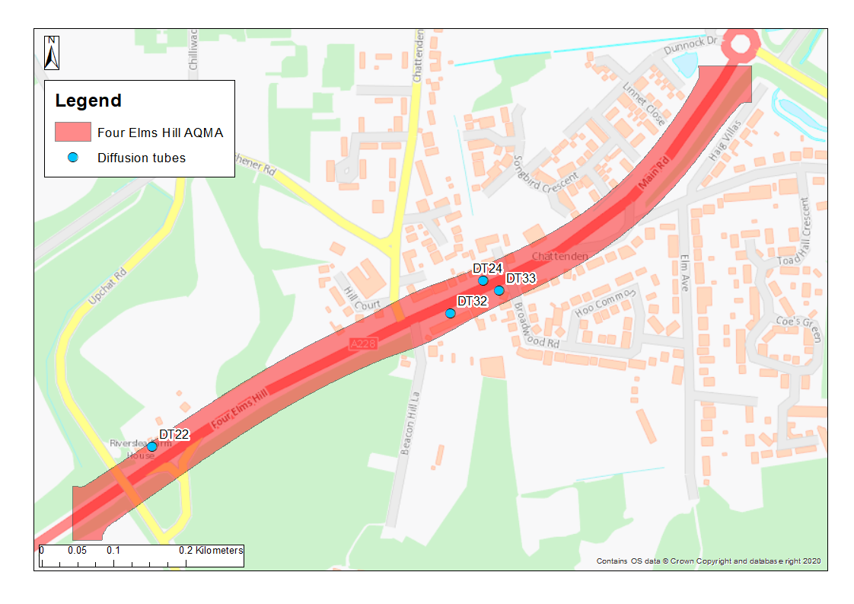

Defra background concentrations
Defra has made estimates of background pollution concentrations on a 1 km² grid for the UK for seven of the main pollutants, including NO₂, nitrogen oxides (NO_{X}), particulate matter with a diameter less than 10µm and 2.5µm (PM₁₀ and PM_{2.5}). The latest estimates are using data for a base year of 2018, making projections for years from 2018 to 2030 inclusive. Background concentrations for 2016 were obtained from an earlier version of the maps, using a base year of 2016.
Table 2.3 shows the estimated concentrations of the pollutants for 2016, 2024 and 2030 for the cells that will be used in the road dispersion modelling as presented in Section 6.
Table 2.3 ‒ Defra mapped background annual mean pollutant concentrations (µgm⁻³)
Pollutant | Grid Cell | 2016 | 2024 | 2030
NO₂ | 575500, 171500  (representative of AQMA diffusion tubes) | 17.0 | 14.3 | 12.1
NO_{X} | 575500, 171500  (representative of AQMA diffusion tubes) | 23.8 | 19.5 | 16.2
PM₁₀ | 575500, 171500  (representative of AQMA diffusion tubes) | 16.0 | 15.6 | 15.5
PM_{2.5} | 575500, 171500  (representative of AQMA diffusion tubes) | 11.0 | 10.2 | 10.0
NO₂ | 576500, 171500 | 16.0 | 12.8 | 11.2
NO_{X} | 576500, 171500 | 22.5 | 17.3 | 15.0
PM₁₀ | 576500, 171500 | 14.8 | 14.5 | 14.3
PM_{2.5} | 576500, 171500 | 10.3 | 9.7 | 9.6

Medway Council’s Air Quality Priorities for Four Elms Hill AQMA

Public Health Context
The impact of air quality upon health is unquestionable and has been a major driver in national and international attempts to reduce levels of air pollution. Pollutants such as NO₂, ozone, benzene, sulphur dioxide (SO₂) alongside PM₁₀ and PM_{2.5} and other chemicals or compounds by both chronic and acute exposure are linked to increased mortality and morbidity. Through their association with the development of cardiovascular disease, lung cancer, aggravation of asthma and other allergic illnesses, reduced quality of life and contribution to low birthweight.

The distribution of harm from low air quality is not even. Air Quality is evidenced to impact those who reside in areas of deprivation to a greater extent and is also recognised as a contributor to widening health inequalities. In Medway rates of long-term illness, emergency hospital admissions and death are higher in those who are more disadvantaged. Health outcomes are not only worse in those who are the most disadvantaged; the inequalities follow a gradient and as such the response also needs to follow a gradient. This means that interventions and measures should to be made available to all, with increasing effort needed for those who are increasingly disadvantaged.
Updated Strood Rural and Peninsular inequality and health profile to be inserted.
Medway council takes action to protect its residents health from potential harm emanating from low air quality in a variety of ways. This includes partnership work with colleagues in planning to mitigate potential for air quality related harm related to developments. As well as proactively through communication initiatives identified in the Medway Air Quality Communications Strategy. Such as undertaking targeted information campaigns to increase community awareness of means by which individuals can reduce their exposure and contributions to poor air quality, or manage their long term health conditions which may otherwise leave greater susceptibility to harm from low air quality. Such initiatives underpin priority actions of the Joint Health and Wellbeing strategy (2018-2023) to encourage self-management of long term conditions and shape the environment to make healthy choices easier.

Planning and Policy Context

Local plan
Medway Council actively manages the effects of new developments on air quality within its area through the Medway Local Plan (2003) Policy BNE24 ‘Air Quality’, to ensure that new developments do not exacerbate existing air quality issues.

Medway Council is currently preparing its emerging Local Plan 2021 – 2037. The plan recognises the Hoo peninsula as an opportunity for growth, and that there is a need to plan for sustainable community development providing the services and infrastructure they need alongside the delivery of new housing and jobs. Large sites at Grain and Kingsnorth are important to Medway’s portfolio of employment land.
As part of the implementation of the Local Plan, a large area of residential and employment land has been attributed for development on the Hoo Peninsula, which will lead to additional traffic on Four Elms Hill.
As part of the Housing Infrastructure Fund (HIF), £170 million of funding has been secured to deliver strategic transport and environmental projects on the Hoo Peninsula. The HIF current proposals are intended to address the challenge of getting on and off the peninsula and include the following transport related improvements:
- An upgrade of the existing road network with the provision of new infrastructure including slip roads, junctions and interchanges on the A228 and A289 and wider highway improvements, as well as a new relief road to access the peninsula via Woodfield Way; and
- a new train station and reinstated passenger service on the Grain branch line.

2015 Air Quality Action Plan
Medway also works to manage local air quality through the implementation of the Medway 2015 AQAP² (covering Central Medway AQMA, High Street Rainham AQMA and Pier Road Gillingham AQMA), and the supporting Medway Air Quality Communications Strategy. Medway Council is also working with Public Health colleagues to prioritise action on air quality in its area to help reduce the health burden from air pollution.

Air quality planning guidance
In conjunction with the Kent and Medway Air Quality Partnership, Medway produced in 2016 its Air Quality Planning Guidance, to deal with planning applications that could impact air quality. The guidance was produced in response to changes in national planning policy, through the National Planning Policy Framework (NPPF). The guidance uses a method for assessing the air quality impacts of a development which includes the quantification of impacts, calculation of damage costs, and the identification of mitigation measures to be implemented to negate the impact of development on air quality. The guidance provides clarity and consistency of approach for developers, the local planning authority and local communities.

Climate change action plan
After declaring a climate emergency in 2019, Medway published its climate change action plan in 2021. The action plan makes clear link between reduction in carbon emissions and improvement in air quality. Measure 6 of the climate change action plan aims to reduce emissions from road transport by promoting and facilitating uptake of electric and ultra-low emissions vehicles, encouraging modal shift through enhanced sustainable infrastructure, and tackling congestion hotspots. Progress to this measure will significantly improve air quality as well as reduce carbon emissions.

Bus Service Improvement Plan
Medway recently published a draft Bus Service Improvement Plan (BSIP) 2021-2026. In order to improve air quality, the plan commits to continue to seek additional funding from government and other available sources to improve fleet standards, whether that be retrofitting to Euro VI, or contributions towards the costs of new low or zero-emission vehicles thus allowing timely improvements to Medway AQMAs.

Source Apportionment
The measures presented in this AQAP are intended to be targeted towards the predominant sources of emissions within the Four Elms Hill area.
As part of the Detailed Assessment¹, a source apportionment exercise was carried out for year 2015 in line with Technical Guidance LAQM.TG16 Chapter 7. 56 sensitive residential receptors were selected to provide an overview of source contributions. Full methodology and details on the source apportionment exercise are included in the Detailed Assessment. The locations of the selected receptors are shown in Table 6.1, 6.2 and 6.3.
The exercise showed that the most significant component at all receptors, other than the ambient background concentrations, was emissions from cars (although not shown, diesel cars will have a greater contribution than petrol cars), followed by HGVs (artic and rigid), LGVs, buses, and motorcycle.
Table 3.1 sets out the percentage contribution from emission sources at the seven receptor locations where the greatest exceedances were predicted.

Table 3.1 ‒ Predicted % Annual Mean Nitrogen Dioxide Contribution (2015)
Receptor | Bkgd % | Local Bkgd % | Car % | LGV % | MCL % | Artic % | Rigid % | Bus % | Total
16 | 13.6 | 18.0 | 34.6 | 14.0 | 0.3 | 6.6 | 9.9 | 3.0 | 100
18 | 14.9 | 19.7 | 33.1 | 13.5 | 0.3 | 6.2 | 9.4 | 2.8 | 100
19 | 15.0 | 19.9 | 31.4 | 11.5 | 0.2 | 8.0 | 10.6 | 3.4 | 100
20 | 15.1 | 20.0 | 31.4 | 11.6 | 0.2 | 7.9 | 10.5 | 3.4 | 100
21 | 15.3 | 20.2 | 31.3 | 11.6 | 0.2 | 7.7 | 10.4 | 3.3 | 100
22 | 15.4 | 20.4 | 31.2 | 11.7 | 0.2 | 7.5 | 10.2 | 3.3 | 100
30 | 14.0 | 18.5 | 34.2 | 13.9 | 0.3 | 6.4 | 9.7 | 2.9 | 100

Required Reduction in Emissions
Table 3.2 sets out the required reduction in local emissions of NO_{X} that would be required at the seven receptor locations where the greatest exceedances were predicted, in order for the annual mean NO₂ AQO to be achieved.
Table 3.2 ‒ Improvement in Annual Mean Nitrogen Dioxide Concentrations and Nitrogen Oxides Concentration Required to Meet the Objective (2015)
Receptor | Required reduction in annual mean nitrogen dioxide concentration (μg/m³) | Required reduction in emissions of oxides of nitrogen from local roads (%)
16 | 8.3 | 28.7
18 | 4.0 | 15.9
19 | 3.8 | 15.0
20 | 3.5 | 14.0
21 | 3.1 | 12.6
22 | 2.7 | 11.1
30 | 7.0 | 25.2

Key Priorities
The key priority sources for the Four Elms Hill AQMA are:
- Priority 1 – Emissions from cars;
- Priority 2 – Emissions from HGVs and LGVs; and
- Priority 3 – Emissions from buses.

Development and Implementation of Medway’s Four Elms Hill AQAP

Consultation and Stakeholder Engagement
In developing this AQAP, we have worked with the local community and relevant Medway Council departments to improve local air quality. We have undertaken the following stakeholder engagement:
- Residents engagement survey in February 2019;
- Medway Council internal workshop in July 2019; and
- Follow up Medway Council internal workshop in September 2021.
The response to our consultation stakeholder engagement is given in Appendix A.
Schedule 11 of the Environment Act 1995 requires local authorities to consult the bodies listed in Table 4.1.
Table 4.1 ‒ Consultation Undertaken
Yes/No | Consultee
 | the Secretary of State
 | the Environment Agency
 | the highways authority
 | all neighbouring local authorities
 | other public authorities as appropriate, such as Public Health officials
 | bodies representing local business interests and other organisations as appropriate

Steering Group
Following the publication of Medway’s first AQAP, a Steering Group, chaired by the Assistant Director of Front Line Services, was established in 2016 to provide oversight, and facilitate further development of the measures included. The Steering Group consists of representatives from key council services including, amongst others, Environmental Protection, Public Health, Planning and Integrated Transport, who have agreed to work together with the shared goal of seeking to improve air quality in Medway through behavioural, strategic and infrastructure change.

As reported in Medway’s ASR, the Air Quality Steering Group has continued to meet on a quarterly basis up until the end of 2019. Frequency of meetings, membership, terms of reference will be reviewed by the group as part of the Four Elms Hill AQAP.

AQAP Measures
Table 5.1 shows the proposed Four Elms Hill AQAP measures. It contains:
- a list of the actions that form part of the plan
- the responsible individual and departments/organisations who will deliver this action
- expected benefit in terms of pollutant emission and/or concentration reduction
- the timescale for implementation
- how progress will be monitored
Please see future ASRs for regular annual updates on the implementation of these measures

Table 5.1 ‒ Air Quality Action Plan Measures
No. | Measure | EU Category | EU Classification | Lead Authority | Planning Phase | Implementation Phase | Key Performance Indicator | Target Pollution Reduction in the AQMA | Progress to Date | Estimated Completion Date | Comments
1 | Several road improvements proposed as part of HIF. This includes:  - New junction off the A289.  - Relief road from Upchat roundabout to the A228 Main Rd roundabout.  - Improvements to Four Elms roundabout.  - New railway station on Hoo peninsula. | Traffic Management | Strategic highway improvements | MC | TBC | TBC | Reduced congestion within AQMA | Low | Not started | TBC
2 | Explore opportunities to support electrification of the bus fleet travelling on Hoo peninsula through the AQMA. | Vehicle Fleet Efficiency | Vehicle Retrofitting programmes | MC | TBC | TBC | % of EV buses travelling through AQMA | Low | Not started | TBC
3 | Explore opportunities to support implementation of zero emissions only HGVs and LGVs travelling on Hoo peninsula through AQMA. | Vehicle Fleet Efficiency | Vehicle Retrofitting programmes | MC | TBC | TBC | % of electric HGV and LGV travelling through AQMA | High | Not started | TBC
4 | Explore opportunities to introduce Park and Ride shuttle buses to shopping hubs such as Bluewater and Hempstead Valley. | Alternatives to private vehicle use | Bus based Park & Ride | MC | TBC | TBC | Number of shuttle users | Low | Not started | TBC
5 | Promote and incentivise car sharing on Hoo peninsula using apps, points system. | Alternatives to private vehicle use | Car Clubs | MC | TBC | TBC | Number of car club users | Medium | Not started | TBC
6 | Improve facilities (medical, leisure, supermarket) within Hoo peninsula to remove need to travel through AQMA. | Alternatives to private vehicle use | Other: Avoid need to travel through AQMA | MC | TBC | TBC | Reduced congestion within AQMA | Medium | Not started | TBC
7 | Explore feasibility to introduce a depot outside Hoo peninsula for goods to be dropped off and transported onto Hoo by zero emissions vehicles. | Freight and Delivery Management | Freight Consolidation Centre | MC | TBC | TBC | Reduced congestion within AQMA | High | Not started | TBC
8 | Development and implementation of Hoo Peninsula Area Wide Travel Plan.  Commitment from new commercial/industrial developments to implement Hoo Peninsula travel plan which could include fleet standard and on number of trips.  Ensure new developments support cycle/ walking schemes.  Explore feasibility of introducing a central contribution fund by developers to explore sustainable transport technologies. | Policy Guidance and Development Control | Air Quality Planning and Policy Guidance | MC | TBC | TBC |  | High | Work commissioned | Hoo Peninsula Travel Plan to be completed by summer 2022
9 | Continue to increase availability of EV infrastructure on development and public spaces in line with Medway’s Air quality Planning Guidance. | Promoting Low Emission Transport | Procuring alternative Refuelling infrastructure to promote Low Emission Vehicles, EV recharging, Gas fuel recharging | MC | Ongoing | Ongoing | Number of EV infrastructure within peninsula | Medium | Ongoing | TBC
10 | Recognise businesses environmental performance through Council procurement. | Promoting Low Emission Transport | Company Vehicle Procurement -Prioritising uptake of low emission vehicles | MC | TBC | TBC |  | Low | Not started | TBC
11 | Build communal work-hubs with fast internet for workers / rent a desk (draft Medway Local Plan proposes to include community spaces including for example coworking space).  Enable ultrafast internet speeds to encourage WFH. | Promoting Travel Alternatives | Encourage / Facilitate home-working | MC | TBC | TBC | Number of residents switching to work-hub or WFH. | Low | MC discussing with developers | TBC
12 | Cycle scheme funding for bikes.  Introduce regular and electric bike hire services.  Dedicated cycle park on peninsula to encourage uptake of cycling.  Tour de Hoo - encourage cycling/ marketing of cycle routes/ competitions for children.  Promote Saxon Shore Way - walking / cycling route.  Segregated safer cycle and walkways / tree or vegetation buffer to separate.  Walking bus for school children. | Promoting Travel Alternatives | Promotion of cycling and walking | MC | TBC | TBC | Number of bike users within AQMA | Low | Not started | TBC
13 | Explore feasibility and opportunities of water-based transport, such as water taxis between riverside urban areas. | Promoting Travel Alternatives | Promote use of rail and inland waterways | MC | TBC | TBC | Number or rail/waterway users. | Medium | Not started | TBC
14 | Raise awareness of health and financial impacts of poor air quality.via communication campaigns. This will include communication on anti-idling (targeting local schools) and encouraging off peak travelling. | Public Information | Via the Internet | MC | TBC | TBC |  | Low | Not started | TBC
15 | Explore opportunities to introduce emerging technologies to monitor air quality and traffic flows, in order to support road improvement schemes.  This could include air quality sensors within AQMA, intelligent road stud scheme at Main Road roundabout, enforcement cameras to monitor HGV movement. | Traffic Management | Strategic highway improvements | MC | TBC | TBC | Reduced congestion within AQMA | Medium | Not started | TBC
16 | Explore opportunities to encourage larger uptake of public transport versus single private vehicle. | Transport Planning and Infrastructure | Public transport improvements-interchanges stations and services | MC | TBC | TBC | Number of public transport users | Medium | Not started | TBC

Dispersion modelling of selected measures

Methodology
A dispersion modelling exercise was undertaken using ADMS-Roads to estimate the potential air quality benefit from three selected measures. Full details on the methodology are included in Appendix C, and detailed results are presented in Appendix D.
Traffic data comprising Annual Average Daily Traffic (AADT) flows of different vehicle types, was obtained from Sweco for the following scenarios:
- 2016 Baseline;
- 2037 Reference Case; and
- 2037 Local plan with Mitigations (including HIF relief road).
The following three measures were selected for modelling:
HIF Relief Road
Annual mean concentrations of NO₂, PM₁₀ and PM_{2.5} were predicted using traffic data corresponding to the implementation of the Local Plan, which includes the construction of the HIF relief road. As part of the implementation of the Local Plan, a large area of residential and employment land has been attributed for development on the Hoo Peninsula, which will lead to additional traffic on Four Elms Hill. The HIF relief road will alleviate some of this additional traffic however it is not currently proposed for HGVs and buses to have access to the relief road.
Zero emissions buses only through AQMA
Annual mean concentrations were predicted using traffic data corresponding to the implementation of the Local Plan including the relief road. Emissions from buses were adjusted as follow:
- NO_{X} emissions were removed; and
- PM₁₀ and PM_{2.5} exhaust emissions were removed but emissions from brake, tyre and road abrasion were retained.
Zero emissions LGVs and HGVs only through AQMA
Annual mean concentrations were predicted using traffic data corresponding to the implementation of the Local Plan including the relief road. In order to highlight reductions in pollution that can be achieved and represent a scenario where only zero emissions HGVs and LGVs are allowed into the AQMA, emissions from HGVs and LGVs were adjusted as follow:
- NO_{X} emissions were removed; and
- PM₁₀ and PM_{2.5} exhaust emissions were removed but emissions from brake, tyre and road abrasion retained.

In summary, the following scenarios were assessed using ADMS-Roads:
HIF Relief Road
- 2024 Local Plan with Mitigations based on 2037 traffic data, 2024 emission factors and predicted background concentrations [2024 LP];
- 2030 Local Plan with Mitigations based on 2037 traffic data, 2030 emission factors and predicted background concentrations [2030 LP];
Zero emissions buses only through AQMA

- 2024 Local Plan with Mitigations, with zero emissions buses, based on 2037 traffic data, 2024 emission factors and predicted background concentrations [2024 LP];
- 2030 Local Plan with Mitigations, with zero emissions buses, based on 2037 traffic data, 2030 emission factors and predicted background concentrations [2030 LP];
Zero emissions LGVs and zero emissions HGVs only through AQMA

- 2024 Local Plan with Mitigations, with zero emissions LGVs and HGVs, based on 2037 traffic data, 2024 emission factors and predicted background concentrations [2024 LP];
- 2030 Local Plan with Mitigations, with zero emissions LGVs and HGVs , based on 2037 traffic data, 2030 emission factors and predicted background concentrations [2030 LP].

Scenarios were modelled with Emission Factor Toolkit (EFT) data and background concentrations for 2024 in line with the HIF relief road initially proposed opening year. This is however a worst-case assumption as future traffic flows used, which account for significant development in the area in accordance with the emerging Local Plan, are for 2037.
Measure scenarios were also modelled using emissions and background for 2030 (the latest year for which EFT and background data is available) for comparison as this represents a more realistic scenario.
Annual mean concentrations of NO₂ as well as PM₁₀ and PM_{2.5} for indication were predicted at the same 56 receptors identified in the 2016 Detailed Assessment¹. Their locations are presented in Figure 6.1, 6.2 and 6.3.
Figure 6.1 ‒ Modelled Receptors 1/3
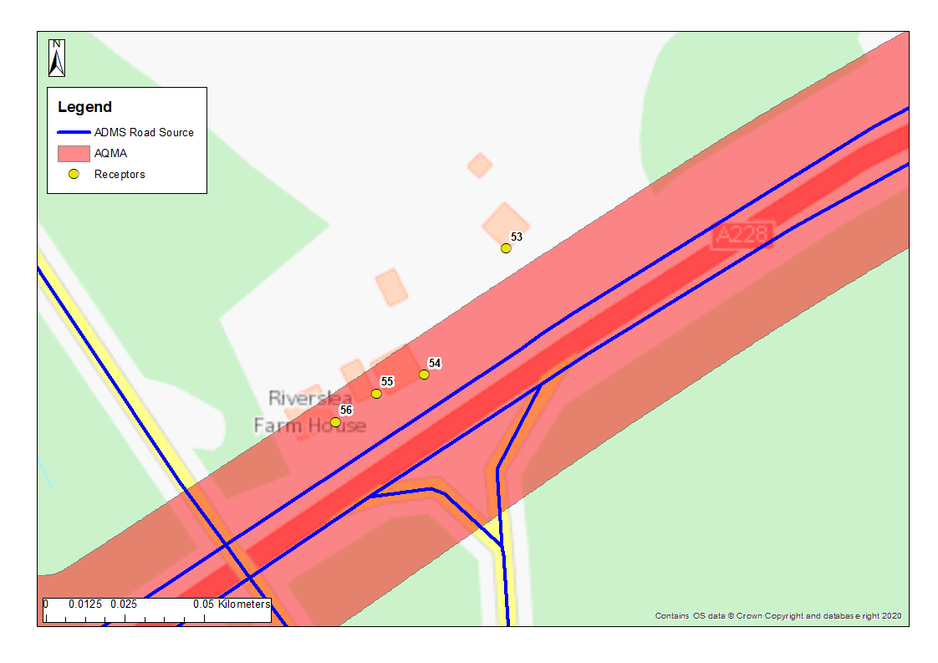
Figure 6.2 ‒ Modelled Receptors 2/3
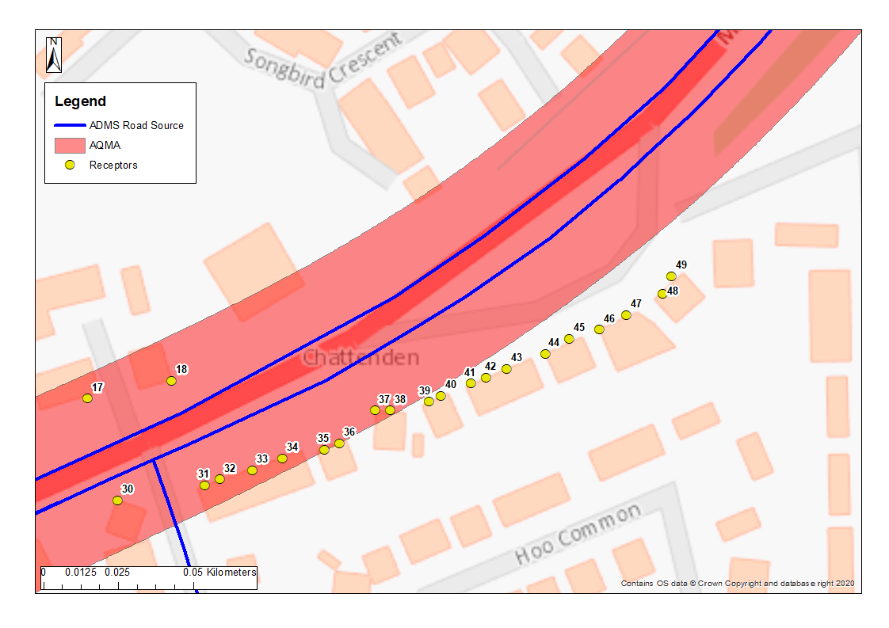
Figure 6.3 ‒ Modelled Receptors 3/3
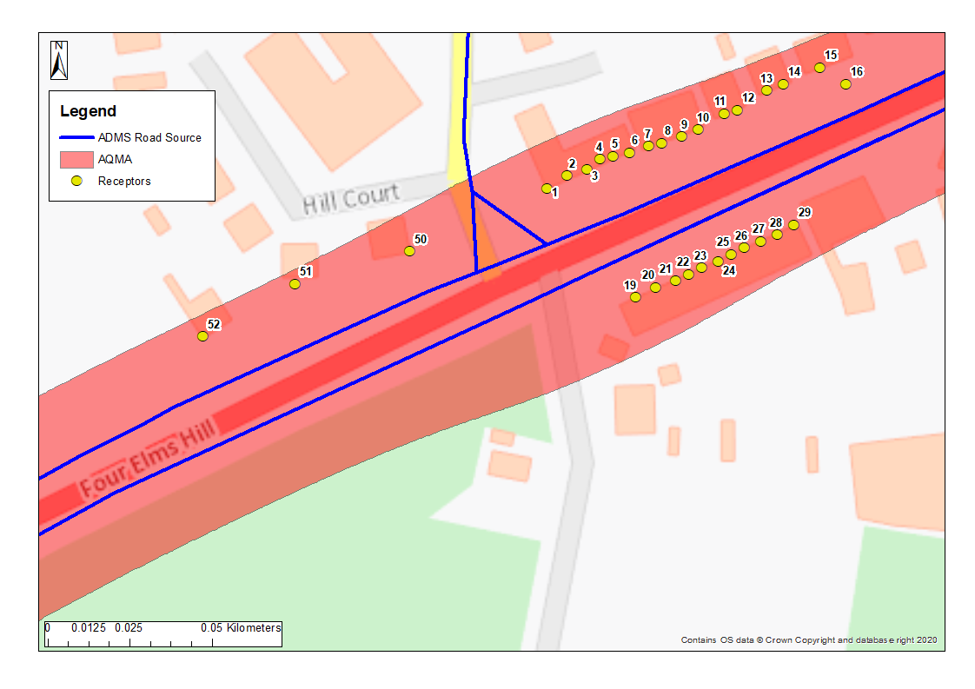

Results
Full detailed results are presented in Appendix D. Table D1, D2 and D3 presents the predicted annual mean concentrations of NO_{2,} PM₁₀ and PM_{2.5}, predicted at all receptors. Concentrations were predicted in 2024 in line with the HIF relief road initially proposed opening year, however this is a worst-case assumption as traffic data used is for 2037. Concentrations were also predicted for 2030 which corresponds to a more realistic assumption for vehicle emissions.
HIF Relief Road
In 2024, several exceedances of the NO₂ annual mean AQO of 40 µgm⁻³ are predicted. The highest concentration predicted is 51.0 µgm⁻³ at receptor 18. Exceedances are also predicted at receptors 1 to 6, 16, 17 and 30, as presented in Figure 6.2 and 6.3.

In 2030, no exceedances of the AQO are predicted, however concentrations are within 10% of the AQO at several receptors. The highest concentration predicted is 39.0 µgm⁻³ also at receptor 18. This suggests that without further measures implemented, concentrations could remain close to the AQO within the AQMA.
Predicted annual concentrations of PM₁₀ and PM_{2.5} remain below the annual mean AQO of 40 µgm⁻³ and 25 µgm⁻³ at all receptors in 2024 and 2030.
Zero emissions buses only through AQMA
In 2024 with zero emissions buses only travelling through the AQMA, exceedances of the NO₂ annual mean AQO of 40 µgm⁻³ were predicted at receptors 2 to 6, 16, 17 and 30. In 2030, no exceedances of the AQO are predicted, however concentrations are still within 10% of the AQO at several receptors. The highest concentration predicted is 38.9 µgm⁻³ at receptor 18.

Predicted annual concentrations of PM₁₀ and PM_{2.5} remain below the annual mean AQO of 40 µgm⁻³ and 25 µgm⁻³ at all receptors in 2024 and 2030.
The significance of the reduction in concentration with the implementation of zero emissions only buses was determined using the Institute of Air Quality Management (IAQM) guidance on planning for air quality, which takes into account the % change of concentration relative to the AQO, as well as the resulting concentration.

Implementing zero emissions buses only travelling through the AQMA had little impact on the predicted annual mean concentrations. In 2024, predicted reductions range from 0.05 µgm⁻³ to 0.32 µgm⁻³. In IAQM terms these reductions are Negligible at 49 out of 56 receptors. They are Slight Beneficial at receptors 5, 6 and 50; and Moderate Beneficial at receptors 1 to 4. In 2030, reductions range from 0.04 µgm⁻³ to 0.28 µgm⁻³ and are considered Negligible at all receptors.
Zero emissions LGVs and HGVs only through AQMA
The modelled scenario with zero emissions LGVs and HGVs allowed to travel through the AQMA had the largest impact on predicted annual mean concentrations. In 2024, concentrations were predicted to be below the annual mean AQO of 40 µgm⁻³ at all receptors with the highest NO₂ concentration predicted to be 26.2 µgm⁻³ at receptor 16. In 2030, the highest NO₂ concentration predicted was 19.2 µgm⁻³ also at receptor 16.

Predicted annual concentrations of PM₁₀ and PM_{2.5} remain below the annual mean AQO of 40 µgm⁻³ and 25 µgm⁻³ at all receptors in 2024 and 2030.

In 2024, the predicted NO₂ reductions range from 5.5 µgm⁻³ to 23.2 µgm⁻³. In IAQM terms these reductions are considered Moderate Beneficial at all receptors. In 2030, reductions range from 3.4 µgm⁻³ to 20.7 µgm⁻³ and are considered as Moderate Beneficial at almost all receptors, with the exception of receptors 45 to 49, where they are considered Slight Beneficial.

Glossary of Terms

Abbreviation | Description
AADT | Average Annual Daily Traffic flows
AQAP | Air Quality Action Plan - A detailed description of measures, outcomes, achievement dates and implementation methods, showing how the local authority intends to achieve air quality limit values’
AQMA | Air Quality Management Area – An area where air pollutant concentrations exceed / are likely to exceed the relevant air quality objectives. AQMAs are declared for specific pollutants and objectives
AQS | Air Quality Strategy
ASR | Air quality Annual Status Report
Defra | Department for Environment, Food and Rural Affairs
EU | European Union
LAQM | Local Air Quality Management
NO₂ | Nitrogen Dioxide
NO_{X} | Nitrogen Oxides
PM₁₀ | Airborne particulate matter with an aerodynamic diameter of 10µm (micrometres or microns) or less
PM_{2.5} | Airborne particulate matter with an aerodynamic diameter of 2.5µm or less

References

¹ Air Quality Consultants. Detailed Assessment of Air Quality at Four Elms Hill, Chattenden for Medway Council, 2016. Available at: https://democracy.medway.gov.uk/mgconvert2pdf.aspx?id=37497
² Medway Council. Air Quality Action Plan, 2015. Available at: https://www.medway.gov.uk/downloads/file/1982/medway_air_quality_action_plan_2015
³ https://uk-air.defra.gov.uk/aqma/local-authorities?la_id=157
⁴ Environmental equity, air quality, socioeconomic status and respiratory health, 2010
⁵ Air quality and social deprivation in the UK: an environmental inequalities analysis, 2006
⁶ Defra. Abatement cost guidance for valuing changes in air quality, May 2013
⁷ Medway Council. 2021 Air Quality Annual Status Report, 2021
⁸ Defra. Background maps, 2018. Available at: https://laqm.defra.gov.uk/air-quality/air-quality-assessment/background-maps/
⁹ Shah et al. Global association of air pollution and heart failure: a systematic review and meta-analysis The Lancet 2013; 382 (9897): 1039 - 1048.
¹⁰ Raaschou-Nielsen et al. Air pollution and lung cancer incidence in 17 European cohorts: prospective analyses from the European Study of Cohorts for Air Pollution Effects (ESCAPE) Lancet Oncology 2013; 14(9): 813-822.
¹¹ Krzyzanowski K.-D. (2005). Health effects of transport-related air pollution. World Health Organization.
¹² Department for Environment, Food and Agricultural Affairs. (2010). Air Pollution: Action in a Changing Climate. Department for Environment, Food and Agricultural Affairs.
¹³ Pedersen et al. Ambient air pollution and low birthweight: a European cohort study (ESCAPE) Lancet Respiratory Medicine 2013; 1(9): 695-704.
¹⁴ WHO (2013) Review of evidence on health aspects of air pollution-REVIHAAP Project Technical Report. Available at: http://www.euro.who.int/pubrequest
¹⁵ Medway. Medway Local Plan, 2003. Available at: https://www.medway.gov.uk/info/200149/planning_policy/146/current_planning_policies/3
¹⁶ Medway. New Medway Local Plan. Available at https://www.medway.gov.uk/info/200149/planning_policy/519/new_medway_local_plan
¹⁷ Medway. Hoo New Routes to Good Growth, January 2021. Available at: https://www.medway.gov.uk/downloads/file/5586/hif_consultation_proposals_-_january_2021
¹⁸ Medway. Future Hoo Consultation 2021 Second round, December 2021. Available at: https://futurehoo.medway.gov.uk/dist/pdf/hif-brochure-second-round-lo-res.pdf
¹⁹ Medway. Air Quality Planning Guidance, 2016. Available at: https://www.medway.gov.uk/downloads/file/2335/medways_air_quality_planning_guidance
²⁰ Medway. Climate Change Action Plan, 2021. Available at: https://www.medway.gov.uk/climatechangeplan
²¹ Medway. Summary: draft bus service improvement plan (BSIP) for Medway 2021 to 2026, 2021. Online available at: https://www.medway.gov.uk/downloads/file/6019/summary_draft_bus_service_improvement_plan_bsip_for_medway_2021_to_2026
²⁴ IAQM. Land-Use Planning & Development Control: Planning For Air Quality, 2017. Available at: http://www.iaqm.co.uk/text/guidance/air-quality-planning-guidance.pdf

Appendix A: Response to Consultation
Table A.1 ‒ Summary of Responses to Consultation and Stakeholder Engagement on the AQAP
Consultee | Category | Response
Engagement survey in February 2019. | Local residents | Many comments highlighted that Four Elms Hill is the only route to access Hoo. Majority agreed that development planning should be a priority, facilities within the peninsula are inadequate therefore people need to travel through the AQMA to access services including schools and medical facilities. A majority agreed that public transport should be encouraged. A majority also agreed that low emissions vehicles should be a priority. A small majority agreed that promoting walking and cycling should be a priority. It was highlighted that it is currently not safe to do so as the route is too busy.
Medway Council workshop in July 2019; | Medway Council | Stakeholders identified a long list of measures to include within AQAP.
Follow up Medway Council workshop in September 2021 | Medway Council | Follow-up discussion to determine if measures identified in 2019 were still suitable.

Appendix B: Reasons for Not Pursuing Action Plan Measures
Table B.1 ‒ Action Plan Measures Not Pursued and the Reasons for that Decision
Action category | Action description | Reason action is not being pursued (including Stakeholder views)
Traffic Management | Timed road use restrictions at peak hours for HGVs / off-peak deliveries | Not a viable option for the A228 as it is a strategic route serving a major port and significant commercial land uses, and represents the only route on and off the Peninsula. This would be met with significant opposition from large employers such as Amazon and enforcement would be extremely challenging. It could also result in HGVs attempting to use unsuitable routes, for example via the B2000.
Traffic Management | Average speed cameras on Four Elms Hill | Potential reduction in traffic speed could increase congestion and emissions.
Transport Planning and Infrastructure | Cablecar between Upnor & St Mary's island | Likely to become a tourist attraction and may increase car use through AQMA. Public transport links would need to be improved prior to implementation.
Transport Planning and Infrastructure | Introduce a tramline | Issue with space available and high costs associated with running a tramline.

Appendix C: Modelling methodology

Annual average concentrations in air of NO_{X}, PM₁₀ and PM_{2.5} have been determined using the ADMS-Roads version 5.0 atmospheric dispersion model.
Annual mean concentrations of NO₂ were derived from the model-predicted NO_{X} concentrations, through application of the NO_{X} to NO₂ conversion tool version 8.1 developed for LAQM purposes, which takes into account the interaction between NO_{X} and background O₃.
The modelling assessment requires source, emissions, meteorological and other site-specific data. For modelling traffic impacts, one year of data is used and model verification is carried out following Defra’s guidance.

Meteorological data
Detailed dispersion modelling requires hourly sequential meteorological data from a representative synoptic observing station. Hourly sequential meteorological data was obtained for the year 2016 for Gravesend, which is considered to provide representative data for the AQMA. The station is located approximately 15km to the north west of the site. The meteorological data for 2016 has been used with monitoring data from 2016 in the traffic assessment and model verification.
Figure C1 summarises the hourly wind speed and wind direction for the meteorological data as a wind rose. The windrose shows a predominance of winds from the south-west which is the usual pattern observed in the south of England.
Figure C1 Gravesend wind rose for 2016
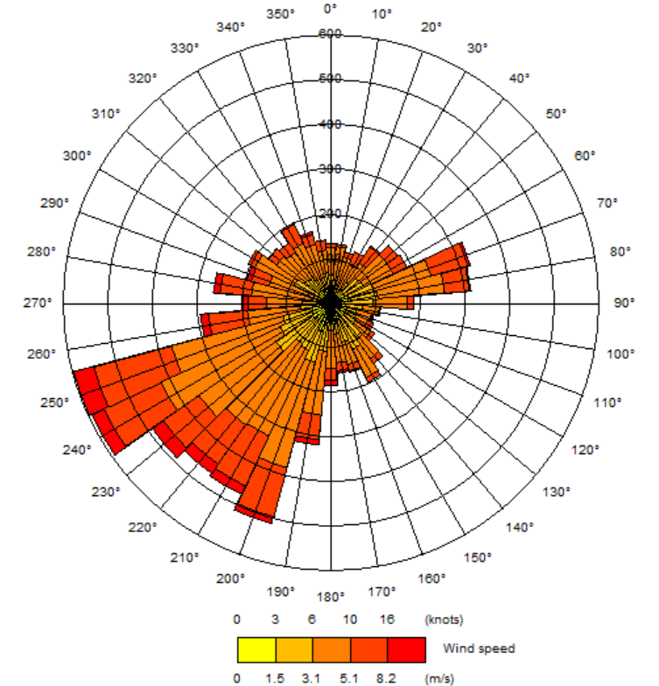

The road network
Traffic data comprising AADT of different vehicle types, was obtained from Sweco for the following scenarios:
- 2016 Baseline;
- 2037 Reference Case; and
- 2037 Local plan with Mitigations.
Future scenarios were modelled with Emission Factor Toolkit (EFT) data and background concentrations for 2024 in line with the HIF relief road initially proposed opening year. This is however a worst-case assumption as future traffic flows used are for 2037. They were also modelled using emissions and background for 2030 (the latest year for which EFT and background data is available) for comparison as this represents a more realistic scenario.

Emissions for 2024 and 2030 were calculated using the latest emissions factors from Defra, the Emission Factor Toolkit (EFT) v10.1, which is used to predict emissions which are imported into ADMS-Roads. Particulate generated due to brake and tyre wear are also included in the EFT.
Emissions for 2016 were calculated using version 8 of the EFT.

In summary the following scenarios were assessed:
- 2016 Baseline used for model verification, based on 2016 traffic data, 2016 emission factors and predicted background concentrations [2016 baseline];
- 2024 Reference case, based on 2037 traffic data, 2024 emission factors and predicted background concentrations [2024 RC];
- 2030 Reference case, based on 2037 traffic data, 2030 emission factors and predicted background concentrations [2030 RC].
HIF Relief Road
- 2024 Local Plan with Mitigations based on 2037 traffic data, 2024 emission factors and predicted background concentrations [2024 LP];
- 2030 Local Plan with Mitigations based on 2037 traffic data, 2030 emission factors and predicted background concentrations [2030 LP].
Zero emissions buses only through AQMA
- 2024 Local Plan with Mitigations, with zero emissions buses, based on 2037 traffic data, 2024 emission factors and predicted background concentrations [2024 LP];
- 2030 Local Plan with Mitigations, with zero emissions buses, based on 2037 traffic data, 2030 emission factors and predicted background concentrations [2030 LP].
Zero emissions LGVs and HGVs only through AQMA
- 2024 Local Plan with Mitigations, with zero emissions LGVs and HGVs, based on 2037 traffic data, 2024 emission factors and predicted background concentrations [2024 LP];
- 2030 Local Plan with Mitigations, with zero emissions LGVs and HGVs, based on 2037 traffic data, 2030 emission factors and predicted background concentrations [2030 LP].

Figure C2 shows the road links that have been modelled and Table C1 shows the traffic data used in the modelling. Traffic data comprising AADT and numbers of different vehicle types, was obtained from Sweco.

Table C1 ADMS-Roads input data
ID | Name | 2016  AADT | 2016  Car % | 2016  LGV % | 2016  HGV % | 2016 Bus and Coach  % | 2016 Speed  kph | 2037  RC  AADT | 2037  RC  Car % | 2037  RC  LGV % | 2037  RC  HGV  % | 2037  RC  Bus and Coach  % | 2037  RC  Speed  kph | 2037 LP AADT | 2037 LP Car  % | 2037 LP  LGV  % | 2037 LP HGV% | 2037 LP Bus and Coach  % | 2037 LP Speed  kph
3139 | Wulfere Way | 13821 | 84.5 | 10.6 | 4.3 | 0.6 | 92 | 13684 | 85.1 | 11.0 | 3.3 | 0.6 | 92 | 14900 | 82.9 | 11.1 | 5.7 | 0.3 | 68
6045 | Peninsula Way E | 9036 | 79.8 | 14.5 | 5.7 | 0.0 | 95 | 17183 | 65.4 | 27.3 | 7.3 | 0.0 | 95 | 19185 | 59.6 | 28.9 | 11.5 | 0.0 | 96
6314 | Wulfere Way | 18683 | 86.3 | 9.7 | 4.0 | 0.0 | 93 | 18760 | 76.2 | 17.6 | 6.1 | 0.0 | 86 | 24636 | 76.3 | 17.4 | 6.3 | 0.0 | 68
6385 | Peninsula Way E | 9869 | 84.3 | 10.6 | 5.1 | 0.0 | 95 | 19548 | 69.3 | 23.9 | 6.8 | 0.0 | 93 | 25405 | 63.4 | 26.7 | 9.9 | 0.0 | 96
7411 | Chattenden Ln | 1770 | 84.4 | 9.9 | 3.1 | 2.6 | 35 | 2156 | 81.0 | 12.7 | 4.2 | 2.1 | 34 | 947 | 77.5 | 12.4 | 5.3 | 4.9 | 34
7422 | Chattenden Ln | 2733 | 89.0 | 10.6 | 0.5 | 0.0 | 31 | 2543 | 81.7 | 15.8 | 2.5 | 0.0 | 30 | 521 | 64.4 | 31.2 | 4.4 | 0.0 | 30
21061 | Wulfere Way | 22510 | 87.1 | 8.0 | 4.6 | 0.2 | 95 | 25521 | 84.9 | 10.7 | 4.2 | 0.2 | 95 | 28035 | 82.1 | 12.2 | 5.6 | 0.2 | 68
21064 | Hasted Rd | 16208 | 85.3 | 10.1 | 4.6 | 0.0 | 96 | 22476 | 76.1 | 17.9 | 6.0 | 0.0 | 96 | 25517 | 66.5 | 22.7 | 10.8 | 0.0 | 68
22139 | Hasted Rd | 15137 | 85.6 | 10.8 | 3.6 | 0.0 | 85 | 17393 | 80.5 | 15.7 | 3.8 | 0.0 | 93 | 26184 | 70.6 | 20.9 | 8.6 | 0.0 | 68
26670 | Main Rd Chattenden | 15246 | 84.4 | 11.6 | 3.9 | 0.1 | 54 | 23818 | 72.4 | 21.7 | 5.9 | 0.1 | 54 | 29787 | 63.6 | 26.7 | 9.6 | 0.0 | 50
27057 | Main Rd Chattenden | 16898 | 87.3 | 8.6 | 4.0 | 0.1 | 55 | 25763 | 74.5 | 19.4 | 6.0 | 0.1 | 54 | 34906 | 68.8 | 22.1 | 9.1 | 0.1 | 55
27058 | Main Rd Chattenden | 16898 | 87.3 | 8.6 | 4.0 | 0.1 | 54 | 25763 | 74.5 | 19.4 | 6.0 | 0.1 | 54 | 34906 | 68.8 | 22.1 | 9.1 | 0.1 | 53
27060 | Peninsula Way | 15246 | 84.4 | 11.6 | 3.9 | 0.1 | 55 | 23818 | 72.4 | 21.7 | 5.9 | 0.1 | 0 | 29787 | 63.6 | 26.7 | 9.6 | 0.0 | 54
36674 | Upchat Rd | 1194 | 63.3 | 11.1 | 20.1 | 5.5 | 84 | 1970 | 79.6 | 7.8 | 9.3 | 3.4 | 82 | 256 | 26.8 | 4.0 | 43.4 | 25.8 | 83
36683 | Upchat Rd | 895 | 99.6 | 0.4 | 0.0 | 0.0 | 89 | 1259 | 99.2 | 0.7 | 0.0 | 0.0 | 87 | 2751 | 86.9 | 12.7 | 0.4 | 0.0 | 91
38674 | Four Elms Hill | 14312 | 83.3 | 11.6 | 4.5 | 0.6 | 95 | 23459 | 72.0 | 21.4 | 6.1 | 0.4 | 95 | 30241 | 64.0 | 26.1 | 9.6 | 0.3 | 68
38675 | Four Elms Hill | 14284 | 83.5 | 11.6 | 4.5 | 0.4 | 96 | 23431 | 72.1 | 21.5 | 6.1 | 0.3 | 96 | 30213 | 64.0 | 26.2 | 9.6 | 0.2 | 87
38678 | Four Elms Hill | 7973 | 77.1 | 15.1 | 6.7 | 1.1 | 84 | 15542 | 66.0 | 25.8 | 7.6 | 0.6 | 85 | 19068 | 56.8 | 29.3 | 13.5 | 0.5 | 68
38679 | Four Elms Hill | 14284 | 83.5 | 11.6 | 4.5 | 0.4 | 92 | 23431 | 72.1 | 21.5 | 6.1 | 0.3 | 90 | 30213 | 64.0 | 26.2 | 9.6 | 0.2 | 86
38680 | Four Elms Hill | 16401 | 86.7 | 8.6 | 4.6 | 0.1 | 94 | 26707 | 74.8 | 19.0 | 6.1 | 0.1 | 93 | 34698 | 68.6 | 22.1 | 9.2 | 0.1 | 94
38682 | Four Elms Hill | 16702 | 84.3 | 9.3 | 5.9 | 0.5 | 95 | 27419 | 74.0 | 19.1 | 6.6 | 0.3 | 89 | 32205 | 66.7 | 22.8 | 10.2 | 0.3 | 68
42213 | Four Elms Hill | 8727 | 90.9 | 3.9 | 5.2 | 0.0 | 95 | 11875 | 84.5 | 10.2 | 5.3 | 0.0 | 93 | 13135 | 81.1 | 13.4 | 5.5 | 0.0 | 68
132643 | Main Rd Chattenden | 16401 | 86.7 | 8.6 | 4.6 | 0.1 | 53 | 26707 | 74.8 | 19.0 | 6.1 | 0.1 | 53 | 34698 | 68.6 | 22.1 | 9.2 | 0.1 | 53
891590 | Peninsula Way | 16898 | 87.3 | 8.6 | 4.0 | 0.1 | 54 | 25763 | 74.5 | 19.4 | 6.0 | 0.1 | 0 | 34906 | 68.8 | 22.1 | 9.1 | 0.1 | 54
132612+18989 | Hoo Rd | 9782 | 77.0 | 13.5 | 7.4 | 2.0 | 38 | 15227 | 78.4 | 14.7 | 5.6 | 1.3 | 38 | 8854 | 75.1 | 13.6 | 9.0 | 2.3 | 38
132655+6920 | Main Rd Hoo | 10753 | 90.2 | 7.3 | 2.2 | 0.3 | 47 | 14278 | 88.3 | 8.5 | 3.0 | 0.2 | 44 | 16922 | 72.7 | 23.0 | 4.1 | 0.2 | 48
18562+18565 | Kitchener Rd | 433 | 87.8 | 9.9 | 2.3 | 0.0 | 30 | 1400 | 87.3 | 10.1 | 2.5 | 0.0 | 33 | 524 | 63.3 | 31.0 | 5.6 | 0.0 | 33
18568+18569 | Kitchener Rd | 2465 | 82.3 | 7.3 | 6.0 | 4.5 | 32 | 3000 | 86.3 | 5.6 | 4.5 | 3.7 | 31 | 328 | 42.3 | 24.1 | 0.0 | 33.6 | 31
2039907+18564 | Kitchener Rd | 2898 | 83.1 | 7.7 | 5.5 | 3.8 | 34 | 4400 | 86.7 | 7.0 | 3.8 | 2.5 | 32 | 4309 | 85.7 | 10.5 | 1.2 | 2.6 | 33
2647+2646 | Upchat Rd | 2227 | 76.8 | 8.3 | 7.1 | 7.8 | 36 | 4021 | 84.8 | 7.0 | 4.0 | 4.3 | 36 | 5133 | 77.1 | 18.3 | 1.2 | 3.4 | 36
2655+201907 | Upchat Rd | 1592 | 77.9 | 9.5 | 9.8 | 2.8 | 37 | 2372 | 83.9 | 7.9 | 6.3 | 1.9 | 35 | 6283 | 85.5 | 11.3 | 2.5 | 0.7 | 36
36683+36674 | Upchat Rd | 2089 | 78.8 | 6.5 | 11.5 | 3.2 | 89 | 3229 | 87.3 | 5.1 | 5.7 | 2.0 | 87 | 3008 | 81.8 | 11.9 | 4.1 | 2.2 | 91
7412+7423 | Chattenden Ln | 4503 | 87.2 | 10.3 | 1.5 | 1.0 | 34 | 4699 | 81.4 | 14.4 | 3.3 | 1.0 | 34 | 1469 | 72.8 | 19.0 | 5.0 | 3.1 | 34
7414+7425 | Chattenden Ln | 4229 | 86.7 | 10.4 | 1.8 | 1.1 | 34 | 4347 | 83.3 | 12.8 | 2.9 | 1.1 | 34 | 944 | 78.1 | 12.4 | 4.7 | 4.9 | 34
7416+7427 | Chattenden Lane | 6693 | 85.0 | 9.3 | 3.4 | 2.3 | 34 | 7325 | 84.5 | 9.8 | 3.5 | 2.1 | 34 | 1265 | 68.7 | 15.5 | 3.5 | 12.3 | 34

Figure C2 Modelled Road Links

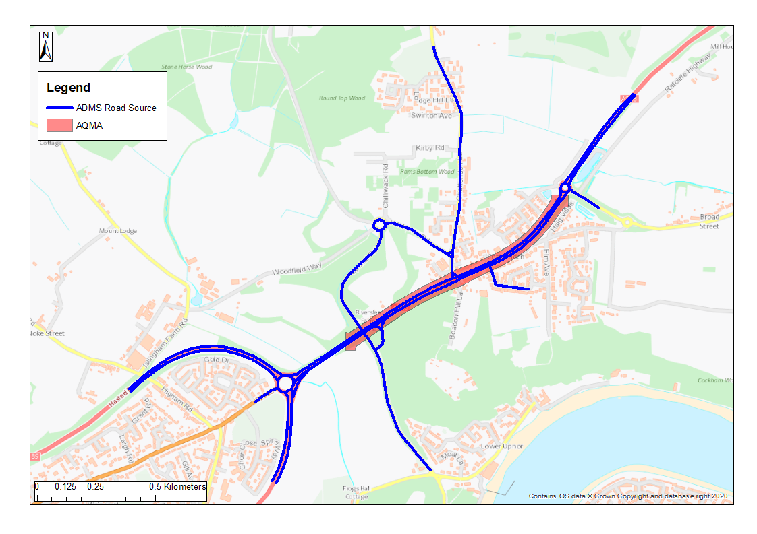

Model verification
The ADMS-Roads dispersion model has been widely validated for this type of assessment and is specifically listed in the Defra’s LAQM.TG(16)¹⁶ guidance as an accepted dispersion model.
Model validation undertaken by the software developer (CERC) will not have included validation in the vicinity of the Proposed Development site. It is therefore necessary to perform a comparison of modelled results with local monitoring data at relevant locations. This process of verification attempts to minimise modelling uncertainty and systematic error by correcting modelled results by an adjustment factor to gain greater confidence in the final results.
The predicted results from a dispersion model may differ from measured concentrations for a large number of reasons, including uncertainties associated with:
- background concentration estimates;
- meteorological data;
- source activity data such as traffic flows and emissions factors;
- model input parameters such as surface roughness length, minimum monin-obukhov length;
- monitoring data, including locations; and
- overall model limitations.
Model verification is the process by which these and other uncertainties are investigated and where possible minimised. In reality, the differences between modelled and monitored results are likely to be a combination of all of these aspects.
Model setup parameters and input data were checked prior to running the models in order to reduce these uncertainties. The following were checked to the extent possible to ensure accuracy:
- traffic data;
- road widths;
- distance between sources and monitoring as represented in the model;
- speed estimates on roads;
- source types, such as elevated roads and street canyons;
- selection of representative meteorological data;
- background monitoring and background estimates; and
- monitoring data.
Suitable local monitoring data for the purpose of verification is available for annual 2016 mean NO_{X}/NO₂ concentrations as shown in Figure C3. Their details are presented in Table C2 below.
Table C2 Local monitoring data suitable for ADMS-roads model verification
Location | 2016 Annual Mean NO₂ (µgm⁻³) | X (m) | Y (m)
DT22 | 29.0 | 575488 | 171616
DT24 | 50.9 | 575950 | 171847

Verification calculations
The verification of the modelling output was performed in accordance with the methodology provided in Annex 3 of LAQM.TG(16). Table C3 shows that there was systematic under prediction of monitored concentrations for all diffusion tubes.
Table C3 Verification, modelled versus monitored
Site | 2016 Modelled Annual Mean NO₂ (µgm⁻³) | 2016 Monitored Annual Mean NO₂ (µgm⁻³) | % (Modelled- Monitored)/ Monitored
DT22 | 24.5 | 29.0 | -15.5%
DT24 | 33.8 | 50.9 | -33.6%

Table C4 shows the comparison of modelled road-NO_{X}, a direct output from the ADMS-Roads modelling, with the monitored road-NO_{X}, determined from the LAQM NO_{X} to NO₂ conversion tool.
Table C4 Comparison of modelled and monitored road NO_{X} to determine verification factor
Site | 2016 Modelled Annual Mean Road NO_{X} (µgm⁻³) | 2016 Monitored Annual Mean Road NO_{X} (µgm⁻³) | Ratio
DT22 | 14.7 | 24.0 | 1.63
DT24 | 34.3 | 75.7 | 2.20

Table C5 shows the comparison of the modelled NO₂ concentration calculated by multiplying the modelled road NO_{X} by the adjustment factor of 1.92 and using the LAQM’s NO_{X} to NO₂ conversion tool to calculate the total adjusted modelled NO₂.
Table C5 Comparison of adjusted modelled NO₂ and modelled NO₂
Site | 2016 Background NO₂ Concentration (µgm⁻³) | 2016 Adjusted Modelled Annual Mean NO₂ (µgm⁻³) | 2016 Monitored Annual Mean NO₂ (µgm⁻³) | % (Adjusted Modelled- Monitored)/ Monitored
DT22 | 17.0 | 31.0 | 29.0 | 6.9%
DT24 | 17.0 | 47.1 | 50.9 | -7.5%

Figure C3 Diffusion tubes used in verification
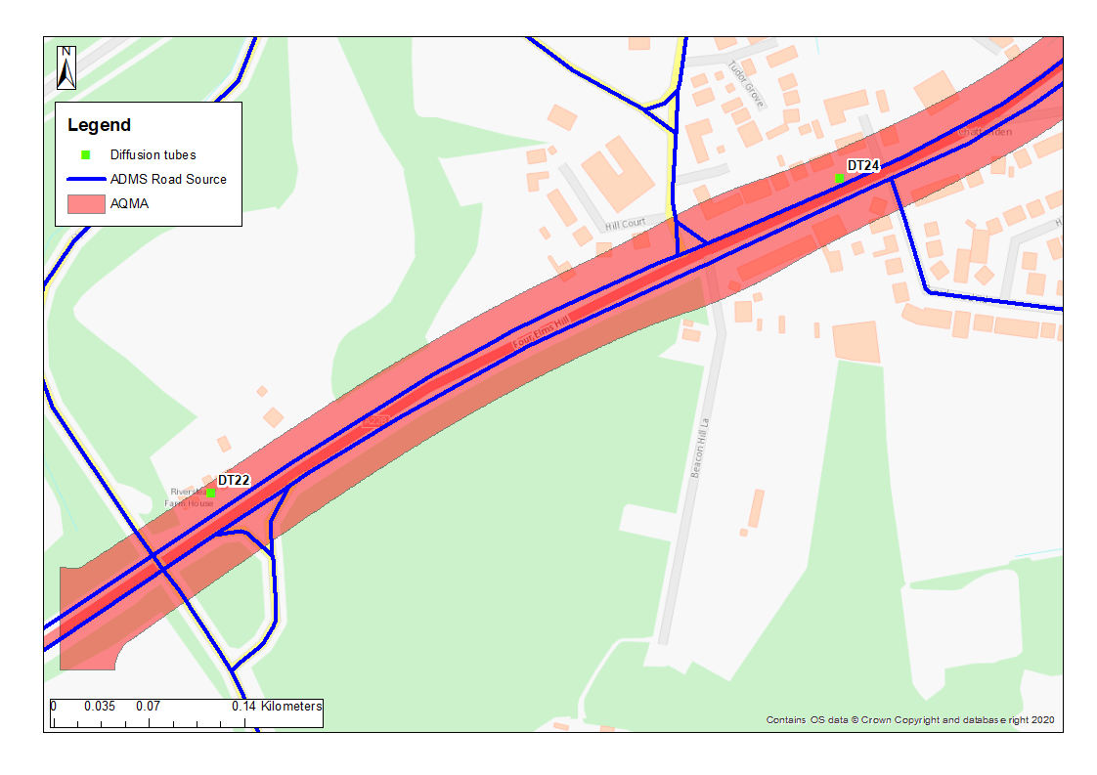

Appendix D: Modelling results

Table D1 NO₂ Annual Mean concentrations (µgm⁻³)
ID | 2016 Baseline | 2024  RC | 2030 RC | 2024  LP | 2024  Zero emissions Buses | Zero emissions Buses  Change | IAQM impact | 2024  Zero emissions HGV  LGV | Zero emissions HGV  LGV Change | IAQM impact | 2030  LP | 2030  Zero emissions Buses | Zero emissions Buses Change | IAQM impact | 2030  Zero emissions HGV  LGV | Zero emissions HGV  LGV Change | IAQM impact
1 | 39.4 | 37.0 | 27.7 | 46.6 | 46.3 | -0.32 | Moderate Beneficial | 23.4 | -23.17 | Moderate Beneficial | 35.7 | 35.4 | -0.28 | Negligible | 17.5 | -18.17 | Moderate Beneficial
2 | 37.5 | 34.9 | 26.1 | 44.0 | 43.7 | -0.28 | Moderate Beneficial | 22.9 | -21.12 | Moderate Beneficial | 33.5 | 33.3 | -0.23 | Negligible | 17.2 | -16.33 | Moderate Beneficial
3 | 37.2 | 34.5 | 25.7 | 43.5 | 43.2 | -0.25 | Moderate Beneficial | 23.0 | -20.54 | Moderate Beneficial | 32.9 | 32.7 | -0.20 | Negligible | 17.2 | -15.73 | Moderate Beneficial
4 | 35.7 | 32.9 | 24.5 | 41.1 | 40.9 | -0.22 | Moderate Beneficial | 22.5 | -18.64 | Moderate Beneficial | 30.9 | 30.8 | -0.19 | Negligible | 16.9 | -14.02 | Moderate Beneficial
5 | 35.6 | 32.6 | 24.1 | 40.7 | 40.5 | -0.21 | Slight Beneficial | 22.6 | -18.09 | Moderate Beneficial | 30.4 | 30.2 | -0.17 | Negligible | 17.0 | -13.43 | Moderate Beneficial
6 | 35.6 | 32.3 | 23.8 | 40.1 | 39.9 | -0.20 | Slight Beneficial | 22.8 | -17.37 | Moderate Beneficial | 29.7 | 29.6 | -0.16 | Negligible | 17.1 | -12.63 | Moderate Beneficial
7 | 35.1 | 31.6 | 23.1 | 38.9 | 38.8 | -0.17 | Negligible | 22.8 | -16.14 | Moderate Beneficial | 28.5 | 28.4 | -0.14 | Negligible | 17.1 | -11.38 | Moderate Beneficial
8 | 35.1 | 31.5 | 22.8 | 38.6 | 38.4 | -0.17 | Negligible | 22.9 | -15.66 | Moderate Beneficial | 28.0 | 27.9 | -0.13 | Negligible | 17.2 | -10.82 | Moderate Beneficial
9 | 35.0 | 31.2 | 22.5 | 38.1 | 37.9 | -0.15 | Negligible | 23.1 | -15.00 | Moderate Beneficial | 27.4 | 27.3 | -0.12 | Negligible | 17.3 | -10.11 | Moderate Beneficial
10 | 34.9 | 30.9 | 22.2 | 37.7 | 37.5 | -0.15 | Negligible | 23.1 | -14.57 | Moderate Beneficial | 27.0 | 26.8 | -0.12 | Negligible | 17.3 | -9.67 | Moderate Beneficial
11 | 33.9 | 29.9 | 21.6 | 36.3 | 36.2 | -0.14 | Negligible | 22.6 | -13.69 | Moderate Beneficial | 26.0 | 25.9 | -0.10 | Negligible | 17.0 | -8.99 | Moderate Beneficial
12 | 34.2 | 30.2 | 21.7 | 36.7 | 36.6 | -0.13 | Negligible | 22.8 | -13.87 | Moderate Beneficial | 26.2 | 26.1 | -0.10 | Negligible | 17.1 | -9.06 | Moderate Beneficial

13 | 33.3 | 29.5 | 21.3 | 35.9 | 35.7 | -0.12 | Negligible | 22.3 | -13.57 | Moderate Beneficial | 25.8 | 25.7 | -0.10 | Negligible | 16.8 | -9.00 | Moderate Beneficial
14 | 33.6 | 29.8 | 21.6 | 36.4 | 36.3 | -0.12 | Negligible | 22.4 | -14.04 | Moderate Beneficial | 26.3 | 26.2 | -0.09 | Negligible | 16.9 | -9.41 | Moderate Beneficial
15 | 34.2 | 30.8 | 22.5 | 38.2 | 38.0 | -0.13 | Negligible | 22.5 | -15.70 | Moderate Beneficial | 27.9 | 27.8 | -0.10 | Negligible | 16.9 | -10.99 | Moderate Beneficial
16 | 41.9 | 38.8 | 28.0 | 49.5 | 49.4 | -0.15 | Negligible | 26.2 | -23.31 | Moderate Beneficial | 36.3 | 36.2 | -0.12 | Negligible | 19.2 | -17.15 | Moderate Beneficial
17 | 36.7 | 34.6 | 26.0 | 44.6 | 44.4 | -0.15 | Negligible | 22.8 | -21.80 | Moderate Beneficial | 34.1 | 34.0 | -0.13 | Negligible | 17.1 | -17.00 | Moderate Beneficial
18 | 41.1 | 39.2 | 29.3 | 51.0 | 50.8 | -0.16 | Negligible | 24.8 | -26.17 | Moderate Beneficial | 39.0 | 38.9 | -0.14 | Negligible | 18.3 | -20.67 | Moderate Beneficial
19 | 35.0 | 31.8 | 23.3 | 39.8 | 39.6 | -0.17 | Negligible | 22.9 | -16.88 | Moderate Beneficial | 29.2 | 29.1 | -0.13 | Negligible | 17.2 | -12.04 | Moderate Beneficial
20 | 34.9 | 31.5 | 22.8 | 39.0 | 38.9 | -0.15 | Negligible | 23.0 | -15.96 | Moderate Beneficial | 28.3 | 28.2 | -0.12 | Negligible | 17.3 | -11.05 | Moderate Beneficial
21 | 34.0 | 30.4 | 22.0 | 37.4 | 37.3 | -0.14 | Negligible | 22.7 | -14.69 | Moderate Beneficial | 27.0 | 26.9 | -0.11 | Negligible | 17.1 | -9.93 | Moderate Beneficial
22 | 33.9 | 30.2 | 21.8 | 37.1 | 36.9 | -0.13 | Negligible | 22.8 | -14.30 | Moderate Beneficial | 26.6 | 26.5 | -0.10 | Negligible | 17.1 | -9.51 | Moderate Beneficial
23 | 33.9 | 30.1 | 21.6 | 36.8 | 36.7 | -0.13 | Negligible | 22.8 | -13.97 | Moderate Beneficial | 26.3 | 26.2 | -0.10 | Negligible | 17.1 | -9.16 | Moderate Beneficial
24 | 33.5 | 29.7 | 21.3 | 36.1 | 36.0 | -0.12 | Negligible | 22.7 | -13.41 | Moderate Beneficial | 25.7 | 25.6 | -0.09 | Negligible | 17.0 | -8.67 | Moderate Beneficial
25 | 33.5 | 29.6 | 21.2 | 36.0 | 35.9 | -0.12 | Negligible | 22.7 | -13.23 | Moderate Beneficial | 25.5 | 25.4 | -0.09 | Negligible | 17.1 | -8.46 | Moderate Beneficial
26 | 33.5 | 29.6 | 21.2 | 35.9 | 35.8 | -0.12 | Negligible | 22.8 | -13.09 | Moderate Beneficial | 25.4 | 25.3 | -0.09 | Negligible | 17.1 | -8.31 | Moderate Beneficial
27 | 33.2 | 29.3 | 21.0 | 35.4 | 35.3 | -0.11 | Negligible | 22.7 | -12.78 | Moderate Beneficial | 25.1 | 25.0 | -0.09 | Negligible | 17.0 | -8.08 | Moderate Beneficial
28 | 33.0 | 29.0 | 20.8 | 35.1 | 35.0 | -0.11 | Negligible | 22.5 | -12.56 | Moderate Beneficial | 24.9 | 24.8 | -0.08 | Negligible | 16.9 | -7.92 | Moderate Beneficial
29 | 33.5 | 29.4 | 21.1 | 35.7 | 35.5 | -0.11 | Negligible | 22.8 | -12.85 | Moderate Beneficial | 25.2 | 25.1 | -0.08 | Negligible | 17.1 | -8.09 | Moderate Beneficial
30 | 41.4 | 39.4 | 29.3 | 50.9 | 50.7 | -0.17 | Negligible | 25.4 | -25.52 | Moderate Beneficial | 38.6 | 38.4 | -0.14 | Negligible | 18.6 | -19.94 | Moderate Beneficial
31 | 32.5 | 29.7 | 22.6 | 37.2 | 37.1 | -0.12 | Negligible | 19.8 | -17.37 | Moderate Beneficial | 28.6 | 28.5 | -0.10 | Negligible | 15.3 | -13.24 | Moderate Beneficial
32 | 31.3 | 28.3 | 21.5 | 35.5 | 35.4 | -0.13 | Negligible | 19.4 | -16.09 | Moderate Beneficial | 27.1 | 27.1 | -0.09 | Negligible | 15.1 | -12.05 | Moderate Beneficial
33 | 28.7 | 25.4 | 19.3 | 31.5 | 31.4 | -0.10 | Negligible | 18.5 | -13.01 | Moderate Beneficial | 23.9 | 23.9 | -0.08 | Negligible | 14.5 | -9.40 | Moderate Beneficial
34 | 27.7 | 24.2 | 18.5 | 29.8 | 29.7 | -0.09 | Negligible | 18.2 | -11.68 | Moderate Beneficial | 22.6 | 22.5 | -0.07 | Negligible | 14.3 | -8.27 | Moderate Beneficial
35 | 26.2 | 22.7 | 17.5 | 27.8 | 27.8 | -0.08 | Negligible | 17.5 | -10.37 | Moderate Beneficial | 21.3 | 21.2 | -0.07 | Negligible | 13.9 | -7.34 | Moderate Beneficial
36 | 26.1 | 22.7 | 17.5 | 27.8 | 27.7 | -0.08 | Negligible | 17.4 | -10.36 | Moderate Beneficial | 21.3 | 21.2 | -0.06 | Negligible | 13.9 | -7.38 | Moderate Beneficial
37 | 28.2 | 25.1 | 19.3 | 31.6 | 31.5 | -0.11 | Negligible | 18.4 | -13.20 | Moderate Beneficial | 24.3 | 24.2 | -0.08 | Negligible | 14.5 | -9.80 | Moderate Beneficial
38 | 27.1 | 23.9 | 18.5 | 29.8 | 29.7 | -0.09 | Negligible | 17.8 | -11.98 | Moderate Beneficial | 23.0 | 22.9 | -0.08 | Negligible | 14.2 | -8.84 | Moderate Beneficial
39 | 25.4 | 22.1 | 17.3 | 27.2 | 27.1 | -0.08 | Negligible | 17.1 | -10.07 | Moderate Beneficial | 21.0 | 21.0 | -0.06 | Negligible | 13.7 | -7.30 | Moderate Beneficial
40 | 25.2 | 21.9 | 17.1 | 26.8 | 26.7 | -0.08 | Negligible | 17.0 | -9.77 | Moderate Beneficial | 20.7 | 20.6 | -0.07 | Negligible | 13.7 | -7.04 | Moderate Beneficial
41 | 24.3 | 20.9 | 16.3 | 25.3 | 25.2 | -0.07 | Negligible | 16.7 | -8.61 | Moderate Beneficial | 19.5 | 19.4 | -0.05 | Negligible | 13.5 | -6.03 | Moderate Beneficial
42 | 23.9 | 20.5 | 16.0 | 24.6 | 24.5 | -0.07 | Negligible | 16.5 | -8.06 | Moderate Beneficial | 18.9 | 18.9 | -0.05 | Negligible | 13.4 | -5.58 | Moderate Beneficial
43 | 23.5 | 19.9 | 15.6 | 23.7 | 23.6 | -0.07 | Negligible | 16.3 | -7.41 | Moderate Beneficial | 18.3 | 18.3 | -0.05 | Negligible | 13.3 | -5.05 | Moderate Beneficial
44 | 22.7 | 19.1 | 15.1 | 22.4 | 22.3 | -0.06 | Negligible | 16.0 | -6.42 | Moderate Beneficial | 17.3 | 17.3 | -0.05 | Negligible | 13.1 | -4.28 | Slight  Beneficial
45 | 22.5 | 18.9 | 14.9 | 22.1 | 22.0 | -0.05 | Negligible | 15.9 | -6.16 | Moderate Beneficial | 17.1 | 17.1 | -0.04 | Negligible | 13.0 | -4.07 | Slight  Beneficial
46 | 22.0 | 18.4 | 14.6 | 21.3 | 21.3 | -0.05 | Negligible | 15.7 | -5.68 | Moderate Beneficial | 16.6 | 16.6 | -0.04 | Negligible | 12.9 | -3.74 | Slight  Beneficial
47 | 21.8 | 18.3 | 14.5 | 21.1 | 21.1 | -0.05 | Negligible | 15.6 | -5.54 | Moderate Beneficial | 16.5 | 16.5 | -0.04 | Negligible | 12.8 | -3.66 | Slight  Beneficial
48 | 21.7 | 18.1 | 14.5 | 21.0 | 20.9 | -0.05 | Negligible | 15.5 | -5.47 | Moderate Beneficial | 16.4 | 16.4 | -0.04 | Negligible | 12.8 | -3.65 | Slight  Beneficial
49 | 22.1 | 18.5 | 14.8 | 21.6 | 21.6 | -0.05 | Negligible | 15.7 | -5.89 | Moderate Beneficial | 16.9 | 16.8 | -0.04 | Negligible | 12.9 | -3.96 | Slight  Beneficial
50 | 34.5 | 31.4 | 23.1 | 38.7 | 38.3 | -0.33 | Slight Beneficial | 22.1 | -16.59 | Moderate Beneficial | 28.6 | 28.3 | -0.27 | Negligible | 16.7 | -11.85 | Moderate Beneficial
51 | 28.9 | 25.4 | 18.6 | 29.8 | 29.6 | -0.17 | Negligible | 19.9 | -9.92 | Moderate Beneficial | 21.6 | 21.4 | -0.13 | Negligible | 15.4 | -6.21 | Moderate Beneficial
52 | 30.7 | 27.4 | 20.1 | 32.9 | 32.7 | -0.21 | Negligible | 20.7 | -12.20 | Moderate Beneficial | 24.0 | 23.8 | -0.16 | Negligible | 15.9 | -8.11 | Moderate Beneficial
53 | 27.1 | 23.7 | 17.9 | 27.5 | 27.3 | -0.21 | Negligible | 18.7 | -8.77 | Moderate Beneficial | 20.6 | 20.5 | -0.16 | Negligible | 14.7 | -5.96 | Moderate Beneficial
54 | 34.0 | 29.3 | 20.7 | 33.3 | 33.0 | -0.29 | Negligible | 22.0 | -11.35 | Moderate Beneficial | 23.5 | 23.3 | -0.21 | Negligible | 16.7 | -6.85 | Moderate Beneficial
55 | 31.4 | 26.8 | 19.1 | 29.9 | 29.6 | -0.27 | Negligible | 20.8 | -9.14 | Moderate Beneficial | 21.2 | 21.0 | -0.19 | Negligible | 15.9 | -5.27 | Moderate Beneficial
56 | 31.3 | 26.6 | 18.9 | 29.4 | 29.2 | -0.25 | Negligible | 20.7 | -8.72 | Moderate Beneficial | 20.8 | 20.6 | -0.17 | Negligible | 15.9 | -4.86 | Moderate Beneficial
Exceedance of the NO₂ annual mean AQO of 40 µgm⁻³ are presented in bold and greyed out.
Table D2 PM₁₀ Annual Mean concentrations (µgm⁻³)
ID | 2016 Baseline | 2024  RC | 2030 RC | 2024  LP | 2024  Zero emissions Buses | Zero emissions Buses  Change | IAQM impact | 2024  Zero emissions HGV  LGV | Zero emissions HGV  LGV Change | IAQM impact | 2030  LP | 2030  Zero emissions Buses | Zero emissions Buses Change | IAQM impact | 2030  Zero emissions HGV  LGV | Zero emissions HGV  LGV Change | IAQM impact
1 | 17.7 | 19.6 | 19.3 | 20.8 | 20.8 | <0.0 | Negligible | 20.7 | -0.17 | Negligible | 20.6 | 20.6 | <0.0 | Negligible | 20.5 | -0.12 | Negligible
2 | 17.6 | 19.4 | 19.2 | 20.7 | 20.7 | <0.0 | Negligible | 20.5 | -0.16 | Negligible | 20.4 | 20.4 | <0.0 | Negligible | 20.3 | -0.11 | Negligible
3 | 17.6 | 19.5 | 19.3 | 20.8 | 20.8 | <0.0 | Negligible | 20.7 | -0.16 | Negligible | 20.6 | 20.6 | <0.0 | Negligible | 20.5 | -0.11 | Negligible
4 | 17.5 | 19.3 | 19.1 | 20.7 | 20.7 | <0.0 | Negligible | 20.5 | -0.15 | Negligible | 20.4 | 20.4 | <0.0 | Negligible | 20.3 | -0.11 | Negligible
5 | 17.6 | 19.4 | 19.2 | 20.8 | 20.8 | <0.0 | Negligible | 20.7 | -0.15 | Negligible | 20.6 | 20.6 | <0.0 | Negligible | 20.5 | -0.11 | Negligible
6 | 17.6 | 19.6 | 19.4 | 21.1 | 21.1 | <0.0 | Negligible | 21.0 | -0.15 | Negligible | 20.9 | 20.9 | <0.0 | Negligible | 20.8 | -0.11 | Negligible
7 | 17.6 | 19.8 | 19.6 | 21.3 | 21.3 | <0.0 | Negligible | 21.2 | -0.15 | Negligible | 21.1 | 21.1 | <0.0 | Negligible | 21.0 | -0.10 | Negligible
8 | 17.7 | 19.9 | 19.7 | 21.5 | 21.5 | <0.0 | Negligible | 21.4 | -0.15 | Negligible | 21.3 | 21.3 | <0.0 | Negligible | 21.2 | -0.11 | Negligible
9 | 17.7 | 20.0 | 19.8 | 21.7 | 21.7 | <0.0 | Negligible | 21.6 | -0.16 | Negligible | 21.5 | 21.5 | <0.0 | Negligible | 21.4 | -0.11 | Negligible
10 | 17.7 | 20.1 | 19.9 | 21.8 | 21.8 | <0.0 | Negligible | 21.7 | -0.16 | Negligible | 21.6 | 21.6 | <0.0 | Negligible | 21.5 | -0.11 | Negligible
11 | 17.7 | 19.9 | 19.7 | 21.5 | 21.5 | <0.0 | Negligible | 21.3 | -0.15 | Negligible | 21.3 | 21.3 | <0.0 | Negligible | 21.2 | -0.11 | Negligible
12 | 17.7 | 20.0 | 19.8 | 21.7 | 21.7 | <0.0 | Negligible | 21.5 | -0.16 | Negligible | 21.5 | 21.5 | <0.0 | Negligible | 21.3 | -0.11 | Negligible
13 | 17.6 | 19.7 | 19.5 | 21.2 | 21.2 | <0.0 | Negligible | 21.1 | -0.16 | Negligible | 21.0 | 21.0 | <0.0 | Negligible | 20.9 | -0.12 | Negligible
14 | 17.6 | 19.7 | 19.5 | 21.3 | 21.3 | <0.0 | Negligible | 21.1 | -0.16 | Negligible | 21.0 | 21.0 | <0.0 | Negligible | 20.9 | -0.12 | Negligible
15 | 17.6 | 19.6 | 19.4 | 21.2 | 21.2 | <0.0 | Negligible | 21.0 | -0.17 | Negligible | 21.0 | 21.0 | <0.0 | Negligible | 20.8 | -0.13 | Negligible
16 | 18.3 | 21.4 | 21.2 | 23.7 | 23.6 | <0.0 | Negligible | 23.4 | -0.22 | Negligible | 23.4 | 23.4 | <0.0 | Negligible | 23.2 | -0.17 | Negligible
17 | 17.5 | 19.3 | 19.1 | 20.7 | 20.7 | <0.0 | Negligible | 20.5 | -0.18 | Negligible | 20.4 | 20.4 | <0.0 | Negligible | 20.3 | -0.13 | Negligible
18 | 17.8 | 20.1 | 19.9 | 21.9 | 21.9 | <0.0 | Negligible | 21.7 | -0.18 | Negligible | 21.6 | 21.6 | <0.0 | Negligible | 21.5 | -0.12 | Negligible
19 | 17.6 | 19.7 | 19.5 | 21.3 | 21.3 | <0.0 | Negligible | 21.1 | -0.23 | Negligible | 21.1 | 21.1 | <0.0 | Negligible | 20.9 | -0.17 | Negligible
20 | 17.7 | 19.9 | 19.7 | 21.6 | 21.6 | <0.0 | Negligible | 21.4 | -0.23 | Negligible | 21.3 | 21.3 | <0.0 | Negligible | 21.2 | -0.17 | Negligible
21 | 17.6 | 19.8 | 19.6 | 21.5 | 21.4 | <0.0 | Negligible | 21.2 | -0.22 | Negligible | 21.2 | 21.2 | <0.0 | Negligible | 21.0 | -0.17 | Negligible
22 | 17.6 | 19.9 | 19.6 | 21.6 | 21.6 | <0.0 | Negligible | 21.3 | -0.23 | Negligible | 21.3 | 21.3 | <0.0 | Negligible | 21.1 | -0.17 | Negligible
23 | 17.7 | 19.9 | 19.7 | 21.7 | 21.7 | <0.0 | Negligible | 21.4 | -0.23 | Negligible | 21.4 | 21.4 | <0.0 | Negligible | 21.2 | -0.17 | Negligible
24 | 17.6 | 19.9 | 19.7 | 21.6 | 21.6 | <0.0 | Negligible | 21.4 | -0.22 | Negligible | 21.3 | 21.3 | <0.0 | Negligible | 21.2 | -0.16 | Negligible
25 | 17.7 | 19.9 | 19.7 | 21.7 | 21.7 | <0.0 | Negligible | 21.4 | -0.22 | Negligible | 21.4 | 21.4 | <0.0 | Negligible | 21.2 | -0.16 | Negligible
26 | 17.7 | 20.0 | 19.8 | 21.7 | 21.7 | <0.0 | Negligible | 21.5 | -0.22 | Negligible | 21.5 | 21.5 | <0.0 | Negligible | 21.3 | -0.16 | Negligible
27 | 17.7 | 19.9 | 19.7 | 21.6 | 21.6 | <0.0 | Negligible | 21.4 | -0.21 | Negligible | 21.4 | 21.4 | <0.0 | Negligible | 21.2 | -0.15 | Negligible
28 | 17.6 | 19.8 | 19.6 | 21.5 | 21.5 | <0.0 | Negligible | 21.3 | -0.21 | Negligible | 21.3 | 21.3 | <0.0 | Negligible | 21.1 | -0.15 | Negligible
29 | 17.7 | 20.0 | 19.8 | 21.8 | 21.7 | <0.0 | Negligible | 21.5 | -0.21 | Negligible | 21.5 | 21.5 | <0.0 | Negligible | 21.3 | -0.15 | Negligible
30 | 17.9 | 20.4 | 20.2 | 22.3 | 22.3 | <0.0 | Negligible | 22.0 | -0.27 | Negligible | 22.0 | 22.0 | <0.0 | Negligible | 21.8 | -0.20 | Negligible
31 | 16.0 | 17.5 | 17.3 | 18.6 | 18.6 | <0.0 | Negligible | 18.4 | -0.20 | Negligible | 18.3 | 18.3 | <0.0 | Negligible | 18.2 | -0.15 | Negligible
32 | 16.0 | 17.4 | 17.2 | 18.5 | 18.5 | <0.0 | Negligible | 18.3 | -0.21 | Negligible | 18.2 | 18.2 | <0.0 | Negligible | 18.1 | -0.16 | Negligible
33 | 15.8 | 17.1 | 16.9 | 18.1 | 18.1 | <0.0 | Negligible | 17.9 | -0.19 | Negligible | 17.8 | 17.8 | <0.0 | Negligible | 17.7 | -0.15 | Negligible
34 | 15.8 | 16.9 | 16.7 | 17.9 | 17.9 | <0.0 | Negligible | 17.7 | -0.17 | Negligible | 17.7 | 17.7 | <0.0 | Negligible | 17.6 | -0.14 | Negligible
35 | 15.6 | 16.6 | 16.4 | 17.4 | 17.4 | <0.0 | Negligible | 17.3 | -0.15 | Negligible | 17.2 | 17.2 | <0.0 | Negligible | 17.1 | -0.12 | Negligible
36 | 15.6 | 16.5 | 16.3 | 17.4 | 17.4 | <0.0 | Negligible | 17.2 | -0.15 | Negligible | 17.2 | 17.2 | <0.0 | Negligible | 17.0 | -0.11 | Negligible
37 | 15.7 | 16.8 | 16.6 | 17.8 | 17.8 | <0.0 | Negligible | 17.7 | -0.15 | Negligible | 17.6 | 17.6 | <0.0 | Negligible | 17.5 | -0.11 | Negligible
38 | 15.7 | 16.6 | 16.4 | 17.5 | 17.5 | <0.0 | Negligible | 17.4 | -0.14 | Negligible | 17.3 | 17.3 | <0.0 | Negligible | 17.2 | -0.10 | Negligible
39 | 15.5 | 16.3 | 16.1 | 17.1 | 17.1 | <0.0 | Negligible | 17.0 | -0.12 | Negligible | 16.9 | 16.9 | <0.0 | Negligible | 16.8 | -0.09 | Negligible
40 | 15.5 | 16.3 | 16.1 | 17.1 | 17.1 | <0.0 | Negligible | 16.9 | -0.13 | Negligible | 16.9 | 16.9 | <0.0 | Negligible | 16.8 | -0.09 | Negligible
41 | 15.5 | 16.2 | 16 | 16.9 | 16.9 | <0.0 | Negligible | 16.8 | -0.13 | Negligible | 16.7 | 16.7 | <0.0 | Negligible | 16.6 | -0.10 | Negligible
42 | 15.5 | 16.1 | 16 | 16.9 | 16.9 | <0.0 | Negligible | 16.7 | -0.12 | Negligible | 16.7 | 16.7 | <0.0 | Negligible | 16.6 | -0.09 | Negligible
43 | 15.4 | 16.1 | 15.9 | 16.8 | 16.8 | <0.0 | Negligible | 16.6 | -0.11 | Negligible | 16.6 | 16.6 | <0.0 | Negligible | 16.5 | -0.09 | Negligible
44 | 15.4 | 15.9 | 15.8 | 16.6 | 16.6 | <0.0 | Negligible | 16.5 | -0.10 | Negligible | 16.4 | 16.4 | <0.0 | Negligible | 16.3 | -0.08 | Negligible
45 | 15.4 | 15.9 | 15.7 | 16.5 | 16.5 | <0.0 | Negligible | 16.4 | -0.10 | Negligible | 16.3 | 16.3 | <0.0 | Negligible | 16.3 | -0.07 | Negligible
46 | 15.3 | 15.8 | 15.6 | 16.4 | 16.4 | <0.0 | Negligible | 16.3 | -0.09 | Negligible | 16.2 | 16.2 | <0.0 | Negligible | 16.1 | -0.07 | Negligible
47 | 15.3 | 15.8 | 15.6 | 16.3 | 16.3 | <0.0 | Negligible | 16.2 | -0.08 | Negligible | 16.1 | 16.1 | <0.0 | Negligible | 16.1 | -0.06 | Negligible
48 | 15.3 | 15.7 | 15.5 | 16.2 | 16.2 | <0.0 | Negligible | 16.2 | -0.08 | Negligible | 16.0 | 16.0 | <0.0 | Negligible | 16.0 | -0.05 | Negligible
49 | 15.3 | 15.8 | 15.6 | 16.4 | 16.4 | <0.0 | Negligible | 16.3 | -0.08 | Negligible | 16.2 | 16.2 | <0.0 | Negligible | 16.1 | -0.06 | Negligible
50 | 17.5 | 19.3 | 19.1 | 20.7 | 20.7 | <0.0 | Negligible | 20.5 | -0.16 | Negligible | 20.5 | 20.5 | <0.0 | Negligible | 20.3 | -0.12 | Negligible
51 | 17.1 | 18.5 | 18.3 | 19.6 | 19.6 | <0.0 | Negligible | 19.5 | -0.11 | Negligible | 19.4 | 19.4 | <0.0 | Negligible | 19.3 | -0.07 | Negligible
52 | 17.3 | 18.8 | 18.6 | 20.0 | 20.0 | <0.0 | Negligible | 19.9 | -0.11 | Negligible | 19.8 | 19.8 | <0.0 | Negligible | 19.7 | -0.07 | Negligible
53 | 16.9 | 17.7 | 17.6 | 18.5 | 18.5 | <0.0 | Negligible | 18.5 | -0.09 | Negligible | 18.3 | 18.3 | <0.0 | Negligible | 18.3 | -0.06 | Negligible
54 | 17.7 | 19.9 | 19.7 | 21.5 | 21.5 | <0.0 | Negligible | 21.3 | -0.12 | Negligible | 21.3 | 21.3 | <0.0 | Negligible | 21.2 | -0.09 | Negligible
55 | 17.5 | 19.2 | 19.1 | 20.6 | 20.6 | <0.0 | Negligible | 20.5 | -0.10 | Negligible | 20.4 | 20.4 | <0.0 | Negligible | 20.3 | -0.07 | Negligible
56 | 17.5 | 19.3 | 19.1 | 20.6 | 20.6 | <0.0 | Negligible | 20.5 | -0.10 | Negligible | 20.4 | 20.4 | <0.0 | Negligible | 20.3 | -0.07 | Negligible
Table D3 PM_{2.5} Annual Mean concentrations (µgm⁻³)
ID | 2016 Baseline | 2024  RC | 2030 RC | 2024  LP | 2024  Zero emissions Buses | Zero emissions Buses  Change | IAQM impact | 2024  Zero emissions HGV  LGV | Zero emissions HGV  LGV Change | IAQM impact | 2030  LP | 2030  Zero emissions Buses | Zero emissions Buses Change | IAQM impact | 2030  Zero emissions HGV  LGV | Zero emissions HGV  LGV Change | IAQM impact
1 | 12.6 | 12.4 | 12.2 | 13.1 | 13.1 | <0.0 | Negligible | 12.9 | -0.20 | Negligible | 12.9 | 12.9 | <0.0 | Negligible | 12.8 | -0.08 | Negligible
2 | 12.5 | 12.3 | 12.1 | 13.0 | 13.0 | <0.0 | Negligible | 12.8 | -0.19 | Negligible | 12.8 | 12.8 | <0.0 | Negligible | 12.7 | -0.07 | Negligible
3 | 12.5 | 12.3 | 12.2 | 13.1 | 13.1 | <0.0 | Negligible | 12.9 | -0.19 | Negligible | 12.9 | 12.9 | <0.0 | Negligible | 12.8 | -0.19 | Negligible
4 | 12.4 | 12.3 | 12.1 | 13.0 | 13.0 | <0.0 | Negligible | 12.8 | -0.18 | Negligible | 12.8 | 12.8 | <0.0 | Negligible | 12.7 | -0.15 | Negligible
5 | 12.5 | 12.3 | 12.1 | 13.1 | 13.1 | <0.0 | Negligible | 12.9 | -0.17 | Negligible | 12.9 | 12.9 | <0.0 | Negligible | 12.8 | -0.14 | Negligible
6 | 12.5 | 12.4 | 12.2 | 13.2 | 13.2 | <0.0 | Negligible | 13.1 | -0.17 | Negligible | 13.0 | 13.0 | <0.0 | Negligible | 12.9 | -0.13 | Negligible
7 | 12.6 | 12.5 | 12.3 | 13.3 | 13.3 | <0.0 | Negligible | 13.2 | -0.17 | Negligible | 13.1 | 13.1 | <0.0 | Negligible | 13.0 | -0.13 | Negligible
8 | 12.6 | 12.6 | 12.4 | 13.5 | 13.5 | <0.0 | Negligible | 13.3 | -0.17 | Negligible | 13.3 | 13.3 | <0.0 | Negligible | 13.1 | -0.12 | Negligible
9 | 12.7 | 12.6 | 12.5 | 13.6 | 13.6 | <0.0 | Negligible | 13.4 | -0.17 | Negligible | 13.4 | 13.4 | <0.0 | Negligible | 13.2 | -0.12 | Negligible
10 | 12.7 | 12.7 | 12.5 | 13.6 | 13.6 | <0.0 | Negligible | 13.4 | -0.17 | Negligible | 13.4 | 13.4 | <0.0 | Negligible | 13.3 | -0.12 | Negligible
11 | 12.6 | 12.5 | 12.4 | 13.4 | 13.4 | <0.0 | Negligible | 13.3 | -0.16 | Negligible | 13.2 | 13.2 | <0.0 | Negligible | 13.1 | -0.12 | Negligible
12 | 12.6 | 12.6 | 12.4 | 13.5 | 13.5 | <0.0 | Negligible | 13.4 | -0.17 | Negligible | 13.3 | 13.3 | <0.0 | Negligible | 13.2 | -0.12 | Negligible
13 | 12.5 | 12.4 | 12.3 | 13.3 | 13.3 | <0.0 | Negligible | 13.1 | -0.16 | Negligible | 13.1 | 13.1 | <0.0 | Negligible | 13.0 | -0.12 | Negligible
14 | 12.5 | 12.4 | 12.3 | 13.3 | 13.3 | <0.0 | Negligible | 13.1 | -0.17 | Negligible | 13.1 | 13.1 | <0.0 | Negligible | 13.0 | -0.12 | Negligible
15 | 12.5 | 12.4 | 12.2 | 13.3 | 13.3 | <0.0 | Negligible | 13.1 | -0.18 | Negligible | 13.1 | 13.1 | <0.0 | Negligible | 12.9 | -0.12 | Negligible
16 | 13.2 | 13.4 | 13.2 | 14.7 | 14.7 | <0.0 | Negligible | 14.4 | -0.25 | Negligible | 14.4 | 14.4 | <0.0 | Negligible | 14.3 | -0.12 | Negligible
17 | 12.4 | 12.2 | 12.1 | 13.0 | 13.0 | <0.0 | Negligible | 12.8 | -0.20 | Negligible | 12.8 | 12.8 | <0.0 | Negligible | 12.7 | -0.12 | Negligible
18 | 12.8 | 12.7 | 12.5 | 13.7 | 13.7 | <0.0 | Negligible | 13.5 | -0.22 | Negligible | 13.5 | 13.5 | <0.0 | Negligible | 13.3 | -0.13 | Negligible
19 | 12.5 | 12.5 | 12.3 | 13.4 | 13.4 | <0.0 | Negligible | 13.1 | -0.21 | Negligible | 13.1 | 13.1 | <0.0 | Negligible | 13.0 | -0.19 | Negligible
20 | 12.6 | 12.6 | 12.4 | 13.5 | 13.5 | <0.0 | Negligible | 13.3 | -0.21 | Negligible | 13.3 | 13.3 | <0.0 | Negligible | 13.1 | -0.15 | Negligible
21 | 12.5 | 12.5 | 12.3 | 13.4 | 13.4 | <0.0 | Negligible | 13.2 | -0.20 | Negligible | 13.2 | 13.2 | <0.0 | Negligible | 13.1 | -0.17 | Negligible
22 | 12.6 | 12.5 | 12.3 | 13.5 | 13.5 | <0.0 | Negligible | 13.3 | -0.20 | Negligible | 13.3 | 13.3 | <0.0 | Negligible | 13.1 | -0.16 | Negligible
23 | 12.6 | 12.6 | 12.4 | 13.5 | 13.5 | <0.0 | Negligible | 13.3 | -0.20 | Negligible | 13.3 | 13.3 | <0.0 | Negligible | 13.2 | -0.16 | Negligible
24 | 12.6 | 12.5 | 12.4 | 13.5 | 13.5 | <0.0 | Negligible | 13.3 | -0.20 | Negligible | 13.3 | 13.3 | <0.0 | Negligible | 13.1 | -0.15 | Negligible
25 | 12.6 | 12.6 | 12.4 | 13.5 | 13.5 | <0.0 | Negligible | 13.3 | -0.20 | Negligible | 13.3 | 13.3 | <0.0 | Negligible | 13.2 | -0.15 | Negligible
26 | 12.6 | 12.6 | 12.4 | 13.6 | 13.6 | <0.0 | Negligible | 13.4 | -0.20 | Negligible | 13.3 | 13.3 | <0.0 | Negligible | 13.2 | -0.15 | Negligible
27 | 12.6 | 12.6 | 12.4 | 13.5 | 13.5 | <0.0 | Negligible | 13.3 | -0.19 | Negligible | 13.3 | 13.3 | <0.0 | Negligible | 13.2 | -0.14 | Negligible
28 | 12.6 | 12.5 | 12.3 | 13.4 | 13.4 | <0.0 | Negligible | 13.3 | -0.19 | Negligible | 13.2 | 13.2 | <0.0 | Negligible | 13.1 | -0.14 | Negligible
29 | 12.6 | 12.6 | 12.4 | 13.6 | 13.6 | <0.0 | Negligible | 13.4 | -0.19 | Negligible | 13.4 | 13.4 | <0.0 | Negligible | 13.2 | -0.14 | Negligible
30 | 12.9 | 12.9 | 12.7 | 13.9 | 13.9 | <0.0 | Negligible | 13.7 | -0.27 | Negligible | 13.7 | 13.7 | <0.0 | Negligible | 13.5 | -0.14 | Negligible
31 | 11.5 | 11.4 | 11.2 | 12.0 | 12.0 | <0.0 | Negligible | 11.8 | -0.19 | Negligible | 11.8 | 11.8 | <0.0 | Negligible | 11.6 | -0.13 | Negligible
32 | 11.5 | 11.3 | 11.1 | 11.9 | 11.9 | <0.0 | Negligible | 11.7 | -0.19 | Negligible | 11.7 | 11.7 | <0.0 | Negligible | 11.6 | -0.14 | Negligible
33 | 11.3 | 11.1 | 11.0 | 11.7 | 11.7 | <0.0 | Negligible | 11.5 | -0.16 | Negligible | 11.5 | 11.5 | <0.0 | Negligible | 11.4 | -0.20 | Negligible
34 | 11.3 | 11.0 | 10.9 | 11.6 | 11.6 | <0.0 | Negligible | 11.4 | -0.15 | Negligible | 11.4 | 11.4 | <0.0 | Negligible | 11.3 | -0.14 | Negligible
35 | 11.2 | 10.9 | 10.7 | 11.3 | 11.3 | <0.0 | Negligible | 11.2 | -0.13 | Negligible | 11.2 | 11.2 | <0.0 | Negligible | 11.1 | -0.14 | Negligible
36 | 11.1 | 10.8 | 10.7 | 11.3 | 11.3 | <0.0 | Negligible | 11.2 | -0.13 | Negligible | 11.1 | 11.1 | <0.0 | Negligible | 11.0 | -0.12 | Negligible
37 | 11.3 | 11.0 | 10.8 | 11.6 | 11.6 | <0.0 | Negligible | 11.4 | -0.14 | Negligible | 11.4 | 11.4 | <0.0 | Negligible | 11.3 | -0.11 | Negligible
38 | 11.2 | 10.9 | 10.7 | 11.4 | 11.4 | <0.0 | Negligible | 11.2 | -0.13 | Negligible | 11.2 | 11.2 | <0.0 | Negligible | 11.1 | -0.10 | Negligible
39 | 11.1 | 10.7 | 10.6 | 11.1 | 11.1 | <0.0 | Negligible | 11.0 | -0.11 | Negligible | 11.0 | 11.0 | <0.0 | Negligible | 10.9 | -0.10 | Negligible
40 | 11.0 | 10.7 | 10.6 | 11.1 | 11.1 | <0.0 | Negligible | 11.0 | -0.11 | Negligible | 11.0 | 11.0 | <0.0 | Negligible | 10.9 | -0.10 | Negligible
41 | 11.0 | 10.6 | 10.5 | 11.0 | 11.0 | <0.0 | Negligible | 10.9 | -0.11 | Negligible | 10.9 | 10.9 | <0.0 | Negligible | 10.8 | -0.09 | Negligible
42 | 11.0 | 10.6 | 10.5 | 11.0 | 11.0 | <0.0 | Negligible | 10.9 | -0.10 | Negligible | 10.8 | 10.8 | <0.0 | Negligible | 10.8 | -0.08 | Negligible
43 | 11.0 | 10.6 | 10.4 | 11.0 | 11.0 | <0.0 | Negligible | 10.9 | -0.10 | Negligible | 10.8 | 10.8 | <0.0 | Negligible | 10.7 | -0.08 | Negligible
44 | 10.9 | 10.5 | 10.4 | 10.8 | 10.8 | <0.0 | Negligible | 10.8 | -0.09 | Negligible | 10.7 | 10.7 | <0.0 | Negligible | 10.6 | -0.08 | Negligible
45 | 10.9 | 10.5 | 10.3 | 10.8 | 10.8 | <0.0 | Negligible | 10.7 | -0.08 | Negligible | 10.7 | 10.7 | <0.0 | Negligible | 10.6 | -0.08 | Negligible
46 | 10.8 | 10.4 | 10.3 | 10.7 | 10.7 | <0.0 | Negligible | 10.7 | -0.08 | Negligible | 10.6 | 10.6 | <0.0 | Negligible | 10.5 | -0.07 | Negligible
47 | 10.8 | 10.4 | 10.3 | 10.7 | 10.7 | <0.0 | Negligible | 10.6 | -0.07 | Negligible | 10.6 | 10.6 | <0.0 | Negligible | 10.5 | -0.06 | Negligible
48 | 10.8 | 10.4 | 10.2 | 10.7 | 10.7 | <0.0 | Negligible | 10.6 | -0.07 | Negligible | 10.5 | 10.5 | <0.0 | Negligible | 10.5 | -0.06 | Negligible
49 | 10.8 | 10.4 | 10.3 | 10.7 | 10.7 | <0.0 | Negligible | 10.7 | -0.07 | Negligible | 10.6 | 10.6 | <0.0 | Negligible | 10.5 | -0.06 | Negligible
50 | 12.4 | 12.2 | 12.1 | 13.0 | 13.0 | <0.0 | Negligible | 12.8 | -0.17 | Negligible | 12.8 | 12.8 | <0.0 | Negligible | 12.7 | -0.05 | Negligible
51 | 12.1 | 11.8 | 11.6 | 12.4 | 12.4 | <0.0 | Negligible | 12.3 | -0.11 | Negligible | 12.2 | 12.2 | <0.0 | Negligible | 12.1 | -0.05 | Negligible
52 | 12.2 | 11.9 | 11.8 | 12.6 | 12.6 | <0.0 | Negligible | 12.5 | -0.12 | Negligible | 12.4 | 12.4 | <0.0 | Negligible | 12.3 | -0.05 | Negligible
53 | 11.8 | 11.3 | 11.2 | 11.8 | 11.8 | <0.0 | Negligible | 11.7 | -0.09 | Negligible | 11.6 | 11.6 | <0.0 | Negligible | 11.6 | -0.12 | Negligible
54 | 12.6 | 12.5 | 12.4 | 13.4 | 13.4 | <0.0 | Negligible | 13.3 | -0.13 | Negligible | 13.2 | 13.2 | <0.0 | Negligible | 13.1 | -0.08 | Negligible
55 | 12.4 | 12.2 | 12.0 | 12.9 | 12.9 | <0.0 | Negligible | 12.8 | -0.11 | Negligible | 12.7 | 12.7 | <0.0 | Negligible | 12.6 | -0.08 | Negligible
56 | 12.4 | 12.2 | 12.0 | 12.9 | 12.9 | <0.0 | Negligible | 12.8 | -0.11 | Negligible | 12.7 | 12.7 | <0.0 | Negligible | 12.7 | -0.06 | Negligible

Air Quality Consultants. Detailed Assessment of Air Quality at Four Elms Hill, Chattenden for Medway Council, 2016. Available at: https://democracy.medway.gov.uk/mgconvert2pdf.aspx?id=37497
Medway Council. Air Quality Action Plan, 2015. Available at: https://www.medway.gov.uk/downloads/file/1982/medway_air_quality_action_plan_2015
https://uk-air.defra.gov.uk/aqma/local-authorities?la_id=157
Environmental equity, air quality, socioeconomic status and respiratory health, 2010
Air quality and social deprivation in the UK: an environmental inequalities analysis, 2006
Defra. Abatement cost guidance for valuing changes in air quality, May 2013
Medway Council. 2021 Air Quality Annual Status Report, 2021
Defra. Background maps, 2018. Available at: https://laqm.defra.gov.uk/air-quality/air-quality-assessment/background-maps/
Shah et al. Global association of air pollution and heart failure: a systematic review and meta-analysis The Lancet 2013; 382 (9897): 1039 - 1048.
Raaschou-Nielsen et al. Air pollution and lung cancer incidence in 17 European cohorts: prospective analyses from the European Study of Cohorts for Air Pollution Effects (ESCAPE) Lancet Oncology 2013; 14(9): 813-822.
Krzyzanowski K.-D. (2005). Health effects of transport-related air pollution. World Health Organization.
Department for Environment, Food and Agricultural Affairs. (2010). Air Pollution: Action in a Changing Climate. Department for Environment, Food and Agricultural Affairs.
Pedersen et al. Ambient air pollution and low birthweight: a European cohort study (ESCAPE) Lancet Respiratory Medicine 2013; 1(9): 695-704.
WHO (2013) Review of evidence on health aspects of air pollution-REVIHAAP Project Technical Report. Available at: http://www.euro.who.int/pubrequest
Medway. Medway Local Plan, 2003. Available at: https://www.medway.gov.uk/info/200149/planning_policy/146/current_planning_policies/3
Medway. New Medway Local Plan. Available at https://www.medway.gov.uk/info/200149/planning_policy/519/new_medway_local_plan
Medway. Hoo New Routes to Good Growth, January 2021. Available at: https://www.medway.gov.uk/downloads/file/5586/hif_consultation_proposals_-_january_2021
Medway. Future Hoo Consultation 2021 Second round, December 2021. Available at: https://futurehoo.medway.gov.uk/dist/pdf/hif-brochure-second-round-lo-res.pdf
Medway. Air Quality Planning Guidance, 2016. Available at: https://www.medway.gov.uk/downloads/file/2335/medways_air_quality_planning_guidance
Medway. Climate Change Action Plan, 2021. Available at: https://www.medway.gov.uk/climatechangeplan
Medway. Summary: draft bus service improvement plan (BSIP) for Medway 2021 to 2026, 2021. Online available at: https://www.medway.gov.uk/downloads/file/6019/summary_draft_bus_service_improvement_plan_bsip_for_medway_2021_to_2026
Since undertaking the road dispersion model, the relief road has had an updated proposed opening year of 2025.
Since undertaking the road dispersion model, the relief road has had an updated proposed opening year of 2025.
IAQM. Land-Use Planning & Development Control: Planning For Air Quality, 2017. Available at: http://www.iaqm.co.uk/text/guidance/air-quality-planning-guidance.pdf
CERC. ADMS-Roads. Available at : www.cerc.co.uk/environmental-software/ADMS-Roads-model.html
AEA Technology (2013). NO_{x} to NO₂ Calculator version 4.1. http://laqm.defra.gov.uk/review-and-assessment/tools/background-maps.html#NOxNO2calc
Since undertaking the road dispersion model, the relief road has had an updated proposed opening year of 2025.
Defra. Emission Factor Toolkit. Available at: https://laqm.defra.gov.uk/air-quality/air-quality-assessment/emissions-factors-toolkit/#:~:text=The%20Emissions%20Factors%20Toolkit%20%28EFT%29%20is%20published%20by,of%20their%20duties%20under%20the%20Environmental%20Act%201995.

