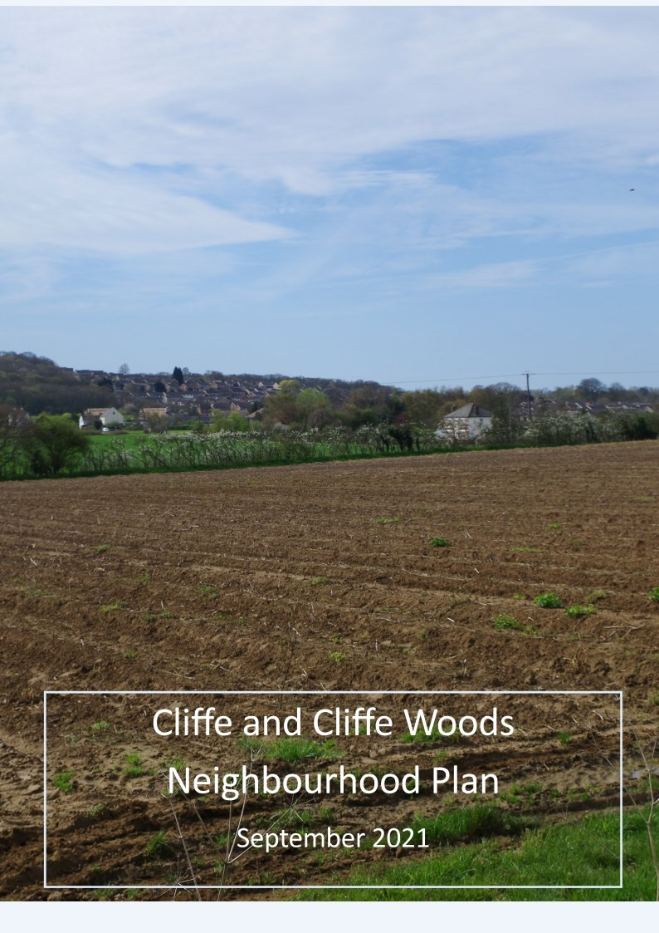

CONTENTS
- About Neighbourhood Planning

- About Cliffe and Cliffe Woods

- The Vision and Objectives of the Neighbourhood Plan

- Sustainable Development in Cliffe and Cliffe Woods

- Housing

- Community Facilities and Well Being

- Environment and Heritage

- Economy and Employment

- Infrastructure

- Appendix Separate Document Design Guidelines

About Neighbourhood Planning
The Government introduced the opportunity for local communities to prepare Neighbourhood Plans through amendments to the Town and Country Planning Act 1990 and the Localism Act 2011, and through the Neighbourhood Planning (General) Regulations 2012, which set out the requirements for Neighbourhood Plans.
Neighbourhood Plans can influence or allocate new housing; produce design policies for allocated sites or for general design policies; protect or identify new community facilities; and identify green spaces to be protected from any future development proposals and more.

How the C&CW Neighbourhood Plan fits into the planning system

Neighbourhood Plans are policy-based land use plans that need to be in general conformity with the Local Plan. In this case, the Local Plan is prepared by Medway Council. Neighbourhood Plans are produced by community forum groups or Parish or town councils. In this case the Neighbourhood Plan has been produced by a Steering Group of residents and Parish councillors with an agreed Terms of Reference to work on the Neighbourhood Plan. This has ensured that residents and local groups were in the driving seat of producing policy based on local knowledge and views.
To do this a dialogue between Cliffe and Cliffe Woods Parish Council (C&CWPC) and Medway Council has been necessary to ensure that the policies and proposals in the Cliffe and Cliffe Woods Neighbourhood Plan conform to national and local policy, as required by the Neighbourhood Plan regulations.
The development of the Neighbourhood Plan has taken place during a period of great uncertainty in relation to Local Plan policy making by Medway Council and has had to follow the Medway Council Local Plan review process. Regulation 18 consultations on the Local Plan took place between Jan 2016 and June 2018. The Medway Local Development Scheme of August 2020 proposes a Regulation 19 consultation on the plan in the spring of 2021 and submission for inspection in December 2021 with final adoption in December 2022. The Medway Local Plan must consider the needs of the whole of Medway and accommodate their duty to cooperate with local authorities and other service providers on issues like housing development, transport, and health provision.
As far as possible the C&CW Neighbourhood Plan Steering Group has taken a flexible and positive approach to the development of the Medway Local Plan’s emerging policies and their supporting evidence as the Neighbourhood Plan has developed and discussed its policies with Medway as part of the process.

Map 1: The Designated Neighbourhood Plan Area

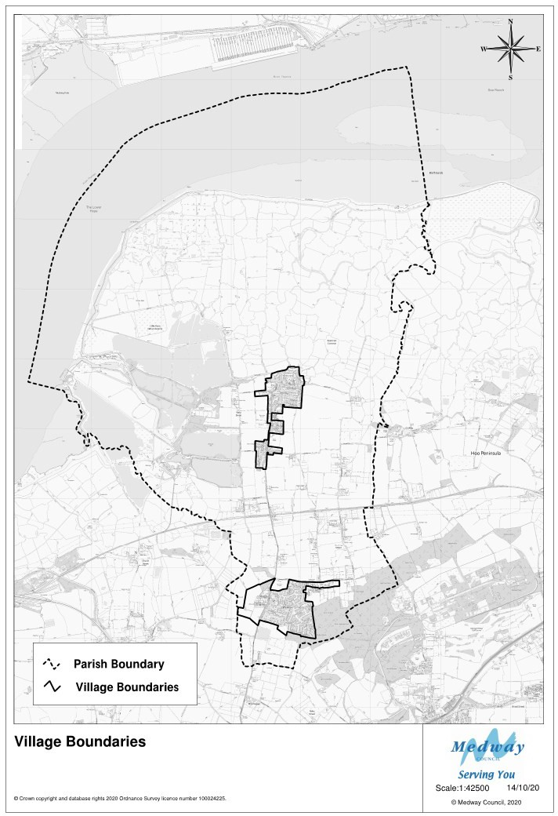

The Neighbourhood Plan area to which the Neighbourhood Plan applies is the whole of the Parish of Cliffe and Cliffe Woods. This was designated as a Neighbourhood Plan area by Medway Council on 16th June 2015 and is shown on the map above.

About Cliffe and Cliffe Woods (C&CW) Parish
The location and character of the Neighbourhood Plan area, which covers the whole Parish is a predominantly rural area which provides both important opportunities for, and constraints to, Neighbourhood Planning proposals and policies to guide future development within the area. Below is an overview of the main characteristics of the Parish today and the current issues that the Parish faces.
The Parish of C&CW is home to over 5,000 people located in the Medway Unitary Authority¹ area. Table 1 below shows key statistics about the population of the Parish.

Table 1: Cliffe and Cliffe Woods Parish Key Statistics
Population | Population | No. of  Households | Under 15 years % | Over 65 years %
 | 5,370 | 2066 aver size 2.6 | 20.7 | 13.6
Transport | No. of cars in Parish | No. of households without a car
 | 3,571 | 173
Employment | Persons economically active  % | Persons Unemployed % | Persons working at home %
 | 72.4 | 2 | 3.4
Travel to work | Car as driver or passenger % | Train % | Bicycle or walking %
 | 55.4 | 4.6 | 2.6
Source 2011 census summary profile

The parish is one of the largest in the historic county of Kent and has two villages: the ancient village of Cliffe which is believed to be one of, if not the oldest, settlement on the Hoo Peninsula, with human evidence from the Mesolithic period continuing to the present day. Cliffe has a compact built form with a variety of vernacular architectural styles and materials.
The more recent village of Cliffe Woods, is essentially a 20th-century development which started as a turn of the century ‘Plot Lands’ development in the proximity of the B2000. It was developed as a mixture of speculative larger scale development and self- build which has given it a more open form than Cliffe but is similarly mixed in form and materials. The Neighbourhood Plan area also has several smaller hamlets such as Cooling Street.
The Parish, due to its location and history, has many heritage assets (scheduled monuments, listed buildings and a conservation area) that benefit from special

¹ Set up in 1998 and administratively independent from Kent County Council.

protections. The landscape and wildlife assets of the parish are similarly protected under local, national, and international law (see Chapter 7).
These special protections are particularly relevant in relation to climate change impacts that may become more pressing over the life of the Neighbourhood Plan. The future management of these areas in relation to resilience to change and protection from disturbance makes initiatives like Birdwise – (the North Kent Strategic Access Management and Monitoring Scheme (SAMMS) which covers the coastline of north Kent, between Gravesend and Whitstable) - important for wildfowl protection and sensible management of their habitats. Medway Council is a supportive member of this initiative.
The basic infrastructure that supports the population of the Parish reflects the character of the landscape and its historical development. The B2000 is the main access road through the Parish. It is the only real access available to connect with the Medway towns, the wider district and beyond.
Provision for walking and cycling exists throughout the Parish but there is some lack of route connectivity. Over 50% of local residents travel to work by car (Census 2011) and increased car ownership since then generally means that existing road infrastructure is under pressure in terms of parking, overall volumes, and types of vehicles (including on un-adopted smaller roads that provide access within and between villages and hamlets).
The water company responsible for provision of water services in the Neighbourhood Plan has been classified by the Environment Agency as operating in an area of severe water stress (Environment Agency (2013) “Water stressed areas”).
Sewage infrastructure is provided via main drainage connecting the core of Cliffe and Cliffe Woods to the sewage plant at Whitewall Creek, Upnor. Outside these core areas residents have their own septic tanks.
Water sewage and wastewater services in the Neighbourhood Plan area raise important issues for accommodating any growth in demand as a result of development. As part of the consultations on the Neighbourhood Plan residents have reported sewage incidents locally. The Medway Council Jan 2017 Infrastructure Position Statement indicated that water services to accommodate growth needed further assessment and the Kent and Medway Growth and Infrastructure Framework (2015) identified problems of identifying the need for new provision and the necessary funds to achieve it.
The most recent views from Southern Water’s regional planning team (February 2020) indicates that in terms of sewerage there are some external flooding issues at Town Road View Road and Church Road Cliffe. The reported sewage leak incidents from local residents are not considered issues of capacity for sewage but blockages and it is their view that capacity is currently adequate. In terms of water supply they stress that although they are not statutory consultees on planning applications, they do encourage Local Planning Authorities to consult them so that the need for extra capacity can be

ascertained and a business case can be made for investment in the network of supply from Colewood Strood Water Service Reservoirs.
The provision of gas services is also relatively recent (the 1980s) and public transport infrastructure relies on infrequent bus services.
Broadband and mobile telephone Infrastructure is problematic for residents and businesses as connectivity is patchy and lacking in speed since it is limited to 3G capability via local boxes.
The residents of the Parish mainly go elsewhere to work according to the 2011 census, since the various cement works and other industry in the area declined and have been replaced by marine aggregate activities, resulting in much reduced and less local employment.
Much of the Parish is high grade agricultural land and local employment in this sector still exists for residents of the Parish. The main sectors they work in (Census 2011) are retail and construction. It is part of the vision and objectives of the Neighbourhood Plan to protect jobs associated with this land use but to also preserve it in uses that are open and rural in feel as they contribute to the overall rural character of the area and landscape of the area. Paragraph 170 of the National Planning Framework 2019 does require that the intrinsic character and beauty of the countryside be recognised and that planning decisions should maintain the character of the undeveloped coast.
Community infrastructure that supports education, health, cultural, leisure and religious activity meets most of the needs of residents The Neighbourhood Plan area, has an exceptionally fine church in Cliffe, two very popular primary schools, one medical practice (part of a group of four surgeries which also serves Higham and Wainscott beyond the Neighbourhood Plan area), social clubs and two community halls. Active leisure facilities include recreation grounds, a bowls club, tennis courts, rugby/football pitches, a skateboard park, ball courts, play areas and allotments.
There are local retail providers in both villages, although Cliffe Woods with its small parade of shops fares slightly better than Cliffe in this regard. The distance between the two villages is a 40-minute walk along the busy B2000 – much of this road has no pavements. Alternatively, it is a 6-minute drive, so provision of services in the two main villages is important for residents for local shopping needs.
Housing in the Parish is mainly owner occupied and is predominantly provided as detached or semi-detached homes although there are rows of terraces in Cliffe associated with its industrial past – their importance in historical terms is covered by their inclusion in the Conservation Area which covers the centre of Cliffe. There are some families within the Parish who are in housing need and since the 2011 census the population of Cliffe village consists of younger families and the population of the village of Cliffe Woods is ageing.

Current Issues

The people of the Parish have had many meetings and participated in surveys about the content of the Neighbourhood Plan and options for its future.² During that time a number of applications have come forward for development of parts of the Parish for housing and discussions have taken place with Medway Council about the future of the Parish as part of their work updating the 2003 Medway Local Plan.
Residents have identified several key issues which they would like to address because of these discussions and development activity within the Parish:
- Provision of affordable housing, particularly to cater for the older population and younger people who would like to remain in the Parish (bungalows and smaller properties)
- Ensuring the design and impact of new development is appropriate to the character of the villages of the Parish, its surrounding countryside, and its supporting infrastructure.
- Protection of the built environment heritage of the Parish
- Protection of the rural character of the Parish and its wildlife
- Pedestrian, cycling, transport, and parking improvements
- Upgrade and extension of community and leisure facilities to meet the needs of the 21st century and any potential increase in the residential population.
- Consider possibilities for visitor and education facilities to support the local economy and provide opportunities for employment that obviate the need to use a car.

² See C&CW Neighbourhood Plan Consultation Statement

The Vision and Objectives of the Neighbourhood Plan

The development of the Neighbourhood Plan has been informed by a long process of discussion between the Parish Council and residents which started with a survey of resident’s views about a range of issues in 2015³.

A Steering Group to start the work of developing a Neighbourhood Plan was established and considered what the scope of the Plan should be in February 2016.

This work identified key issues for local residents as concern about development impacts on existing community infrastructure, speeding and traffic, housing development and need. To follow this up, a wider process of consultation began in July 2016 with a general community planning event and then focussed on the content of a Neighbourhood Plan at events held between February and July of 2017.

A series of themed workshops were widely publicised and held in the Parish. These workshops were organised with the participation of Medway Council planning department and considered both the purpose and potential of a Neighbourhood Plan for the Parish, a vision for the Parish, how to engage as wide a cross section of the community as possible and how Neighbourhood Plans fitted into the Local Plan making process in Medway.

In addition, detailed workshops based on the following themes were held, where participants looked at current data under each theme and considered both challenges and options for addressing them:

- Environment and Heritage | - Housing and Community Facilities | - Traffic Transport and the Economy

The results of these workshops enabled the Neighbourhood Plan Steering Group – made up of local residents and Parish Councillors, to develop the following Vision and Objectives for the Neighbourhood Plan.

³ See C&CW NP Consultation Statement

Vision
“By 2037 the unique rural landscape of Cliffe and Cliffe Wood Parish will continue to be a haven for wildlife and agriculture, and provide homes, jobs and community infrastructure for people by protecting the heritage of the area and enhancing its character through sustainable development.”
Policy Theme | Objectives
Sustainable Development | - To ensure that the distinct identity of the two main settlements in the Parish is preserved and enhanced.  - To ensure that existing facilities to support life for residents in the Neighbourhood Plan area are not depleted.  - To encourage an increase in the services and employment available to residents and in the Neighbourhood Plan area that will support increases in its population and reduce the need to travel
Community Facilities | - To enable improved community spirit in the villages and settlements of the Parish with infrastructure and facilities that cater for all age groups within a rural setting.
Housing | - To provide housing in the Neighbourhood Plan area to fulfil local needs that is sustainable including: affordable housing, retirement housing, bungalows, chalet bungalows and small terraces.  - To ensure that all housing development proposals are appropriate to the rural setting.  - To provide a choice of ways that housing can be developed
Employment | - To promote green and historic tourism, and small-scale craft workshops using redundant farm buildings and mixed-use development opportunities to provide opportunities for local benefit from visitors to the area in a sustainable way that is appropriate to the Parish and its setting.  - To protect agricultural jobs and employment land in the Parish
Environment | To enhance the rural, environmental, and historic character and assets of the Parish by:  - Conserving the rural environment which already has extensive environmental protection for negative impacts of development and climate change,  - To enable the green and blue infrastructure of the Parish to deliver a wide range of environmental, economic, health and well-being benefits for nature, climate, and the wider community.  - Preserving rural views, wildlife sites and corridors and agricultural land uses.
Heritage | To enhance and the historic character of the Parish and its hidden history by  - Consideration of expansion of the existing conservation area and appraisal of the present Conservation Area in collaboration with Medway Council  - Protecting the character of farmsteads in the Parish (including buildings)  - Preserving the historic landscape features that define today’s Parish: the pattern of draining ditches, earthworks, and sea defences, field boundaries tracks and lanes.  - Conserving properties and archaeological areas that are still of value despite their Non-Designated Heritage Asset status.  - Ensuring the materials and design of all new development in the Parish is sympathetic to its existing character and avoids poor quality design.  - Preserving for the future archaeological sites in the Parish for learning and historical recording
Infrastructure | - To improve the safety of roads in the Parish  - To improve connections with footpaths, cycle ways and public transport.  - To improve the connection of the residents and businesses of the Parish to online resources.  - To ensure that the provision of schools, public transport services and health services keep pace with increases in population in the Parish

Sustainable Development in Cliffe and Cliffe Woods

Introduction

The Neighbourhood Plan area and the settlements within it are currently not sustainable from an economic, environmental, and social perspective. This is not uncommon for many rural areas and their villages in England who all face similar issues. Addressing this means that development can be used as a good opportunity to improve the area and services for existing and new residents and businesses as well as its features that are valued locally.
Future development in the neighbourhood plan area is constrained by both its existing rural character and unique landscape and the lack of facilities to support people going about their daily lives (shops, services). Currently the infrastructure for movement of goods and people is dominated by the car and heavy good vehicles with the concomitant effects on the environment. These effects encompass people’s safety and health (pollution) and potential degradation of its nationally and internationally recognised sites of wildlife importance and heritage assets. Additionally, the economy of the area is dominated by one or two employers with most people travelling out of the area for employment.

Table SD1 – Getting Around in the neighbourhood Area
Car Ownership
 | Cliffe and Cliffe Woods | % | Medway | %
Households without a car/van | 173 | 8.4 | 23,231 | 21.9
Households with 1  car/van | 711 | 34.4 | 45,163 | 42.5
Households with 2 cars/vans | 856 | 41.4 | 28,790 | 27.1
Households with 3  cars/vans | 218 | 10.6 | 6,609 | 6.2
Households with 4 or more cars/vans | 108 | 5.2 | 2,416 | 2.3
Total cars/vans in the area | 3,571 |  | 133,257
Source 2011 census

Table SD2 – Travel to work
Travel to Work | Cliffe and Cliffe Woods | % | Medway | %
Work mainly at or from home | 134 | 3.4 | 4,615 | 2.4
Underground, metro, light rail, tram | 3 | 0.1 | 283 | 0.1
Train | 178 | 4.5 | 11,252 | 5.8
Bus, minibus, or coach | 72 | 1.8 | 5,903 | 3.0
Taxi | 4 | 0.1 | 444 | 0.2
Motorcycle, scooter or moped | 22 | 0.6 | 1,416 | 0.7
Driving a car or van | 2,083 | 52.2 | 80,403 | 41.4
Passenger in a car or van | 127 | 3.2 | 7,778 | 4.0
Bicycle | 13 | 0.3 | 1,449 | 0.7
On foot | 90 | 2.3 | 12,461 | 6.4
Other method of travel to work | 17 | 0.4 | 685 | 0.4
Not in employment | 1,250 | 31.3 | 67,469 | 34.7
Source 2011 census

Despite this there are landowners who wish to develop land, but the neighbourhood will have difficulty absorbing its impacts. The scale and design of previous proposals has failed in the past to take account of the character of the Parish; it has a remote and wild character, open views, big skies and extensive areas of agricultural land, open water, woodland, and wetland.
Valuing the character of the Parish whilst at the same time wanting to address the needs of its population has been the focus of people’s concerns during consultation on this plan and guiding future development in the neighbourhood. There is a desire to address the lack of services, local housing needs, sustainable travel options and opportunities for employment whilst retaining the rural nature of the two settlements and their surroundings.

Neighbourhood Plan Policies
To achieve the vision for the Neighbourhood Plan, the following objectives have been adopted to develop policy for sustainable development across the Neighbourhood Plan area.

Objectives
Sustainable Development in Cliffe and Cliffe Woods Parish | To ensure that the distinct identity of the two main settlements in the Parish is preserved | To ensure that existing facilities to support life for residents in the Neighbourhood Plan area are not depleted | To encourage an increase in the services and employment available to residents in the Neighbourhood Plan area that will support increases in its population and  reduce the need to travel
Sustainable development is a cornerstone of national planning policy in England and Wales and its importance to the health and well-being of places and people cannot be understated since planning control presumes that sustainable development of land and buildings should be favoured.
Sustainable development in the National Policy Planning Framework 2019 is summarised as “meeting the needs of the present without compromising the ability of future generations to meet their own needs” (Para 7). In more detail the policy framework suggests that the planning system can achieve this by pursuing economic, environmental, and social objectives in “mutually supportive ways (so that opportunities can be taken to secure net gains across each of the different objectives) (para 8)”.

POLICY SUSDEV 1: Settlement coalescence
Development proposals that would result in the visual or physical merging of Cliffe and Cliffe Woods will not be permitted.

To preserve the unique characteristics and differences between the two main villages and preserve the open areas between them is considered a key objective to ensure that

the rural character of the Neighbourhood Plan area is protected⁴. This is also important to the future economic prospects of the neighbourhood as currently visitor and visitor related facilities are one of the few areas of potential employment that have seen growth in the last ten years across Medway as a whole⁵. (See Chapter 8 Economy and Employment). The value to the local economy and biodiversity of the neighbourhood and the viability of the wildlife and landscape protections that currently exist may be undermined if development proposals result in ribbon development along the B2000 – the main artery that could make development possible on the grounds of accessibility.

POLICY SUSDEV2: Loss of local facilities
Development proposals that would involve the loss of one of the uses listed below in the Neighbourhood Plan area, other than those which are permitted development, will not be supported, unless they relate to a change of use to another use in this list.
shops
financial and professional services restaurants and cafes
drinking establishments hot food takeaways Hotels
Non-residential institutions
Assembly and leisure

National policies on permitted development have impacted on the ability of rural settlements to protect high street and services available locally. Notwithstanding these changes every effort should be made to maintain the currently limited provision of shops and other facilities since these can support the local economy, provide services to local residents and visitors, and encourage social interaction. Further loss of these uses through development would undermine the sustainability of the two main settlements and the ability of existing and future residents to meet their needs for retail services and leisure activities and for local businesses to thrive.

POLICY SUSDEV3: Changes of use
Within the Neighbourhood Plan area, development or change of use to the uses listed in Policy SUSDEV2 will be supported in principle, where they do not conflict with other policies within this Plan, and where they would not be harmful to the living conditions of neighbouring residents and are otherwise consistent with sustainable development.
Changes of use will need to be justified with evidence of their non-viability and demonstrate that every effort has been made to market them in their current use.

Work on the Medway Local Plan that will replace its current 2003 Local Plan has seen several iterations of the Medway Strategic Housing Land Availability and Assessment. These have both rejected the possibilities of all sites offered up by local landowners in

⁴ See 2017 AECOM Cliffe and Cliffe Woods Heritage and Character Assessment
⁵ See 2018 Destination Research - Economic Impact of Tourism Medway 2017 Results

the Neighbourhood Plan area on the basis of the infrastructure which exists to support new residents and their impact on agricultural land and wildlife sites. However, despite this, some applications have been approved. Influencing the design and infrastructure support available to new support development and limiting the loss of existing facilities in the development process was a desire expressed consistently in consultations with local residents and businesses in the Neighbourhood.

POLICY SUSDEV4: Character
All new development, particularly on Greenfield site land, should be sensitive to the landscape and be of a height that does not impact adversely on views from the surrounding countryside.
All development proposals should demonstrate how they conserve, enhance, or strengthen the character and distinctive features of the landscape of the Neighbourhood Plan area and comply where feasible with the Design Guidelines appended to this plan.
Where appropriate, a Landscape and Visual Impact Assessment should be provided with proposals to ensure that impacts, mitigation, and enhancement opportunities are appropriately addressed.

The Heritage and Character Assessment produced by AECOM for this Neighbourhood Plan outlines the strong attributes of the four local character areas it describes in terms of its rural feel, its strong farmland features, and their importance as backdrops to SSSI designated land and its visibility from surrounding areas. Ensuring that development proposals address these strengths is a key objective of policy in the Neighbourhood Plan.
The individual chapters of the plan identify the current infrastructure available in the Neighbourhood Plan area and its current condition and identifies need for improvement where necessary. Ensuring that all development proposals are underpinned by supporting infrastructure is key to achieving the vision of the Neighbourhood Plan.
To ensure that these issues are considered in the round, future development proposals should specifically consider how their plans can be accommodated by existing or committed infrastructure provided by the various agencies that are responsible for them and specific discussion with those agencies on the impact of their proposals on infrastructure capacity:
- Cliffe and Cliffe Woods Parish Council
- Medway Clinical Commissioning group
- Medway Council
- Southern Water
Proposals that the Neighbourhood Plan specifically supports in relation to infrastructure provision within the area are included in Chapter 9.

POLICY SUSDEV5: Infrastructure Sufficiency Statements
All major new development ⁶ proposals must be supported by a statement demonstrating infrastructure sufficiency to support the proposal. An assessment of existing infrastructure provision should be undertaken which addresses:
- Waste, water, health, education and transport provision and the needs, commitments and planning requirements set out in the Medway Local Plan and relevant thematic policies and site allocation specifications that it contains.
- Recent technical studies and engagement with strategic infrastructure commissioners and providers that may update the position set out in the latest Medway Local Plan Infrastructure position statement/ Infrastructure Development Plan or Strategy.
- Accessibility, capacity, and availability of existing infrastructure in the area where this is to be relied upon to support a development proposal.

Chapter 9 of this plan outlines proposals for infrastructure improvements which are needed in the Neighbourhood Plan area.

⁶ The threshold for a major development is any application that involves mineral extraction,
waste development, the provision of 10+ dwellings / a site area over 0.5 Hectares or a floor space of over 1,000sqm / an area of 1 hectare.

Housing

Introduction

The Neighbourhood Plan area has some small hamlets, but has two main villages, Cliffe and Cliffe Woods (which are situated two miles apart) with agricultural and commercial land between, with one minor road, B2000, connecting the two. Cliffe, being the older village, consists of brick-built terraces many of which were extended in later years to accord with modern life, and modern developments have been erected both on Greenfield site land and infill sites. The properties in Cliffe Woods are now mostly post 1960s, earlier houses having been demolished and rebuilt.
Tables H1 and H2 below show the nature of housing currently in the Neighbourhood Plan area compared with Medway as a whole, showing the dominance of houses and bungalows and the limited availability of shared ownership provision and of housing provided by the local authority or registered providers.

Table H1: Housing Types in the Neighbourhood Plan area
 | Cliffe and Cliffe Woods | % | Medway | %
Total Household spaces | 2,145 | 100% | 110,263 | 100%
Detached houses or bungalows | 663 | 30.9 | 15,031 | 13.6
Semi-detached houses or bungalows | 870 | 40.6 | 32,487 | 29.5
Terraced houses or Bungalows | 480 | 22.4 | 44,980 | 40.8
Flats Maisonettes of apartments | 127 | 5.9 | 16,856 | 15.3
Caravans or other Temporary structures | 5 | 0.2 | 909 | 0.8
Source 2011 census

Table H2: Housing Tenure in the Neighbourhood Plan area
 |  | Cliffe and Cliffe Woods | %
All Households |  | 2,066 | 100%
Owner Occupied Households |  | 1,666 | 80.6
Shared Ownership |  | 12 | 0.6
Living Rent free |  | 22 | 1.
Rented households: |  | 366 | 17.7
 | Rented from a local authority | 17 | 4.6
 | Rented from a housing association | 167 | 45.6
 | Privately rented | 182 | 46.4
Source 2011 census

Since the 2003 Local Plan there have been relatively low levels of development but since 2016 there had been an increase in development proposals coming forward across Medway as a whole. As of September 2020, there are a total of 506 new dwellings in the planning application process in the Neighbourhood Plan area.
Little has changed in relation to housing need in the Neighbourhood Plan area over this period and affordable housing in particular. As with the rest of Medway this has grown. The Strategic Housing and Economic Needs Assessment conducted for Medway in 2018 identified a need for 13,387 affordable homes over the Local Plan period 2017-2037 (the Local Plan period had since been changed to 2019-2037). At a neighbourhood level affordability is an issue as so few of the rented properties are provided by Registered Providers or the Local Authority and privately rented property is more expensive. The responses to the 2017 Cliffe and Cliffe Woods Housing Needs Survey, showed that most properties are owner occupied, some were rented, some were shared ownership, and many families were living with relatives. The comments received identified the need for affordable housing and some housing for older people. It also showed that:
- Residents wanted to remain in the villages, but the housing stock was not available

- Some older people wanted to move to smaller accommodation that more suited their needs
- Young families wanted to move into the area but there was no affordable housing.

Most however wanted to maintain the character of the neighbourhood and felt that any development should take account of the rural nature of the Neighbourhood Plan area and must be sustainable.
Medway Council is in the process of updating their Local Plan. In this new draft plan (Regulation 18 Development Strategy consultation version 2018), there is a requirement for 29,463 homes to be built by 2037. Currently, based on the Medway SLAA⁷ as of 2019, thirty-two sites were submitted for consideration for development. All the sites were assessed by Medway as unsuitable for development as part of the SLAA process. The Neighbourhood Plan process has also considered these sites. In fact, 5 of the sites now have planning consent providing 350 homes, but the remainder were assessed for potential designation in the Neighbourhood Plan, and it was considered most of them were unsuitable for development for the same reasons as the Medway Council SLAA assessments.

Neighbourhood Plan Policies

Our approach to development of housing in the Neighbourhood Plan area is to accept that although Medway Council has not currently allocated sites in the Neighbourhood Plan area for housing, the future development of the Local Plan may result in some allocations prior to its final adoption in 2021⁸. In addition, applications are likely to be received and may be approved before the Local Plan is adopted. This means that Cliffe

⁷ Strategic Land Availability Assessment 2019
⁸ Medway Local Development Scheme December 2019

and Cliffe Woods will play its part in meeting the number of homes Medway Council needs. Whilst the need for new homes is recognised, any development within the Neighbourhood Plan area should be sustainable and achieve the Neighbourhood Plan Vision.
To do this, the following objectives were agreed to guide the development of policy in relation to housing development in the Neighbourhood Plan area but considering the Housing Needs Survey 2017 of the area.

Objectives
Housing in | To provide housing in the | To ensure that all | To provide a
Cliffe and | Neighbourhood Plan area to fulfil | housing | choice of ways
Cliffe Woods– | local needs that is sustainable | development | that housing
meeting Local | including: affordable housing, | proposals are | can be
and Wider | retirement housing, bungalows, | appropriate to the | developed
needs | chalet bungalows and small | rural setting
 | terraces

POLICY H1: Housing on Greenfield ⁹Sites
Major development proposals for housing on Greenfield sites in the Neighbourhood Plan area will be requested to contribute to sustainable development by including uses other than housing that are appropriate to the size and location of sites and where they do not conflict with other policies in this plan

The nature and character of the Neighbourhood Plan area means that sites coming forward for housing development within it should include other land uses, not just housing or mitigation through planning obligations, to meet the requirements of the Local Plan. This will help to ensure that residents and visitors have access to a range of supporting services and potential employment in the Neighbourhood Plan area and reduce the need to travel.
There is no green belt designated land in the Neighbourhood Plan area (although there is designated green belt land in the adjacent Parish of Gravesham), but it does have designations that underline the rural character and setting of the Parish in the form of a number of SSSIs, the RAMSAR and Special Protected Area. Greenfield sites must therefore be carefully developed at a scale that is appropriate to the rural location of the Neighbourhood Plan area.

POLICY H2: Housing Infill
Within the Neighbourhood Plan area proposals for new housing development on Previously Developed Land, within the existing village boundaries (Map 2) will be supported in the form of small-scale infill development within or immediately adjoining the boundaries of its two main villages.

⁹ Previously undeveloped land

Although the amount of previously developed land in the Parish is likely to be limited (no sites are identified in the Medway Brownfield Land register of 2019), it is important that it is developed wherever feasible and appropriate to ensure the effective use of land in the Neighbourhood Plan area. These and Rural Exception sites and conversions will help to meet the local need for housing.
The following maps outline the village boundaries of the two main villages, the ‘village
envelopes.

MAP 2 Village boundaries for Cliffe and Cliffe Woods
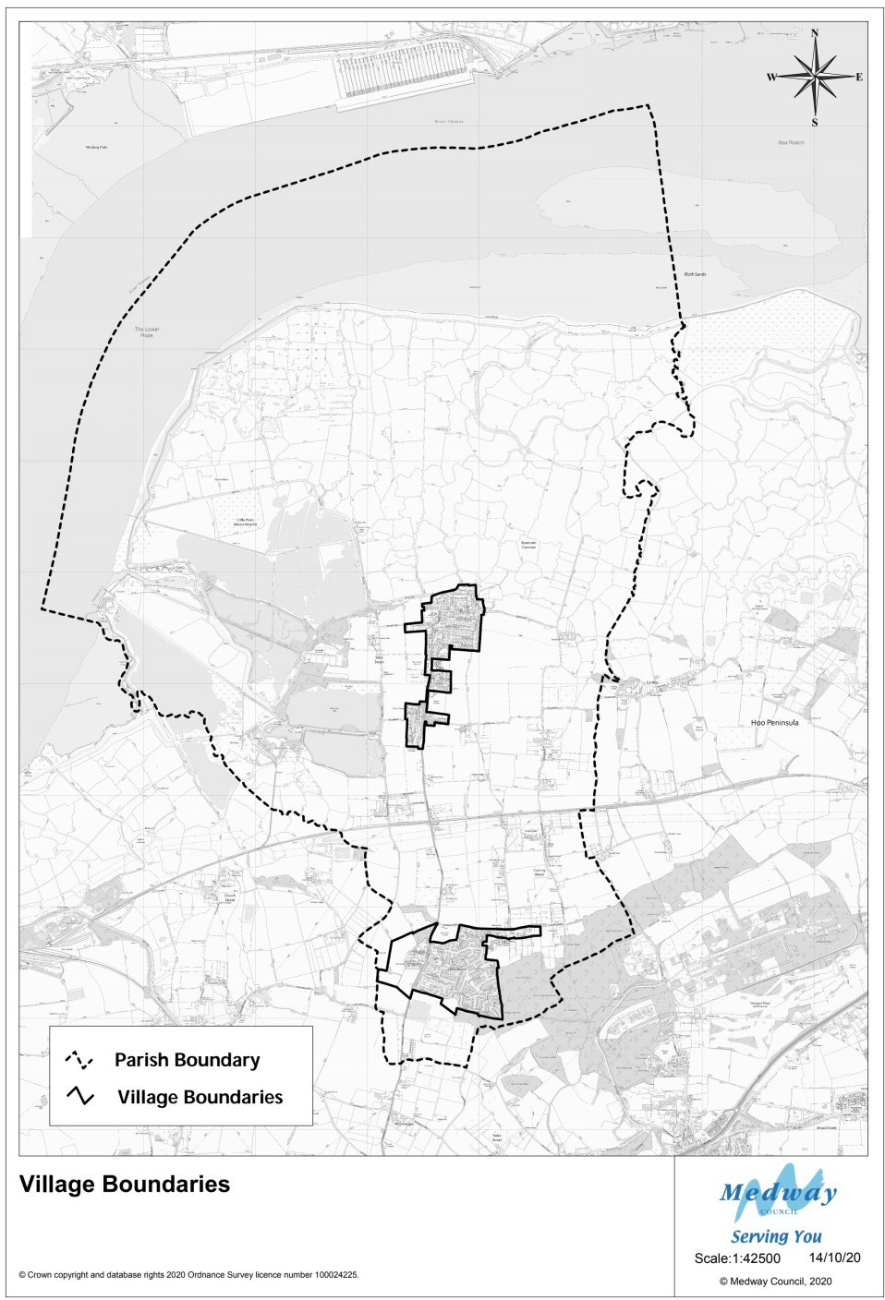

POLICY H3: Rural Exception sites
Within the Neighbourhood Plan area proposals for new housing development on previously undeveloped land to meet an identified local need which cannot be met in any other way will be supported subject to the other policies in this Neighbourhood Plan. Criteria to be applied to define local need are:
- A local connection to the Neighbourhood Plan Area – currently resident, currently employed or with a close family connection.
- To address housing need that cannot otherwise be met locally at affordable
cost

POLICY H4: Conversion of Agricultural Buildings to Residential Use
Proposals for the conversion of existing agricultural buildings in the countryside to small scale residential use will be supported if they:
- Do not result in a significant increase in the existing building footprint or height, are confined to the existing area of farm buildings and maintain the main characteristics of farm buildings, as set out in the Kent Farmsteads Design Guidance
- Conform to the relevant aspects of the Design Guidelines appended to this plan.
- In the event of wishing to develop farmsteads or their attendant farmyards and agricultural buildings designs should be shown to conform to the Kent Farmsteads Design Guidance Part 5.
- Do not conflict with other policies in this plan, particularly ECON&EMP1

This will preserve the rural characteristics of the Neighbourhood Plan area, whilst increasing the housing stock and ensuring there will be minimal impact on the rural setting of the Neighbourhood Plan area.

POLICY H5: House Extensions outside Village Boundaries
Proposals to extend existing houses in the countryside will be supported, provided they are not in conflict with the other policies in this plan and follow the Design
Guidelines appended to this plan.

Extensions to existing homes enable households to meet their housing needs as they change over time. However, it is important that they do not have negative impacts on their immediate neighbours and the wider area.

POLICY H6: House Design
All new housing design should respect the rural character of the Neighbourhood Plan area and its immediate context having appropriate regard to the standards set out in the Design Guidelines appended to this plan. Residential development will be permitted to encourage a sustainable mix of housing types and sizes to address local requirements to include social housing in accordance with the Medway Local Plan.
Particular attention should be given to building heights to ensure that roof heights do not spoil the aesthetic of the local area. Open front gardens or low hedges will be encouraged to retain the general open look and feel of the Parish.

The villages of Cliffe and Cliffe Woods can be seen from a wide distance from the rest of the Neighbourhood Plan area which is principally countryside; the design of new homes needs to consider this visibility and the resultant need to carefully consider its interface with the wider area in terms of appropriate design for its setting.

POLICY H7: Housing Type and Tenure
New housing development should reflect local housing need, particularly for bungalows and small family accommodation in the Neighbourhood Plan area in

POLICY H7: Housing Type and Tenure
terms of mix and tenure as identified in the most up to date SHMA/SHENA¹⁰ and any additional up-to-date evidence.
The mix must be appropriate to the size, location, and characteristics of the site as well as to the established character and density of the immediate environment to include sufficient parking appropriate to the size of the property as set out in Policy INFRA4 of this plan.

In common with Medway as a whole, housing need and affordability are a challenge in Cliffe and Cliffe Woods. Across Medway the SHENA (2015) concluded that “Over the assessed projection period (2012 -2037) the calculated need for 18,592 affordable dwellings (744 dwellings per annum) constitutes 58% of the total number of dwellings required to deliver the OAN¹¹ figure of 1,281 dwellings per annum.)

At the Neighbourhood Plan level, the Housing Needs Survey (2017) undertaken for Cliffe and Cliffe Woods Parish identified need for 18 affordable homes; 3 of which are for older households. In addition, it identified a requirement for 4 open market properties suitable for older households who want to downsize or move to more suitable housing for their needs. The need identified was for smaller homes with a mixture of 1-3 bedrooms for first time owners, “downsizers” and homes suitably adapted to accommodate the needs of the elderly. Bungalows were particularly supported as they are one of the major housing types in the Neighbourhood Plan area.
In addition, the survey identified that 56 households had seen members of their household – mainly their children leave the Parish in the last five years with the majority citing lack of affordable housing or employment opportunities as the reason they left.

POLICY H8: Housing Density
The density of new housing development on Greenfield¹² sites in the Neighbourhood Plan area should, as far as possible, be no more than 30 dwellings per hectare to maintain the rural character of the area its sustainability and promote good health impacts from improved residential quality.

Building at higher densities than those which currently exist in the Parish will inevitably create public concerns because of perceived changes it may bring to its character. Good design can address this challenge to some extent and can potentially enhance the character of the Parish.
In addition, densities do vary across the Neighbourhood Plan area. Cliffe for example, at its historic core is denser than Cliffe Woods – but this is largely due to its historic character. To maintain the overall character of existing settlements and their surroundings, densities on Greenfield sites should, wherever possible, be kept at levels

¹⁰ Strategic Housing and Economic Needs Assessment 2015
¹¹ Objectively Assessed Need
¹² Land that has not been previously developed

which address the local distinctiveness of the Neighbourhood Plan area, particularly its historic features notable landscape character and unique biodiversity.
The Medway Local Plan proposes a site-by-site approach to housing density but given the limited sites considered acceptable for development in the Neighbourhood Plan area and the associated infrastructure needed to support it, any developer should be guided to lower expectations of the amount of housing that can be achieved on sites within it.
Homes designed for health such as those proposed to meet the criteria for Homes Plus (which has been developed by the NHS England Healthy New Towns Programme¹³) are encouraged in the Neighbourhood Plan area which also require lower density. The criteria for homes of this standard provide increased space and other facilities to enable healthy living and so will also need lower density site layouts and detailed design features related to natural ventilation, noise abatement and energy generation that can be included in the design of new homes such as solar roofs and ground source heat pumps.

Community Facilities and Well Being

Introduction

The community halls and other buildings made available for hire by local groups and individuals in Cliffe and Cliffe Woods play an important role in dealing with isolation, providing for social interaction and spaces for education, health, and leisure activities.

Table CF1 shows the facilities currently available in each settlement and in addition there are spaces available in Cliffe Woods Academy, St Helens School, and the Six Bells Public House in Cliffe, and a small meeting room in the Buckland Nature Reserve (just south of Cliffe).

Provision currently needs improvement in terms of the potential for a wide range of uses. Many current facilities are already operating at capacity given the mainly voluntary nature of their management. Some are currently a simple hall with some ancillary facilities i.e., kitchens and toilets but many cannot accommodate or are unsuitable for informal sports or leisure activities.

Table CF1: Community Facilities in the Neighbourhood Plan area
Cliffe | Limitations | Cliffe Woods | Limitations
Cliffe Memorial Hall | Lack of storage space and internet access.  Limited disabled  WC facilities to all halls | Cliffe Woods Community centre | Size of main hall and kitchen, ceiling heights do not allow for indoor sports

¹³ https://www.england.nhs.uk/ourwork/innovation/healthy-new-towns/

Table CF1: Community Facilities in the Neighbourhood Plan area
Cliffe | Limitations | Cliffe Woods | Limitations
St Helen’s House | Limited size | Cliffe Woods Social Club (Woodpecker Lounge) | Mainly functions for socialising rather than events as Cliffe Woods has no  public house
Cliffe Men’s Social  Club | Limited size | Emmanuel Christian Centre | Needs another small room as main hall though sub-dividable does not cater for demand
Village Club | Mainly for  members of the club
Scout Hut | Not available for non-scouting  activities
Bowling Club Pavilion | Members only

As part of the evidence base collated for the current Medway Local Plan review, Parish councils in Medway were required to complete a Village infrastructure Audit (2015) for both villages in the Parish. These were collated into a final report in 2017. This noted the audit response in relation to Cliffe and Cliffe Woods requesting further provision overall. The tables below show its summary analysis. This was supplemented by a survey undertaken for the Neighbourhood Plan which covered further details such as WC and kitchen provision, promotion, opening hours, equipment, and pricing.

Summaries from Medway Village Infrastructure Audit January 2017

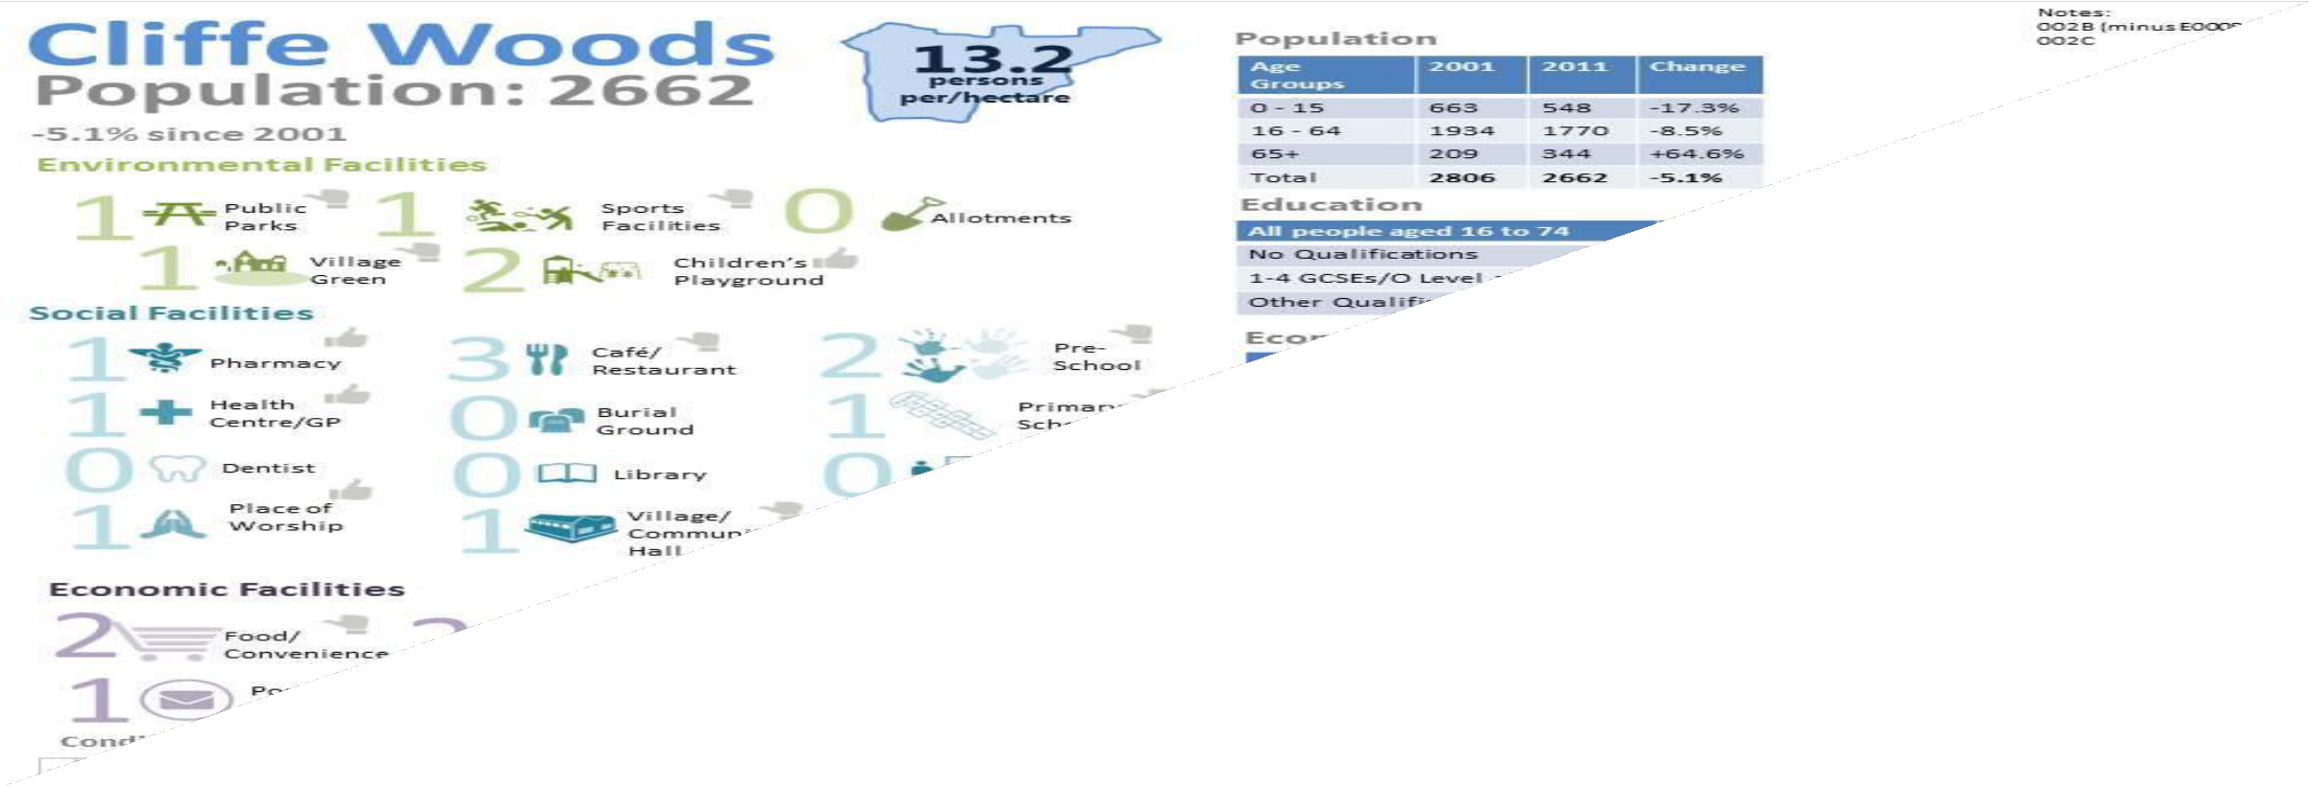

In addition, there is a weekly mobile library service that stops near Cliffe Woods shops and then at the primary school.
Schools in the Parish go to Hoo for pupil swimming lessons.

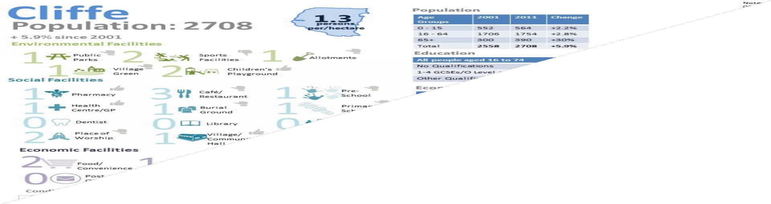

Both of these analyses are in fact out of date – there is no longer a petrol station and no outdoor ATM either. But they do indicate that the following improvements are needed to existing facilities:
- An overall increase in provision is required due to the limited capacity and suitability for some activities in the stock of facilities available.
- An increase in storage capacity at Cliffe Village Hall
- Upgrading of the Cliffe Memorial Hall due to its age
- An increase in the range of halls at Cliffe Woods Community Centre (including smaller rooms and new storage)
- A need for secure youth facilities in Cliffe Woods
There is a need for places for residents and visitors to use spaces when activities cannot be accommodated in their own home. They are also needed to allow service providers to make services available to people in Cliffe and Cliffe Woods Parish without the need for them to travel.
Similarly, there are a limited number of leisure facilities in the Neighbourhood Plan area, including allotments. Most residents must travel to Strood or Hoo to make use of indoor sports facilities, e.g., for gym work and swimming. The NPPF ¹⁴ (para 8b and 91a) policies make it clear that social objectives, including health should be considered in the planning of development into the future. These facilities offer opportunities and provide for activities conducive to health, social interaction, well-being, and lifelong learning.

¹⁴ National Planning Policy Framework 2019

Neighbourhood Plan Policies
The Neighbourhood Plan has identified the following objective in relation to community facilities to guide policy making in the Plan.

Objectives
Community Facilities | - To enable improved community spirit in the villages and settlements of the Parish with infrastructure and facilities that cater for all age groups within a rural setting.

All the Neighbourhood Plan policies have been developed to ensure that facilities are protected as far as possible given the limited potential for development in the Neighbourhood Plan area. All these facilities are important due to the limited number and variety of shops, cafes, and other entertainment facilities available to residents and visitors. Their continued improvement over time to allow them to cope with the impacts of Climate change and pandemics are very important since they are often the base for front line response to support communities in difficult times.

POLICY CF1: Loss of leisure and recreation facilities
Proposals that result in the loss of existing facilities used for indoor and outdoor leisure and recreation shown on Table CF1 and Map CF1 will be resisted unless there is clear evidence that there is no need for the facility or a suitable alternative of facilities of a similar size, quality and accessibility are re-provided or where proposals offer alternative benefits in terms of increased access to leisure and recreation
activities

The Medway Council “Playing Pitch Strategy - Needs Assessment” of October 2019 identified that C&CW Parish Council and Medway operate pitches in the area of the Neighbourhood Plan. Currently there is a shortfall for one additional rugby pitch and one youth size pitch and flood-lit training /mid-week facilities (4G pitch). The opportunity to increase the facilities would need external support (grant funding) to address this and this need is reflected in Policy INFRA9 which identifies local priorities for investment in facilities in the neighbourhood area.
The following maps show the locations of both the community facilities and outdoor recreation facilities in the Neighbourhood Plan area.

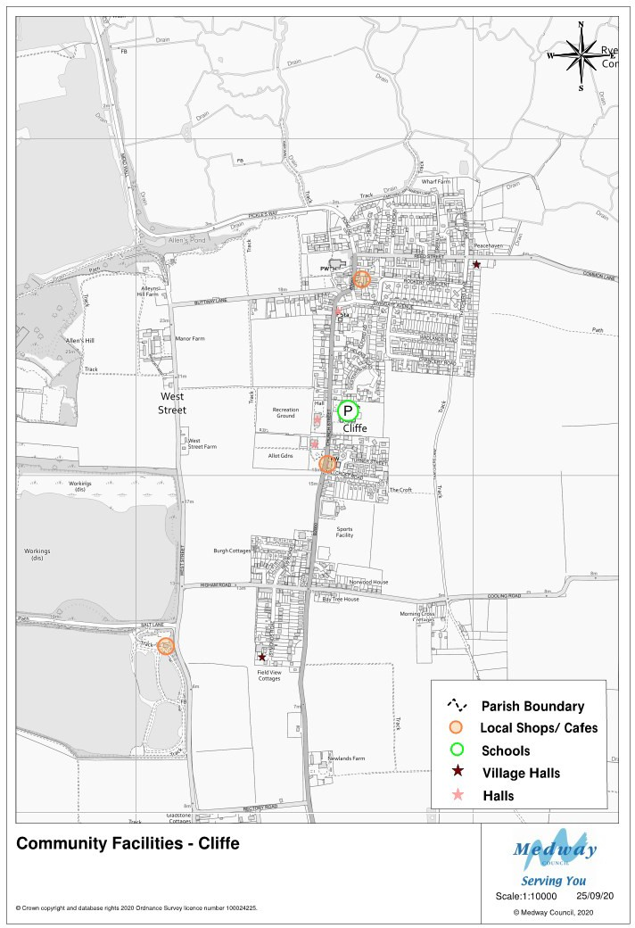

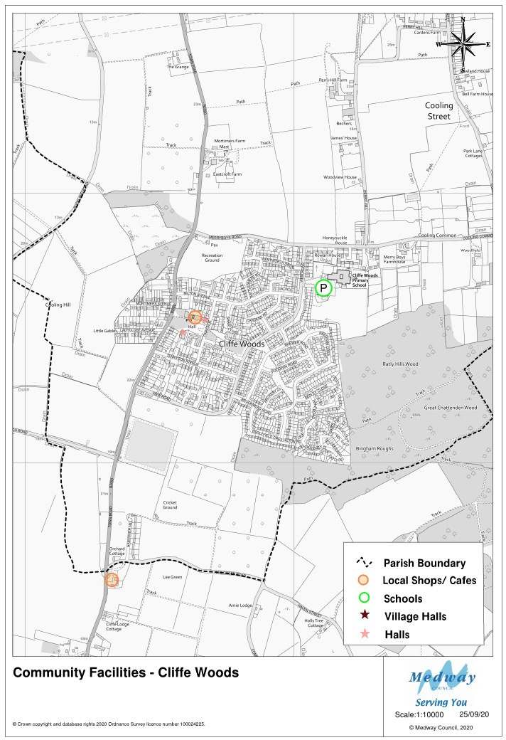

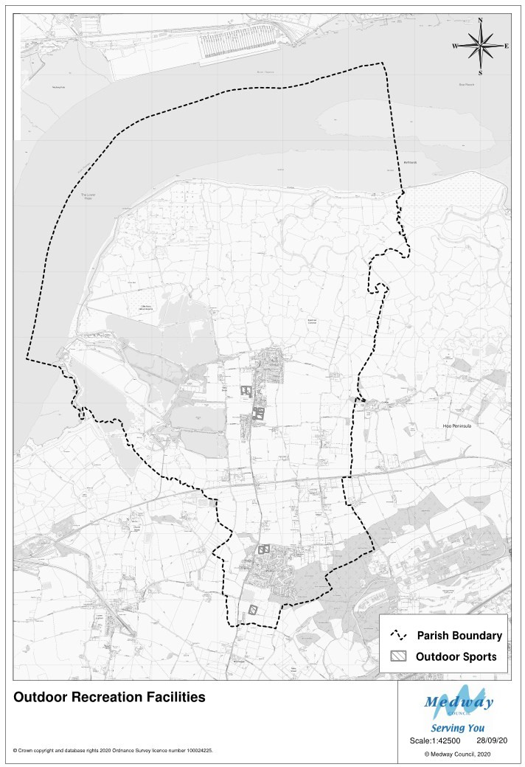

POLICY CF2: New and Improved provision
Development proposals within the Neighbourhood Plan area which include new leisure and recreation facilities, or the improvement of existing facilities will be encouraged where they are consistent with other proposals and policies in this Plan and adequate to meet the needs generated by new proposals.
Facilities should be designed for multiple uses to ensure that facilities are viable and sustainable. Developers will be encouraged to work with providers of such facilities to develop proposals and to design them in accordance with the Design Guidelines appended to this plan.

POLICY CF3: Loss of community halls, centres, and place of worship
Proposals that result in the loss of existing community facilities will not be permitted unless there is clear evidence that:
- there is no need for the facility (in terms of the current capacity of existing provision, its opening times, location, accessibility, and range of facilities available to local people and businesses) or suitable alternative facilities of a similar size and quality are re-provided as part of the proposal.
- proposals offer alternative benefits to the community in terms of access to space to assemble, worship, participate in educational activities and personal or
civic celebrations

POLICY CF4: Allotments
- Any proposals that result in harm to or loss of existing allotments will not be permitted unless:

  - The proposal provides a clear and significant social, economic, or environmental benefit to the local population that outweigh the benefits of their current use as allotments.
  - Replacement provision is made of at least an equivalent area and quality.
  - The proposed alternative land will be located within a radius of no more than 1000 metres of its present location.
  - Any developer will prepare new land for immediate use.
  - Any developer will compensate existing tenants for loss of any crops and relocation costs.

- Any proposal to increase allotment or community garden provision across the Neighbourhood Plan area will be welcomed and encouraged where it is consistent with other policies in this Plan.

POLICY CF5: Community Health
Development proposals should be supported by a health impact assessment that is proportionate to their size and scope.

The protection and improvement of community facilities and the provision of outdoor sports and leisure facilities is critical to the sustainability of the settlements into the

future and the health of its residents. It is important that this issue is taken account of in all development proposals and that proposals are informed by a proper assessment of health impacts in terms of the checklist in Table CF2.

Table CF2: Health Impact Checklist
Housing quality and design | Access to healthcare services and other social infrastructure
Access to open space and nature | Air quality, noise, and neighbourhood amenity
Accessibility and active travel | Crime reduction and community safety
Access to healthy food | Access to work and training
Social cohesion and lifetime neighbourhoods | Minimising the use of resources Climate change

This checklist (source - HUDU (2013) Planning for Health Rapid Health Impact Assessment Tool) should provide the basis for promoters of development to scope the potential impacts of their proposals during their design to ensure that all potential impacts are mitigated.

Environment and Heritage

Introduction
The Cliffe and Cliffe Woods Neighbourhood Plan area is characterised by and celebrated for its attractive, distinctive estuarine landscape to the north and its farmed countryside to the south. Ancient woodlands form an important part of the area too (See Map showing Environmental designations in the Neighbourhood Plan Area). As a whole the neighbourhood area sustains a rich diversity of wildlife. It also faces key challenges in terms climate change impacts like flooding, putting at risk the environment and heritage assets of the area.
The area has a rich built heritage and historic assets, with twenty-five listed buildings, a conservation area in Cliffe and a two Scheduled Monuments. It also has a wealth of natural heritage which is of local, national, and international importance, most of which is protected under local, national, and international laws such as EU Special Protection Areas (SPA), Ramsar sites (Wetland bird habitats of global importance) and Sites of Special Scientific Interest (SSSI) landscape designations.
The area is a rich mosaic of habitats, filled with birds and other flora and fauna including some of the most threatened and vulnerable species in the UK i.e., water vole, nightingales, shrill carder bees and scarce emerald damselfly to name but a few.
It has a farming heritage with predominantly the highest-grade agricultural land and some lower grade grazing marsh, a national resource. The plan area also includes a national Cycle Trail, the England Coastal Path National Long-Distance Walking Trail and miles of footpaths, bridle paths, byways, Public Rights of Way (PRoW) and common land.
The protection of this environment is important to both the resident and business communities of the area and visitors to it; views of the hills, woodlands, river, open farmland, and marshes form part of the daily lives of residents and provide opportunities for outdoor learning, physical activity, and involvement in environment, ecology, landscape, and social history.
The farmland of the area is classified as excellent Grade I and Grade II. There are orchards too. This farmland is important as a national resource that contributes to future food security as well as biodiversity. It is currently very fragile. A survey of Farms undertaken for this plan in 2020 shows that overwhelmingly farmland in the Neighbourhood Plan area is tenanted rather than owned outright, leaving farming activity vulnerable to the intentions of owners who want to release it to achieve more financial value from its development.
For the future planning of the local economy, it also provides opportunities for visitor accommodation, tea rooms, tours and cultural pursuits related to arts and crafts, writing and photography as well as healthy activity like cycling, running, walking, sailing and so on; provided it is appropriate to co-existence with the wildlife of the area.
Local residents are fortunate to have access to such a rich landscape and wildlife assets, but they also have green spaces which are on their doorstep necessary to allow for relief from buildings and street activity and to allow for play and recreation – both active and passive.
The extent and location of these natural environment and heritage assets is summarized in the following tables and maps:

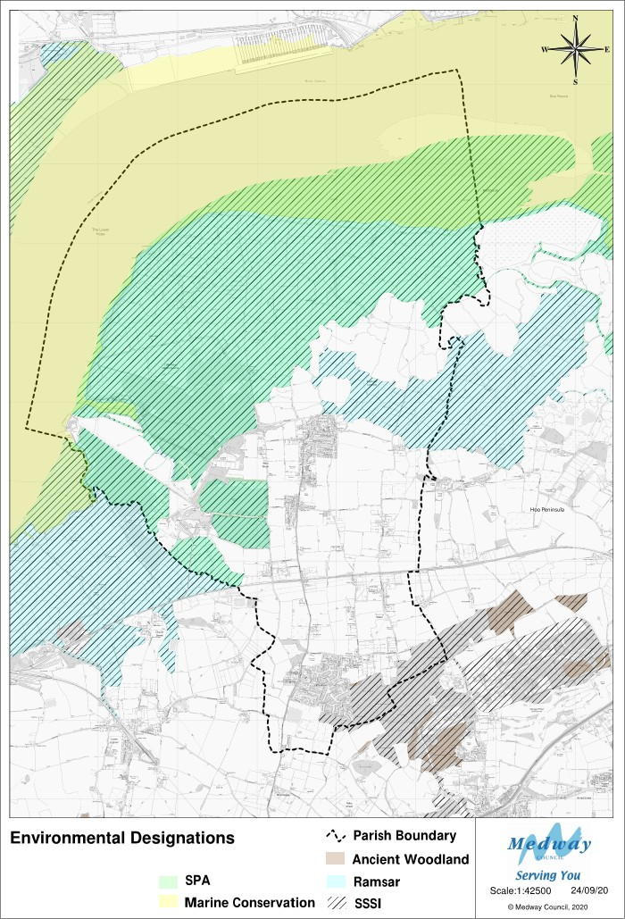

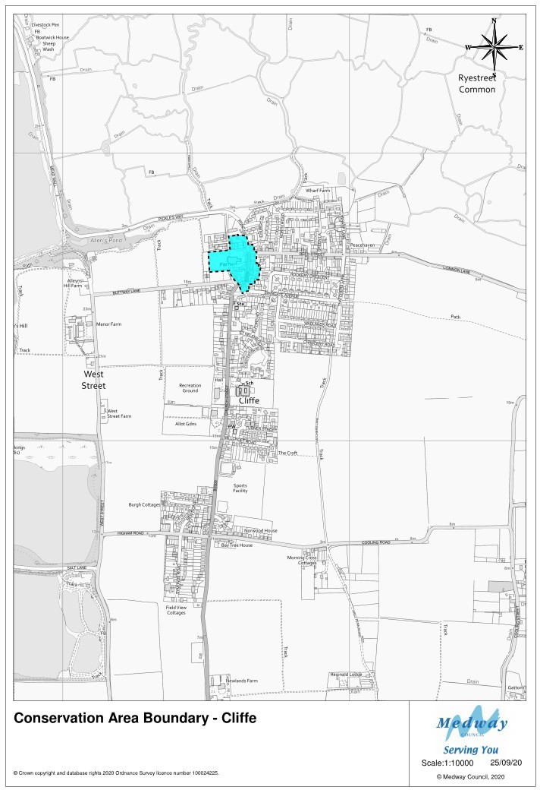

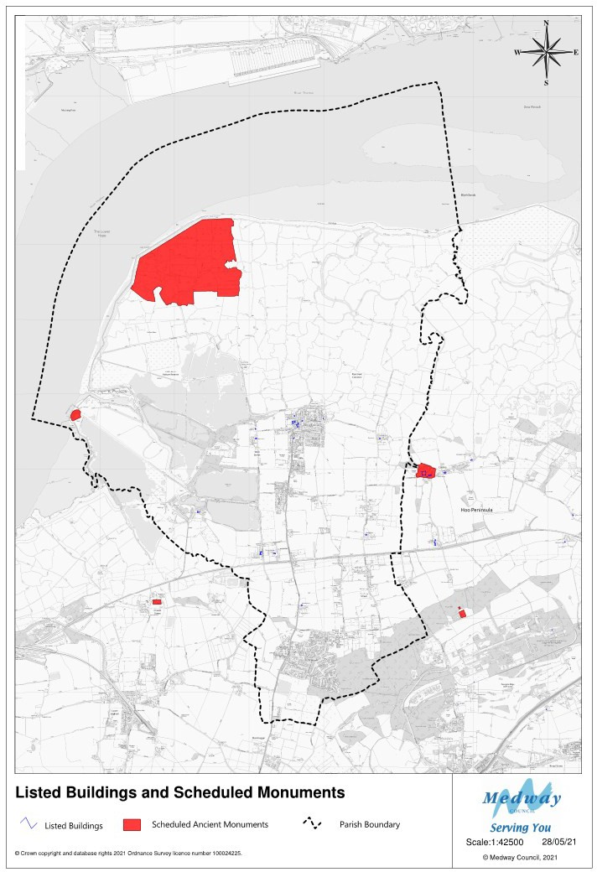

E& | H Tabl  ID | e 1 : Anc  List Entry | ient Monuments and Listed Bui  Area  Name | ldings i  Grade |  | n the Neig  Eastings | hbourhoo  Northings | d Plan  List Date
 | SM1 | 1003403 | Cliffe Fort
 |  |  | Location: TQ 70675 76724
 | SM2 | 1428315 | Cliffe Explosive Works
 |  |  | Location: The scheduled monument covers
 |  |  | an area of about 114 hectares located at TQ
 |  |  | 72399 78947
 | 1 | 1085760 | WEST COURT FARMHOUSE | II |  | 572311.6 | 175417.2 | 14-11-86
 | 2 | 1085761 | GRANARY 20 YARDS NORTH EAST OF WEST | II |  | 572333.7 | 175423.4 | 14-11-86
 |  |  | COURT FARMHOUSE
 | 3 | 1085762 | MANOR FARMHOUSE | II |  | 573096.9 | 176407.1 | 21-11-66
 | 4 | 1085763 | GRANARY AT BUCKLAND FARM | II |  | 573158.7 | 174847 | 14-11-86
 | 5 | 1085764 | CHARNEL HOUSE AT NORTH WEST CORNER | II |  | 573509.5 | 176655.8 | 14-11-86
 |  |  | OF CHURCHYARD
 | 6 | 1085765 | HARVEY MONUMENT 20 YARDS SOUTH | II |  | 573573 | 176602.4 | 14-11-86
 |  |  | WEST OF SOUTH PORCH OF CHURCH OF ST
 |  |  | HELEN
 | 7 | 1085766 | 170-174, CHURCH STREET | II |  | 573651.5 | 176564 | 14-11-86
 | 8 | 1085767 | THE RED HOUSE | II |  | 573712 | 176645.4 | 14-11-86
 | 9 | 1085768 | WALNUT TREE COTTAGE | II |  | 573993 | 176673.4 | 14-11-86
 | 10 | 1086505 | 185, CHURCH STREET | II |  | 573636.7 | 176586 | 17-07-90
 | 11 | 1204042 | CHURCH OF ST HELEN | I |  | 573594 | 176626.4 | 21-11-66
 | 12 | 1204054 | STEEL AND HATCH MONUMENT 1 YARD | II |  | 573596 | 176614.4 | 14-11-86
 |  |  | SOUTH OF SOUTH AISLE OF CHURCH OF ST
 |  |  | HELEN
 | 13 | 1204092 | THE RECTORY HOUSE | II* |  | 573338.3 | 174867.4 | 21-11-66
 | 14 | 1204114 | MORTIMER'S FARM HOUSE | II |  | 573704 | 174169.4 | 14-11-86
 | 15 | 1278057 | CHANTRY COTTAGE | II |  | 573636.9 | 176591.6 | 17-07-90
 | 16 | 1281378 | BARN AT RYE FARM | II |  | 574753.1 | 176406.2 | 14-11-86
 | 17 | 1281406 | SMITH MONUMENT 30 YARDS WEST OF | II |  | 573550 | 176617.4 | 14-11-86
 |  |  | CHURCH OF ST HELEN
 | 18 | 1281409 | 176, CHURCH STREET | II |  | 573655.9 | 176599.7 | 14-11-86
 | 19 | 1336467 | GATTONS FARMHOUSE | II |  | 574569 | 175115.9 | 21-11-66
 | 20 | 1336468 | ALLENS HILL FARMHOUSE | II |  | 573087.2 | 176533.6 | 14-11-86
 | 21 | 1336469 | BARN AT BUCKLAND FARM | II |  | 573149 | 174870.6 | 14-11-86
 | 22 | 1336470 | QUICKRILLS | II |  | 573600 | 176405.4 | 21-11-66
 | 23 | 1336471 | LONGFORD HOUSE | II |  | 573657.9 | 176611.2 | 21-11-66
 | 24 | 1336472 | COURT SOLE | II |  | 573607.5 | 176708.8 | 21-11-66
 | 25 | 1432857 | CLIFFE WAR MEMORIAL | II |  | 573576 | 176602 | 23-05-16

Neighbourhood Plan Policies
The distinctive nature of the Neighbourhood Plan area is described in the Heritage and Character Assessment 2017 undertaken to inform the development of this Neighbourhood Plan. The Assessment identifies four-character areas:

  - The Historic Settlement of Cliffe
  - Cliffe Marshland and Cliffe Pools
  - Cliffe and Cliffe Woods Farmland
  - Cliffe Woods Modern Settlement

The assessment also sets out the particular challenges in each area for managing change in the future and which have been addressed as far as possible in the Design Guidelines which form part of the policies of this Neighbourhood Plan related to Environment and Heritage and to meet the following objectives and Neighbourhood Plan vision.

Objectives
Environment | To enhance the rural, environmental, and historic character and assets of the Parish by:  - Conserving the rural environment which already has extensive environmental protection for negative impacts of development and climate change,  - To enable the green and blue infrastructure of the Parish to deliver a wide range of environmental, economic, health and well-being benefits for nature, climate, and the wider community.  - Preserving rural views, wildlife sites and corridors and agricultural land uses.
Heritage | To enhance and the historic character of the Parish and its hidden history by  - Consideration of expansion of the existing conservation area and appraisal of the present Conservation Area in collaboration with Medway Council  - Protecting the character of farmsteads in the Parish (including buildings)  - Preserving the historic landscape features that define today’s Parish: the pattern of draining ditches, earthworks, and sea defences, field boundaries tracks and lanes.  - Conserving properties and archaeological areas that are still of value despite their Non-Designated Heritage Asset status.  - Ensuring the materials and design of all new development in the Parish is sympathetic to its existing character and avoids poor quality design.  - Preserving for the future archaeological sites in the Parish for learning and historical recording

Environment

The sensitivity of the character of the Neighbourhood Plan area is such that all potential development in the future is likely to be located at the edge of the two existing main settlements and affect both agricultural land and sites with specific environmental designations. The Design Guidelines appended to this plan and Environment and Heritage policies have been devised to minimise these impacts and ensure that development is sensitive to and protects the heritage and character of the Neighbourhood Plan area.
These policies are complimentary to those set out in Chapter 6 that concern provision of community facilities and development impacts on the health of local people and visitors.

Those living and working in the Neighbourhood Plan area benefit from the wider countryside, but this does not replace the function of Public Open spaces as smaller areas for social interaction, children’s play and so on. Currently, the area benefits from fifteen spaces, two of which have play facilities. These are shown on the maps below:
As these are key infrastructure to support the needs of children and families their loss should be avoided.

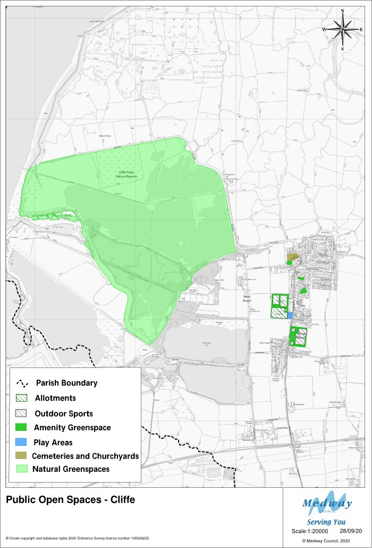

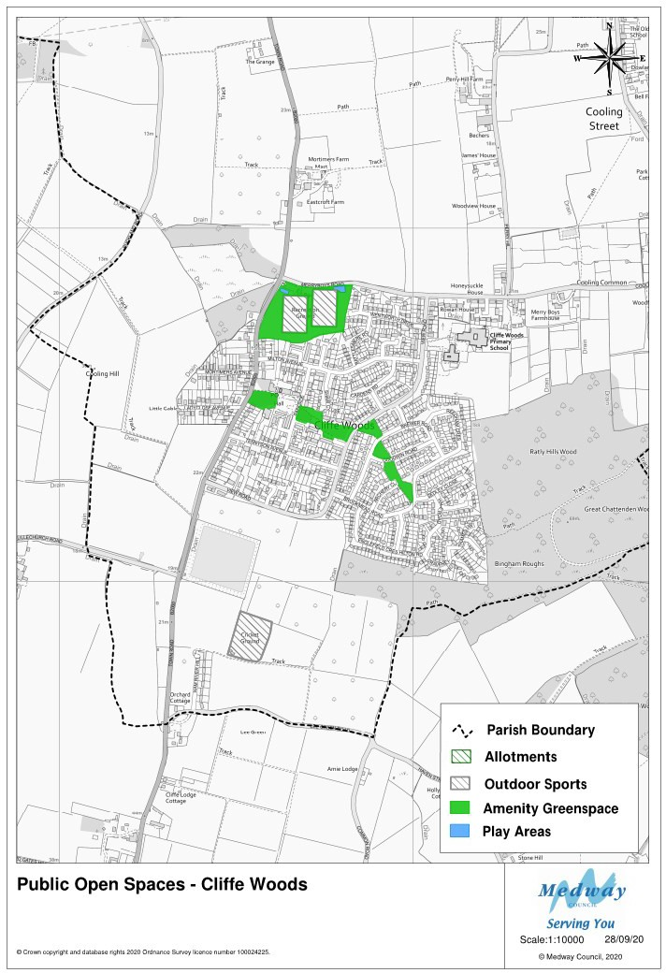

POLICY E&H1: Public Open Spaces
Development proposals that result in any loss of existing public green spaces as
shown on the maps, across all types within the Neighbourhood Plan area will be

supported only where replacement green spaces which are suitably located and equal or superior (in terms of size and quality) are provided for public use.

POLICY E&H2: Biodiversity
All development in the Neighbourhood Plan area will be expected to protect and enhance biodiversity in line with NPPF and Medway Local Plan requirements. Development must demonstrate a net gain in biodiversity in an ecological report consistent with BS 42020.¹⁵
Proposals for additional tree planting, where appropriate, will be welcomed.

Heritage
The Neighbourhood Plan area, as described in Chapter 2 of this plan and in the Heritage and Conservation Assessment (2018), prepared to inform it, is a place with a rich and long history. As a result, it has many building and landscape designations that seek to protect and enhance it.
This plan also seeks to protect and enhance, wherever appropriate, the built heritage and history of the area for the purposes of learning into the future and to guide the design of future development which will allow it to consider its distinct character.
This means not only what is visible, but what is hidden in terms of archaeology.
To develop the Neighbourhood Plan, significant work has gone into providing guidance to developers about the presence or likely presence of historical artefacts - their presence and relative density across the area in order to identify areas where a variety of approaches set out in policy E&H3 may need to be taken to proposals for development in the planning process.
As a result of feedback from Kent Archaeological Services on the Neighbourhood Plan, we have produced maps to support Policy E&H3 that reflect not only the historic character of Cliffe and Cliffe Woods and their environs, but the north of the Parish, bordered by the village of Cliffe and the River Thames, which covers part of the North Kent Marshes which is rich in both military and industrial history.
At one time the ‘marshes’ were known to be firm and there existed a crossing point of the Thames to Essex by means of a ford.
Throughout the area comprising the ‘marshes’ there is strong evidence that suggests that salt working formed an important component of the Bronze Age economy of the area and that, together with the Hoo Peninsula, became an important centre for Romano-British industry, with production of pottery and salt being undertaken on a large-scale. Within the Cliffe Marshes there are several identified Romano-British and medieval salt-working sites along with Romano-British occupation and burial sites. During the digging for mud at the area to the north of the site of Thames Works (Alpha Cement Works) much concern was raised by the vast amount of important

¹⁵ BS42020:2013 Biodiversity Code of Practice for Planning and Development

archaeological finds that were cast aside or completely destroyed. It is here that finds of a Roman altar and yet another Roman cemetery, comprising several inhumations together with several cremation urns were uncovered.
One important factor supporting the amount of industry, military presence and enabling the growth of the Parish is that of the River Thames as a major route way. All along the foreshore of the Thames there are numerous examples of significant archaeological remains dating from the Prehistoric period onwards and preserved archaeological remains can still be found in the intertidal zone and buried archaeological remains preserved within the alluvial deposits.
At some point, towards the end of the Anglo-Saxon period, the land became susceptible to flooding and conditions deteriorated continuously from the late 12th century to the early 15th Century, and it was during this time that extensive works were carried out, initiated by Christ Church Priory, to drain and protect the land. The drainage channels and earthworks, together with the field patterns, some of which are still in evidence today.
It has been recorded that Cliffe was once a large town of much importance by William Lambarde, (A Perambulation of Kent, 1576), again by Richard Kilburn in 1659 and finally by Edward Hasted, in his work ”The History and Topographical History of the County of Kent” where he writes “ once being a larger town than it is now” and continued to describe Cliffe as “daily growing into further ruin and poverty, the number of the inhabitants lessening yearly, and several of the houses, for want of them, lying in ruins”
The Parish’s two scheduled monuments, Cliffe Fort, and the Curtis & Harvey Explosives Works, are situated in this area.
Cliffe Fort is one of five surviving Royal Commission Coastal Forts in the Thames and Medway and construction began in 1861, under the supervision of General Charles George Gordon.
In 1855 building work commenced to convert one of the 9" magazines into a Brennan Torpedo Station, the Brennan Torpedo was introduced at the fort in 1890. The torpedo was a wire-guided harbour defence missile that was launched from the station via launching rails – the remains of the launching rails are still visible today. Cliffe Fort, together with the Brennan Torpedo rails, have been recorded as being on the ‘At Risk Register’ by Heritage England due to its flooded condition and impact erosion. Presently Cliffe Fort and the connecting road access are in the private ownership of Brett Aggregates.
The Curtis & Harvey Explosives Works began life as a Gunpowder Works, established in 1892 by Hay, Merricks and Company, gunpowder makers of Roslin, Scotland. In 1898 the site was acquired by Curtis's and Harvey for the manufacture of nitro-glycerine, and nitro-glycerine-based products.
Extensive remains of the factory survive on Cliffe Marshes with the potential to recover an almost complete plan of the works. The remains comprise earthworks of traverses and the lines of internal tramways, concrete floor slabs and several standing but roofless buildings. A row of concrete stanchions also survives on the site, which may

represent the line of steam heating pipes or may be an element of a Second World War Bombing Decoy.
Together with the nearby cement work plants it was the major source of employment for the expanding village of Cliffe.
The Second World War stop line between Hoo St. Werburgh and Higham Marshes is a notable surviving example of anti-invasion defence. It is the northern section of the Newhaven-Hoo General Headquarters (GHQ) Line where it crosses the Hoo Peninsula in Kent between the rivers Medway and Thames. It is an important remnant of the Second World War defended landscape of the peninsula and is a well-preserved example of this type of defence and is understood to be one of the best and most complete remaining examples of a section of the GHQ line in the country, which is part of a major chapter in the national story.
Several structures associated with this Stop Line survive within the Neighbourhood Plan area; these include several pillboxes and other features. Elsewhere along the Stop Line individual pillboxes have been designated as Listed Buildings. Development that erodes our ability to appreciate the Stop Line as a coherent feature should be avoided. The Stop Line should be considered as a monument in its own right, with the surviving pillboxes etc. being component features of the line.
The ‘marshes’ also saw the sites of the construction of a number of cement works
between 1854 – 1970, much of their remains can still be seen today at:

The Pottery (Cliffe Creek Cement Works) 1854 – 1886
Nine Elms (Cliffe Creek, Francis & Co. Cement Works) 1867 – 1900 Cliffe Quarry (Johnson's Cement Works) 1874 – 1921
Thames Works (Alpha Cement Works) 1912 – 1970.
The Nine Elms plant began its operation with nine bottle kilns to which a further ten were added. The kiln block of 1866-8 can still be seen today together with a grinding mill base a possible prototype for the Johnson chamber kiln.
Cliffe Conservation Area was designated in 1973 covering part of the core area of the nucleated settlement of Cliffe which includes St Helens Church. It has been suggested that a formal Conservation Area appraisal is undertaken by Medway Council as part of its ongoing heritage programme. This will reflect new historical data studies and may include items such as a revision of the boundary area and additional controls such as Article 4 direction guidance and a management plan to help to protect and enhance its character and appearance.
Evidence is mounting of the fundamental significance that the ecclesiastical establishment had in Cliffe parish as a whole being a Parish Peculiar of the Archbishop of Canterbury up to the 19th century. The nucleated village appears to be the Manor of Parsons Borough in which the Conservation Area now sits.

Hidden History Map 1 – Cliffe and Cliffe Woods
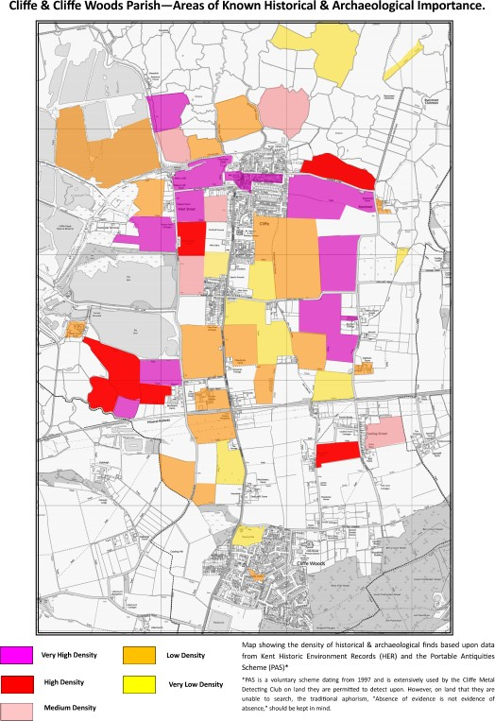

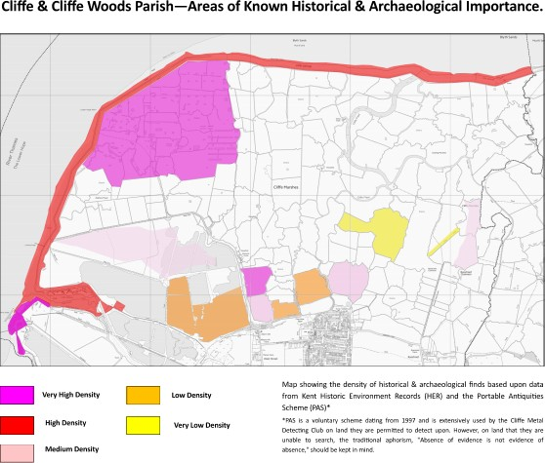
Hidden History Map 2 - Marshes

POLICY E&H3: Hidden History
Development proposals in the Neighbourhood Plan area will be expected to consider its unique history and heritage assets as part of developing the details of their proposals. In particular regard should be had to:
- The nature and significance of the heritage assets identified within the detailed records Heritage Environmental Records (HER).
- The general location and grouping of known heritage assets (see Hidden History Maps 1 and 2) Maps that will aid Medway Council, as the planning authority to be more aware of the possible hidden heritage. Areas within the nucleus of the old village of Cliffe and surrounding ancient manors and farmsteads should be treated as highly significant.
- It will be necessary for any development proposal to be discussed with Medway Council at the earliest opportunity to review the Kent Heritage Environment Records and maps showing areas of archaeological/historical significance in an around the development proposal site. This will guide the nature of investigations required and enable early guidance from Kent County Council’s Heritage Conversation team on purely archaeological matters, where relevant.
Development proposals should include;
- An assessment of the likely impact of development on the heritage assets in and around the site and how impact can be avoided or mitigated.
- Any proposals for enhancement of any heritage asset in and around the
development site

POLICY E&H3: Hidden History
c) Ensure that these assessments and proposals are distinctly and conspicuously included in the development proposals.

The development of the Neighbourhood Plan has seen a significant investment in developing guidance for promoters of development in the area to guide its form and character. This is so that it enhances local distinctiveness whilst respecting appropriate architectural diversity, originality, and innovation. The Design Guidelines (2019) created for the Neighbourhood Plan area, is a very important guide to achieving the Vision and Objectives for this plan and are referred to in many of its policies.

POLICY E&H4: Design Guidelines
All development proposals in the Neighbourhood Plan area should apply the principles and guidelines included in the Design Guidelines appended to this plan.

Economy and Employment

Introduction

The 2011 census shows that in the Neighbourhood Plan area of the residents aged 16- 74, 3,993 were economically active and 2,680 were employed. These employees work in the following sectors:

POLICY ECON&EMP Table 1: Employment in the Neighbourhood Plan area
Industry | % age of the population aged 16-64 in  employment
Wholesale and Retail | 14.7%
Construction | 13.9%
Education | 10.00%
Human Health and Social Work | 10.2%
Manufacturing | 7.8%
Source: 2011 Census

The number of residents who work within (or close to) the Parish lies between 90 and 180 see Table SD2.

Industry within the Parish is concentrated in the Salt Lane Industrial Area, to the west of the village of Cliffe which grew in relation to the employment opportunities offered. This includes the Alpha and Conoco jetties, although the amount of industry has declined in the last 50 years, the population of Cliffe has not.

E&E Map 1 of Salt Lane Industrial area
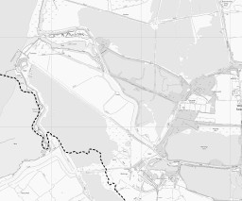

There is a lot of land in the Neighbourhood Plan area, which is in agricultural use, a lot of it high grade (see E&E Map 2). As a result, it does provide some employment opportunities for local people.

E&E Map 2: Agricultural Land in Cliffe and Cliffe Woods
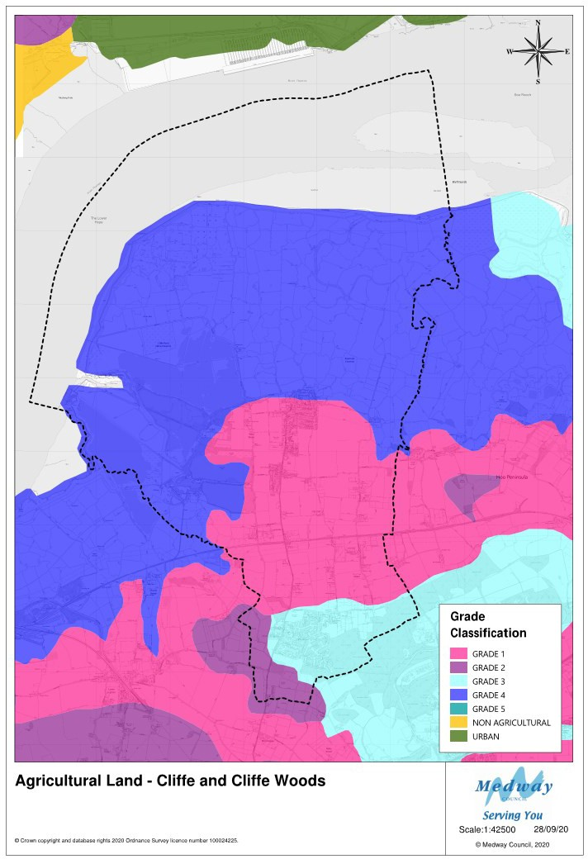

There are 19 farms in the Neighbourhood Plan Area either owned by or leased by farmers, which are a combination of arable, grazing for both livestock and horses as well as fruit growing. Three of these farms are affected by future plans for development. (See E&E Map 4) As with many aspects of the economy, technology has reduced the number of people employed in agriculture. There is however a seasonal workforce on some farms. Mockbeggar Farm, albeit just outside the Neighbourhood

Plan area typically has 180 seasonal staff. This sector is very important to the Neighbourhood Plan area as many residents have low levels of skill and qualifications (See ECON&EMP Table 2).

ECON&EMP Table 2 - Qualifications
 | Cliffe and Cliffe Woods |  | Medway |  | South East
% of population aged 16+ |  | % |  | % |  | %
No Qualifications | 887 | 20.8 | 48,226 | 22.9 | 1,333,955 | 19.1
Level 1 qualifications | 837 | 19.7 | 35,473 | 16.9 | 946,056 | 13.5
Level 2 qualifications | 787 | 18.5 | 38,653 | 18.4 | 1,110,706 | 15.9
Apprenticeship | 248 | 5.8 | 9,857 | 4.7 | 253,423 | 3.6
Level 3 qualifications | 526 | 12.4 | 26,818 | 12.7 | 892,915 | 12.8
Level 4 qualifications and above | 804 | 18.9 | 40,275 | 19.1 | 2,093,693 | 29.9
Other qualifications | 169 | 4.0 | 11,209 | 5.3 | 361,918 | 5.2
Source 2011 census

The Royal Society for the Protection of Birds owns the area of land known as Cliffe Pools, which is next to the Salt Lane Industrial Area. The RSPB is considering siting a visitor centre in the area (shown E&E Map 3 below) to enable people to fully enjoy and appreciate the beauty and variety of birds in the Neighbourhood Plan area and their associated habitats.

E&E Map 3: RSPB Potential Locations for a visitor centre
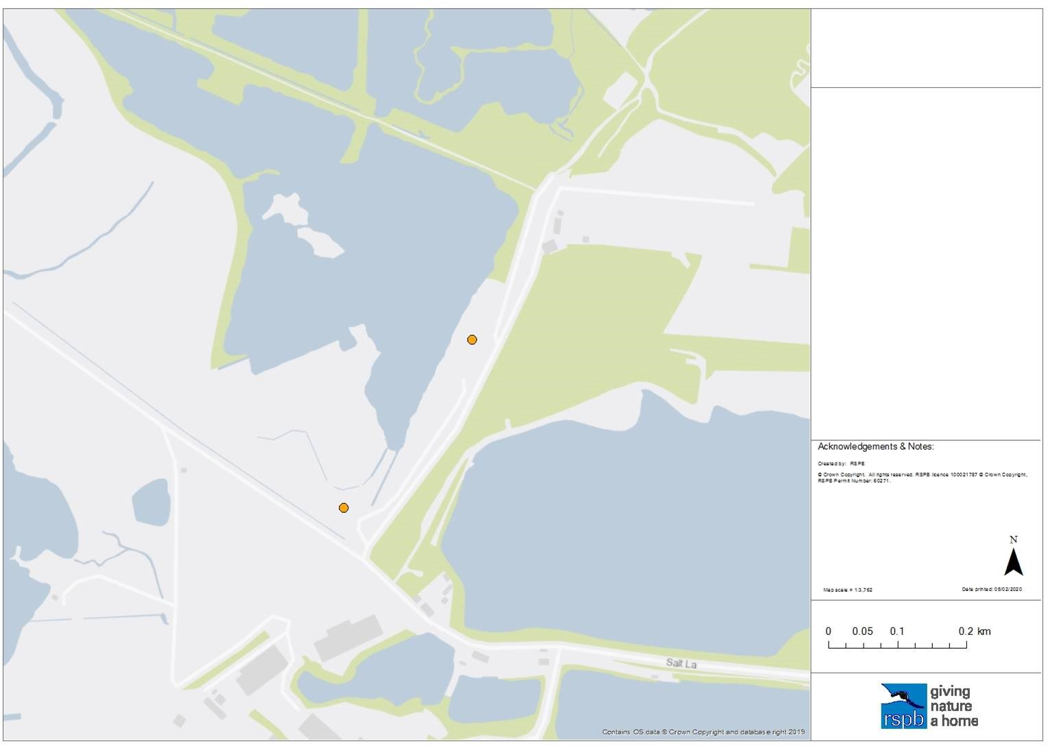
Significantly, a defined group of workers in terms of travel is those who “work mainly
at or from home” (See Table SD2). There is no detail related to these workers in terms

of the sectors that they work in and the extent to which they may be smaller companies rather than self-employed individuals. As data suggests that construction is a main employment sector for people locally it is likely that they are based in the Parish but work in multiple locations. Based on the popularity of small storage premises in the parish or just outside (Mockbeggar Farm provides this facility) it is likely that they meet some of their space needs for their work in this way or keep tools and materials in their vehicles.

Information on business premises that pay non-domestic rates (ECON&EMP Table 3) will not cover this category of employment activity. But as the need to reduce car travel to limit climate change and pandemics such as COVID 19 impacts are felt, it may be that this pool of workers will grow into the future and that there may be demand for small flexible workspace or shared managed workspace within the Neighbourhood Plan area if it was available.

A UK study of shared workspace undertaken in 2016, noted the vigorous growth of shared and managed workspace across the UK and pointed to the variations in the size and location of provision to address local needs, particularly outside major cities.
There are 1,299 residents who are not in employment (54.6% compared to the national figure of 35.6%, possibly indicating more retired residents than other areas). Data on educational qualifications indicates that 29.6% of residents have no qualifications compared to the national figure of 22.7%. The Local Education Authority and Regional Schools Commissioners should be encouraged to examine this in relation to education/training opportunities.
The analysis of business premises in the Neighbourhood Plan area based on the payment of non-domestic rates identifies a total of 43 premises categorised as follows:

ECON&EMP Table 3: Business premises in the Neighbourhood Plan area
Warehouses | 2 | Riding schools/stables | 2 | Workshops | 2 | Car Parks | 1
Outdoor Storage areas | 1 | Fish Farms | 1 | Vehicle Repair Workshops | 2 | Surgeries | 2
Offices | 1 | Halls/Community Centres | 8 | Guesthouses | 1 | Shops | 7
Schools | 2 | Fire stations | 1 | Public Houses | 1 | WCs | 1
Kennels | 1 | Catteries | 1 | Nurseries | 1 | Farms | 3
Comms stations/Masts | 2 | Concrete/aggregates | 4
Source: Valuation Office Agency (downloaded May 2018)

This shows the limited economic base on which the Neighbourhood Plan area is based and data for employment (See Table SD2) underlines the extent to which residents travel out of the area to work.

This presents an opportunity into the future for provision of new employment space and employment generating facilities, but also the need to protect existing employment land into the future. As a result, the Neighbourhood Plan has adopted the following objectives in relation to the economy and employment.

Objectives
Employment | - To promote green and historic tourism, and small-scale craft workshops using redundant farm buildings and mixed-use development opportunities to provide opportunities for local benefit from visitors to the area in a sustainable way that is appropriate to the Parish and its setting. | - To protect agricultural jobs and employment land in the Parish

The protection of farmland and the employment associated with it is an objective of the Neighbourhood Plan. This has been agreed to protect the viability of the communities of the hamlets and villages in the Neighbourhood Plan area by ensuring that everyone does not have to travel out of the area for employment, adding to problems of congestion and pollution that are already significant challenges. This policy will help to ensure that the character of the area is protected, and that farming does not disappear as a result of individual farms areas being reduced to the point that they are unviable enterprises. A survey of farms undertaken for the Neighbourhood Plan shows that of the 20 farms identified, one is no longer in operation. The rest are dominated by tenanted farmland which makes them vulnerable to the plans of landowners for development. Policy H4 related to residential conversion of agricultural buildings will also need to be considered in relation to the viability of farming across the Neighbourhood Plan area.

E&E MAP 4 : Farms in the Neighbourhood Plan Area
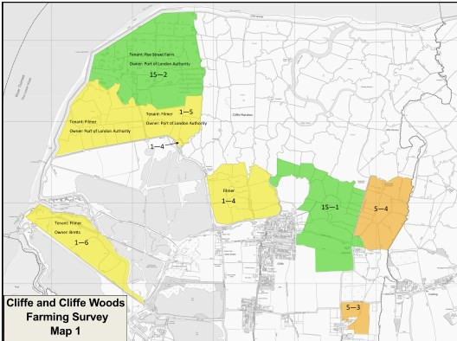

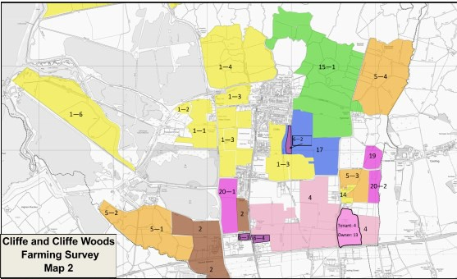

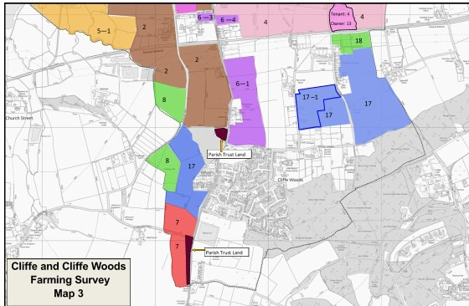

E&E Table 4 : Cliffe and Cliffe Woods Farming Survey 2020
 | Farm | Use
1 | Filmer Farms (Allens Hill) (West Street Farm) | Area 1-1 Owned and used as arable land  Area 1-2 Purchased from Brett site with quarry Area1-3 Land rented from Trenport (owners)  Area 1-4 Land owned but rented out to neighbour –  use not stated  Area 1-5 Land rented from Port of London Authority used as grazing/pasture  Area 1-6 Land rented from Brett used as grazing/pasture No outbuildings to let out
2 | J L Wright Limited Bucklands Farm | Owned - all the land marked 2 on the map.  Owns Grange Farm but this is farmed by Stuart Wright for arable crops. Small piece of land marked 2-1 rented from Trenport.  Outbuildings only on Bucklands Farm. None let out.
3 | Fenn Ltd | Farm now part of 2 above
4 | Newlands Farm | Tenant.  Fields rented. Grows vegetables/arable crops.  Minimal outbuildings – none rented out
5 | West Court Farm | Area 5-1 is owned and used as grazing for cattle/sheep Area 5-2 Tenanted  Area 5-3 Tenanted  Area 5-4 Owned and used for livestock grazing. Farm used mainly for livestock. No arable Outbuildings – all owned and used for farming
6 | Eastcroft Farm S & G Lane | Area 6-1 largely rented.  Remainder used by Eastcroft Roses which is co-owned with Peter Cox  Area 6-2 is owned but rented out to Nick Whitebread (Spendiff Farm)  Area 6-3 is owned and left fallow Area 6-4 rented out to tenant of Newlands Farm  Outbuildings located only on Area 6-1.  8 units let out for light industrial purposes

E&E Table 4 : Cliffe and Cliffe Woods Farming Survey 2020
7 | Lillechurch Farm | Tenant. Works on two small parcels of land within the Parish which is  owned by St John’s College.  Used as arable farming. No outbuildings let
8 | Oakleigh Farm | Tenant. Works on two small parcels of land within the Parish which is  owned by St John’s College.  Used as livestock/grazing.  No outbuildings let
9 | (J Myatt & Co) | Based on comments from other farmers operates on land east of Cliffe Woods from Lee Green Road up to the southern edge of the village. Status not confirmed.
10 | Perry Hill Farm | A parcel of land from Mockbeggar Road north to the railway line along Perry Hill and east towards Cooling Street.  Status not confirmed.
11 | Merryboys Farm (Tile Barn Farm on map) | (extent of land unknown) Large areas of land on both  sides along Cooling Common. Some land was owned by Gattons Farm but sold to Merryboys Farm.  Land owned and used primarily for equestrian/stabling and grazing of horses. Now developing land east of the main  house but refused permission for land west
12 | Bell Farm | (not operating)
13 | Gatton Farm | Rented to Newlands Farm
14 | Berry Court Farm | Minimal amount of land which is used primarily as stable and horse grazing
15 | Rye Street Farm | Land used primarily for grazing for livestock (cattle and sheep)  Some arable land  Equestrian centre and stables  Owns land on Area 15-1 which includes equestrian centre and stables Tenant on land marked 15-2 on Marshes – land owned by Port of London Authority.
16 | West Street Farm (no longer operates) | Land owned by Trenport and rented to Filmer Farm.
17 | Spendiff Farm | Area 17 owned and all fields used primarily for arable stewardship (environmental crops).  Area 17 in Cliffe Woods subject to planning application (Gladman). Area 17-1 owned but rented out.  Outbuildings – none sublet
18 | Satis House | Area 18 Owned and mainly used for livestock grazing and growing animal feed.
19 | Cooling Castle | Land owned and used for grazing. Extent unknown
20 | Childs Farm (Cooling) | Area 20-1 Owned and used as orchard  Area 20-2 Owned and used as arable/fruit growing

The NPPF 2019 para 118b states that planning policies “should recognise that some undeveloped land can perform many functions, such as for wildlife, recreation, flood risk mitigation, cooling/shading, carbon storage or food production”. Combined with the wildlife value of much of the undeveloped land in the Neighbourhood Plan area, the protection of agricultural land in the area enables the achievement of both the Neighbourhood Plan vision and national policy related to the effective use of land.
Much of the land in agricultural use (see E&E Map 2 and E&E Map 4) also holds some of its most important environmental designations - Sites of Special Scientific Interest

that protect rare flora and fauna, Ancient Woodlands, Special Protected Areas to protect wild birds and RAMSAR sites to protect wetland. In these cases where they are in agricultural use there is limited threat to their current function, but in others they present a challenge to balancing the need to protect land that can contribute to food supply and the protection of biodiversity. As noted in “Foresight. The Future of Food and Farming (2011) Final Project Report” - “Until recently, policies in conservation and in food security were largely developed in isolation. However, they are increasingly being pursued together, driven by a growing realisation of their interdependence“.
In particular residents and businesses in the Neighbourhood Plan area, and visitors to it, benefit from the Future of Food and Farming report definition of eco-system services classified as:
- Provisioning services are direct goods such as food, fibre, or timbers.
- Regulating services help enable the provision of direct goods, for example by providing pollinators, natural enemies of pests, pure water, and a conducive local climate.
- Supporting services are more fundamental processes, such as those producing fertile soils and recycling water or nutrients, as well as the maintenance of genetic diversity that may be of future value to agriculture.
- Cultural services are generally less tangible public goods, such as landscapes that people cherish, and the preservation of biodiversity, that in most value systems are considered beneficial.
Protecting agricultural land from development enables these benefits to be preserved in addition to meeting national policy objectives on the effective use of land.

POLICY ECON&EMP1: Agriculture
Development proposals that result in the loss of land classified as agricultural (Grades 1-3) will not be supported unless there is a proven need for sustainable development which demonstrates benefits which far outweigh the loss of food growing space in the Neighbourhood Plan area and its contribution to national food security.

Sustainable development in the Neighbourhood Plan area needs to address the current lack of employment opportunities available. As noted in Chapter 5, across Medway visitor and visitor related facilities are one of the few areas of potential employment that is currently growing across the District as a whole. Undoubtedly the COVID pandemic will have undermined some of this sector’s resilience. Hospitality businesses have however adapted the way that they can serve and accommodate customers and accommodation venues have reconfigured to accommodate COVID restrictions. The ICAEW (2020)¹⁶ has reported that private rentals of accommodation are part of the way that the sector is responding as well as using technology to reduce costs where appropriate for bookings, reception and so on.

¹⁶ ICAEW Business and Management Magazine July 2020 – Tourism in the UK Post COVID)

The landscape and wildlife assets of the Neighbourhood Plan area provide good opportunities for this sector to adapt safely and opportunities to protect it and to encourage growth at an appropriate scale and in keeping with the character of the area should be considered.

POLICY ECON&EMP2: Recreation and Tourism
Development proposals for recreational and tourism activities/facilities will be encouraged in the Neighbourhood Plan area provided that the proposals do not conflict with other policies in this Plan and that:

- It can be demonstrated that they do not have a significantly harmful effect on congestion or road safety as defined by Medway Council
- Their siting and scale have strong regard to potential impacts on the character and the historic, natural environment and disruption of wildlife assets of the Neighbourhood Plan area
- Design and materials are in keeping with the character of the area, reinforce local distinctiveness and sense of place and follow the principles set out in the Design Guidelines included in this plan.

The assets of the Neighbourhood Plan area for enjoyment of nature and other leisure pursuits are very significant. Opportunities for development such as visitor centres, visitor accommodation and facilities that support them such as cafés, rural craft workshops and retail would add to the possibilities of increasing locally based employment opportunities for residents, with potential beneficial increases in business for those that support their supply chains.

POLICY ECON&EMP3: Change of use
Proposals for the redevelopment or change of use of land or buildings in employment use to non-employment uses, other than those which are permitted development, will only be permitted when:

- Marketing of the site over a period of a minimum of 24 months demonstrates that there is no realistic prospect of the use of the site for employment purposes; or
- The proposals allow for retention of some employment uses on the proposed site where feasible given the size of the site

The loss of existing employment space to other uses will further undermine the local economic base of the Neighbourhood Plan area and increase pressure on the limited local travel infrastructure that currently serves it.

POLICY ECON&EMP4: Retail
Development proposals for local retail and other village centre uses will be supported in suitable alternative locations elsewhere in the Parish. Proposals for a new grocery store/small supermarket will be supported provided that:

- It does not conflict with other polices in this plan:
- It is no larger than 200–300 sq. m,

POLICY ECON&EMP4: Retail
c) It is in an accessible and central position, providing good links to each village and other community facilities.

There are currently very few retail spaces available in the Neighbourhood Plan area which adds considerably to the need for residents to travel by car out of it. This is particularly the case for Cliffe and new provision, based on consultation for the Neighbourhood Plan, would be welcomed and supported subject to the other policies in the Plan.

POLICY ECON&EMP5: New employment space
Applications for the development of new small business units, including through change of use of redundant rural buildings to business use, will be favourably considered, subject to other policies in this plan and the following criteria:
- that proposals are designed to accommodate the Design Guidelines of this plan
- there is no harm to the rural character of the area or to the amenities of residents
- there would be no negative impact on the local road network.
- there is no unacceptable conflict with agriculture and other land-based activity
- if an existing building, the building concerned would not require substantial
extension by over 50% of its current footprint.

Infrastructure

Introduction

The Infrastructure of the Neighbourhood Plan area is deficient from several perspectives – physical and network connectivity is poor, roads are felt to be unsafe for pedestrians and cyclists due to traffic speeds, lack of pavements and pollution. Roads are also unsuitable for their current traffic volumes and types due to their character and the existing prevalence of on street parking. Like much of Medway there is a shortage of play facilities.
Currently Medway plans for infrastructure are underdeveloped and focused on areas of growth associated with the emergent Local Plan. The Infrastructure Position Statement produced by Medway in 2017 is a high-level commitment to ensuring that infrastructure is in place as development happens and that all needs are catered for. This will be developed into a full Infrastructure plan as the Local Plan progresses.
The policies at neighbourhood level set out here are proposed to ensure that developers are clear about the need to consider the impact of their proposals on current infrastructure provision and to ensure that the provision of new infrastructure is provided for as part of their developments if they are required and are viable.
In Medway there is no Community Infrastructure Levy regime in place so there is a reliance on the use of planning obligations to achieve new provision. Consultation for the Neighbourhood Plan has uncovered great concern about any development which will add any further pressure on all infrastructure and improvements were regarded as a high priority for residents and businesses. Similarly, there is concern about the extent to which developer contributions arising from development within the Neighbourhood Plan area have been invested in the area in line with Medway policy (currently the Guide to Developer Contributions and Obligations 2018) . The Neighbourhood Plan proposals and policies on improving infrastructure can guide Medway on what these contributions should be applied to when proposals come forward and are approved within the Neighbourhood Plan area.
Neighbourhood Plan policies are based on improving the current situation and guiding development so that it does not have further negative impact on the infrastructure of the area and providing local priorities for the type and location of improvements.
This is particularly the case for parking provision associated with new development proposals. The parking survey undertaken for the Neighbourhood Plan showed a clear problem with on street parking and a problem with the size of car parking spaces and garages provided in relation to modern car sizes. This has been recognised by both the Automobile Association and National Car Parks, with damage to cars, problems turning and garages being too small to accommodate modern cars being recognised problems due to an increase in car sizes since the common standard of 2.4 x 4.8m was adopted.
Public transport provision is currently a serious impediment to the sustainability of the villages of the Neighbourhood Area. The nearest train stations are at Higham and Strood for connections to the Medway towns and London where most people locally

need to travel for work and leisure. This lack of provision creates the usual circular problem of people having to use their cars if no public transport option is available.
Unless improvements are secured, businesses and residents will struggle with travel accessibility to all parts of the Neighbourhood area and their homes and to be connected to on-line service provision. In addition, local businesses will experience difficulty operating viably to serve their customers.
The following objectives were therefore agreed for the Neighbourhood Plan:

Objectives
 | To improve the | To improve | To improve | To ensure that the
 | connection of the | the safety | connections with | provision of schools,
 | residents and | of roads in | footpaths, cycle | public transport services
Infrastructure | businesses of the  Parish to online | the Parish | ways and public  transport for | and health facilities  keeps pace with
 | resources |  | residents, | increases in population
 |  |  | businesses, and | in the Parish and the
 |  |  | visitors | needs of all age groups

Neighbourhood Plan Policies
All the policies associated with provision have been developed to guide development proposals, the use of planning obligations and investment by other statutory service providers.
As outlined in Chapter 2 the Neighbourhood Plan area needs improvements to infrastructure to enable it to be sustainable into the future. The policies are a combination of improving existing infrastructure capacity which enables sustainable modes of transport to be used in the Neighbourhood Plan area and dealing with existing problems associated with car parking, road safety and online connectivity.

POLICY INFRA1: Health Facilities
Proposals for new health facilities in the Neighbourhood Plan area will be supported where they:
- Enable an increase in capacity for numbers of patients from the Neighbourhood Plan area to be accommodated.
- Are consistent with other policies in this Plan.
Developers will be encouraged to work with relevant partners to ensure that adequate health facilities are delivered and included within development proposals where appropriate, or through planning obligations to provide land or make financial contributions towards their development.

POLICY INFRA2: Communications
Proposals for the provision, improvement, and enhancement of the speed of advanced communication technologies within the Neighbourhood Plan area for residents and businesses for education, training and access to services will be
supported as part of development proposals where they are consistent with other

POLICY INFRA2: Communications
policies in this Plan. These should include the following that should have the ability for further upgrade as technology advances:
- Implementation of Fibre optic broadband connection to all premises
- Full 4G and 5G mobile telephone coverage and next generation telephone data systems as they become available.
- Radio and television broadcasting reception and coverage.

POLICY INFRA3: Transport – walking and bridle ways
Existing rights of way will be protected from development that adversely impact on accessibility within and between settlements within the Neighbourhood Plan area
Proposals for new development will be expected to take advantage of opportunities to make appropriate connections to, and where feasible improvements, to existing footpaths, alleyways, public rights of way and bridleways in the Neighbourhood Plan area to improve connectivity for residents and businesses.
Where changes to paths and bridleways are needed as a result of new development opportunities to make them multi-user should be considered.

POLICY INFRA4: Parking – Cars and Cycles
The provision of car and cycle parking should, as far as possible, allow for:
- Off street vehicle and cycle parking to be contiguous with, and part of, each property, rather than provided as part of a shared arrangement.
- Shared parking areas that are provided are built to Secured by Design standards and each space is clearly visible from the property it serves.
- Parking provision for new development will be required to meet the following standards set out below unless there is a clear justification for the application of a lower standard to achieve sustainable development:
- 1 bed house/flat - 1.5 off-road car parking space (rounded down, i.e., 3 dwellings = rounded to 4)
- 2 bed house/flat - 2 off-road car parking spaces
- 3 bed house/flat - 3 off-road car parking spaces
- 4+ bed house/flat - 3 off-road car parking spaces
- A garage will be acceptable as a parking space provided that its internal dimensions are at least 3m wide x 6m long. Tandem parking will only be permitted where there is no suitable alternative.
- Car space dimensions should be 2.7m x 5.4.
- Electric charging points accessible to all spaces

POLICY INFRA5: Public Transport
The improvement of the bus terminus in Cliffe at the Six Bells Public House, should be pursued to improve its safety and usability (lighting, amenity for bus users). This should be secured through planning obligations for its provision or for financial
contributions towards their implementation.

POLICY INFRA6: Public Transport - Cycling in the Neighbourhood Area
Locations for improvements to cycling in the neighbourhood area are shown on the
INFRA6 MAP below.
- the joint footpath/cycle path on the B2000 at Mockbeggar Farm
- New cycle and pedestrian access routes from the Neighbourhood Plan area to Higham Station, Hoo Centre and Strood town centre

New shared pedestrian/cycling provision should be provided in accordance with Department of Transport Local Transport Note 1/12 September 2012

These improvements will be secured, where applicable, via Section 106 agreements attached to planning consents within the Neighbourhood Plan area.

INFRA 6 MAP: New proposed cycle and pedestrian access routes
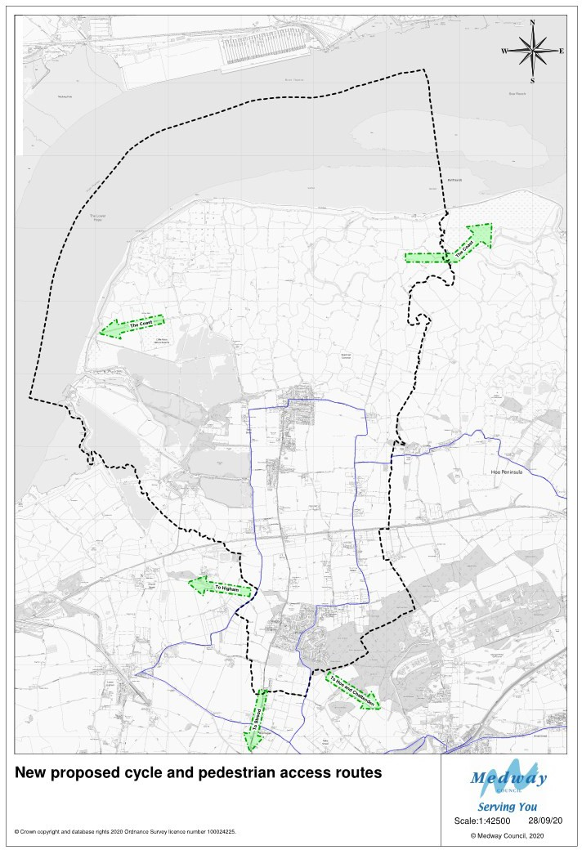

POLICY INFRA7: Road Safety
The improvement of visibility on the B2000 at its junctions with View Road, Tennyson Avenue, Ladyclose Avenue, Mortimers Avenue, Milton Road and Merryboys Road will be secured through planning obligations for their provision or for financial contributions towards their implementation

POLICY INFRA 8: Provision of outdoor sports pitches
Currently there is a shortfall for one additional rugby pitch and one youth size pitch and flood-lit training /mid-week facilities (4G pitch) within the neighbourhood area to enable residents to take part locally without the need to travel. Support to
provide these facilities will be secured through planning obligations for their provision or for financial contributions towards their implementation

POLICY INFRA 9: Infrastructure priorities
Provision of infrastructure improvements outlined in policies INFRA 2, INFRA 5, INFRA6 INFRA7 and INFRA8 are regarded as priorities for implementation using section 106 contributions secured from developments that take place within the neighbourhood area in order to mitigate pressures on local infrastructure arising from development

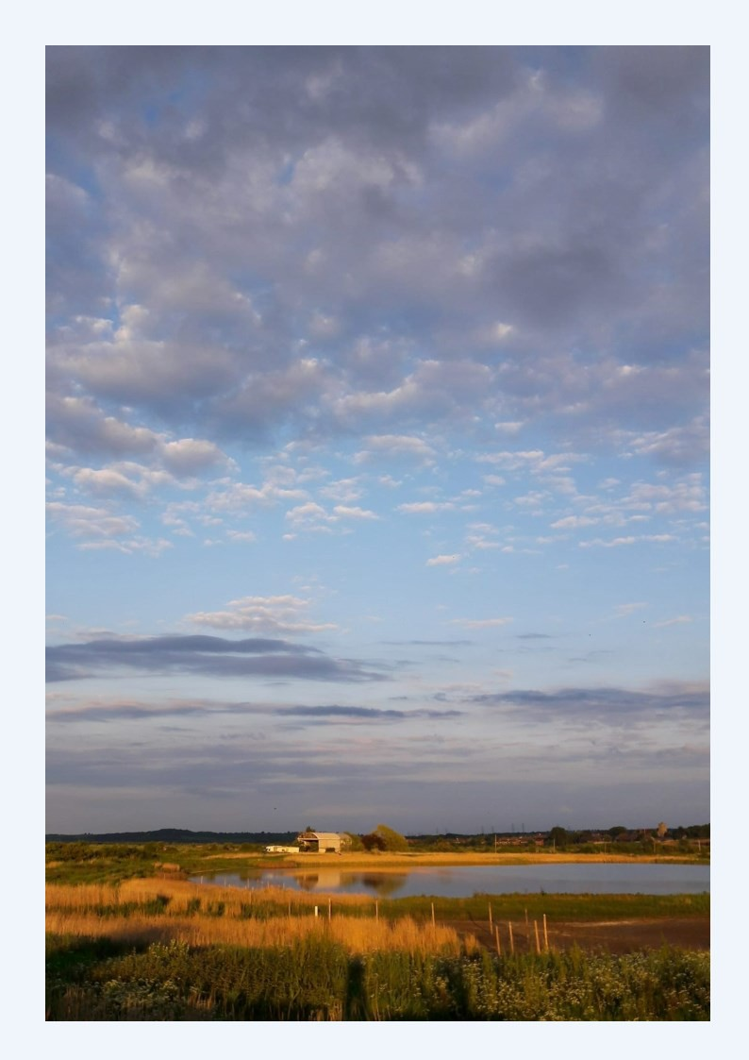
Cliffe and Cliffe Woods Neighbourhood Plan 2021 Submission Version

