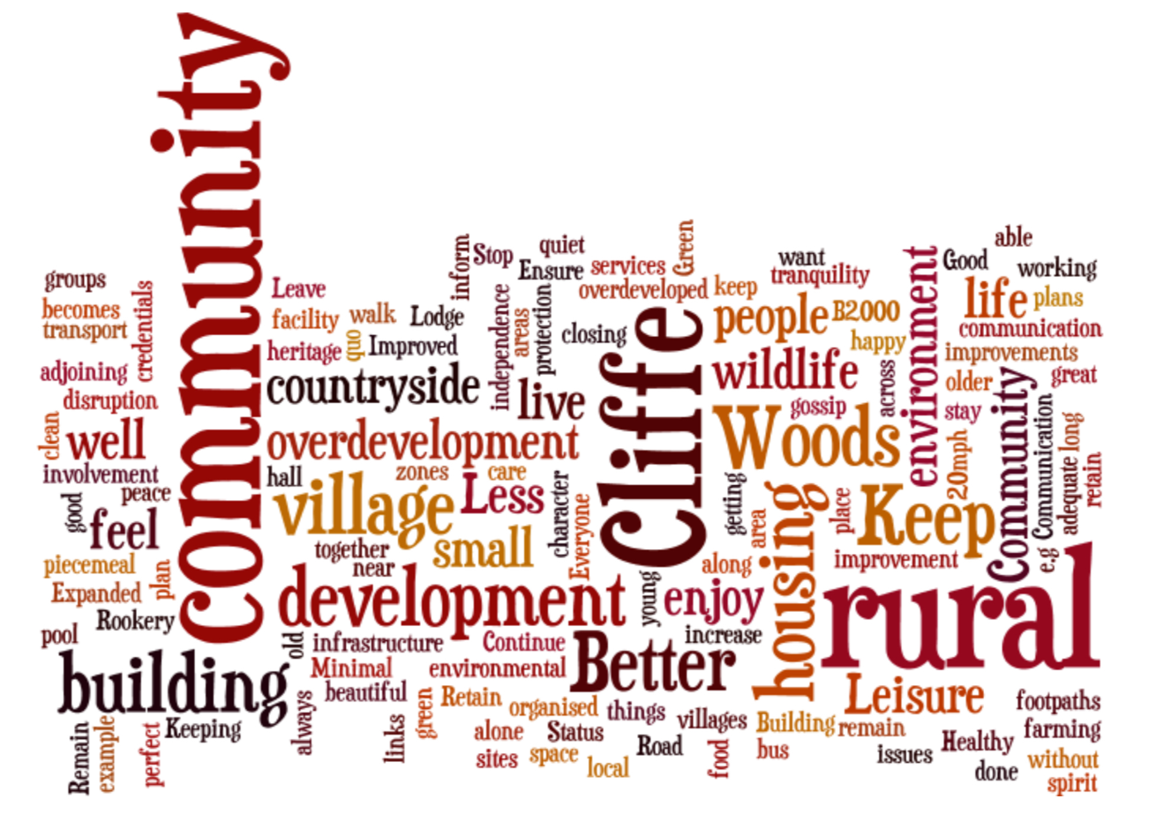
Cliffe and Cliffe Woods Neighbourhood Plan
Consultation Statement
Part 1: Consultation Prior to Regulation 14
Revised July 2021

Table of Contents
1. INTRODUCTION 3
2. BACKGROUND TO CLIFFE AND CLIFFE WOODS 3
3. THE PURPOSE OF THIS DOCUMENT 3
4. OUR OVERALL APPROACH TO CONSULTATION 4
5. CONSULTATIONS DURING THE NEIGHBOURHOOD PLAN PROCESS 4
Designation of Neighbourhood Plan Area 4
Formation of working group 4
6. Consultation – overview 7
Parish Survey – July 2015 7
Village Infrastructure Survey - 2015 8
Community Planning Workshop – June 2016 9
Visioning Workshop – February 2017 9
Transport and employment workshop – April 2017 10
Heritage and environment workshop – April 2017 10
Housing and Community facilities workshop – July 2017 11
Housing Needs Survey conducted by Action for Communities in Rural Kent (ACRK) – October 2017 12
Cliffe and Cliffe Woods Neighbourhood Plan Steering Group Workshop, 21st February 2019 13
Vision, objectives and policies exhibitions, Cliffe 13th July and Cliffe Woods, 16th July 2019 13
Consultation on a first draft NP with Medway Council and Kent County Council (heritage and conservation) – September to December 2019 13
“We Asked, You Said, We Listened” summary table 13
7. Next Steps 21
8. Acknowledgements 21

INTRODUCTION
Cliffe and Cliffe Woods Parish Council has produced a draft Neighbourhood Plan based on the consultations it has carried out (see Summary Table “You said, we did”), and the evidence it has gathered. It has produced the plan with the help of a steering group of local residents and parish councillors as well as officers at Medway Council.
The decision to undertake the Cliffe and Cliffe Woods Neighbourhood Plan was motivated by a number of factors including the high number of planning applications coming forward, the lack of an up to date Medway Local Plan and concerns about lack of infrastructure.
These were highlighted by residents in a parish survey conducted in the summer of 2015 followed by a Community Planning Workshop conducted in June 2016 funded by the Big Lottery’s Village SOS scheme. As a result the parish council, who had already considered developing a Neighbourhood Plan, formed a steering group to take the project forward. The steps are set out in more detail later in the document.

BACKGROUND TO CLIFFE AND CLIFFE WOODS
The Parish sits on the Hoo Peninsula in the Greater Thames Estuary, which is one of the most important areas for birdlife in Europe. The Parish is one of the largest in the historic county of Kent and has two villages: the ancient village of Cliffe which is believed to be one of, if not the oldest, settlement on the Hoo Peninsula, with evidence of habitation from the Bronze Age continuing to the present day. Cliffe has a compact built form with a variety of styles and materials.
The more recent village of Cliffe Woods, is essentially a 20th-century development which started as a turn of the century ‘Plot Lands’ development in the proximity of the B2000. It was developed as a mixture of speculative larger scale development and self-build which has given it a more open form than Cliffe but is similarly mixed in form and materials.
Due to its location and history, the Parish has many heritage assets (two scheduled ancient monuments, listed buildings and a conservation area) that benefit from special protections. The landscape and wildlife assets of the Parish are similarly protected under local, national and international law.
The basic infrastructure that supports the population of the Parish reflects the character of the landscape and its historical development. The B2000 is the main access road through the Parish. It is the only real access available to connect with the Medway towns, the wider district and beyond. The provision of gas services is also relatively recent (the 1980s) and public transport infrastructure relies on infrequent bus services.

THE PURPOSE OF THIS DOCUMENT
The Neighbourhood Planning (General) Regulations 2012 set out a legal requirement at Regulation 15 that a parish council submitting a neighbourhood plan proposal to the local planning authority must include certain documents, amongst which is a “consultation statement”. In this regulation, “consultation statement “means a document which:
- contains details of the persons and bodies who were consulted about the proposed neighbourhood development plan
- explains how they were consulted
- summarises the main issues and concerns raised by the persons consulted; and
- describes how these issues and concerns have been considered and , where relevant, addressed in the proposed neighbourhood development plan
This document is intended to fulfil the above legal requirement

OUR OVERALL APPROACH TO CONSULTATION
Throughout the preparation of the Cliffe and Cliffe Woods Neighbourhood Development Plan, we have tried to promote the widest possible engagement of the local community in planning for the future development of the parish. Our guiding principles have been:
- to commence community engagement early on, before we started drafting anything , and to seek a clear understanding of those issues and concerns which are of most importance to the local community;

- as work progressed on the plan, to offer further opportunities for comment as draft objectives and planning policies were worked up and a draft plan prepared;

- to offer a range of different ways for people to engage as preparation of the plan has progressed. We have tried to make our arrangements appropriate and proportionate for a small rural community. This has included residents’ surveys, workshops and discussions, web site, parish newsletter, public notice boards , and direct contact with key groups in the local community (such as businesses, developers , clubs and societies) and external consultee such as Medway Council and the RSPB;

- tapping into the knowledge and experience available in the local community wherever possible, by making the process as open and inclusive as possible;

- through all the above actions, to meet the statutory requirements for public engagement set out in in the Neighbourhood Plan Regulations.

CONSULTATIONS DURING THE NEIGHBOURHOOD PLAN PROCESS

Designation of Neighbourhood Plan Area
Cliffe and Cliffe Woods Parish Council decided to make a formal application to the Medway Council, the Local Planning Authority (LPA)for the parish, under regulation 5 of the Neighbourhood Planning Regulations 2012, for the designation of a neighbourhood area in early 2015. The application was for a neighbourhood plan to cover the entire civil parish of Cliffe and Cliffe Woods. (See map below in Fig 1.)
Planning officers met representatives of the Parish Council on 9 March 2015 to discuss how it intended to approach the preparation of the Neighbourhood Plan, including the scope of the plan, and the timetable for developing a draft. The application was published on the Medway Council web site over a four week period and invited representations from interested parties. The LPA also had a copy of the application available for public inspection at their offices in Chatham. The application was also publicised locally in the parish. There were no responses received to the consultation.
The application by Cliffe and Cliffe Woods Parish Council for designation of the parish as a neighbourhood area was approved at Medway Council’s Cabinet meeting on 16 June 2015. Since the designation of the area the Parish Council has been working residents, stakeholders and Medway Council to progress the plan.

Formation of working group
The Parish Council then set up a Working Group to oversee the preparation of the plan, comprising the following councillors and volunteers, meeting at regular intervals:
- Fred Harper – Parish Councillor, Chair of Planning Committee, designer
- Annette Cooper – resident 30 years, Parish Councillor (Planning, finance and governance committees), ICT Project Manager, Lloyds of London
- Sue McDermid – resident 42 years, Parish Councillor (Chair 2015-19), Trustee of Cliffe Wood Community Association and member of Highparks Medical Practice Participation Group
- Frank Withers – resident 37 years, civil and aerospace engineer, local historian (vernacular architecture 1066 to Restoration 17C.)
- Dave Green – resident 40 years, deputy head teacher, Member of the Kent Archaeological Society and administrator for the Cliffe History website.
- Chris Fribbins – resident 41 years, former parish council chair, district and unitary councillor, primary school governor and trustee of community association and community trust. Parish Clerk for 5 years in Cliffe & Cliffe Woods and Allhallows. ICT professional.
- Di Harper – Legal Secretary
- Dianne Forman
- Roger Brown – resident 45 years, former director of multi-academy trust, former chair / trustee of Cliffe Woods Residents Association, retired head teacher, member of CPRE
The Group has worked throughout the process to gather together an evidence base to support the Neighbourhood Plan. This has used both published and online sources – such as the Census and documents produced by the local authorities and the NPA - and information gathered through surveys and other local sources.
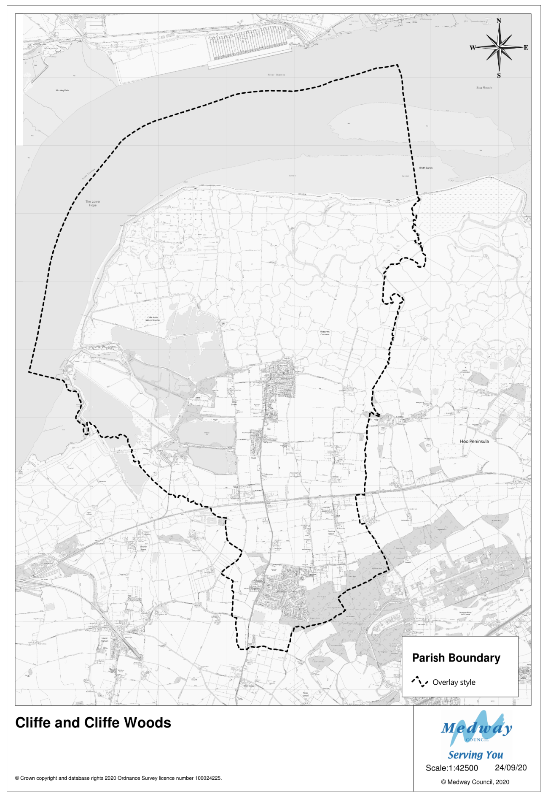
Figure 1: The Cliffe and Cliffe Woods Neighbourhood Plan Area

Consultation – overview
Early on the Parish Council engaged Jim Boot, an Associate with Action for Communities in Rural Kent (ACRK) to provide community planning and engagement assistance and latterly Lorraine Hart RTPI of Community Landuse Associates to provide professional planning assistance with the work. AECOM have assisted by produced a Heritage Character Assessment and Design Guidance through a Technical Support Package provided by Locality.
Even before the formal Neighbourhood Plan started, the parish council has consulted with residents. The first action being a parish survey conducted in the summer of 2015 followed by a Community Planning Workshop conducted in June 2016 funded by the Big Lottery’s Village SOS scheme at which residents were asked whether to continue with the Neighbourhood Plan. Throughout the process, the parish council and the Neighbourhood Plan steering group have had in mind the words of the government’s Planning Practice Guidance which states: ‘The consultation statement submitted with the draft neighbourhood plan should reveal the quality and effectiveness of the consultation that has informed the plan proposals.’
During the development of the plan, the parish council and steering group has met with Medway Council’s planning policy team on a regular basis and Catherine Smith, Planning Policy Manager and other officers have participated in the workshops and steering group meetings including providing feedback on an early draft of the Neighbourhood Plan in September 2019
A Dropbox folder for all documents, plans and photos was shared with members of the steering group and the planning policy team at Medway Council so that they could track activity, drafting the plan and evidence documents.
Below is a list of the consultation events carried out in relation to the Neighbourhood. Later in this report Plan the results of the activities and events are summarised under the headings: ‘We asked’ (what was the purpose of the event), ‘You said’ (what the key observations or outcomes from the consultation event) and ‘We listened’ (how the consultation influenced the contents of the Neighbourhood Plan). The key consultation events / activities were:
- Parish survey – July 2015
- Village infrastructure survey (Medway Council) – 2015
- Community planning workshop – June 2016
- Visioning workshop – February 2017
- Transport and employment workshop – April 2017
- Heritage and environment workshop – April 2017
- Housing and Community facilities workshop – July 2017
- Housing Needs Survey conducted by Action for Communities in Rural Kent (ACRK) – October 2017
- Cliffe and Cliffe Woods Notes of Neighbourhood Plan Steering Group Workshop, 21st February 2019
- Vision, objectives and policies exhibitions, Cliffe 13th July and Cliffe Woods, 16th July 2019
- Consultation on a first draft NP with Medway Council and Kent County Council (heritage and conservation) – September to December 2019/
To follow is a summary description of the consultation events / activities and their outputs:

Parish Survey – July 2015
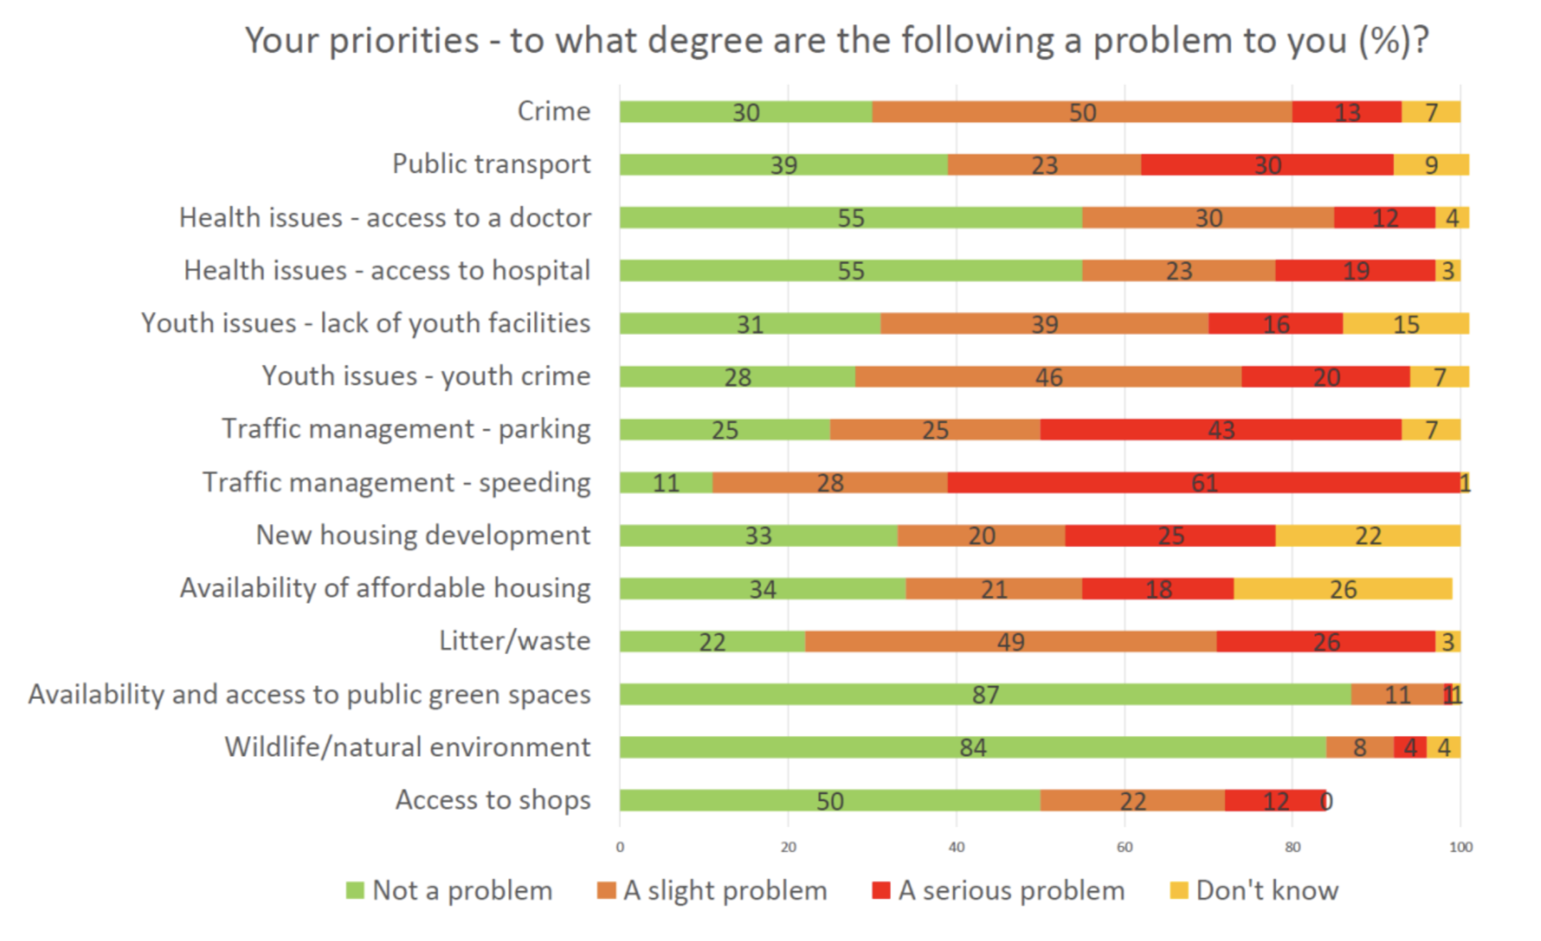
A survey form was sent to every household in the parish. The results are set out in more detail in the Visioning Workshop report February 2017 which can be found at: http://www.cliffeandcliffewoods-pc.gov.uk/community/cliffe-and-cliffe-woods-parish-council-12909/ccw-neighbourhood-plan/ . Here is a list of the parish priorities from that survey:
Figure 2: Results of parish survey (summary)

Village Infrastructure Survey - 2015
A survey was sent by Medway Council and completed by the parish council to inform the Medway Local Plan. They survey looked at community infrastructure. The full survey results are available in the supporting evidence folder on the Neighbourhood Plan website. Opposite is an extract for Cliffe Woods. s
Figure 3: Village infrastructure survey (Medway Council) – 2015
Economic
Would you like to see more employment provision in the village? | Yes | x | No
What type of employment provision would you like to see in the village? | Office  Manufacturing  Storage  Retail  Other (please specific) | Green Infrastructure  Green Tourism
If there are any specific sites where you think employment provision could or should be located, please provide details here and mark them on the map at the beginning of the survey | There are concerns about existing HGV lorry traffic on B2000 and speed of vehicles through the village

Community Planning Workshop – June 2016
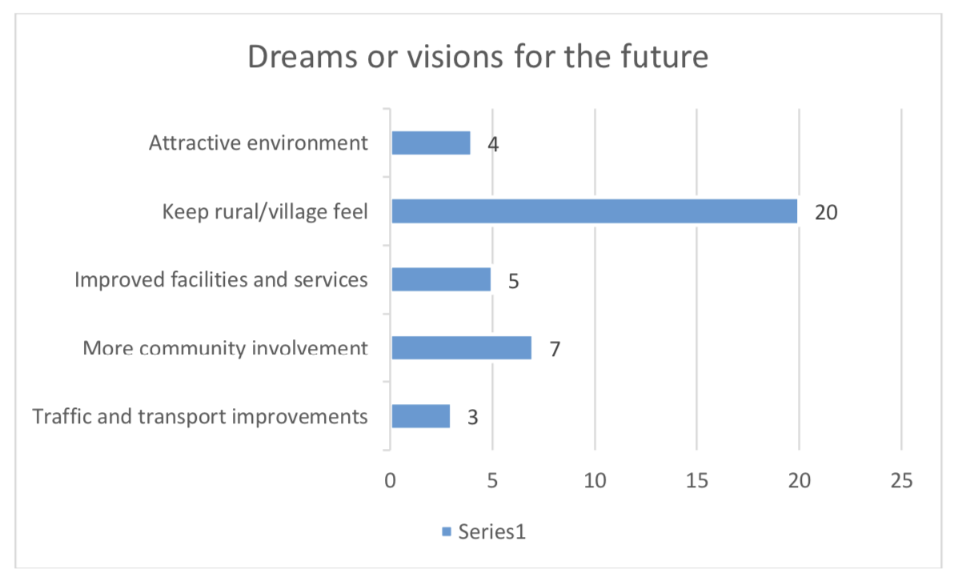
The workshop was commissioned through Action for Communities in Rural Kent (ACRK) by the parish council and funded by the Big Lottery’s Village SOS to ascertain if there was a need and appetite to undertake a NP in Cliffe and Cliffe Woods. It was well attended approx. 35 people. A ‘good’, ‘bad’, ‘dreams’ post-it note exercise enabled attendees to think about what was working well in the parish, what needed improving and their dreams or visions for the future. Here is a summary of their dreams that were used to inform the visioning workshop that followed early in the new year:
Figure 4: Dreams from Community Planning Workshop

Visioning Workshop – February 2017
Following the Community Planning Workshop in the summer of 2016 it took a little while to form a steering group, carry out preliminary scoping work, appoint a consultant and then plan for a visioning workshop to re-launch the NP in February 2017. This event was held in Cliffe (the previous event being held in Cliffe Woods – the aim was to hold events in each of the settlements so that both would be fully involved. The event recapped on the household survey and the community planning event (see Wordle on front page) before setting the 60+ participants to work on developing and then voting on a series of visions.
The most popular vision on the day was:
Maintain rural environment with wildlife corridors and agriculture using only sustainable development and brownfield sites with bungalows/chalet bungalows linked by traffic calming and roads and continuous footpath/cycle way.
This has since been refined by the steering group and shared with residents and stakeholders through the Regulation 14 plan.

Transport and employment workshop – April 2017
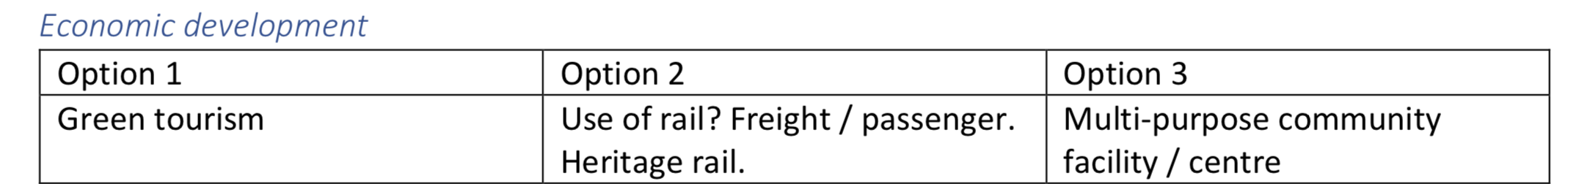
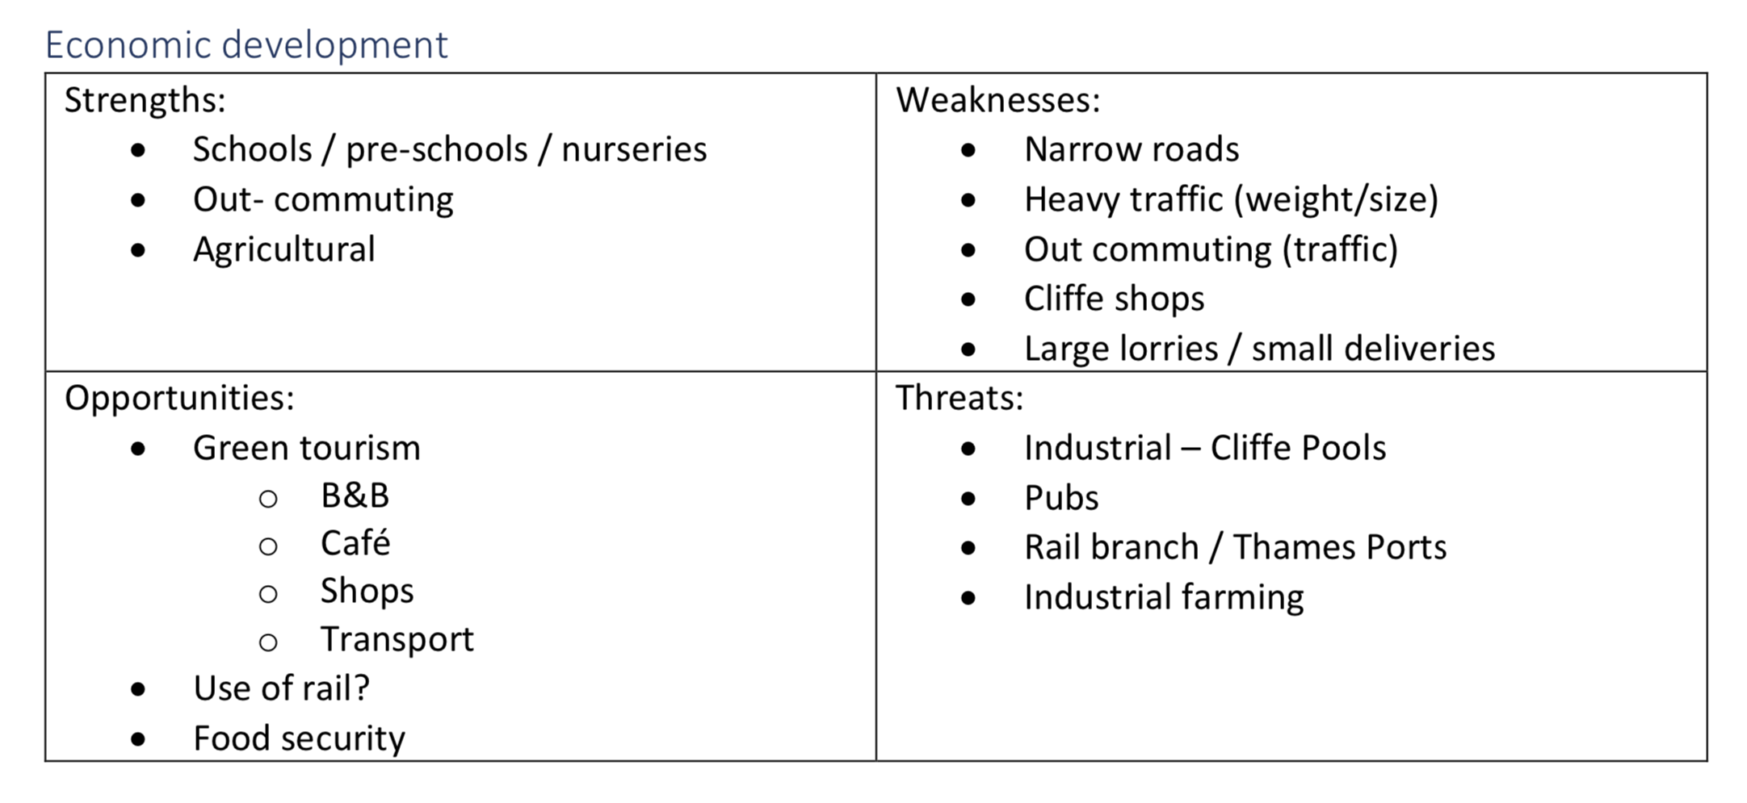
This was the first themed workshop covering two areas of high interest to the community. The aim was to present and then interrogate issues and options to be addressed through the NP. It included presentations on Census data on traffic, car ownership and employment and from a transport planner at Medway Council showing travel to work patterns. The workshop element involved the 30+ participants carrying out a SWOT analysis for topics including public transport, speeding and economic development and then with the same groups teasing out a series of options or reasonable alternatives based on the opportunities. Here is the employment SWOT and options:

Heritage and environment workshop – April 2017
Speakers from the RSPB and Medway Council were able to set the context in terms of landscape, environment and heritage. The steering group’s own very experienced local archaeologists / historians Frank Withers and Dave Green gave a presentation on the history of the area from the Palaeolithic to the present including Cliffe’s conservation area and both scheduled ancient monuments Cliffe Fort and Curtis and Harvey Explosive Works and Cliffe Woods’ more recent history from the WW1 Plotlands, the 1960s Compulsory Purchase and creation of the new village from 1970s. This followed a similar format to the previous workshop with SWOTs used to generate reasonable alternatives.

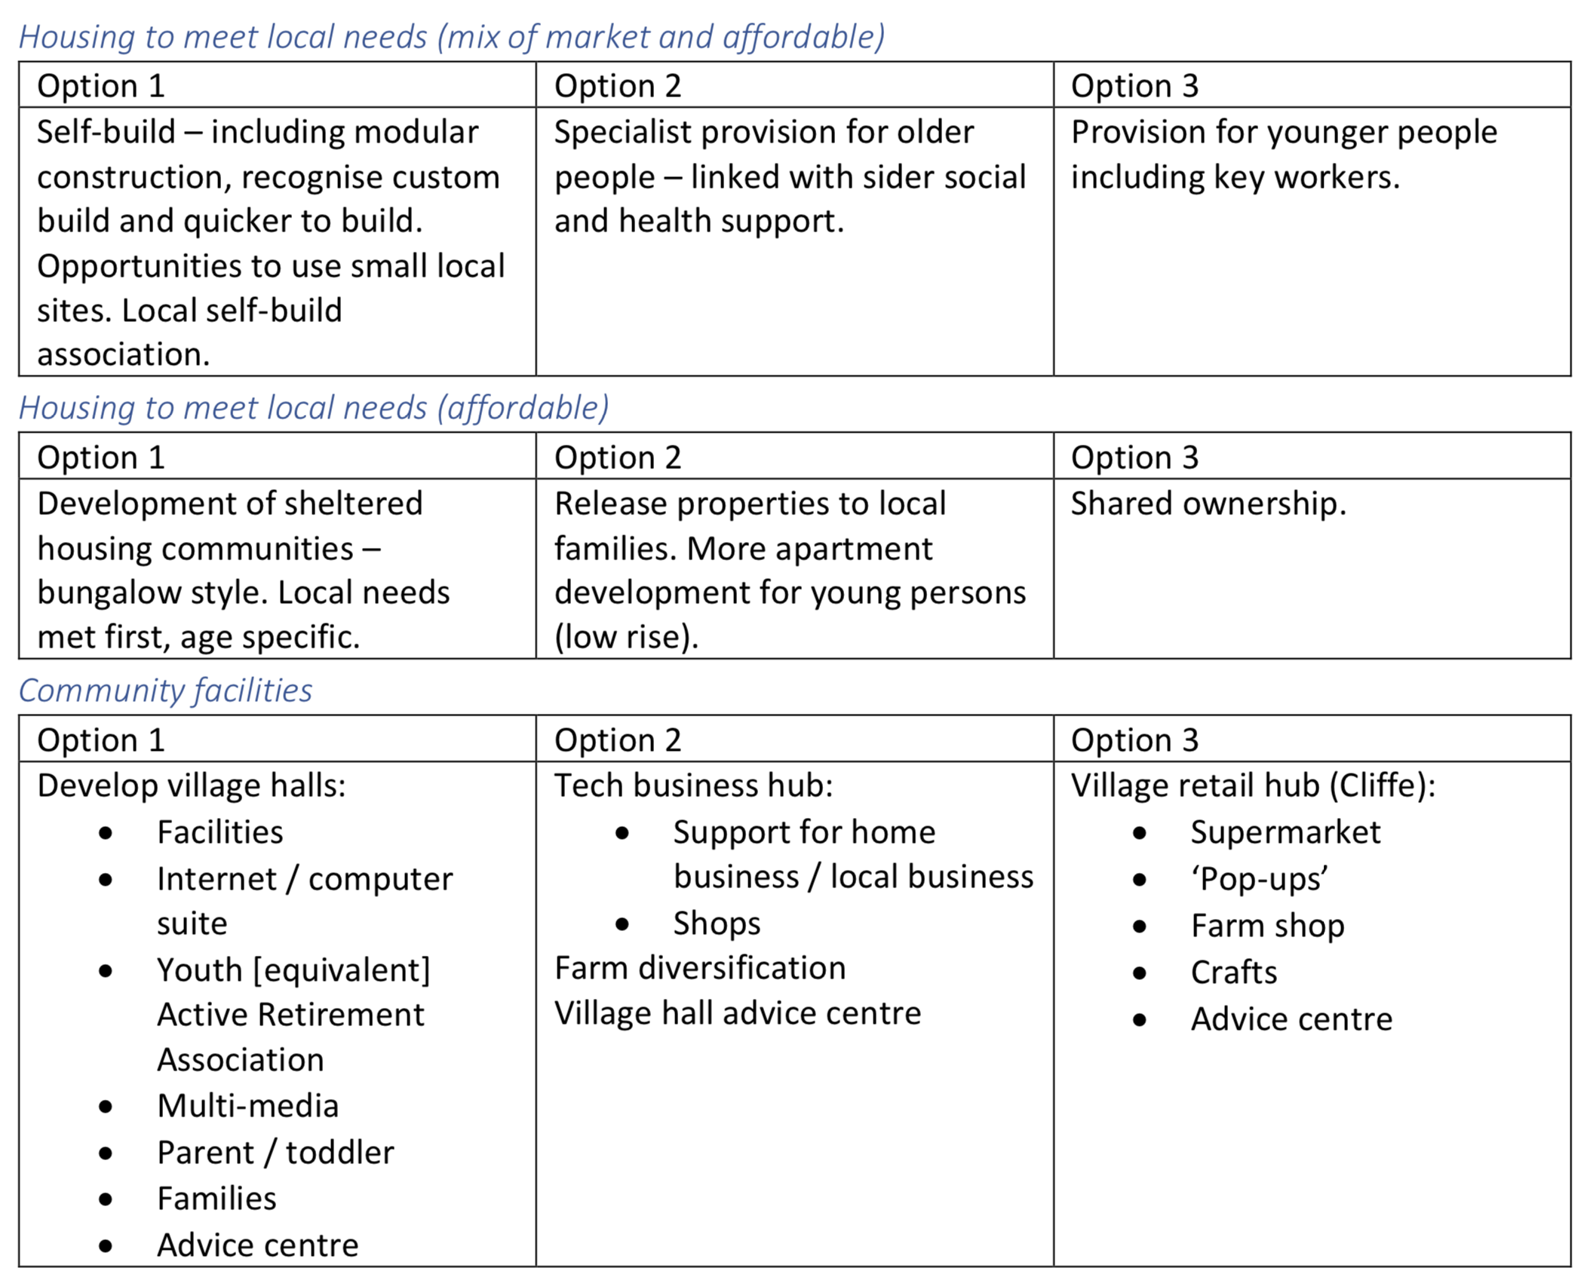
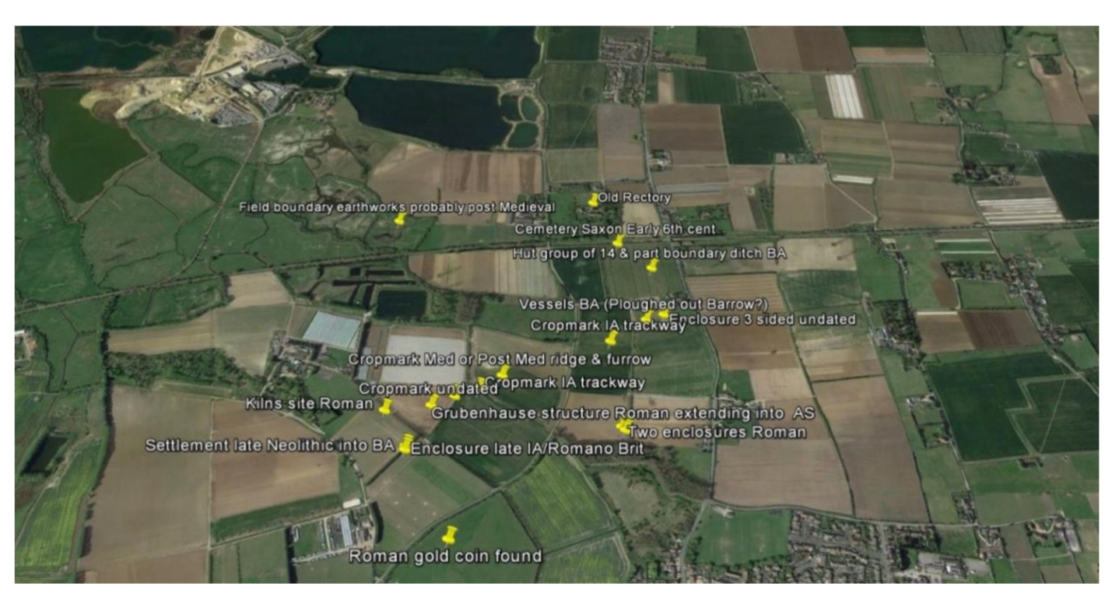
Housing and Community facilities workshop – July 2017
Figure 5: Map showing archaeological finds in the area
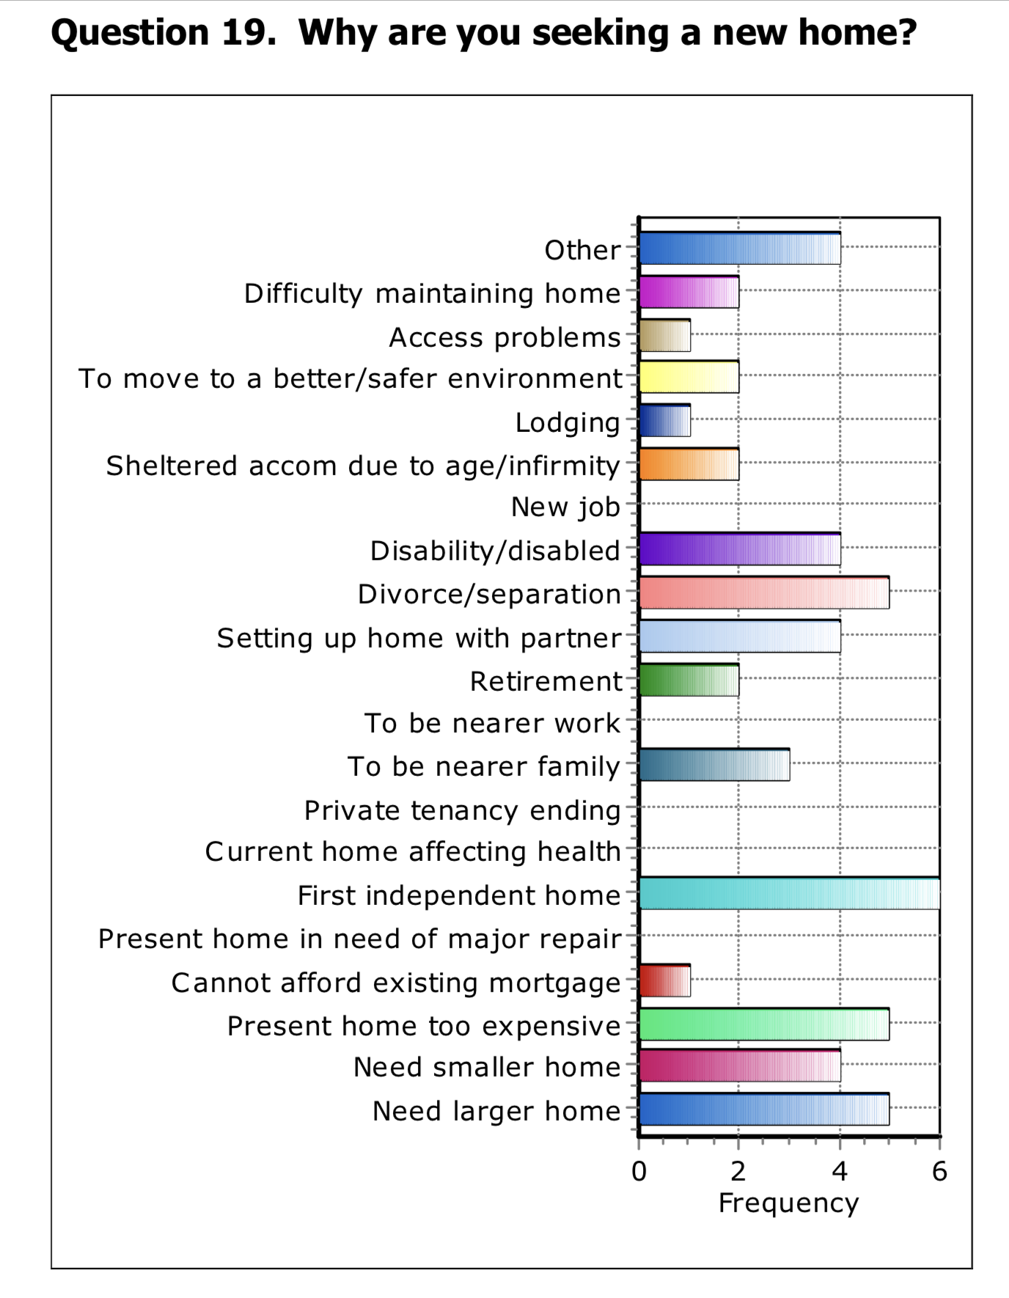
This was the last in the series of themed workshops with residents and other stakeholders. Options on design and character drawn up at the last workshop were shared along with a breakdown on house types and tenure. Some time was spent explaining the definitions of affordable housing and windfall sites so that residents had a better understanding of the context. Then as before a series of SWOT analyses to develop issues and options were worked on in groups. The results are shown on the previous page.
Figure 6: Excerpt from Housing Needs Survey

Housing Needs Survey conducted by Action for Communities in Rural Kent (ACRK) – October 2017
The housing needs survey was commissioned from Action for Communities for Rural Kent’s Rural Housing Enabler. The survey is a standard survey slightly to establish local housing needs and was slightly adapted so that older residents wishing to move into more appropriate accommodation provided either by social landlords or the market. A survey was delivered to every household in the parish in September (2100 surveys) with 296 surveys returned or a 14% response rate. The survey identified a need for 18 affordable homes; 3 of which are for older households. A full copy of the report is available on the NP website. The following chart shows the reasons why people might be seeking a new affordable home:

Cliffe and Cliffe Woods Neighbourhood Plan Steering Group Workshop, 21st February 2019
This was a low-key meeting of the steering group that looked at Parking Standards, GP Surgeries, Pre-School, Nurseries and Primary Schools and the overall structure of the NP.

Vision, objectives and policies exhibitions, Cliffe 13th July and Cliffe Woods, 16th July 2019
Two exhibitions were held in both settlements to share the vision, objectives and policies as well as the stages that led up to this point. The Partnership also shared an earlier draft of the ‘We asked, you said, we listened’ in the following table. In Cliffe 127 people attended (leaving their contact details) and in Cliffe Woods 94. There were strong concerns raised about the level of development set out in the draft Medway Local Plan and about its impact on the two villages, the surrounding countryside and the ability of the road and other infrastructure to cope.

Consultation on a first draft NP with Medway Council and Kent County Council (heritage and conservation) – September to December 2019
Given the split in responsibilities both within Medway Council and with Kent County Council it was decided to seek comments from the two local planning authorities on a 1st draft of the NP prior to going to formal Regulation 14 pre-submission consultation. The feedback from MC and KCC is summarised at the end of the table that follows.

“We Asked, You Said, We Listened” summary table
The following table summarises the feedback that was given at each of the consultation events / activities and how this was used to develop the objectives and policies in the Plan.
Date & activity | We asked | You said | We listened (objectives and policies)
July 2015  Parish Survey | To what degree are the following a problem to you? | … the following were a slight or serious problem:  - Crime 63%  - Public transport 53%  - Lack of youth facilities 55%  - Youth crime 66%  - Speeding 68%  - New housing development 45%  - Availability of affordable housing 39%  Litter / waste 75% | We have included objectives and policies on:  - Transport and traffic- including road safety  - Community facilities including youth facilities  - Housing that is affordable and appropriate to the rural setting  - Conserving the rural environment and environmental protection  We embarked on a programme of continuing community engagement including with schools.
2015  Village infrastructure survey | Medway Council asked the parish council about the facilities within the two villages and their condition. | - Allotments have a waiting list,  - Capacity issues at the Cliffe Woods Community Centre,  - Lack of youth centre, super-market in both villages,  - Heavy HGV traffic on B2000 & speeding,  - Nature sites need further interpretation / education, but an opportunity for green tourism,  - Memorial hall is ageing, has capacity, poor storeage and maintenance issues. | Further allotment provision to be considered, enhancements sough for both village community centres through S106 or CIL, youth provision, limits on HGV movements without improvements to B2000, a visitor centre at Cliffe Pools RSPB.
June 2016 Community Planning Workshop funded by Village SOS / Big Lottery | What is ‘good’ or working well  What is ‘bad’ or needs improving  Your ‘dreams’ or visions for the future | - Attractive environment  - Community spirit  - Traffic and transport  - Facilities and services  - Concerns over development  - Keep rural / village feel  More community involvement | We have sought to protect the attractive environment, build on the community spirit, address traffic and transport issues, seek developer contributions for facilities and services and address concerns over development by making sure it is sustainable and meets the housing and other needs of local residents. We have taken steps to involve the community throughout the NP process.
February 2017  Visioning workshop | Describe your ideal or dream Cliffe and Cliffe Woods in 2035 | Attendees developed six visions with common themes but favoured:  - Maintain rural environment with wildlife corridors and agriculture using only sustainable development and brownfield sites with bungalows/chalet bungalows linked by traffic calming and roads and continuous footpath/cycle way. | We developed these into:  “By 2035 the unique rural landscape of Cliffe and Cliffe Wood Parish will continue to be a haven for wildlife and agriculture, and provide homes, jobs and community infrastructure for people by protecting the heritage of the area and enhancing its character through sustainable development.”
April 2017  Transport and Employment Workshop | What are the Options for:  Cycling and walking  Public transport  Speeding traffic  Parking  Economic development | - Shuttle / more convenient buses and rail improvements  - 20 mph zones, footpaths on B2000, narrowing of road not widening  - Identify current issues, off-street parking  - Green tourism, multi-use community facilities | Improve safety of roads in the parish and connections with footpaths, cycle ways and public transport  Include sufficient parking appropriate to the size of the property including cycle parking in new developments  Joint foot and cycle path and improvements of visibility on B2000  Encourage recreational and tourism activities and facilities
June 2017  Heritage and Environment Workshop | What are the Options for:  Agriculture  Heritage  Nature conservation | - Preserve landscape, wildlife corridors and high-quality agricultural land, more self-sufficiency, limited development of low-grade land  - Survey and record heritage, describe and maintain local character, avoid uniform development  - Protect and retain special landscape for future generations, celebrate natural wildlife assets and preserve quality of life for residents. | Protect agricultural jobs and employment land  Enhance and preserve the historic character of the Parish  Enhance and preserve the rural, environmental and historic assets of the Parish
July 2017  Housing and Community Facilities Workshop | What are the Options for:  Affordable and market housing to meet local needs  Community facilities | - Self-build, small local sites  - Provision of housing for older people with social care and health support  - Housing for younger people including key workers  - Sheltered housing – downsizing and shared ownership  - Improve existing village halls, tech hub and improved Cliffe village retail | New housing development should reflect local housing need, particularly for bungalows and small family accommodation  Development proposals for local retail including a new grocery store or small supermarket will be supported  Proposals that result in the loss of existing facilities used for indoor and outdoor leisure and recreation will be resisted
October 2017  Housing Needs Survey | Would you support a small development of affordable housing if there was a proven need for people with a genuine local connection? And do you or a member of household need separate or alternative accommodation now or in the next five years? In response to the questionnaire, 296 surveys were returned. | The survey identified a total need for 18 affordable homes; 3 of which are for older households. In addition there is a requirement for 4 open market properties suitable for older households who want to downsize/move to more suitable housing for their needs. Also:  - Many young people wish to live in Cliffe but cannot afford to  - It would need to be both a small development and truly affordable. We did not have a positive experience with shared ownership housing when our son was moving out!  - These proposals are put forward as benefitting local residents but these types of homes are not taken by locals but are allocated to outsides  - We need more one and two bedroom properties so people like myself can free up bigger homes  - There is enough housing in village now, without the amenities to cope with so no more housing is needed | New development should reflect local housing need, particularly for bungalows and small family accommodation in terms of mix and tenure.  All major new development proposals must be supported by a statement demonstrating infrastructure sufficiency to support the proposal. An assessment should be undertaken which takes into account:  - The needs, commitments and planning requirements set out in the Medway Local Plan and relevant thematic policies and site allocation specifications that it contains;  - Recent technical studies and engagement with strategic infrastructure commissioners and providers that may update the position set out in the latest Medway Local Plan Infrastructure position statement of Infrastructure, Infrastructure Development Plan or Strategy;  - Accessibility, capacity and availability of existing infrastructure in the area where this is to be relied upon to support a development proposal.
July 2019  Vision, objectives and policies exhibitions | What do you think of the vision, objectives and policies proposed for the draft Neighbourhood Plan? | - Overdevelopment is unsustainable, too many houses, not enough infrastructure,  - Don’t mind more houses if we get better transport links and more frequent buses,  - Can schools, doctors cope,  - Concerned about flooding from a Thames surge,  - Housing for local needs including elderly residents to downsize,  - B2000 is unsafe / needs a by-pass. | The Neighbourhood Plan needs to acknowledge and where it can address residents’ concerns in particular by making new development conditional on bringing about improvements to services and infrastructure, providing homes to meet local needs, and all the while ensuring that climate change is also taken into account (a more detailed response is set out below).
December 2019  Consult on draft Neighbourhood Plan with Medway Council and Kent County Council (Archaeological Dept) | The vision, objectives and polices were amended following the July 2019 exhibitions and included in a first draft NP. This was sent to Medway and Kent Councils for comment. | - Concern raised about consulting on Regulation 14 Draft NP prior to Regulation 19 Draft Local Plan,  - Greater policy reference to the extensive designated habitats, climate change (especially flood risk) and health impacts,  - Medway LP now to 2037,  - Role of farming, accommodation of seasonal workers and poly tunnels,  - Managing recreation and its impact on vulnerable wildlife and habitats,  - Stronger use of / reference to evidence ie for need for chalet bungalows and housing types,  - Clearer priorities for infrastructure improvements,  - Mention Thames path and Medway PROW improvement plan,  - Map wildlife corridors,  - Travel to work information,  - Reference Draft Medway Heritage Strategy including the newly scheduled Ancient Monument Cliffe Explosive Works,  - Give consideration to a Conservation Area Appraisal as none exists,  - Reference Kent Historic Landscape Characterisation 2014 and Historic England Hoo Peninsula Historic Landscape Project,  - Also mention WW2 GHQ Stop Line (anti-invasion defence) including pill-boxes and Nine Elms (cement) Works,  - There were further comments on the Design Guidance for AECOM to implement,  - There were recommendations on farm-steads and archaeology to be addressed. | Generally the NP steering group and parish council were supportive of the comments received and have used these to make greater cross-reference use of evidence and address gaps such as role of agricultural businesses.
Reports of all the consultation events and activities listed above are available on the parish council’s neighbourhood plan page on its website: http://www.cliffeandcliffewoods-pc.gov.uk/community/cliffe-and-cliffe-woods-parish-council-12909/ccw-neighbourhood-plan/. Representatives of the parish council and steering group have met with Medway Council planning policy officers on a regular basis throughout the NP process. They have also met as a steering group on an almost monthly basis throughout the development of the Neighbourhood Plan. The minutes of the steering group meetings will soon be posted on the website as well.

Next Steps
The comments received from residents and other stakeholders at the exhibitions in July 2019 were incorporated into a first draft NP which was sent to Medway Council and forwarded to Kent County Council in September 2019. Their extensive commentary was considered and where appropriate the Neighbourhood Plan has been amended. The Parish Council were then asked to approve a revised draft NP for formal (Regulation 14) consultation in Spring 2020. The statutory consultation period is six weeks. Following the consultation, the responses from residents, businesses, developers, neighbours and statutory bodies have again been considered and where appropriate incorporated into a revised draft NP to be submitted by the parish council to Medway Council with a Basic Conditions and Consultation Statement (Regulation 15). Medway Council will then undertake their own consultation (Regulation 16) prior to jointly appointing and submitting the NP and supporting documents to an Examiner. Following Examination the Examiner may require the parish council (as the qualifying body) to make some modifications at which point the residents of the parish of voting age will be allowed to vote for or against the NP at a Referendum. If a majority of those who vote are in favour of the NP, the NP will be ‘made’.

Acknowledgements
The parish council would like to thank the following other residents of the parish who have also been involved in one way or another:
- Nigel Moore
- Joan Darwell
- Gill Moore (died 2017, sadly missed)
- Sue Hibbert
- Iain Walton
- Barry Dibble
- Lynne Bush
- Phillip Stanley
- Ian Prior
- Ron Naughton-Dean
Jim Boot, Community Planner, originally April 2020, revised July 2021

Same timeframe as the Medway Local Plan
The threshold for a major development is any application that involves mineral extraction, waste development, the provision of 10+ dwellings / a site area over 0.5 Hectares or a floorspace of over 1,000sqm / an area of 1 hectare
Although due to the Covid 19 pandemic it is likely this will need to be postponed until at least the summer or perhaps the autumn 2020.
HM Gov Neighbourhood Planning Guidance, Paragraph: 007 Reference ID: 41-007-20190509, Revision date: 09 05 2019

