Smoking and Tobacco Control

Summary

Introduction
Smoking rates have fallen significantly in England with less than one in five adults now reported as smoking. Despite this progress, smoking continues to account for more lives lost than any other modifiable risk factor and remains one of the main causes of health and social inequalities.¹
People from lower socio-economic groups, those suffering from mental health conditions and some minority ethnic groups have higher rates of smoking. Factors influencing smoking prevalence include educational attainment, employment, housing, income, and social cues. Young people who grow up in a household where adults smoke are more likely to become smokers themselves.²
The early onset of smoking related disease and premature death causes distress and hardship to individuals and their families. It also creates a greater burden of care on health and social care systems.

Key issues and gaps
- There are variations in smoking prevalence between different socio-economic groups. This is evident at both national and local level.³ Targeted interventions and cohesive partnerships will help improve outcomes in specific population groups.
- Reducing the uptake of smoking in young people remains a key driver to reducing overall smoking prevalence and attaining a ‘smokefree generation.’
- People with mental illnesses are twice as likely to smoke. High levels of tobacco dependency is more likely for those with more severe mental health conditions.⁴ Very Brief Advice and increased referrals from mental health services will enable more people with mental health conditions to undertake a quit attempt.
- Smoking prevalence in pregnant women in Medway remains higher than the national average.⁵ Training for care professionals working with pregnant women and their families will help increase referrals and support better outcomes for infants and neonates.

Recommendations for commissioning
- ‘Very Brief Advice’ (VBA) and an offer of quit support from healthcare professionals is an important trigger to quitting. Contracts and service level agreements should include protected time for staff to receive training, and key performance indicators to measure the volume of stop smoking referrals. Referral pathways should be regularly reviewed.
- Acute trusts to introduce smoking cessation treatment provision for inpatients in accordance with recommendations in the NHS Long Term Plan.
- Health and social care providers should work in partnership with Public Health to amplify marketing messages and encourage more smokers to quit.
- Organisations that provide publicly funded services to set up and enforce smokefree sites. This can make smoking less socially acceptable and encourage more smokers to quit.

1) Introduction
Tobacco Control is an internationally recognised approach to applying policy and practice dedicated to reducing tobacco use and the morbidity and mortality associated with it.⁶ Smoking is a leading cause of preventable ill health such as cancer, cardiovascular and respiratory diseases. It is also a key modifiable risk factor for many health conditions including diabetes, cardiovascular diseases, cancer, chronic obstructive pulmonary disease, asthma, dementia and age related eye disorders.⁷ Lung cancer has the largest proportion of cases caused by smoking. According to a recent estimate, in the UK about 87% of lung cancer cases in men are attributable to tobacco and about 84% of cases in women.⁷
Tobacco use is an addiction influenced by complex social and environmental factors including education, employment and living conditions. Prevalence is disproportionately high in poorer socio-economic groups, which in turn contributes to and creates social inequalities. Smoking accounts for approximately half the difference in life expectancy between the richest and poorest in society.⁸
The Department of Health’s ‘Tobacco Control Plan 2017 – 2022, Towards a Smokefree generation’ requires a reduction in adult smoking prevalence to 12% by 2022.² Given the link that exists between smoking and the onset of disease, The Tobacco Control Plan supports a broader objective to reduce premature mortality from non-communicable diseases by one third by 2030.⁹
The NHS Long Term Plan continues to highlight the association between tobacco use and health outcomes across a broad range of diseases. Smokers see their GP over a third more often than non-smokers, and smoking is linked to nearly half a million hospital admissions each year.¹ The Plan defines specific actions relating to maternity care and cardiovascular disease and emphasises system wide interventions to reduce tobacco use.

2) Who’s at risk and why?
England has seen a continuous decline in the number of adult smokers.¹⁰ The availability of free NHS stop smoking support, together with a range of national and local initiatives have been key factors in achieving this. However, there are some key population groups where prevalence remains high. This can lead to poorer outcomes and the creation, continuation and worsening of health and social inequalities.²
Stop Smoking Services in England have been providing quit support to smokers since 1999 and adult smoking prevalence has declined from 19.8% in 2011 to 13.9% in 2019.¹⁰ The majority of smokers say they would like to quit. The combination of addiction and social and behavioural cues makes it challenging for smokers to quit without professional support.
Nationally, there is a strong emphasis on reducing health inequalities.¹ Population groups requiring a specific focus include young people, pregnant women, those at higher risk of health conditions such cardiovascular disease, and people with a mental health condition.²
Smokers employed in routine and manual work - In 2016, the prevalence of smoking among people working in jobs classed as routine and manual was more than double that of people working in managerial and professional occupations²
- Poorer smokers tend to spend proportionately more of their weekly household budget on smoking as richer smokers.
- These families often face multiple disadvantages including lower income and poorer health.
Young people - Preventing uptake of smoking in young people is vital if we are to stop a new generation from becoming addicted to nicotine.
- In England, 5% of 15 year olds are reported to be regular smokers.¹¹
- The national target is to reduce this to 3% or less by 2022.²
Risk factors influencing uptake of smoking in young people include: living in a low-income household, adult smoking prevalence within the household and peer pressure. The availability of cheap illicit tobacco also makes it easier for young people to start smoking.
Pregnant women - Smoking whilst pregnant places the woman at increased risk of miscarriage and circulatory problems. The unborn child is also at increased risk of premature birth and stillbirth. Following birth, the baby is at higher risk of sudden infant death syndrome. Smoking affects a baby’s development in the womb and is a significant factor in low birth weight.¹²
- National data for 2019/20 reports that 10.4% of pregnant women were smoking at time of delivery (SATOD). This has been decreasing over the past 5 years.⁵
- Sustained focus is required in order to meet the national target of a 6% SATOD prevalence by 2022.²
The NHS 10 year Plan reports that nearly a quarter of pregnant women in the UK smoke at some point during their pregnancy.¹ Factors influencing smoking in pregnancy are complex. Multiple issues commonly feature in this population cohort. Women often present with issues such as low educational attainment, poor housing, unemployment, financial constraints, stress and anxiety, and unstable relationships.
People with mental health conditions - Smoking prevalence in those with a mental health condition is considerably higher than that in the general population. The association between smoking and mental health becomes stronger relative to the severity of the mental health condition. Psychiatric in-patients are found to have the highest levels of smoking. Evidence suggests that the more severe a person’s mental health condition, the more likely they are to be a smoker.¹³
- An estimated 40.5% of those with a severe a mental health illness also smoke.¹³
- Research also suggests that smokers who are highly dependent on tobacco and consequently smoke more cigarettes are at greater likelihood of developing a mental health condition.¹³

3) The level of need in the population
Smoking prevalence in Medway has been declining year on year, and the gap that has historically existed between national and local prevalence has been eliminated.³ Building on this achievement in order to realise the national target of 12% by 2022 will require a concerted effort by public service providers. Health and social care professionals should engage with smokers at every opportunity to offer a brief advice intervention.¹⁴ Reducing smoking prevalence is fundamental to improving health and wellbeing at an individual and population level as well as reducing demand on NHS and social care services.
The Annual Population Survey is the main source of data for smoking prevalence. The data is reported via Public Health England’s ‘Local Tobacco Control Profiles.’ The profile reports on a range of indicators associated with smoking.³
Medway has traditionally reported a higher adult smoking prevalence rate when compared to the national average. However, the trajectory of decline has recently accelerated and the current 14.1% (2019) adult prevalence rate for Medway has eliminated the gap between local and national prevalence.¹⁰
Variations continue to exist at ward level in Medway. Action on Smoking and Health’s ‘Ready Reckoner’ tool estimates that smoking is concentrated more in areas of deprivation. Five wards are shown has having a prevalence rate of over 15%.¹⁵
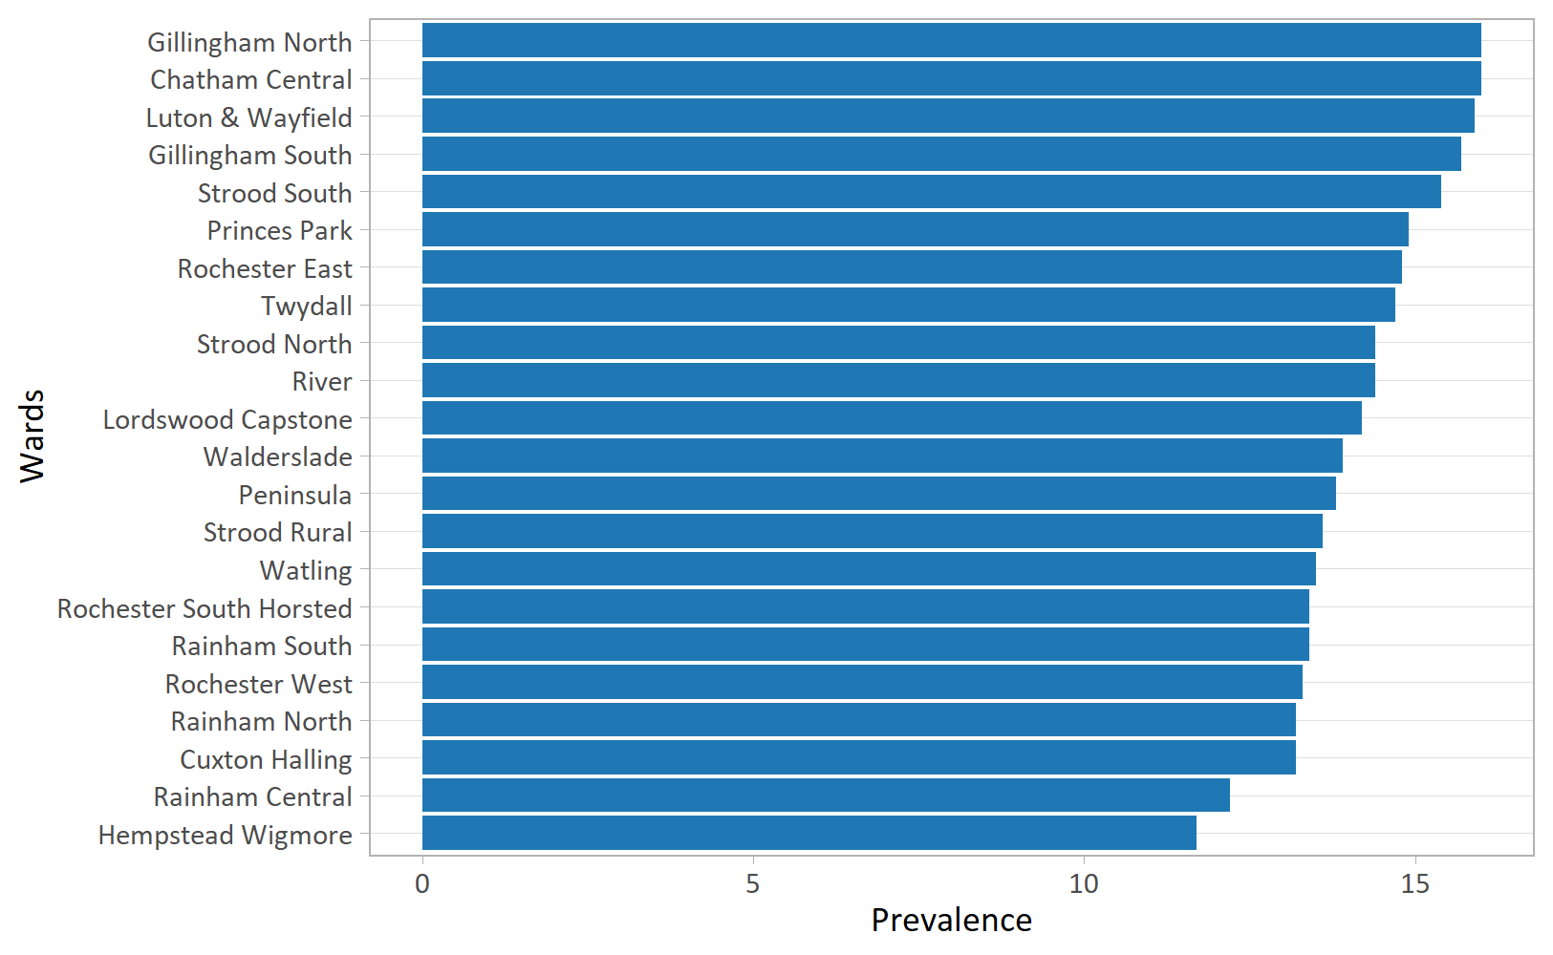
Figure 1: Smoking Prevalence in Medway – an evidence based estimate from the Annual Population Survey, 2018.¹⁵
Smokers employed in routine and manual work
Smoking prevalence in routine and manual workers was reported at 25.7% in Medway for 2019, compared to 23.2% in England. There is a strong local emphasis placed on working with this group.
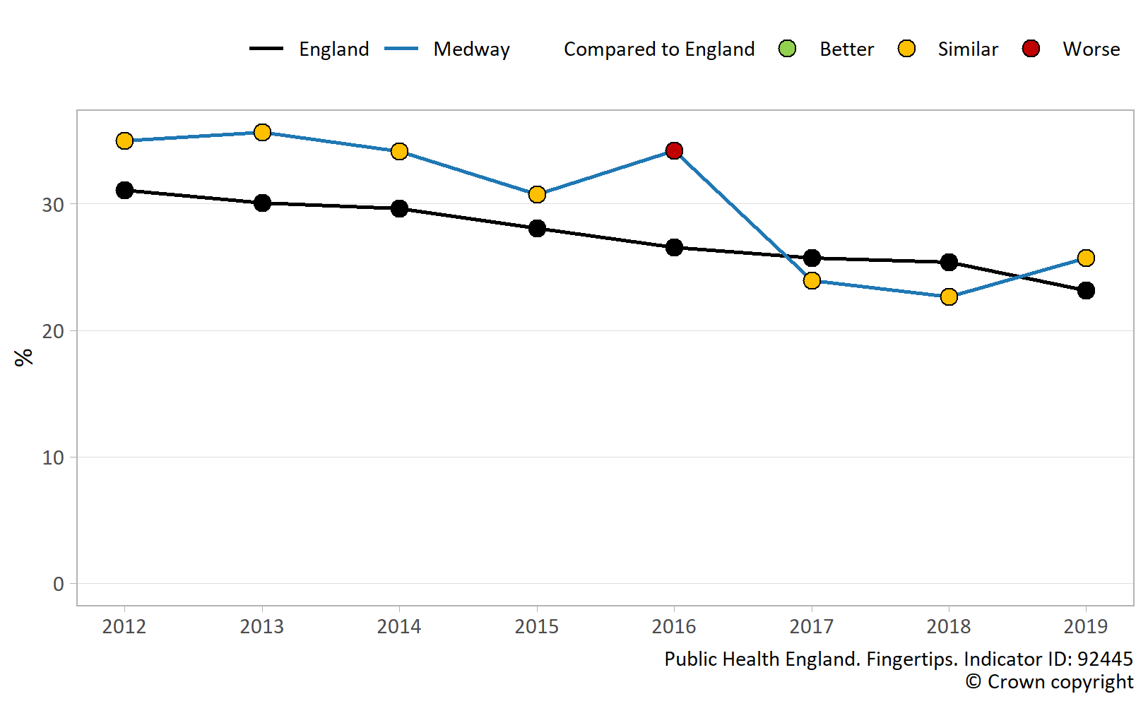
Figure 2: Fingertips Smoking prevalence in routine and manual occupations.¹⁶
Young people
In Medway 10% of those aged 15 years were reported to be smokers in 2014/15, this compares to 8.2% in England.¹⁷ More recent data from the Smoking, Drinking and Drug Use Among Young People in England survey reports a 5% prevalence rate for England in 2018. However this survey does not provide local data.
Smoking remains an addiction that is largely taken up in childhood, with the majority of smokers starting as teenagers. In England in 2014, 77% of smokers aged 16 years to 24 years began smoking before the age of 18. Many young people become addicted before they fully understand the health risks associated with smoking. Young peoples’ perception of risk can be different to that of an adult and they are often influenced by factors such as peer pressure and the need to conform to behaviours they observe in their peer group.¹⁸
The implementation of national tobacco control measures have resulted in legislation being introduced to make it an offence to sell tobacco to those under the age of 18 years. It is also an offence for an adult to purchase tobacco on behalf of a person under the age of 18 years. These measures are intended to protect young people from tobacco related harm but can be undermined through the availability of illicit tobacco.
Reducing both the uptake of smoking and access to illicit tobacco is facilitated through collaborative work with young peoples’ services and enforcement agencies.
Pregnant women
Medway has seen a statistically significant decrease in the percentage of women smoking at time of delivery (SATOD) since 2010/11 with the rate reducing from 19.9% to 15.2% in 2019/20. England has also seen a decrease in this time period from 13.6% to 10.4%.⁵
Giving every child the best start in life remains a priority for local authorities and reducing smoking in pregnancy is a key driver for local authorities and NHS organisations. Smoking in pregnancy is implicated in adverse birth outcomes including miscarriage, stillbirth, pre-term birth, low birth weight, congenital defects and developmental disorders.¹ NHS England’s ‘Saving Babies Lives Care Bundle’ defines five elements of care, one of which is smoking cessation, in order to improve outcomes.¹⁹ The focus on this is further consolidated within the NHS Long Term Plan.
The wider determinants of health are key factors to consider when engaging with pregnant smokers. Women often report difficulties with housing, relationships, social isolation, financial constraints and stress and anxiety.
Some pregnant smokers will quit spontaneously when they learn of their pregnancy. Others are prepared to undertake a quit attempt, and a further group feel they are unable to quit for a range of reasons and will continue to smoke. Women often feel that some of the challenges present in their lives will have an adverse impact on their ability to quit and for this reason choose not to accept the offer of quit support.
People with mental health conditions
Smoking is around twice as common among people with mental health problems but can be even higher depending on the severity of the condition. A third of all cigarettes smoked in England are smoked by people with a mental disorder. In contrast to the decline in overall smoking prevalence, the rate of smoking among those with mental disorders has remained steady over the past 20 years. Smokers with mental disorders are just as likely to want to stop but are more likely to be heavily addicted to smoking, more likely to anticipate difficulty stopping smoking, and historically much less likely to succeed in any attempt.²⁰
Interventions that combine behavioural support with pharmacotherapy that are effective in the general population are also likely to be effective for people with mental disorders. Nicotine replacement therapy, whilst being effective, is likely to be required in higher doses, for longer durations, and with more intensive behavioural support than in the general population.
Symptoms of nicotine withdrawal can be easily confused with symptoms of mental disorders. These symptoms can be mitigated by higher doses of pharmacotherapy. Smoking cessation does not worsen symptoms of mental disorders and improves symptoms in the longer term.²⁰
The National Institute for Health and Clinical Excellence (NICE) recommends that smokers who do not wish to quit or feel they are unable to, should be encouraged to cut down as well as using pharmacotherapies or other nicotine containing devices.²¹
The Tobacco Control Plan 2017-2022 requires improved data collection to support development of services for smokers with mental disorders. Primary, community and secondary care services are encouraged to record smoking status and provide effective cessation or harm reduction interventions as part of a systematic component of care delivery.²

4) Current services in relation to need
A universal stop smoking service is provided in Medway. It is led by Medway Council and delivered in partnership with a range of healthcare professionals. This ensures there is a broad reach and greater accessibility for smokers who wish to quit.
A comprehensive range of ‘over the counter’ nicotine replacement pharmacotherapies are available, as well as Varenicline and Bupropion, which are prescription only treatments.
Specialist Smoking Cessation Practitioners - A team of specialist stop smoking practitioners is available six days a week. The team offer daytime, evening and weekend support. Behavioural support conforms to both ‘National Centre for Smoking Cessation and Training’ (NCSCT)²² and NICE guidance.¹⁴
Service users can book a one-to-one session with a specialist practitioner or engage in group support. For smokers who do not wish to commit to an appointment, a ‘walk-in’ clinic is available six days a week in a town centre location. This provides ease of access and parking. Interventions are provided via a range of options including:
- Face to face (temporarily paused due to COVID restrictions).
- Telephone.
- Digital (mobile phone app and video support via Skype and Microsoft Teams).
The service works collaboratively with the following providers:
Secondary & Community Care Settings - Approximately one out of every four hospital beds is occupied by a smoker.²³ The Stop Smoking Service provides a specialist adviser at the acute trust and support conforms to NICE Guidance PH48.²¹ Both patients and staff are able to take advantage of the service.
Medway Stop Smoking Service designs and delivers bespoke training packages for hospital and community healthcare staff. The service also provides guidance and support on implementing referral pathways, and assists in the implementation and review of ‘smokefree’ policies. Statistical data is shared to support decision making and ensure service user needs are met.
General Practice & Pharmacy settings - Staff employed by GP surgeries and pharmacies across Medway are trained to deliver smoking cessation support to NCSCT and NICE standards. Regular support and supervision is provided to the staff. The availability of this service ensures that smokers can be offered expert advice and support at a time and place that suits their needs.
Mental Health Settings - The service works collaboratively with mental health settings to support the review, implementation and maintenance of ‘smokefree’ policies. A tailored support model has been developed to meet the needs of smokers with a mental health condition.
Workplace Health - Medway Council’s Public Health team works with employers based in Medway to offer staff information about ways in which they can improve their health and wellbeing. Information about smoking cessation and access to services is included within the range of interventions offered.
Maternal Smoking - The Public Health team work closely with midwives and health visitors to identify and provide targeted support to pregnant smokers in accordance with NICE recommendations.²⁴ Maternity care teams carry out routine carbon monoxide breath testing at every consultation with a pregnant woman. This enables the identification and referral of smokers at multiple points in the care pathway and increases the probability of a successful referral and quit attempt.
Medway NHS Foundation Trust employs a specialist midwife for smoking cessation and this enhances the support options available. In addition to the standard interventions provided by Medway Stop Smoking Service, two additional support options are available to pregnant smokers:
1 - Home visiting quit support. To help women who are unable to attend a community venue. (Temporarily paused due to COVID restrictions)
2 - Group intervention which combines stop smoking support with other elements including infant feeding, nutrition, exercise and mental wellbeing. (Face to face intervention temporarily replaced by digital engagement due to COVID restrictions)
Support for Young People - Public Health works with schools and academies in Medway to provide guidance on educational approaches to help young people avoid peer pressure, a key factor in the uptake of smoking. Young people who smoke can access quit support via the range of support options provided by Medway Stop Smoking Service.
Tobacco Control - Public Health work in partnership with local and regional enforcement agencies to tackle the supply of illicit tobacco. The availability of cheap illicit tobacco makes it easier for people to continue smoking and for young people to access tobacco. It undermines both legislative approaches to reducing smoking prevalence and the work carried out locally to support smokers to quit. Reducing the availability of cheap illicit tobacco is an integral part of an effective tobacco control strategy.
Additional work undertaken includes working with partner organisations to amplify tobacco control messages. These include reducing exposure to secondhand tobacco smoke, raising awareness of the impact of tobacco related litter, promoting smokefree environments, and working with emergency services to highlight the risks associated with tobacco use.

5) Projected service use and outcomes in 3-5 years and 5-10 years
Based on the current prevalence rate of 14.1%, it is estimated that in 2018 Medway had approximately 30,098 adult smokers.¹⁵ Since 2011 Medway has seen an accelerated rate of decline in its smoking population. This has resulted in local prevalence now being similar to the national rate.¹⁰
Since 2011, smoking prevalence in England has been decreasing. As the number of smokers continues to decrease, the costs of poor health outcomes associated with smoking will fall. There is evidence at national level that more smokers are turning to e-cigarettes as a means of quitting smoking.²⁵ Despite the reduction in the number of smokers accessing stop smoking services at a national level, smokers in Medway continue to access quit support.²⁶
Data for 2019/20 shows that Medway achieved higher than average quits per 100,000 population, with 3,641 per 100,000, compared to the national average of 1,808 per 100,000. Nationally, the quality of service has remained consistently high with services in England supporting 221,678 people during 2019/20 of which 114,153 (51%) successfully quit.²⁶
Achieving the national target of 12% adult smoking prevalence by 2022, preventing illness and tackling health inequalities as defined in the NHS Long Term Plan will require sustained focus on supporting smokers to quit. The NHS can make a significant contribution toward achieving this by providing quit support to smokers who access services.¹ This approach has proven to be successful as demonstrated by the Ottawa Model for Smoking Cessation and Greater Manchester’s ‘The Cure Project.’ This project provides specialist treatment for tobacco addiction in a secondary care setting.²⁷

6) Evidence of what works
Stop smoking support is a highly cost effective measure to improve health and has been the single biggest factor in reducing deaths from heart disease within the UK. There is a strong collection of evidence underpinning service delivery and the following interventions have been evaluated and are recommended by the National Centre for Smoking Cessation and Training (NCSCT) and/or NICE:
- NICE Guidance NG92, Stop Smoking Interventions & Services – Brief interventions involving opportunistic advice, discussion, encouragement and referral to more intensive treatment where appropriate. https://www.nice.org.uk/guidance/ng92/resources/stop-smoking-interventions-and-services-pdf-1837751801029
- NCSCT Standard Treatment Programme - Behavioural counselling that typically involves scheduled meetings where smokers receive information, advice, and encouragement. This is normally combined with pharmacotherapy. https://www.ncsct.co.uk/publication_ncsct-standard-treatment-programme.php
- NICE Guidance PH48, Smoking: acute, maternity and mental health services - this guidance promotes smokefree policies and services. It recommends effective ways to help people either stop smoking or abstain whilst using or working in a secondary care setting. https://www.ncsct.co.uk/usr/pub/Guidance_smoking-acute-maternity-and-mental-health-services.pdf
- NICE Guidance PH45, Tobacco: harm reduction approaches to smoking – How to help smokers who may not be able to, or want to, quit in one step. It provides guidance on reducing the amount smoked and addresses how to support smokers who may wish to stop smoking without giving up nicotine. https://www.ncsct.co.uk/usr/pub/NICE_Harm_reduction.pdf
- NICE Guidance PH26, How to stop smoking in pregnancy and following childbirth – discussing smoking cessation with pregnant women in a sensitive and client centred manner and prompting them to take advantage of quit support at different stages during pregnancy and after childbirth. https://www.ncsct.co.uk/usr/pub/how-to-stop-smoking-in-pregnancy-and-following-childbirth.pdf
- NICE Guidance PH5, Smoking: workplace interventions – how employers can encourage and support employees to stop smoking. It aims to reduce the number of people who smoke or are exposed to second-hand smoke. https://www.nice.org.uk/guidance/ph5
- Cochrane Library, Mass media interventions for smoking cessation in adults – the intensity and duration of mass media campaigns that combine multiple types of media such as TV, radio and national newspaper advertising can be effective in changing smoking behaviour in adults. https://www.cochranelibrary.com/cdsr/doi/10.1002/14651858.CD004704.pub3/abstract
- Ottawa Model for Smoking Cessation (OMSC) - a cost effective approach to translating evidence into clinical practice. The model highlights the need for clinicians and healthcare delivery systems to integrate the identification and treatment of smokers as part of routine clinical practice. https://ottawamodel.ottawaheart.ca/about-omsc
- The Cure Project (Manchester) - a comprehensive secondary care treatment programme for tobacco addiction. The programme requires the systematic identification and treatment of all active smokers admitted into secondary care and immediately offering pharmacotherapies and behavioural support both for the duration of the admission and following discharge. https://thecureproject.co.uk/
- Towards a Smokefree Generation, A Tobacco Control Plan for England - This document outlines effective enforcement of tobacco control at a national level including taxation, illicit tobacco strategy, and regulation and enforcement.
Specialist interventions provided by trained practitioners are highly effective in helping smokers quit. Targeted, high quality services play an important role in identifying smokers and enhancing the motivation to quit. For smokers who are not ready, willing, or able to quit in one-step, harm reduction interventions can support them in moving closer to becoming smokefree.²⁸

7) User views
Medway Stop Smoking Service receives positive feedback from service users and partner organisations to whom professional support is provided.
A Patient Group Directive for Varenicline has been introduced in response to the need for ease of access to prescription only smoking cessation treatments. This has received positive reviews from clients and stakeholders.
A consultation with pregnant smokers revealed the need for more holistic support encompassing a range of wellbeing topics. The views expressed informed the development of a support model. This model will help pregnant smokers address some of the barriers that prevent them from embarking on a quit attempt.
A survey about illicit tobacco demonstrated that 37 out of 73 respondents (51%) felt that illicit tobacco sold at pocket money prices made it easier for children to start smoking. Overall, 70 out of 73 respondents (96%), felt illicit tobacco was implicated in exposing children to harm associated with both tobacco and crime.

8) Unmet needs and service gaps
Estimates suggest that Medway has approximately 30,098 adult smokers. Prevalence varies across the local authority with two electoral wards, Chatham Central and Gillingham North both estimated to have a prevalence rate of 16%. At the other end of the spectrum, at 11.7%, Hempstead and Wigmore has the lowest estimated rate.
Locally, the rate of maternal smoking has reduced but remains high (15.2%) when compared to the national rate (10.4%).⁵ A specialist smoking cessation midwife has been appointed at the local acute trust. This appointment demonstrates progress towards meeting requirements defined in the NHS Long Term Plan for the provision of smoking cessation treatment within a secondary care setting. Further work is required for the acute trust to meet the needs of all smokers who present within this setting.
People with mental health conditions tend to smoke more. Although a specialist extended support programme is available to smokers with a mental health condition, further collaborative work with mental health settings could serve to promote availability and uptake of quit support for this population cohort.
Preventing young people from adopting the habit of smoking is an important component of an effective tobacco control strategy. Young people in Medway receive education on resisting peer pressure in relation to smoking. There is scope for this to be supplemented with additional work with young people to improve knowledge about the harms of smoking.

9) Recommendations for commissioning
- ‘Very Brief Advice’ (VBA) and an offer of quit support from healthcare professionals is an important trigger to quitting. Contracts and service level agreements should include protected time for staff to receive training, and key performance indicators to measure the volume of stop smoking referrals. Referral pathways should be regularly reviewed.
- Acute trusts to introduce smoking cessation treatment provision for inpatients in accordance with recommendations in the NHS Long Term Plan.
- Health and social care providers should work in partnership with Public Health to amplify marketing messages and encourage more smokers to quit.
- Organisations that provide publicly funded services to set up and enforce smokefree sites. This can make smoking less socially acceptable and encourage more smokers to quit.

10) Recommendations for needs assessment work
There are no recommendations for any additional needs assessments.

11) References
1. NHS. The NHS Long Term Plan. NHS; 2019. https://www.longtermplan.nhs.uk/
2. Department of Health. Smoke-Free Generation: Tobacco Control Plan for England. Department of Health; 2017. https://www.gov.uk/government/publications/towards-a-smoke-free-generation-tobacco-control-plan-for-england
3. Public Health England. Fingertips. Local Tobacco Control Profiles. https://fingertips.phe.org.uk/profile/tobacco-control
4. Mental Health Taskforce. Five Year Forward View for Mental Health: A Report from the Independent Mental Health Taskforce to the NHS in England. NHS England; 2016. https://www.england.nhs.uk/publication/the-five-year-forward-view-for-mental-health
5. Public Health England. Fingertips. Child and Maternal Health. Smoking status at time of delivery. Indicator ID: 93085.
6. World Health Organisation. Framework Convention on Tobacco Control.; 2003. https://www.who.int/fctc/text_download/en/
7. Action on Smoking and Health. Health Inequalities and Smoking. ASH; 2019. https://ash.org.uk/wp-content/uploads/2019/09/ASH-Briefing_Health-Inequalities.pdf
8. Marmot, M. Fair Society, Healthy lives. The Marmot Review. Strategic Review of Health Inequalities in England post-2010. Institute of Health Equity; 2010. http://www.instituteofhealthequity.org/resources-reports/fair-society-healthy-lives-the-marmot-review
9. United Nations. Sustainable Development Goal 3. Ensure Healthy Lives and Promote Well-Being for All at All Ages. United Nations; 2016. https://sdgs.un.org/goals/goal3
10. Public Health England. Fingertips. Smoking Prevalence in adults (18+) - current smokers (APS). Indicator ID: 92443.
11. Public Health England. Smoking Prevalence Age 15 Years - Regular Smokers (SDD Survey). https://fingertips.phe.org.uk/profile/tobacco-control/data#page/3/gid/1938132885/pat/6/ati/302/are/E06000035/iid/91183/age/44/sex/4/cid/4/tbm/1/page-options/car-do-0
12. Tobacco Advisory Group of the Royal College of Physicians. Passive Smoking and Children.; 2010. https://shop.rcplondon.ac.uk/products/passive-smoking-and-children?variant=6634905477
13. Action on Smoking and Health. Fact Sheet No. 12: Smoking and Mental Health. Action on Smoking; Health; 2019. https://ash.org.uk/wp-content/uploads/2019/08/ASH-Factsheet_Mental-Health_v3-2019-27-August-1.pdf
14. National Institute for Health and Care National. Stop smoking interventions and services. Published 2018. https://www.nice.org.uk/guidance/ng92
15. Action on Smoking & Health. The local costs of tobacco. Published 2019. https://ash.org.uk/ash-ready-reckoner/
16. Public Health England. Fingertips. Local Tobacco Control Profiles. Smoking Prevalence in Adults in Routine and Manual Occupations (18-64) - Current Smokers (APS). Indicator ID: 92445. https://fingertips.phe.org.uk/profile/tobacco-control/data#page/3/gid/1938132900/pat/6/par/E12000008/ati/302/are/E06000035/iid/92445/age/183/sex/4/cid/4/tbm/1
17. Public Health England. Smoking Prevalence at Age 15 - Current Smokers (WAY Survey). https://fingertips.phe.org.uk/search/way%20survey#page/3/gid/1/pat/6/par/E12000008/ati/302/are/E06000035/iid/91548/age/44/sex/4/cid/4/tbm/1
18. Action on Smoking and Health. Fact Sheet No. 2: Young People and Smoking. Action on Smoking; Health; 2015. http://ash.org.uk/wp-content/uploads/2015/07/FS2YoungPeople1803FINAL.pdf
19. NHS England. Saving Babies’ Lives Version Two. NHS England; 2019. https://www.england.nhs.uk/wp-content/uploads/2019/07/saving-babies-lives-care-bundle-version-two-v5.pdf
20. Royal College of Physicians. Smoking and Mental Health; a Joint Report by the Royal College of Physicians and the Royal College of Psychiatrists.; 2013.
21. National Institute for Health and Care National. Smoking: Acute, maternity and mental health services. Published 2013. https://www.nice.org.uk/Guidance/PH48
22. National Centre for Smoking Cessation and Training. Standard treatment programme. Published 2019. https://www.ncsct.co.uk/publication_ncsct-standard-treatment-programme.php
23. Public Health England. Health matters: Tobacco and alcohol CQUIN. Published 2019. https://www.gov.uk/government/publications/health-matters-preventing-ill-health-from-alcohol-and-tobacco/health-matters-preventing-ill-health-from-alcohol-and-tobacco-use
24. National Institute for Health and Care National. Smoking: Stopping in pregnancy and after childbirth. Published 2010. https://www.nice.org.uk/guidance/ph26
25. Action on Smoking and Health. Use of e-Cigarettes Among Adults in Great Britain. Action on Smoking; Health; 2019. https://ash.org.uk/wp-content/uploads/2019/09/Use-of-e-cigarettes-among-adults-2019.pdf
26. NHS Digital. Statistics on NHS stop smoking services in england april 2019 to march 2020. https://digital.nhs.uk/data-and-information/publications/statistical/statistics-on-nhs-stop-smoking-services-in-england/april-2019-to-march-2020
27. The Cure Project. Curing tobacco addiction in greater manchester. https://thecureproject.co.uk/
28. NHS. Quit smoking. https://www.nhs.uk/better-health/quit-smoking/

