Suicide Prevention

Summary

Introduction
Suicide is a major issue for society and a leading cause of life years lost.¹ On average, tragically 13 people take their own life every day in England. The most recent analysis estimates that each suicide costs the economy in England around £1.67 million, although the full costs may be difficult to quantify.² Suicides are not inevitable and while numbers are small, the impact of suicide on families, friends, colleagues and communities is significant. Suicide risk reflects wider inequalities as there are marked differences in suicide rates according to people’s social and economic circumstances with those in poorer communities more likely to be affected.³
This JSNA chapter looks specifically at suicide in Medway. Additional information on self-harm in children and young people is contained within the Emotional health and wellbeing of children and young people chapter in the Children section.

Key issues and gaps
The suicide rate for the most deprived area in Medway (local quintile 1) is over 50% higher than the Medway average and the most deprived area in Medway (local decile 1) has a self-harm admission rate that is nearly 80% higher than the Medway average.
It is recommended that any postvention service should be able to offer individuals a wide choice of support tailored to their needs. There is currently no specialised suicide bereavement pathway in Medway.
Official suicide data is not always timely enough to enable local services to respond adequately to emerging situations. An effective postvention bereavement support service requires monitoring of means of self-harm and suicide through real time surveillance in order to implement timely interventions and targeted strategies. There is currently no formal real time surveillance system although a pilot project is in development for Medway as a part of a county wide project.
Performance monitoring data of the Mental Health Matters contract has identified that demand is particularly high within Medway. The service provides support online or via telephone from trained counsellors to prevent mental health crisis. Demand for the service overall is greater than capacity with a high percentage of calls being unanswered.
Training for all primary care staff in suicide awareness and safety planning can play a crucial role in suicide prevention. There is no specific programme of suicide prevention training within Medway Primary Care or postvention training for professionals.
It is foreseeable that the COVID-19 pandemic may heighten suicide risk through a predicted increase in some of the existing suicide risk factors, along with emerging risk factors which are directly related to the pandemic itself. If these impacts are severe and sustained there is potential increased risk of suicide.

Recommendations for commissioning
NHS England transformation funding for the current Kent and Medway suicide prevention programme is available until the end of 2020/21. Sustainability of the programme is an area of risk and further financial investment is required for projects to continue to prevent suicides in Medway.
Commissioners and providers of secondary care and community services should look to implement the clinical messages outlined within the National Confidential Inquiry into Suicide and Safety in Mental Health (NCISH) 2019 annual report.
Work to continue with commissioners and mental health service providers to review and implement local crisis service development improvement plan.
Ensure specialist pathways are in place that provide effective and timely support for families and other people bereaved or affected by suicide. Work should continue to promote the Help is at Hand resource across Medway ensuring that all partners have access to online and hard copies when required.
Identify and implement a peer led suicide prevention training programme for all clinicians within primary care networks and explore the requirement for Postvention Assisting those Bereaved By Suicide (PABBS) training for professionals working within the community. This work should be targeted at GP practices located in areas of higher deprivation.
A review of the Mental Health Matters contract should be undertaken and the need for additional investment considered to ensure the service has capacity to meet the demand.
Promotion of the Release the Pressure helpline and other relevant services should continue to be widely promoted and be targeted in areas of deprivation due to the higher prevalence of suicide in these areas, this should include GP practices and also involve working closely with the Medway Task Force based at the council.

1) Introduction
Suicide is a major issue for society and a leading cause of life years lost.¹ On average, tragically 13 people take their own life every day in England. Suicides are not inevitable and while numbers are small, the impact of suicide on families, friends, colleagues and communities is significant. The act of suicide is a deliberate act that intentionally ends one’s life and can be defined as ‘deaths given an underlying cause of intentional self-harm or injury/poisoning of undetermined intent.’⁴
The most recent analysis estimates that each suicide costs the economy in England around £1.67 million, although the full costs may be difficult to quantify.² A national suicide prevention strategy was published in 2012 focusing on preventing suicide through a public health approach.² The strategy committed to tackling six key areas for action and recently expanded to an additional action which addresses self-harm, due to its role as a key indicator of suicide risk. National Institute for Health and Care Excellence guidelines define self-harm as ‘any act of self poisoning or self injury carried out by a person, irrespective of their motivation’. People who self-harm are at increased risk of suicide, although many people do not intend to take their own life.² UK studies have estimated that in the year after an act of deliberate self-harm the risk of suicide is 30-50 times higher than in the general population.³
This JSNA chapter looks specifically at suicide in Medway. Additional information on self-harm in children and young people is contained within the Emotional health and wellbeing of children and young people chapter in the Children section.
The Five Year Forward View for Mental Health (FYFVMH) and NHS Long Term Plan (LTP) set a national ambition to reduce suicide rates by 10% by March 2021 and this target has been adopted locally by the Kent and Medway Sustainability and Transformation Partnership (STP). The Kent and Medway Suicide Prevention Strategy 2015-2020 sets out the following six priorities which are aligned to the national strategic priorities:
- Reduce the risk of suicide in key high-risk groups
- Tailor approaches to improve mental health and wellbeing in Kent and Medway
- Reduce access to the means of suicide
- Provide better information and support to those bereaved or affected by suicide
- Support the media in delivering sensitive approaches to suicide and suicidal behaviour
- Support research, data collection and monitoring
A suicide prevention transformation programme has been underway across the Kent and Medway STP since 2017 following the allocation of NHS England funding to a selection of localities across England. The current local strategy expires in 2020 and work is underway to develop a new strategy for 2020-2025.

2) Who’s at risk and why?
In 2019 there were 5,691 suicides registered in England and Wales, an age-standardised rate of 11.0 deaths per 100,000 population.⁴ The number of suicides in a group (e.g. in a country or a specific age group) can give a misleading picture of the incidence of suicide when considered alone. Rates per 100,000 people are calculated in order to adjust for the underlying population size. An area or group with a larger population may have a higher number of suicides than an area or group with a smaller population, but the rate per 100,000 may be lower.
Suicide risk reflects wider inequalities as there are marked differences in suicide rates according to people’s social and economic circumstances with those in poorer communities more likely to be affected.³ Stigma, prejudice, harassment and bullying can all contribute to increasing an individual’s vulnerability to suicide.² Whilst suicide can affect anyone there are some specific groups within the population at greater risk of dying in this way.
The information below describes some of the population risk groups and wider risk factors in more detail.

Risk by gender
Men are the most at risk group and three times more likely to die by suicide than women. Suicide is the biggest killer in men under 50 years old and a leading cause of death in young men.³ There are a range of factors associated with suicide that are particularly common in men. These include depression, especially untreated or undiagnosed; alcohol and drug misuse; unemployment; family and relationship breakdown; social isolation and low self-esteem.³ We also know that men are less likely to seek help or talk about suicidal feelings and can be reluctant to engage with health and other support services.

Risk by occupation
Risk of suicide and self-harm is higher in people who are unemployed.⁵ However, evidence shows there are certain occupational groups that are at higher risk of suicide such as doctors, nurses, veterinary workers, farmers and agricultural workers, this is usually related to means, such as medication and firearms.¹

People bereaved by suicide
Around 60% of the cost of each suicide is attributed to the impact on the lives of those bereaved by suicide. People bereaved by suicide are more likely to experience mental health problems and may be at higher risk of suicide themselves.² Suicide can also have a profound effect on the local community and also those whose work brings them into contact with a suicide.³

People in contact with secondary mental health services
People in the care of mental health services are a group with a high-risk of death by suicide.¹ Psychiatric inpatients, people recently discharged from hospital and those who refuse treatment are the highest risk.¹ The National Confidential Inquiry into Suicide and Safety in Mental Health (NCISH) provides annual reports and recommendations for improving clinical practice and service delivery.
- 30% of all suicides are by people who had contact with mental health services in the past twelve months
- Suicides by patients under crisis and home treatment teams have increased, particularly during the first 7 days following discharge from hospital

People in contact with criminal justice system
People in contact with prisons, probation and the courts are a high-risk group for suicide. Local authorities have an important role in preventing suicide among those in contact with the criminal justice system working with partners, such as the National Offender Management Service and Youth Justice Board. Evidence shows that suicide risk is at its highest at transition points as people move into and out of the criminal justice system.³ Self-inflicted deaths and self-harming in prison has reached record high levels. Risk among recently released prisoners is at its highest within the first 28 days of release.⁶

People with co-existing substance misuse and mental health conditions
Many people with drug and alcohol problems also have some form of mental health problem. There is increasing concern about the rising rates of drug-related deaths, in which suicide features considerably.⁶ Similarly, about half of people with mental health problems misuse alcohol and/or drugs. Co-existing substance misuse and mental ill health is associated with increased risk of suicide and suicide attempts.⁷

People with long term physical conditions
Around 25 per cent of mental health patients who die by suicide have a major physical illness and this rises to almost 45 per cent in patients over the age of 65.² In Medway, 16.4 per cent of the population have a long-term condition or disability. Some long-term conditions are associated with an increased risk of suicide, e.g. epilepsy, cancer, coronary heart disease and chronic obstructive airways disease. For cancer, the risk of suicide increases by more than ten times in the week after diagnosis.²

People with a history of self-harm
Self-harm, whether involving intentional self-poisoning or self-injury, is the most important risk factor for subsequent death by suicide.³ However, many people who self-harm do not intend to take their own life, but engage in self-harm as behaviour to manage distressing thoughts and feelings. People who frequently present to hospital following self-harm are a particularly vulnerable group.³
The UK has high rates of self-harm, there are around 200,000 episodes of self-harm that present to hospital services each year.
- 50% of people who die by suicide have history of self-harm
- 1 in 50 of people seen in A&E after self-harm have died within a year
- Risk of suicide increased up to 50-fold in year after self-harm
- Only around 60% of those who present at hospital receive a psychosocial assessment as recommended within NICE guidelines
Medway data for self-harm in adults can be found in section 3 of this chapter. Additional information on self-harm in children and young people is contained within the Emotional health and wellbeing of children and young people chapter in the Children section.

Suicide and deprivation
People who live in more deprived areas, where there is less access to things like services, work and education, are more at risk of suicide. People among the most deprived 10% of society are more than twice as likely to die from suicide than the least deprived 10% of society.⁸
Section 3 outlines further information on suicide and deprivation within Medway.

Other risks
Depression is one of the most important risk factors for suicide and undiagnosed or untreated depression can heighten that risk.¹ Based on 2017 coroner registrations in Kent and Medway we know that 67 per cent of people who died by suicide were not known to mental health services.
Relationship breakdown can also contribute to suicide risk. The greatest risk is among divorced men, who in 2015 were almost three times more likely to end their lives than men who were married or in a civil partnership.⁹
There are strong links between partner violence and suicidal thoughts and behaviours. Domestic violence and abuse have considerable impact on the mental health of victims and their children.⁶ In 2018/19, there were 34.0 per 1,000 domestic abuse-related incidents and crimes in Medway, higher than both the South East and England rates.¹⁰
Research literature suggests that lesbian, gay, bisexual and transgender (LGBT) people are at much higher risk of suicidal ideation and deliberate self-harm. LGBT people are twice as likely to self-harm than heterosexual people.¹

Risks associated with COVID-19 pandemic
It is foreseeable that the pandemic may heighten suicide risk through a predicted increase in some of the existing risk factors discussed above, along with emerging risk factors which are directly related to the pandemic itself.¹¹
The impact of factors such as quarantine, isolation, unemployment, debt and domestic abuse are likely to have a negative impact on individual mental wellbeing. If these impacts are severe and sustained there is potential increased risk of suicide.¹¹
Factors may be primarily related to COVID-19, such as isolation, increased anxiety or bereavement due to the pandemic, or they may be secondary, systemic factors, such as discontinuity, lack of access to mental health care or appropriate support due to changes in available provision.¹¹
People may experience new anxieties or depression and be at risk when they were not at risk previously. As new data emerges the specific needs of frontline workers or carer’s responding to the pandemic will need to be considered and those of any specific population subgroups which may have become apparent as a result of COVID-19.

3) The level of need in the population

Suicide in Medway
Table 1 shows the overall suicide rate for Medway is 8.3 deaths per 100,000 people.¹² The suicide rate for women is not shown as the numbers for Medway are too small to provide a reliable value.
The Medway suicide rate is statistically similar to both the national and South East region averages when confidence intervals for the data are taken into account¹² as shown in the table below.
Table 1: Age-standardised suicide rates per 100,000 population (95% confidence intervals) for England, South East region and Medway, rolling three year aggregates, deaths registered 2017 - 19.¹²
Area name | Persons | Male | Female
England | 10.1 ( 9.9-10.3) | 15.5 (15.2-15.8) | 4.9 ( 4.7- 5.1)
South East | 9.6 ( 9.2-10.0) | 14.6 (13.9-15.3) | 4.8 ( 4.4- 5.2)
Medway | 8.3 ( 6.3-10.8) | 14.6 (10.7-19.5) | Suppressed

Suicide by age group and sex
Figure 1 shows the number of deaths from suicide and events of undetermined intent of Medway residents by age group and sex.¹³
It can be seen that 84% of the individuals who died by suicide in Medway between 2015 and 2019 were male.¹³ Males have a higher number of deaths from suicide compared to females across all age groups.¹³ There were fewer than three deaths under the age of 15 for suicide and events of undetermined intent between 2015 and 2019.¹³
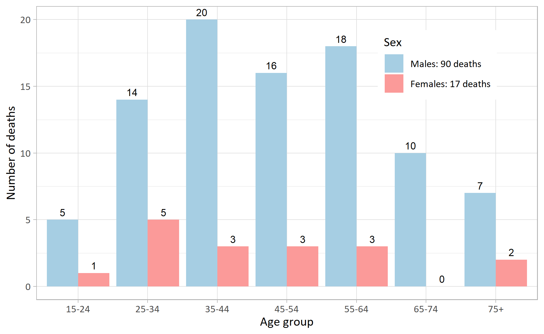
Figure 1: Number of deaths from suicide and events of undetermined intent, by age group and sex, Medway residents, 2015-2019 registrations.¹³

Suicide by method
Figure 2 shows the number of deaths from suicide and events of undetermined intent of Medway residents by method and sex.¹³
The majority of deaths from suicide were due to hanging for males and poisoning for females in Medway. The second most common method of suicide was poisoning for males and hanging for females, this pattern is similar to the England average.¹³
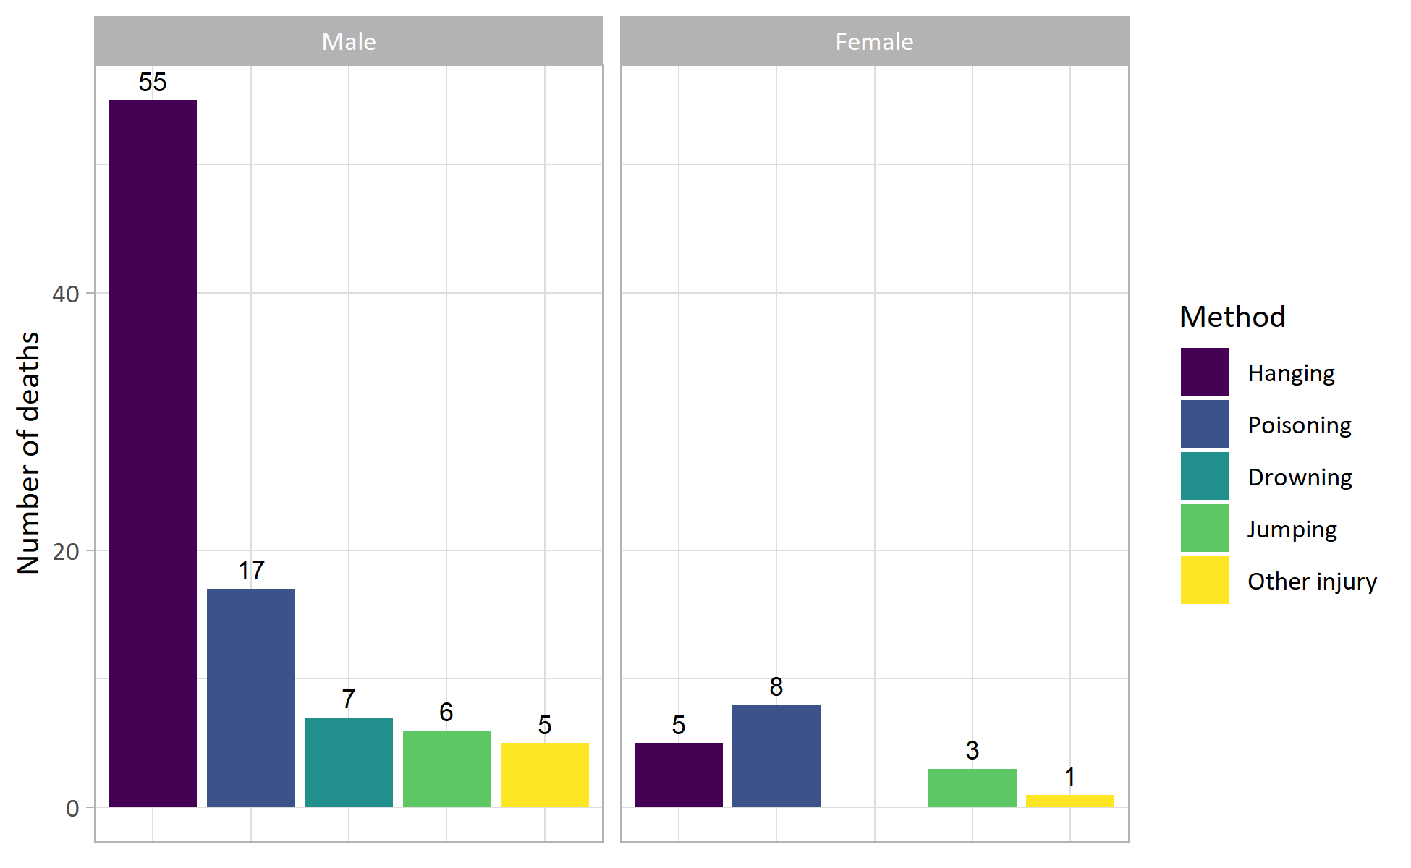
Figure 2: Deaths from suicide and events of undetermined intent by method and sex, aged 15 and over, Medway residents, 2015-2019 registrations.¹³

Suicide by place of death
There were 93 deaths from suicide in Medway between 2015 and 2019, 58.1% had a place of death type as home, 14.0% as hospital (Medway Maritime Hospital), 1.1% as communal establishment, and 26.9% occurred elsewhere.¹³
Of those suicides where the place of death was ‘hospital’, it is unclear whether the suicide occurred in hospital or occurred in another location, but the person later died while in hospital.
Based on the available data, there appear to be no patterns when analysing the suicides that occurred ‘elsewhere’ by postcode. Although, recent surveillance does appear to indicate that there are key high-risk locations within Medway for death by suicide.

Suicide by electoral ward
Figure 3 shows the age-standardised incidence ratio (SIR) for deaths from suicide and events of undetermined intent by ward.¹³
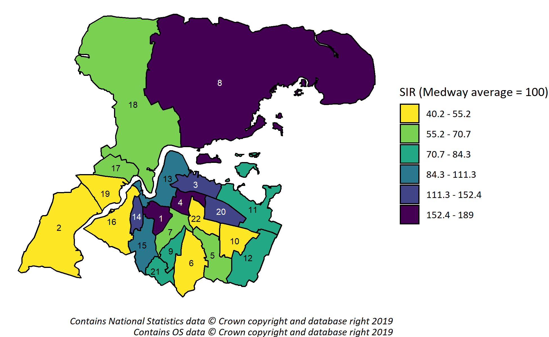
Figure 3: Age-standardised incidence ratio (SIR) for suicide and events of undetermined intent by ward, aged 15 and over, Medway residents, 2015-2019 registrations.¹³
Ward key: 1 - Chatham Central; 2 - Cuxton and Halling; 3 - Gillingham North; 4 - Gillingham South; 5 - Hempstead and Wigmore; 6 - Lordswood and Capstone; 7 - Luton and Wayfield; 8 - Peninsula; 9 - Princes Park; 10 - Rainham Central; 11 - Rainham North; 12 - Rainham South; 13 - River; 14 - Rochester East; 15 - Rochester South and Horsted; 16 - Rochester West; 17 - Strood North; 18 - Strood Rural; 19 - Strood South; 20 - Twydall; 21 - Walderslade; 22 - Watling.
Due to small numbers at ward level (0 to 12 deaths from suicide and events of undetermined intent per ward over 5 years),¹³ counts can vary significantly from year to year and this can lead to wide variance in the SIRs.
Between 2015 and 2019 several wards had a high SIR for suicide and events of undetermined intent, including Peninsula (189.0), Chatham Central (188.4), Gillingham South (168.9), Twydall (152.4), Rochester East (147.5), Gillingham North (145.1) and Rochester South and Horsted (111.3).¹³ These are generally some of the more deprived wards in Medway. However, Peninsula and Chatham Central are the only wards with SIRs that are statistically significantly higher than Medway as a whole.¹³ These wards have suicide rates that are approximately 90% higher than the Medway average. A ward’s SIR is defined as being statistically significantly higher if the lower confidence interval of a ward’s SIR is above the Medway average of 100.

Suicide by local deprivation quintile
Figure 4 shows the age-standardised incidence ratio (SIR) for suicide and events of undetermined intent of Medway residents by local deprivation quintile (Index of Multiple Deprivation (IMD) 2019).¹³ A quintile is simply one fifth or 20% of the population.
There is a clear gradient in the rate across deprivation quintiles. The most deprived area in Medway (local quintile 1) has the highest SIR and the suicide rate is over 50% higher than the Medway average.¹³
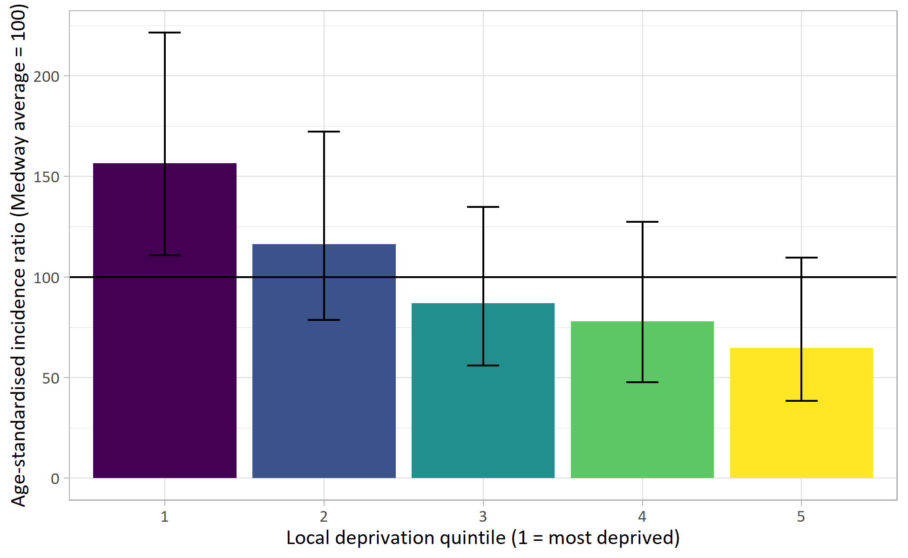
Figure 4: Age-standardised incidence ratio (SIR) for suicide and events of undetermined intent by local deprivation quintile (IMD 2019), aged 15 and over, Medway residents, 2015-2019 registrations.¹³

Self-harm in Medway
The relationship between self-harm and suicide is outlined in the ‘Who’s at risk and why section. Given that there is an increased risk of suicide for those who self-harm, it is helpful to look at some of the data for adults in Medway who self-harm.

Self-harm by age group and sex
Figure 5 shows the number of emergency hospital admissions for intentional self-harm in Medway by age group and sex.¹⁴
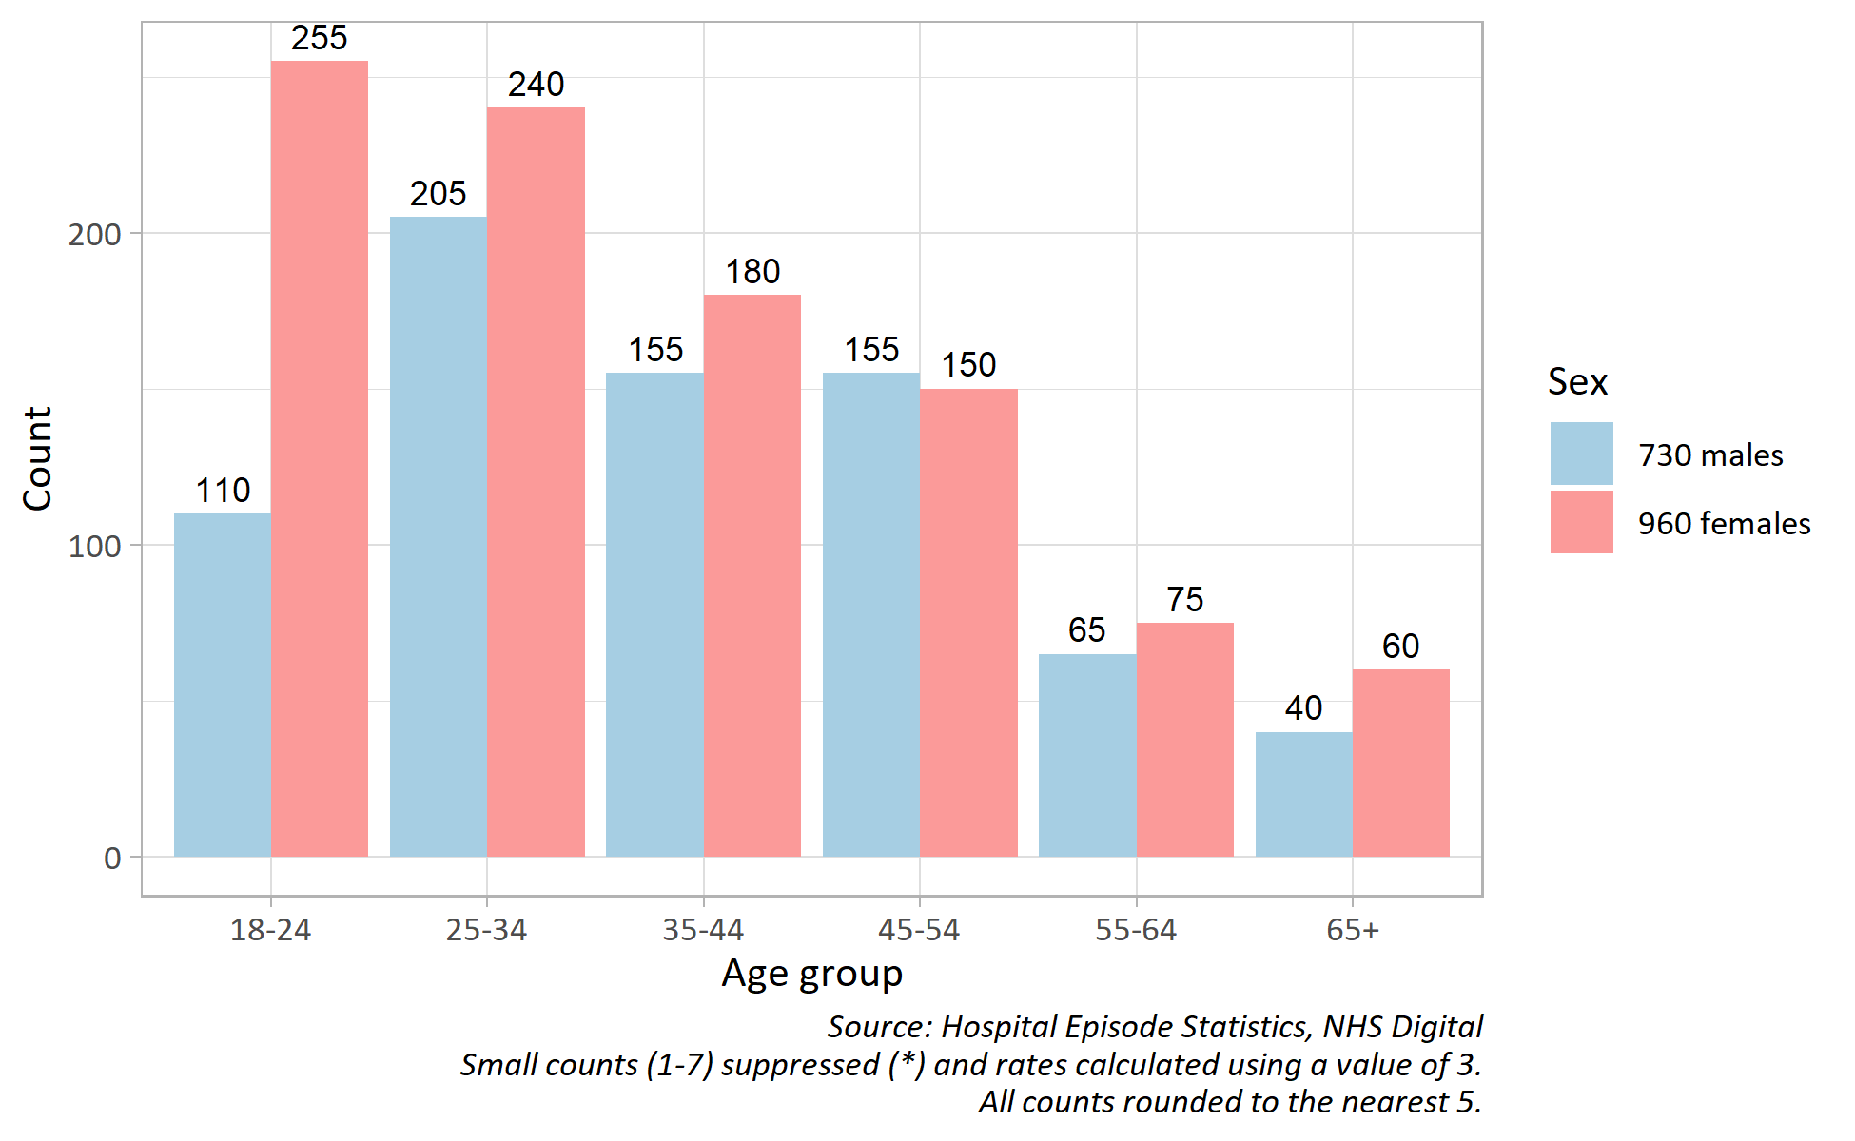
Figure 5: Number of emergency hospital admissions for intentional self-harm in Medway, by age group and sex, 2015/16-2019/20.¹⁴
More females were admitted to hospital due to self-harm than males in Medway between 2015/16 and 2019/20 (males: 43.2%; females: 56.8%).¹⁴
Females have a higher number of emergency admissions compared to males across most age groups.¹⁴

Self-harm by electoral ward
Figure 6 shows the age-standardised incidence ratio for hospital admissions related to intentional self-harm in Medway by ward for persons aged 18 and over.¹⁴
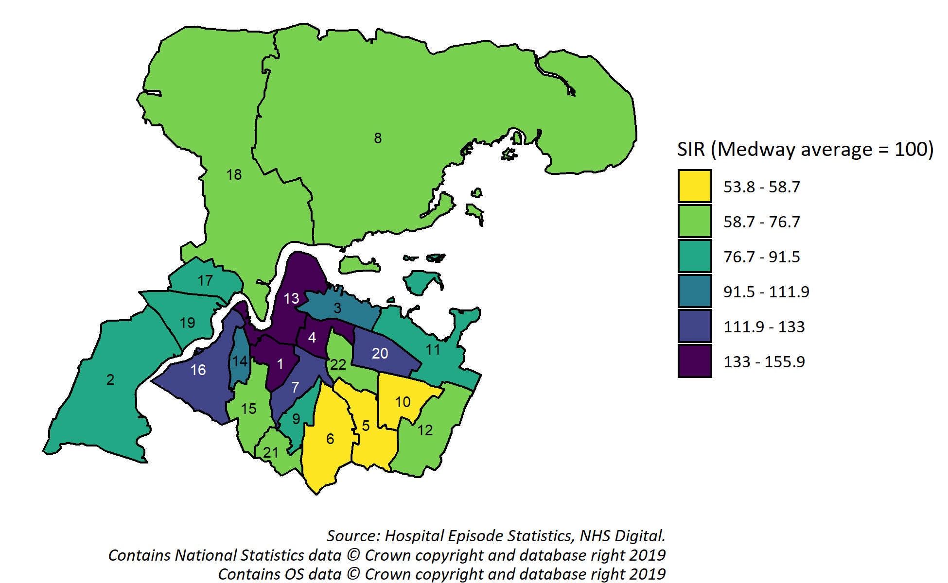
Figure 6: Age-standardised incidence ratio (SIR) for emergency hospital admissions related to intentional self-harm by ward, persons aged 18 and over, Medway residents, 2015/16-2019/20.¹⁴
Ward key: 1 - Chatham Central; 2 - Cuxton and Halling; 3 - Gillingham North; 4 - Gillingham South; 5 - Hempstead and Wigmore; 6 - Lordswood and Capstone; 7 - Luton and Wayfield; 8 - Peninsula; 9 - Princes Park; 10 - Rainham Central; 11 - Rainham North; 12 - Rainham South; 13 - River; 14 - Rochester East; 15 - Rochester South and Horsted; 16 - Rochester West; 17 - Strood North; 18 - Strood Rural; 19 - Strood South; 20 - Twydall; 21 - Walderslade; 22 - Watling.
The wards with statistically significantly higher SIRs for emergency hospital admissions related to intentional self-harm are: Gillingham South (155.9); River (143.6); Chatham Central (142.7); Luton and Wayfield (133); Rochester West (126).¹⁴ These wards have self-harm admission rates that are approximately 30% to 60% higher than the Medway average.¹⁴ These wards are some of the more deprived in Medway.

Self-harm by local deprivation decile
Figure 7 shows the age-standardised incidence ratio for hospital admissions related to intentional self-harm in Medway by local deprivation decile (IMD 2019) for persons aged 18 and over.¹⁴ A decile is simply one tenth or 10% of the population. It is possible to examine hospital admission for self-harm in greater detail by decile because it is more common than suicides and hence the analysis is more robust.
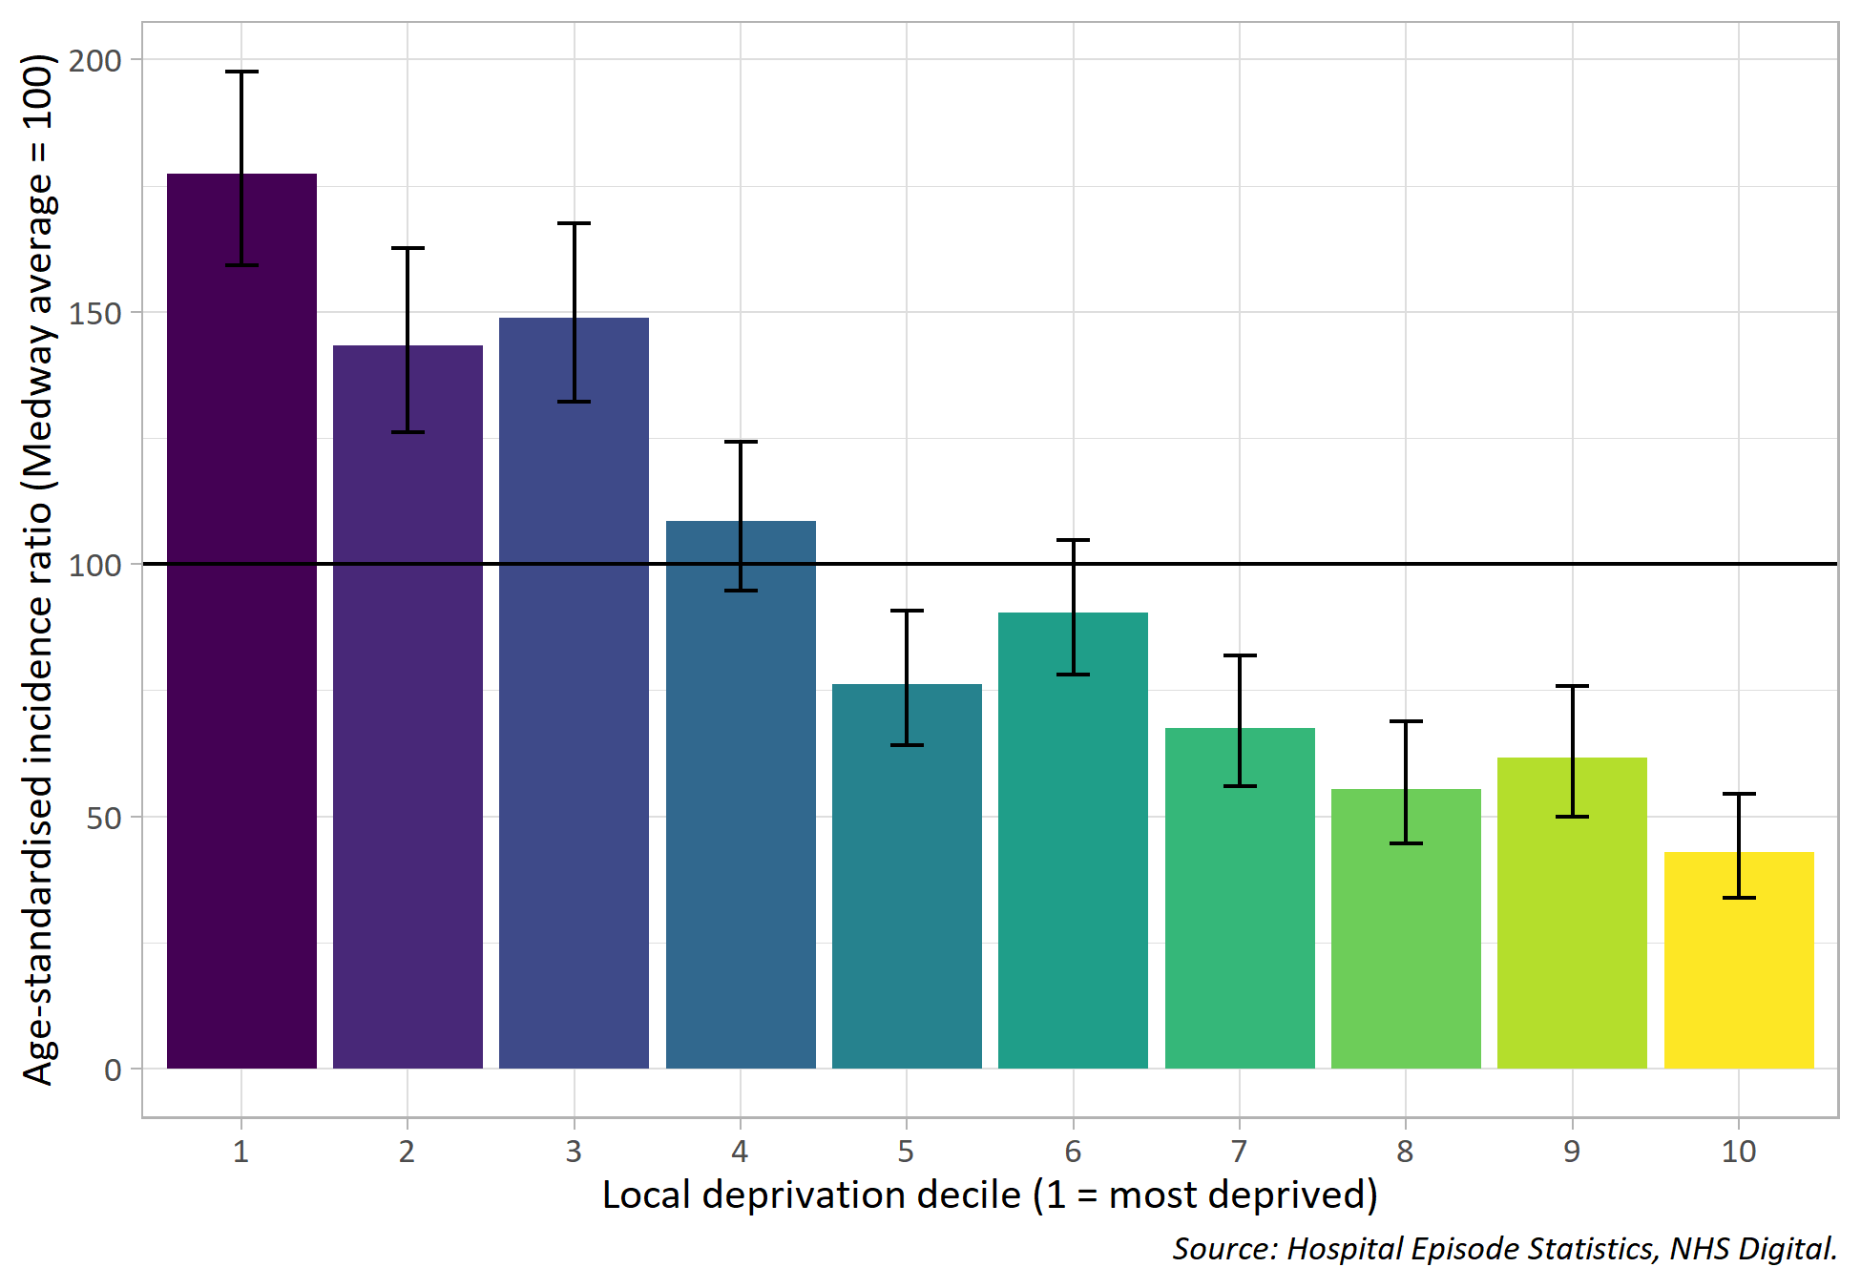
Figure 7: Age-standardised incidence ratio (SIR) for emergency hospital admissions related to intentional self-harm by local deprivation decile (IMD 2019), persons aged 18 and over, Medway residents, 2015/16-2019/20.¹⁴
More deprived areas (local deciles 1-3) have SIRs above the Medway average. The most deprived area in Medway (local decile 1) has a self-harm admission rate that is nearly 80% higher than the Medway average.¹⁴
Less deprived areas (local deciles 5, 7-10) have SIRs below the Medway average. The least deprived area in Medway (local decile 10) has a self-harm admission rate that is nearly 60% lower than the Medway average.¹⁴

4) Current services in relation to need
The NHS England funding provided to the Kent and Medway STP has enabled a range of additional services to be available in Medway.
Many services have been adapted during the outbreak of COVID-19 to be virtual, delivered online rather than face-to-face, although access to these digital services may not currently be equitable across the population.
A helpline Release the Pressure (0800 107 0160) is available 24/7 and delivered by Mental Health Matters. Mental Health Matters is jointly commissioned by Medway Clinical Commissioning Group and Medway Council. Callers access online or telephone support from trained counsellors to prevent mental health crisis. The helpline is promoted through an extensive social marketing campaign which provides posters, leaflets and promotional products. The volume of calls to the helpline is monitored and averages at around 2,000 per month.
The Stay Alive App has also been made available through the STP programme and is free to access. The app enables users to create their own safety plan and offers help to those who are concerned about the safety of someone else.
A crisis text service, called Shout, is also available by texting the word MEDWAY to 85258 . Messages are responded to by trained volunteers and supervised by mental health clinicians. Although this service is not currently commissioned at a local level.
A Suicide Awareness training programme is available to anyone in Kent and Medway which offers free training to anyone and is provided by Maidstone Mind, over 1,000 people have been trained since 2017. Medway Public Health also delivers subsidised Mental Health First Aid training and Connect 5 training, both include a section on suicide prevention.
Medway Public Health commissions a Men in Sheds scheme which aims to reduce the risk of suicide in men, particularly those who are not currently in work or are experiencing isolation. The scheme has supported over 200 individuals and outcomes indicate that it has an impact on reducing feelings of isolation and hopelessness.
Medway council’s workplace health programme offers support to local businesses with developing suicide prevention and postvention policies along with training on the use of a workplace suicide prevention toolkit. Workplaces are encouraged to reduce stigma through signing the Time to Change Employer pledge. In addition, a dedicated project officer is working across workplace settings with high-risk occupation groups.
The Time to Change Medway HUB is funded and hosted by Medway Council. The HUB is coordinated by Porchlight and recruits and trains people with lived experience of mental illness to become community mental health champions. The aim of the HUB is to reduce mental health stigma particularly amongst men in Medway.
Medway Council has a project officer for self- harm and a strategic plan for identification and prevention of self -harm amongst adolescents is in development with an expected completion date of January 2021.
Kent and Medway CCG is responsible for commissioning mental health treatment services which contribute to suicide prevention.
- The local mental health provider Kent and Medway Partnership Trust (KMPT) provides community, outpatient and inpatient services for adults and KMPT have their own specific suicide prevention strategy.
- Crisis and Home Treatment team and psychiatric hospital in- patient facilities are provided by KMPT and available within Kent to those who are severely depressed and at the greatest risk of suicide.
- An A&E Psychiatric Liaison service is available at Medway Maritime hospital for people experiencing suicidal thoughts or self-harm.
- The NHS Medway talking therapies service is available to people who are experiencing issues such as anxiety, depression and occasional suicidal thoughts at a lower intensity.
- A Safe Haven is available for Medway residents to attend which provides a safe place for reassurance and emotional support from 6pm to 11pm, 365 days from qualified Mental Health Matters staff.
The voluntary sector in Medway also provides support to people who may be feeling suicidal and plays a vital role within the suicide prevention system, supporting people with wider issues, such as debt, relationships, unemployment and loneliness.
Samaritans is a charity that offers support to people who are experiencing feelings of despair, including those who may be feeling suicidal.
Improve Mental Health Provision (IMHP) are a service user led organisation funded by the Police and Crime commissioner to offer out of hours crisis support to people.

5) Projected service use and outcomes in 3-5 years and 5-10 years
Forecasting suicides is complex, and it is difficult to incorporate significant influences such as economic conditions. While suicide rates among older people have been decreasing in recent years, an increase in absolute numbers is expected in the coming decades due to the increase in numbers of older people.¹
In recent decades, the suicide rate in Medway has fluctuated and there is no discernible trend. The best estimate is to assume a similar number of suicides over the next 3 years; 65 suicides were reported in 2016-18. However, the impact of COVID-19 is yet to be seen on suicide and it is reasonable to anticipate that the pandemic may heighten suicide risk.¹¹

6) Evidence of what works
Preventing suicides in public places: a practice resource (2015) draws on recent research and expert opinion and provides examples of innovative practice.
Support after a suicide: a guide to providing local services is the new PHE guidance that makes the case for commissioning postvention services and how this work fits into suicide prevention strategies. There is emerging evidence that post-suicide interventions at community level can help to prevent copycat or suicide ‘contagion’ behaviours and suicide ‘clusters.’⁵
Help is at Hand is a resource for people who have been bereaved by suicide and other sudden, traumatic death. Individuals who have been bereaved by suicide have been the principal authors of the guide, with support from experts at Public Health England (PHE) and the National Suicide Prevention Alliance (NSPA).
Mental health services: cost-effective commissioning. This PHE guidance looks at the most cost-effective interventions for mental health promotion and is accompanied by a return on investment tool. The provision of suicide prevention training in primary care is one of the eight interventions featured within this tool.

The National Institute for Health and Care Excellence (NICE) guidance
Self-harm. NICE quality standard QS34. This quality standard covers the initial management of self-harm and the provision of longer-term support for children and young people (aged 8 to 18) and adults (aged 18 and over) who self-harm.
The guidance states that commissioned services should undertake an initial assessment of physical health, mental state, safeguarding concerns, social circumstances and risk of further self-harm or suicide for people after an episode of self-harm.
Depression in adults: recognition and management. NICE clinical guideline CG90. This guideline covers identifying and managing depression in adults aged 18 years and older, in primary and secondary care. It aims to improve care for people with depression by promoting improved recognition and treatment.
Depression in adults with a chronic physical health problem: recognition and management. NICE clinical guideline CG91. This guideline covers identifying, treating and managing depression in people aged 18 and over who also have a chronic physical health problem such as cancer, heart disease or diabetes. It aims to improve the care of people with a long-term physical health problem, which can cause or exacerbate depression. This has the potential to increase their quality of life and life expectancy.
Preventing suicide in community and custodial settings. NICE guideline NG105. The guideline covers ways to reduce suicide and help people bereaved or affected by suicides. It aims to:
- help local services work more effectively together to prevent suicide
- identify and help people at risk
- prevent suicide in places where it is currently more likely.

7) User views
Service user groups and carers are represented on the Kent and Medway Suicide Prevention Steering Group and were involved and consulted on the development of the strategy in 2015 through a series of workshops.
In August 2018, a workshop was held involving service user groups to map bereavement services across the locality, identify gaps and inform future service provision. An additional piece of research was carried out to look at themes within 119 coroners inquests for suicides locally. The themes that were highlighted as triggers for suicide were relationship breakdown, bereavement, debt and self-harm.
In Autumn 2018, Healthwatch Medway spoke to 46 service users about their experiences of services received. There was dissatisfaction expressed by some service users for the lack of responsive support available during a mental health crisis and during periods of suicidality or self-harm. A recommendation of the Healthwatch report was for a review of the crisis service.
In January 2019, a stakeholder survey was circulated to gather data to inform the development of services and projects aimed at reducing suicide in men. The results indicated that stigma and social conditioning were the main barriers to seeking help at the early signs of mental distress and men felt it was important to promote the concept of ‘Looking Out For Your Mate’ to break down social norms around masculinity.

8) Unmet needs and service gaps

Postvention and specialist suicide bereavement services
It is recommended that any postvention service should be able to offer individuals a wide choice of support tailored to their needs. There is currently no specialised suicide bereavement pathway in Medway, although work is underway to address this gap.

Real time surveillance
Official suicide data is not always timely enough to enable local services to respond adequately to emerging situations. An effective postvention bereavement support service requires monitoring of means of self-harm and suicide through real time surveillance in order to implement timely interventions and targeted strategies. A formal real time surveillance system is currently unavailable in Medway although work is underway to address this gap.

Mental Health Matters/Release the pressure helpline
Performance monitoring data of the Mental Health Matters contract has identified that demand is particularly high within Medway although a proportion of these calls are at times, from high frequency callers. Demand for the service overall is greater than capacity with a high percentage of calls being unanswered.

Suicide prevention training
Training for all primary care staff in awareness of suicidality and safety planning can play a crucial role in suicide prevention. There is no specific programme of suicide prevention training within Medway Primary Care or postvention training within the community, such as Postvention Assisting those Bereaved By Suicide (PABBS).

9) Recommendations for commissioning
NHS England transformation funding for the current Kent and Medway suicide prevention programme is available until the end of 2020/21. Sustainability of the programme is an area of risk and further financial investment is required for projects to continue to prevent suicides in Medway.
Commissioners and providers of secondary care and community services should look to implement the clinical messages outlined within the National Confidential Inquiry into Suicide and Safety in Mental Health (NCISH) annual report 2019.
Work to continue with commissioners and mental health service providers to review and implement local crisis service development improvement plan.
A whole system approach should be adopted to ensure that acute and community services are better joined up, avoiding gaps in support during transitions and improving access for those who need it most.
Ensure pathways are in place that provide effective and timely support for families and other people bereaved or affected by suicide. Work should continue to promote the Help is at Hand resource across Medway ensuring that all partners have access to online and hard copies when required.
Identify and implement a peer led suicide prevention training programme for all clinicians within primary care networks and explore the requirement for Postvention Assisting those Bereaved By Suicide (PABBS) training with the community. This work should be targeted at GP practices located in areas of higher deprivation.
A review of the Mental Health Matters contract should be undertaken and the need for additional investment considered to ensure the service has capacity to meet the demand. Consideration should be given to commissioning SHOUT, the national crisis text service, locally.
Promotion of the Release the Pressure helpline and other relevant services should be targeted in areas of deprivation due to the higher prevalence of suicide in these areas. This should include GP practices and also involve working closely with the Medway Task Force based at the Council.

10) Recommendations for needs assessment work
Further work should be undertaken to ascertain the impact of COVID-19 on mental health and the risk factors for suicide within population groups.

References
1. Department of Health and Social Care. Preventing Suicide in England: A Cross-Government Outcomes Strategy to Save Lives. HM Government; 2012. https://www.gov.uk/government/publications/suicide-prevention-strategy-for-england
2. Department of Health and Social Care. Preventing Suicide in England: Third Progress Report of the Cross-Government Outcomes Strategy to Save Lives. HM Government; 2017. https://www.gov.uk/government/publications/suicide-prevention-third-annual-report
3. Public Health England. Local Suicide Prevention Planning: A Practice Resource. HM Government; 2020. https://www.gov.uk/government/publications/suicide-prevention-developing-a-local-action-plan
4. Office for National Statistics. Suicide Occurrences, England and Wales. Office for National Statistics; 2020. https://www.ons.gov.uk/peoplepopulationandcommunity/birthsdeathsandmarriages/deaths/datasets/suicideinenglandandwales
5. Samaritans. Dying from Inequality: Socioeconomic Disadvantageand Suicidal Behaviour. Samaritans; 2017. https://www.samaritans.org/about-samaritans/research-policy/inequality-suicide/
6. Department of Health and Social Care. Preventing Suicide in England: Fourth Progress Report of the Cross-Government Outcomes Strategy to Save Lives. HM Government; 2019. https://www.gov.uk/government/publications/suicide-prevention-fourth-annual-report
7. Weaver, T., Charles, V., Madden, P., and Renton, A. Co-morbidity of Substance Misuse and Mental Illness Collaborative Study (COSMIC): A study of the Prevalence and Management of Co-Morbidity amongst Adult Substance Misuse & Mental Health Treatment Populations. Department of Health; 2002. http://dmri.lshtm.ac.uk/docs/weaver_es.pdf
8. Office for National Statistics. Who Is Most at Risk of Suicide? Analysis and Explanation of the Contributory Risks of Suicide. Office for National Statistics; 2017. https://www.ons.gov.uk/peoplepopulationandcommunity/birthsdeathsandmarriages/deaths/articles/whoismostatriskofsuicide/2017-09-07
9. Wyllie, C., Platt, S., Brownlie, J., Chandler, A., Connolly, S., Evans, R., Kennelly, B., Kirtley, O., Moore, G., O’Connor, R., and Scourfield, J. Men, Suicide and Society: Why Disadvantaged Men in Mid-Life Die by Suicide. Samaritans; 2012. https://media.samaritans.org/documents/Samaritans_MenSuicideSociety_ResearchReport2012.pdf
10. Public Health England. Domestic abuse-related incidents and crimes. Indicator ID: 92863.
11. Gunnell, D., Appleby, L., Arensman, E., Hawton, K., John, A., Kapur, N., Khan, M., O’Connor, R., Pirkis, J., and COVID-19 Suicide Prevention Research Collaboration. Suicide risk and prevention during the covid-19 pandemic. Lancet Psychiatry. 2020;7(6):468-471. https://www.thelancet.com/journals/lanpsy/article/PIIS2215-0366(20)30171-1/fulltext
12. Public Health England. Fingertips. Suicide rate. Indicator ID: 41001.
13. Public Health Intelligence Team, Medway Council. Primary Care Mortality Database Analysis.
14. Public Health Intelligence Team, Medway Council. Admitted Patient Care analysis. Hospital Episode Statistics, NHS Digital.

